**Objective Questions**

1. What is the total no. of tables present in the data?  
     
   **2 Table are present in the data   
   One is in raw data sheet and another is in country description sheet**
2. What is the total no. of attributes present in the data?  
     
   **20 Attributes (Columns) are present in the data before analysis  
   24 Attributes (Columns) are present in the data after analysis**
3. How many categorical columns are there in the data? [Search about categorical and continuous data, and try to answer this question]  
     
   **There are 12 categorical columns are there in the data listed below  
     
   1 – Restaurant (Restaurant ID , Restaurant Name)  
   2 – Location : (Country Code , City , Address ,Locality ,Locality Verbose,  
   Longitude, Latitude)  
   3 - Cuisines  
   4 - Currency  
   5 – Table booking  
   6 – Delivery (Has Online delivery Is delivering now)  
   7 – Switch to order menu  
   8 – Price range  
   9 - Votes  
   10 – Average Cost for two  
   11 - Rating  
   12 – Date key Opening**
4. The data consists of some inconsistent and missing values so ensure that the data used for further analysis is cleaned.  
     
   **CUISINES COLUMN have few missing data as I have shared below  
   by going forward for analysis I will be deleting these 9 rows for analysis as per our requirement**   
   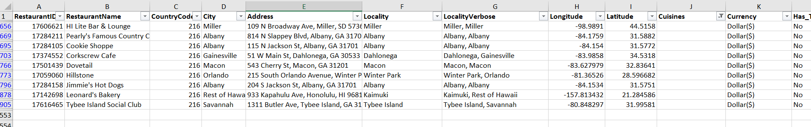
5. Using the Look Up functions, fill up the countries in the original data using the country code.  
     
   **Used VLOOKUP to derive the country data using the country code**  
   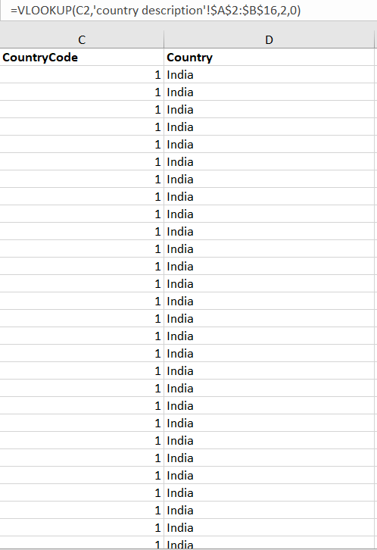
6. Create a table to represent the number of restaurants opened in each country.  
     
   **using pivot table we can find number of restaurants by country  
     
   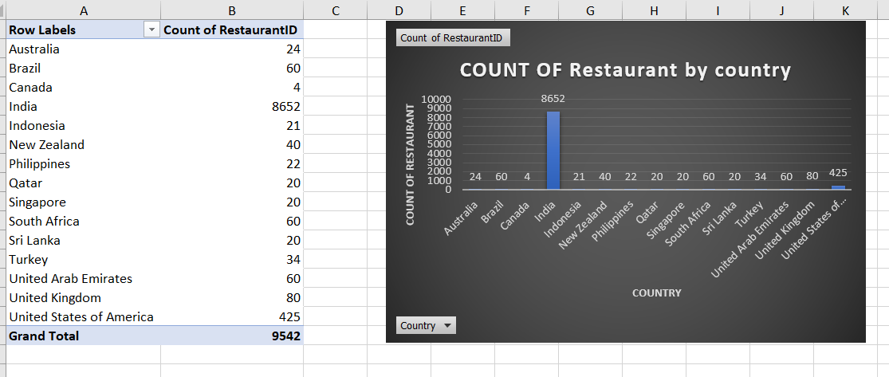**
7. Also, the management wants to look at the number of restaurants opened each year, so provide them with something here.  
     
   **using pivot table we can find number of restaurants opened by each year**  
     
   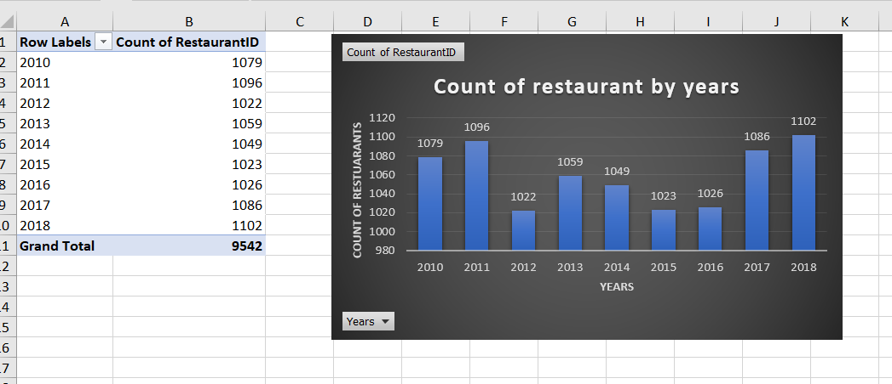
8. What is the total number of restaurants in India in the price range of 4?   
    **388 restaurants in India in the price range of 4**  
   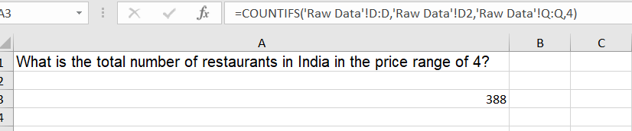
9. What is the average number of voters for the restaurants in each country according to the data? **Below Image shows the avg votes by country  
   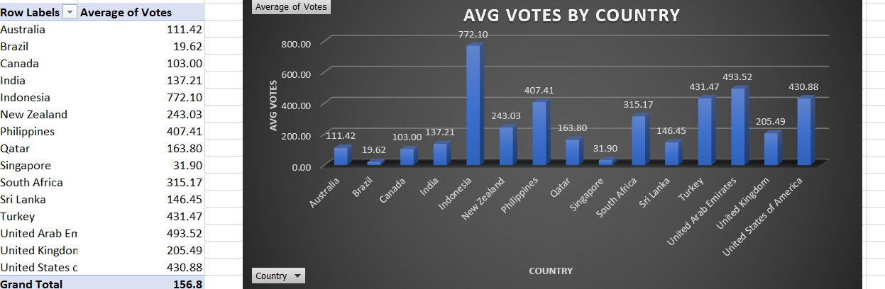**
10. Calculate the average rating for all the restaurants that have price_range < 4 and provide online delivery. Use only the “IF” function, Logical Operators, and Aggregation functions to solve this problem. **[Note: Don’t use Conditional aggregation in this question.]  
      
    AVGERAGE OF RESTAURANTS HAVING PRINCE RANGE LESS THEN 4 AND HAS ONLINE DELIVRY IS 3.37   
      
    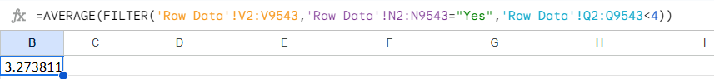**
11. Using Conditional formatting highlight the rows of restaurants that are located in the countries or cities that you’ve suggested to the management for opening new restaurants.   
      
      
    **Go to conditional formatting and gave the below formula to colour the row background as blue  
      
    =OR($C:$C = 30,$C:$C = 148,$C:$C = 189,$C:$C = 214,$C:$C = 215)  
    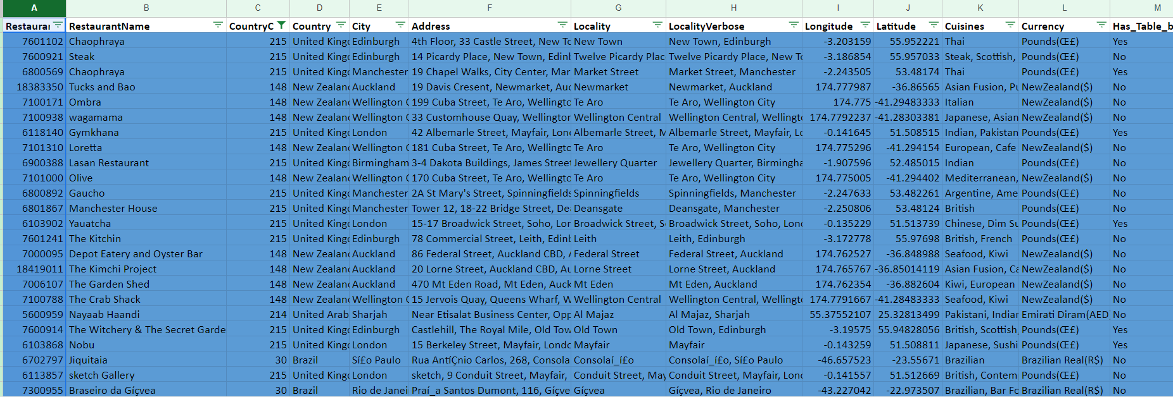  
      
    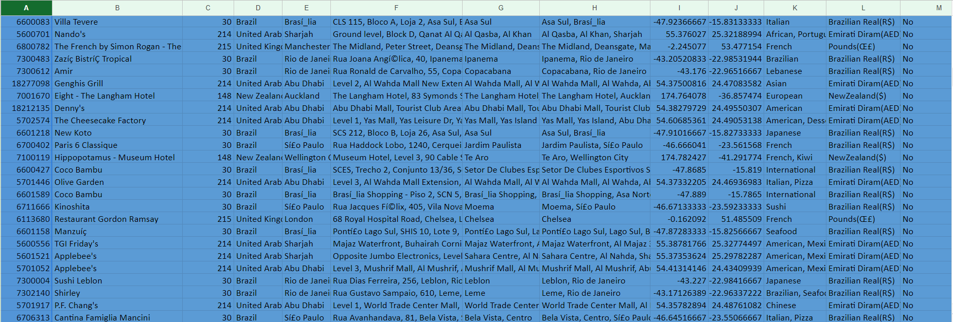**
12. Create a new customized price column that consists of the abbreviation/symbol of the currency along with the Average_cost_for_two value. [Use string operations to do this task]  
      
    **Using this formula we can merge abb/symbol with amount  
      
    =CONCATENATE(MID(L2, FIND("(", L2) + 1, FIND(")", L2) - FIND("(", L2) - 1)," ",S2)**  
    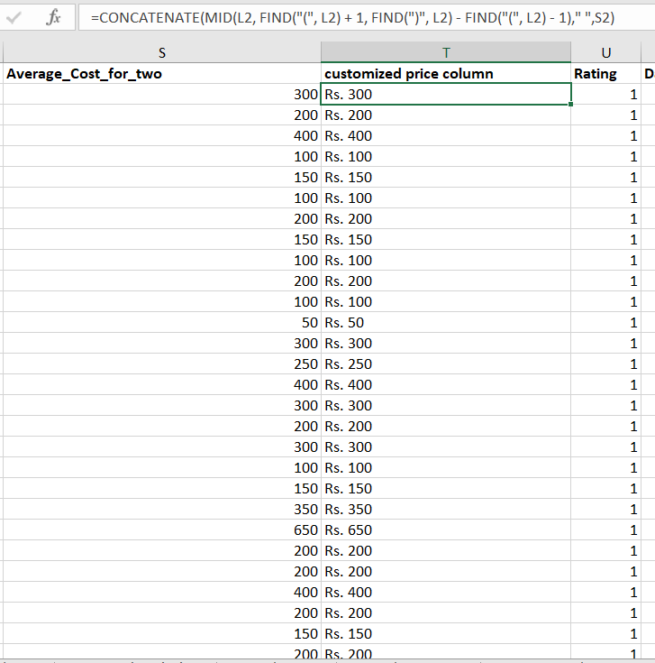
13. How can you create an array formula in Excel or Google Sheets to count the number of restaurants listed that do not offer online delivery, are in the lowest price range, and have an average cost for two people less than or equal to 250 Indian Rupees?  
      
    **Here I used ARRAY FORMULA with COUNTIFS containing three criteria based on it count ifs function will count the data**  
    **1692**  
      
    

**Subjective Question:**

1. Suggest a few countries where the team can open newer restaurants with lesser competition. Which visualization/technique will you use here to justify the suggestions?

**Ignoring USA and India for a higher competition are present in these countries  
  
Brazil, New Zealand, South Africa, United Arab Emirates, United Kingdom  
Above 5 country have lesser competition and zomota have already have 40+ restaurants running so we can open the new restaurants in above mentioned 5 countries  
  
Ignoring remaining country for the reason they have less than 40 restaurants comparing to above 5 country Zomato is not familiar to other countries**   
  
  
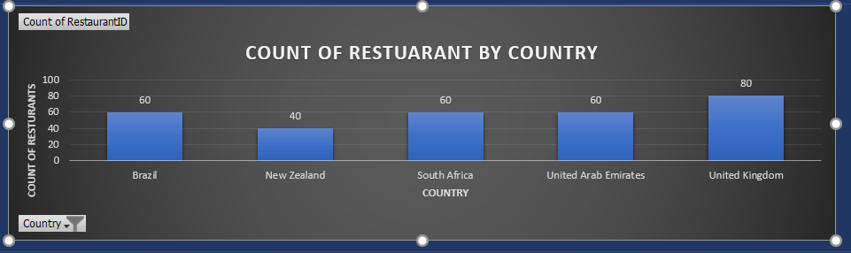

1. Come up with the names of States and cities in the suggested countries suitable for opening restaurants.

**There are 18 state or cities were new restaurants can be opened in the suggested countries  
  
Those 18 I was selecting because the rating is more then 4 , that means in these area both number of people using restaurants and restaurants in their area are running good  
those 18 state or cities are mentioned below with country**

|  |  |
| --- | --- |
| **Brazil** | **Silo Paulo** |
| **Rio de Janeiro** |
| **Brasília** |
| **New Zealand** | **Wellington City** |
| **Auckland** |
| **South Africa** | **Johannesburg** |
| **Cape Town** |
| **Pretoria** |
| **Sand ton** |
| **Inner City** |
| **Ransburg** |
| **United Arab Emirates** | **Sharjah** |
| **Abu Dhabi** |
| **Dubai** |
| **United Kingdom** | **Edinburgh** |
| **Manchester** |
| **London** |
| **Birmingham** |

1. According to the countries you suggested, what is the current quality regarding ratings for restaurants that are open there?  
     
   **AVG rating by the suggested country   
   all the suggested country are rating more then 3.8**

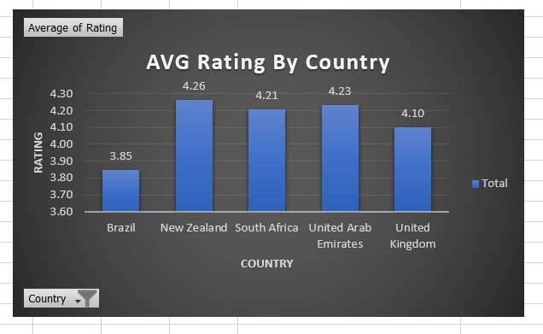

1. Also, what is the current expenditure on food in the suggested countries, so we can keep our financial expenditure in control?  
     
   **AVG cost in the suggested country is mentioned below**  
   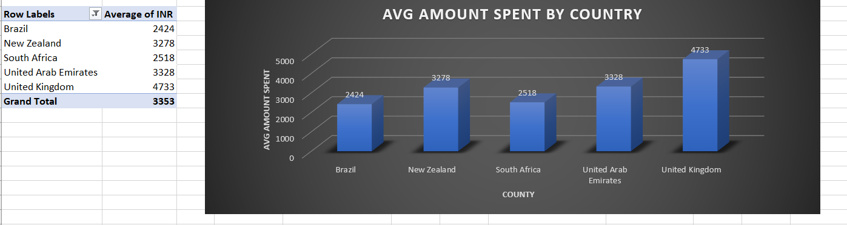

1. Come up with the names of restaurants from the recommended states that are our biggest competitors and also those that are rated in the lower brackets, i.e. 1-2 or 2-3.

|  |  |  |  |
| --- | --- | --- | --- |
| **Country** | **city** | **biggest competitors** | **lower brackets(1-2) or (2-3)** |
| Brazil | Silo Paulo | Skye - Hotel Unique | Super Grill |
| Rio de Janeiro | Braseiro da Gíçvea | Quiosque Chopp Brahma |
| Brasília | Coco Bambu | Sandubas Cafí© |
| New Zealand | Wellington City | The Hangar | - |
| Auckland | Miann | De Fontein Belgian Beer Cafe |
| South Africa | Johannesburg | Marble | - |
| Cape Town | Jarryds | - |
| Pretoria | Restaurant Mosaic @ The Orient | - |
| Sand ton | Gemelli Cucina Bar | - |
| Inner City | Urbanologi | - |
| Ransburg | The Whippet | - |
| United Arab Emirates | Sharjah | Rajasthan Al Malaki | Pizza Hut |
| Abu Dhabi | Punjab Grill | - |
| Dubai | Tresind - Nassima Royal Hotel | - |
| United Kingdom | Edinburgh | Roseleaf Bar Cafe | - |
| Manchester | Solita | - |
| London | Bao | - |
| Birmingham | Bodega | Damascena Coffee House |

1. Which cuisines should we focus on in the newer restaurants to get better feedback? Does the choice of cuisines affect the restaurant ratings?

**Based on the country and cities , the cuisines may differ from various locations  
  
From my suggested Country and cities , picked the famous cuisines based on location , so that we can satisfy the customer and can get good feedback and rating** as well  
  
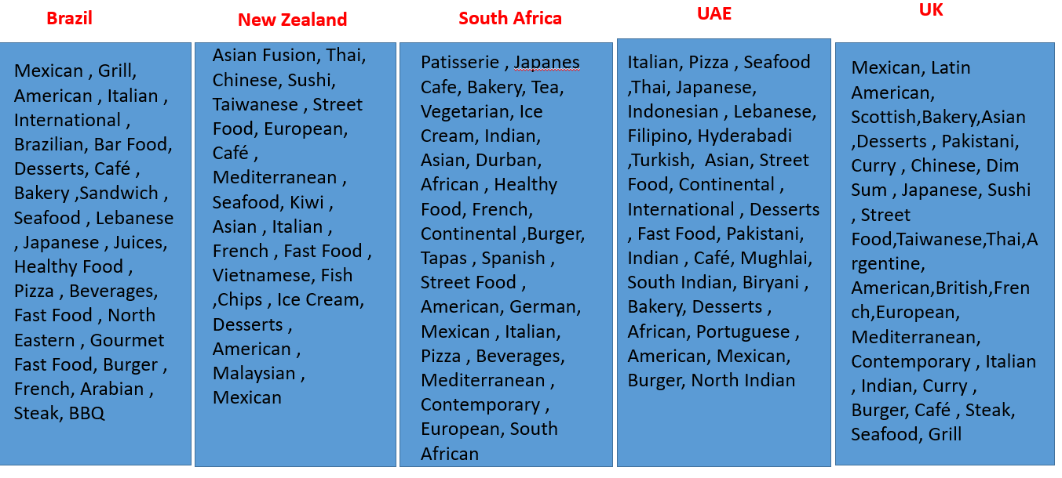

1. According to our current data, should we go for online delivery and table booking? Does that affect the customer’s ratings?  
     
   **Online Delivery status**  
   **According to the analysis based on 5 suggested countries the count online delivery services is only 28 , so we can’t open for online delivery**  
   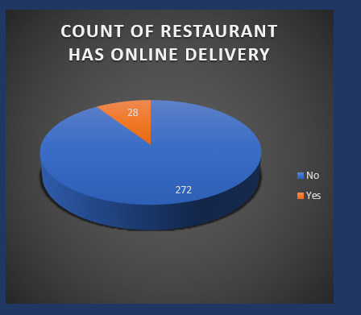 **Table booking status  
     
   Out of 300 restaurants only 32 restaurants are having table booking in the suggested country   
   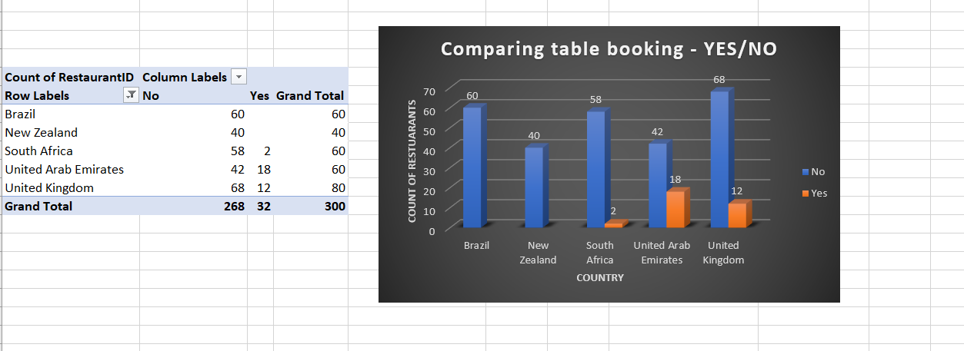**  
   **In my view online delivery and Table booking both are important and necessary where it is already available locations ,but for other locations after opening new branch based on the demand we can start the table booking and online delivery**
2. Should the team keep the rate of cuisines higher? Will that affect the feedback? According to our data are the rates of cuisines and ratings, correlated?  
    **We can keep the price range (2-3)   
   Yes cuisines and rating are correlated to each other**
3. What is the distribution of the number of restaurants of different price ranges in all the countries?  
   **Number of restaurants of different price ranges in all the countries**  
     
   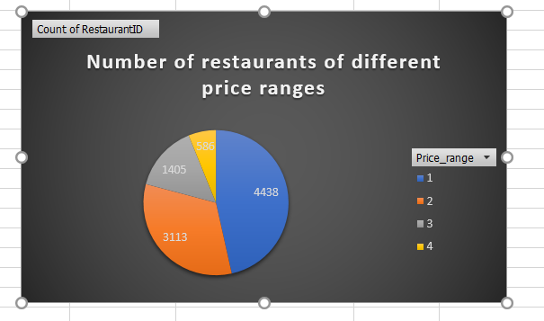
4. Explain your approach in brief for suggesting countries/cities in order to open new restaurants, if the objective and subjective questions would have not been given to assist you. **[you have to give bullet pointers in order to answer this question]**

**If the objective and subjective questions would have not been given my analysis would have been first find the top performing country  
  
And next I would have been remove the top 2 or 3 country from my analysis because the competitor are very high in those locations  
  
And based on the rating I would have select the top country with lesser competitor and will select the top performing city based on rating   
  
After that based on cost , votes will select the location for opening new branch**   
  
**At last based on the location some dish will be running good so while opening new branch those dishes will be on the new branch**  
 **The dashboard must consist of Year-wise and country slicers.**