Python Activity Based Learning
University Admission Decision Engine | Ten Executed Test Cases
This report implements the admission rules in the supplied exercise, runs ten applicant cases, and records the program output for each run. The sample marks Esha as ineligible, but its stated rules classify Esha as eligible; this report follows the stated rules and flags that source inconsistency in the test table.

1. Problem Statement
Create a Python program that checks an applicant’s Mathematics, Physics and Computer Science marks, calculates the three-subject aggregate, applies the minimum for the selected course, and reports admission eligibility. The supplied exercise also describes ranking eligible applicants by aggregate, then Mathematics, then Computer Science, then alphabetical name.

2. Objectives
- Check that each subject mark is at least 50.
- Calculate the average mark as a percentage.
- Apply CSE 70%, ECE 65% and EEE 60% aggregate thresholds.
- Separate eligible applicants from ineligible applicants.
- Provide a ranking key using aggregate and the stated tie breakers.

3. Assumptions
- Each subject is scored from 0 to 100 and all three subjects have equal weight.
- The minimum subject mark is inclusive: 50 qualifies.
- The aggregate is the arithmetic mean of the three subject marks.
- Course names are CSE, ECE or EEE; course thresholds follow the supplied exercise.
- Ranking is descending by aggregate, Mathematics and Computer Science, then ascending alphabetically.

4. Algorithm
- Read an applicant’s name, course and three marks.
- Look up the threshold for the course and calculate the average.
- If any subject mark is below 50, report ineligible.
- Otherwise compare the average to the course threshold.
- Report eligible if both checks pass; otherwise report ineligible.
- For a group, sort eligible records by the stated ranking rules.

5. Flowchart
The flow follows the two eligibility checks: subject minimum first, followed by the course aggregate threshold.
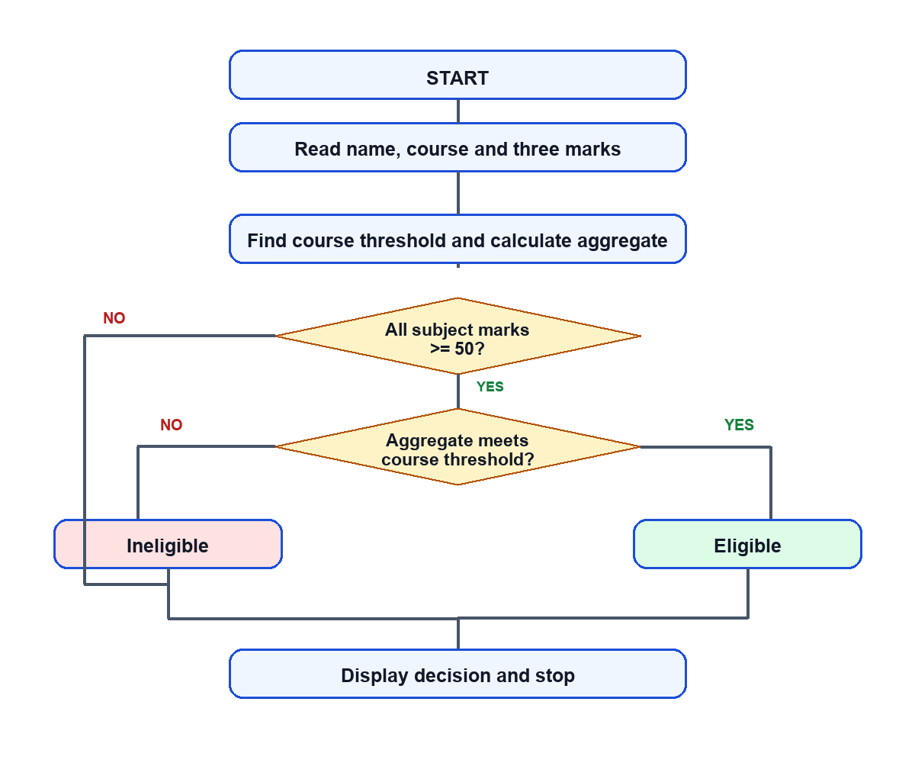

6. Pseudocode
START
Read name, course, maths, physics, computer_science
aggregate = (maths + physics + computer_science) / 3
IF any subject mark < 50 THEN result = INELIGIBLE
ELSE IF aggregate < threshold[course] THEN result = INELIGIBLE
ELSE result = ELIGIBLE
Display aggregate and result
STOP

7. Python Code
# University Admission Decision Engine
MINIMUM_SUBJECT_MARK = 50
THRESHOLDS = {"CSE": 70, "ECE": 65, "EEE": 60}

def evaluate(applicant):
name, course, maths, physics, computer = applicant
aggregate = (maths + physics + computer) / 3
eligible = (all(mark >= MINIMUM_SUBJECT_MARK for mark in
(maths, physics, computer)) and
aggregate >= THRESHOLDS[course])
return {"name": name, "course": course, "aggregate": aggregate,
"eligible": eligible}

def rank_eligible(applicants):
eligible = [evaluate(a) for a in applicants if evaluate(a)["eligible"]]
return sorted(eligible, key=lambda r: (
-r["aggregate"],
-next(a[2] for a in applicants if a[0] == r["name"]),
-next(a[4] for a in applicants if a[0] == r["name"]),
r["name"]))

if __name__ == "__main__":
# One applicant per run: NAME COURSE MATHS PHYSICS COMPUTER_SCIENCE
import sys
if len(sys.argv) != 6:
raise SystemExit("Usage: python admission.py NAME COURSE MATHS PHYSICS COMPUTER")
name, course = sys.argv[1], sys.argv[2].upper()
marks = tuple(map(int, sys.argv[3:]))
result = evaluate((name, course, *marks))
print("UNIVERSITY ADMISSION DECISION")
print(f"Applicant: {result['name']} | Course: {result['course']}")
print(f"Marks (Maths, Physics, Computer Science): {marks}")
print(f"Aggregate: {result['aggregate']:.2f}%")
print(f"Result: {'ELIGIBLE' if result['eligible'] else 'INELIGIBLE'}")

8. Test Cases
# | Applicant / Course | Marks M/P/CS | Aggregate | Actual | Expected / Check
01 | Anil (CSE) | 82, 76, 88 | 82.00% | Eligible | Eligible; above CSE threshold.
02 | Bhavya (ECE) | 70, 68, 72 | 70.00% | Eligible | Eligible; ECE aggregate is 70%.
03 | Charan (CSE) | 74, 70, 76 | 73.33% | Eligible | Eligible; above CSE threshold.
04 | Divya (EEE) | 65, 60, 70 | 65.00% | Eligible | Eligible; above EEE threshold.
05 | Esha (CSE) | 69, 72, 75 | 72.00% | Eligible | The supplied table says Ineligible; stated rules and 69/72/75 yield Eligible.
06 | Farhan (ECE) | 70, 68, 72 | 70.00% | Eligible | Eligible; same marks as Bhavya.
07 | Gita (CSE) | 50, 80, 80 | 70.00% | Eligible | Eligible; subject minimum is inclusive at 50, aggregate 70%.
08 | Hari (CSE) | 49, 90, 90 | 76.33% | Ineligible | Ineligible; Maths is below the 50 mark minimum.
09 | Isha (ECE) | 60, 65, 70 | 65.00% | Eligible | Eligible; aggregate is exactly the ECE threshold of 65%.
10 | Jai (EEE) | 59, 60, 60 | 59.67% | Ineligible | Ineligible; aggregate is below the EEE threshold.
Cases 01–06 use the six applicants from the sample. Cases 07–10 are additional boundary checks. Case 05 exposes an inconsistency in the sample: Esha’s marks clear all three 50-mark minimums and her 72% aggregate exceeds the 70% CSE cutoff, so the program returns Eligible.

9. Output Screenshots
Each image shows the command and captured console output from an actual execution of the included Python program.
Test Case 01 | Anil - Eligible
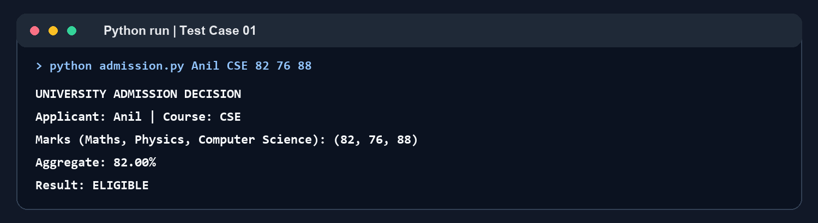
Test Case 02 | Bhavya - Eligible
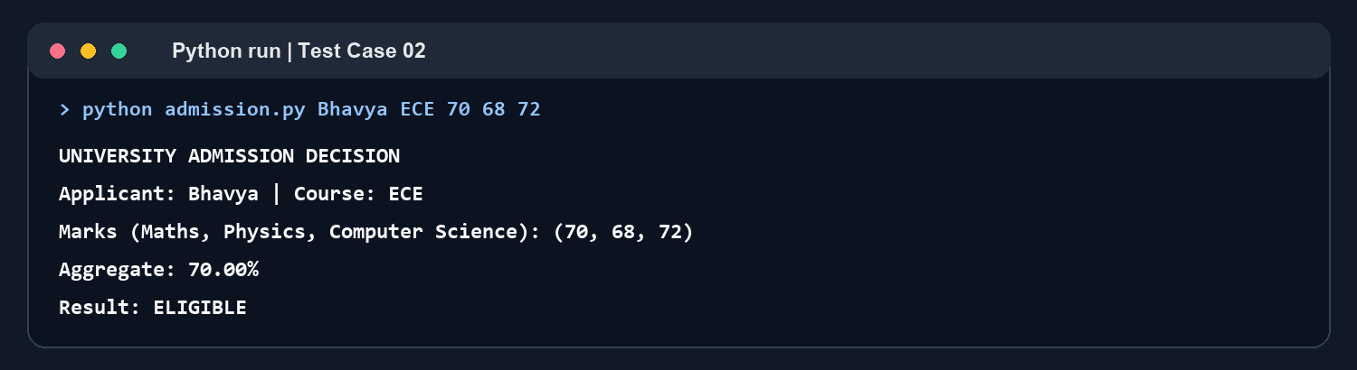
Test Case 03 | Charan - Eligible
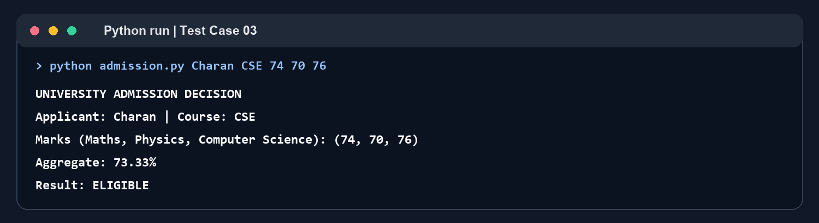
Test Case 04 | Divya - Eligible
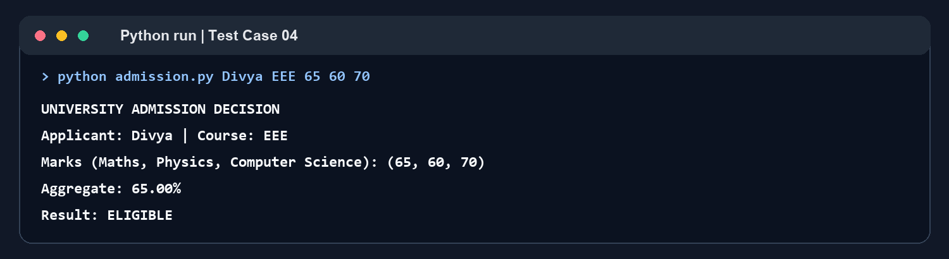
Test Case 05 | Esha - Eligible
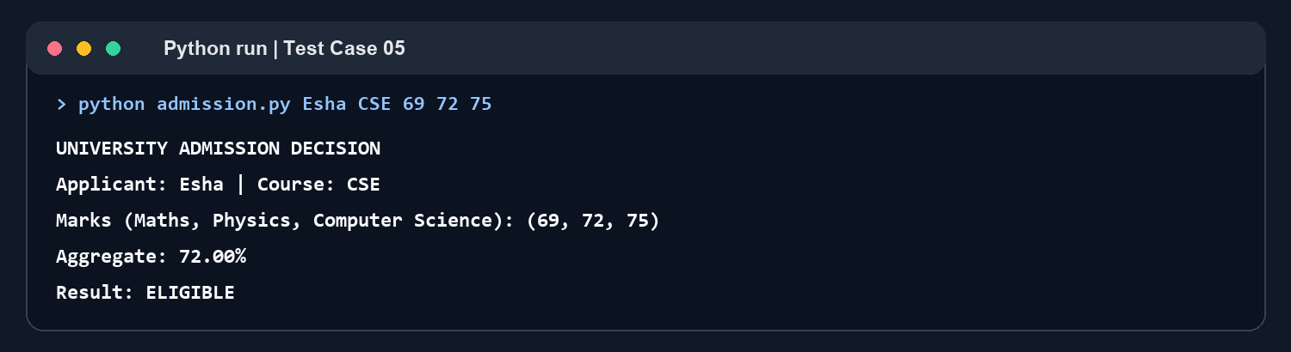
Test Case 06 | Farhan - Eligible
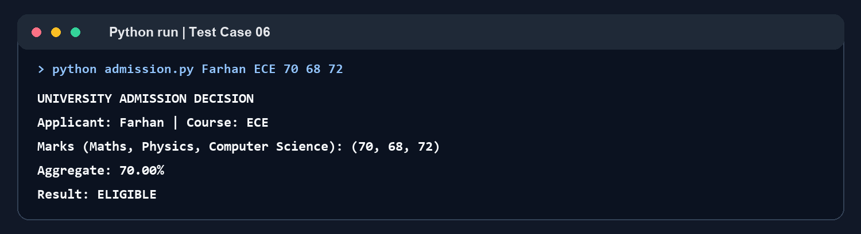
Test Case 07 | Gita - Eligible
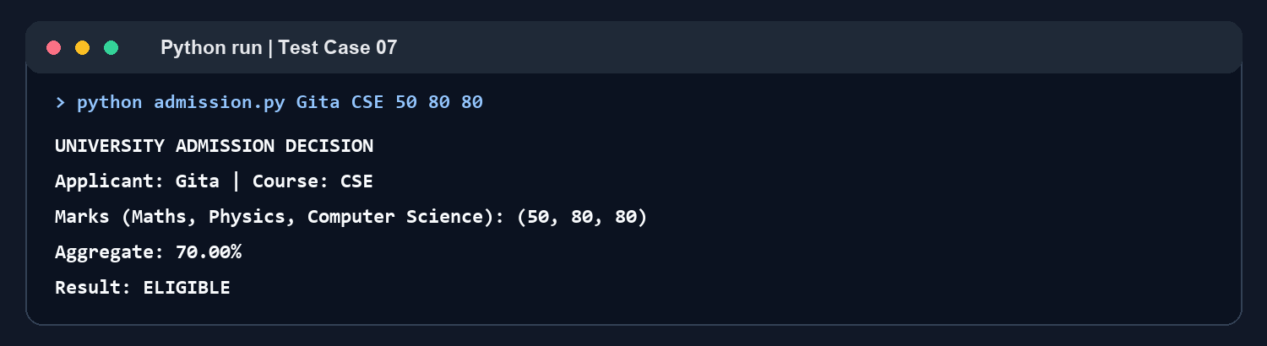
Test Case 08 | Hari - Ineligible
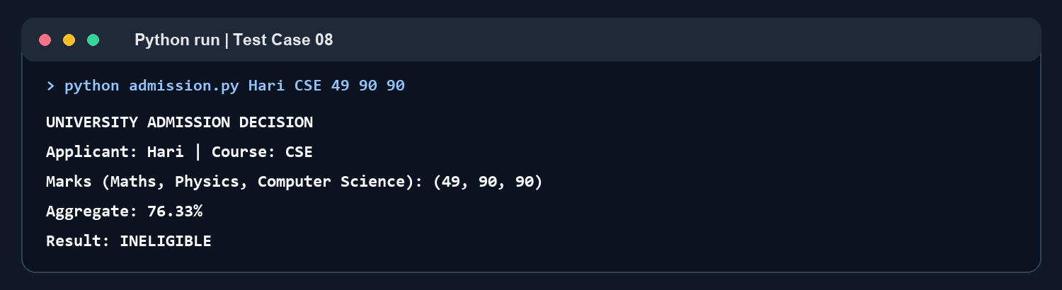
Test Case 09 | Isha - Eligible
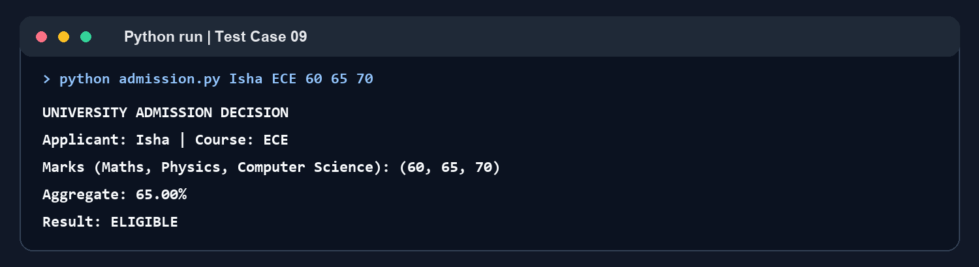
Test Case 10 | Jai - Ineligible
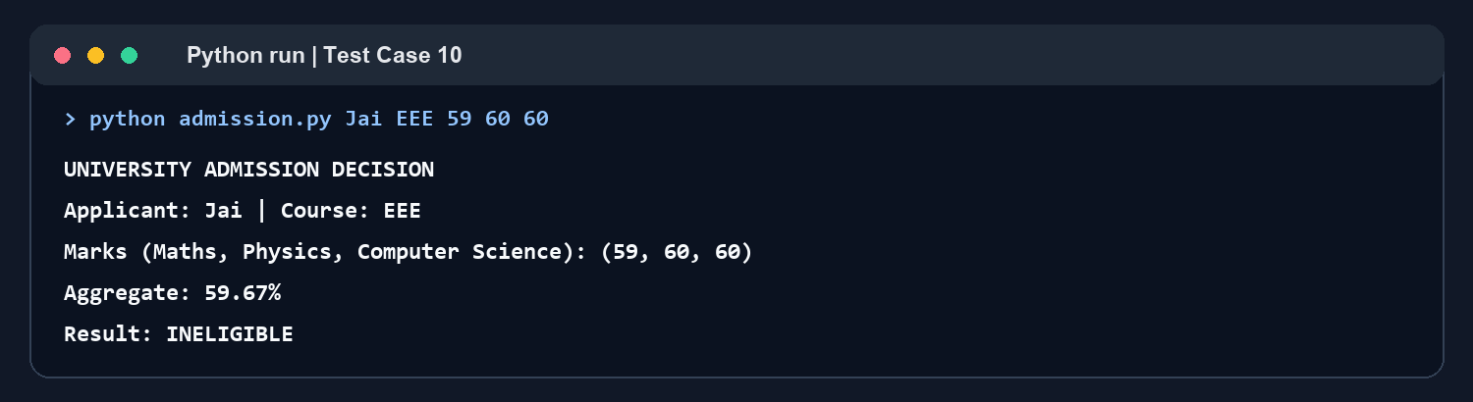

10. Conclusion
The program executed all ten applicant cases and applied the subject minimum and course-specific aggregate rules consistently. The boundary cases confirm that a mark of exactly 50 and an aggregate exactly equal to the course cutoff qualify. The runs also identify a mismatch in the supplied exercise: Esha’s listed expected result conflicts with the rule and her marks. Under the stated criteria, Esha is eligible.

