* <dependencyManagement></ dependencyManagement> allows us to set up dependencies that can be inherited from POM downstream.
* When we install the project, project jar file going to save locally in .m2 folder.

(Installing D:\Java_Learning\Microservices_Guru\mssc-brewery-bom\pom.xml to C:\Users\User\.m2\repository\guru\springframework\mssc-brewery-bom\0.0.1-SNAPSHOT\mssc-brewery-bom-0.0.1-SNAPSHOT.pom)

1. What is datasource configuration ?

It tells java how to connect JDBC complaint Data source.

JDBC is a standard for connecting to relational databases.

**H2 DATABASE**

* H2 db preferred for local development
* If spring dev tools is on classpath DB console is auto configured for browsing the db or add “spring.h2.console.enabled=true”.
* H2 has compatibility mode.

“spring.datasource.url = jdbc:h2:mem:testdb;MODE=MYSQL”.

**Bootstrap data from data.sql (Baeldung)**

[**https://www.baeldung.com/spring-boot-data-sql-and-schema-sql**](https://www.baeldung.com/spring-boot-data-sql-and-schema-sql)

**Hikari Connection Pooling**

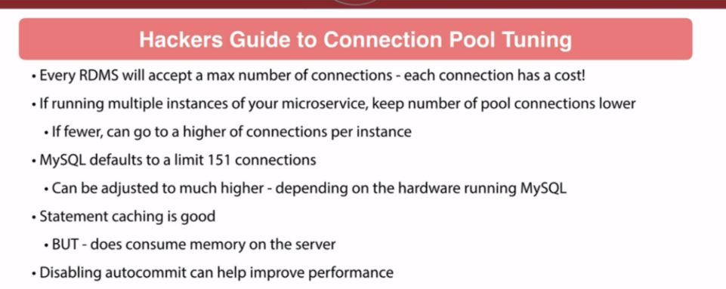

* Messaging feature: Spring for Apache ActiveMQ Artemis is by RedHat