ITC505 WEB TECHNOLOGY LAB-6

URL:

https://vigneshchowdarypamulapati.github.io/ITC505/lab-6/index.html https://vigneshchowdarypamulapati.github.io/ITC505/lab-6/styles.css

Github Link: https://github.com/vigneshchowdarypamulapati/ITC505/tree/main/ lab-6

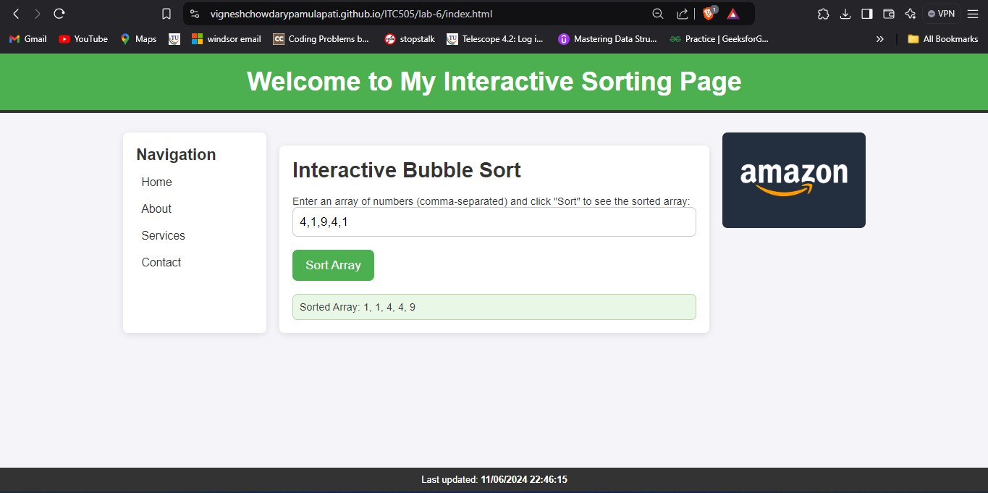

# Source Code Link: https://github.com/vigneshchowdarypamulapati/ITC505/blob/main

**/lab-6/index.html**

# index.html:

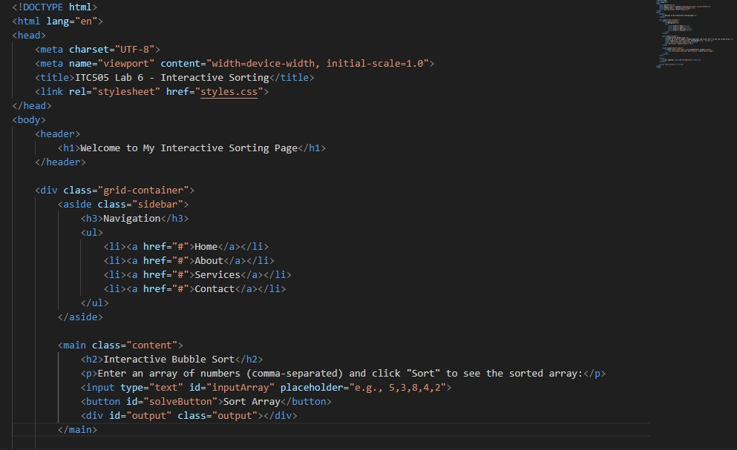

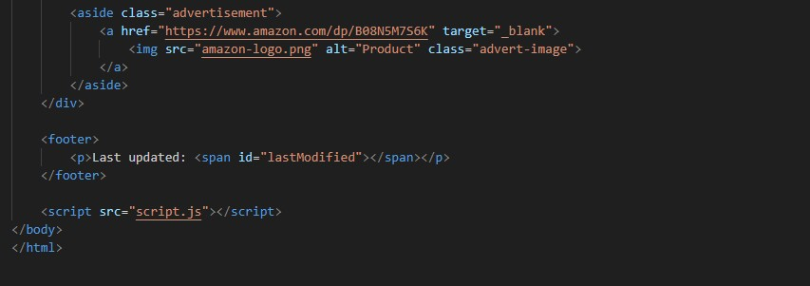

**Styles.css:**

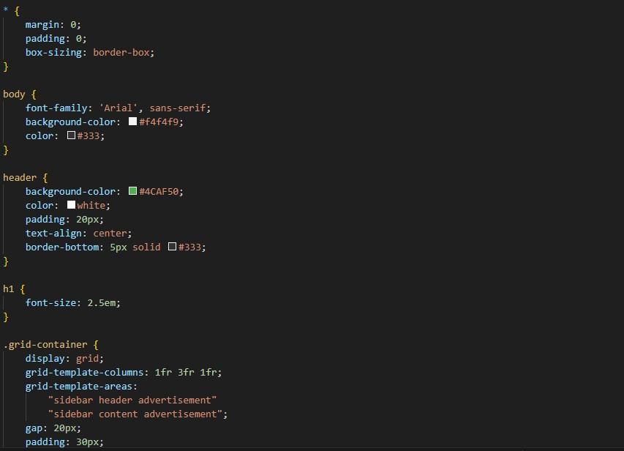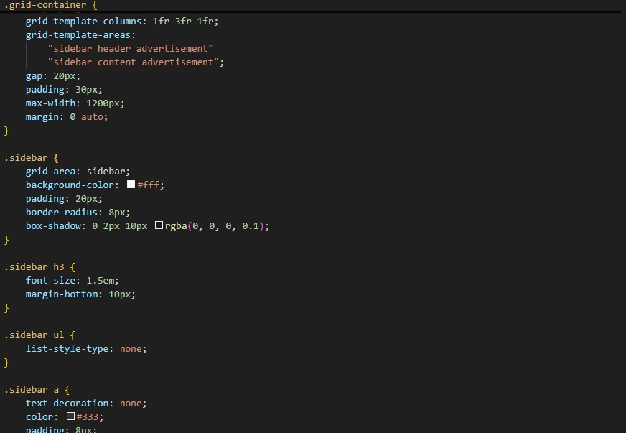

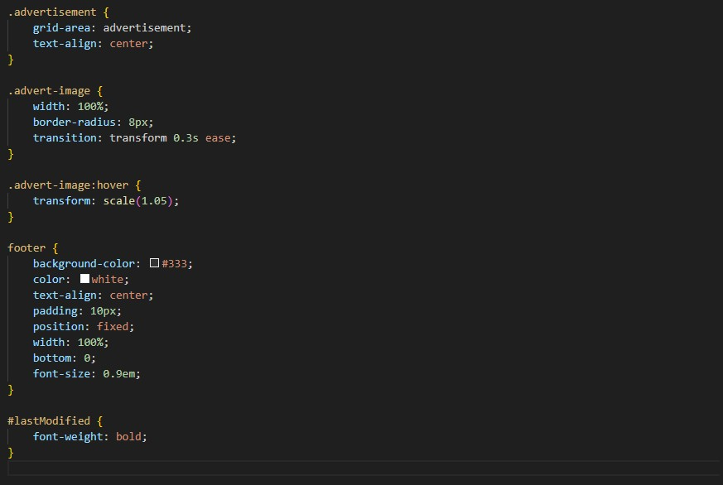

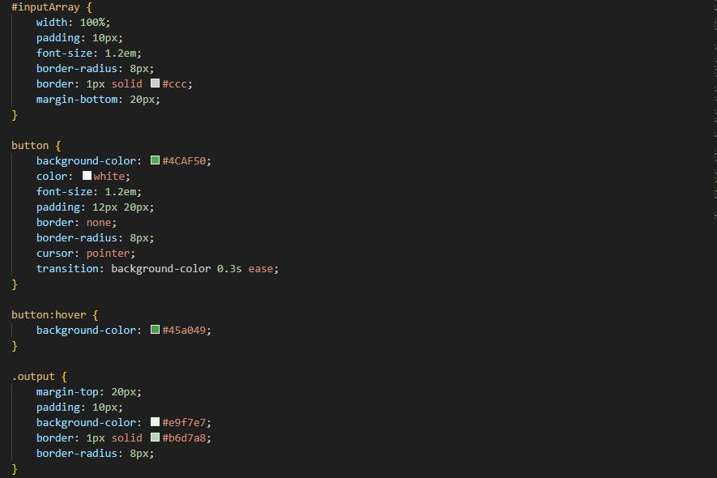

# Script.js:

