**Project Report**

|  |  |
| --- | --- |
| **Team ID** | NM2023TMID05211 |
| **Project Name** | Food Tracking System |

**Submitted by**

**TEAM LEADER :** DEVATHAI D

**TEAM MEMBER 1 :** KEERTHANA N

**TEAM MEMBER 2 :** RANJITHA S

**TEAM MEMBER 3 :** ANITHA PRIYADARSHINI S

**PROJECT REPORT FORMAT**

**1.INTRODUCTION**

1.1 Project Overview

1.2 Purpose

**2.LITERATURE SURVEY**

2.1 Existing problem

2.2 References

2.3 Problem Statement Definition

**3.IDEATION & PROPOSED SOLUTION**

3.1 Empathy Map Canvas

3.2 Ideation & Brainstorming

**4.REQUIREMENT ANALYSIS**

4.1 Functional requirement

4.2 Non-Functional requirements

**5.PROJECT DESIGN**

5.1 Data Flow Diagrams &User Stories

5.2 Solution Architecture

**6.PROJECT PLANNING & SCHEDULING**

6.1 Technical Architecture

6.2 Sprint Planning & Estimation

6.3 Sprint Delivery Schedule

**7.CODING & SOLUTIONING**

7.1 Feature 1

7.2 Feature 2

7.3 Database Schema (if Applicable)

**8. PERFORMANCE TESTING**

8.1 Performace Metrics

**9. RESULTS**

9.1 Output Screenshots

**10.ADVANTAGES & DISADVANTAGES**

**11.CONCLUSION**

**12.FUTURE SCOPE**

**13.APPENDIX**

13.1 Source Code

13.2 GitHub & Project Demo Link

**1.INTRODUCTION**

**FOOD TRACKING SYSTEM :**

A food tracking system is a digital tool or application designed to help individuals monitor and manage their dietary intake. It typically allows users to record the foods and beverages they consume, track calorie and nutrient intake, set dietary goals, and analyze their eating habits. These systems can provide valuable insights into one's diet, aiding in weight management, nutritional awareness, and overall health improvement. Food tracking systems are available in various forms, from mobile apps to web platforms, making it convenient for users to maintain a record of their daily meals and make informed choices about their nutrition.

* 1. **Project overview :**

User Registration and Authentication: Users can create accounts and log in securely.

Food Logging: Users can record the foods and beverages they consume, including portion sizes.

Nutrient Tracking: The system calculates and displays the nutritional content of logged items (e.g., calories, protein, carbs, fats).

Meal Planning: Users can create meal plans and set dietary goals.

Barcode Scanner: A feature to scan barcodes on food packaging for quick entry.

Data Visualization: Visual representations of nutritional data and progress over time (graphs, charts).

Customization: Users can set dietary preferences, restrictions, and health goals.

Reminders and Notifications: Users can receive reminders to log meals and stay on track.

Social Sharing: Option to share achievements and progress with friends or on social media.

Data Backup and Sync: Data is securely stored and can be synchronized across devices

* 1. **Purpose**

Provides users with a tool to take control of their nutrition and dietary choices.Encourages healthier eating habits and weight management.Promotes community support and engagement for achieving dietary goal. Privacy and Security: Ensure the security and privacy of user data, building trust in the system.In summary, a food tracking system serves as a valuable tool for individuals looking to take control of their nutrition, whether for health, weight management, fitness, or dietary preferences, by providing a structured way to monitor, analyze, and improve their eating habits.

**2.LITERATURE SURVEY**

Demographic Information:

Age:

Gender:

Location:

Occupation:

Dietary Habits:

Do you currently track your food intake?

If yes, what methods or apps do you use for tracking?

What are your main reasons for tracking your food?

Technology Usage:

What type of smartphone do you use?

Do you use any fitness or health-related apps?

Food Preferences:

Do you have any dietary restrictions (e.g., vegetarian, gluten-free, etc.)?

What types of foods do you typically consume?

Features and Preferences:

What features would you like to see in a food tracking system?

How often would you prefer to log your meals (e.g., daily, weekly, etc.)?

Would you prefer a mobile app or a web-based system for tracking food?

User Experience:On a scale of 1 to 5, how easy do you find it to track your food intake?

Are there any challenges you face when tracking your food?

Privacy and Security:

How concerned are you about the privacy and security of your food tracking data?

Additional Comments:Is there anything else you would like to share or suggest for the food tracking system?

**2.1 Existing problem**

1.Inaccurate Data Entry: Users may enter incorrect portion sizes or misidentify foods, leading to inaccurate calorie and nutrient tracking.

2. Lack of Standardization: There's no universal standard for food data, so the same item may have different nutritional information in different databases or apps.

3. Limited Food Database: Some systems have incomplete or outdated food databases, making it challenging to find certain foods or restaurant items.

4. User Fatigue: Keeping a food diary can be time-consuming, leading to user fatigue and reduced adherence over time.

5. Limited Context: Many systems lack the ability to consider individual health conditions, dietary preferences, or activity levels when providing recommendations.

6. Privacy Concerns: Users may be uncomfortable sharing their dietary habits and health data with these systems due to privacy concerns.

7. Reliability of User-Generated Content: In systems that allow user-generated content, the accuracy and reliability of added food items can be questionable.

8. Overemphasis on Calories: Focusing solely on calorie counting can lead to an incomplete view of nutrition and may not promote a balanced diet.

9. Complex User Interfaces: Complicated user interfaces can deter users from using the system effectively.

10. Integration Challenges: Many food tracking systems do not integrate well with other health and fitness apps or devices, making it less convenient for users.

11. Sustainability: Long-term adherence to food tracking can be challenging, and many users eventually stop tracking.

These problems highlight areas where food tracking systems can improve, such as enhancing accuracy, personalization, and ease of use, addressing privacy concerns, and promoting sustainable, healthy eating habits.

**2.2 References**

academic papers, articles, and books on food tracking systems using online databases and libraries. can start with these keywords to refine your search:

1. Food tracking system
2. Dietary tracking technology
3. Nutrition apps
4. Food diary apps
5. Diet and nutrition software

**2.3 Problem Statement Definition**

**Problem statement**

In an age where health and nutrition are of increasing importance, individuals face challenges in accurately monitoring and managing their dietary habits. Existing food tracking systems often suffer from issues related to data accuracy, user engagement, and personalization. Users are burdened by inaccurate or incomplete food databases, user fatigue, and privacy concerns, which hinder their ability to maintain a consistent and balanced diet. This problem statement seeks to address the need for a food tracking system that provides a seamless, user-friendly experience, integrates personal health and dietary preferences, ensures data accuracy, and addresses privacy concerns, ultimately promoting healthier eating habits and overall well-being."

This problem statement outlines the challenges and the overarching goal of developing an effective food tracking system that caters to the needs and concerns of users. It can serve as a basis for your project or research in this area.

**Issues and challenges**

1. Data Accuracy: Users may input incorrect portion sizes or misidentify foods, leading to inaccurate calorie and nutrient tracking.

2. Lack of Standardization: There is no universal standard for food data, so the same food item may have different nutritional information in different databases or apps.

3. Limited Food Database: Some systems have incomplete or outdated food databases, making it challenging to find certain foods or restaurant items.

4. User Fatigue:Keeping a food diary can be time-consuming, leading to user fatigue and reduced adherence over time.

5. Lack of Personalization:Many systems do not consider individual health conditions, dietary preferences, or activity levels when providing recommendations.

6. Privacy Concerns: Users may be uncomfortable sharing their dietary habits and health data with these systems due to privacy concerns.

7. Reliability of User-Generated Content:In systems that allow user-generated content, the accuracy and reliability of added food items can be questionable.

8. Overemphasis on Calories: Focusing solely on calorie counting can lead to an incomplete view of nutrition and may not promote a balanced diet.

9. Complex User Interfaces:Complicated user interfaces can deter users from using the system effectively.

10. Integration Challenges: Many food tracking systems do not integrate well with other health and fitness apps or devices, making it less convenient for users.

11. Sustainability: Long-term adherence to food tracking can be challenging, and many users eventually stop tracking.

These challenges highlight areas where food tracking systems can improve, such as enhancing accuracy, personalization, and ease of use, addressing privacy concerns, and promoting sustainable, healthy eating habits.

**3.IDEATION & PROPOSED SOLUTION**

**3.1 Empathy Map Canvas**

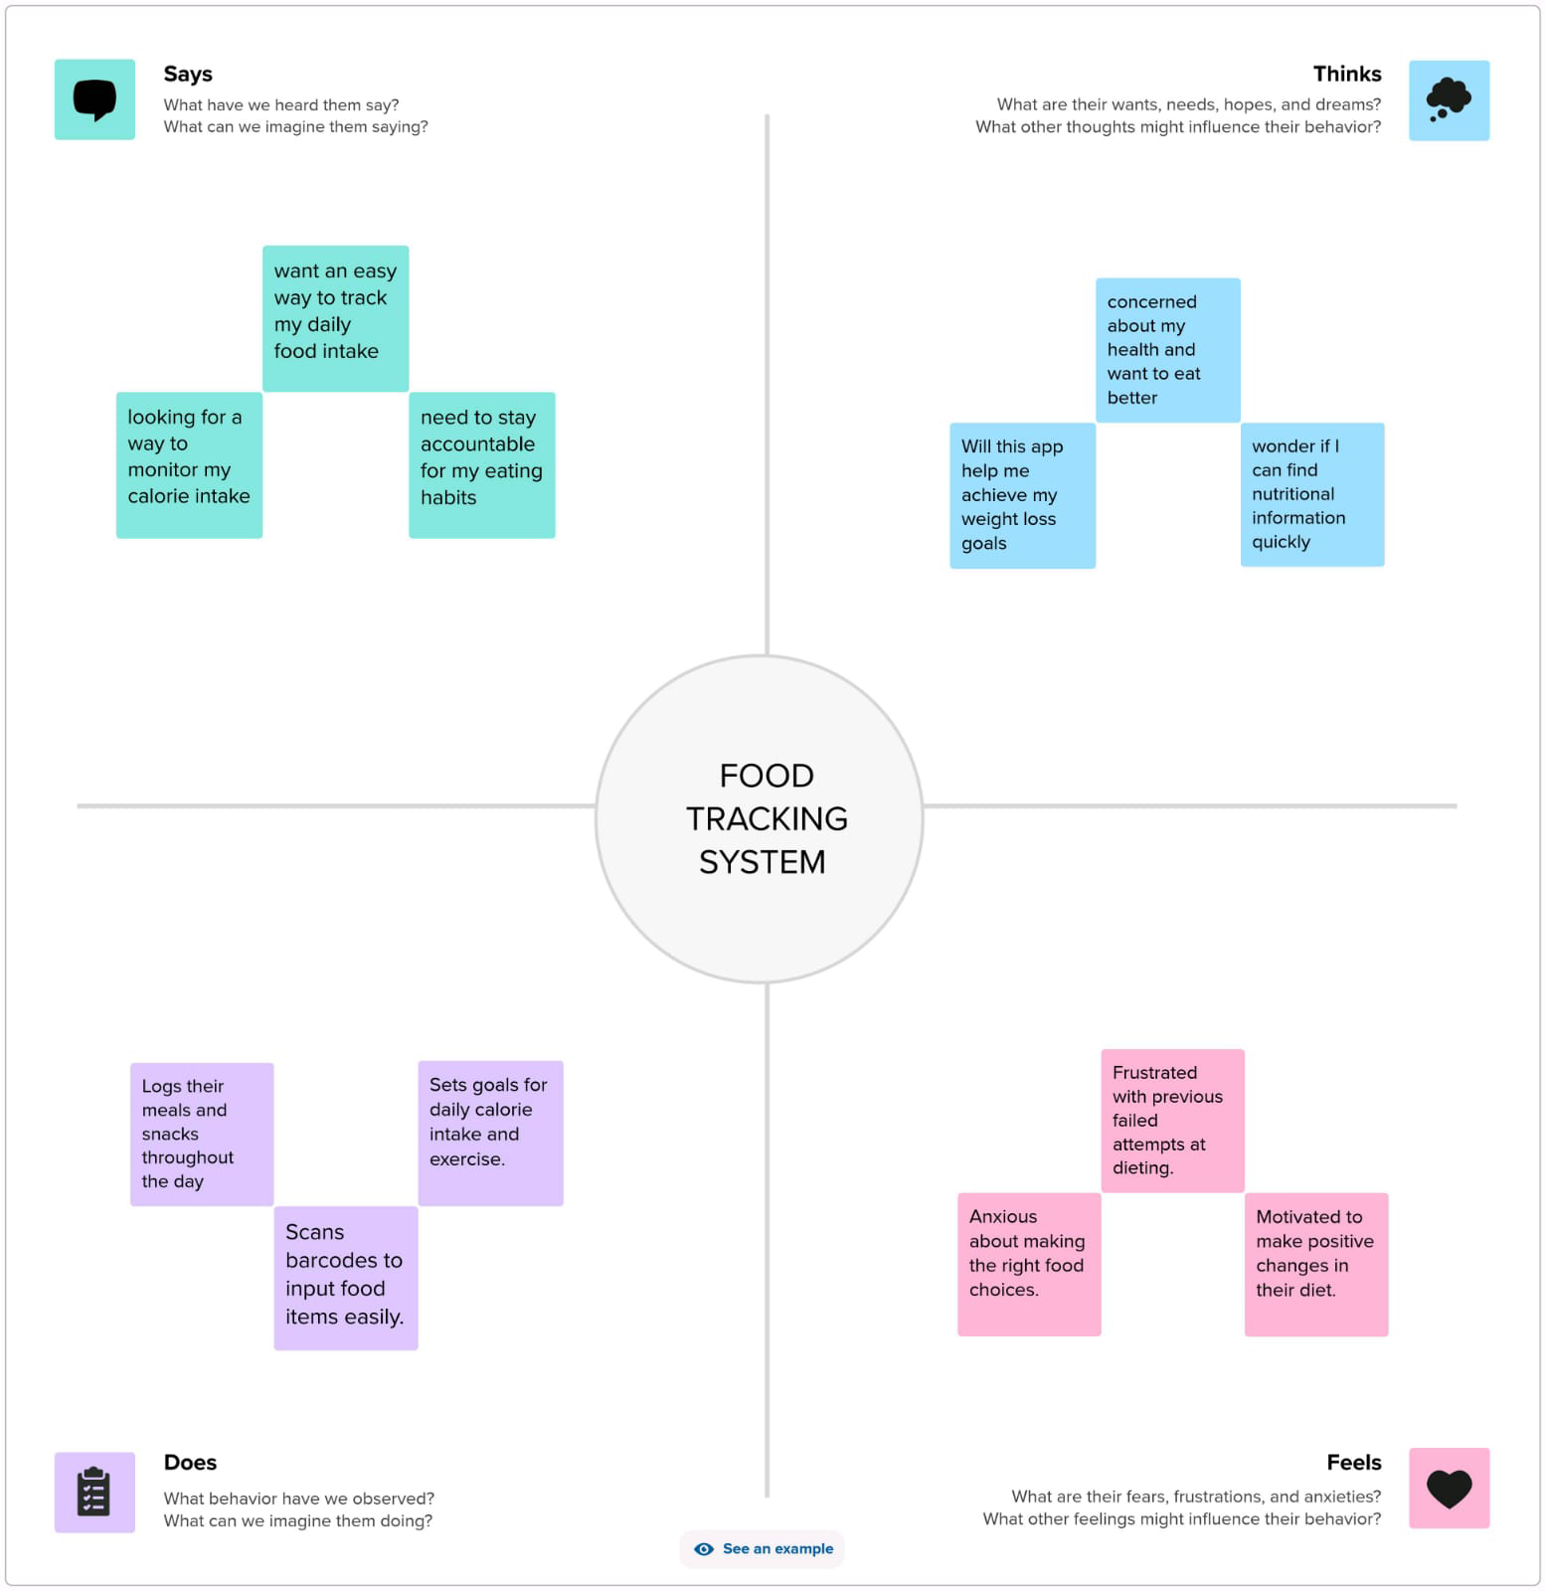

**3.2 Ideation & Brainstorming**

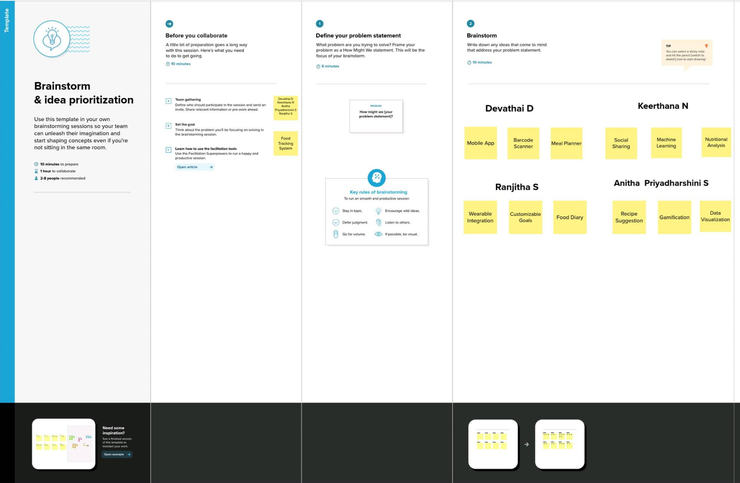

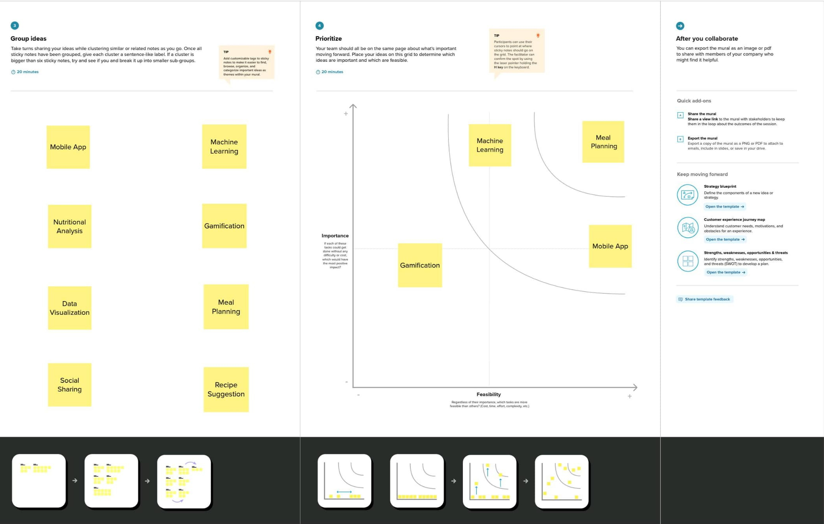

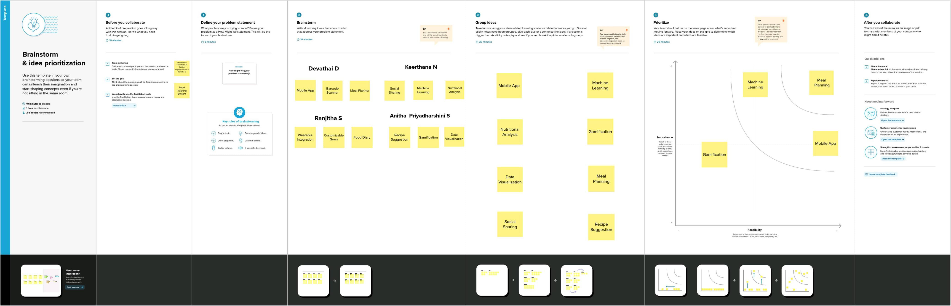

**4.REQUIREMENT ANALYSIS**

**4.1 Functional requirement**

1. User Registration and Profile Management:

- Users should be able to create accounts.

- Users can set up and manage their profiles with personal information and dietary preferences.

2. Food Logging:

- Users can input details about the food they consume, such as name, quantity, and time of consumption.

- The system should offer a database of food items for easy selection.

- Support for barcode scanning or image recognition for food identification may be included.

3. Nutritional Information:

- The system should provide nutritional details (e.g., calories, macronutrients, vitamins) for logged food items.

- It should calculate daily intake based on logged data and user goals (e.g., calorie count, protein intake).

4. Meal Planning and Recipes:

- Users can create meal plans and recipes by combining food items.

- The system should calculate nutritional values for custom meals and recipes.

5. Goal Setting:

- Users can set and track dietary and fitness goals (e.g., weight loss, muscle gain).

- The system should provide guidance and progress tracking towards these goals.

6. Data Visualization:

- Provide charts and graphs to display nutritional intake and progress over time.

7. Notifications and Reminders:

- Send reminders for meal times, water intake, or exercise routines.

8. Social Features:

- Users can connect with friends, share progress, and exchange recipes or meal plans.

9. Integration with Wearables and Fitness Devices:

- Sync with devices like smartwatches to track physical activity and calorie expenditure.

10. Export and Sharing:

- Allow users to export their data (e.g., reports) and share it with healthcare professionals or trainers.

11. Search and Filtering:

- Search for specific foods, filter food options based on dietary preferences or allergies.

12. Multi-Platform Accessibility:

- Access the system through a website, mobile app, and potentially desktop applications.

13. Data Backup and Security:

- Ensure data security and regular backups to prevent data loss.

14. User Support:

- Provide customer support channels for user inquiries and issues.

15. Data Privacy:

- Implement data privacy features, such as user consent for data usage and compliance with relevant regulations (e.g., GDPR).

These are general functional requirements for a food tracking system. Specific features and details may vary based on the target audience, such as individuals, healthcare professionals, or fitness enthusiasts.

**4.2 Non-Functional requirements**

Non-functional requirements for a food tracking system encompass aspects that describe how the system should perform, rather than what it should do. These requirements are critical for ensuring the system's usability, performance, security, and other important attributes. Here are some non-functional requirements for a food tracking system:

1. Usability:

- User-Friendly Interface: The system should have an intuitive and easy-to-navigate user interface to ensure a positive user experience.

- Accessibility:The system should be accessible to users with disabilities, following accessibility standards.

2. Performance:

- Response Time:The system should respond promptly to user actions, with minimal latency.

- Scalability:It should be capable of handling an increasing number of users and data without a significant drop in performance.

3. Reliability:

- Availability: The system should be available 24/7 with minimal downtime for maintenance.

- Fault Tolerance: It should continue to function even in the presence of hardware or software failures.

4. Security:

- Data Encryption: User data should be encrypted to protect it from unauthorized access.

- Authentication and Authorization: Implement strong user authentication and authorization mechanisms to ensure data privacy and security.

- Data Backup and Recovery:Regularly backup user data and have a reliable recovery plan in case of data loss or system failures.

5. Privacy:

- User Data Privacy:Ensure that user data is kept private and is only used in accordance with privacy regulations and user consent.

6. Scalability:

- Load Handling: The system should be able to handle varying loads as more users join or during peak usage periods.

7. Compatibility:

- Cross-Platform Compatibility:The system should work seamlessly across different platforms (e.g., iOS, Android, web browsers).

- Browser Compatibility: If the system is web-based, it should support major web browsers.

8. Performance Monitoring:

- Monitoring and Reporting:Implement tools and processes for monitoring system performance and generating reports to identify and address performance issues.

9. Compliance:

- Regulatory Compliance:Ensure that the system complies with relevant data protection and privacy regulations, such as GDPR or HIPAA, if applicable.

10. Localization:

- Multilingual Support:If targeting a global audience, support multiple languages and regional preferences.

11. Documentation:

- User and Administrative Documentation:Provide comprehensive documentation for users and administrators to understand the system's functionalities and how to use it effectively.

12. Maintainability:

- Code Quality:Maintain high code quality standards to facilitate future updates and maintenance.

- Modularity: Design the system in a modular fashion to make it easier to extend and maintain.

13. Performance Optimization:

* Efficient Resource Usage:Optimize resource usage to minimize server and bandwidth costs.

14. Backup and Recovery:

- Regular Backups: Implement a scheduled backup system to protect user data.

- Disaster Recovery Plan:Have a plan in place to recover from data loss or system failure.

These non-functional requirements are essential to ensure that the food tracking system not only performs its functions but does so in a secure, reliable, and user-friendly manner.

**5. PROJECT DESIGN**

**5.1 Data Flow Diagrams & User Stories**

**Data Flow Diagrams**

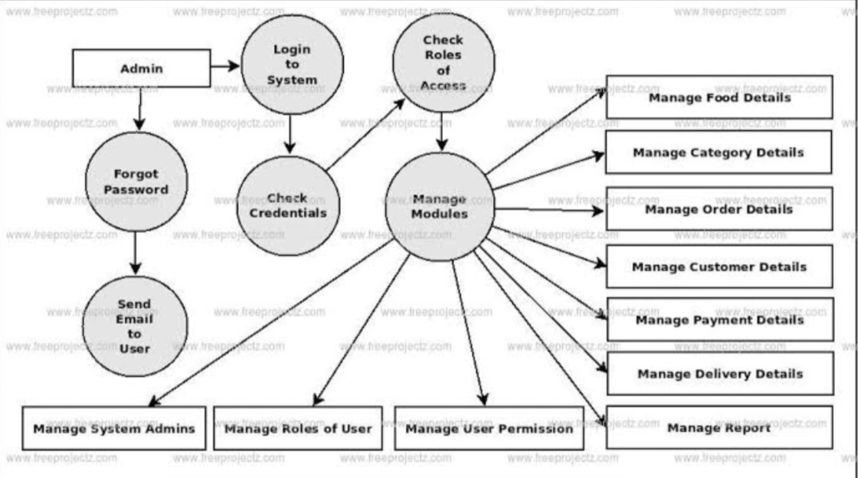

**User Stories**

1. As a user, I want to be able to log my daily meals and snacks, including the type of food and portion sizes, so I can track my calorie intake accurately.

2. As a user, I want to be able to search for specific foods in the database and add them to my meal log, to make the tracking process more convenient.

3. As a user, I want to set personal dietary goals, such as daily calorie limits, macronutrient targets, or specific food restrictions, so the system can help me stay on track.

4. As a user, I want to receive meal suggestions and recipe ideas based on my dietary preferences and restrictions to help me plan healthier meals.

5. As a user, I want to view detailed nutritional information for the foods I've logged, including calories, protein, carbohydrates, and fats, to make informed choices.

6. As a user, I want to see a visual representation of my daily or weekly food intake, including charts and graphs, to monitor my progress more easily.

7. As a user, I want to receive reminders to log my meals and stay on top of my dietary goals throughout the day.

8. As a user, I want to track my physical activities and exercise routines alongside my food intake, to get a complete view of my fitness journey.

9. As a user, I want to be able to sync the app with wearable devices, like fitness trackers, to automatically record my physical activity and update my calorie burn.

10. As a user, I want to track my weight and body measurements over time and see how they correlate with my food and exercise data.

11. As a user, I want to set and track specific health markers, such as blood pressure, cholesterol levels, or blood sugar, if applicable.

12. As a user, I want to receive insights and recommendations based on my food and activity data to help me make healthier choices.

These user stories cover a range of features and functionalities that a food tracking system can offer to its users. They address tracking, planning, analysis, and personalization aspects of such a system.

**5.2 Solution Architecture**

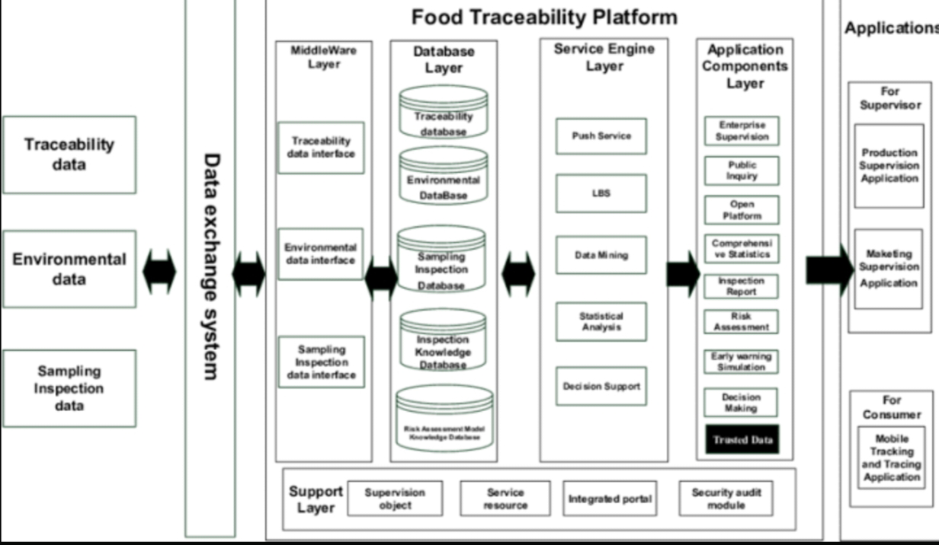

**6.PROJECT PLANNING & SCHEDULING**

**6.1 Technical Architecture**

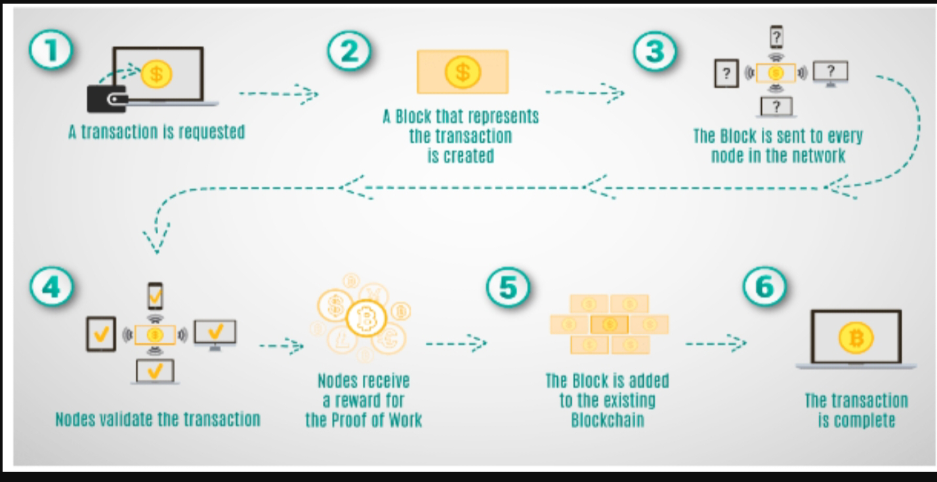



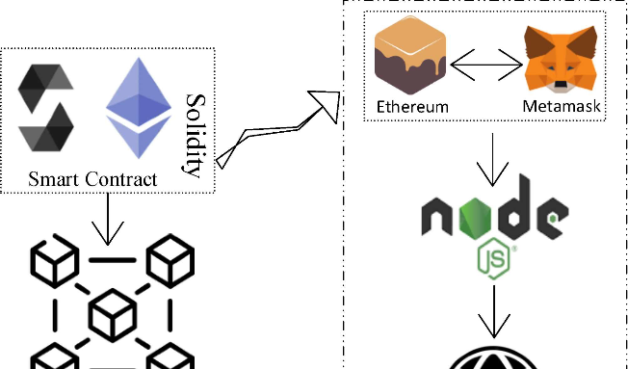

**6.2 Sprint Planning & Estimation**

Sprint planning and estimation in a food tracking system development project involves breaking down the work into manageable tasks, setting priorities, and estimating the effort required for each task. Here's a general overview of how this process might work:

1. Product Backlog: Start with a product backlog that includes all the features, user stories, and improvements needed for the food tracking system. This backlog is a prioritized list of what needs to be done.

2. Sprint Goals: Define the goals or objectives for the upcoming sprint. What do you want to accomplish in this time frame?

3. Sprint Planning Meeting: In a sprint planning meeting, the development team, product owner, and stakeholders discuss the top-priority items from the backlog and decide what can be completed in the sprint. The team selects a set of user stories or tasks to work on.

4. Task Breakdown: Break down the selected user stories into smaller, manageable tasks. These tasks should be specific and actionable.

5. Estimation: Estimate the effort required for each task. Common estimation techniques include story points, hours, or t-shirt sizing. The development team can use their historical velocity to help with these estimates.

6. Assign Tasks: Assign tasks to team members based on their skills and availability.

7. Definition of Done (DoD): Define what it means for a task to be "done." This includes criteria that must be met for a task to be considered complete.

8. Sprint Commitment: The team commits to completing the selected tasks during the sprint.

9. Daily Stand-ups: Hold daily stand-up meetings to track progress, discuss challenges, and make any necessary adjustments.

10. Review and Retrospective: At the end of the sprint, review the completed work with stakeholders, get feedback, and conduct a retrospective to identify areas for improvement.

In a food tracking system, user stories could represent features like "Add a new food item," "Calculate daily calorie intake," or "Create a meal plan." Estimation helps the team understand how much work can be accomplished in a sprint and ensures a realistic workload.

Keep in mind that agile methodologies like Scrum are often used for software development, but they can be adapted for various projects, including food tracking systems, to improve efficiency and responsiveness to user needs.

**6.3 Sprint Delivery Schedule**

Sprint 1 (2 weeks):

- Define project scope and objectives

- Gather requirements from stakeholders

- Create user stories and prioritize them

- Set up the development environment

Sprint 2 (2 weeks):

- Design the user interface for the app

- Develop the user registration and login functionality

- Begin working on the database structure

Sprint 3 (2 weeks):

- Continue developing the database structure

- Implement basic food tracking features

- Start building the user dashboard

Sprint 4 (2 weeks):

- Refine the user dashboard

- Integrate user authentication

- Add the ability to input food data

Sprint 5 (2 weeks):

- Develop reporting and analytics features

- Begin testing and bug fixes

- Plan for user testing in the next sprint

Sprint 6 (2 weeks):

- Conduct user testing and gather feedback

- Make necessary adjustments and improvements

- Prepare for deployment

Sprint 7 (2 weeks):

- Final testing and bug fixes

- Create documentation and user guides

- Deploy the food tracking system

This schedule assumes 2-week sprints, but you can adjust the duration based on your team's capacity. Additionally, each sprint should include tasks for testing and quality assurance to ensure a reliable food tracking system.

**7. CODING & SOLUTIONING (Explain the features added in the projectalong with code)**

**7.1 Feature 1**

**Smart Contract (Solidity):**

Smart contracts can be a valuable component of a food tracking system, enhancing transparency, security, and automation. Here are some features and benefits of using smart contracts in such a system:

1. Transparency: Smart contracts on a blockchain provide a transparent and immutable ledger of all food-related transactions and data, ensuring that all stakeholders have access to the same information.

2. Traceability: Smart contracts enable the tracking of food products from their source to the end consumer. Each transaction is recorded, making it easier to trace the origin of a particular food item.

3. Automation: Smart contracts can automate various processes, such as payment settlements, quality control checks, and delivery confirmations, reducing the need for manual intervention and human error.

4. Trust and Security: The decentralized nature of blockchain and the self-executing nature of smart contracts enhance trust and security. Once a condition is met, the contract automatically enforces the agreed-upon terms.

5. Food Safety: Smart contracts can be programmed to trigger alerts or actions in case of safety issues, such as product recalls. This can help in swiftly addressing potential food safety concerns.

6. Compliance: Smart contracts can be designed to ensure that all parties involved in the food supply chain adhere to regulatory and compliance requirements.

7. Real-time Updates: Participants in the food supply chain can receive real-time updates on the status of products, shipments, and payments, leading to improved efficiency and reduced delays.

8. Cost Reduction: Automation through smart contracts can lead to cost savings by reducing administrative overhead and the need for intermediaries.

9. Dispute Resolution: Smart contracts can include predefined mechanisms for dispute resolution, streamlining conflict resolution processes.

10. Consumer Confidence: A transparent and secure food tracking system with smart contracts can enhance consumer confidence in the safety and authenticity of food products.

11. Sustainability: Smart contracts can help track the environmental impact of food production and distribution, supporting sustainability efforts.

12. Data Analytics: The data stored in the blockchain can be analyzed to gain insights into the supply chain, helping identify areas for improvement and optimization.

Overall, integrating smart contracts into a food tracking system can revolutionize the way food supply chains operate by improving transparency, traceability, and efficiency while enhancing trust and security throughout the process.

**7.2 Feature 2**

**Trasfor Ownership :**

Transferring ownership of a food tracking system typically involves legal and administrative processes. Here are the general steps to consider:

1. Legal Agreement: Create a legal agreement that outlines the terms and conditions of the ownership transfer. This agreement should specify the transfer of all relevant assets, including intellectual property rights, software, data, and any associated contracts or licenses.

2. Due Diligence: Both the current owner and the new owner should perform due diligence to ensure that all assets, liabilities, and obligations related to the food tracking system are properly documented and transferred.

3. Intellectual Property Transfer: If there are patents, trademarks, copyrights, or other intellectual property associated with the system, you'll need to transfer these rights through the appropriate legal processes.

4. Data Transfer: Ensure that all data associated with the food tracking system is securely transferred to the new owner. This may involve migrating databases, archives, and historical records.

5. Contract and License Transfer: Transfer any existing contracts, licenses, or agreements related to the system, including agreements with suppliers, customers, and service providers.

6. Regulatory Compliance: Ensure that the transfer complies with any industry-specific regulations or standards, especially if the food tracking system is used in a regulated sector.

7. Notify Stakeholders: Inform all relevant stakeholders about the ownership transfer, including employees, customers, and suppliers. Provide information about how the transition will affect them.

8. Transition Plan: Develop a transition plan that outlines how the system will be handed over to the new owner, including any necessary training or support during the transition period.

9. Financial Settlement: Determine the financial arrangements for the ownership transfer, including the purchase price or compensation for the transfer of assets and liabilities.

10. Legal Assistance: Consult with legal professionals or experts in mergers and acquisitions to ensure that the transfer is executed correctly and that all legal requirements are met.

11. Post-Transfer Support: Provide ongoing support and assistance to the new owner during the transition phase to ensure a smooth handover of the food tracking system.

Keep in mind that the specific details of the ownership transfer may vary depending on the nature of the system, the entities involved, and the relevant legal and regulatory requirements. It's crucial to seek legal counsel to facilitate a successful and legally compliant transfer of ownership.

**7.3 Database Schema (if Applicable)**

**On-Chain Ethereum Smart Contracts:**

Incorporating an on-chain Ethereum smart contract into a food tracking system can provide several advantages in terms of transparency, trust, and automation. Here's how it can be applied:

1. Transparency: Ethereum's blockchain ensures all transactions are publicly recorded and immutable. This transparency can be leveraged to track the movement of food products in the supply chain, making it accessible to all stakeholders.

2. Traceability: An Ethereum smart contract can record data about food products at each stage of the supply chain, creating a comprehensive history of their journey from source to destination. This makes it easier to trace the origin of a specific product.

3. Decentralization: Ethereum's blockchain is decentralized, reducing the risk of a single point of failure and enhancing the security of the system. This can help prevent fraudulent activities in the food tracking process.

4. Smart Contract Automation: Ethereum smart contracts can be programmed to execute specific actions automatically when predefined conditions are met. For example, payments can be automatically released when food products reach a certain destination, reducing the need for intermediaries.

5. Proof of Authenticity: Smart contracts can verify the authenticity of food products by checking data such as production dates, origin, and quality at each stage of the supply chain.

**Off-Chain Metadata Storage (Traditional Database or Decentralized**

**Storage):**

In a food tracking system, you can use either off-chain metadata storage in a traditional database or decentralized storage solutions, each with its own advantages and considerations:

1. Traditional Database (Off-Chain):

- Data Control: With traditional databases, you have complete control over the data, making it easier to manage, update, and ensure data integrity.

- Scalability: Traditional databases can be scaled vertically or horizontally to accommodate growing data volumes and increasing system demands.

- Performance: These databases often provide high performance for read and write operations, making them suitable for applications with complex querying requirements.

- Data Privacy: You can implement access control mechanisms to protect sensitive data from unauthorized access.

- Established Technology: Traditional databases, such as SQL or NoSQL databases, have well-established best practices and tools.

2. Decentralized Storage:

- Data Immutability: Decentralized storage systems, like IPFS or blockchain-based storage, offer data immutability, ensuring that once data is stored, it cannot be altered or deleted.

- Data Availability: Data stored on decentralized networks is typically available as long as the network itself is operational, reducing the risk of data loss due to centralized server failures.

- Distributed Trust: Decentralized storage relies on a distributed network, which can enhance trust and security by reducing single points of failure.

- Reduced Costs: Depending on the specific solution, decentralized storage may offer cost advantages, especially for large-scale, long-term storage.

- Resilience: Data stored on decentralized networks can be more resilient against censorship and attacks.

**Additional details**

Food tracking systems are essential tools for the food industry, aiding in safety, quality control, and regulatory compliance while meeting the demands of today's consumers for transparency and sustainability. They play a vital role in ensuring that food products reach consumers safely and with high quality.

**8. PERFORMANCE TESTING**

**8.1 Performace Metrics**

Performance metrics for a food tracking system are crucial for assessing its effectiveness and optimizing its functionality. Here are some key performance metrics to consider:

1. User Engagement Metrics:

- Daily Active Users (DAU):The number of users actively using the system on a daily basis.

- Monthly Active Users (MAU): The number of users using the system on a monthly basis.

- User Retention Rate: The percentage of users who continue using the system over time.

- Session Duration: How long users stay engaged during a single session.

2. Data and Content Metrics:

- Food Entries: The number of food items added to the system daily or monthly.

- User-Generated Content: Measuring the quantity and quality of user-contributed data (e.g. food photos, reviews, recipes).

- Data Accuracy: Ensuring the accuracy of nutritional information and food database.

3. Performance Metrics:

- Load Time:The time it takes for the system to load and display information.

- Response Time: The time it takes for the system to respond to user interactions (e.g., searching for food items).

- Uptime and Reliability:Measuring system availability and minimizing downtime.

4. Conversion and Monetization Metrics (if applicable):

-Conversion Rate: The percentage of users who take a specific desired action (e.g., subscribing to a premium plan).

- Average Revenue Per User (ARPU): The average revenue generated from each user.

5. Security Metrics:

- Security Incidents: Monitoring and minimizing security breaches, data leaks, and vulnerabilities.

- Authentication and Authorization Failures: Tracking unauthorized access attempts.

6. User Feedback and Satisfaction:

- User Ratings and Reviews:Collecting and analyzing user feedback and ratings.

- Net Promoter Score (NPS):Measuring user satisfaction and their likelihood to recommend the system to others.

7. Technical Performance:

- Server Response Time: Monitoring the performance of backend servers.

- Scalability: Assessing the system's ability to handle increased load and user growth.

- Error Rate:Tracking and reducing system errors and crashes.

8. Compliance Metrics:

- Regulatory Compliance:Ensuring adherence to relevant food and health data regulations.

- Privacy Compliance:Complying with data privacy laws and user data protection.

9. Cost Metrics:

- Infrastructure Costs: Monitoring the cost of servers, storage, and other resources.

- Cost Per User: Calculating the cost of serving each user.

10.Environmental Impact (optional):

- Carbon Footprint: Measuring the system's environmental impact and working to reduce it.

Regularly tracking these metrics and acting on the insights gained is essential for improving the food tracking system and ensuring it meets the needs of its users while maintaining high performance and security standards.

**9.RESULTS**

**9.1 Output Screenshots**

Implementing a food tracking system using blockchain technology can provide enhanced transparency, security, and traceability. Here's an outline of the potential outputs and benefits of such a system:

1. Traceability Reports:

- Detailed reports showing the origin, journey, and handling of food products. Users can access information on where a specific item was sourced, processed, and distributed.

2. Immutable Records:

- Records of food items on the blockchain are tamper-proof. Once information is added, it cannot be altered, ensuring data integrity.

3. Smart Contracts:

- Automated smart contracts can trigger actions like payments, quality checks, and notifications when predefined conditions are met, streamlining supply chain processes.

4. Verification and Authentication:

- Users can easily verify the authenticity of food products by scanning QR codes or checking blockchain records, reducing the risk of counterfeit items.

5. Food Safety Alerts:

- Real-time alerts and notifications to users if a batch of food products is found to be contaminated or unsafe, allowing for rapid recalls and safety measures.

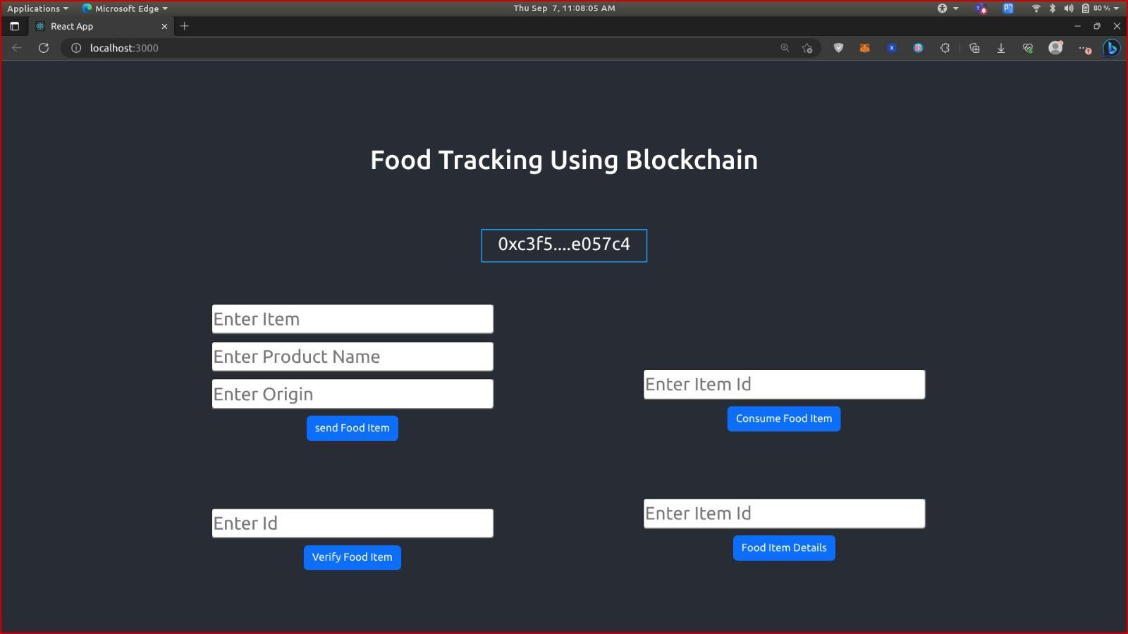

**10. ADVANTAGES & DISADVANTAGES**

**Advantages**

A food tracking system offers various advantages that benefit consumers, food producers, and the entire food supply chain. Some of the key advantages include:

1. Improved Transparency: - Consumers can access detailed information about the origin, sourcing, and processing of food products, promoting transparency and trust in the supply chain.

2. Enhanced Food Safety: - Quick identification and recalls of contaminated or unsafe products, reducing the risk of foodborne illnesses.

3. Quality Assurance: - Monitoring and reporting on the quality and freshness of food items, ensuring higher product standards.

4. Reduced Food Waste: - Better inventory management and tracking can minimize food waste by optimizing shelf life and reducing overproduction.

5. Ethical Sourcing: - Consumers can make informed choices based on ethical considerations, such as fair trade, sustainability, and responsible sourcing.

**Disadvantages**

There are several disadvantages to food tracking systems, including:

1. Time-consuming: Keeping track of everything you eat can be time-consuming, especially if you need to log every meal and snack.

2. Inaccuracy: Food tracking often relies on estimates and can be inaccurate, as it's challenging to measure portion sizes and calorie counts precisely.

3. Obsessive behavior: Some individuals may become obsessed with tracking their food, leading to unhealthy relationships with eating and potential eating disorders.

4. Privacy concerns: Storing detailed information about your diet in an app or online platform can raise privacy concerns, as this data may be vulnerable to breaches or misuse.

**11. CONCLUSION**

In conclusion, a food tracking system is a transformative solution that offers numerous benefits to consumers, food producers, and the entire food supply chain. It enhances transparency, safety, and efficiency while fostering trust and informed decision-making. Key takeaways include:

1. Transparency and Trust:Food tracking systems provide consumers with detailed information about the sourcing, processing, and quality of food products, building trust and confidence in the supply chain.

2. Food Safety: By enabling quick identification and recall of unsafe products, these systems significantly improve food safety and reduce the risk of foodborne illnesses.

3. Quality Assurance:Monitoring and reporting on the quality and freshness of food items ensure higher product standards and reduce waste.

4. Efficiency: Enhanced supply chain management, streamlined logistics, and better inventory control result in cost savings and reduced environmental impact.

In essence, a food tracking system is a powerful tool that addresses critical issues in the food industry, from safety and authenticity to sustainability and ethical considerations. By offering comprehensive data, engagement opportunities, and trust-building mechanisms, these systems play a pivotal role in shaping a more transparent, secure, and responsible food supply chain.

**12. FUTURE SCOPE**

The future scope for food tracking systems is quite promising, driven by various technological advancements and increasing consumer demand for transparency and safety in the food supply chain. Here are some potential future developments and opportunities for food tracking systems:

1. Blockchain Integration: Blockchain technology will likely play a more significant role in food tracking. It offers immutable and transparent ledgers, making it ideal for ensuring the authenticity and traceability of food items.

2. IoT Integration: Internet of Things (IoT) devices, such as sensors and RFID tags, will provide real-time data on food conditions during transportation and storage, helping prevent spoilage and ensuring food safety.

3. AI and Machine Learning: These technologies can be used for predictive analytics to optimize supply chain management, detect anomalies, and forecast demand more accurately.

4. Mobile Apps and Consumer Engagement: Consumers will have access to mobile apps that allow them to scan QR codes or RFID tags on food items to access detailed information about the product's journey from farm to table.

5. Sustainability Tracking: Food tracking systems may expand to include information on the environmental impact of food production, helping consumers make more sustainable choices**.**

**13.APPENDIX**

**Source Code**

**Solidity coding :**

# Define a class for FoodItem

class FoodItem:

def __init__(self, name, category, expiration_date):

self.name = name

self.category = category

self.expiration_date = expiration_date

# Create an empty list to store food items

food_items = []

# Function to add a new food item

def add_food_item(name, category, expiration_date):

new_item = FoodItem(name, category, expiration_date)

food_items.append(new_item)

print(f"Added {name} to the food tracking system.")

# Function to list all food items

def list_food_items():

if food_items:

for index, item in enumerate(food_items):

print(f"{index + 1}. Name: {item.name}, Category: {item.category}, Expiration Date: {item.expiration_date}")

else:

print("No food items in the system.")

# Main program loop

while True:

print("\nFood Tracking System")

print("1. Add Food Item")

print("2. List Food Items")

print("3. Exit")

choice = input("Enter your choice (1/2/3): ")

if choice == "1":

name = input("Enter the name of the food item: ")

category = input("Enter the category of the food item: ")

expiration_date = input("Enter the expiration date (YYYY-MM-DD): ")

add_food_item(name, category, expiration_date)

elif choice == "2":

list_food_items()

elif choice == "3":

print("Exiting the food tracking system.")

break

else:

print("Invalid choice. Please select 1, 2, or 3.")

**Java script :**

<!DOCTYPE html>

<html>

<head>

<title>Food Tracking System</title>

</head>

<body>

<h1>Food Tracking System</h1>

<form id="food-form">

<input type="text" id="food-name" placeholder="Food Name">

<input type="number" id="calories" placeholder="Calories">

<input type="date" id="date">

<button type="button" id="add-food">Add Food</button>

</form>

<table id="food-list">

<tr>

<th>Food Name</th>

<th>Calories</th>

<th>Date</th>

</tr>

</table>

<div id="total-calories">

Total Calories: <span id="calories-total">0</span>

</div>

<script>

// JavaScript functions for adding and displaying food entries

// Add your code here

</script>

</body>

</html>

**HTML coding:**

<!DOCTYPE html>

<html>

<head>

<title>Food Tracking System</title>

</head>

<body>

<h1>Food Tracking System</h1>

<form id="food-form">

<label for="food-name">Food Name:</label>

<input type="text" id="food-name" required>

<label for="calories">Calories:</label>

<input type="number" id="calories" required>

<label for="date">Date:</label>

<input type="date" id="date" required>

<button type="button" id="add-food">Add Food Entry</button>

</form>

<h2>Food Entries</h2>

<table id="food-list">

<tr>

<th>Food Name</th>

<th>Calories</th>

<th>Date</th>

</tr>

</table>

<h2>Total Calories</h2>

<p id="calories-total">0</p>

<script>

document.getElementById("add-food").addEventListener("click", function() {

// Get user inputs

var foodName = document.getElementById("food-name").value;

var calories = document.getElementById("calories").value;

var date = document.getElementById("date").value;

// Create a new row for the table

var table = document.getElementById("food-list");

var newRow = table.insertRow(-1);

// Insert data into the new row

var cell1 = newRow.insertCell(0);

var cell2 = newRow.insertCell(1);

var cell3 = newRow.insertCell(2);

cell1.innerHTML = foodName;

cell2.innerHTML = calories;

cell3.innerHTML = date;

// Calculate and update the total calories

var currentTotal = parseInt(document.getElementById("calories-total").textContent);

var newCalories = parseInt(calories);

var totalCalories = currentTotal + newCalories;

document.getElementById("calories-total").textContent = totalCalories;

// Clear the input fields

document.getElementById("food-name").value = "";

document.getElementById("calories").value = "";

document.getElementById("date").value = "";

});

</script>

</body>

</html>

**GitHub :**

https://github.com/DEVATHAID/Food-tracking-system-