WEB BASED AYURVEDIC DIET PLANNER

An Industry Oriented Project Report Submitted
In partial fulfillment of the requirements for the award of the degree of

Bachelor of Technology
in
Computer Science and Engineering

by

Manda Aditi Madhumitha 24N31A05Q5

Mangalapally Vennela 24N31A05Q6

Kethavath Ragya Naik 24N31A05L0

Under the esteemed guidance of
Ms. S.J. Shruthi Yadav
Assistant Professor



Department of Computer Science and Engineering
Malla Reddy College of Engineering & Technology
(Autonomous Institution- UGC, Govt. of India)
(Affiliated to JNTUH, Hyderabad, Approved by AICTE, NBA &NAAC with ‘A’Grade) Maisammaguda, Kompally, Dhulapally, Secunderabad – 500100
website: www.mrcet.ac.in

Malla Reddy College of Engineering & Technology
(Autonomous Institution- UGC, Govt. of India)
(Affiliated to JNTUH, Hyderabad, Approved by AICTE, NBA &NAAC with ‘A’ Grade)
Maisammaguda, Kompally, Dhulapally, Secunderabad – 500100
website: www.mrcet.ac.in

CERTIFICATE

This is to certify that this is the Bonafide record of the project entitled “Ayurvedic diet planner”, submitted by Manda Aditi Madhumitha(24N31A05Q5), Mangalapally Vennela (24N31A05Q6) and Kethavath Ragya Naik(24N31A05L0) of B. Tech in the partial fulfillment of the requirements for the degree of Bachelor of Technology in Computer Science and Engineering/in the Department of Computer Science and Engineering during the year 2025-2026.

Internal Guide Class Incharge HOD
Ms. S.J. Shruthi Yadav Ms. S.J. Shruthi Yadav Dr. G. Ravi
Assistant Professor Assistant Professor Professor

External Examiner

DECLARATION

We hereby declare that the industry-oriented project titled “Web based Ayurvedic Diet Planner” submitted to Malla Reddy College of Engineering and Technology (UGC Autonomous), affiliated to Jawaharlal Nehru Technological University Hyderabad (JNTUH) for the award of the degree of Bachelor of Technology in Computer Science and Engineering is a result of original research carried- out in this thesis. It is further declared that the project report or any part thereof has not been previously submitted to any University or Institute for the award of a degree.

Manda Aditi Madhumitha(24N31A05Q5)

Mangalapally Vennela (24N31A05Q6)

Kethavath Ragya Naik(24N31A05L0)

ACKNOWLEDGEMENT

We feel honored to place our warm salutation to our college Malla Reddy College of Engineering and Technology (UGC-Autonomous) for giving us an opportunity to do this Project as part of our B.Tech Program. We are ever grateful to our Principal Sir Dr. V. Murali Mohan who enabled us to have experience in engineering and gain profound technical knowledge.
We express our heartiest thanks to our HOD Dr. G. Ravi for encouraging us in every aspect of our course and helping us realize our full potential.
We would like to thank our Project Guide Ms. S.J. Shruthi Yadav for her regular guidance, suggestions and constant encouragement.
We would like to thank our Class Incharge Ms. S.J. Shruthi Yadav who in spite of being busy with her academic duties took time to guide and keep us on the correct path.
We would also like to thank all the faculty members and supporting staff of the Department of CSE and all other departments who have been helpful directly or indirectly in making our project a success.
We are extremely grateful to our parents for their blessings and prayers for the completion of our project that gave us strength to do our project. With regards and gratitude

Manda Aditi Madhumitha-24N31A05Q5

Mangalapally Vennela-24N31A05Q6

Kethavath Ragya Naik-24N31A05L0

ABSTRACT

The Ayurvedic Diet Recommendation System is a web-based application developed to provide personalized diet suggestions based on a user’s health information. The system collects basic details such as name, age, height, weight, and selected health issues, and then calculates the user’s Body Mass Index (BMI) to determine their health category. Based on this information, the application recommends suitable Ayurvedic food items and suggests foods that should be avoided for better health management. The system is developed using Python with the Flask framework, along with HTML and CSS for the user interface, and SQLite database to store patient details and health records. The main goal of this application is to promote healthier dietary habits using Ayurvedic principles while providing a simple, efficient, and user-friendly platform for users.

TABLE OF CONTENTS

S. no | Title | Pg.no
1 | INTRODUCTION  1.1 PURPOSE AND OBJECTIVES  1.2 EXISTING AND PROPOSED SYSTEM  1.3 SCOPE OF PROJECT | 1
2 | SYSTEM ANALYSIS  2.1 HARDWARE AND SOFTWARE REQUIREMENTS | 4
3 | SYSTEM DESIGN  3.1 ARCHITECTURE DIAGRAM  3.2 UML DIAGRAMS | 5
4 | METHODOLOGY  4.1 MODULE DESCRIPTION  4.2 ALGORITHM | 10
5 | IMPLEMENTATION  5.1 SOURCE CODE AND OUTPUT SCREENS | 13
6 | CONCLUSION AND FUTURE SCOPE | 22
7 | BIBLIOGRAPHY | 23

1.INTRODUCTION
  - Purpose And Objectives
The Ayurvedic Diet Planner is a web-based application designed to provide personalized diet recommendations based on an individual’s health conditions. It uses basic user inputs such as age, height, weight, and selected health issues to generate suitable food suggestions. The system also calculates Body Mass Index (BMI) to assess the user’s health status. It suggests foods to consume and foods to avoid according to Ayurvedic principles. This application aims to promote healthier lifestyle choices through simple and effective diet planning.
The main purpose of the Ayurvedic Diet Planner is to help users get suitable diet recommendations based on their health conditions and physical details. Many people find it difficult to decide what food to eat when they are dealing with health issues like diabetes, obesity, or acidity. This system provides a simple solution by allowing users to enter their details and receive instant diet suggestions based on Ayurvedic principles.
The project also aims to reduce the time and effort required to consult different sources for diet planning. By using this system, users can quickly understand what foods are good for their health and what foods they should avoid. The application is designed with a user-friendly interface so that even beginners can use it easily without any technical knowledge.
The main objectives of developing the Ayurvedic Diet Planner are:
• To develop a web-based application that provides diet suggestions based on user health conditions.
• To create a secure system with user login and signup functionality.
• To collect user details such as age, height, weight, and health issues.
• To calculate BMI and determine the user’s health status.
• To display recommended foods and foods to avoid for better health management.
• To store patient data for future reference and tracking.
• To provide a simple and interactive interface for easy user experience.
• To improve knowledge in web development technologies such as Python, Flask, HTML, CSS, and database management.
• To design a system that can be further enhanced with advanced features like AI-based recommendations in the future.

  - Existing System and Proposed System
Existing system:
In the existing system, people usually rely on traditional methods such as consulting doctors, dieticians, or searching various websites and applications to find suitable diet plans. These approaches are often time-consuming, require continuous effort, and may involve additional costs. Moreover, most online diet resources provide general guidelines rather than personalized recommendations based on an individual’s specific health conditions, lifestyle, and physical parameters.
Additionally, there is no integrated system that effectively combines user health data with Ayurvedic principles to generate customized and reliable diet suggestions. Users often face confusion in deciding what foods to consume and what to avoid, especially when they are dealing with multiple health issues simultaneously. The lack of automation, personalization, and centralized access makes the existing system less efficient, less accurate, and not very user-friendly.
Proposed system:
The proposed system is an Ayurvedic Diet Planner that provides personalized diet recommendations based on user inputs such as age, height, weight, and selected health conditions. The system calculates the Body Mass Index (BMI) to evaluate the user’s health status and then suggests appropriate foods along with foods to avoid according to Ayurvedic principles.
Furthermore, the application includes features like user registration and login for secure access, along with database storage to maintain patient records. It provides a simple and interactive interface, enabling users to easily input their details and receive instant diet suggestions. This system improves efficiency, accuracy, and convenience compared to traditional methods.

Advantages of Proposed System:
- Personalized Diet Recommendations
- Saves time and effort for users
- Simple and easy-to-use interface
- Stores search history for future reference
- Diet Guidance (Foods to Eat & Avoid)

  - Scope Of the Project
The scope of the Ayurvedic Diet Planner is to provide an effective and user-friendly solution for generating diet recommendations based on individual health conditions.
It can be used by people who want to maintain a healthy lifestyle, manage specific diseases, or improve their dietary habits through Ayurvedic practices. The system simplifies diet planning and makes it accessible to a wider audience.
In the future, the project can be enhanced by including more health conditions, a larger food database, and detailed nutritional information. Advanced features such as AI-based recommendations, mobile application development, and integration with wearable health devices can also be added. These improvements can increase the system’s usability, accuracy, and overall effectiveness.

\

2.SYSTEM ANALYSIS
2.1 Hardware and Software Requirements
Hardware Requirements:
The hardware requirements for developing and running the Ayurvedic Diet Planner are minimal, as it is a lightweight web-based application. A basic computer system with standard configuration is sufficient to ensure smooth performance during development and execution.
- Computer or Laptop with basic configuration
- Minimum 4 GB RAM (8 GB recommended for better performance)
- Processor: Intel i3 or above
- Hard Disk: 500 GB or above
- Input devices such as Keyboard and Mouse
- Stable Internet connection for development and updates
Software Requirements
The software requirements for the Ayurvedic Diet Planner include the necessary tools and technologies used for developing, running, and managing the application. These software components ensure proper functionality of both frontend and backend operations.
- Operating System: Windows, Linux, or macOS
- Programming Language: Python
- Framework: Flask (for backend development)
- Frontend Technologies: HTML, CSS
- Database: SQLite (for storing user and patient data)
- Code Editor/IDE: Visual Studio Code or PyCharm
- Web Browser: Google Chrome, Microsoft Edge, or any modern browser
3.SYSTEM DESIGN
3.1 Architecture Diagram
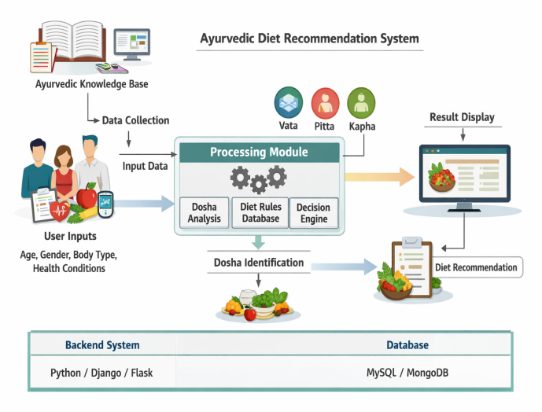

The architecture of the Ayurvedic Diet Planner is based on a simple client-server model. The user interacts with the system through the frontend interface, which collects input data. The Flask backend processes the data, performs BMI calculation, and generates diet recommendations. The SQLite database stores user and patient details, ensuring efficient data handling and retrieval.

  - UML Diagrams
- Use Case Diagram
A Use Case Diagram represents the interaction between users and the system. It shows different functionalities of the system and how users access them. In this project, it includes actions like login, entering health details, and viewing diet suggestions. It helps in understanding the system from the user’s perspective.
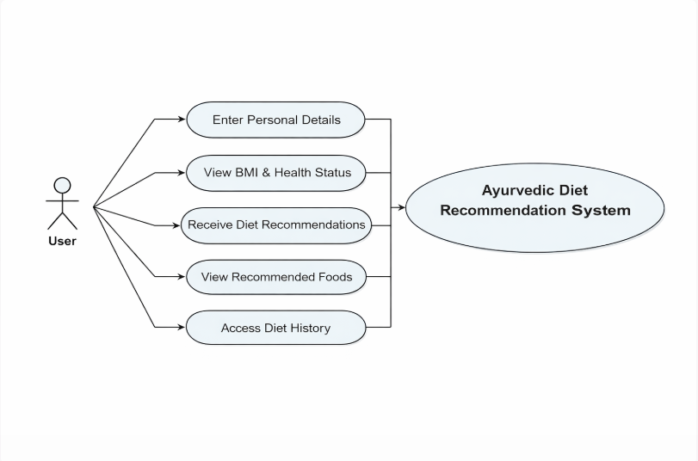

2.Class Diagram
A Class Diagram represents the structure of the system by showing classes, attributes, and relationships. It defines how different parts of the system are organized and connected. In this project, classes like User and Patient are used to store data. It helps in designing the database and backend logic.
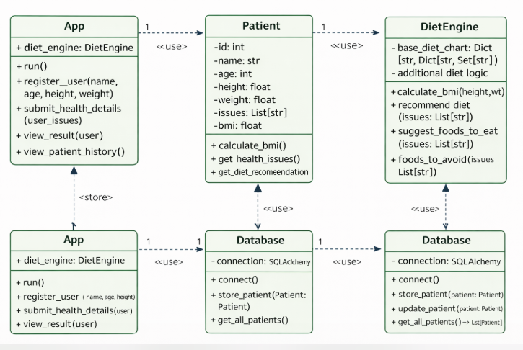

3.Sequence Diagram
A Sequence Diagram shows the step-by-step flow of interactions between different components over time. It explains how requests move from the user to the system and back. In this project, it includes login, data input, processing, and result display. It helps in understanding the order of operations clearly.
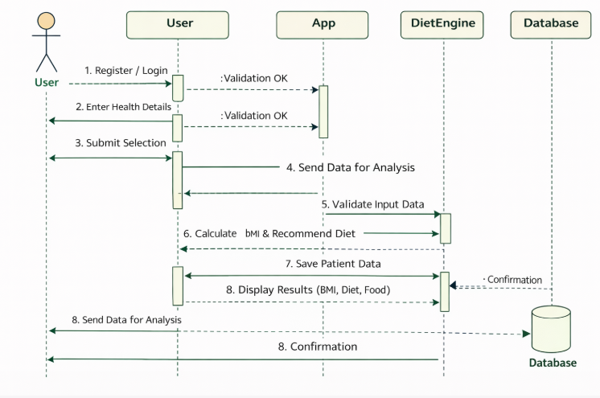

4.Activity Diagram
An Activity Diagram represents the workflow of the system from start to end. It shows different actions, decisions, and the flow between them. In this project, it includes steps like login, entering details, processing, and displaying results. It helps in visualizing the overall working process of the system.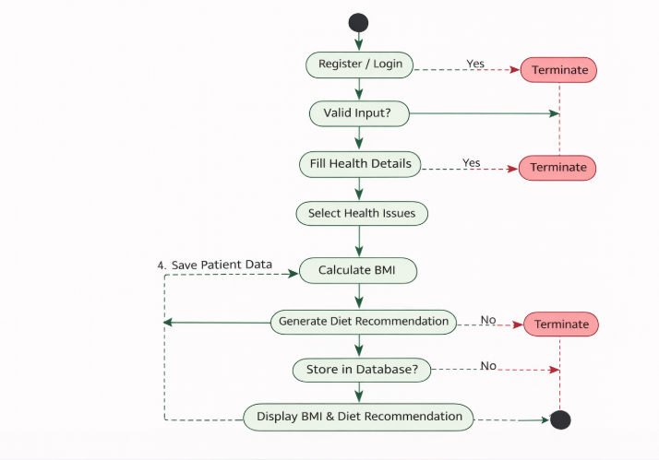

4.METHODOLOGY

The Ayurvedic Diet Planner was developed by first identifying and analyzing the system requirements to provide diet recommendations based on user health conditions. Based on this, the system design and UML diagrams were created to understand the workflow and structure clearly. The application was then implemented using Python Flask for backend processing and HTML/CSS for designing the user interface. SQLite database was used to store user and patient details. The system accepts user inputs, validates them, calculates BMI, and generates suitable diet recommendations. Finally, the application was tested to ensure proper functionality, and necessary improvements were made.

4.1 Module Description
The Ayurvedic Diet Planner consists of the following modules:
- User Authentication Module: Allows users to register and login securely before accessing the system.
- Health Data Input Module: Collects user details such as name, age, height, weight, and health issues.
- BMI Calculation Module: Calculates Body Mass Index and determines the health category.
- Diet Recommendation Module: Provides suitable food suggestions and foods to avoid based on selected health conditions.
- Result Display Module: Displays BMI, health status, and diet plan along with food images in a user-friendly format.
- Database Management Module: Stores patient details and health information for future reference and analysis.

4.2 Algorithm
- Start
- Display the Login/Signup page
- If the user is a new user, then
Enter username and password
Store the details in the database
- Else (existing user),
Enter username and password
Validate credentials from the database
- If login is successful,
Redirect to the health data input page
Else
Display error message and return to login
- Accept user details:
Name, Age, Height, Weight
Select one or more health issues
- Validate the input data:
Name should contain only alphabets
Age, height, and weight must be within valid limits
- Calculate Body Mass Index (BMI) using:
BMI = weight / (height in meters)²
- Determine BMI category:
Underweight / Normal / Overweight
- For each selected health issue,
Retrieve recommended food items
Retrieve food items to avoid
- Combine all food recommendations and avoid lists
- Store patient details (name, age, height, weight, issues) in the database
- Display the result page with:
User details
BMI and health status
Recommended foods (with images)
Foods to avoid
- Provide option to logout
- Stop

5.IMPLEMENTATION
5.1 Source Code
The Ayurvedic diet planner is developed using Python Flask for backend and HTML, CSS for frontend. The following sections show the important source codes used for implementing different modules of the system.
- Main Application Code (app.py)

from flask_sqlalchemy import SQLAlchemy
from flask import Flask, render_template, request, redirect
app = Flask(__name__)
app.config['SQLALCHEMY_DATABASE_URI'] = 'sqlite:///patients.db'
app.config['SQLALCHEMY_TRACK_MODIFICATIONS'] = False

db = SQLAlchemy(app)

class Patient(db.Model):
id = db.Column(db.Integer, primary_key=True)
name = db.Column(db.String(100))
age = db.Column(db.Integer)
height = db.Column(db.Float)
weight = db.Column(db.Float)
issues = db.Column(db.String(200))

diet_chart = {
"Diabetes": {"foods": ["Brown rice", "Oats", "Bitter gourd", "Fenugreek"], "avoid": ["Sugar", "White rice", "Sweets"]},
"PCOS": {"foods": ["Flax seeds", "Vegetables", "Fruits", "Moong dal"], "avoid": ["Junk food", "Cheese"]},
"Thyroid": {"foods": ["Iodized salt", "Curd", "Apple"], "avoid": ["Soy", "Cabbage"]},
"Obesity": {"foods": ["Millets", "Green tea", "Salads"], "avoid": ["Fried food", "Bakery items"]},
"Anemia": {"foods": ["Spinach", "Beetroot", "Dates", "Jaggery"], "avoid": ["Tea after meals"]},
"Hypertension": {"foods": ["Banana", "Garlic", "Oats"], "avoid": ["Salt", "Pickles"]},
"Acidity": {"foods": ["Banana", "Buttermilk", "Coconut water"], "avoid": ["Spicy food", "Tea"]},
"Constipation": {"foods": ["Papaya", "Warm water", "Ghee", "Oats"], "avoid": ["Processed food"]},
"Hair fall": {"foods": ["Almonds", "Walnuts", "Spinach", "Carrot"], "avoid": ["Junk food"]},
"Skin problems": {"foods": ["Neem", "Turmeric milk", "Cucumber"], "avoid": ["Fried food", "Sugar"]}
}

food_images = {
"Brown rice":"brownrice.jpg","Oats":"oats.jpg","Bitter gourd":"bittergourd.jpg","Fenugreek":"fenugreek.jpg",
"Flax seeds":"flaxseed.jpg","Vegetables":"veggies.jpg","Fruits":"fruits.jpg","Moong dal":"moongdal.jpg",
"Iodized salt":"salt.jpg","Curd":"curd.jpg","Apple":"apple.jpg",
"Millets":"millets.jpg","Green tea":"greentea.jpg","Salads":"salads.jpg",
"Spinach":"spinach.jpg","Beetroot":"beetroot.jpg","Dates":"dates.jpg","Jaggery":"jaggery.jpg",
"Banana":"banana.jpg","Garlic":"garlic.jpg",
"Buttermilk":"buttermilk.jpg","Coconut water":"coconutwater.jpg",
"Papaya":"papayaa.jpg","Warm water":"warmwater.jpg","Ghee":"ghee.jpg",
"Almonds":"almonds.jpg","Walnuts":"walnuts.jpg","Carrot":"carrot.jpg",
"Neem":"neem.jpg","Turmeric milk":"turmericmilk.jpg","Cucumber":"cucumber.jpg"
}

@app.route("/")
def home():
issues = list(diet_chart.keys())
return render_template("index.html", issues=issues)

@app.route("/form")
def form():
issues = list(diet_chart.keys())
return render_template("index.html", issues=issues)

@app.route("/result", methods=["POST"])
def result():
name = request.form["name"]
if not name.replace(" ", "").isalpha():
return "Name should contain only letters"
age = int(request.form["age"])
height = float(request.form["height"])
weight = float(request.form["weight"])
if age <= 0 or age > 120:
return "Enter valid age"
if height < 50 or height > 250:
return "Enter valid height"
if weight < 10 or weight > 250:
return "Enter valid weight"

height_m = height / 100
bmi = round(weight / (height_m ** 2), 2)
if bmi < 18.5:
bmi_status = "Underweight"
elif bmi < 25:
bmi_status = "Normal"
else:
bmi_status = "Overweight"

selected_issues = request.form.getlist("issues")
recommended = set(); avoid = set()
for issue in selected_issues:
recommended.update(diet_chart[issue]["foods"])
avoid.update(diet_chart[issue]["avoid"])

issues_str = ", ".join(selected_issues)
new_patient = Patient(
name=name,
age=age,
height=height,
weight=weight,
issues=issues_str
)
db.session.add(new_patient)
db.session.commit()

return render_template(
"result.html",
name=name,
bmi=bmi,
bmi_status=bmi_status,
issues=selected_issues,
foods=recommended,
avoid=avoid,
food_images=food_images
)

@app.route("/patients")
def patients():
all_patients = Patient.query.all()
return render_template("patients.html", patients=all_patients)

if __name__ == "__main__":
with app.app_context():
db.create_all()
app.run(debug=True)

- Signup.html

<html>
<head>
<title>Signup</title>
</head>
<body>

<h2>Signup</h2>

<form method="POST">
Username:
<input type="text" name="username" required><br><br>

Password:
<input type="password" name="password" required><br><br>

<button type="submit">Signup</button>
</form>

<a href="/login">Already have an account? Login</a>

</body>
</html>

- Login.html
<html>
<head>
<title>Login</title>
</head>
<body>

<h2>Login</h2>

<form method="POST">
Username:
<input type="text" name="username" required><br><br>

Password:
<input type="passwAord" name="password" required><br><br>

<button type="submit">Login</button>
</form>

<a href="/signup">New user? Signup</a>

</body>
</html>
- Patient.html

<!DOCTYPE html>
<html>
<head>
<title>Patient History</title>
</head>
<body>

<h2>Patient History</h2>

<table border="1">
<tr>
<th>Name</th>
<th>Age</th>
<th>Height</th>
<th>Weight</th>
<th>Issues</th>
</tr>

{% for p in patients %}
<tr>
<td>{{p.name}}</td>
<td>{{p.age}}</td>
<td>{{p.height}}</td>
<td>{{p.weight}}</td>
<td>{{p.issues}}</td>
</tr>
{% endfor %}

</table>

</body>
</html>

- Result.html

<!DOCTYPE html>
<html>
<head>
<title>Diet Result</title>
<style>
body{font-family:Arial;background:linear-gradient(to right,#d4fc79,#96e6a1);}
.container{background:white;padding:20px;margin:auto;width:80%;border-radius:15px;}
.card{display:inline-block;background:#f0fff0;padding:10px;margin:10px;border-radius:10px;width:150px;text-align:center;}
.card img{width:120px;height:100px;border-radius:10px;}
</style>
</head>
<body>
<div class="container">
<h2>Hello {{name}} 🌿</h2>
<h3>BMI: {{bmi}} ({{bmi_status}})</h3>
<h3>Recommended Foods</h3>
{% for food in foods %}
<div class="card">
<p>{{food}}</p>
<img src="{{ url_for('static', filename='images/' + food_images[food]) }}" width="120" height="100">
</div>
{% endfor %}
<h3>Foods to Avoid❌</h3>
<ul>
{% for food in avoid %}
<li>{{food}}</li>
{% endfor %}
</ul>
</div>
</body>
</html>

5.1 Output Screens:

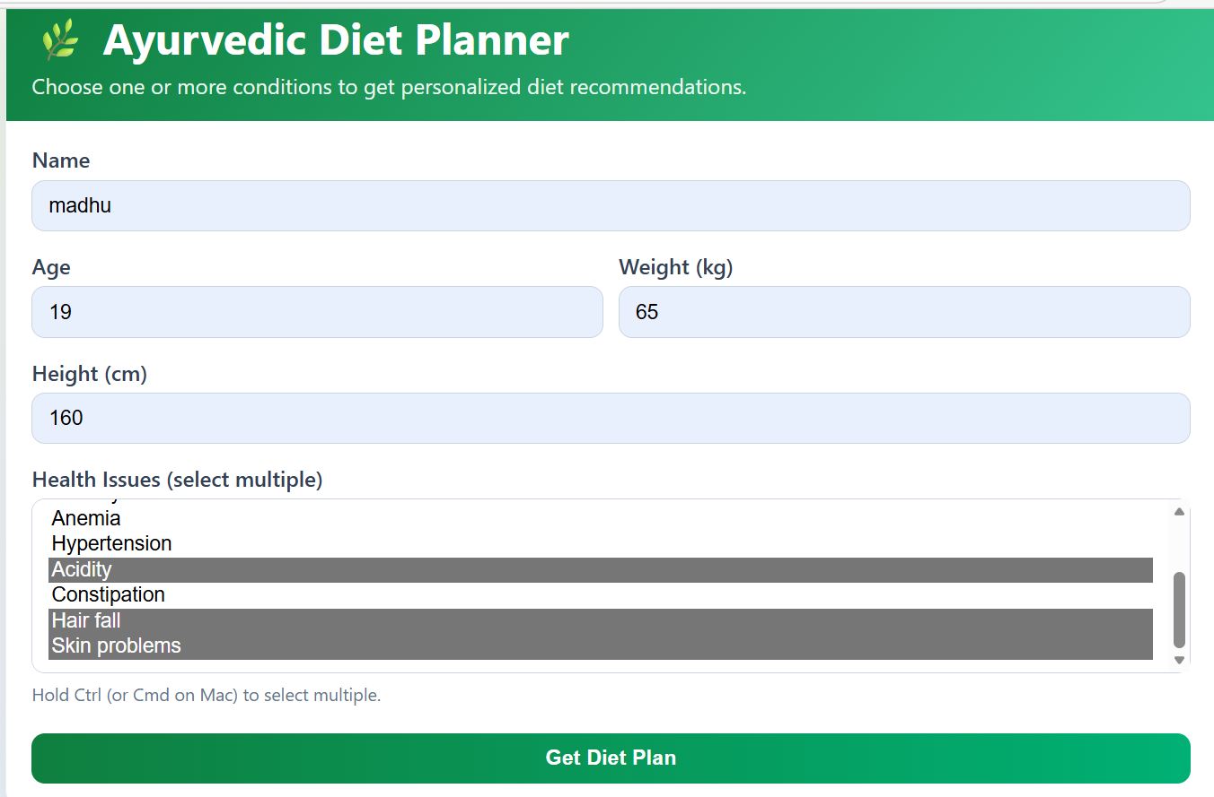

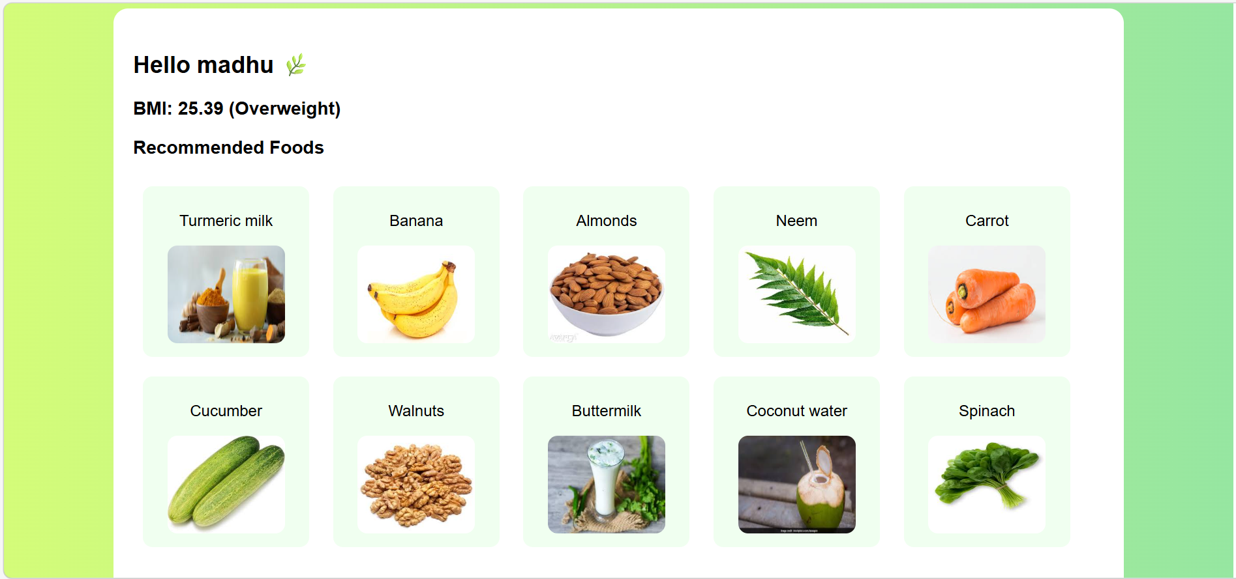

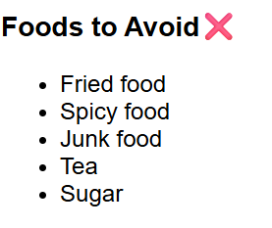
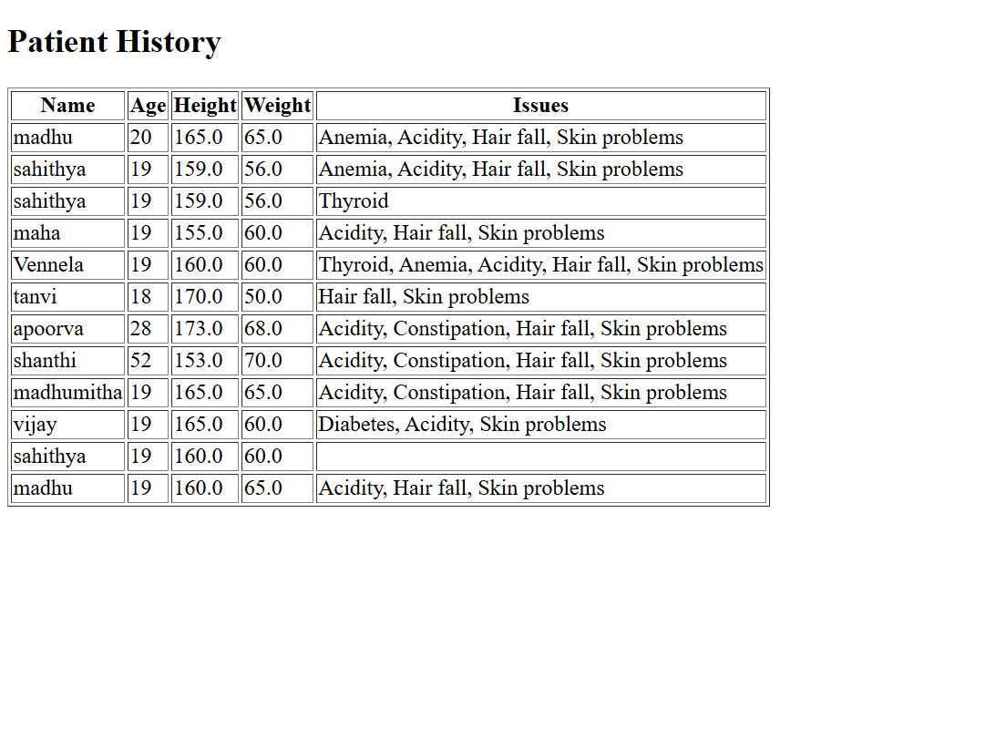

6.CONCLUSION & FUTURE SCOPE
6.1 conclusion
The Ayurvedic Diet Planner is a user-friendly web application that provides personalized diet recommendations based on an individual’s health conditions and basic details such as age, height, and weight. By using Flask and a database, the system efficiently processes user input, calculates BMI, and suggests suitable foods while highlighting items to avoid, while also maintaining patient records, making it useful for both users and dieticians. Overall, the project demonstrates the practical application of web development and database integration in solving real-world health problems, and with further enhancements like AI-based recommendations and mobile accessibility, the system has the potential to become a more advanced and widely usable health support tool.
6.2 Future Scope
The Ayurvedic Diet Planner can be enhanced by integrating AI and machine learning to provide more personalized recommendations and by expanding the database of health conditions and Ayurvedic foods. Additional features like nutritional information, calorie tracking, and user history can help monitor health over time, while improvements in user interface and multi-language support can increase accessibility. In the future, the system can be developed into a mobile application, integrated with wearable devices for real-time tracking, and include features like voice input, chatbot assistance, and online dietician consultation.

BIBILOGRAPHY
- Python Software Foundation – Python Docs: https://docs.python.org
- Pallets Projects – Flask Docs: https://flask.palletsprojects.com
- W3Schools – HTML & CSS: https://www.w3schools.com
- SQLite – Database Docs: https://www.sqlite.org/docs.html
- MDN Web Docs – Web Dev Reference: https://developer.mozilla.org

