algorithms <- list(

"item-based CF1" = list(name="IBCF", param=list(k=5,method = "cosine",alpha=0.5,normalize="center")),

"item-based CF2" = list(name="IBCF", param=list(k=5,method = "jaccard",alpha=0.5,normalize="center")),

"item-based CF3" = list(name="IBCF", param=list(k=5,method = "pearson",alpha=0.5,normalize="center")))

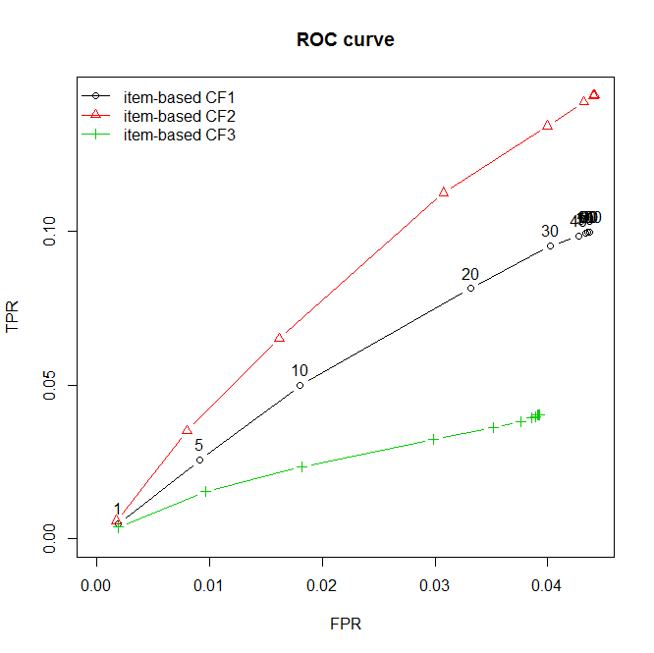

algorithms <- list(

"item-based CF2-1" = list(name="IBCF", param=list(k=5,method = "jaccard",alpha=0.5,normalize="Z-score")),

"item-based CF2-2" = list(name="IBCF", param=list(k=5,method = "jaccard",alpha=0.5,normalize="center"))

)

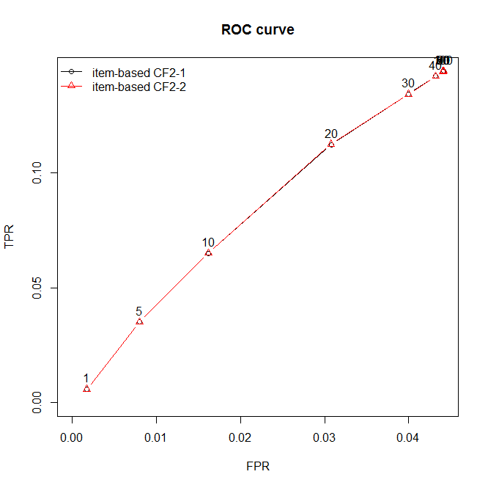

UBCF

algorithms <- list(

"user-based CF2-1" = list(name="UBCF", param=list(nn=5,method = "cosine",normalize="center")),

"user-based CF2-2" = list(name="UBCF", param=list(nn=5,method = "jaccard",normalize="center")),

"user-based CF2-2" = list(name="UBCF", param=list(nn=5,method = "pearson",normalize="center"))

)

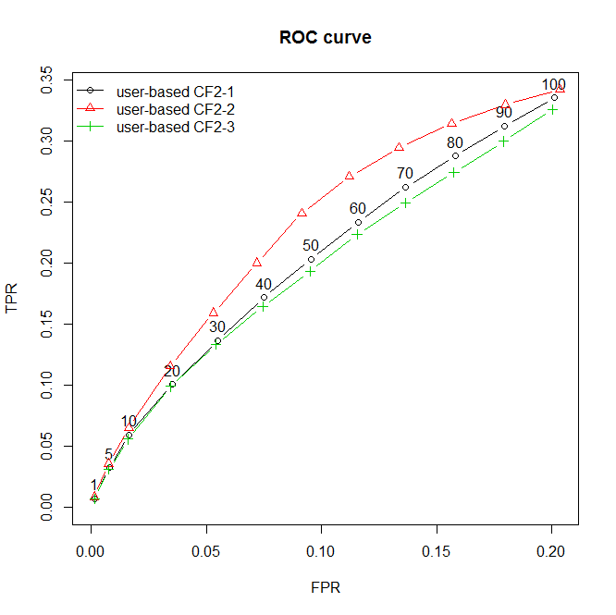

algorithms <- list(

"user-based CF2-zscore" = list(name="UBCF", param=list(nn=5,method = "jaccard",normalize="Z-score")),

"user-based CF2-center" = list(name="UBCF", param=list(nn=5,method = "jaccard",normalize="center"))

)

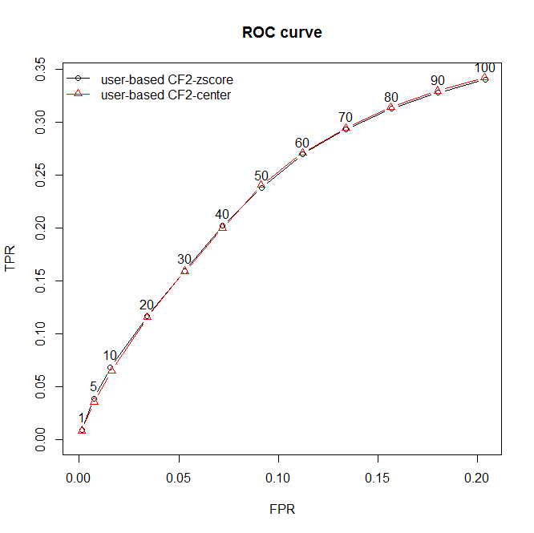

SVD

algorithms <- list(

"SVD-1" = list(name="SVD", param=list(k=5,normalize="Z-score")),

"SVD-2" = list(name="SVD", param=list(k=5,normalize="center"))

)

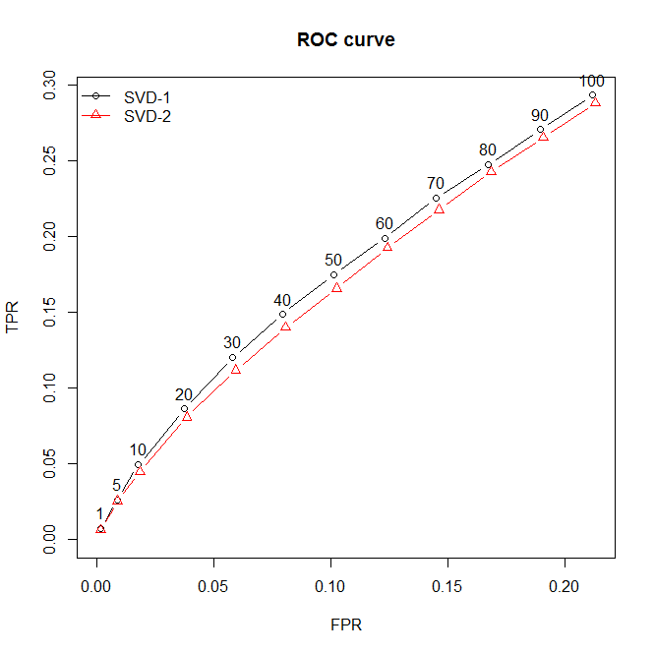

SVDF

algorithms <- list(

"SVDF approximation" = list(name="SVDF", param=list(k=1,gamma=0.015,lambda=0.01)),

"SVDF approximationv2" = list(name="SVDF", param=list(k =1 ,gamma=0.45,lambda=0.001)),

"SVDF approximationv3" = list(name="SVDF", param=list(k =1 ,gamma=0.0000012,lambda=0.0001))

)

FINAL

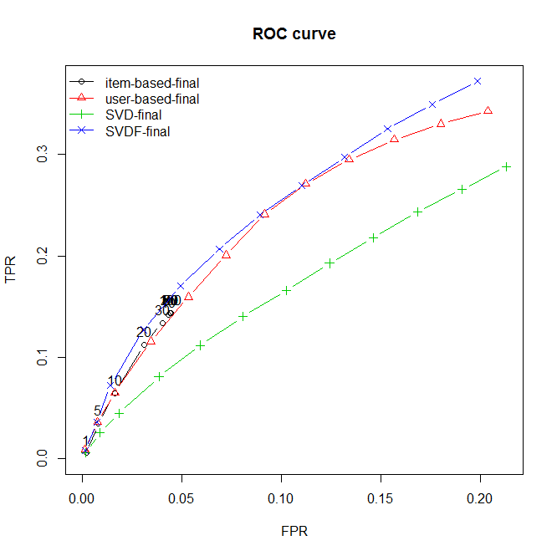

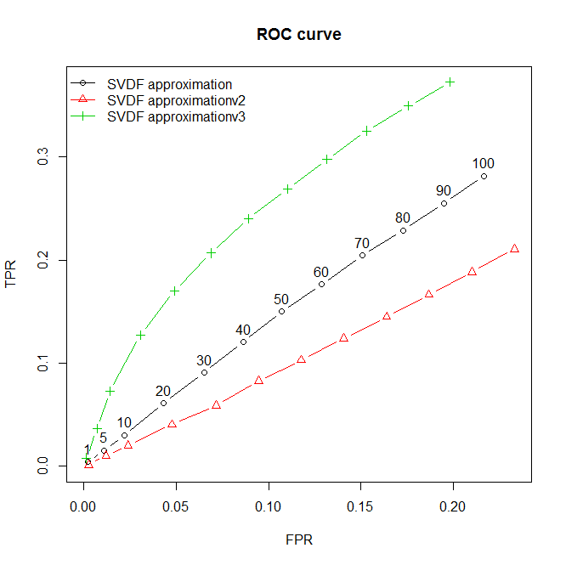

algorithms <- list(

"SVDF approximation1" = list(name="SVDF", param=list(k=1,gamma=0.0000012,lambda=0.0001,min_improvement= 1e-06)),

"SVDF approximation2" = list(name="SVDF", param=list(k =1 ,gamma=0.0000012,lambda=0.0001,min_improvement= 100)),

"SVDF approximation3" = list(name="SVDF", param=list(k =1 ,gamma=0.0000012,lambda=0.0001,min_improvement= 1e-08))

)

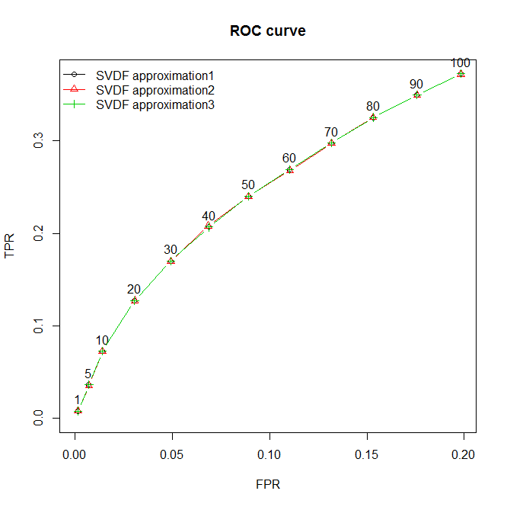

FINAL

algorithms=list(

"item-based-final" = list(name="IBCF", param=list(k=5,method = "jaccard",alpha=0.5,normalize="center")),

"user-based-final" = list(name="UBCF", param=list(nn=5,method = "jaccard",normalize="center")),

"SVD-final" = list(name="SVD", param=list(k=5,normalize="center")),

"SVDF-final" = list(name="SVDF", param=list(k =1 ,gamma=0.0000012,lambda=0.0001))

)

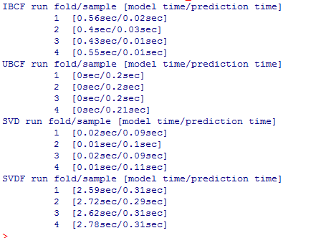

Precision/recall

