Structure-Based Virtual Screening and Molecular Docking of
Zika Virus NS5 RNA-Dependent RNA Polymerase Inhibitors from the MMV Pandemic Response Box
A Dissertation Report
M.Sc. Biotechnology and Bioinformatics

1. Introduction

1.1 Zika Virus: Classification, Transmission and Clinical Disease
Zika virus (ZIKV) is a mosquito-borne member of the genus Flavivirus, family Flaviviridae, transmitted primarily by Aedes aegypti and Aedes albopictus mosquitoes, with documented secondary transmission through sexual contact, blood transfusion, and vertical (mother-to-fetus) routes. Unlike the closely related dengue virus, which circulates as four antigenically distinct serotypes, ZIKV exists as a single serotype comprising two principal phylogenetic lineages: the African lineage and the Asian lineage, the latter being responsible for the large outbreaks in the Pacific and the Americas (2013-2016).
The majority of ZIKV infections (an estimated 70-80%) are asymptomatic or subclinical. When symptomatic, the disease typically presents as a self-limiting febrile illness lasting 2-7 days, characterised by low-grade fever, maculopapular rash, non-purulent conjunctivitis, arthralgia (particularly of the small joints of the hands and feet), myalgia, headache, and retro-orbital pain. Two complications distinguish ZIKV from other flaviviral infections and account for its designation as a Public Health Emergency of International Concern in 2016: (i) Guillain-Barre syndrome, an acute autoimmune polyradiculoneuropathy that can follow ZIKV infection in adults, and (ii) congenital Zika syndrome, encompassing microcephaly, intracranial calcifications, and other severe neurodevelopmental abnormalities resulting from transplacental infection of the fetus.
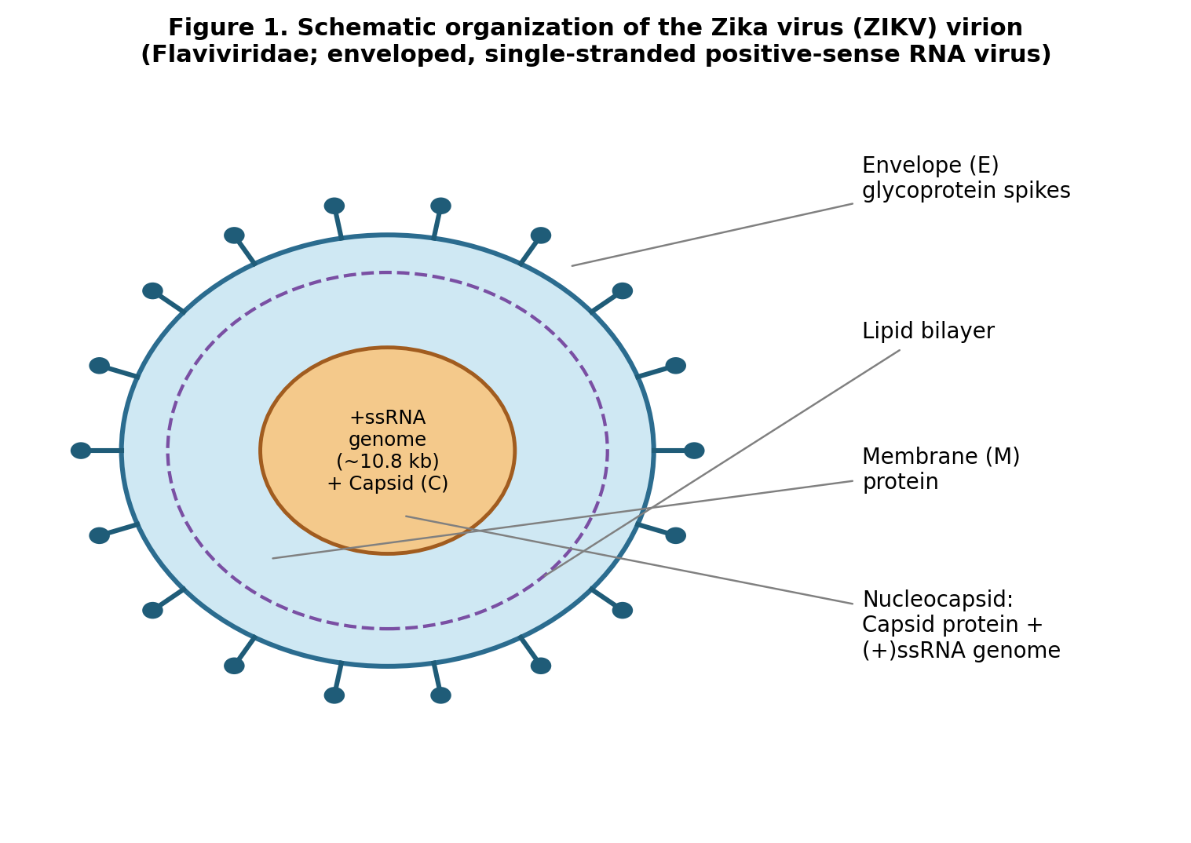
Figure 1. Schematic organisation of the Zika virion (Flaviviridae), showing the envelope (E) and membrane (M) glycoproteins, lipid bilayer, and nucleocapsid core (capsid protein + ~10.8 kb genomic RNA).

1.2 Antagonism of Type I Interferon Signalling
ZIKV, like other flaviviruses, has evolved dedicated mechanisms to subvert the host innate antiviral response mediated by type I interferons (IFN-alpha/beta). Upon IFN-alpha/beta binding to the IFNAR1/IFNAR2 receptor complex, the canonical JAK-STAT pathway is activated: receptor-associated Janus kinases (JAK1, TYK2) phosphorylate STAT1 and STAT2, which heterodimerise, associate with IRF9 to form the ISGF3 complex, translocate to the nucleus, and drive transcription of interferon-stimulated genes (ISGs) that establish an antiviral state. The ZIKV non-structural protein 5 (NS5), the same protein targeted in this study, is the principal antagonist of this pathway: NS5 binds host STAT2 and directs its proteasomal degradation via the ubiquitin-proteasome system, thereby preventing ISGF3 assembly and blunting ISG induction. This STAT2-degradation activity is functionally independent of, but structurally encoded within, the same polyprotein product whose enzymatic (RdRp) activity is the target of the present docking study.

1.3 Host Cell Entry Receptors
Cellular entry of ZIKV is mediated by attachment factors and entry receptors expressed on permissive cell types, most notably the TAM family receptor tyrosine kinases AXL and TYRO3, which recognise phosphatidylserine on the viral envelope via the bridging ligand Gas6, and the C-type lectin receptor DC-SIGN. AXL is particularly implicated in ZIKV tropism for neural progenitor cells, placental trophoblasts, and Sertoli cells, correlating with the tissues most affected in congenital Zika syndrome and sexual transmission. Receptor engagement is followed by clathrin-mediated endocytosis, endosomal acidification, E-protein-driven membrane fusion, and cytoplasmic release of the viral genome, which is translated as a single polyprotein and cleaved into three structural (C, prM/M, E) and seven non-structural (NS1, NS2A, NS2B, NS3, NS4A, NS4B, NS5) proteins.

2. NS5: RNA-Dependent RNA Polymerase Domain

2.1 Domain Architecture
NS5 is the largest and most highly conserved flaviviral protein (~900 residues) and is organised into two functional modules connected by a flexible linker: an N-terminal methyltransferase (MTase) domain, responsible for capping the viral genomic RNA, and a C-terminal RNA-dependent RNA polymerase (RdRp) domain, which catalyses de novo synthesis of the complementary negative-strand RNA and subsequent genome replication. The RdRp domain adopts the canonical, cupped-right-hand fold shared by all template-dependent nucleic acid polymerases, organised into three subdomains conventionally termed fingers, palm and thumb. The fingers and thumb subdomains enclose the palm to form a fully encircled active-site cavity through which the template RNA and incoming nucleotides are channelled, a feature unique to the flaviviral RdRp fold relative to other viral polymerases.
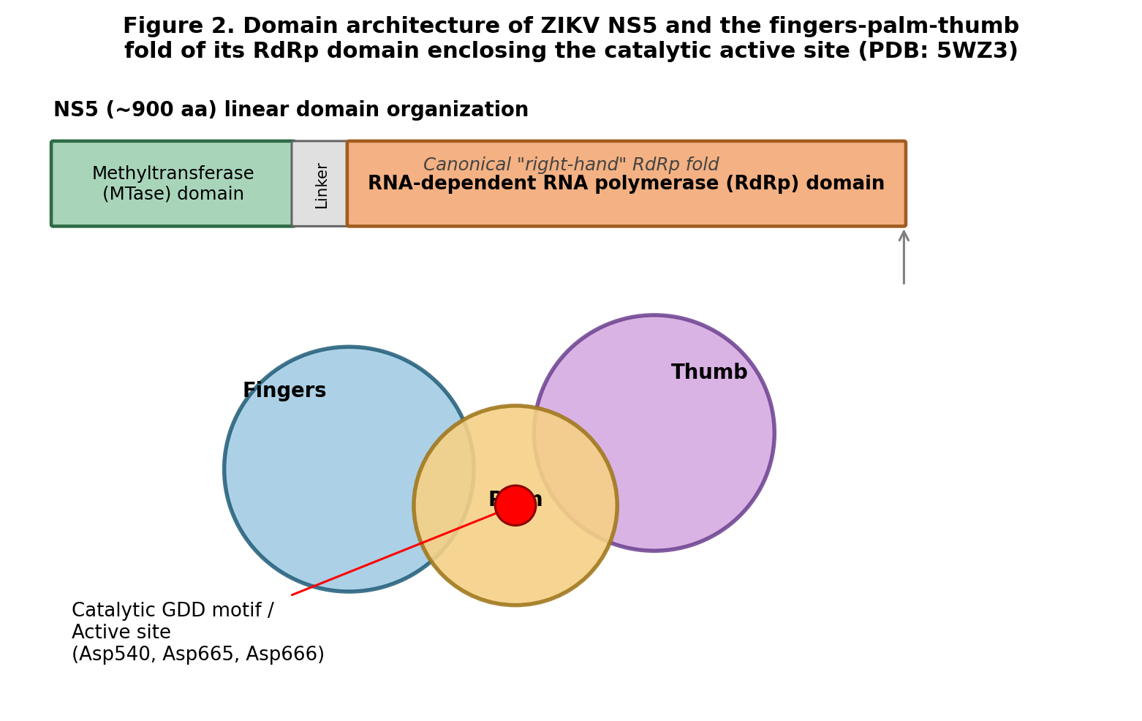
Figure 2. Domain organisation of ZIKV NS5 (MTase-linker-RdRp) and the fingers-palm-thumb subdomain architecture of the RdRp module, showing the catalytic active site within the palm (PDB: 5WZ3).

2.2 Active Site and Catalytic Residues
The catalytic centre of the RdRp resides within the palm subdomain and comprises the canonical two-metal-ion mechanism characteristic of nucleotidyl transferases, coordinated by conserved acidic residues that chelate the catalytic Mg2+ ions required for phosphodiester bond formation. For the ZIKV NS5 RdRp (PDB: 5WZ3), three catalytic aspartate residues, Asp540, Asp665 and Asp666, identified from the literature and confirmed by structural analysis in PyMOL, constitute the active site targeted for structure-based virtual screening in this study. Because this catalytic machinery is essential for viral genome replication, is highly conserved across flaviviruses, and has no direct human structural homologue, the RdRp active site represents an attractive and selective target for antiviral drug design.

2.3 Rationale for Targeting the RdRp Active Site
Direct-acting antivirals targeting viral polymerases (nucleoside and non-nucleoside inhibitors) have an established precedent in other RNA virus infections (e.g., HCV, HIV, SARS-CoV-2), and the essential, highly conserved nature of the flaviviral RdRp active site makes it a rational target for ZIKV. Competitive inhibition at the catalytic pocket is expected to abrogate de novo RNA synthesis and, consequently, viral replication, without requiring the compound to interfere with host cell machinery. This structural and mechanistic rationale underpinned the decision to perform structure-based virtual screening against the 5WZ3 catalytic pocket, described in the following section.

3. Materials and Methods

3.1 Protein Structure Preparation
The crystal structure of the ZIKV NS5 RdRp (PDB ID: 5WZ3) was retrieved from the RCSB Protein Data Bank. Missing residues were modelled using CHARMM-GUI. The repaired structure was subsequently converted to PDBQT format using the prepare_receptor.py script from AutoDock Tools, a pipeline comprising: (i) removal of heteroatoms and crystallographic water molecules, (ii) addition of polar hydrogens, and (iii) assignment of Gasteiger partial charges prior to PDBQT generation. As an internal cross-check, the same preparation could equivalently be reproduced in PyMOL (deletion of heterogens, charge computation, PDBQT export), which was used for visual verification and troubleshooting of the prepared receptor.

3.2 Ligand Library and Preparation
The compound library screened was the Medicines for Malaria Venture (MMV) Pandemic Response Box, comprising 392 diverse, drug-like and pre-clinical compounds supplied in tabulated (Excel) format with associated SMILES strings. SMILES were parsed and validated using RDKit, and three-dimensional conformers were generated and geometry-optimised using the MMFF94 force field. Prior to docking, the library was filtered for drug-likeness using standard medicinal-chemistry cut-offs: molecular weight 300-500 Da, calculated LogP 1.5-5.0, and fewer than 10 rotatable bonds, to enrich for compounds with favourable oral bioavailability potential.

3.3 Molecular Docking Protocol
Structure-based virtual screening was performed using AutoDock Vina with an exhaustiveness setting of 8. All 392 filtered compounds were docked against the catalytic pocket of the prepared 5WZ3 receptor, centred on the Asp540/Asp665/Asp666 active site. Docked poses were ranked by predicted binding affinity (kcal/mol), and the top 20 compounds were carried forward for post-docking pharmacokinetic filtering.

3.4 Post-Docking ADME Filtering
The top 20 docking hits were profiled using SwissADME to predict key absorption, distribution, metabolism and excretion (ADME) parameters, including gastrointestinal (GI) absorption, P-glycoprotein (P-gp) substrate liability, topological polar surface area (TPSA), and a composite oral bioavailability score. Compounds failing accepted drug-likeness/bioavailability thresholds were flagged and deprioritised regardless of docking rank, ensuring the final lead selection balanced predicted binding affinity against pharmacokinetic developability.
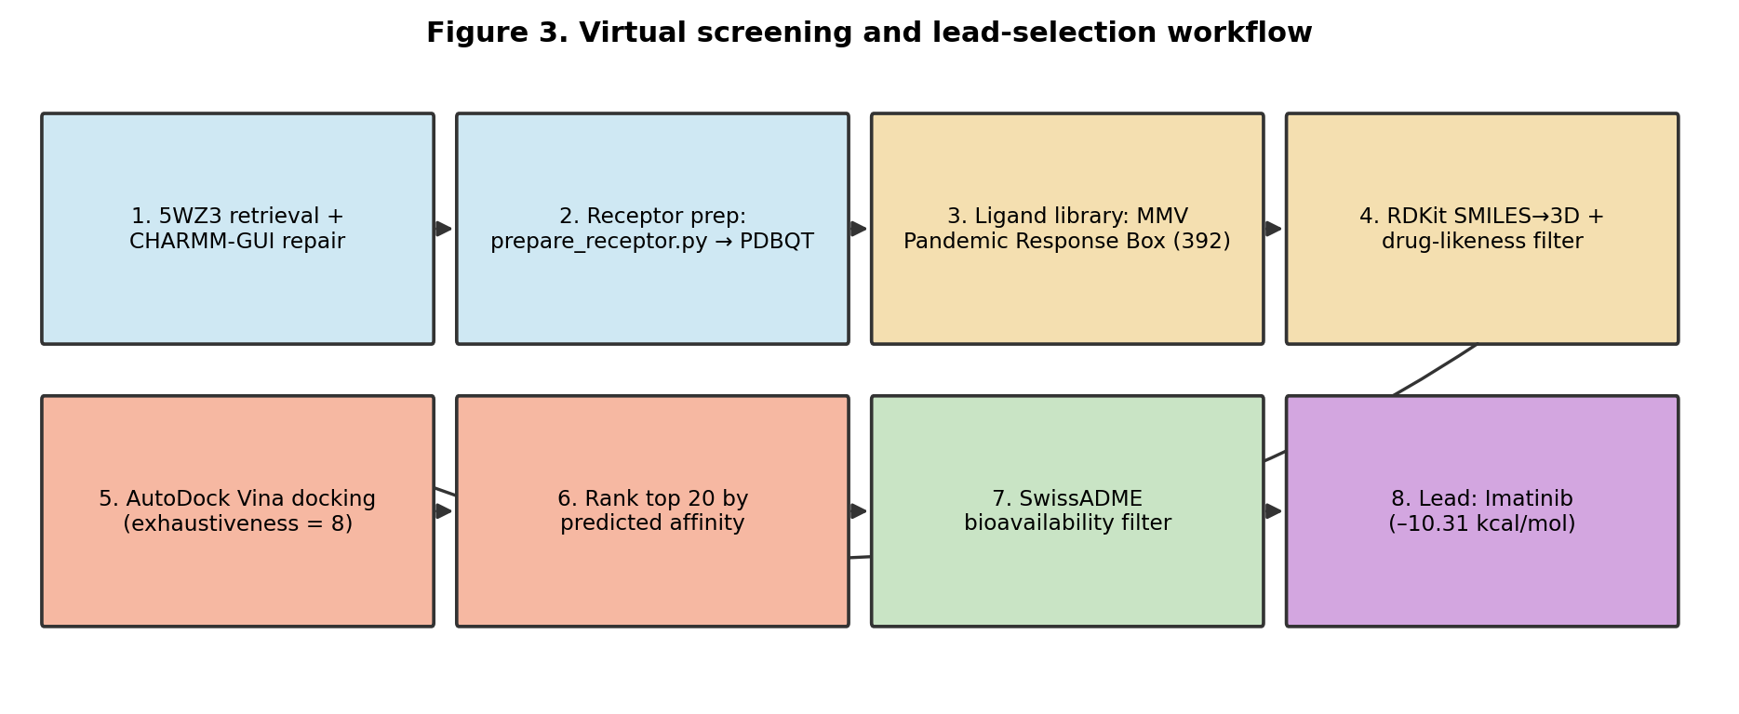
Figure 3. Overall virtual screening and lead-selection workflow, from receptor/ligand preparation through docking, ranking, and ADME filtering, to selection of the lead compound for MD validation.

4. Results

4.1 Docking Outcomes and Ranking
Docking of all 392 MMV Pandemic Response Box compounds against the 5WZ3 catalytic pocket yielded predicted binding affinities ranging from -11.55 to -10.16 kcal/mol among the top 20 ranked hits. The five highest-ranked compounds by docking score are summarised in Table 1.
Rank | Compound | Affinity (kcal/mol) | SwissADME
1 | MMV1580853 | -11.55 | Passed
2 | MMV003069 | -11.51 | Passed
3 | MMV009948 | -11.23 | Passed
4 | MMV020752 | -11.08 | Passed
5 | MMV1634557 | -10.78 | Failed
Table 1. Top five ranked compounds by AutoDock Vina predicted binding affinity against the ZIKV NS5 RdRp catalytic pocket (5WZ3), with SwissADME outcome.

4.2 ADME Profiling
Of the top 20 docked compounds, 19 (95%) passed SwissADME drug-likeness and bioavailability screening. The sole exception, MMV1634557 (rank 5, docking affinity -10.78 kcal/mol), was rejected on the basis of three converging pharmacokinetic liabilities: (i) high predicted P-glycoprotein (P-gp) substrate character, associated with poor intestinal absorption due to efflux; (ii) a topological polar surface area (TPSA) exceeding 140 A2, limiting predicted passive membrane permeability; and (iii) a composite bioavailability score below the 0.5 acceptance threshold, indicating low predicted oral bioavailability. This result illustrates that strong docking affinity alone is insufficient for lead nomination in the absence of favourable predicted pharmacokinetics.

4.3 Lead Compound Selection: Imatinib
Imatinib was selected as the lead compound for downstream molecular dynamics validation on the strength of its combined binding affinity and pharmacokinetic profile: a predicted docking affinity of -10.31 kcal/mol together with an excellent SwissADME profile (high predicted GI absorption, favourable bioavailability). Its molecular properties, molecular weight approximately 420 Da, calculated LogP 3.2-3.8, hydrogen-bond donor/acceptor counts within Lipinski limits, and fewer than 10 rotatable bonds, place it firmly within the drug-like chemical space and support its prioritisation over compounds with marginally stronger docking scores but comparatively less balanced developability profiles.

5. Discussion and Future Directions
This virtual screening campaign against the ZIKV NS5 RdRp catalytic pocket demonstrates a structure-based pipeline integrating receptor preparation, large-scale ligand docking, and post-docking pharmacokinetic filtering to prioritise candidates for experimental and computational follow-up. Although four compounds (MMV1580853, MMV003069, MMV009948, MMV020752) returned numerically stronger docking affinities than the selected lead, Imatinib's combination of a strong, favourable docking score with an unblemished ADME profile supported its nomination as the primary candidate for molecular dynamics (MD) validation, while the remaining high-scoring, ADME-passing compounds are retained as viable back-up candidates.
Docking scores are a static, rigid-receptor approximation of binding and do not capture the dynamic behaviour of a ligand within a flexible, solvated binding pocket over time. The essential next phase of this work is therefore all-atom molecular dynamics simulation of the complex, evaluating ligand positional stability, persistence of interactions with functionally critical residues, and whether the ligand remains stably engaged within the intended site or migrates toward a secondary binding mode. Sections 6-8 report this MD validation phase in full, for both the originally selected lead (Imatinib) and a second candidate, betulinic acid, assessed on the basis of independent literature precedent (see Section 8).

6. Molecular Dynamics Simulation: Methodology

6.1 System Setup and Equilibration
Protein-ligand complexes (5WZ3 RdRp domain with Imatinib, and separately with betulinic acid) were built using CHARMM-GUI, employing the CHARMM36m force field with the TIP3P water model in a cubic box with a minimum 1.0 nm solute-boundary distance. Systems were neutralised and brought to physiological ionic strength (150 mM) using K+ and Cl- ions. Two catalytic Zn2+ ions present in the crystal structure were retained and coordinated per the native active-site geometry. Each system was energy-minimised (steepest descent), followed by sequential NVT and NPT equilibration (stages eq1-eq5) under position restraints on heavy atoms, progressively relaxed, to allow solvent and ion relaxation around the fixed protein-ligand complex prior to unrestrained production dynamics.

6.2 Production MD Parameters
Production simulations were performed in GROMACS 2023.3 for 300 ns (Imatinib complex) and up to 118 ns (betulinic acid complex, ongoing at time of writing), using a 2 fs integration timestep, LINCS constraints on hydrogen-containing bonds, Particle Mesh Ewald (PME) electrostatics, and the Nose-Hoover thermostat/Parrinello-Rahman barostat maintaining 310 K and 1 bar. Trajectories were saved every 100 ps. Prior to all post-processing analyses, trajectories were corrected for periodic boundary artefacts using gmx trjconv with -pbc mol -ur compact, ensuring intact molecular representations across the periodic box boundary; this correction was found to be essential, as a subset of frames processed without it produced non-physical energetic and geometric artefacts (Section 6.4).

6.3 Trajectory Analysis Methods
Ligand positional stability was assessed by root-mean-square deviation (RMSD) following least-squares fitting on the protein backbone, and by per-atom root-mean-square fluctuation (RMSF) to distinguish rigid-body relocation from internal ligand unfolding. Ligand-residue proximity was quantified by two complementary metrics: (i) centre-of-mass (COM) distance between the ligand and defined residue clusters, and (ii) minimum atom-to-atom distance and per-residue contact frequency (fraction of trajectory frames with any ligand atom within 5 A of a given residue), computed using MDAnalysis. Residue identities were independently verified against ground-truth coordinates from the pre-equilibration CHARMM-GUI structure (step3_pbcsetup.pdb) at every stage, to eliminate numbering ambiguities between differently-indexed topology files.

6.4 MM-GBSA Binding Free Energy Calculation
Binding free energies were computed using gmx_MMPBSA (Generalised Born model, igb=5, 150 mM salt) on PBC-corrected trajectories. For Imatinib, the trajectory was partitioned into a bound phase (0-90 ns) and a relocated phase (100-300 ns), based on an observed transition in ligand RMSD and positional metrics at approximately 90 ns; each phase was analysed independently (901 and 2001 frames respectively). Frames exhibiting non-physical energy values (a signature of residual periodic-boundary artefacts) were identified by outlier screening of the total energy distribution and excluded prior to PBC correction of the source trajectory; following correction, no such outliers remained in either phase.

6.5 Principal Component Analysis and Free Energy Landscape
Collective protein motion was characterised by principal component analysis (PCA) of the C-alpha covariance matrix (gmx covar), with the resulting eigenvalue spectrum used to assess the dimensionality of dominant motion. A two-dimensional free energy landscape (FEL) was constructed by projecting the trajectory onto the first two principal components (PC1, PC2) and applying Boltzmann inversion to the resulting population density (gmx sham). Dynamic cross-correlation (DCCM) analysis was performed to identify residue pairs and regions exhibiting correlated or anti-correlated motion across the simulation.

7. Post-MD Analysis: Results and Interpretation

7.1 Ligand Positional Stability
Imatinib exhibited a clear two-phase RMSD profile: a stable initial period (~2-4 A, 0-90 ns) followed by a transition to a new, stable plateau (~10-14 A, 90-300 ns), indicating a discrete relocation event rather than progressive unfolding (Figure 4). Per-atom RMSF confirmed the ligand retained its internal conformation throughout (0.35-2.4 A across all atoms), consistent with rigid-body repositioning rather than structural disordering. Betulinic acid showed a comparable transition, but timed differently: ground-truth coordinate analysis of the pre-equilibration structure and all equilibration stages (eq1-eq5) confirmed tight engagement (1.8-4.4 A) with the catalytic/priming-loop cluster throughout equilibration, with relocation to a distinct, stable secondary binding mode occurring specifically at the eq5-to-production transition and persisting, without reversion, for the full 118 ns tracked to date.
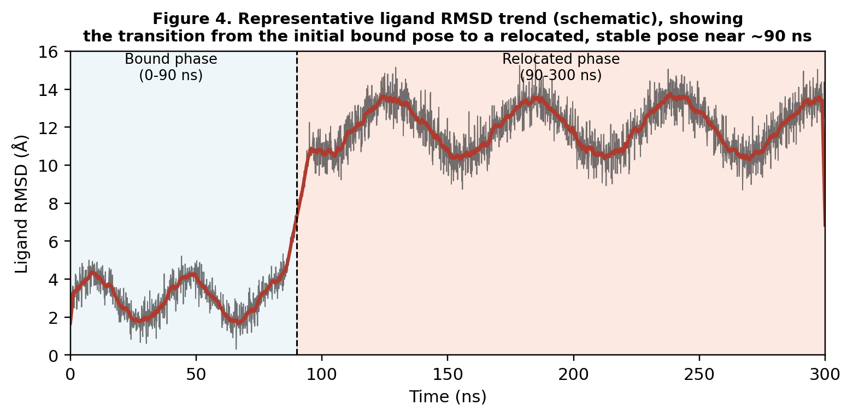
Figure 4. Representative ligand RMSD profile illustrating the two-phase behaviour observed for Imatinib: a stable bound phase (0-90 ns) followed by transition to a stable relocated pose (90-300 ns).

7.2 Binding Free Energy (MM-GBSA)
Contrary to an expectation that relocation would coincide with weaker binding, Imatinib's MM-GBSA binding free energy was more favourable in the relocated phase (-31.29 +/- 0.08 kcal/mol) than in the original bound phase (-20.38 +/- 0.14 kcal/mol) (Figure 5). Energy decomposition indicated the relocated pose is driven predominantly by van der Waals contributions (Delta VDWAALS -55.81 kcal/mol vs. -45.79 kcal/mol in the bound phase), consistent with a snugly-fitting hydrophobic engagement at the new site. This result demonstrates that binding free energy alone does not indicate which site is occupied, or whether that site is catalytically relevant, reinforcing the need for residue-level and mechanistic follow-up before drawing functional conclusions from energetics.
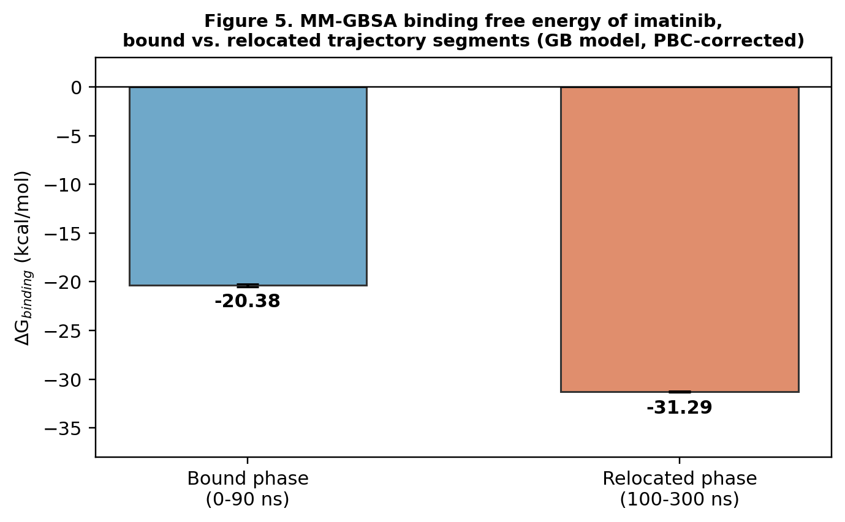
Figure 5. MM-GBSA binding free energy of Imatinib in the bound versus relocated trajectory segments. Error bars denote SEM across all analysed frames per segment.

7.3 Residue-Level Contact Analysis
Ground-truth contact mapping from the pre-equilibration structure showed both ligands engaging an overlapping set of residues spanning the catalytic aspartates (Asp540, Asp665, Asp666), the fingers-subdomain motif-F loop (approximately residues 400-494, including Gly604-Thr608), and the thumb-domain priming loop (785-810, including Trp797-Ile799) simultaneously, at sub-3 A contact distances. Across the production trajectories, contact persistence (percentage of frames with ligand-residue contact within 5 A) was computed for this shared residue set for both compounds (Table 2, Figure 7).

7.4 The Priming Loop: A Shared Functional Hotspot
The most notable finding of the residue-level analysis is convergent engagement of the thumb-domain priming loop by both structurally unrelated ligands. Trp797, at the loop's entry point, showed near-total contact persistence in all three conditions examined: Imatinib bound phase (99.4%), Imatinib relocated phase (100.0%), and betulinic acid (100.0%). More strikingly, contact with residues deeper within the loop interior (Ser798, Ile799) was low during Imatinib's initial bound phase (20.2%, 6.8%) but rose substantially in its relocated phase (81.7%, 74.5%), converging toward the pattern shown by betulinic acid from the outset of production (93.4%, 52.1%). Concurrently, contact with the catalytic aspartate Asp665 fell from 25.1% (Imatinib, bound) to near-zero in both the Imatinib relocated phase and throughout the betulinic acid trajectory (0.7%), indicating a shift away from direct catalytic-residue engagement toward deeper priming-loop engagement in both cases.
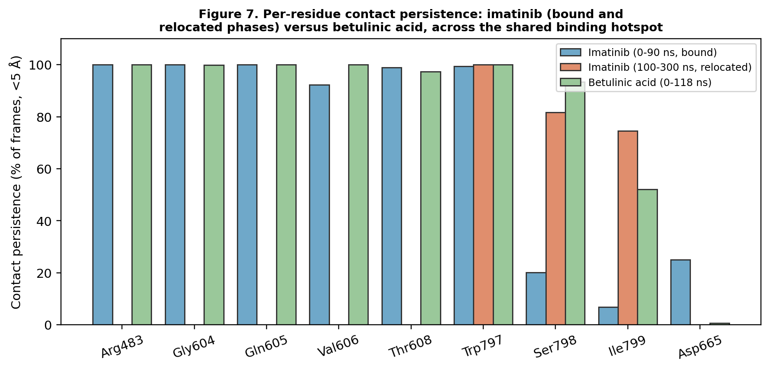
Figure 7. Per-residue contact persistence across the shared catalytic/fingers-loop/priming-loop cluster, comparing Imatinib (bound and relocated phases) and betulinic acid.
A direct measurement of ligand-to-priming-loop minimum atom-atom distance, using the confirmed real residue range (785-810), showed betulinic acid maintaining continuous close contact (mean 2.65 A, range 2.23-3.16 A) across its entire 118 ns trajectory, with 100% of frames below both a 4.5 A contact threshold and a 3.5 A close-contact threshold. An analogous corrected contact-count analysis for Imatinib's relocated phase likewise showed contact in 100% of frames (mean approximately 857 contact pairs per frame), confirming that both ligands maintain sustained, non-transient physical engagement with this loop rather than incidental, momentary contact.
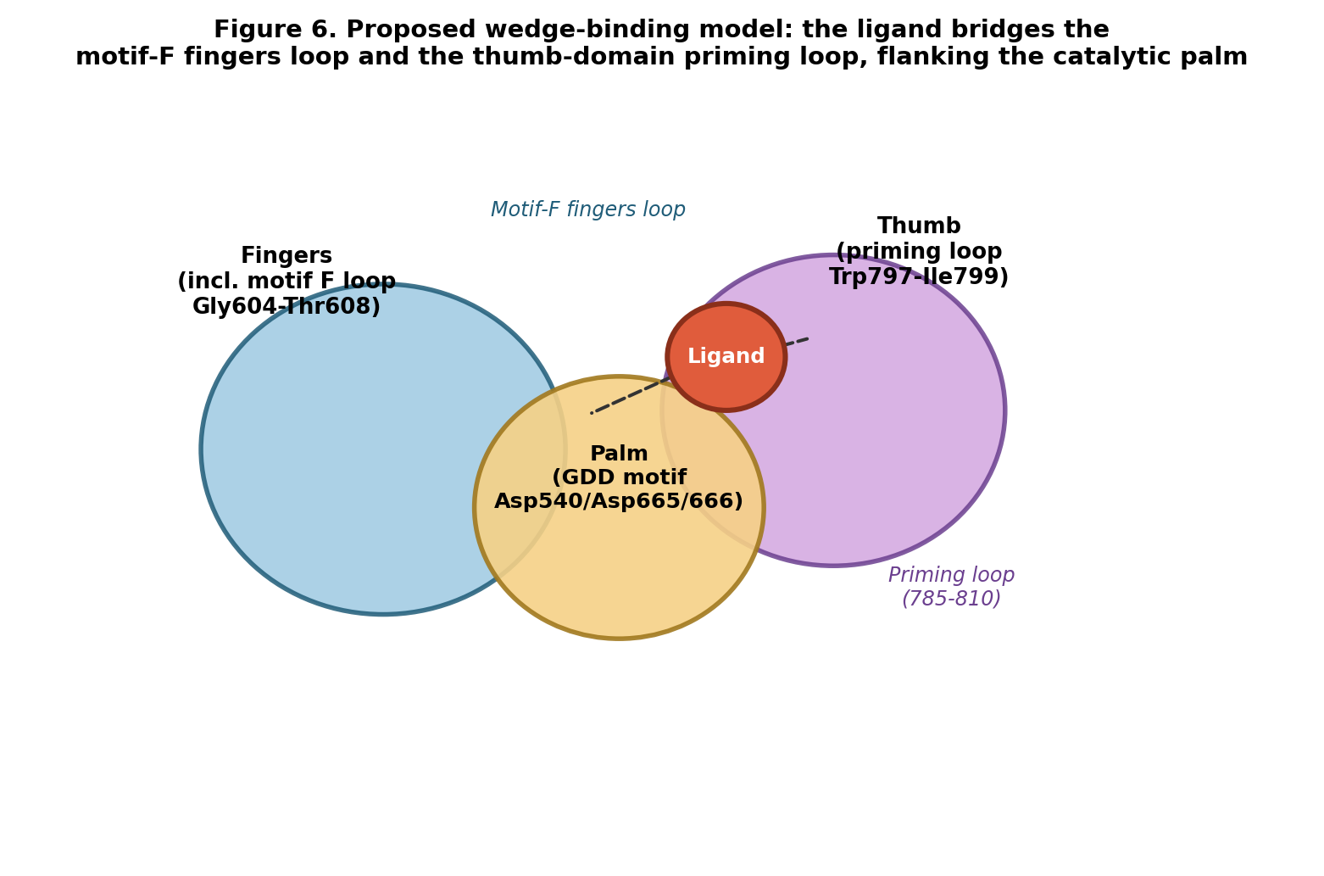
Figure 6. Proposed wedge-binding model in which the ligand occupies the interface between the motif-F fingers loop and the thumb-domain priming loop, flanking the catalytic palm subdomain without directly contacting the GDD catalytic motif.

7.5 Global Conformational Dynamics
Dynamic cross-correlation analysis of the Imatinib-bound trajectory revealed pronounced anti-correlated motion between the fingers/palm region and the thumb-domain region, consistent with the coupled fingers-thumb opening/closing motion required for the polymerase initiation-to-elongation transition (Figure 8). Principal component analysis of the same trajectory showed a sharply dominant first eigenvalue with rapid decay thereafter, indicating that overall protein motion is dominated by one or two large collective modes rather than diffuse, uncorrelated fluctuation (Figure 9). Projection onto the first two principal components resolved three distinct, well-separated free-energy basins (Figure 10), indicating the complex samples multiple discrete conformational states rather than fluctuating around a single structure. Direct measurement of the centre-of-mass distance between the priming loop (785-810) and the motif-F fingers loop (475-483) during the period of sustained ligand engagement was found to be tightly constrained (mean 25.85 +/- 0.62 A, range 23.89-27.82 A, with no long-term drift between the first and second halves of the relocated-phase trajectory), a narrower range than would be expected for two loops undergoing unrestricted natural flexing over 200 ns; comparison against an equivalent measurement on the ligand-free (apo) trajectory is identified as the critical outstanding experiment to establish whether this constraint is ligand-induced.
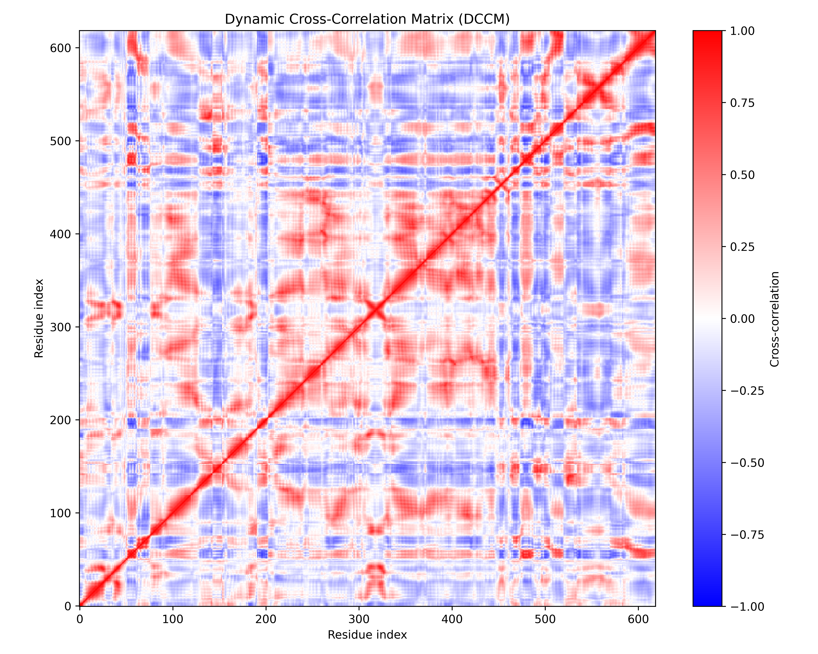
Figure 8. Dynamic cross-correlation matrix (DCCM) of the Imatinib-bound trajectory. Red indicates positively correlated motion; blue indicates anti-correlated motion. Pronounced anti-correlation is observed between the fingers/palm and thumb-domain regions.
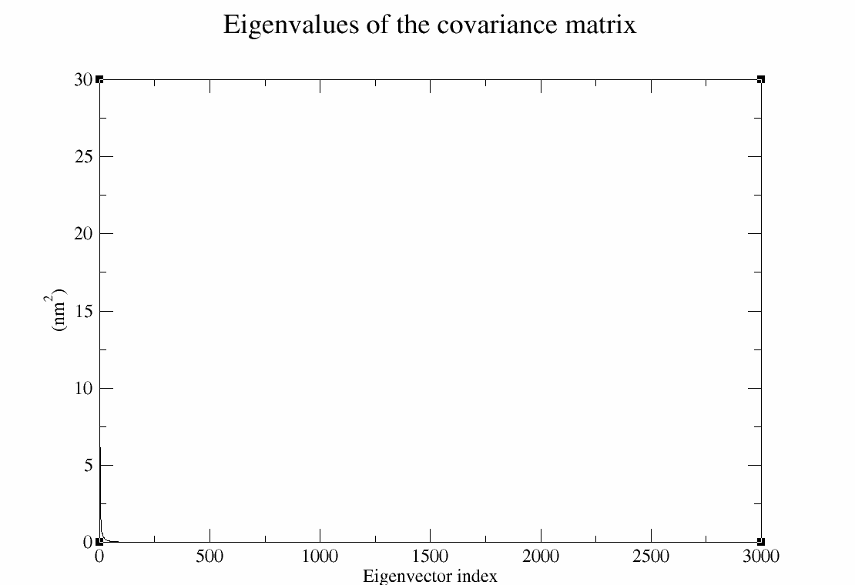
Figure 9. Eigenvalue spectrum of the covariance matrix, showing a dominant first component and rapid decay, indicative of large-scale collective motion rather than uncorrelated local fluctuation.
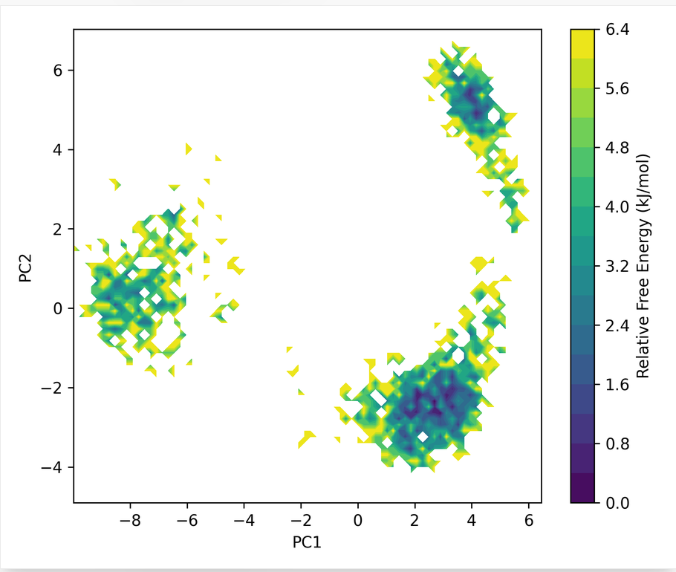
Figure 10a. Free energy landscape projected onto the first two principal components (PC1, PC2), resolving three distinct conformational basins.
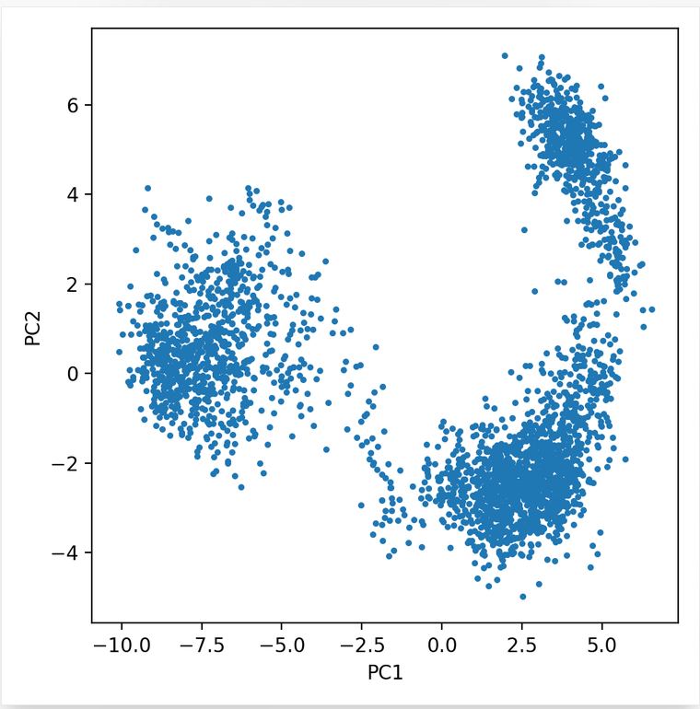
Figure 10b. Corresponding PC1 vs. PC2 scatter plot of the sampled trajectory, showing three discrete population clusters consistent with the free energy landscape.

8. Comparative Discussion: Imatinib and Betulinic Acid
Betulinic acid was assessed alongside Imatinib on the basis of independent experimental precedent: prior cell-free enzymatic assays and a 2020 cell-based study demonstrated that betulinic acid inhibits dengue virus (DENV) NS5 RdRp activity, acting at a post-entry stage to reduce viral RNA synthesis and protein production across multiple DENV serotypes. Given the high conservation of the NS5 RdRp architecture across flaviviruses, this experimentally-validated DENV mechanism provides a meaningful structural benchmark against which the present ZIKV MD findings, for both compounds, can be interpreted.
Ground-truth structural analysis showed that both Imatinib and betulinic acid, in their initial docked and equilibrated poses, simultaneously engage the catalytic aspartates, the motif-F fingers loop, and the thumb-domain priming loop, at close (<4.5 A) range. Over the course of unrestrained production dynamics, both ligands undergo a relocation away from direct catalytic-residue contact: Imatinib after approximately 90 ns of stable initial engagement, and betulinic acid immediately upon release of equilibration restraints. Despite these differing timelines, both ligands converge on a strikingly similar relocated binding character, marked by near-total, sustained contact with the priming loop entry residue Trp797 and substantial engagement of the loop interior (Ser798, Ile799), alongside near-complete loss of contact with the catalytic aspartate Asp665.
This convergent behaviour, observed independently for two structurally unrelated compounds approaching the site from different trajectories and timescales, is considered meaningful supporting evidence that the priming-loop-proximal pocket represents a genuine, energetically favourable, and structurally accessible binding mode, rather than an artefact specific to either simulation. Because betulinic acid's experimentally-confirmed DENV inhibitory mechanism does not require direct catalytic-site contact, and because the ZIKV binding pattern reported here for betulinic acid (deep priming-loop engagement, negligible catalytic-aspartate contact) mirrors this precedent, the present data constitute reasonable structural rationale supporting the hypothesis that betulinic acid may interfere similarly with ZIKV RNA synthesis via priming-loop engagement. The corresponding convergence of Imatinib's relocated-phase binding character toward the same pattern extends this rationale to Imatinib, notwithstanding its markedly different initial docking rationale and chemical scaffold.
This inference is deliberately framed as a hypothesis rather than a confirmed mechanism. Molecular dynamics and MM-GBSA analyses establish where a ligand resides, how persistently, and with what energetic favourability; they do not, on their own, establish that this occupancy measurably impairs polymerase function. The loop-loop distance constraint reported in Section 7.5 is consistent with restricted fingers-thumb flexing during the period of ligand engagement, but the essential confirmatory comparison, against the equivalent measurement in the ligand-free (apo) trajectory, remains outstanding. Definitive functional evidence, whether computational (apo-versus-holo comparison of loop dynamics) or experimental (in vitro RdRp enzymatic assay), is required before either compound can be described as a confirmed ZIKV NS5 RdRp inhibitor.

9. Conclusion and Future Directions
This study integrated structure-based virtual screening with all-atom molecular dynamics validation to evaluate candidate inhibitors of the ZIKV NS5 RdRp. While Imatinib satisfied initial docking and pharmacokinetic filters, extended MD simulation revealed a relocation from its intended catalytic-site pose after approximately 90 ns, with binding free energy and residue-contact analysis indicating convergence toward a priming-loop-associated secondary site also independently favoured by betulinic acid, a compound with established experimental precedent for RdRp inhibition in the closely related dengue virus. These findings illustrate that docking affinity and even favourable MM-GBSA energetics are, in isolation, insufficient indicators of sustained or functionally relevant target engagement, and underscore the necessity of extended MD validation, ground-truth structural verification, and eventual experimental confirmation in any computational antiviral discovery pipeline. Priority next steps are: (i) completion of the apo-trajectory loop-loop distance comparison to test whether ligand engagement measurably restrains fingers-thumb dynamics; (ii) per-residue MM-GBSA energy decomposition to quantify the individual energetic contribution of priming-loop residues; and (iii) in vitro RdRp enzymatic assays for both compounds to establish definitive functional inhibition.

