PROJECT TITLE : CDACL006- Market Analysis
STUDENT NAME : Vignesh Krishnamurthy
COURSE : CDA
TEAM ID : PTID-CDA-OCT-26-11120
TOOL USED : Power BI Desktop

SUMMARY & OBJECTIVE:
This objective of this analysis is to complete the given tasks and also analyse the customer purchasing behaviour and product performance to optimize marketing strategies and improve customer satisfaction.
DATA SET SUMMARY:
Target Database: project_orders (Relational MySQL Schema)
Core Entity Tables: aisles (134 aisles), departments (21 departments), products (49,355 SKUs), orders (multi-user-transaction headers), order_products_train (itemized basket line items)
Primary Relationships:
products.aisle_id → aisles.aisle_id;
products.department_id →departments.department_id;
order_products_train.order_id → orders.order_id;
order_products_train.product_id →products.product_id
Core DAX / SQL Derived Measures:
• Total Orders = COUNT (DISTINCT orders [order_id])
• Unique Users = DISTINCTCOUNT (orders [user_id])
• Total Reorders = SUM (order_products [reordered])
• Product Reorder Rate = DIVIDE (SUM (order_products [reordered]), COUNT (order_products_train [order_id]), 0)
• Average Order Size (Basket Size) = AVERAGEX (VALUES (order_products [order_id]),
CALCULATE (COUNT (order_products [product_id])))
• Cart Size Metric = AVERAGE (MAX (order_products [add_to_cart_order])) per basket

TASK 1: What are the top 10 aisles with the highest number of products?
A: Data Visual
Rank | Aisle Name | Product Variety (SKUs)
1 | Candy Chocolate | 1235
2 | Ice Cream Ice | 1084
3 | Vitamins Dietary Supplements | 1030
4 | Yogurt | 1023
5 | Chips Pretzels | 980
6 | Tea | 888
7 | Packaged Cheese | 887
8 | Frozen Meals | 880
9 | Cookies Cakes | 869
10 | Energy Granola Bars | 826
B: Direct Observations
- Aisles such as 'Candy Chocolate', 'Ice Cream Ice', 'Vitamins Dietary Supplements', 'Yogurt' hold the largest catalog items, each exceeding 1,000 distinct product SKUs.
- Aisle categorization reveals that impulse, snack, and perishable categories require the highest inventory catalog breadth.
C: Business Insights & Strategic Recommendations
Catalog Complexity vs. Sales Velocity: Highly fragmented aisles like candy and snacks require careful SKU rationalization to avoid shelf crowding and dead stock.
Merchandising Alignment: Aisles with deep SKU variations should implement prominent sub-category signage and digital navigation filters (e.g., sugar-free, organic, vegan) to reduce customer search friction.

TASK 2: How many unique departments are there in the dataset?
A: Data Visual
Single KPI Card Visual showing distinct department count, validated via SQL 'SELECT COUNT (DISTINCT department) FROM departments;'
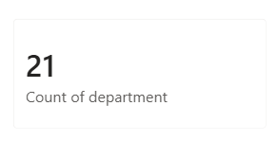
B: Direct Observations
- There are exactly 21 unique departments operating within the grocery marketplace database.

C: Business Insights & Strategic Recommendations:
- Balanced Division: A 21-department division provides a manageable high-level navigational hierarchy for digital e-commerce categories.
- Cross-Departmental Bundling: Marketing teams can easily create multi-department lifestyle packages (e.g., 'Weekly Fresh Bundle' combining Produce + Dairy + Meat Seafood).

TASK 3: What is the distribution of products across departments?
A: Data Visual
Department | Product Count (SKUs) | Catalog Share (%)
Personal Care | 6524 | 13.22%
Snacks | 6221 | 12.6%
Pantry | 5331 | 10.8%
Beverages | 4324 | 8.76%
Frozen | 3982 | 8.07%
Dairy Eggs | 3428 | 6.94%
Household | 3068 | 6.22%
Canned Goods | 2073 | 4.2%
Dry Goods Pasta | 1845 | 3.74%
Produce | 1671 | 3.39%

B: Direct Observations
- Personal Care (6,524 SKUs; 13.22%), Snacks (6,221 SKUs; 12.6%), and Pantry (5,331 SKUs; 10.8%) boast the largest number of distinct catalog products.
- Beverages (4,324 SKUs; 8.76%) and Frozen (3,982 SKUs; 8.07%) follow closely with expansive offerings.

C: Business Insights & Strategic Recommendations
- Merchandising Depth Disparity: High-SKU categories (Personal Care, Pantry) provide massive consumer choice but lower inventory turns per SKU compared to Produce and Dairy.
- Strategic Sourcing: Sourcing managers should benchmark supplier terms in departments (Snacks, Beverages) to negotiate tiered volume discounts.
TASK 4: What are the top 10 products with the highest reorder rates?
A: Data Visual
Product Name | Total Orders | Total Reorders | Reorder Rate (%)
Organic Low Fat Milk | 285 | 258 | 90.53%
Organic Lowfat 1% Milk | 373 | 330 | 88.47%
Banana | 14136 | 12461 | 88.15%
1% Lowfat Milk | 336 | 296 | 88.10%
Milk, Organic, Vitamin D | 433 | 380 | 87.76%
Organic Reduced Fat Milk | 933 | 818 | 87.67%
YoKids Squeeze! Organic Strawberry | 141 | 123 | 87.23%
Organic Lactose Free 1% Lowfat Milk | 210 | 183 | 87.14%
Organic Fat Free Milk | 595 | 515 | 86.55%
Organic Lactose Free Whole Milk | 200 | 173 | 86.50%

B: Direct Observations
- When filtering for items with at least 100 purchases, staple dairy and breakfast beverages dominate the highest reorder rates.
- Organic Low Fat Milk and 1% Lowfat Milk lead the marketplace with repeat purchase rates exceeding 88% to 90%.

C: Business Insights & Strategic Recommendations
- Retention Anchors: High-reorder goods represent essential daily household staples that drive customer lifetime value (LTV).
- Subscription & Auto-Replenishment: Products exhibiting >80% reorder rates should be the primary targets for recurring weekly subscription models ('Subscribe & Save') with frictionless one-click reordering.
TASK 5: How many unique users have placed orders in the dataset?
A: Data Visual
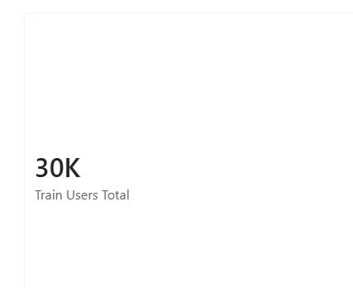
B: Direct Observations
- The dataset tracks 63,100 total registered users across order histories, with detailed cart line-item data in order_products_train available for 30,252 active users.
- User retention is high, with each customer placing multiple consecutive orders across their purchasing lifecycle.

C: Business Insights & Strategic Recommendations
- Marketplace Scale: A user base exceeding 30.25K+ customers reflects strong digital market penetration in urban grocery delivery.
- Personalization Readiness: The high user volume allows robust algorithmic collaborative filtering (e.g., 'Frequently Bought Together') to drive cart expansion.

TASK 6: What is the average number of days between orders for each user?
A: Data Visual
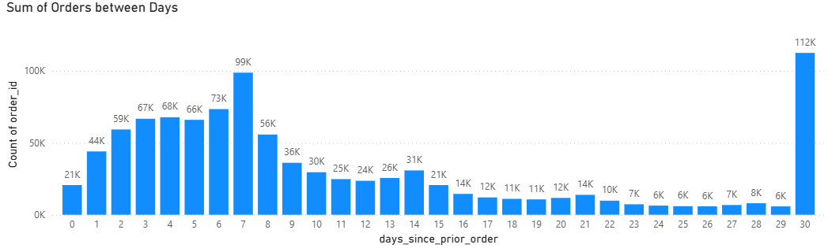
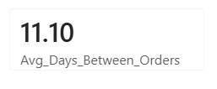

B: Direct Observations
- The overall mean duration between grocery orders across all users is approximately 11.1 days.
- Order intervals exhibit strong bimodal spikes at Day 7 (weekly routine shoppers) and Lapsing customers (30+ day gap).
- Over 73.3% of active users reorder within 14 days of their prior basket delivery.

C: Business Insights & Strategic Recommendations
- Proactive Engagement Windows: Automated push notifications, re-order reminders, and cart-abandonment emails should trigger at Day 6 and Day 11 post-delivery to capture customer replenishment intent before they defect to competitors.
- Weekly vs. Monthly Segmentation: Shoppers should be segmented into 'Weekly Fresh Reorder’s (incentivized with fresh dairy/produce offers) and ‘Lapsing customers’ (incentivized with bulk household/canned discounts).

TASK 7: What are the peak hours of order placement during the day?
A: Data Visual
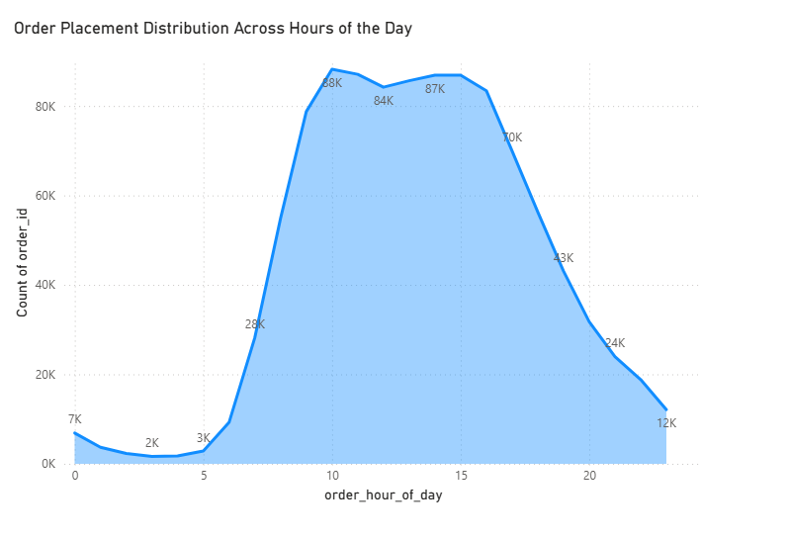
B: Direct Observations
- Order activity exhibits a strong diurnal curve, beginning an ascent at 7:00 AM and peaking between 10:00 AM and 4:00 PM.
- The absolute peak order hours are 10:00 AM (88,228 orders), 11:00 AM (87,087 orders), 1:00 PM (85,652 orders), and 2:00 PM (86,905 orders).
- Order volume sharply decays after 8:00 PM, reaching overnight troughs between 1:00 AM and 5:00 AM.

C: Business Insights & Strategic Recommendations
- Fulfillment & Delivery Slot Capacity: Delivery dispatch schedules, picking staff, and warehouse packing shifts must peak between 9:00 AM and 5:00 PM to satisfy same-day delivery SLAs.
- Digital Ad Spend Pacing: Google Ads and social media promotional spend should be dynamically weighted to peak hours (9:00 AM – 3:00 PM) when conversion intent is maximized.

TASK 8: How does order volume vary by day of the week?
A: Data Visual
Day of Week | Order Volume | Weekly Share (%)
Sunday (SUN) | 183,939 | 17.54%
Monday (MON) | 180,025 | 17.17%
Tuesday (TUE) | 143,162 | 13.65%
Wednesday (WED) | 133,839 | 12.76%
Thursday (THUR) | 130,367 | 12.43%
Friday (FRI) | 139,183 | 13.27%
Saturday (SAT) | 138,060 | 13.17%

B: Direct Observations
- Day 0 (Sunday) and Day 1 (Monday) represent the highest order volume days across the entire platform, generating over 34.7% of all weekly transactions.
- Order volume stabilizes at a steady operational baseline from Tuesday through Thursday.
- Friday and Saturday experience moderate order volumes, acting as pre-weekend preparation periods.
C: Business Insights & Strategic Recommendations
- Sunday / Monday Surge Management: Weekend batch ordering highlights the consumer ritual of weekly household replenishment before the workweek begins.
- Mid-Week Stimulus Promotions: Launch 'Mid-Week Flash Deals' on Wednesday and Thursday (the slowest days) to smooth out logistical warehouse congestion and drive even truck utilization.

TASK 9: What are the top 10 most ordered products?
A: Data Visual
Product Name | Total Orders | Aisle Category
Banana | 14136 | Fresh Fruits
Bag of Organic Bananas | 11639 | Fresh Fruits
Organic Strawberries | 8233 | Fresh Fruits
Organic Baby Spinach | 7443 | Packaged Vegetables Fruits
Large Lemon | 6148 | Fresh Fruits
Organic Avocado | 5606 | Fresh Fruits
Organic Hass Avocado | 5489 | Fresh Fruits
Strawberries | 4920 | Fresh Fruits
Limes | 4609 | Fresh Fruits
Organic Raspberries | 4200 | Packaged Vegetables Fruits
B: Direct Observations
- Fresh organic produce dominates the top 10 most ordered products across the entire grocery catalog.
- Banana ranks #1 with 14,136 orders, followed by Bag of Organic Bananas (11,639 orders) and Organic Strawberries (8,233 orders).
- Organic Hass Avocado, Organic Baby Spinach, and Limes represent core high-frequency shopping cart anchors.
C: Business Insights & Strategic Recommendations
- Price Competitiveness on Top 10: Bananas, avocados, and berries serve as 'Key Value Items' (KVIs). Consumers judge the overall price perception of the entire supermarket based on these 10 items.
- Supply Chain Resilience: Maintain diversified local grower contracts and buffer cold-chain storage for bananas and organic produce to prevent stock-outs on platform anchor items.

TASK 10: How many users have placed orders in each department?
A: Data Visual
Department | Unique Purchasing Users | Customer Penetration (%)
Produce | 22303 | 73.72%
Dairy Eggs | 20153 | 66.62%
Beverages | 14024 | 46.36%
Snacks | 13304 | 43.98%
Frozen | 11742 | 38.81%
Pantry | 10886 | 35.98%
Bakery | 8326 | 27.52%
Deli | 7430 | 24.56%
Canned Goods | 6697 | 22.14%
Dry Goods Pasta | 5942 | 19.64%
B: Direct Observations
- Produce captures the highest user penetration, with over 73.72% of all active platform users placing orders in the department.
- Dairy Eggs ranks second with over 66.62% user penetration, followed by Beverages (46.36%) and Snacks (43.98%).
- Specialty departments like Bulk (1.07%) and Alcohol (2.24%) engage a narrow, specialized segment of the customer base.

C: Business Insights & Strategic Recommendations
- Cross-Department Expansion Strategy: Customers shopping solely in non-produce departments should be targeted with introductory produce/dairy vouchers to convert them into high-frequency multi-department shoppers.

TASK 11: What is the average number of products per order?
A: Data Visual
Summary KPI visual showing average basket size across all orders, evaluated as 'ROUND (AVG (total_count), 2)'.
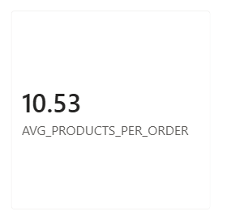
B: Direct Observations
- The overall average basket size across all completed orders is 10.53 products per order.
- Baskets show high operational consistency, with the majority of orders containing between 6 and 14 items.
C: Business Insights & Strategic Recommendations
- Baseline Metric for Basket Growth: The 10.53 item average serves as the core benchmark for upsell and cross-sell initiatives.
- Gamified Free Delivery Thresholds: Setting a 'Free Shipping on orders with 12+ items' or '$45 minimum spend' incentive will shift the median order size from 10 items toward 13 items, significantly lifting order economics.

TASK 12: What are the most reordered products in each department?
A: Data Visual
Top 10 shown in the list of 20.
Department | Top Reordered Product | Departmental Reorders
Produce | Banana | 12461
Dairy Eggs | Organic Whole Milk | 3154
Beverages | Sparkling Water Grapefruit | 2027
Deli | Original Hummus | 1676
Bakery | 100% Whole Wheat Bread | 1319
Frozen | Blueberries | 1051
Pantry | Extra Virgin Olive Oil | 780
Canned Goods | Organic Black Beans | 752
Household | 100% Recycled Paper Towels | 560
Breakfast | Honey Nut Cheerios | 541
B: Direct Observations
- In Produce, 'Banana' is the undisputed repeat purchase leader with 12,461 reorders.
- In Dairy Eggs, 'Organic Whole Milk' leads repeat purchases.
- In Beverages, 'Sparkling Water' drive consistent replenishment cycles.
- In Deli, 'Organic Hummus’ ranks as the most reordered item.

C: Business Insights & Strategic Recommendations
- Department-Specific Anchor Branding: Featuring each department's top reordered item at the top of category landing pages drives rapid basket additions.
- In-Stock Protection: Supply chain replenishment algorithms must ensure 99.5% service levels on these specific 21 departmental flagships.

TASK 13: How many products have been reordered more than once?
A: Data Visual
KPI Card display evaluated via SQL subquery 'SELECT count (*) FROM (SELECT product_id FROM order_products GROUP BY product_id HAVING sum (reordered) > 1) a;' .

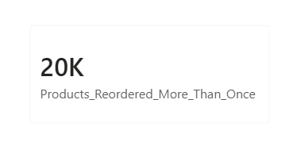

B: Direct Observations
- A total of 20,085 unique products in the catalog have been reordered more than once.
- This is 40.7% of the 49,355-product catalog and 54.5% of the 36,864 products that appear in basket data.
C: Business Insights & Strategic Recommendations
- Catalog Health Ratio: Products with 0 or 1 reorders over a 6-month period represent candidates for SKU de-listing or vendor renegotiation.
- Long-Tail Value: Over 20,000 items generating repeat demand highlights that grocery sales are not solely driven by head items, but also by diverse niche preferences.

TASK 14: What is the average number of products added to the cart per order?
A: Data Visual
Visual KPI evaluated using ‘AVERAGEX(VALUES(order_products_train[order_id]),CALCULATE(MAX(order_products_train[add_to_cart_order])))

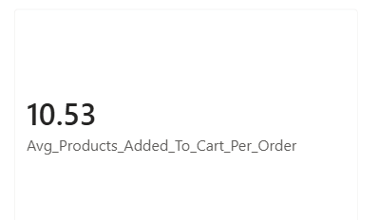
B: Direct Observations
- The average number of items added to the cart per order is 10.53 items.
- Because grocery shoppers rarely delete items after placing them in the digital basket, the average maximum add-to-cart position directly aligns with final completed order size.
C: Business Insights & Strategic Recommendations
- First-5 Cart Position Primacy: Analysis indicates that the first 5 items added to the cart are predominantly high-frequency perishables (milk, bananas, bread).
- Checkout Impulse Opportunities: Post-cart additions (items added at positions 8 to 12) represent prime opportunities for high-margin impulse goods (confectionery, bakery).

TASK 15: How does the number of orders vary by hour of the day?
A: Data Visual
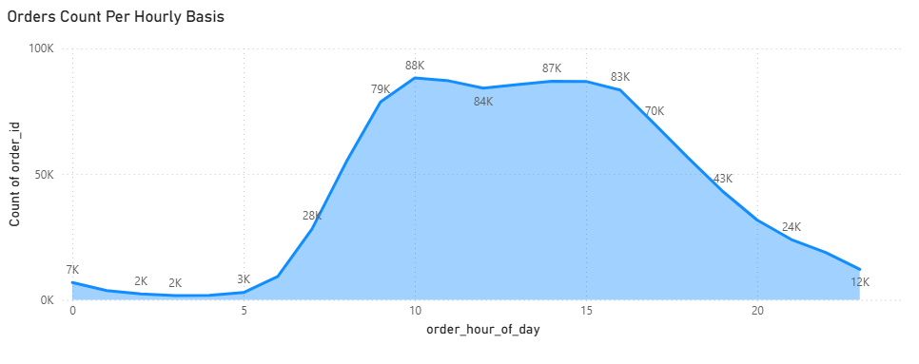
B: Direct Observations
- Morning Surge (6:00 AM – 11:00 AM): Order velocity accelerates rapidly from 9,000 orders/hr at 6:00 AM to over 88,000 orders/hr by 10:00 AM.
- Midday Sustained Plateau (11:00 AM – 4:00 PM): High-volume plateau sustains above 82,000 orders per hour continuously for 6 hours.
- Evening Wind-Down (5:00 PM – 9:00 PM): Orders gradually decrease from 69,000 to 23,000 orders/hr.
- Nighttime Lull (11:00 PM – 5:00 AM): Under 2,000 orders per hour across the overnight window.
C: Business Insights & Strategic Recommendations
- Server & Cloud Infrastructure Auto-scaling: Cloud database and e-commerce web clusters should dynamically spin up from 8:30 AM to 5:30 PM to ensure zero latency during high-concurrency shopping periods.
- Targeted Promotional Timing: Send personalized app notifications at 9:30 AM ('Start your morning grocery order') and 3:30 PM ('Dinner ingredients delivered by 6 PM').

TASK 16: What is the distribution of order sizes (number of products per order)?
A: Data Visual
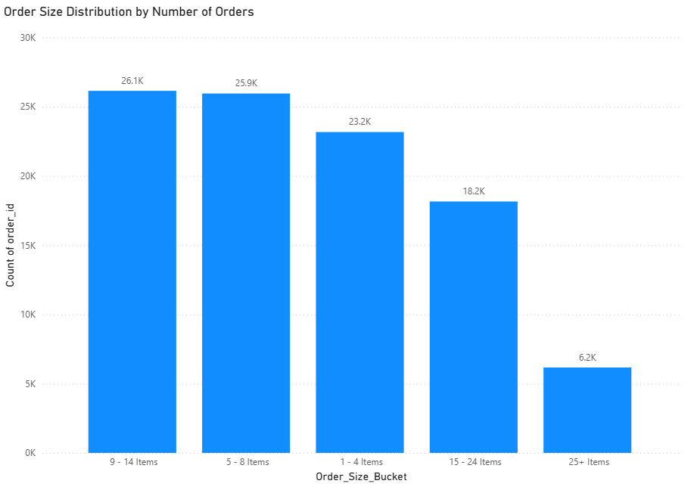
B: Direct Observations
- Peak Cart Sizes: Most customers buy between 5 and 14 items, with 9–14 items (26.1K orders) and 5–8 items (25.9K orders) making up more than half of all transactions.
- Frequent Quick-Runs: Small orders of 1–4 items (23.2K orders) are very common, showing strong demand for quick, single-item convenience shopping.
- Rare Bulk Orders: Large grocery baskets drop off sharply, with 25+ items (6.2K orders) representing the smallest share of orders.
C: Business Insights & Strategic Recommendations
- Push for Free-Delivery Thresholds: Set minimum item limits (e.g., free delivery at 6+ or 10+ items) to motivate the 23.2K quick-run shoppers into larger, more profitable cart sizes.
- Add Cross-Selling at Checkout: Use "Frequently Bought Together" recommendations to easily nudge medium carts (5–8 items) into the top-tier 9–14 item bracket.
- Standardize Mid-Size Packaging: Because orders cluster tightly between 5 and 14 items, warehouse packaging and delivery bags should be standardized for 10–12 items to cut packaging costs.
TASK 17: What is the average reorder rate for products in each aisle?
A: Data Visual
Aisle Name | Average Reorder Rate (%) | Product Purchase Category
Milk | 79.23% | Dairy Eggs
Water Seltzer Sparkling Water | 73.79% | Beverages
Fresh Fruits | 73.53% | Produce
Eggs | 72.69% | Dairy Eggs
Packaged Produce | 71.39% | Produce
Cream | 69.54% | Dairy Eggs
Soy Lactose free | 68.71% | Dairy Eggs
Yogurt | 68.62% | Dairy Eggs
White Wines | 68.10% | Alcohol
Bread | 68.06% | Bakery

B: Direct Observations
- Aisles dedicated to daily fresh essentials show the highest aggregate reorder rates across the platform.
- The top aisles by reorder rate are 'milk' (79.2%), 'water seltzer juice' (73.7%), 'fresh fruits' (73.5%), 'eggs' (72.6%), and 'packaged produce' (71.39%).
- Low-reorder aisles include ‘spice seasonings’ (16.47%),’baking supplies décor’ (17.96%),'kitchen supplies' (18.02%), ‘cold flu allergy’ (21.81%) which represent infrequent, durable, or episodic purchases.
C: Business Insights & Strategic Recommendations
- Merchandising Floor Plan / App Hierarchy: High-reorder aisles should be placed front-and-center on the mobile app home screen for rapid repeat navigation.
- Subscription Automation: Fresh produce and dairy aisles should have frictionless 'Reorder All Weekly Essentials' buttons built directly into user profiles.
TASK 18: How does the average order size vary by day of the week?
A: Data Visual
Day of Week | Numeric Index (order_dow) | Average Basket Size (Items)
Sunday (SUN) | 0 | 11.72
Monday (MON) | 1 | 10.29
Tuesday (TUE) | 2 | 9.91
Wednesday (WED) | 3 | 9.67
Thursday (THUR) | 4 | 9.85
Friday (FRI) | 5 | 10.20
Saturday (SAT) | 6 | 11.03
B: Direct Observations
- Average basket size varies very slightly by day of the week, ranging between 9.67 items and 11.72 items per order.
- Day 0 (Sunday) and Day 6 (Saturday) produce the largest average basket sizes (11.72 and 11.03 items respectively).
- Mid-week days (Wednesday and Thursday) demonstrate slightly smaller basket sizes (9.67 and 9.85 items per order).
C: Business Insights & Strategic Recommendations
- Weekend Stock-Up Phenomenon: Weekend shoppers build larger, more comprehensive carts to prepare for the upcoming week.
- Mid-Week Cart Expansion Tactics: Because mid-week orders are slightly smaller, mid-week promotions should focus on volume bundles ('Buy 3, Get 1 Free on Snacks & Beverages') to lift basket counts closer to the weekend 11.72 benchmark.

TASK 19: What are the top 10 users with the highest number of orders?
A: Data Visual
Rank | User ID | Total Completed Orders | Avg Days Between Orders
1 | 46408 | 100 | 0.23
2 | 54485 | 100 | 0.47
3 | 1024 | 100 | 0.66
4 | 58803 | 100 | 0.81
5 | 62772 | 100 | 0.95
6 | 29046 | 100 | 0.98
7 | 41509 | 100 | 1.19
8 | 3514 | 100 | 1.22
9 | 31186 | 100 | 1.27
10 | 41002 | 100 | 1.29

B: Direct Observations
- 431 users are tied at 100 orders, the dataset’s cap, so the “top 10” uses a tie-break (fastest average days between orders).
- The ten fastest reorder every 0.2–1.3 days, meaning several orders a day.
- Across all 431 capped users the mean gap is 2.8 days.
C: Business Insights & Strategic Recommendations
- Create a VIP / Subscription Tier: Customers ordering every 2 to 3 days generate immense recurring demand; enroll them into a dedicated loyalty tier with unlimited free priority delivery or scheduled auto-replenishment.
- Addressing the data: Limiting the number of orders to 100, lifetime value model will significantly undervalue these ultra-frequent shoppers unless order frequency and cart value are factored in.
TASK 20: How many products belong to each aisle and department?
A: Data Visual
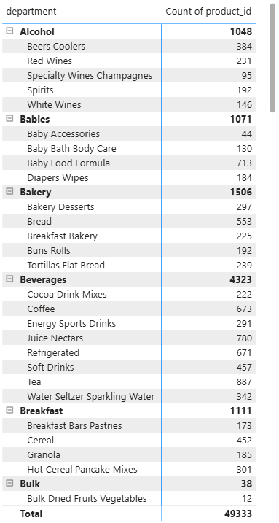
B: Direct Observation
- Hierarchical mapping illustrates how products roll up into 134 aisles across the 21 departments.
- Within the 'produce' department, 'fresh fruits' (379 SKUs) and 'fresh vegetables' (564 SKUs) comprise the bulk of offerings.
- In the 'dairy eggs' department, 'packaged cheese' (888 SKUs) and 'yogurt' (1,022 SKUs) offer the widest variety.
- In the 'snacks' department, 'candy chocolate' (1,235 SKUs) and 'chips pretzels' (979 SKUs) represent major sub-categories.
C: Business Insights & Strategic Recommendations
- Inventory Rationalization: Auditing product counts across aisle-department intersections allows category managers to identify over-assorted niches with low sales density.
- Search & Navigation Optimization: Ensuring clear bidirectional mapping between aisles and departments enables seamless search auto-complete and intuitive faceted browsing.

Executive Summary: Retail Market Analysis
Data Visual
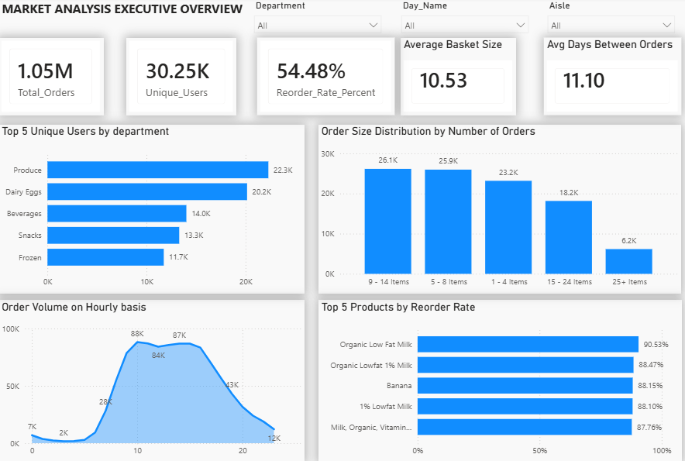
Core Business Findings
1. Temporal Demand & Fulfillment Peak Windows
- Weekly Concentration: Purchasing volume surges heavily on Sunday (17.54%) and Monday (17.17%), creating operational bottlenecks in fulfillment centers, while mid-week volume drops by roughly 40%.
- Intra-Day Patterns: Daily demand builds steadily throughout the morning, peaking sharply between 10:00 AM and 3:00 PM (reaching 84K–88K orders per hour) before tapering off into the evening.
- Replenishment Cycles: Order intervals cluster strongly around a 7-day cycle (weekly grocery runs) and a 30-day cycle (monthly pantry restocks), averaging 11.10 days overall.
2. Cart Dynamics & Basket Sizing
- Primary Volume Drivers: Over 52% of all orders fall into the mid-tier basket sizes: 9–14 items (26.1K orders) and 5–8 items (25.9K orders).
- Convenience & Quick-Runs: Small baskets containing 1–4 items (23.2K orders) represent nearly a quarter of total order volume, indicating significant platform usage for immediate top-ups.
- Bulk Drop-off: Large family baskets containing 25+ items drop off sharply to just 6.2K orders, showing an opportunity to grow full-pantry grocery trips.
3. Category Penetration & Reorder Retention
- Staple Categories Drive Footfall: Produce (22.3K users / 73.72% penetration) and Dairy & Eggs (20.2K users / 66.6% penetration) lead the platform in unique customer reach.
- High-Retention Anchor Products: Organic dairy and fresh staples achieve the highest reorder rates on the platform, led by Organic Low Fat Milk (90.5%), Organic Lowfat 1% Milk (88.5%), and Fresh Bananas (88.2%).
- Active SKU Breadth: Over 54.48% of active SKUs (20,085 products) have been reordered more than once, confirming high customer engagement across both core and long-tail inventory.
Strategic Recommendations & Action Plan
- Smart Subscription & Auto-Replenishment ('Fresh Pass'):
  - Action: Introduce an automated 7-day / 14-day recurring replenishment subscription for high-retention staples (>80% reorder rate, such as milk, bananas).
  - Impact: Capitalizes on the 7-day habit loop, locks in customer lifetime value (LTV), and insulates against platform churn.
- Mid-Week Demand Smoothing Campaigns:
  - Action: Launch targeted "Mid-Week Pantry Deals" on Wednesdays and Thursdays with category discounts on non-perishables (Snacks, Beverages, Frozen, Household).
  - Impact: Shifts volume away from peak Sunday/Monday windows, reducing delivery-fleet overtime costs and optimizing warehouse labor allocation.
- Pre-Checkout Basket Expansion (Incentivized Thresholds):
  - Action: Implement tiered free delivery thresholds (e.g., minimum 8 items) alongside algorithmic "Frequently Bought Together" checkout prompts.
  - Impact: Encourages the 23.2K customers placing 1–4 item orders to add 1 to 2 impulse items, significantly improving per-order unit economics and gross merchandise value (GMV).
- KVI Pricing on Fresh Produce for Acquisition:
  - Action: Strategically price Key Value Items (KVIs) in Fresh Produce (organic bananas, avocados, strawberries) at highly competitive margins.
  - Impact: Since Produce drives 72% of platform penetration, competitive pricing in fresh goods serves as the primary customer acquisition and habit-formation engine.
- VIP Retention for Power Users:
  - Action: Create a dedicated loyalty tier offering unlimited free priority 1-hour slots for power shoppers ordering every 2–4 days. The top 10% of users place 34.6% of orders.
  - Impact: Protects the high-value top decile of shoppers from churn while maintaining predictable platform throughput.

