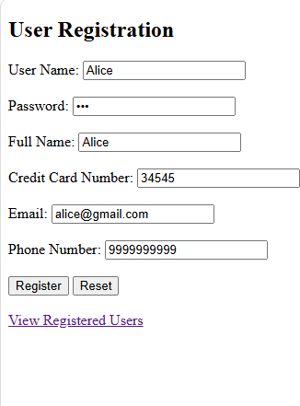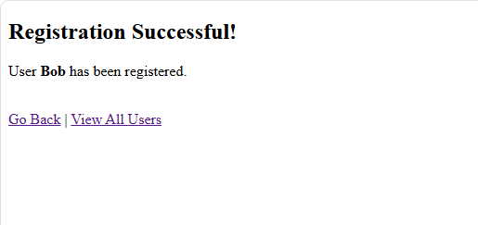

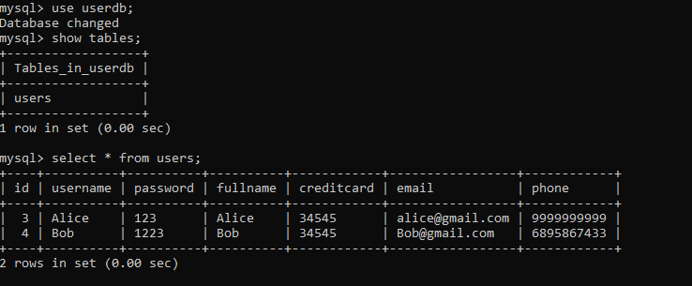
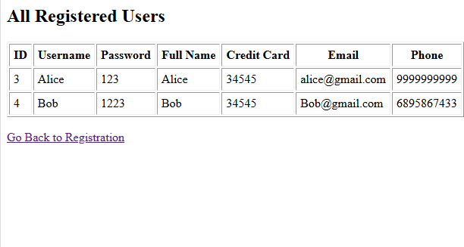

index.html
<!DOCTYPE html>
<html lang="en">
<head>
<meta charset="UTF-8">
<title>User Registration Form</title>
</head>
<body>
<h2>User Registration</h2>
<form action="register.jsp" method="post">
<label for="username">User Name:</label>
<input type="text" id="username" name="username" required><br><br>

<label for="password">Password:</label>
<input type="password" id="password" name="password" required><br><br>

<label for="fullname">Full Name:</label>
<input type="text" id="fullname" name="fullname" required><br><br>

<label for="creditcard">Credit Card Number:</label>
<input type="text" id="creditcard" name="creditcard" required><br><br>

<label for="email">Email:</label>
<input type="email" id="email" name="email" required><br><br>

<label for="phone">Phone Number:</label>
<input type="text" id="phone" name="phone" required><br><br>
<input type="submit" value="Register">
<input type="reset" value="Reset">
</form>
<br>
<a href="displayUsers.jsp">View Registered Users</a>
</body>
</html>

register.jsp
<%@ page import="java.sql.*" %>
<%@ page contentType="text/html; charset=UTF-8" language="java" %>
<!DOCTYPE html>
<html>
<head>
<meta charset="UTF-8">
<title>Registration Result</title>
</head>
<body>
<%
String username = request.getParameter("username"); String password = request.getParameter("password"); String fullname = request.getParameter("fullname"); String creditcard = request.getParameter("creditcard"); String email = request.getParameter("email");
String phone = request.getParameter("phone");
Connection conn = null; PreparedStatement pstmt = null;

try {
// 1. Load JDBC driver Class.forName("com.mysql.cj.jdbc.Driver");

// 2. Establish connection (with SSL disabled to prevent GlassFish keystore issues) conn =
DriverManager.getConnection("jdbc:mysql://localhost:3306/userdb?useSSL=false&allowPublicKeyRetrie val=true", "root", "mysql");
// 3. Prepare SQL INSERT query for all fields
String sql = "INSERT INTO users(username, password, fullname, creditcard, email, phone) VALUES(?,
?, ?, ?, ?, ?)";
pstmt = conn.prepareStatement(sql); pstmt.setString(1, username); pstmt.setString(2, password); pstmt.setString(3, fullname); pstmt.setString(4, creditcard); pstmt.setString(5, email); pstmt.setString(6, phone);

int rows = pstmt.executeUpdate(); if (rows > 0) {
%>
<h2>Registration Successful!</h2>
<p>User <strong><%= username %></strong> has been registered.</p>
<%
} else {

%>
<h2>Registration Failed!</h2>
<%
}
} catch (Exception e) {
out.println("<p style='color:red'>Error: " + e.getMessage() + "</p>");
} finally {
try { if (pstmt != null) pstmt.close(); } catch (Exception e) {} try { if (conn != null) conn.close(); } catch (Exception e) {}
}
%>
<br>
<a href="registration.html">Go Back</a> | <a href="displayUsers.jsp">View All Users</a>
</body>
</html>

displayUsers.jsp

<%@ page import="java.sql.*" %>
<%@ page contentType="text/html; charset=UTF-8" language="java" %>
<!DOCTYPE html>
<html>
<head>
<meta charset="UTF-8">
<title>Registered Users</title>
</head>
<body>
<h2>All Registered Users</h2>
<table border="1" cellpadding="5">
<tr>
<th>ID</th>
<th>Username</th>
<th>Password</th>
<th>Full Name</th>
<th>Credit Card</th>
<th>Email</th>
<th>Phone</th>
</tr>
<%
Connection conn = null; Statement stmt = null; ResultSet rs = null;

try {
Class.forName("com.mysql.cj.jdbc.Driver"); conn =
DriverManager.getConnection("jdbc:mysql://localhost:3306/userdb?useSSL=false&allowPublicKeyRetrie val=true", "root", "mysql");
stmt = conn.createStatement();
rs = stmt.executeQuery("SELECT * FROM users");

while (rs.next()) {
%>
<tr>
<td><%= rs.getInt("id") %></td>
<td><%= rs.getString("username") %></td>
<td><%= rs.getString("password") %></td>
<td><%= rs.getString("fullname") %></td>
<td><%= rs.getString("creditcard") %></td>
<td><%= rs.getString("email") %></td>
<td><%= rs.getString("phone") %></td>
</tr>
<%
}
} catch (Exception e) {
out.println("<tr><td colspan='7' style='color:red'>" + e.getMessage() + "</td></tr>");
} finally {
try { if (rs != null) rs.close(); } catch (Exception e) {}
try { if (stmt != null) stmt.close(); } catch (Exception e) {} try { if (conn != null) conn.close(); } catch (Exception e) {}
}
%>
</table>
<br>
<a href="registration.html">Go Back to Registration</a>
</body>
</html>

