Social Media Analytics-YouTube API

# Introduction:

The YouTube APIs and Tools let you bring the YouTube experience to your webpage, application or device. There are many APIs available in YouTube supported by GOOGLE.

# YouTube Data API: The Data API allows a program to perform many of the operations available on the YouTube website. It is possible to search for videos, retrieve standard feeds, and see related content. A program can also authenticate as a user to upload videos, modify user playlists, and more.

# YouTube Analytics API:

The Analytics API lets your application retrieve viewing statistics, popularity metrics, and demographic information for YouTube videos and channels.

# YouTube Live Streaming API:

The YouTube Live Streaming API lets you create, update, and manage live events on YouTube. Using the API, you can schedule events (broadcasts) and associate them with video streams, which represent the actual broadcast content.

# YouTube Player API:

YouTube players can be embedded in a web page or app.

# Installations:

## Tools Required:

* + Python 2.7 or higher
  + Google developer console

### List of packages to be installed

* + Setuptools
  + gdata apiclient
  + mimeparse
  + oauthclient
  + urllib
  + httplib2
  + pafy
  + csv
  + uritemplate
  + Element tree(for python 2.6 or earlier)
  + BeautifulSoup

# 🡺Getting started

* You need a GOOGLE ACCOUNT to access Google developers console.
* Request for an API key and register your application.

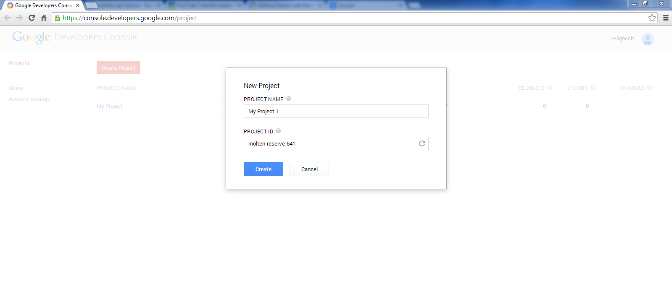

* After registering, select YouTube API data as one of the service.
  + Go to DEVELOPER CONSOLE (console.developers.google.com ) and select the project that you have registered.
  + In the sidebar on the left, select **APIs & auth**. In the list of APIs, make sure the status is **ON** for the **YouTube Data API v3**.

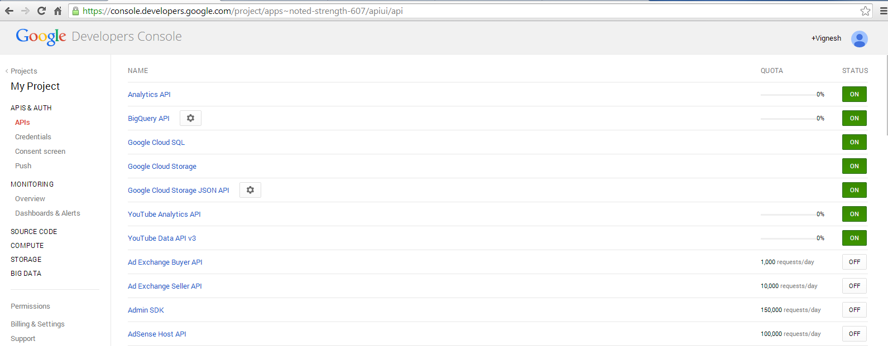

* Create an OAuth 2.0 Credentials
  + Your application must send an OAuth 2.0 token with any request that accesses private user data. Your application sends a client ID and, possibly, a client secret to obtain a token. You can generate OAuth 2.0 credentials for web applications, service accounts, or installed applications.
* Getting started with Python
  + Download and Install Python from the following link
    - https://www.python.org/download/
  + Choose the python version depending on the platform you use.
  + To interact with Python YouTube API libraries , we need Python

2.2+ and the Element Tree.

* Installing library Packages
  + On windows platform, enter WIN+R and Type CMD.
  + In the command prompt, set the path to Python directory.
  + Consider the python directory as C:\Python27\
  + Type set path=%path%;C:\Python27\
  + Now change the directory to Python27 (cd to change directory)

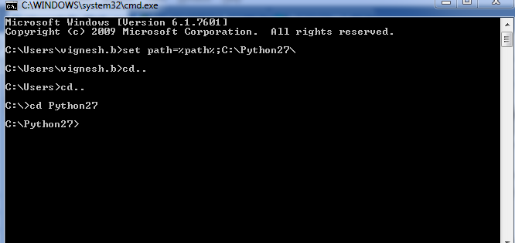

* + To install a library (say pafy), download pafy and extract it in Python27 directory. ­­

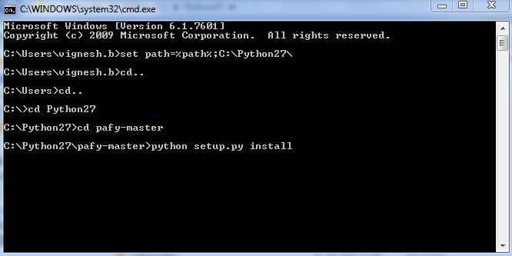

* Now move to downloaded folder and type python setup.py install and press enter.
* Now the package pafy will be installed.
* To install any package, SETUPTOOLS Package must be first installed.

# Libraries with description:

* GDATA: The Google data Python client library (GDATA) makes it easy to interact with Google services through the Google Data APIs. This library provides data models and service modules for many Google data services.
* MIME PARSE:A module provides basic functions for parsing mime-type names and matching them against a list of media-ranges.
* OAuth 2.0:A generic, spec-compliant, thorough implementation of the OAuth request-signing logic.
* URLLIB:HTTP library with thread-safe connection pooling, file post, and more.
* HTTPLIB 2:A comprehensive HTTP client library.
* PAFY:To retrieve YouTube content and metadata.
* CSV: To handle .CSV files.
* BeautifulSoap: It is a Python library for pulling data out of HTML and XML files. It works with your favourite parser to provide idiomatic ways of navigating, searching, and modifying the parse tree.

# Scripts in Python:

* Open Python 2.7 IDLE .
* In order to create a new script file, click on File->NewFile or ( CTRL+N)
* To save the script file, File->SaveAs or CTRL+S and save the file as (AnyName.py) .

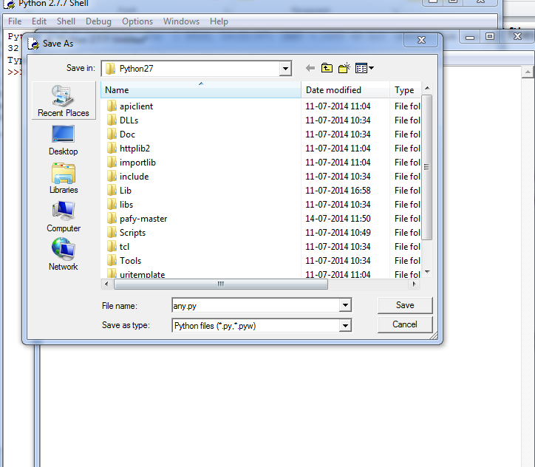

* To run the script, Press F5 or Run->RunModule . The output of the script will be displayed on the SHELL.
* To run the YouTube analytics scripts, internet connection should be enabled and must be signed in to the google account.

# Errors Faced:

* Package not found (To check if the package is installed or not type **import** followed the package name in shell).
* Socket Connection Error (occurs If the internet connection not enabled).
* Io exceptional error (occurs If we are trying to access the already opened file ).
* Indentation errors (python handles scoping through indents.so proper indent should be provided).