SELENIUM WEBDRIVER
REGISTRATION FORM AUTOMATION
Automation Testing Practical Report
Name | Vignesh M
Register Number | 212223240176
Date | 06 October 2026

1. Objective
To automate a registration form using Selenium WebDriver with Python by entering personal details, selecting gender and course options, filling address information, selecting a country, and entering email and demo-date details.
2. Tools & Technologies
- Python 3.x
- Selenium WebDriver
- Google Chrome
- ChromeDriver
- XPath locators
- Selenium Select class for dropdown handling
3. Test Website
Demo site: https://vinothqaacademy.com/demo-site/
4. Automated Test Data
Field | Test Value
First Name | Vignesh
Last Name | M
Full Name | Vignesh M
Register Number | 212223240176
Gender | Male
Courses | Selenium WebDriver, Java, TestNG
Street Address | 123 Main Street
Apt / Suite / Bldg. | Apt 204
City | Chennai
State / Province / Region | Tamil Nadu
Postal / Zip Code | 600001
Country | India
Email | vignesh@example.com
Date of Demo | 10/06/26
5. Selenium Automation Code
import time
from selenium import webdriver
from selenium.webdriver.common.by import By
from selenium.webdriver.support.ui import Select
driver = webdriver.Chrome()
driver.maximize_window()
driver.get("https://vinothqaacademy.com/demo-site/")
time.sleep(3)
first_name = driver.find_element(
By.XPATH,
"//label[contains(text(),'First Name')]/following::input[1]"
)
first_name.send_keys("Vignesh")
time.sleep(3)
last_name = driver.find_element(
By.XPATH,
"//label[contains(text(),'Last Name')]/following::input[1]"
)
last_name.send_keys("M")
time.sleep(3)
male = driver.find_element(
By.XPATH,
"//label[contains(.,'Male')]//input | //input[@value='Male']"
)
if not male.is_selected():
male.click()
time.sleep(3)
selenium_webdriver = driver.find_element(
By.XPATH,
"//label[contains(.,'Selenium WebDriver')]//input | //input[@value='Selenium WebDriver']"
)
if not selenium_webdriver.is_selected():
selenium_webdriver.click()
time.sleep(3)
java = driver.find_element(
By.XPATH,
"//label[contains(.,'Java')]//input | //input[@value='Java']"
)
if not java.is_selected():
java.click()
time.sleep(3)
testng = driver.find_element(
By.XPATH,
"//label[contains(.,'TestNG')]//input | //input[@value='TestNG']"
)
if not testng.is_selected():
testng.click()
time.sleep(3)
street_address = driver.find_element(
By.XPATH,
"//label[contains(text(),'Street Address')]/preceding::input[1]"
)
street_address.send_keys("123 Main Street")
time.sleep(3)
apt = driver.find_element(
By.XPATH,
"//label[contains(text(),'Apt, Suite, Bldg.')]/preceding::input[1]"
)
apt.send_keys("Apt 204")
time.sleep(3)
city = driver.find_element(
By.XPATH,
"//label[contains(text(),'City')]/preceding::input[1]"
)
city.send_keys("Chennai")
time.sleep(3)
state = driver.find_element(
By.XPATH,
"//label[contains(text(),'State / Province / Region')]/preceding::input[1]"
)
state.send_keys("Tamil Nadu")
time.sleep(3)
postal_code = driver.find_element(
By.XPATH,
"//label[contains(text(),'Postal / Zip Code')]/preceding::input[1]"
)
postal_code.send_keys("600001")
time.sleep(3)
country = Select(
driver.find_element(
By.XPATH,
"//label[contains(text(),'Country')]/preceding::select[1]"
)
)
country.select_by_visible_text("India")
time.sleep(3)
email = driver.find_element(
By.XPATH,
"//label[contains(text(),'Email')]/following::input[1]"
)
email.send_keys("vignesh@example.com")
time.sleep(3)
date_demo = driver.find_element(
By.XPATH,
"//label[contains(text(),'Date of Demo')]/following::input[1]"
)
date_demo.send_keys("10/06/26")
time.sleep(3)
print("First Name:", first_name.get_attribute("value"))
print("Last Name:", last_name.get_attribute("value"))
print("Street Address:", street_address.get_attribute("value"))
print("Apt:", apt.get_attribute("value"))
print("City:", city.get_attribute("value"))
print("State:", state.get_attribute("value"))
print("Postal Code:", postal_code.get_attribute("value"))
print("Country:", country.first_selected_option.text)
print("Email:", email.get_attribute("value"))
print("Date:", date_demo.get_attribute("value"))
print("Form fields completed successfully!")
input("Press ENTER to close browser...")
driver.quit()
6. Output / Execution Evidence
The following screenshots show the Selenium-controlled browser after the form fields were populated.
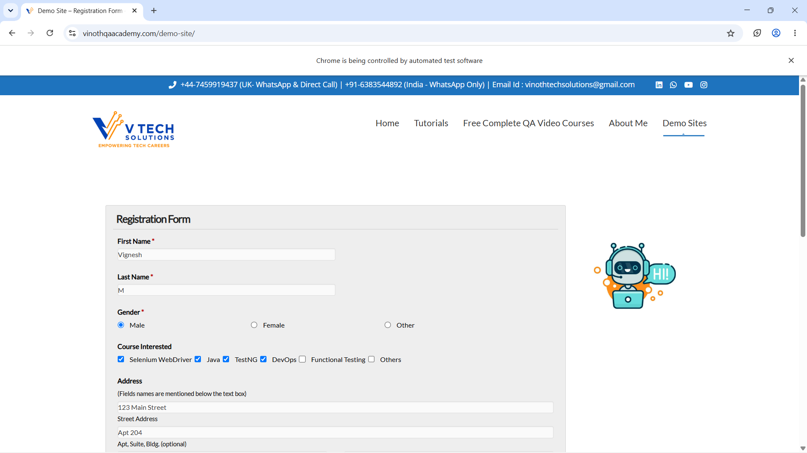
Output 1 – Registration form with personal details and course selections
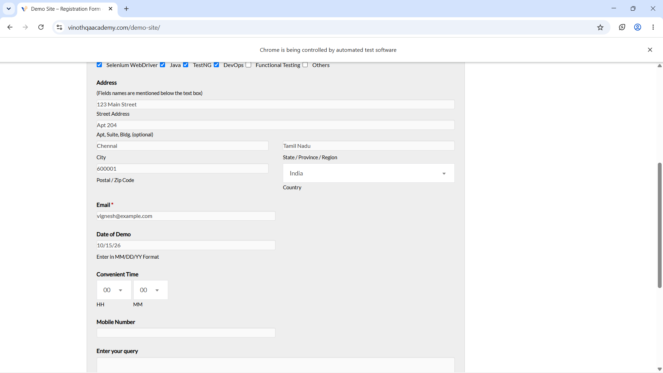
Output 2 – Address, country, email and demo-date fields populated
7. Expected Console Output
First Name: Vignesh
Last Name: M
Street Address: 123 Main Street
Apt: Apt 204
City: Chennai
State: Tamil Nadu
Postal Code: 600001
Country: India
Email: vignesh@example.com
Date: 10/06/26
Form fields completed successfully!
8. Result
PASS – The Selenium script successfully automates the selected registration-form fields and keeps the browser open until the user presses ENTER.

