SELENIUM WEBDRIVER

WEB TABLE
AUTOMATION
Python Practice • Test Cases • Execution Evidence
━━━━━━━━━━━━━━━━━━━━━━━━━━━━━━━━━━━━
NAME | Vignesh M
REGISTER NUMBER | 212223240176
DATE | 09 October 2026
PRACTICE URL | https://assertqa.com/practice/webtables
REPORT CONTENT
Complete Code → Topic-wise Outputs → Screenshots → Evidence Summary

1. Objective
To practise Selenium WebDriver with Python by extracting table headers and rows, searching an employee by last name, printing email addresses, finding the maximum salary, checking links, and counting the data rows visible on the current page.

2. Test Case Overview
TEST ID | TOPIC | PURPOSE
TC01 | Print Table Headers | Read all header cells (<th>).
TC02 | Print First Row | Print all cells from the first body row.
TC03 | Print Last Row | Print all cells from the last body row currently loaded.
TC04 | Search by Last Name | Find the row whose Last Name is Smith.
TC05 | Print All Emails | Print the email cell from each visible row.
TC06 | Maximum Salary | Convert salary text to an integer and find the maximum.
TC07 | Link Checking | Find anchor tags inside the table and print href values.
TC08 | Count Data Rows | Count rows containing <td> cells.

3. Complete Python Selenium Code
Run the following script in VS Code. The code is presented first, followed by topic-wise output and screenshot evidence.
from selenium import webdriver
from selenium.webdriver.common.by import By
import time

driver = webdriver.Chrome()
driver.maximize_window()
driver.get("https://assertqa.com/practice/webtables")

time.sleep(2)

employee_table = driver.find_element(
By.XPATH, '//*[@id="employees-table"]'
)
rows = employee_table.find_elements(By.XPATH, ".//tbody/tr")

# TC01 - Table Headers
print("\nTC01 - Table Headers")
headers = employee_table.find_elements(By.XPATH, ".//th")
for h in headers:
print(h.text, end=" ")
print()

# TC02 - First Row
print("\nTC02 - First Row")
first_row = employee_table.find_elements(
By.XPATH, ".//tbody/tr[1]/td"
)
for data in first_row:
print(data.text, end=" ")
print()

# TC03 - Last Row
print("\nTC03 - Last Row")
last_row = employee_table.find_elements(
By.XPATH, ".//tbody/tr[last()]/td"
)
for data in last_row:
print(data.text, end=" ")
print()

# TC04 - Search Employee by Last Name
print("\nTC04 - Employee Search Based on Last Name")
last_name_search = "smith"
found = False

for row in rows:
row_data = row.find_elements(By.TAG_NAME, "td")
if row_data and len(row_data) > 2:
if row_data[2].text.strip().lower() == last_name_search.lower():
for data in row_data:
print(data.text, end=" ")
print()
found = True

if not found:
print("Employee Data Not Found")

# TC05 - Print All Email Addresses
print("\nTC05 - Email of All Rows")
for row in rows:
row_data = row.find_elements(By.TAG_NAME, "td")
if row_data and len(row_data) > 3:
print(row_data[3].text)
print("Email Printing Success")

# TC06 - Find Maximum Salary
print("\nTC06 - Maximum Salary")
max_salary = 0
for row in rows:
row_data = row.find_elements(By.TAG_NAME, "td")
if row_data and len(row_data) > 5:
salary_text = row_data[5].text
salary = int(salary_text.replace("$", "").replace(",", ""))
max_salary = max(salary, max_salary)

print("Maximum Salary:", max_salary)
print("Maximum Salary Printing Success")

# TC07 - Check Links Inside the Table
print("\nTC07 - Link Checking")
links = employee_table.find_elements(By.TAG_NAME, "a")
if links:
print("Links Exist")
for link in links:
print(link.text, link.get_attribute("href"))
else:
print("FAIL - No links found in the table")
print("Link Checking Completed")

# TC08 - Count Data Rows
print("\nTC08 - Count Data Rows")
count_data_rows = 0
for row in rows:
data_exists = row.find_elements(By.TAG_NAME, "td")
if data_exists:
count_data_rows += 1

print("Data Row Count:", count_data_rows)
print("Count Data Rows Success")

time.sleep(3)
driver.quit()

4. Topic-wise Output and Evidence
The outputs below are transcribed from the supplied VS Code screenshot. They represent the first page currently displayed by the website.

TC01 — Table Headers
ID FIRST NAME LAST NAME EMAIL AGE SALARY DEPT STATUS

TC02 — First Row
1 John Smith john.smith@company.com 35 $75,000 Engineering Active

TC03 — Last Row
5 David Jones d.jones@company.com 45 $120,000 Executive Active

TC04 — Employee Search Based on Last Name
1 John Smith john.smith@company.com 35 $75,000 Engineering Active

TC05 — Email of All Rows
john.smith@company.com
sarah.j@company.com
m.williams@company.com
emily.brown@company.com
d.jones@company.com
Email Printing Success

TC06 — Maximum Salary
Maximum Salary: 120000
Maximum Salary Printing Success

TC07 — Link Checking
FAIL - No links found in the table
Link Checking Completed

TC08 — Count Data Rows
Data Row Count: 5
Count Data Rows Success

5. Screenshots
Screenshots supplied with the practice report are included below as supporting evidence.
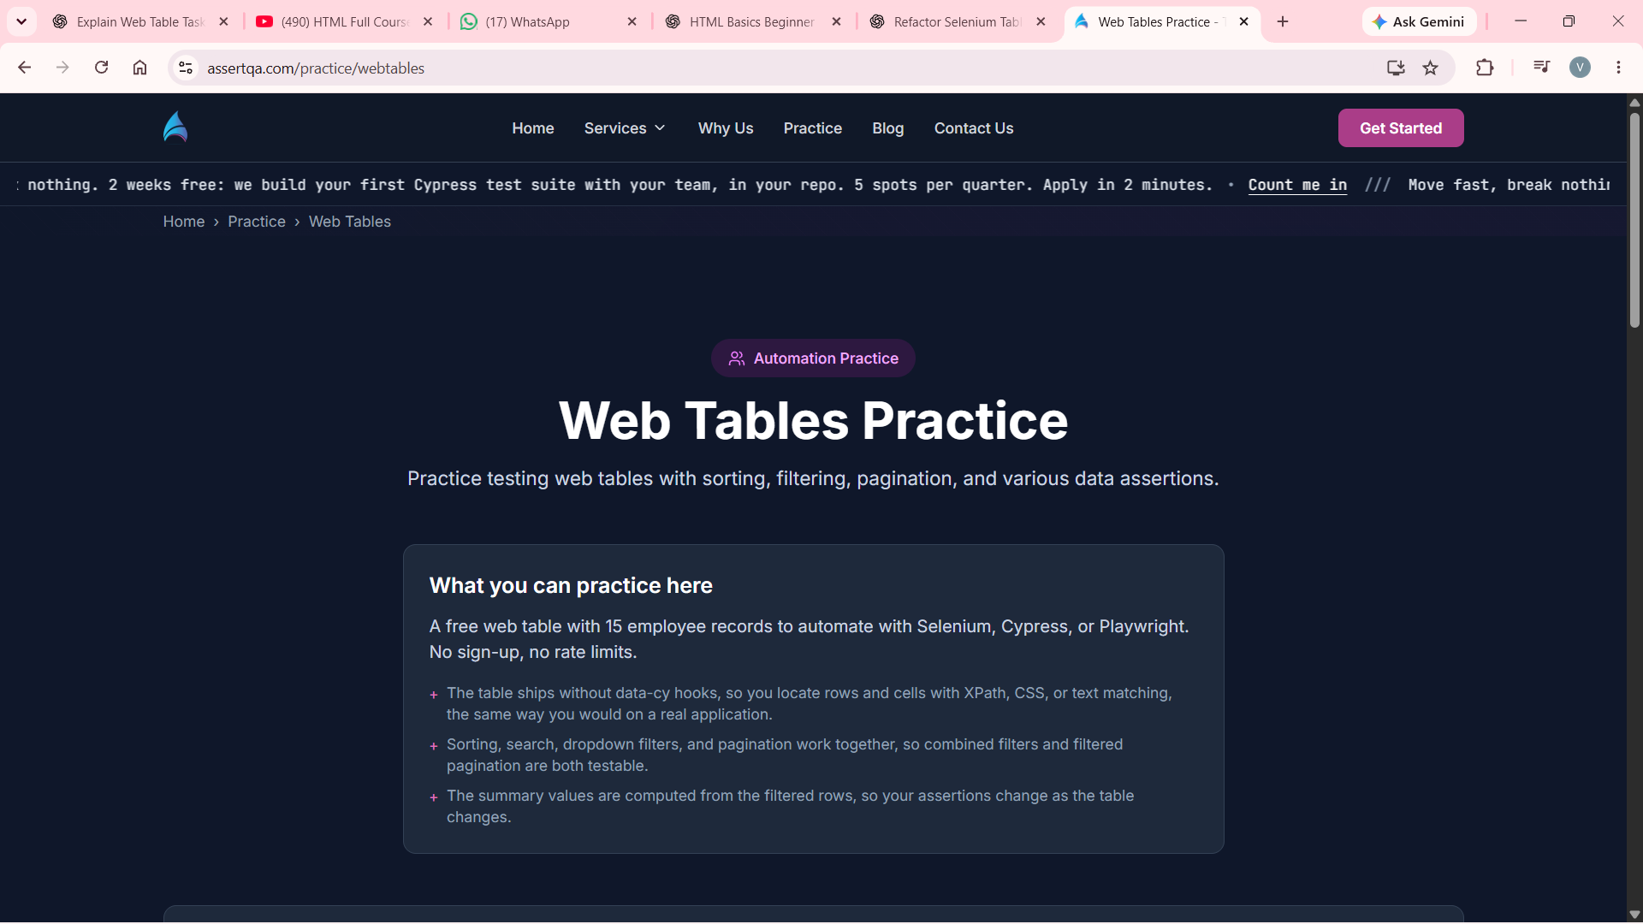
Screenshot 1 — Web Tables Practice page
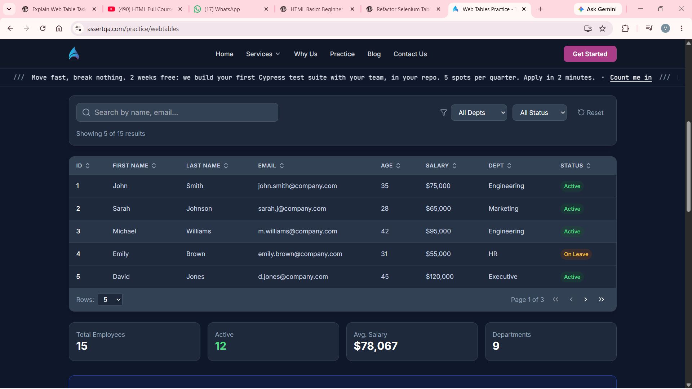
Screenshot 2 — Employee table and pagination
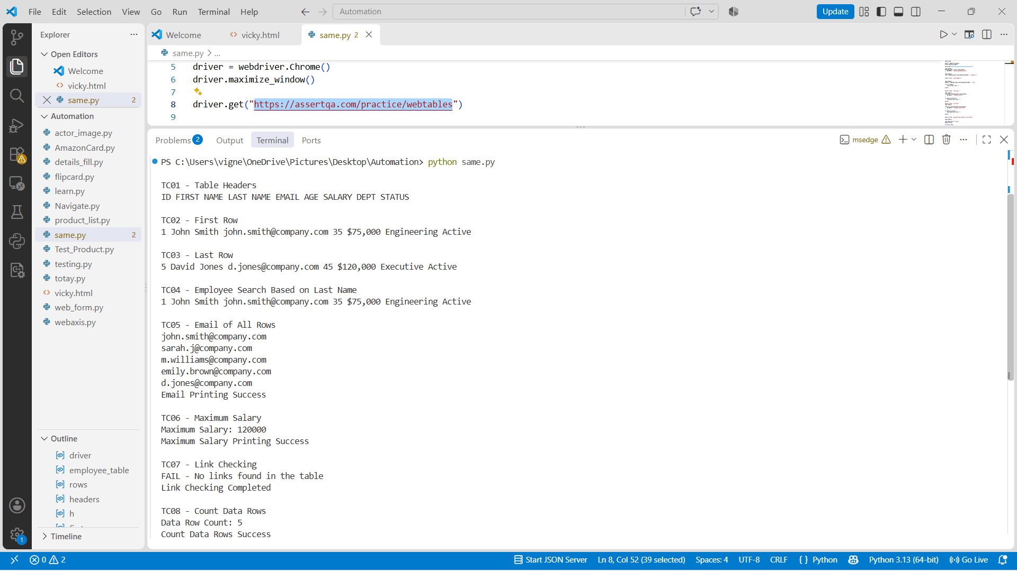
Screenshot 3 — Selenium code output in VS Code

6. Important Notes
- The website indicates 15 employee records, but the default page displays 5 rows at a time. This script processes only rows currently present in the DOM; it does not automate pagination.
- For that reason, the row count is 5 and the maximum salary of $120,000 is the maximum among the visible five rows, not necessarily all 15 records.
- Column indexes used: row_data[2] = Last Name, row_data[3] = Email, and row_data[5] = Salary.
- TC07 reports no links because no anchor elements were found inside the employee table in this run. This is a recorded observation.
- A more robust production script would use WebDriverWait rather than relying on fixed time.sleep() pauses.
- Use a plain URL in driver.get('https://assertqa.com/practice/webtables'), without Markdown link brackets.

7. Conclusion
The script practises eight web-table tasks using Selenium: reading headers and rows, searching by last name, extracting emails, finding a maximum salary, checking for links, and counting visible records. Pagination automation can be added as the next improvement to process all 15 employee records.
Github Link:

https://github.com/vigneshm278/HCL_SF_TESTING/blob/main/Selenium_Web_Table_Automation_Vignesh_M_Evidence_Report.docx

