HCLTECH 60-DAY TRAINING
TESTING & AUTOMATION
TASK 01
SauceDemo Login & Product Extraction
━━━━━━━━━━━━━━━━━━━━━━━━━━━━━━━━
STUDENT NAME | Vignesh M
REGISTER NUMBER | 212223240176
TECHNOLOGY | Python • Selenium WebDriver • Chrome
A professional Selenium automation exercise focused on login validation and product data extraction.

01 | OBJECTIVE
The objective of this task is to automate the SauceDemo e-commerce website using Python and Selenium WebDriver. The automation verifies the login process with valid credentials and extracts all available product names from the Products page.
TEST TARGET  SauceDemo website | AUTOMATION  Python + Selenium | VALIDATION  Login + product extraction

02 | AUTOMATION FLOW
STEP | ACTION | PURPOSE
01 | Launch | Open SauceDemo in Chrome
02 | Locate | Find the username and password fields
03 | Authenticate | Enter valid credentials and click Login
04 | Extract | Collect all visible product names
05 | Verify | Print the count and extracted names

03 | WORK COMPLETED
✓ Opened the SauceDemo website using Selenium WebDriver.
✓ Located the login fields and entered the valid test credentials.
✓ Triggered the Login action through Selenium.
✓ Navigated to the Products page after successful authentication.
✓ Located the product-name elements and extracted their visible text.
✓ Displayed the number of products and each product name in the Python console.

04 | SELENIUM CONCEPTS PRACTICED
SELENIUM API / LOCATOR | PURPOSE IN THIS TASK
webdriver.Chrome() | Creates a Chrome WebDriver session and controls the browser.
driver.get() | Navigates the browser to the target web address.
find_element() | Locates a single web element.
find_elements() | Locates a collection of matching web elements.
By.ID | Identifies elements using their HTML id attribute.
By.CLASS_NAME | Identifies elements using their CSS class name.
send_keys() | Types text into an input field.
click() | Performs a click action on an element.
.text | Reads visible text from a web element.

05 | AUTOMATION SCRIPT
Implementation used for the task:
from selenium import webdriver
from selenium.webdriver.common.by import By
# Start Chrome
driver = webdriver.Chrome()
# Open SauceDemo
driver.get("https://www.saucedemo.com/")
# Enter username
username = driver.find_element(By.ID, "user-name")
username.send_keys("standard_user")
# Enter password
password = driver.find_element(By.ID, "password")
password.send_keys("secret_sauce")
# Login
login_button = driver.find_element(By.ID, "login-button")
login_button.click()
# Extract product names
products = driver.find_elements(
By.CLASS_NAME, "inventory_item_name"
)
print("Login completed successfully")
print("Number of products:", len(products))
for product in products:
print("Product:", product.text)
input("Press Enter to close the browser")

06 | EXPECTED EXECUTION
→ Chrome launches and loads the SauceDemo login page.
→ The username and password fields are populated automatically.
→ The Login button is clicked by Selenium.
→ The Products page becomes available after successful authentication.
→ The script counts the matching product elements and prints each product name.

07 | EXECUTION EVIDENCE
Capture your own execution screenshots and place them in the evidence boxes below. The sections are intentionally redesigned so the final report clearly separates browser evidence from console evidence.
EVIDENCE 01 | LOGIN AUTOMATION
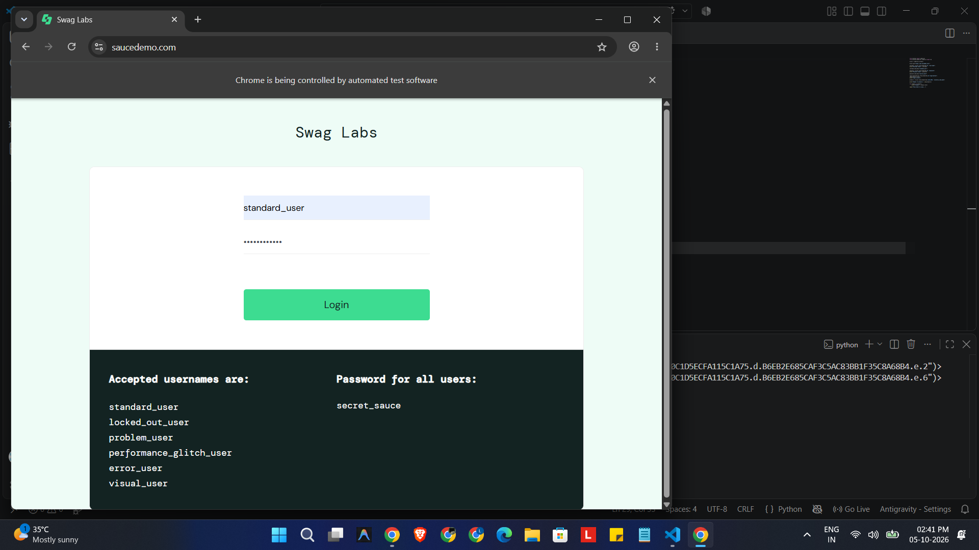

EVIDENCE 02 | PRODUCTS PAGE
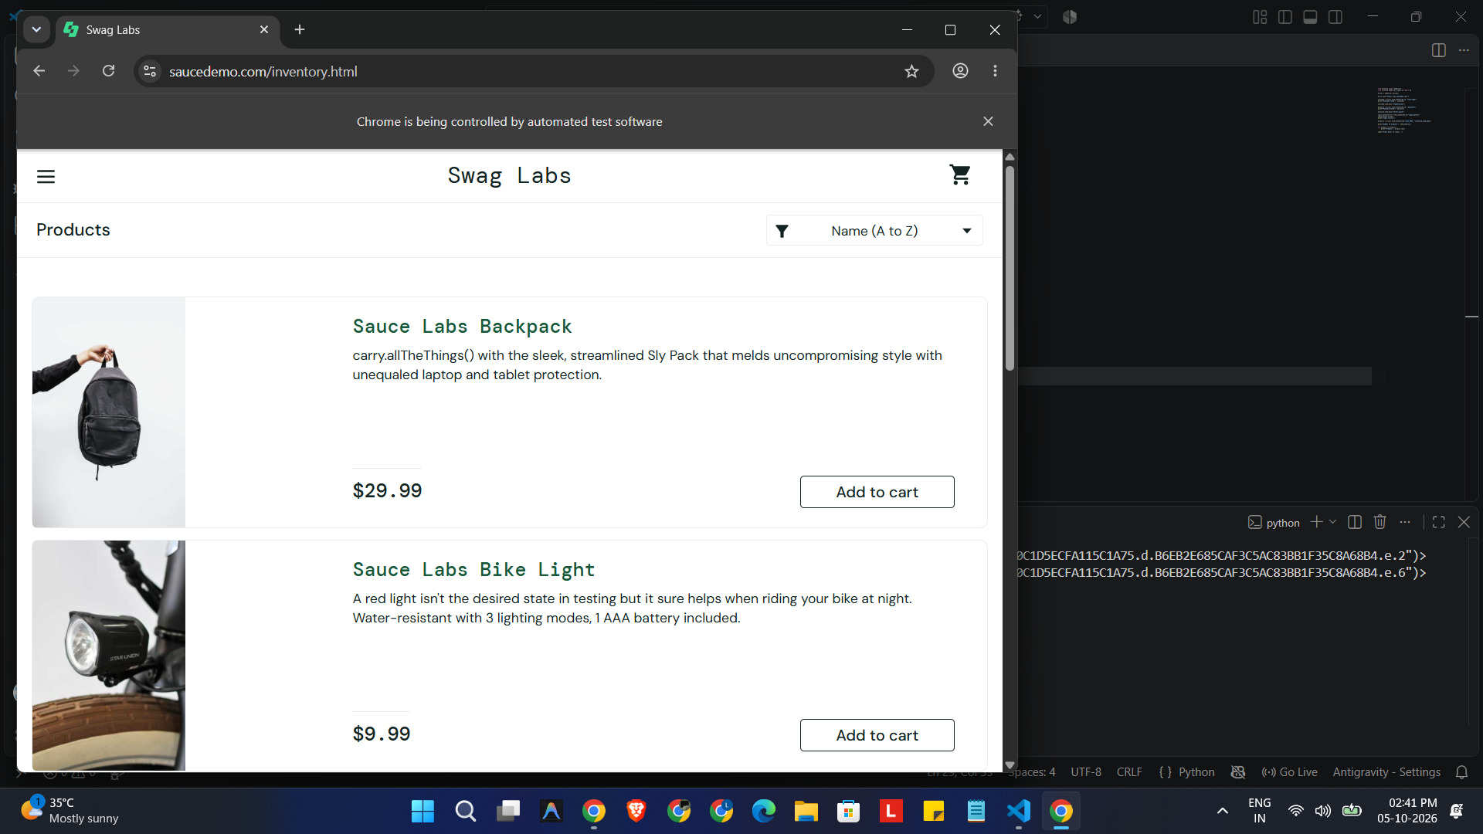

EVIDENCE 03 | CONSOLE OUTPUT
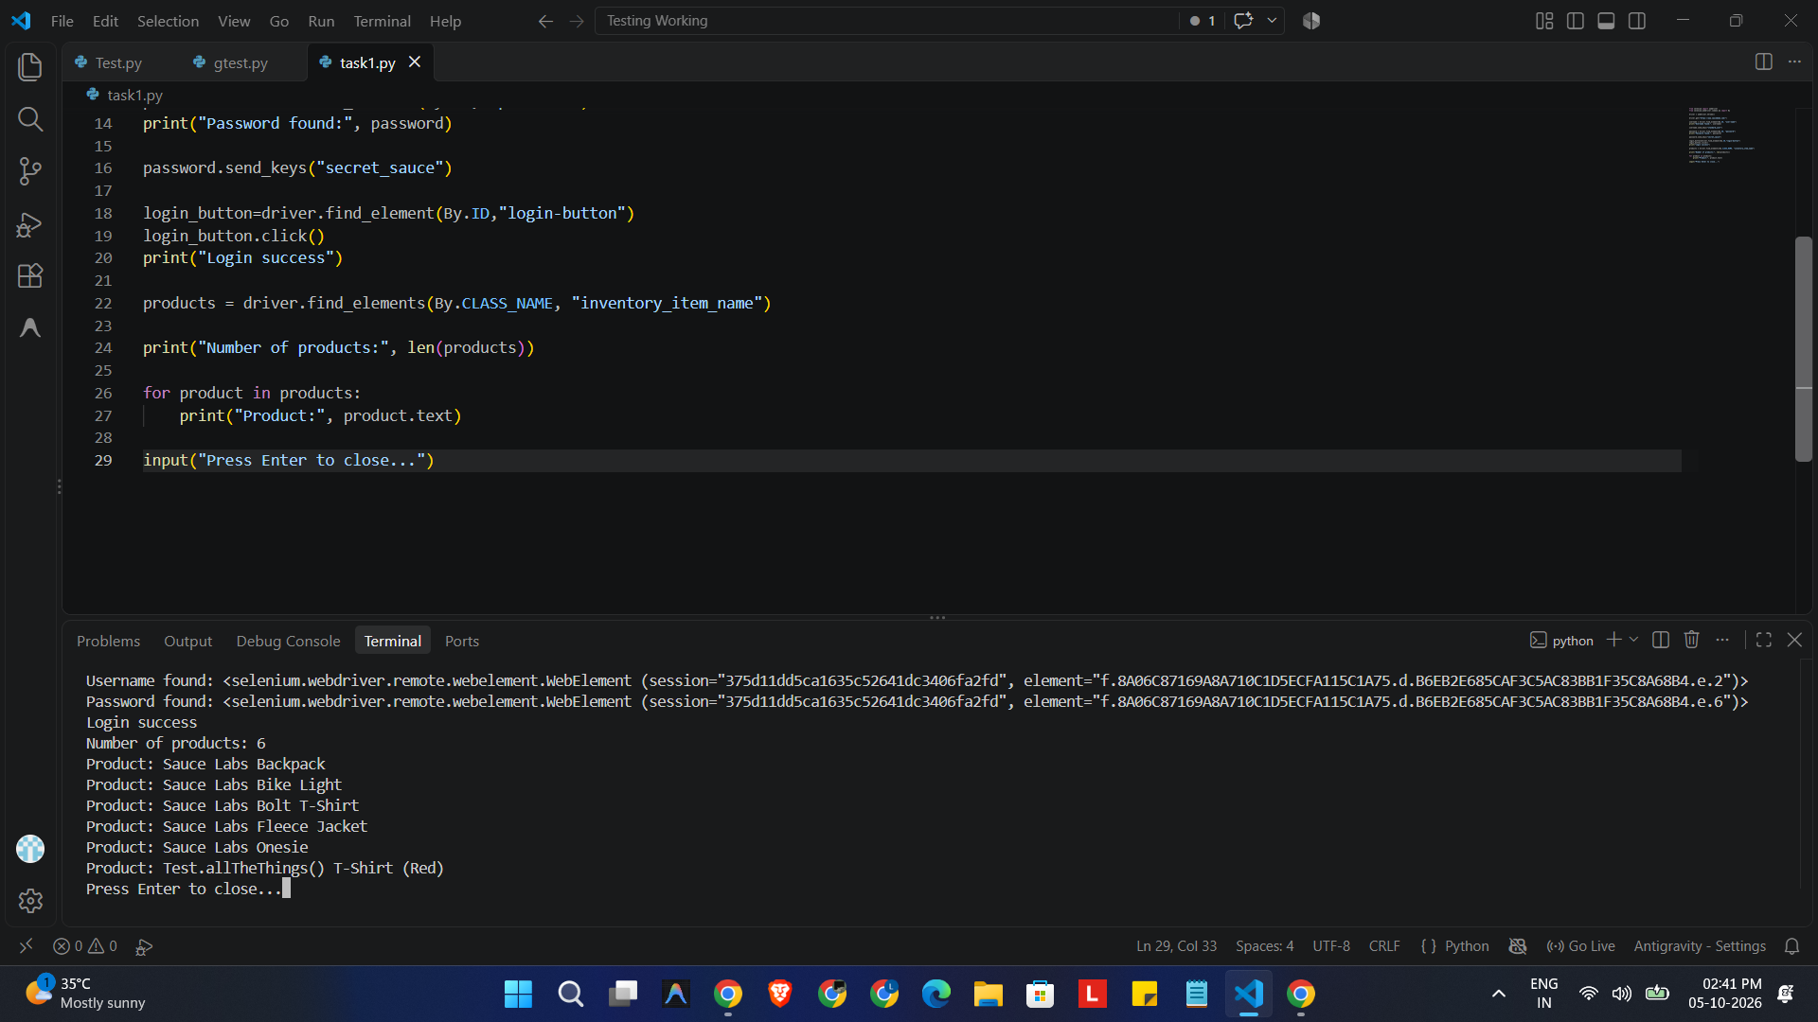

Execution screenshots reproduced from the supplied task evidence and placed under the matching automation stages.

08 | RESULT
✓ AUTOMATION FLOW COMPLETED
The SauceDemo login workflow and product-name extraction were implemented using Python and Selenium WebDriver. The final execution should be validated with Vignesh M's own screenshots.

09 | LEARNING OUTCOME
• Understood the basic Selenium WebDriver lifecycle.
• Practiced locating elements with ID and CLASS_NAME.
• Learned to automate text entry and button clicks.
• Practiced extracting visible web content with .text.
• Understood how browser evidence and console evidence support an automation task report.

