Selenium Web Form Automation – Test Documentation
Python + Selenium WebDriver | Selenium Web Form

1. Test Objective
This document records a beginner-level Selenium WebDriver automation test for the Selenium Web Form. The script demonstrates browser control, explicit waits, XPath locators, form interactions, element relationships, dropdown selection, and successful form submission.

2. Test Data
Field | Value
Student Name | Vignesh M
Registration Number | 212223240177
Password | Vignesh@123
Textarea | AI and ML Student
Target Page | https://www.selenium.dev/selenium/web/web-form.html

3. Test Case Execution Summary
Test Case | Description | Technique | Result
TC01 | Page Opened | driver.get() | PASS
TC02 | Student Name Entered | send_keys() | PASS
TC03 | Password Entered | send_keys() | PASS
TC04 | Submit Located | XPath + WebDriverWait | PASS
TC05 | Textarea Located | XPath + WebDriverWait | PASS
TC06 | Starts With XPath | starts-with() | PASS
TC07 | AND XPath | and operator | PASS
TC08 | OR XPath | or operator | PASS
TC09 | Parent XPath | parent::* | PASS
TC10 | Ancestor XPath | ancestor::*[1] | PASS
TC11 | Child Elements Found | //form/* | PASS – 1 found
TC12 | Following Element Found | following::*[1] | PASS
TC13 | Checkbox Selected | click() + is_selected() | PASS
TC14 | Radio Selected | click() | PASS
TC15 | Dropdown Selected | Select.select_by_index(1) | PASS
TC16 | Textboxes Found | //input[@type='text'] | PASS – 4 found
TC18 | Total Input Fields | //input | PASS – 14 found
TC19 | Contains XPath | contains() | PASS
TC17 | Submit Clicked | click() | PASS
TC20 | Complete Registration | Success message verification | PASS

4. Complete Python Selenium Script
from selenium import webdriver
from selenium.webdriver.common.by import By
from selenium.webdriver.support.ui import WebDriverWait
from selenium.webdriver.support import expected_conditions as EC
from selenium.webdriver.support.ui import Select
import time

name = "Vignesh M"
reg_no = "212223240177"

driver = webdriver.Chrome()
driver.maximize_window()

wait = WebDriverWait(driver, 10)

driver.get("https://www.selenium.dev/selenium/web/web-form.html")

print("TC01 - Page Opened")
time.sleep(2)

student_name = wait.until(
EC.presence_of_element_located(
(By.XPATH, "//input[@name='my-text']")
)
)
student_name.send_keys(name)

print("TC02 - Student Name Entered")
time.sleep(2)

password = wait.until(
EC.presence_of_element_located(
(By.XPATH, "//input[@name='my-password']")
)
)
password.send_keys("Vignesh@123")

print("TC03 - Password Entered")
time.sleep(2)

submit_button = wait.until(
EC.presence_of_element_located(
(By.XPATH, "//button[text()='Submit']")
)
)

print("TC04 - Submit Located")
time.sleep(2)

additional_info = wait.until(
EC.presence_of_element_located(
(By.XPATH, "//textarea")
)
)
additional_info.send_keys("AI and ML Student")

print("TC05 - Textarea Located")
time.sleep(2)

starts_with = wait.until(
EC.presence_of_element_located(
(By.XPATH, "//input[starts-with(@name,'my-')]")
)
)

print("TC06 - Starts With XPath")
time.sleep(2)

and_element = wait.until(
EC.presence_of_element_located(
(By.XPATH, "//input[@name='my-text' and @type='text']")
)
)

print("TC07 - AND XPath")
time.sleep(2)

or_element = wait.until(
EC.presence_of_element_located(
(By.XPATH, "//input[@name='my-text' or @name='my-password']")
)
)

print("TC08 - OR XPath")
time.sleep(2)

parent_element = wait.until(
EC.presence_of_element_located(
(By.XPATH, "//input[@name='my-text']/parent::*")
)
)

print("TC09 - Parent XPath")
time.sleep(2)

ancestor_element = wait.until(
EC.presence_of_element_located(
(By.XPATH, "//input[@name='my-text']/ancestor::*[1]")
)
)

print("TC10 - Ancestor XPath")
time.sleep(2)

child_elements = driver.find_elements(
By.XPATH,
"//form/*"
)

print("TC11 - Child Elements Found:", len(child_elements))
time.sleep(2)

following_element = wait.until(
EC.presence_of_element_located(
(By.XPATH, "//input[@name='my-text']/following::*[1]")
)
)

print("TC12 - Following Element Found")
time.sleep(2)

checkbox = wait.until(
EC.element_to_be_clickable(
(By.XPATH, "//input[@type='checkbox']")
)
)

if not checkbox.is_selected():
checkbox.click()

print("TC13 - Checkbox Selected")
time.sleep(2)

radio = wait.until(
EC.element_to_be_clickable(
(By.XPATH, "//input[@type='radio']")
)
)

radio.click()

print("TC14 - Radio Selected")
time.sleep(2)

dropdown_element = wait.until(
EC.presence_of_element_located(
(By.XPATH, "//select")
)
)

dropdown = Select(dropdown_element)
dropdown.select_by_index(1)

print("TC15 - Dropdown Selected")
time.sleep(2)

textboxes = driver.find_elements(
By.XPATH,
"//input[@type='text']"
)

print("TC16 - Textboxes Found:", len(textboxes))
time.sleep(2)

all_inputs = driver.find_elements(
By.XPATH,
"//input"
)

print("TC18 - Total Input Fields:", len(all_inputs))
time.sleep(2)

dynamic_element = wait.until(
EC.presence_of_element_located(
(By.XPATH, "//input[contains(@name,'my-')]")
)
)

print("TC19 - Contains XPath")
time.sleep(2)

submit_button = wait.until(
EC.element_to_be_clickable(
(By.XPATH, "//button[text()='Submit']")
)
)

submit_button.click()

print("TC17 - Submit Clicked")
time.sleep(2)

success_message = wait.until(
EC.presence_of_element_located(
(By.XPATH, "//h1[text()='Form submitted']")
)
)

print("TC20 - Complete Registration")
print("Name:", name)
print("Reg No:", reg_no)
print("Success Message:", success_message.text)
print("Registration Completed Successfully!")

time.sleep(3)

driver.quit()

5. Selenium Concepts Demonstrated
Concept | Purpose
WebDriver | Controls the Chrome browser through Selenium.
WebDriverWait | Waits for elements instead of relying only on fixed delays.
Expected Conditions | Checks conditions such as element presence or clickability.
By.XPATH | Locates elements using XPath expressions.
send_keys() | Enters text into input fields.
click() | Clicks buttons, checkboxes, radio buttons, and other clickable elements.
is_selected() | Checks whether a checkbox/radio element is selected.
find_elements() | Returns a list of all matching elements.
Select | Provides methods for selecting HTML <select> dropdown options.
driver.quit() | Closes the browser and ends the WebDriver session.

6. XPath Techniques Used
XPath Type | Example
Attribute XPath | //input[@name='my-text']
Text XPath | //button[text()='Submit']
starts-with() | //input[starts-with(@name,'my-')]
AND | //input[@name='my-text' and @type='text']
OR | //input[@name='my-text' or @name='my-password']
Parent | //input[@name='my-text']/parent::*
Ancestor | //input[@name='my-text']/ancestor::*[1]
Child | //form/*
Following | //input[@name='my-text']/following::*[1]
contains() | //input[contains(@name,'my-')]

7. Execution Result
The automation completed successfully. The browser displayed the Web Form, the required fields were populated, checkbox/radio/dropdown interactions were performed, and the form was submitted. The final page displayed the success heading 'Form submitted' and the message 'Received!'.

8. Execution Evidence
Console execution output – corrected student name
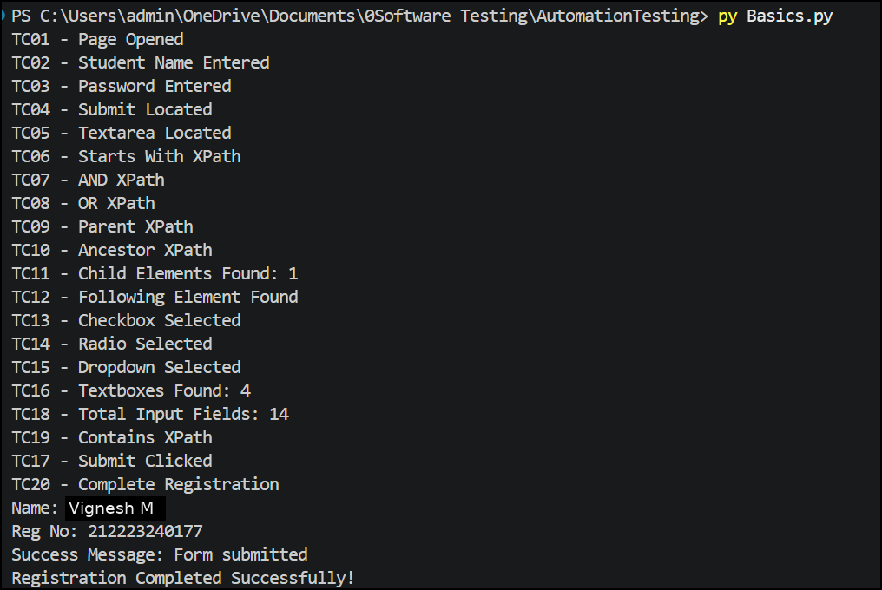
Submitted form result
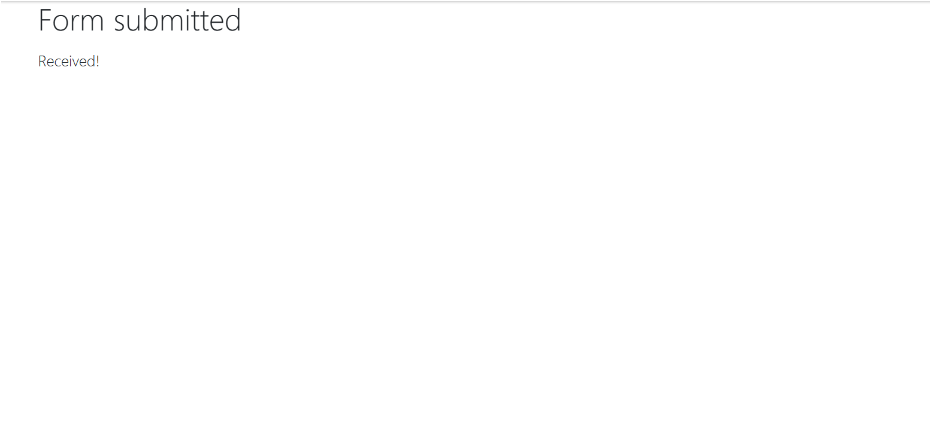
Web form with corrected student name
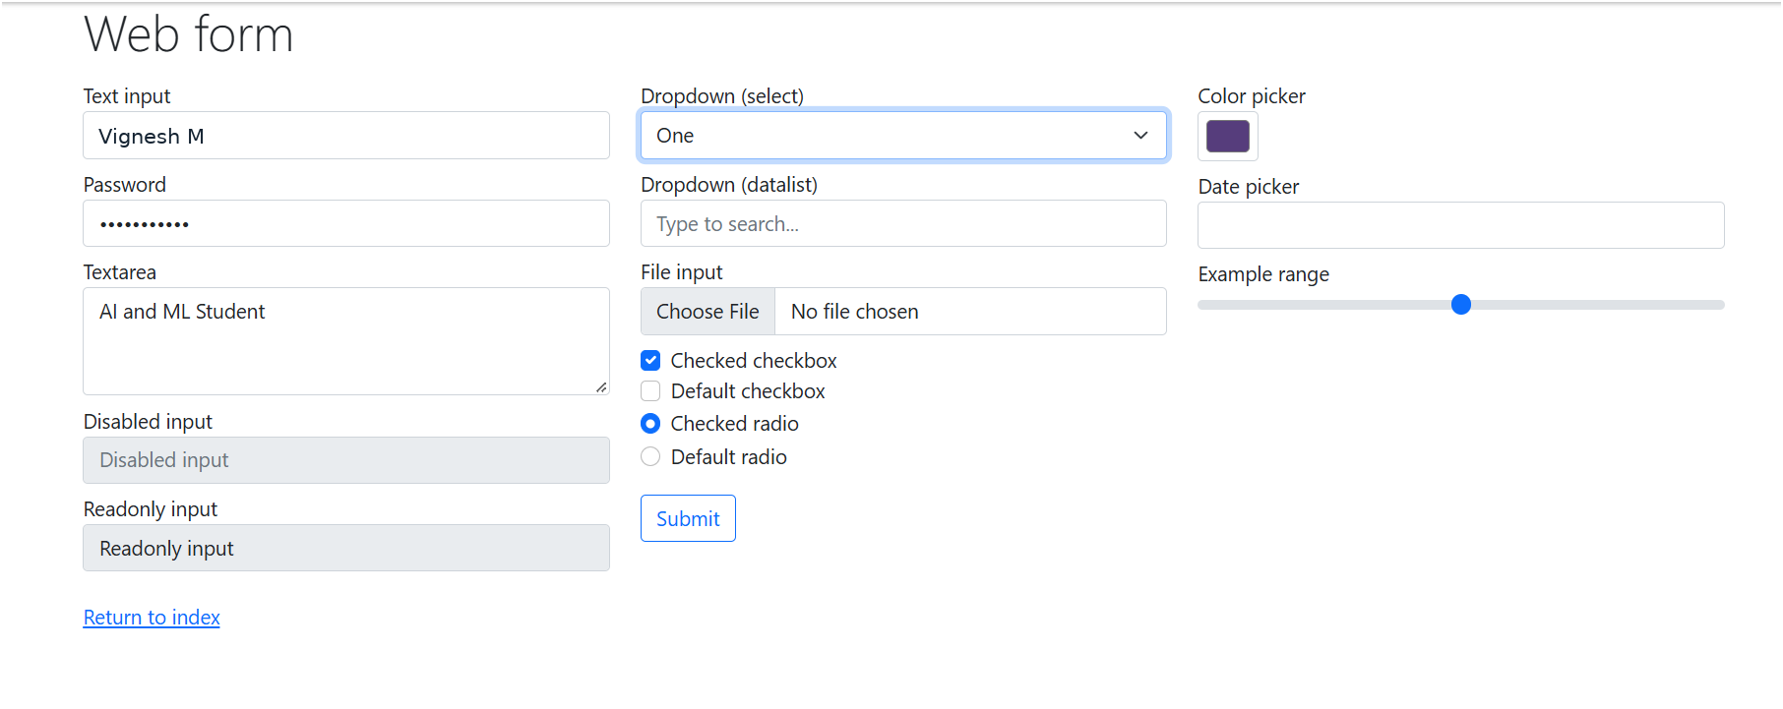
Web form interaction state with corrected student name
Web form final interaction state with corrected student name
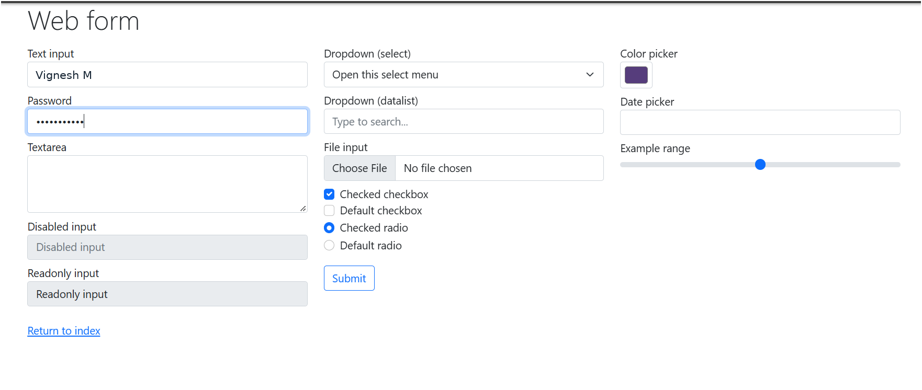

9. Final Status
PASS – Registration Completed Successfully

