**FSD Final SBA Assessment**

**Project Name:** Project Mangement

**Technologies Used:** Angular 6, Web API & Entity Framework

**IDE:** Visual Studio 2017, MS SqlServer 2012 and Visual Studio Code

**Sql Connection String Configuration:**

<connectionStrings>

<add name="ProjectManagementEntities" connectionString="metadata=res://*/Model.ProjectMngtModel.csdl|res://*/Model.ProjectMngtModel.ssdl|res://*/Model.ProjectMngtModel.msl;provider=System.Data.SqlClient;provider connection string=&quot;data source=DOTNET;initial catalog=ProjectManagement;integrated security=True;multipleactiveresultsets=True;App=EntityFramework&quot;" providerName="System.Data.EntityClient" />

</connectionStrings>



**Git Repository Url**

<https://github.com/vigneshma162604/FSE_SBA_FinalProject>

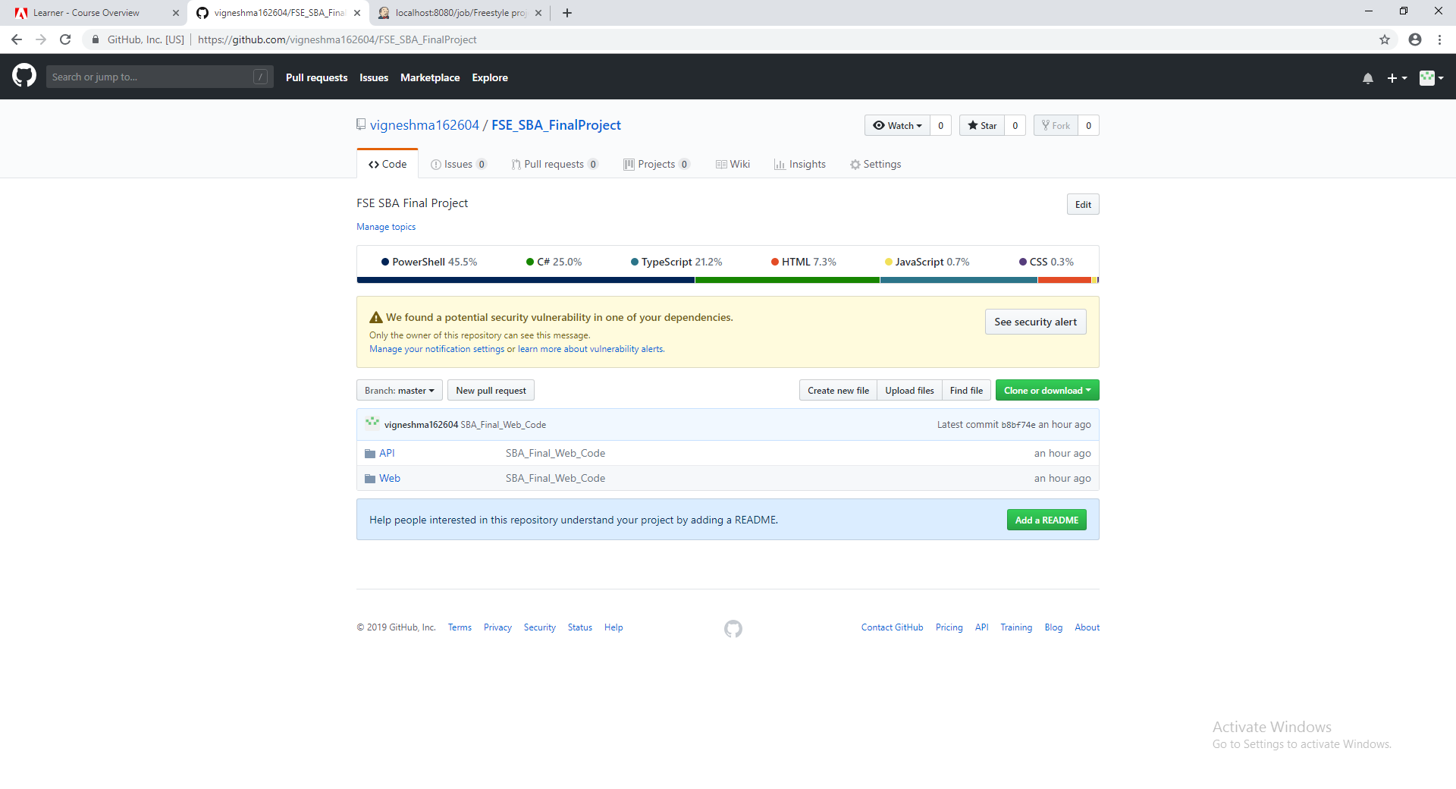

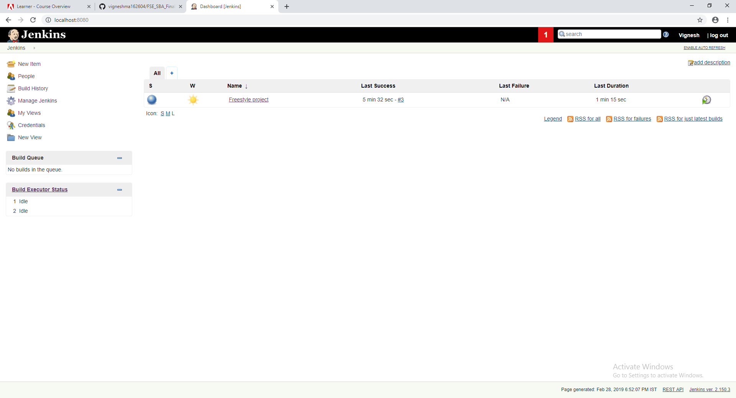

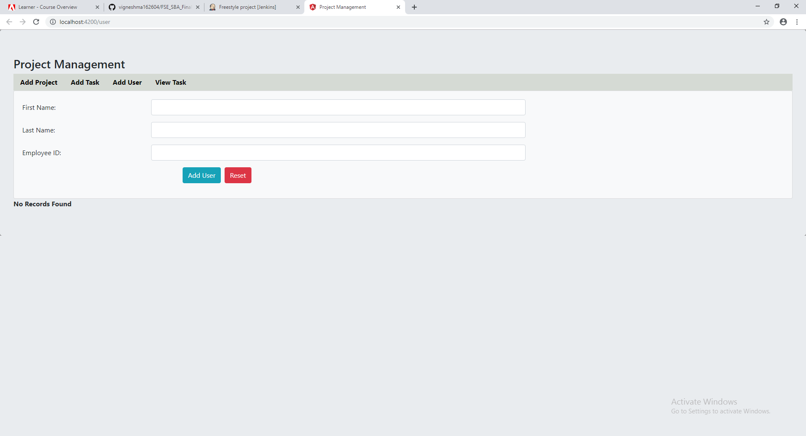

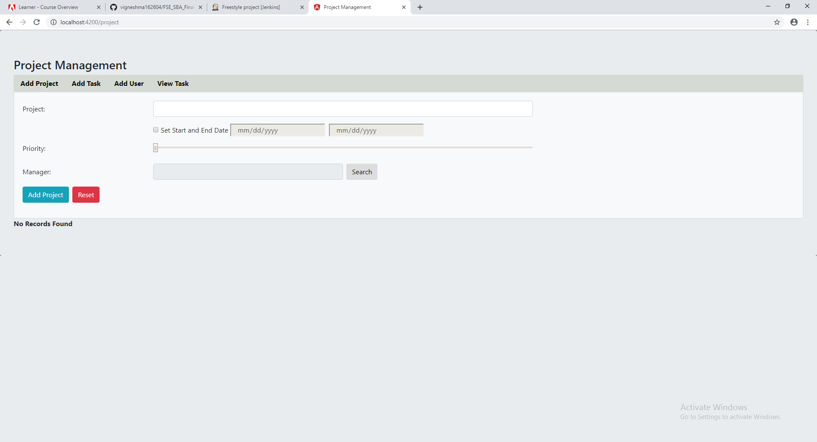

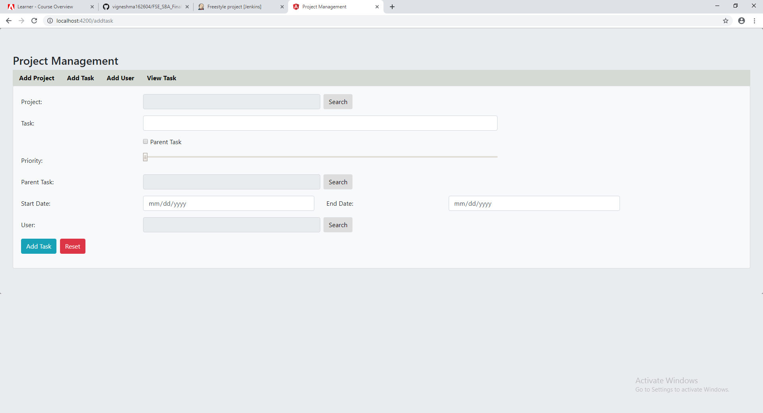

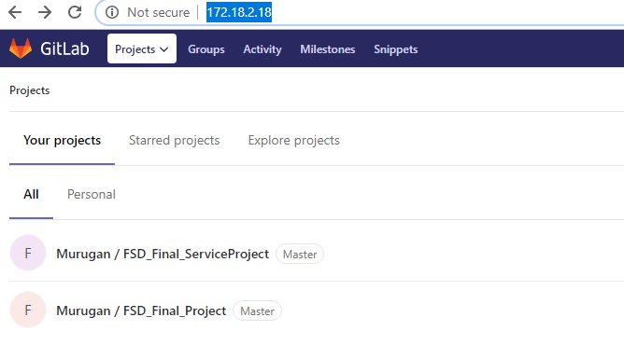

**Jenkins Configuration for DI**

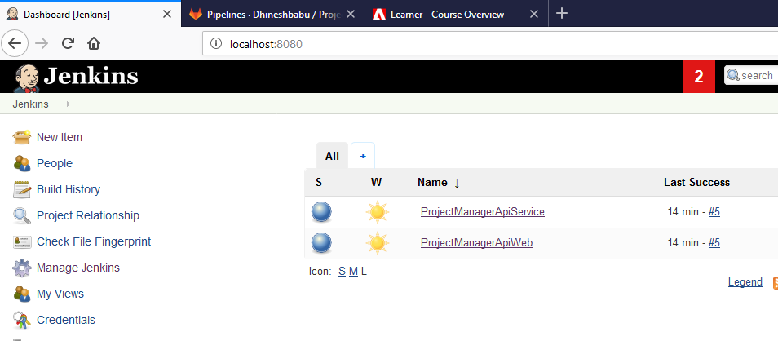

**Build Batch file configuration**

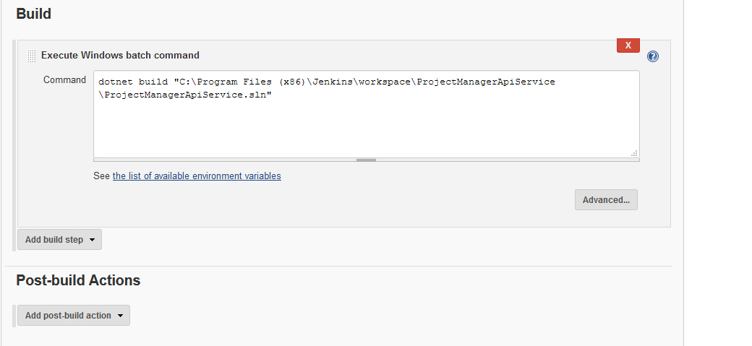

**Build Commands Configuration**

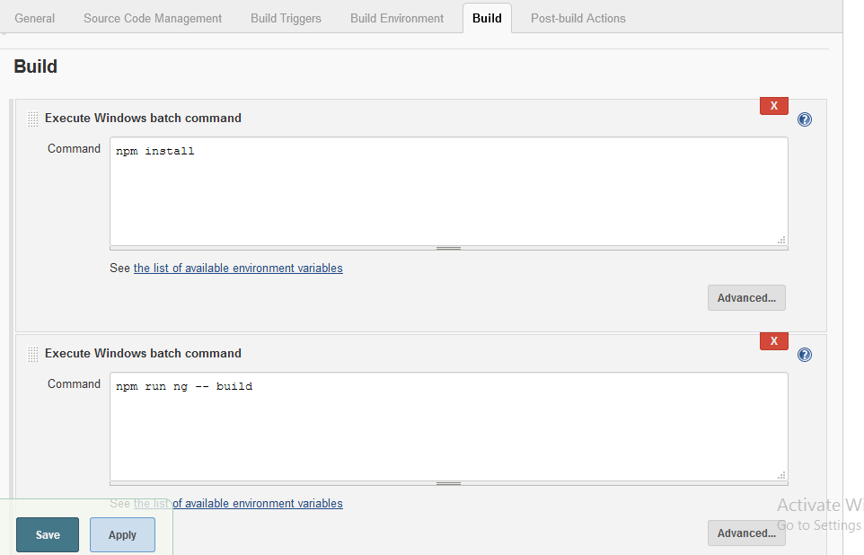

**Sample Outputs:**