**Veermata Jijabai Technological Institute**

Mumbai – 400 019

Department of Electrical Engineering



Report on

3rd Eye For Blind

**Subject: Instrumentation & Electrical System**

**Course Name: Diploma in Electronics Engineering (DElnE)**

**Semester: Fourth**

**Guided by**

Prof. Anurag Ukande

Prof. Rahul Kirpane

**Submitted by**

Smruti Pawaskar (174131009)

Bhagyesh Kolekar (174130010)

Prathamesh Kadam (174130013)

Prajakta Bamankar (174131017)

Shrutika Avhad (174131018)

**ACKNOWLEDGEMENT**

We wish to express our sincere gratitude to dean academics of diploma for providing us the opportunity to do this survey.

We sincerely thank Prof. Anurag Ukande & Prof. Rahul Kirpane for their guidance and encouragement in carrying out this project and analysis . Prof Chetan Kamble also helped us this project so we express our gratitude to him for making our project successful. Our classmate Master Rudra Joshi also helped us in making the code for the sensors.

We would also like to thank the lab assistants for their help and co-operation. Our group also gave the best for this project and helped each other in all difficult situations.

We would thank Master Shreyas Kardekar our classmate for helping us with the components.

**Introduction**:

Vision is a beautiful gift to human beings by GOD. Vision allows people to perceive and understand the surrounding world. Till date blind people struggle a lot to live their miserable life. In the presented work, a simple, cheap, friendly user, virtual eye is designed and implemented to improve the mobility of both blind and visually impaired people in a specific area. The presented work includes a wearable equipment consists of head hat, mini hand stick and foot shoes to help the blind person to navigate alone safely and to avoid any obstacles that may be encountered, whether fixed or mobile, to prevent any possible accident. The main component of this system is the ultrasonic sensor which is used to scan a predetermined area around blind by emitting-reflecting waves. The reflected signals received from the barrier objects are used as inputs to Arduino microcontroller.

This report presents a device to detect an obstacle for the blind people. Third eye for people who are blind is an innovation which helps the blind people to navigate with speed and confidence by detecting the nearby obstacles using the help of ultrasonic waves and notify them with buzzer sound or vibration. They only need to wear this device as a band or cloth. The idea was inspired from bats, which also use sound waves of high frequency to move.

According to WHO 39 million peoples are estimated as blind worldwide. They are suffering a lot of hardship in their daily life. The affected ones have been using the traditional white cane for many years which although being effective, still has a lot of disadvantages. Another way is, having a pet animal such as a dog, but it is really expensive. So the aim of the project is to develop a cheap and more efficient way to help visually impaired to navigate with greater comfort, speed and confidence.

The advantage of our project is the first wearable technology for people who are blind using ultrasonic waves to detect the obstacles thus notifying the user through vibrations/buzzer sound. Now a days there are so many instruments and smart devices for visually impaired peoples for navigation but most of them have certain problems for carrying and the major drawbacks is those need a lot of training to use. The one of the main peculiarity of this innovation is, it is affordable for everyone, the total cost being less than $25 (~1500INR). There are no such devices available in the market that can be worn like a cloth and having such a low cost and simplicity. When used on a large scale, with improvements in the prototype, it will drastically benefit the community.

* **Existing Systems :**

1. White cane
2. Pet dog
3. Smart devices (eg : Vision a torch for blinds)

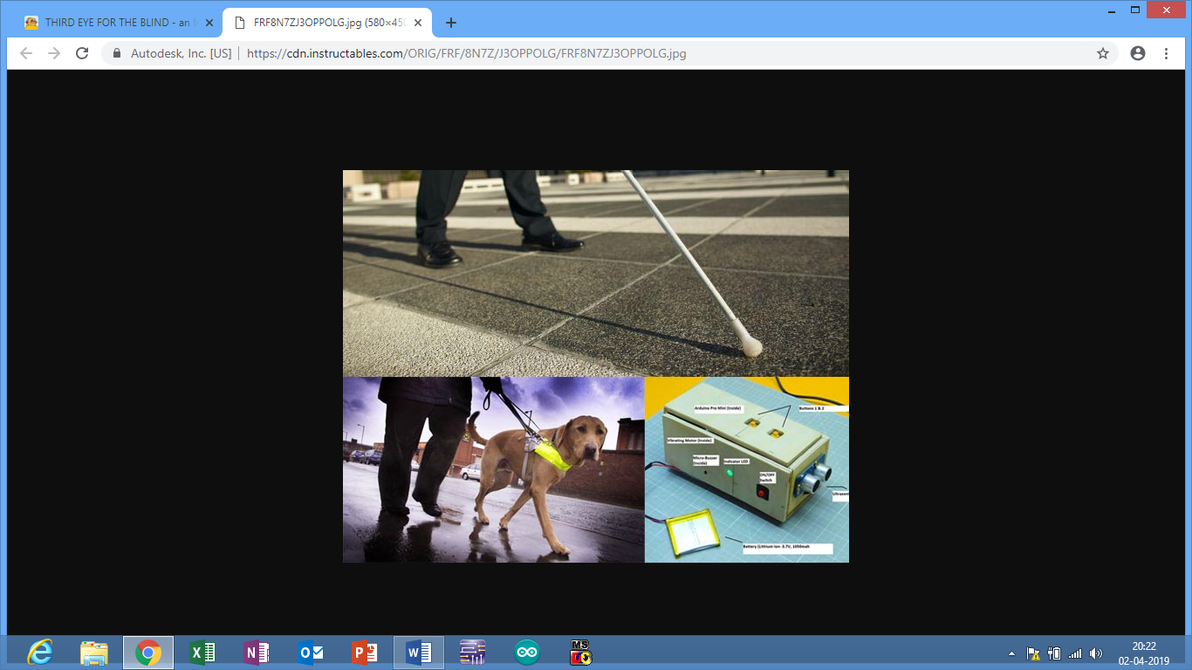

Fig 1 : Existing Systems

* **Problem of the Existing Systems:**

1. White cane - May easily crack/break,The stick may get stuck at pavement cracks of different objects.
2. Pet dog - Huge cost. (~$42,000 / 280000Rs )
3. Common Disadvantages (Including the the smart devices) Cannot be carried easily, needs a lot of training to use.

* **Features of Third eye for blind people:**

By wearing this device they can fully avoid the use of white cane and such other devices. This device will help the blind to navigate without holding a stick which is a bit annoying for them. They can simply wear it as a band or cloth and it can function very accurately and they only need a very little training to use it.

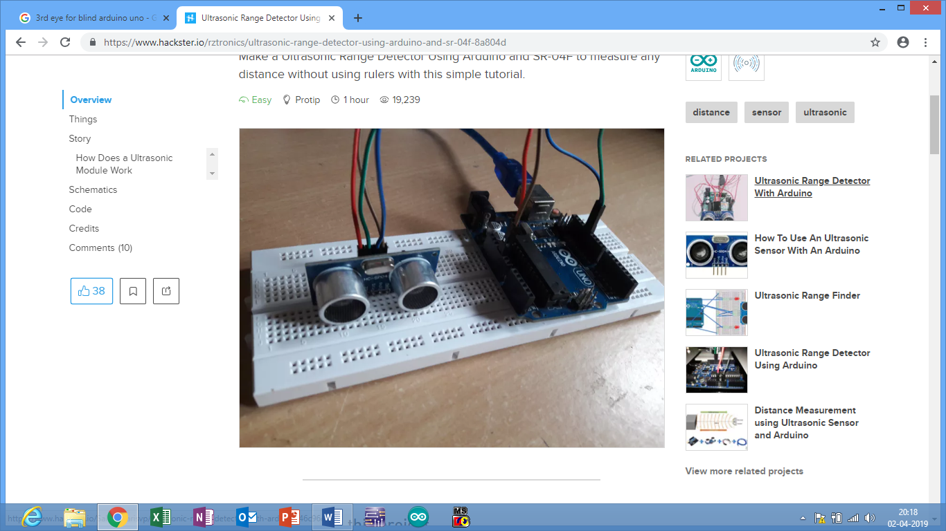

Fig 2 : Picture of the circuit

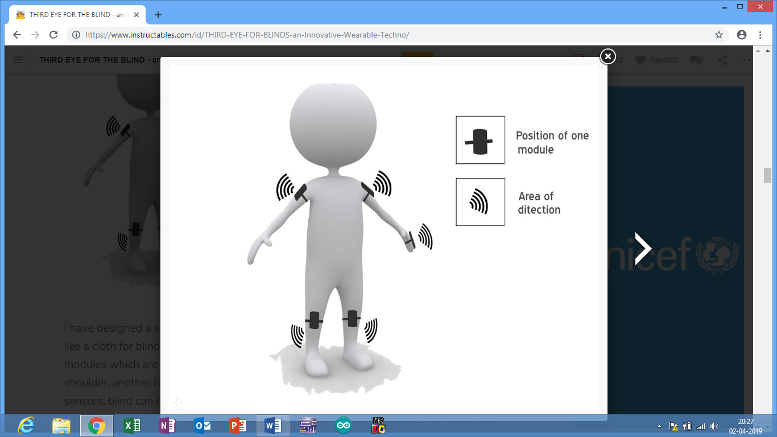

Fig 3 : If the Module is made in the form of band.

* **Circuit Diagram**:

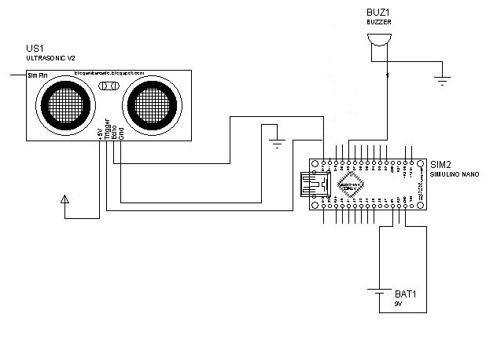

Fig 4 : Circuit Diagram of Project

* **Explanation of the Components and the Circuit** :

We will use Arduino UNO board and ultrasonic sensor for making the project.

Arduino Microcontroller- The UNO is the best board to get started with electronics and coding. If this is your first experience tinkering with the platform, the UNO is the most robust board you can start playing with. The UNO is the most used and documented board of the whole Arduino family. Arduino is a single-board microcontroller, intended to make the application of interactive objects or environments more accessible. The hardware consists of an open-source hardware board designed around an 8-bit Atmel AVR microcontroller, or a 32-bit Atmel ARM. It has 16 MHz crystal oscillator, a USB connection, a power jack, an ICSP header, and a reset button. It contains everything needed to support the microcontroller; simply connect it to a computer with a USB cable or power it with a ac to dc adapter or battery to get started.

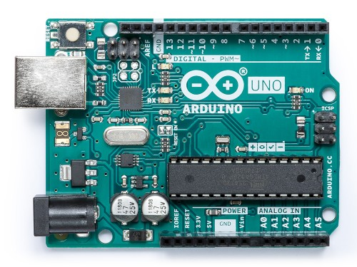

Fig 5: Arduino UNO board

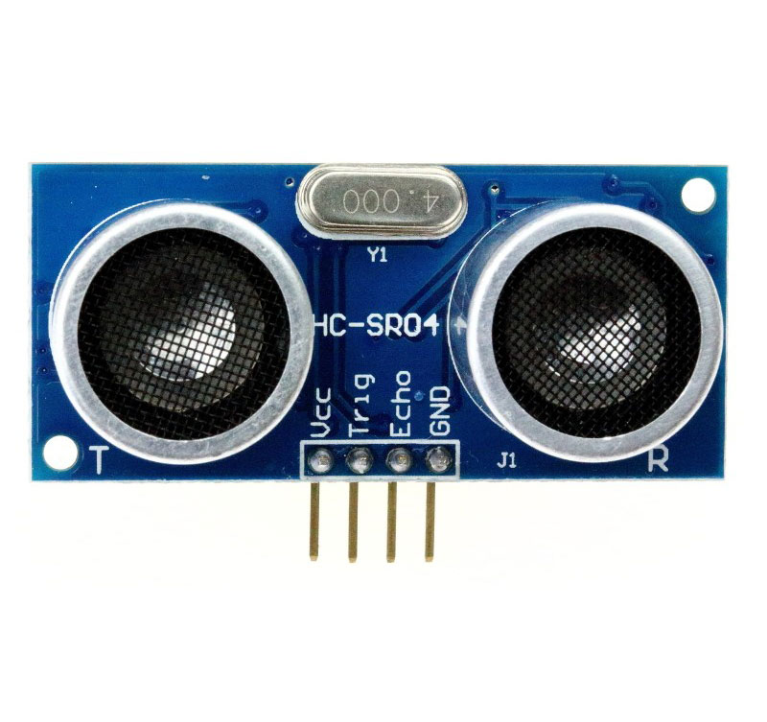

Fig 6 : Ultrasonic sensor

Ultrasonic Sensors- In order to provide the obstacle avoidance, Ultrasonic sensor is used. Ultrasonic ranging provides 2cm- 400cm non-contact measurement function, the ranging accuracy can reach to 3mm.it includes ultrasonic transmitters, receiver and control circuit. Ultrasonic use I/O trigger for at least 10us high level signals. Sensor automatically sends eight 40 KHz and detect whether there is a pulse signal back. IF the signal back, through high level, time of high output I/O duration is the time from sending ultrasonic to returning. The ultrasonic sensor determines the distance to a reflective surface by emitting high-frequency sound waves and measuring the time it takes for the echo to be picked up by the detector.

We need to assemble the components according to the circuit diagram. As the code changes the connections also change. In our case, we have designed it as per the distance from the obstacle. If the Sensor is 200 cm away then the buzzer will make sound with less amplitude and as soon as the obstacle comes closer the buzzer will make sound with more and more amplitude and with less time delay.

We have connected :

Pin 5 (Arduino)- Trigger pin (Sensor)

Pin 6 (Arduino) -Echo pin(sensor)

Pin 4 (Arduino)- Output (Buzzer)

To implement, the ultrasonic sensors, Arduino microcontroller are used. Based on signals, decision is made in Arduino to manage and give timely signals. The input string is from the ultrasonic sensors which generate high frequency sound waves and evaluate the echo which is received back by the sensor. Sensors calculate the time interval between sending the signal and receiving the echo to determine the distance to an object. Ultrasonic sensor can measure distances in centimeters and inches. It can measure from 0 to 2.5 meters, with a precision of 3 cm. The input string is received by the Arduino microcontroller. The microcontroller will carry out the issued commands and then communicate the status of a given project.

* **Drawbacks:** This device cannot be used in crowded. The present technology of this project doesn't allow it to be used at places which may require very fast responses.
* **Future Improvements:**  
  - The entire project can also be made in the form of jacket, so that the device doesn't need to be wear one by one.  
  - Make the device much smaller by use of surface mounted components (SMD) and avoid spacing between the parts.  
  - Use Lithium Polymer battery instead of Lithium ion to provide greater power with less weight.  
  - Use of specially designed boards instead of arduino makes faster response.
* **Advantages :**

1) Low design time.

2) Low production cost.

3) This system is applicable for both the indoor and outdoor environment.

4) Setting the destination is very easy.

5) It is dynamic system.

6) Less space.

7) Low power consumption.

* **Result**:

While walking on roads, Blind people would help themselves without others help. They can be self-independent through such innovation. It will help them even when they are having any difficulty.

This is very cost effective and keeps the society happy. The blind shouldn’t feel scared of going out and face the world. Such ideas can make their life easier and more comfortable. They don’t need to take the help of others while crossing the road or any other daily household work. They can simply carry this project anywhere they want and help themselves.

* **Conclusion:**

Since number of accidents on highways increases day by day so it is necessary to check the facilities available to the blind so as to remove accident cases and to provide a safe journey. It also minimizes the difficulties of blind community and make ease to their walking speed on roads . The blind can perform their responsibilities while walking in market and can move with more ease. This concept can be extended in future by making more advance changes in the code and implementing them on the Arduino.

* **References:**

1. <https://www.instructables.com/id/Arduino-Based-Simple-Blind-Navigation-Bracelet-AID/>
2. <https://www.ijireeice.com/upload/2015/march-15/IJIREEICE6.pdf>
3. <https://store.arduino.cc/usa/arduino-uno-rev3>
4. <https://www.robotechmaker.com/2016/11/third-eye-for-blind.html>
5. <https://create.arduino.cc/projecthub/muhammedazhar/third-eye-for-the-blind-8c246d>