SUP-1419 — Pareto Summary: 100% vs. Less Than 100%
"Contributions from Top 50% CCs" shows how much of total sales, margin, and units come from just the best-selling half of style-colors (CCs). Two examples below, pulled from QA, show what this looks like when the result is 100% and when it's below 100%.

Example 1 — 100% (Total Brand scope)
Torrid, Total Brand, 2025-W10-Apr-W1 to 2025-W13-Apr-W4, flow status: All.
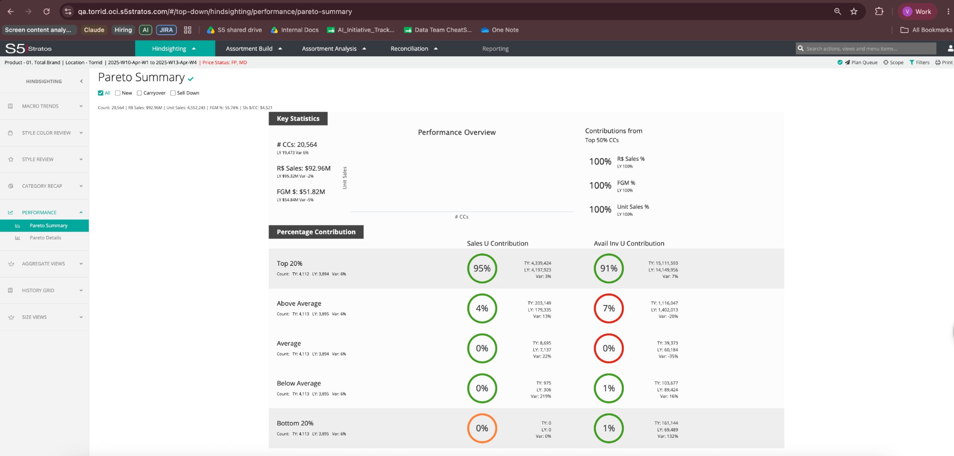
Top 50% CCs | R$ Sales % | FGM % | Unit Sales %
Result | 100% | 100% | 100%
Observed: all three numbers show 100%.

Example 2 — Less than 100% (Belle Isle scope)
Torrid, Belle Isle, 2025-W10-Apr-W1 to 2025-W13-Apr-W4, flow status: All.
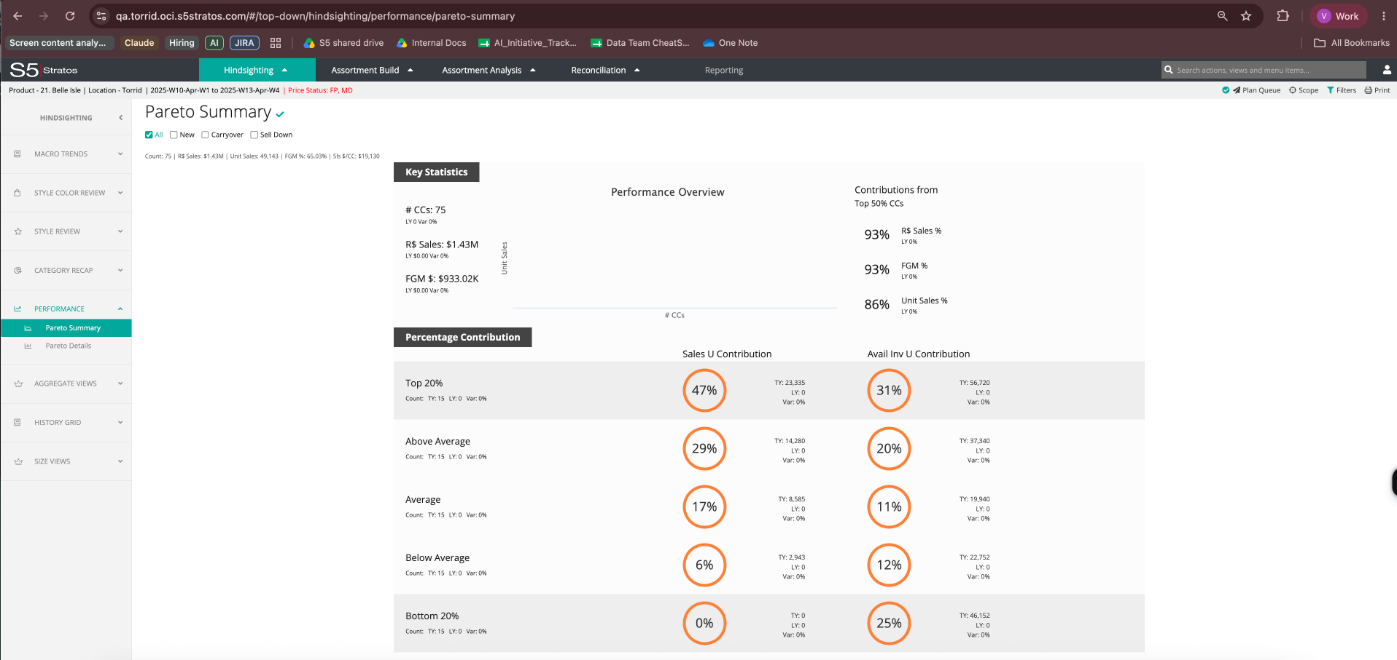
Top 50% CCs | R$ Sales % | FGM % | Unit Sales %
Result | 93% | 93% | 86%
Observed: the three numbers differ, and all are below 100%.
In both cases, these numbers match what the performance bands below them show (Top 20% through Bottom 20%) — the calculation is behaving consistently in both examples. We have not found a scope yet where the numbers look wrong or inconsistent.

