Chapter 1
INTRODUCTION
The brief description about computer graphics and also about OpenGL is given in
this chapter. Along with it, a brief description of this project is also provided.

1.1 About Computer Graphics
Computer Graphics is generally regarded as a branch of computer science that deals with the theory and technology for computerized image synthesis. A computer generated image can depict a scene as simple as the outline of a triangle on a uniform background and as complex as magnificent dinosaur in a tropical forest. Computer graphics is concerned with all aspects of producing pictures or images using a computer. Graphics provide one of the most natural means of computing with a computer, since our highly developed 2D and 3D pattern recognition abilities allow us to perceive and process pictorial data rapidly and effectively.

1.2 About OpenGL
Graphics applications can be easily implemented using OpenGL. OpenGL is a graphics software system which has become a widely accepted standard for developing graphics application. OpenGL is a device independent graphics library that allows the programmer to use a common set of functions with an application. It provides the actual drawing tools through a collection of functions that are called within an application.
OpenGL can be accessed using GL library, OpenGL utility library (GLU), OpenGL utility toolkit (GLUT). GL library have names that begin with the letters gl. The GLU library is available in all OpenGL implementations. Functions in the GLU library begin with the letters glu. GLUT will use GLX and the X libraries. The application program can use only GLUT functions.
OpenGL offers a rich and highly usable API for 2D and 3D graphics and image manipulations. OpenGL makes heavy use of macros to increase code readability and avoid the use of magic numbers. The OpenGL way of creating graphics is used widely in both academics and industries.
1.3 About Project
The project “3D MANHATTEN BRIDGE” demonstrates how to draw object i.e. car and bridge and how to give motion to the car on bridge. Through keyboard events the bridge can be rotated in three different directions and bridge can be opened and closed. Also car can be moved in forward and reverse way.

Chapter 2
SYSTEM REQUIREMENTS

2.1 Hardware Requirements
- Processor : Pentium 4 2.0 GHz
- RAM : 1GB DDR RAM
- Hard disk: 40GB

2.2 Software Requirements
- Operating System : Windows XP
- Programming Language :Visual C++ with OpenGL API

Chapter 3
DESIGN
The most important aspect of the project is its design phase. This chapter gives the overall design of the project. Initially when we execute, the output window will be displayed. Sequence of operations can take place based on the user’s input. The flow of execution is depicted in the following block diagram.
3D Manhattan Bridge
Keyboard

User
Interaction

Rotation
Key ‘f’ fforward

Key ‘r’
Key ‘o’
Key ‘c’

Key ‘x’
Key ‘y’
Key ‘z’

Fig 3.1 Design of the project

The execution starts from main () and calls the program to begin an event processing loop. Initially the bridge is displayed. User interaction is provided using keyboard. The user can rotate bridge using certain keys in the keyboard.
The user interface options are shown below:
f: car moves in forward direction.
r: car moves in reverse direction.
x: rotates in negative x axis.
X: rotates in positive x axis.
y: rotates in negative y axis.
Y: rotates in positive y axis
z: rotates in negative z axis.
Z: rotates in positive z axis.
o: Bridge opens.
c: Bridge close.

Chapter 4
IMPLEMENTATION
Implementation is third phase of the project. In this phase the project inception review is done and the activity schedule is prepared. This chapter provides an insight of how the code has been developed with the help of pseudocode.
4.1 Pseudocode:
Pseudocode is a compact and informal high level description of computer programming algorithm.
main () : The program execution begins from the first statement of this function. It
also calls various other functions defined in the program.
Keyboard () : The function catches keyboard events and performs necessary
operation.
Init () : Initializes the window.
object () : calls this function and creates a 3D bridge.
key () : In this function keys are initialized for user interaction.

4.2 Flowchart
Start

Initially bridge close

Y
If(key==f)
Car movement

Y
If car on middle of the bridge

N
If(car==dest)
N
switch
Y
N

Case‘o’

Case ‘c’
Car moved to destination

Y
N Y N
Car not moved

End
Fig 4.1 Flowchart of the project
4.3 Functions
The implementation of the project requires the usage of different kinds of functions. Functions can either be inbuilt or defined by the user. The functions used in the project are discussed below.

4.3.1 Inbuilt functions:
- glClearColor (GLclampf r, GLclampf g, GLclampf b, GLclampf a):
It is used to clear the color buffer.
- glFlush ():
Forces any buffered Opengl commands to execute .Sets keyboard call back to current window.
- void glutDisplayFunc(void (*func)(void)):
It registers the display function callback be executed after the current callback when
window needs to be redrawn.
- void glTranslatef(GLfloat x, GLfloat y, GLfloat z):
This function multiplies the current matrix by a translation matrix. This function does not return a value.
- void glScalef(GLfloat x, GLfloat y, GLfloat z):
This function multiplies the current matrix by a general scaling matrix. This function does not return a value.
- void glRotatef (GLfloat angle, GLfloat x, GLfloat y, GLfloat z):
This function multiplies the current matrix by a rotation matrix.
- void glutSolidCube (GLdouble size):
The cube is centered at the modeling coordinate’s origin with sides of length size.
- void glutSolidSphere (GLdouble radius, GLint slices, GLint stacks):
Renders a sphere centered at the modeling coordinates origin of the specified radius. The sphere is subdivided around the Z axis into slices and along the Z axis into stacks.

- void glPushMatrix(void), void glPopMatrix(void):
The glPushMatrix and glPopMatrix functions push and pop the current matrix
stack.

- void WINAPI gluLookAt, GLdouble eye x, GLdouble eye y, GLdouble eye z, GLdouble center x, GLdouble center y, GLdouble center z, GLdouble up x, GLdouble up y, GLdouble up z):
The gluLookAt function defines a viewing transformation. gluLookAt creates a viewing matrix derived from an eye point, a reference point indicating the center of the scene, and an UP vector.
4.3.2 User defined functions
- void object() :
This function is used to draw 3D bridge and create a car.
- void key() :
This function is used to assign a particular key to particular function. It will be set to
the keyboard callback function.
- Bridge_blocks():
The blocks are created by calling this function.
- Bridge_arm():
The arms of bridge are created by calling this function.
- Road():
We create roads within this function by using API’s.
- Car():
We create a car to demonstrate object movement through the bridge by calling this
function.

Chapter 5
SNAPSHOTS

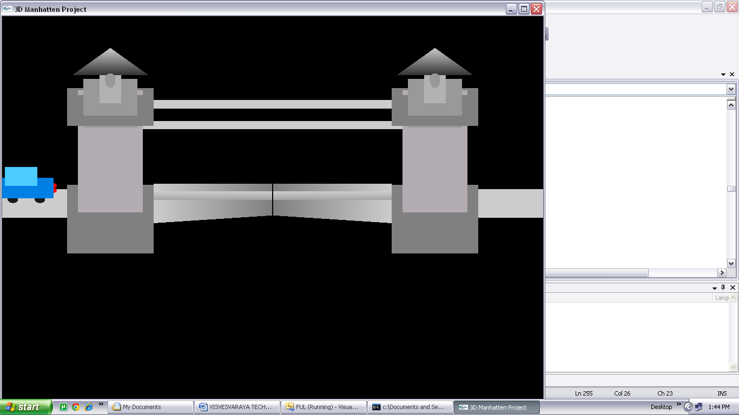
FIG 5.1 Initial Bridge
The snapshot 5.1 shows the initial position of bridge. The Bridge has been drawn using OpenGL and user defined functions.

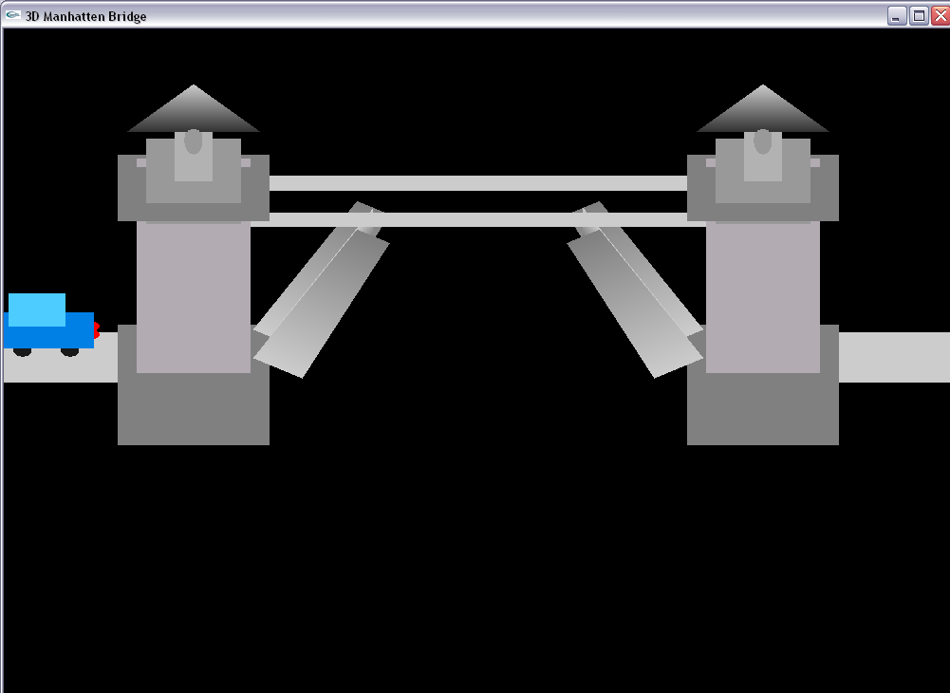
FIG 5.2 Opened Bridge
The snapshot 5.2 shows a bridge with opened gate which is done by pressing the key using keyboard interface.

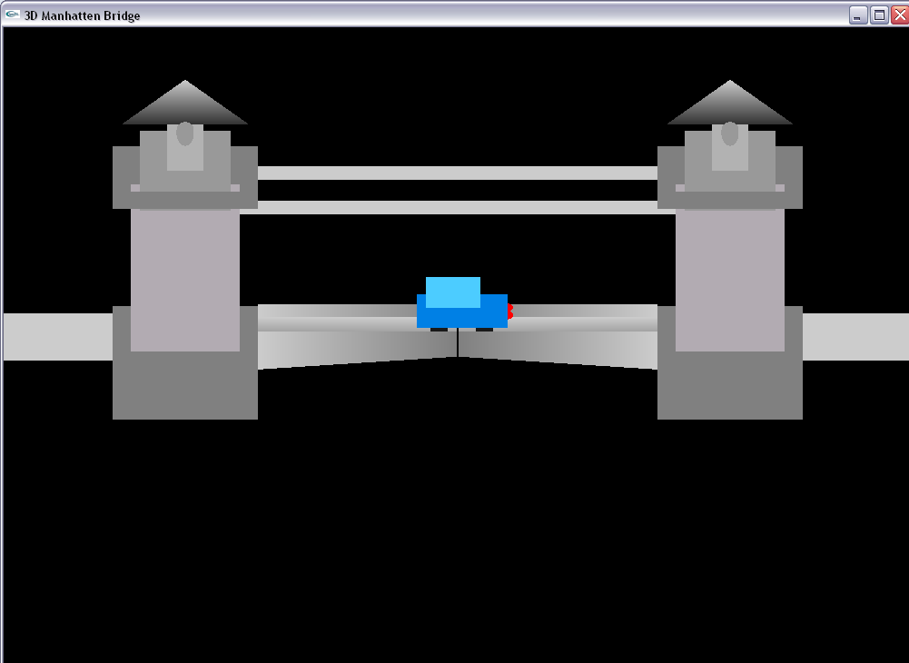
FIG 5.3 Car moving in forward direction.
The snapshot 5.3 shows a car moving in forward direction which is done using keyboard interface.

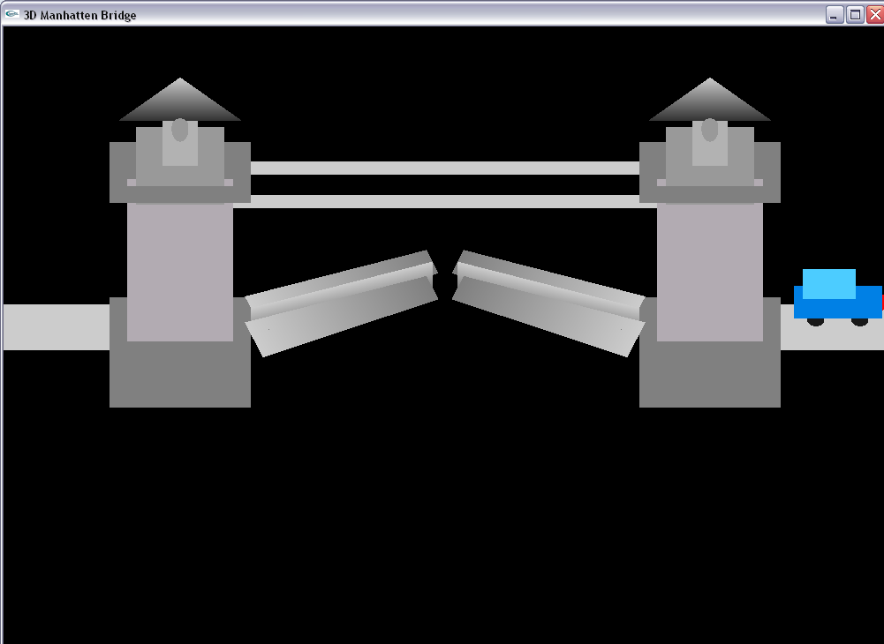
FIG 5.4 Closing of Bridge
The snapshot 5.4 shows that car has reached the destination and bridge is being closed which is done using keyboard interface.

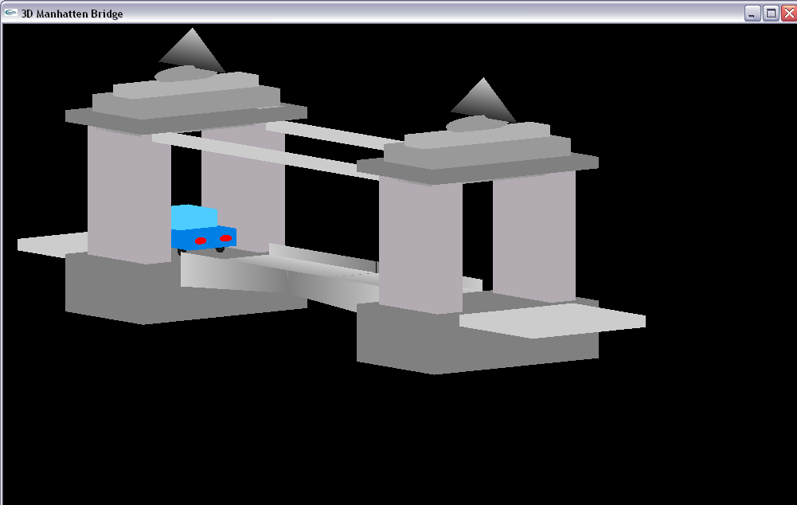
FIG 5.5(a) Bridge rotating in negative X axis.

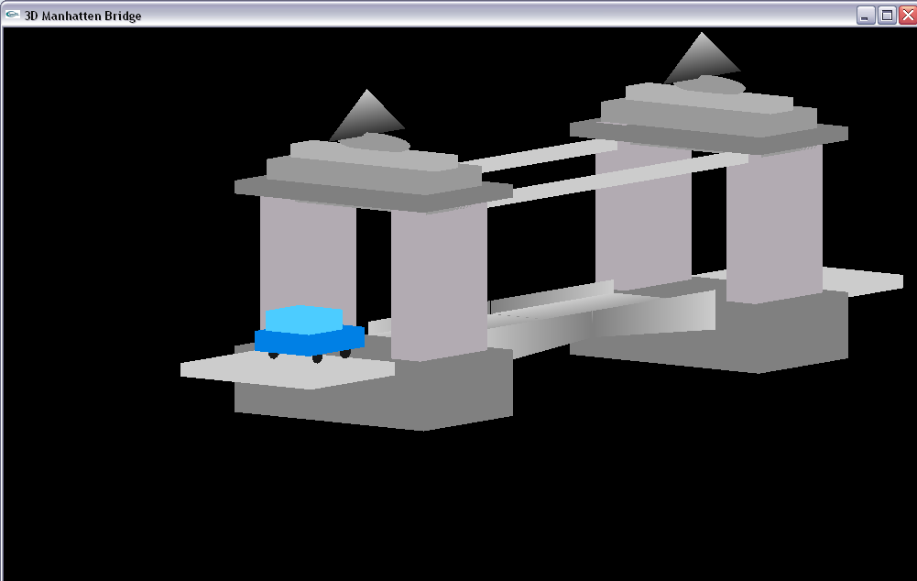
FIG 5.5(b) Bridge rotating in positive X axis.

The snapshot 5.5(a) and 5.5(b) shows the rotation of bridge. The rotation for the bridge is given through pressing the keys using keyboard interface.

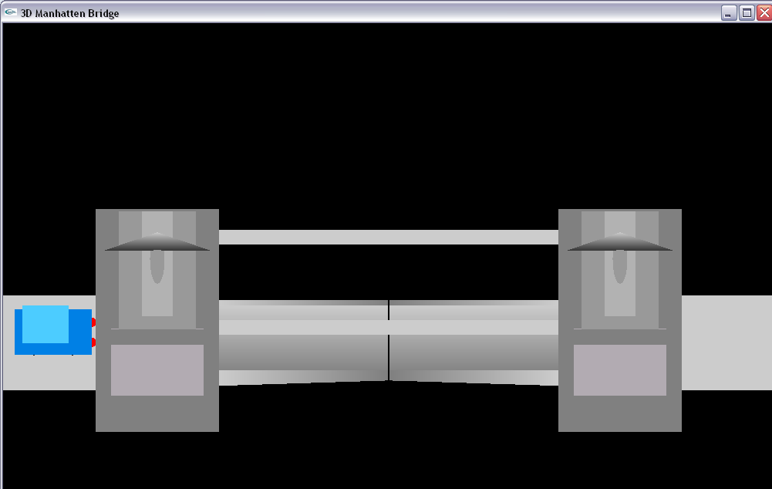
FIG 5.6(a) Bridge rotating in negative Y axis.

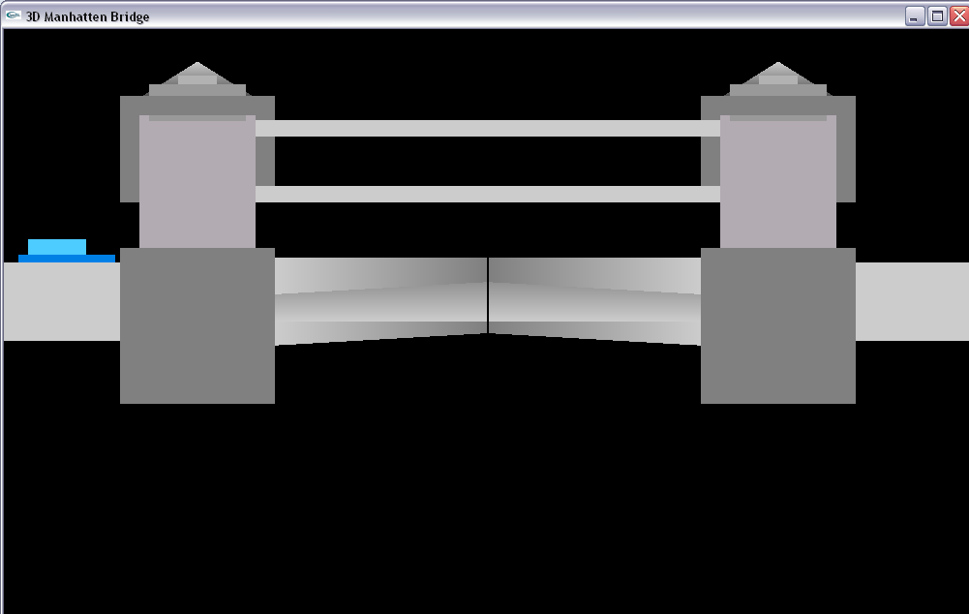
FIG 5.6(b) Bridge rotating in positive Y axis.

The snapshot 5.6(a) and 5.6(b) shows the rotation of bridge. The rotation for the bridge is given through pressing the keys using keyboard interface.

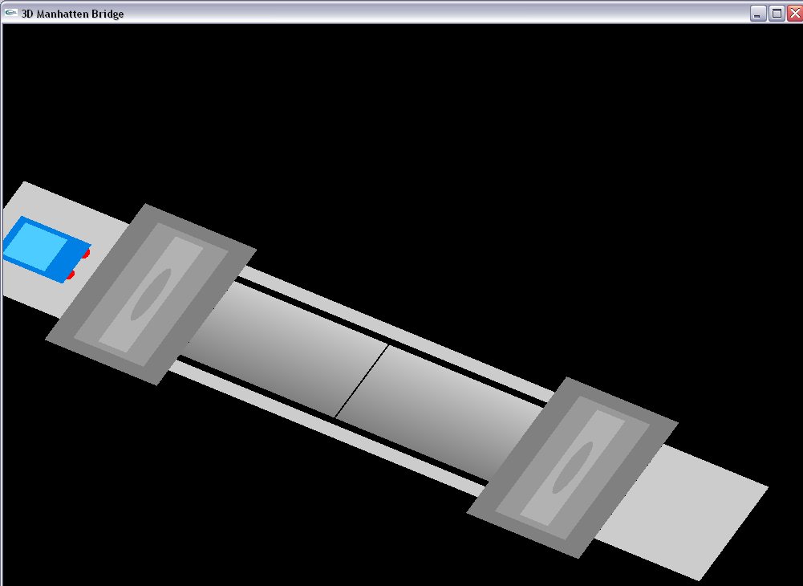
FIG 5.7(a) Bridge rotating in negative Z axis.
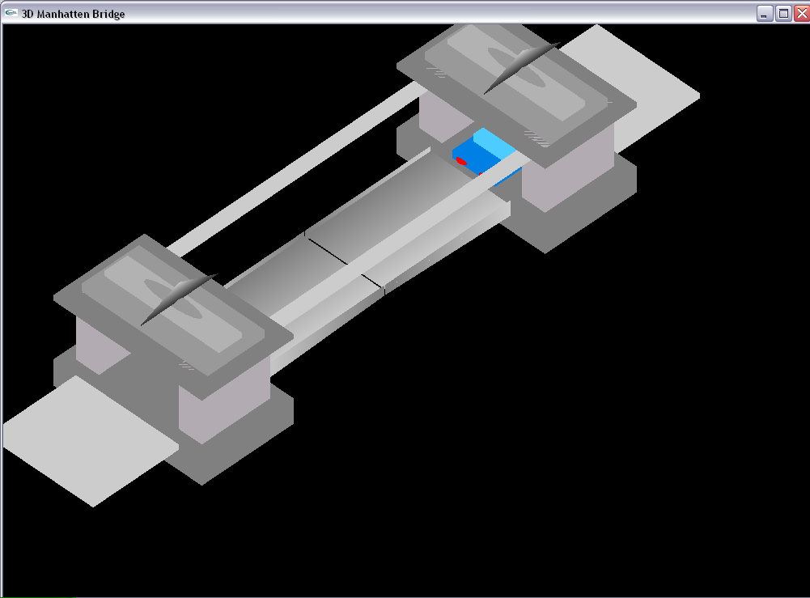
FIG 5.7(b) Bridge rotating in positive Z axis.

