**Snewflake:**

**Snowflake Architecture:**

**Cloud Service** 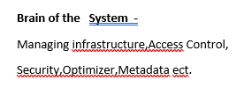

**Query Processing** Virtual Virtual virtual -**Muscle of the system-**

Warehouse Warehouse Warehouse Performs MMP

(Massive parallel Processing)

**Storage -Hybrid Columnar Storage-**

Saved in blobs

**Virtual Warehouse Sizes:**

**Xs -1(server) -Billed by Second- with 1 minute as minimum**

**S -2(server) -Multi-Clustering(more queries)**

**M -4(servers)**

**L—8**

**XL-16**

**4XL-128**

**Multi clustering**

**S * \***

**S * \***

**S * \***

**Create Warehouse**

CREATE WAREHOUSE TEST_WH WITH WAREHOUSE_SIZE = 'XSMALL' WAREHOUSE_TYPE = 'STANDARD' AUTO_SUSPEND = 600 AUTO_RESUME = TRUE MIN_CLUSTER_COUNT = 1 MAX_CLUSTER_COUNT = 3 SCALING_POLICY = 'STANDARD' COMMENT = 'This is my First warehouse';

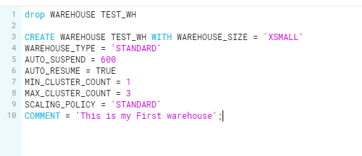

**Scaling:**

**>Auto Scaling 🡪 When to start an additional cluster**

**Scalling**

**Standared (Default) Economy**

**(Favor starting additiona WH(SAWH)) (Favors Conserving credits rather then SAWH)**

**Standered:**

1.Immediately when either a query is queued or the system detects that there are more queries then can be executed by the currentlyavailable cluster.

2. After 2 to 3 consecutive successful checks(performed at 1 minute intervals),

Which determine whether the load on the least-loaded cluster could be redistributed to the other cluster

**Economy:**

1.Only if the system estimates there’s enough query load to keep the cluster busy for at least 6 minutes

2.After 5 to 6 consecutive successdul check

**Creationg DB:**

**CREATE DATABASE My_First_DB COMMENT = 'This is my First DB';**

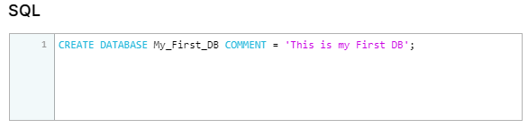

**Creating the Table :**

**CREATE TABLE "MY_FIRST_DB"."PUBLIC"."FIRST_TABLE" ("ID" INTEGER NOT NULL, "NAME" STRING NOT NULL) COMMENT = 'My First Table';**

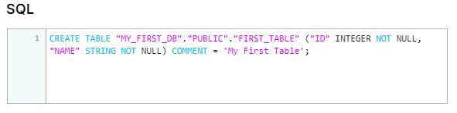

**//Creating the table / Meta data**

**CREATE TABLE "OUR_FIRST_DB"."PUBLIC"."LOAN_PAYMENT" (**

**"Loan_ID" STRING,**

**"loan_status" STRING,**

**"Principal" STRING,**

**"terms" STRING,**

**"effective_date" STRING,**

**"due_date" STRING,**

**"paid_off_time" STRING,**

**"past_due_days" STRING,**

**"age" STRING,**

**"education" STRING,**

**"Gender" STRING);**

**//Check that table is empy**

**USE DATABASE OUR_FIRST_DB;**

**SELECT * FROM LOAN_PAYMENT;**

**//Loading the data from S3 bucket**

**COPY INTO LOAN_PAYMENT**

**FROM s3://bucketsnowflakes3/Loan_payments_data.csv**

**file_format = (type = csv**

**field_delimiter = ','**

**skip_header=1);**

**//Validate**

**SELECT * FROM LOAN_PAYMENT;**

**Data WareHouse**

**HR data**

**ETL**

**Sales data**

**Data Warehouse**

**=Database that is used for reporting and data analysis**

**ETL=Extract , Transform & Load**

**Reporting**

**Different Layer**

**HR data data Science**

**Other apps**

**Sales data**

**Raw Data --🡪 data integration🡪 Access layer**

**Data Sources**

**Raw layer -- Staging Area**

**Data Integration --- Data Transformation**

**Cloud Computing**

**Data centre(infrastructure,security, electricity,software/hardware Upgrades)**

**Software-as-a Services**

**Application databases,tables,ect**

**|**

**Software Snowflake**

**| managing data storage,Virtual**

**Software as a service Data Warehouses,**

**| Upgrades/Metadata ect.**

**Operation System**

**|**

**Physical Servers**

**| Cloud Provider**

**Virtual Machines AWS,Azure,GCP**

**|**

**Physical Storage**

**GCP-Google Cloud Platform**

**Snowflack Editions**

**1.Standard - ----** introductory level

**2.Enterprise ---**additional features for the needs of large-scale enterprises (multi-cluster warehouse)

**3.Business Critical ---**even higher level of data protection for orrganizations with extremely sensitive data(Extended support)

**4.Virtual Private –** Highest level of security

Snowflack pricking depends on region,Plotform,service, size

Compute cast

Storage cast -🡪 1.on Demand storage 2.Capacity Storage

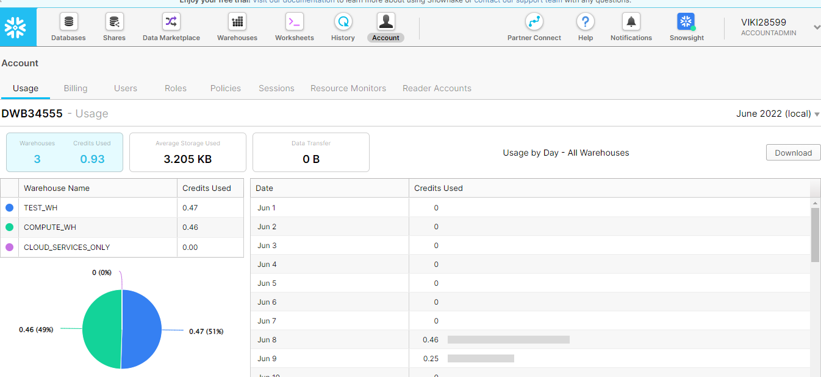

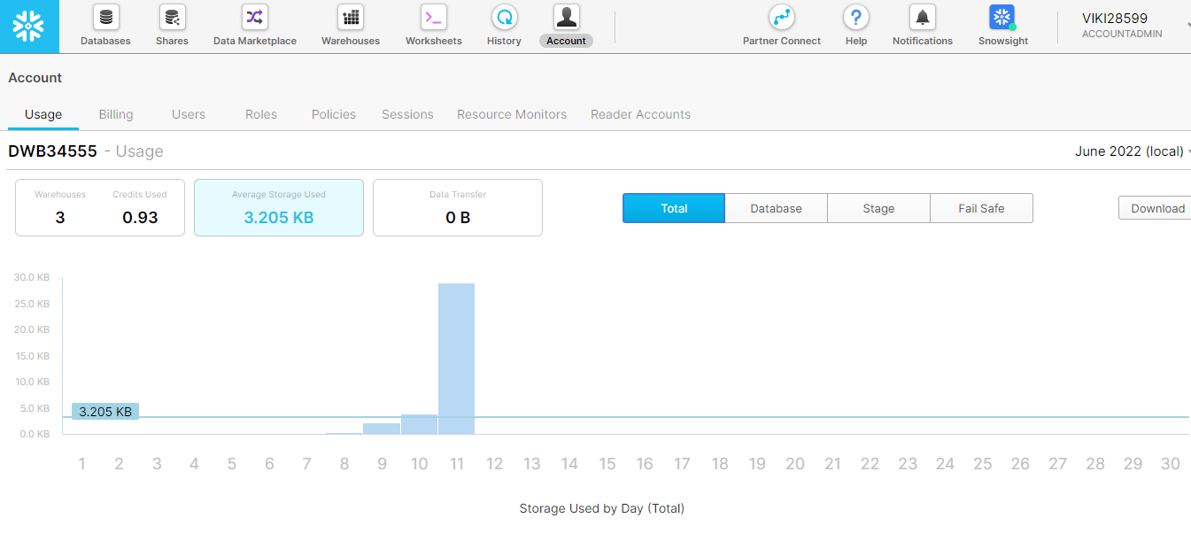

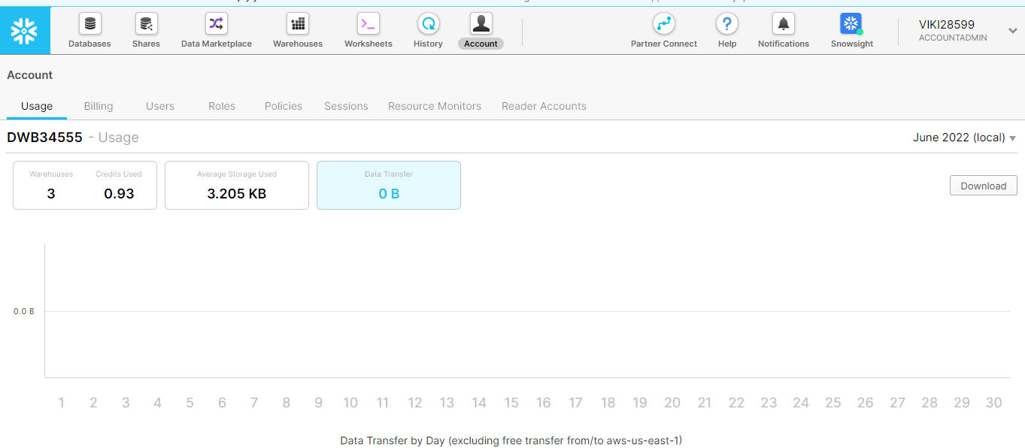

SnowFlack Roles

ACCOUNTADMIN

SYSADMIN

SECURITYADMIN

Custom Role Custom Role

Custom Role 2

Custom Role 1

USERADMIN

Custom Role 3

PUBLIC

**ACCOUNTADIMN :**

**1.SYSADMIN and SECURITYADIMN**

**2.Top-levelrole in the system**

**3.should be granted only to a limites number of users**

**SECURITYADMIN:**

**1.USERADMINrole is granted to SECURITYADMIN**

**2.Can manage users and roles**

**3.Can manage any object grant globally**

**SYSADMIN:**

**1.create warehouses and databases(and more objects)**

**2.REcommented that all custom roles are assigned**

**USERADMIN:**

**1.Dedicated to user and role management only**

**2.Can create users and roles**

**PUBLIC:**

**1.Automatically granted to every user**

**2.can create own objects like every other role(available to every other user/role)**

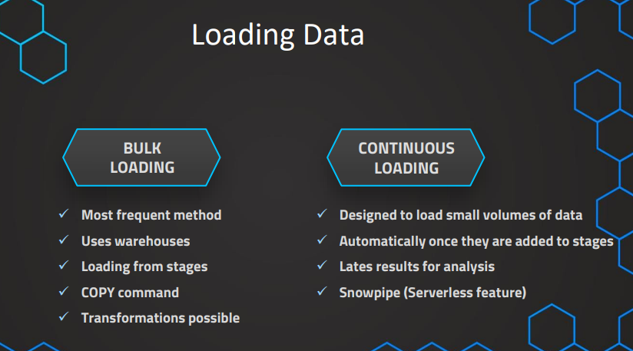

**Snowpipe (Serverless feature)**

**Stages:**

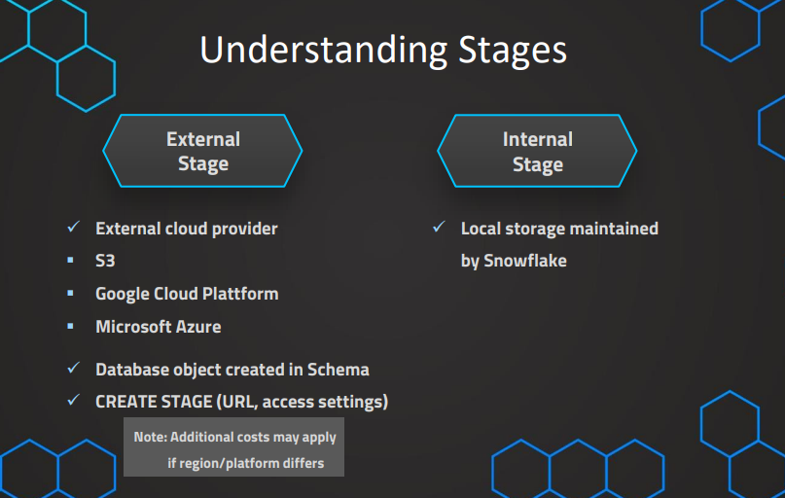

// Database to manage stage objects, fileformats etc.

CREATE OR REPLACE DATABASE MANAGE_DB;

CREATE OR REPLACE SCHEMA external_stages;

// Creating external stage

CREATE OR REPLACE STAGE MANAGE_DB.external_stages.aws_stage

url='s3://bucketsnowflakes3'

credentials=(aws_key_id='ABCD_DUMMY_ID' aws_secret_key='1234abcd_key');

Copy Comment

// Creating ORDERS table

CREATE OR REPLACE TABLE OUR_FIRST_DB.PUBLIC.ORDERS (

ORDER_ID VARCHAR(30),

AMOUNT INT,

PROFIT INT,

QUANTITY INT,

CATEGORY VARCHAR(30),

SUBCATEGORY VARCHAR(30));

SELECT * FROM OUR_FIRST_DB.PUBLIC.ORDERS;

// First copy command

COPY INTO OUR_FIRST_DB.PUBLIC.ORDERS

FROM @aws_stage

file_format = (type = csv field_delimiter=',' skip_header=1);

// Copy command with fully qualified stage object

COPY INTO OUR_FIRST_DB.PUBLIC.ORDERS

FROM @MANAGE_DB.external_stages.aws_stage

file_format= (type = csv field_delimiter=',' skip_header=1);

// List files contained in stage

LIST @MANAGE_DB.external_stages.aws_stage;

// Copy command with specified file(s)

COPY INTO OUR_FIRST_DB.PUBLIC.ORDERS

FROM @MANAGE_DB.external_stages.aws_stage

file_format= (type = csv field_delimiter=',' skip_header=1)

files = ('OrderDetails.csv');

// Copy command with pattern for file names

COPY INTO OUR_FIRST_DB.PUBLIC.ORDERS

FROM @MANAGE_DB.external_stages.aws_stage

file_format= (type = csv field_delimiter=',' skip_header=1)

pattern='.*Order.*';

// Description of external stage

DESC STAGE MANAGE_DB.external_stages.aws_stage;

// Alter external stage

ALTER STAGE aws_stage

SET credentials=(aws_key_id='XYZ_DUMMY_ID' aws_secret_key='987xyz');

// Publicly accessible staging area

CREATE OR REPLACE STAGE MANAGE_DB.external_stages.aws_stage

url='s3://bucketsnowflakes3';

// List files in stage

LIST @aws_stage;

//Load data using copy command

COPY INTO OUR_FIRST_DB.PUBLIC.ORDERS

FROM @aws_stage

file_format= (type = csv field_delimiter=',' skip_header=1)

pattern='.*Order.*';

Transforming Data

// Transforming using the SELECT statement

COPY INTO OUR_FIRST_DB.PUBLIC.ORDERS_EX

FROM (select s.$1, s.$2 from @MANAGE_DB.external_stages.aws_stage s)

file_format= (type = csv field_delimiter=',' skip_header=1)

files=('OrderDetails.csv');

// Example 1 - Table

CREATE OR REPLACE TABLE OUR_FIRST_DB.PUBLIC.ORDERS_EX (

ORDER_ID VARCHAR(30),

AMOUNT INT

)

SELECT * FROM OUR_FIRST_DB.PUBLIC.ORDERS_EX;

// Example 2 - Table

CREATE OR REPLACE TABLE OUR_FIRST_DB.PUBLIC.ORDERS_EX (

ORDER_ID VARCHAR(30),

AMOUNT INT,

PROFIT INT,

PROFITABLE_FLAG VARCHAR(30)

)

// Example 2 - Copy Command using a SQL function (subset of functions available)

COPY INTO OUR_FIRST_DB.PUBLIC.ORDERS_EX

FROM (select

s.$1,

s.$2,

s.$3,

CASE WHEN CAST(s.$3 as int) < 0 THEN 'not profitable' ELSE 'profitable' END

from @MANAGE_DB.external_stages.aws_stage s)

file_format= (type = csv field_delimiter=',' skip_header=1)

files=('OrderDetails.csv');

SELECT * FROM OUR_FIRST_DB.PUBLIC.ORDERS_EX

// Example 3 - Table

CREATE OR REPLACE TABLE OUR_FIRST_DB.PUBLIC.ORDERS_EX (

ORDER_ID VARCHAR(30),

AMOUNT INT,

PROFIT INT,

CATEGORY_SUBSTRING VARCHAR(5)

)

// Example 3 - Copy Command using a SQL function (subset of functions available)

COPY INTO OUR_FIRST_DB.PUBLIC.ORDERS_EX

FROM (select

s.$1,

s.$2,

s.$3,

substring(s.$5,1,5)

from @MANAGE_DB.external_stages.aws_stage s)

file_format= (type = csv field_delimiter=',' skip_header=1)

files=('OrderDetails.csv');

SELECT * FROM OUR_FIRST_DB.PUBLIC.ORDERS_EX

//Example 3 - Table

CREATE OR REPLACE TABLE OUR_FIRST_DB.PUBLIC.ORDERS_EX (

ORDER_ID VARCHAR(30),

AMOUNT INT,

PROFIT INT,

PROFITABLE_FLAG VARCHAR(30)

)

//Example 4 - Using subset of columns

COPY INTO OUR_FIRST_DB.PUBLIC.ORDERS_EX (ORDER_ID,PROFIT)

FROM (select

s.$1,

s.$3

from @MANAGE_DB.external_stages.aws_stage s)

file_format= (type = csv field_delimiter=',' skip_header=1)

files=('OrderDetails.csv');

SELECT * FROM OUR_FIRST_DB.PUBLIC.ORDERS_EX;

//Example 5 - Table Auto increment

CREATE OR REPLACE TABLE OUR_FIRST_DB.PUBLIC.ORDERS_EX (

ORDER_ID number autoincrement start 1 increment 1,

AMOUNT INT,

PROFIT INT,

PROFITABLE_FLAG VARCHAR(30)

)

//Example 5 - Auto increment ID

COPY INTO OUR_FIRST_DB.PUBLIC.ORDERS_EX (PROFIT,AMOUNT)

FROM (select

s.$2,

s.$3

from @MANAGE_DB.external_stages.aws_stage s)

file_format= (type = csv field_delimiter=',' skip_header=1)

files=('OrderDetails.csv');

SELECT * FROM OUR_FIRST_DB.PUBLIC.ORDERS_EX WHERE ORDER_ID > 15;

DROP TABLE OUR_FIRST_DB.PUBLIC.ORDERS_EX

// Create new stage

CREATE OR REPLACE STAGE MANAGE_DB.external_stages.aws_stage_errorex

url='s3://bucketsnowflakes4'

// List files in stage

LIST @MANAGE_DB.external_stages.aws_stage_errorex;

// Create example table

CREATE OR REPLACE TABLE OUR_FIRST_DB.PUBLIC.ORDERS_EX (

ORDER_ID VARCHAR(30),

AMOUNT INT,

PROFIT INT,

QUANTITY INT,

CATEGORY VARCHAR(30),

SUBCATEGORY VARCHAR(30));

// Demonstrating error message

COPY INTO OUR_FIRST_DB.PUBLIC.ORDERS_EX

FROM @MANAGE_DB.external_stages.aws_stage_errorex

file_format= (type = csv field_delimiter=',' skip_header=1)

files = ('OrderDetails_error.csv');

// Validating table is empty

SELECT * FROM OUR_FIRST_DB.PUBLIC.ORDERS_EX

// Error handling using the ON_ERROR option

COPY INTO OUR_FIRST_DB.PUBLIC.ORDERS_EX

FROM @MANAGE_DB.external_stages.aws_stage_errorex

file_format= (type = csv field_delimiter=',' skip_header=1)

files = ('OrderDetails_error.csv')

ON_ERROR = 'CONTINUE';

// Validating results and truncating table

SELECT * FROM OUR_FIRST_DB.PUBLIC.ORDERS_EX

SELECT COUNT(*) FROM OUR_FIRST_DB.PUBLIC.ORDERS_EX

TRUNCATE TABLE OUR_FIRST_DB.PUBLIC.ORDERS_EX;

// Error handling using the ON_ERROR option = ABORT_STATEMENT (default)

COPY INTO OUR_FIRST_DB.PUBLIC.ORDERS_EX

FROM @MANAGE_DB.external_stages.aws_stage_errorex

file_format= (type = csv field_delimiter=',' skip_header=1)

files = ('OrderDetails_error.csv','OrderDetails_error2.csv')

ON_ERROR = 'ABORT_STATEMENT';

// Validating results and truncating table

SELECT * FROM OUR_FIRST_DB.PUBLIC.ORDERS_EX

SELECT COUNT(*) FROM OUR_FIRST_DB.PUBLIC.ORDERS_EX

TRUNCATE TABLE OUR_FIRST_DB.PUBLIC.ORDERS_EX;

// Error handling using the ON_ERROR option = SKIP_FILE

COPY INTO OUR_FIRST_DB.PUBLIC.ORDERS_EX

FROM @MANAGE_DB.external_stages.aws_stage_errorex

file_format= (type = csv field_delimiter=',' skip_header=1)

files = ('OrderDetails_error.csv','OrderDetails_error2.csv')

ON_ERROR = 'SKIP_FILE';

// Validating results and truncating table

SELECT * FROM OUR_FIRST_DB.PUBLIC.ORDERS_EX

SELECT COUNT(*) FROM OUR_FIRST_DB.PUBLIC.ORDERS_EX

TRUNCATE TABLE OUR_FIRST_DB.PUBLIC.ORDERS_EX;

Copy Option ONERROR

// Error handling using the ON_ERROR option = SKIP_FILE_<number>

COPY INTO OUR_FIRST_DB.PUBLIC.ORDERS_EX

FROM @MANAGE_DB.external_stages.aws_stage_errorex

file_format= (type = csv field_delimiter=',' skip_header=1)

files = ('OrderDetails_error.csv','OrderDetails_error2.csv')

ON_ERROR = 'SKIP_FILE_2';

// Validating results and truncating table

SELECT * FROM OUR_FIRST_DB.PUBLIC.ORDERS_EX

SELECT COUNT(*) FROM OUR_FIRST_DB.PUBLIC.ORDERS_EX

TRUNCATE TABLE OUR_FIRST_DB.PUBLIC.ORDERS_EX;

// Error handling using the ON_ERROR option = SKIP_FILE_<number>

COPY INTO OUR_FIRST_DB.PUBLIC.ORDERS_EX

FROM @MANAGE_DB.external_stages.aws_stage_errorex

file_format= (type = csv field_delimiter=',' skip_header=1)

files = ('OrderDetails_error.csv','OrderDetails_error2.csv')

ON_ERROR = 'SKIP_FILE_0.5%';

SELECT * FROM OUR_FIRST_DB.PUBLIC.ORDERS_EX

CREATE OR REPLACE TABLE OUR_FIRST_DB.PUBLIC.ORDERS_EX (

ORDER_ID VARCHAR(30),

AMOUNT INT,

PROFIT INT,

QUANTITY INT,

CATEGORY VARCHAR(30),

SUBCATEGORY VARCHAR(30));

COPY INTO OUR_FIRST_DB.PUBLIC.ORDERS_EX

FROM @MANAGE_DB.external_stages.aws_stage_errorex

file_format= (type = csv field_delimiter=',' skip_header=1)

files = ('OrderDetails_error.csv','OrderDetails_error2.csv')

ON_ERROR = SKIP_FILE_3

SIZE_LIMIT = 30;

File Formater

// Specifying file_format in Copy command

COPY INTO OUR_FIRST_DB.PUBLIC.ORDERS_EX

FROM @MANAGE_DB.external_stages.aws_stage_errorex

file_format = (type = csv field_delimiter=',' skip_header=1)

files = ('OrderDetails_error.csv')

ON_ERROR = 'SKIP_FILE_3';

// Creating table

CREATE OR REPLACE TABLE OUR_FIRST_DB.PUBLIC.ORDERS_EX (

ORDER_ID VARCHAR(30),

AMOUNT INT,

PROFIT INT,

QUANTITY INT,

CATEGORY VARCHAR(30),

SUBCATEGORY VARCHAR(30));

// Creating schema to keep things organized

CREATE OR REPLACE SCHEMA MANAGE_DB.file_formats;

// Creating file format object

CREATE OR REPLACE file format MANAGE_DB.file_formats.my_file_format;

// See properties of file format object

DESC file format MANAGE_DB.file_formats.my_file_format;

// Using file format object in Copy command

COPY INTO OUR_FIRST_DB.PUBLIC.ORDERS_EX

FROM @MANAGE_DB.external_stages.aws_stage_errorex

file_format= (FORMAT_NAME=MANAGE_DB.file_formats.my_file_format)

files = ('OrderDetails_error.csv')

ON_ERROR = 'SKIP_FILE_3';

// Altering file format object

ALTER file format MANAGE_DB.file_formats.my_file_format

SET SKIP_HEADER = 1;

// Defining properties on creation of file format object

CREATE OR REPLACE file format MANAGE_DB.file_formats.my_file_format

TYPE=JSON,

TIME_FORMAT=AUTO;

// See properties of file format object

DESC file format MANAGE_DB.file_formats.my_file_format;

// Using file format object in Copy command

COPY INTO OUR_FIRST_DB.PUBLIC.ORDERS_EX

FROM @MANAGE_DB.external_stages.aws_stage_errorex

file_format= (FORMAT_NAME=MANAGE_DB.file_formats.my_file_format)

files = ('OrderDetails_error.csv')

ON_ERROR = 'SKIP_FILE_3';

// Altering the type of a file format is not possible

ALTER file format MANAGE_DB.file_formats.my_file_format

SET TYPE = CSV;

// Recreate file format (default = CSV)

CREATE OR REPLACE file format MANAGE_DB.file_formats.my_file_format

// See properties of file format object

DESC file format MANAGE_DB.file_formats.my_file_format;

// Truncate table

TRUNCATE table OUR_FIRST_DB.PUBLIC.ORDERS_EX;

// Overwriting properties of file format object

COPY INTO OUR_FIRST_DB.PUBLIC.ORDERS_EX

FROM @MANAGE_DB.external_stages.aws_stage_errorex

file_format = (FORMAT_NAME= MANAGE_DB.file_formats.my_file_format field_delimiter = ',' skip_header=1 )

files = ('OrderDetails_error.csv')

ON_ERROR = 'SKIP_FILE_3';

DESC STAGE MANAGE_DB.external_stages.aws_stage_errorex;