Knowledge Graph Application

Table of Contents
- Start Services
- CSV Upload
- Query Neighborhood
- Add Relationship & Query Neighborhood
- Shortest Path

Start services

Start frontend
Assignment-1 % ls -l
192 Dec 14 23:19 backend
21951 Aug 27 2023 delhi_metro.csv
288 Dec 14 21:26 frontend

Assignment-1 % cd ./frontend/build/
Assignment-1 % python3 -m http.server 3000
Serving HTTP on :: port 3000 (http://[::]:3000/) ...

Start backend
Assignment-1 % ls -l
192 Dec 14 23:19 backend
21951 Aug 27 2023 delhi_metro.csv
288 Dec 14 21:26 frontend

Assignment-1 % cd ./backend/
Assignment-1 % python3 DelhiMetroKGApp.py
🚇 Delhi Metro Knowledge Graph API Started
Current Graph: 0 stations, 0 edges
Upload delhi_metro.csv via the UI to load the full metro network
* Serving Flask app 'DelhiMetroKGApp'
* Debug mode: on
WARNING: This is a development server. Do not use it in a production deployment. Use a production WSGI server instead.
* Running on http://127.0.0.1:5000

CSV Upload
Upload delhi_metro.csv via the UI to load the full metro network

Steps:
- Reach URL http://localhost:3000/ and Download delhi-metro-dataset
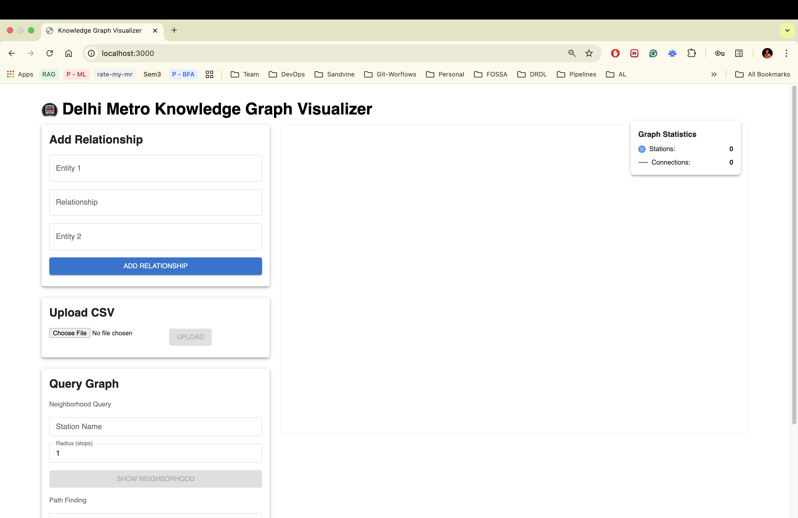
- Click on upload button and upload delhi-metro-dataset CSV file 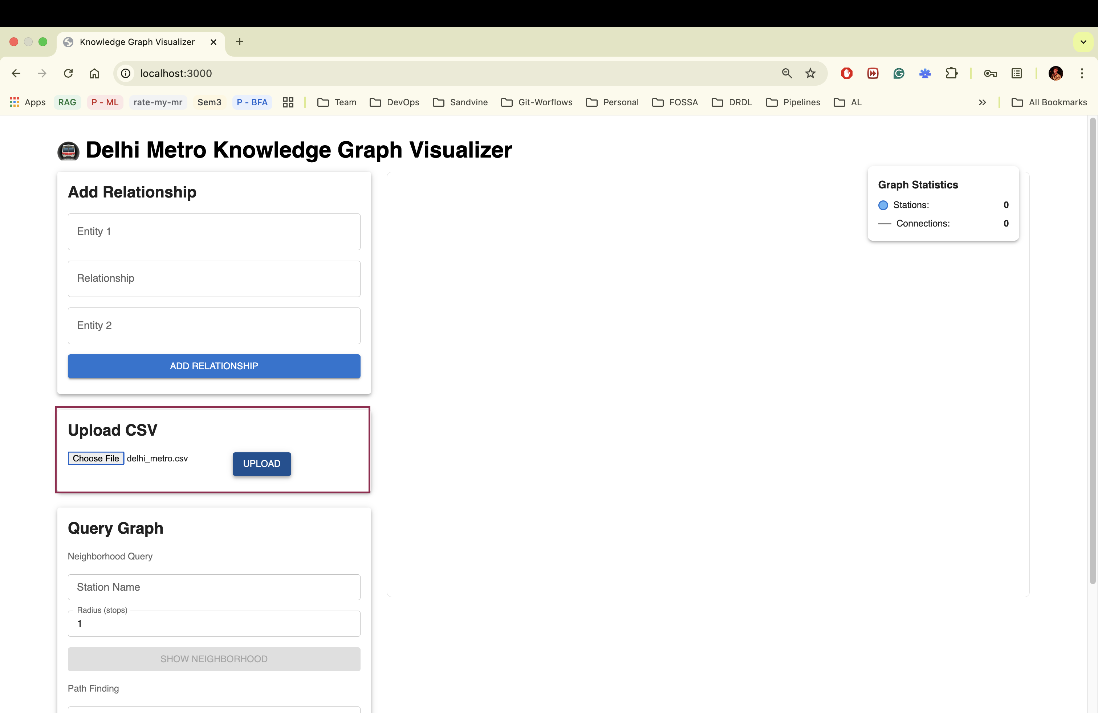
- Ack: Successful message
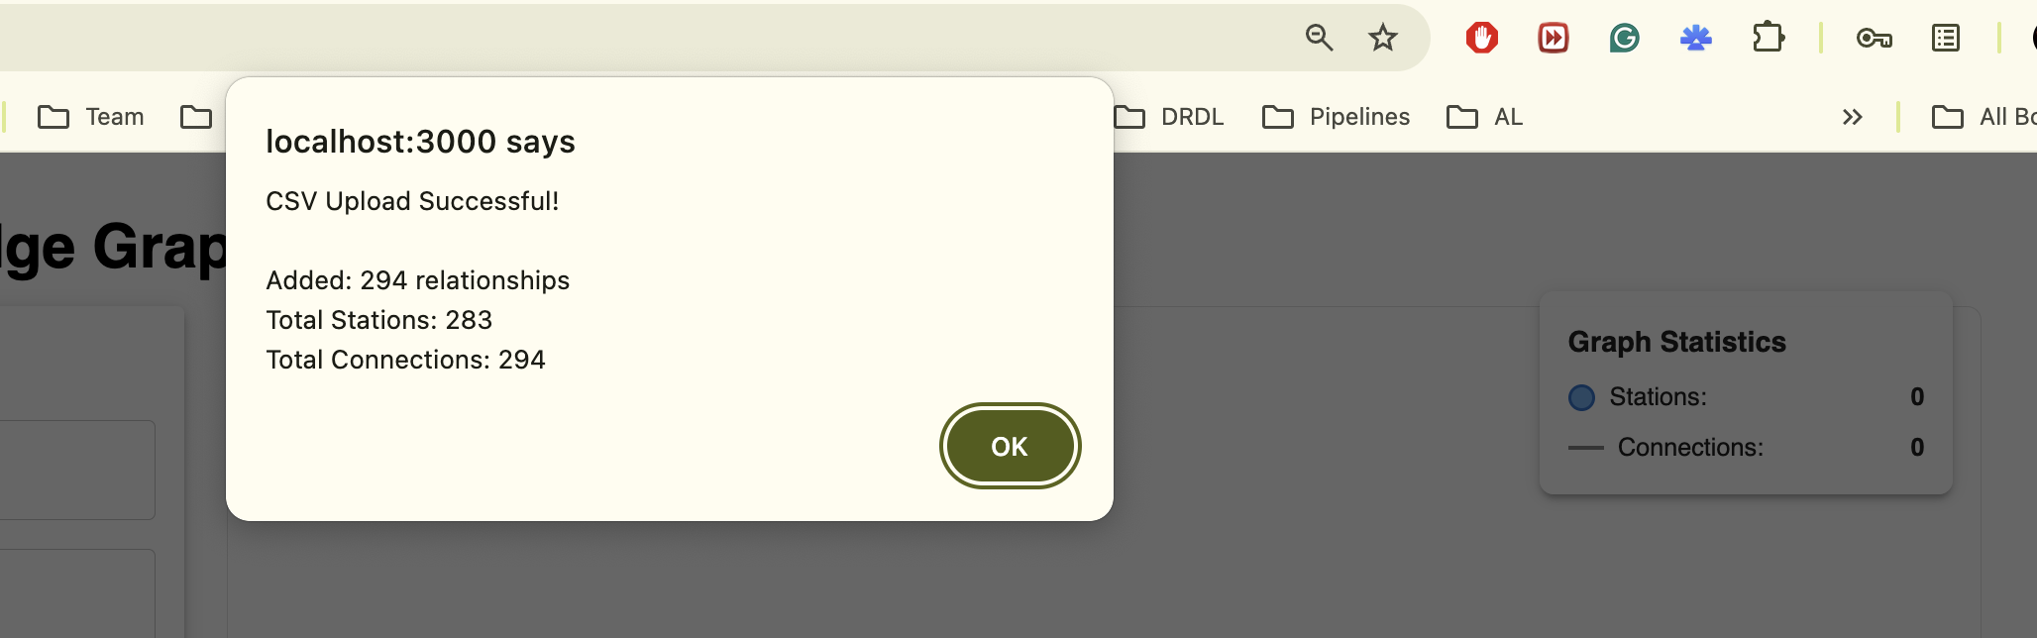
- Graph visualization loaded instantly
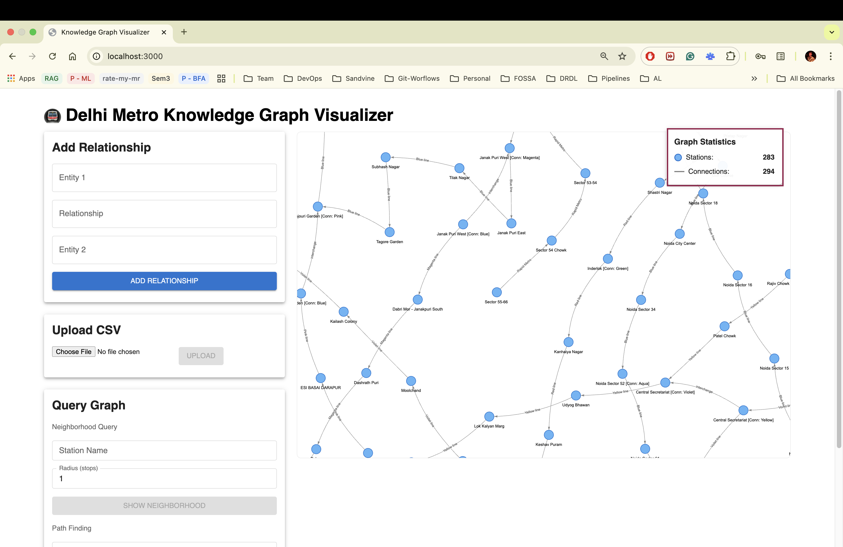

Query Neighborhood
Test neighborhood query to see both metro and walking connections

Steps:
- Enter Station Name: Central Secretariat [Conn: Violet]
- Enter Radius: 1 (Immediate Neighbor) / Radius: 2 (Extended Neighbor)
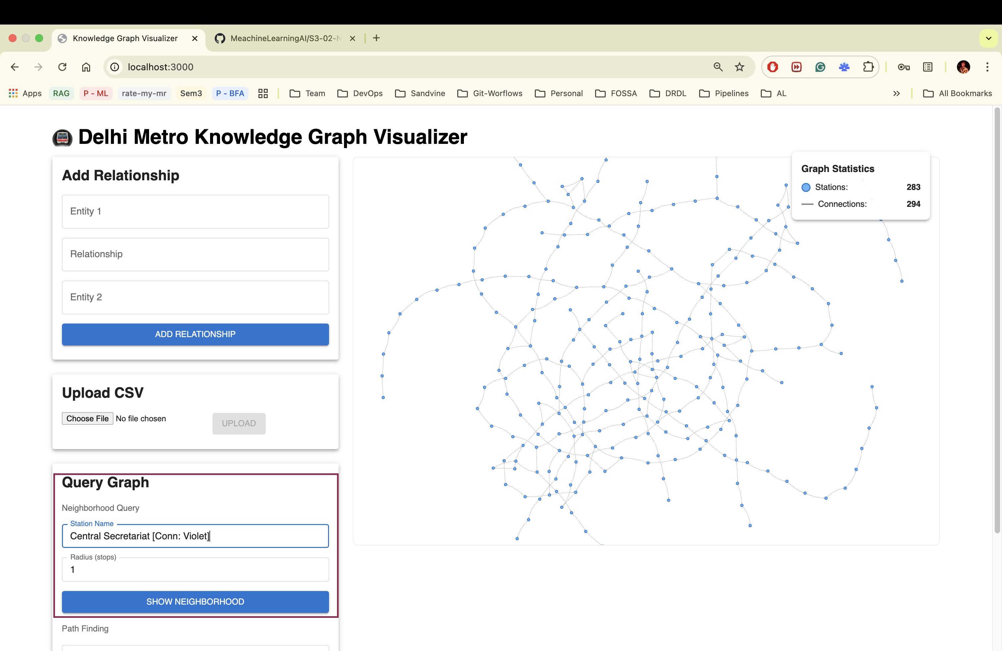
- Click on SHOW NEIGHBORHOOD button to show neighbors of the station
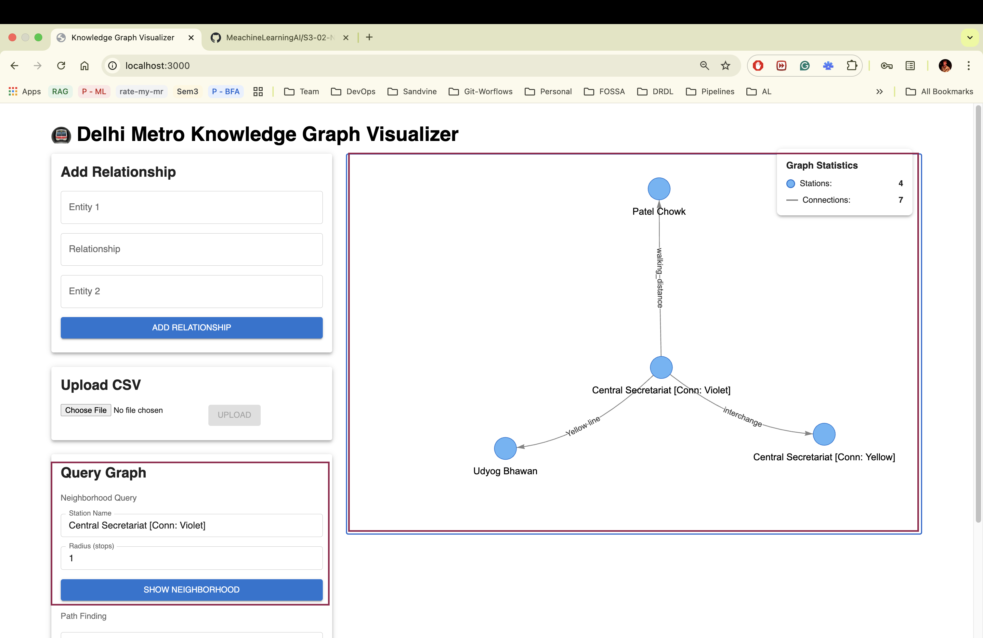

Add Relationship & Query Neighborhood
Add/Create/Update relationship between entities also test the Neighborhood of the created entity.
- Enter Entity 1: Central Secretariat [Conn: Violet]
- Enter Relationship: walking_distance
- Enter Entity 2: Udyog Bhawan
- Click on “ADD RELATIONSHIP” button
- You Will notice that connection from 294 to 295 in the Graph Legend
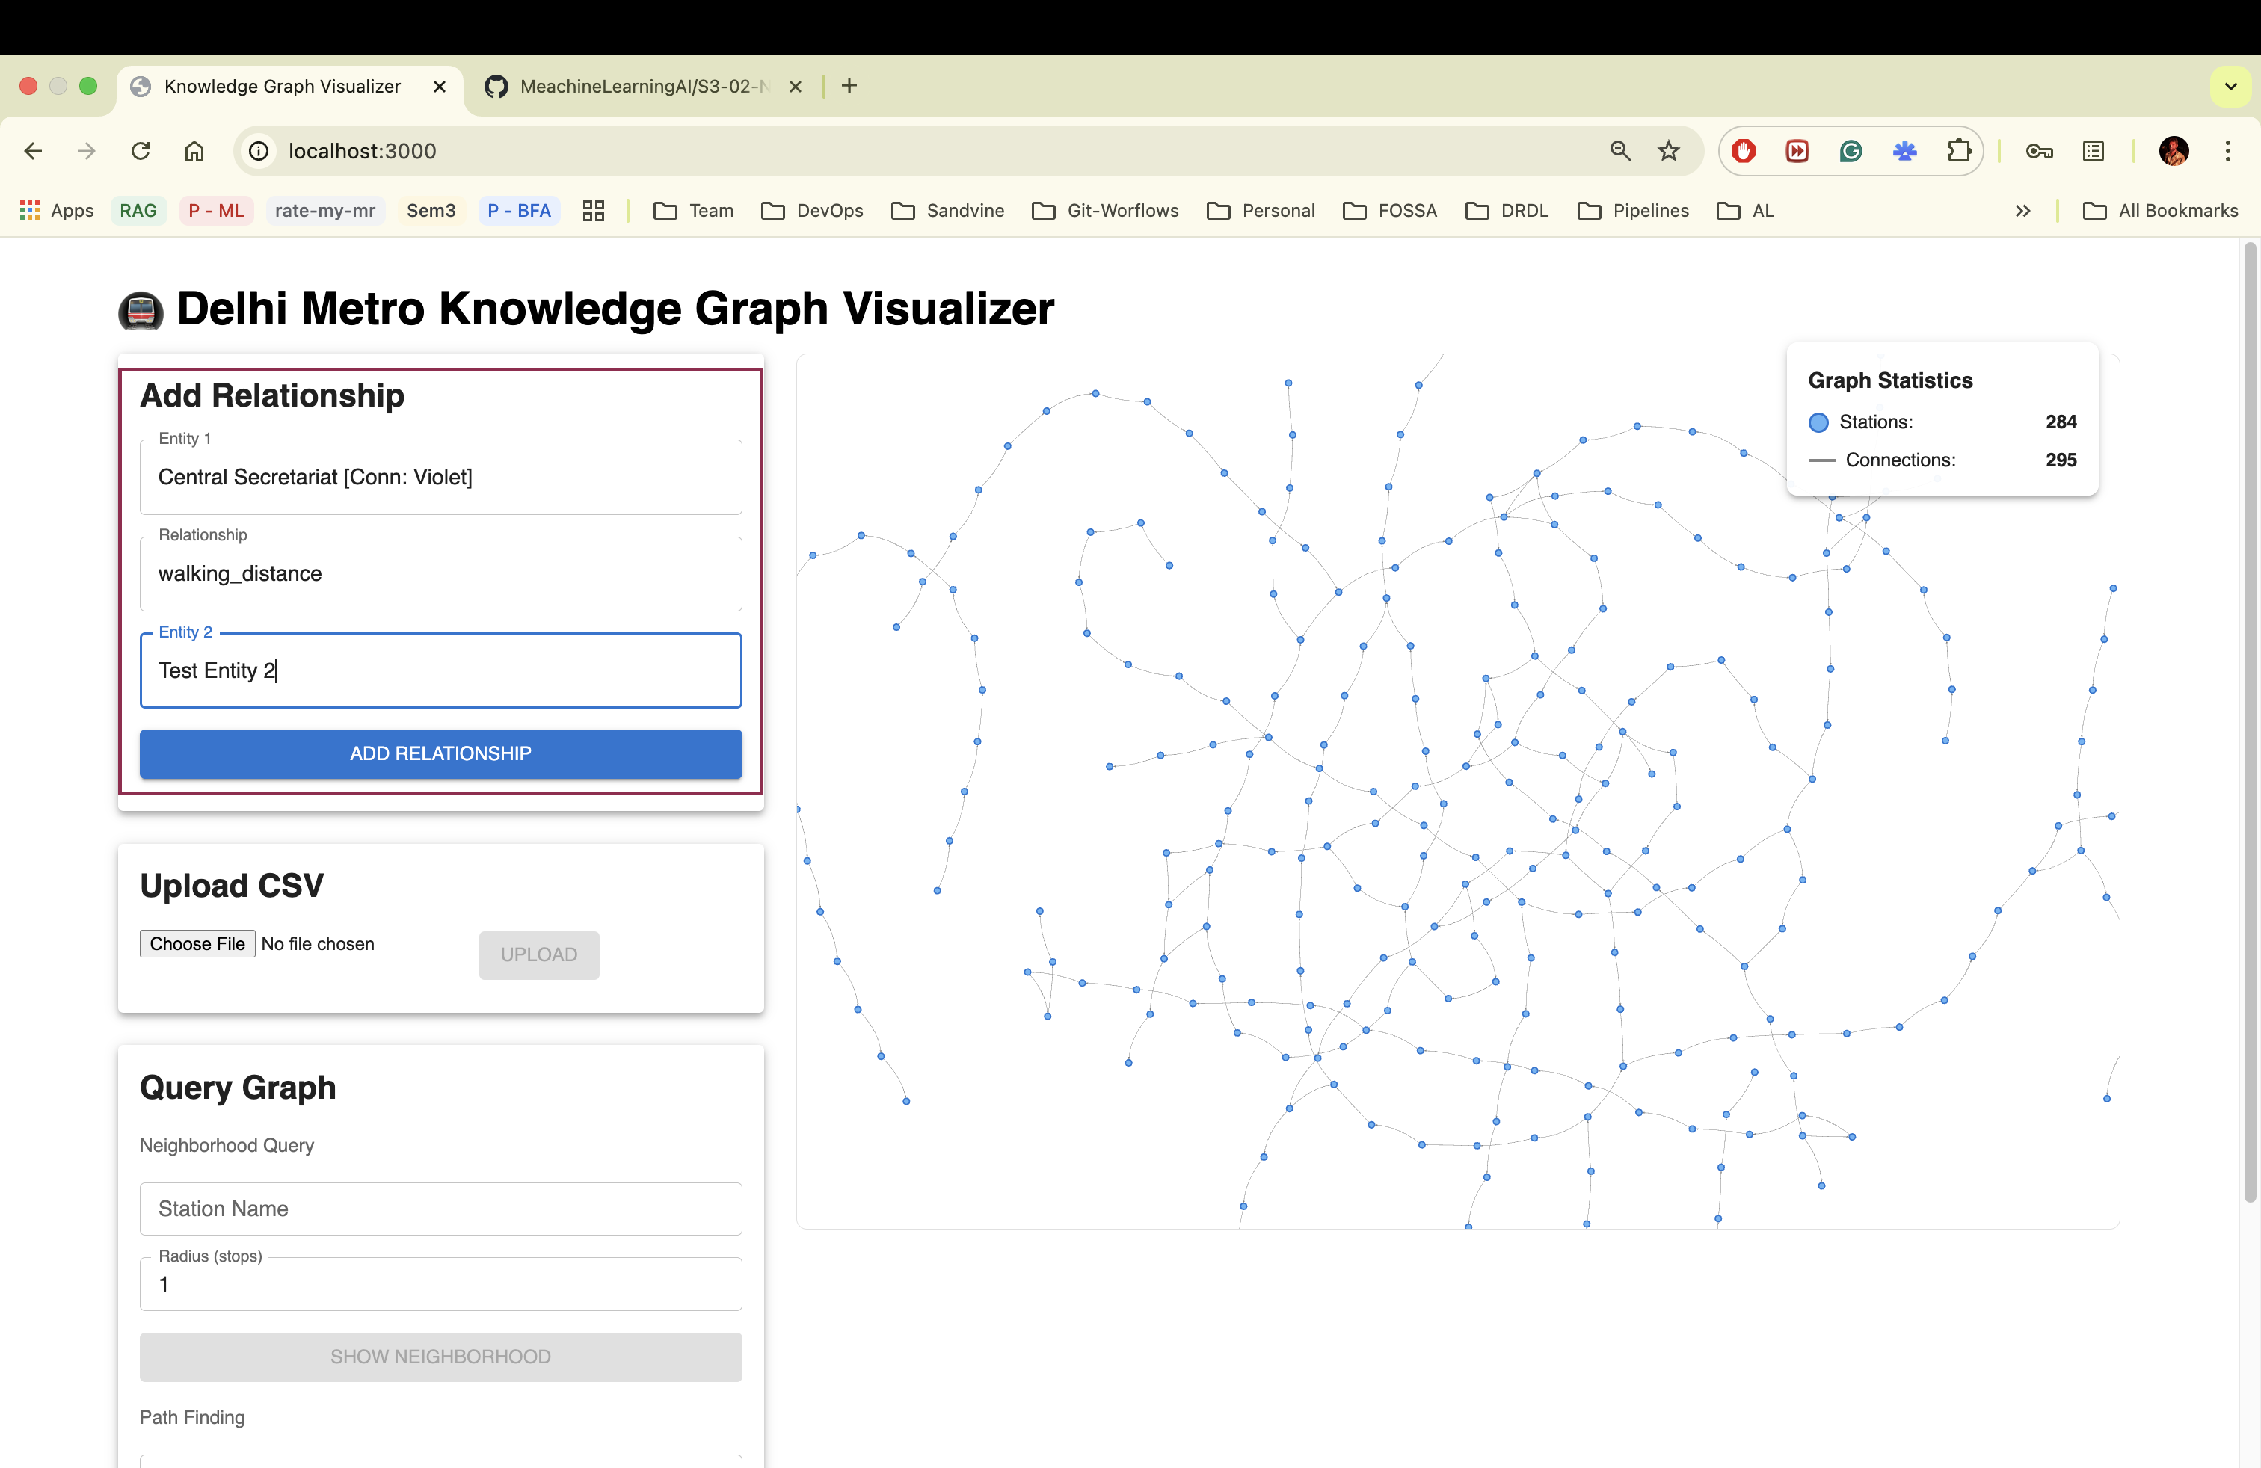
- Again do “Query Neighborhood”
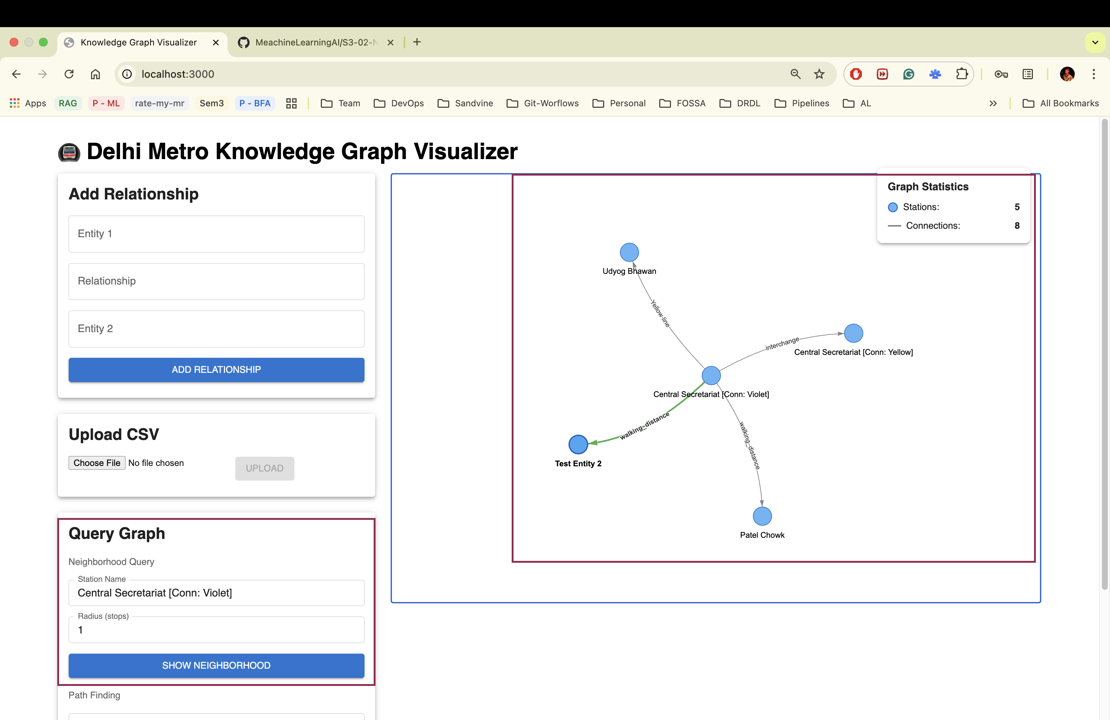

Shortest Path
Search shortest path between 2 stations from the metro dataset.

- Enter Source Station: Rajiv Chowk [Conn: Blue]
- Enter Destination Station: Udyog Bhawan
- Click “FIND SHORTEST PATH”
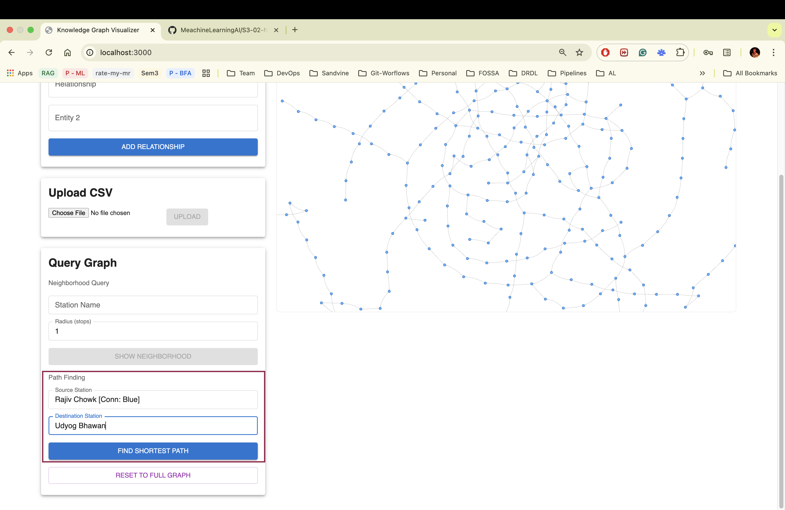
- Now showing the shortest path between 2 stations

