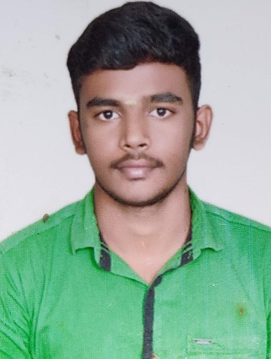

**Name : Vigneshwaran P**

**Role : Full Stack Developer**

I have an experience in building end to end applications, starting with building rich user interfaces, service layer and database access layer for multiple applications.

* Self-learner
* Strong problem-solving skills
* Ability to learn an apply new frameworks and tools.
* Competent and knowledgeable in multiple JS Frameworks like, Angular, React JS.
* Knowledge and experience in developing Java
* Has experience in using Flowable for building simple to complex flows.
* Trained in configuring rules in Drools Rule engine and integrating with applications.
* Adept in understanding business rules and implementing them using the best coding practices.

**Technical Competency**

* Java Spring Boot
* Angular
* React JS
* Bootstrap
* JavaScript
* HTML, CSS
* SQL Server, MYSQL
* Python

**Experience**

***Project 1:*** Creating application UI, API and integrating them for a Learning management system application using Spring Boot and Angular.

**Project 2:** Building POC UI for Mail Viewer using Angular.

**Project 3:** Created the POC API for Bank Loan application and Credit card transaction using Spring Boot.