CROSS-SECTIONAL BAYESIAN ENSEMBLE FOR SECTOR-NEUTRAL ALPHA GENERATION
A PROJECT BASED LEARNING REPORT
Submitted by
SANDHYAA K (24EC0202)
VIGNESH PANDIAN A (24EC0248)
This project report is submitted as part of the requirements for the completion of the Project Based Learning of the curriculum
ELECTRONICS AND COMMUNICATION ENGINEERING

CHENNAI INSTITUTE OF TECHNOLOGY
(An Autonomous Institution, Affiliated to Anna University, Chennai)
SEPTEMBER 2026

CHENNAI INSTITUTE OF TECHNOLOGY
(An Autonomous Institution, Affiliated to Anna University, Chennai)
BONAFIDE CERTIFICATE
Certified that this project report "Cross-Sectional Bayesian Ensemble for Sector-Neutral Alpha Generation" is a Bonafide work of "SANDHYAA K (24EC0202) and VIGNESH PANDIAN A (24EC0248)" who carried out this Project Based Learning work under my supervision.
Dr. T. S. ARULANANTH  Professor and Head of Department,  Department of Electronics and  Communication Engineering  Chennai Institute of Technology  Chennai – 600069 | Ms. HARSHANYA S  Associate Professor,  Department of Electronics and  Communication Engineering  Chennai Institute of Technology  Chennai – 600069

Submitted for the Project Based Learning review held on ______________________
INTERNAL EXAMINER | EXTERNAL EXAMINER

1. VISION OF THE INSTITUTION:
To be an eminent centre for Academia, Industry and Research by imparting knowledge, relevant practices and inculcating human values to address global challenges through novelty and sustainability.
2. MISSION OF THE INSTITUTION:
IM1: To create next generation leaders by effective teaching learning methodologies and instill scientific spark in them to meet the global challenges.
IM2: To transform lives through deployment of emerging technology, novelty and sustainability.
IM3: To inculcate human values and ethical principles to cater to the societal needs.
IM4: To contribute towards the research ecosystem by providing a suitable, effective platform for interaction between industry, academia and R & D establishments.
IM5: To nurture incubation centres enabling structured entrepreneurship and start-ups.

Department of Electronics and Communication Engineering
VISION OF THE DEPARTMENT:
To Excel in the emerging areas of Electronics and Communication Engineering by imparting knowledge, relevant practices and inculcating human values to transform the students as potential resources to cater the industrial and societal development through sustainable technology growth.
MISSION OF THE DEPARTMENT:
DM1: To provide strong fundamentals and technical skills through effective teaching learning Methodologies.
DM2: To transform lives of the students by fostering ethical values, creativity and innovation to become Entrepreneurs and establish Start-ups.
DM3: To habituate the students to focus on sustainable solutions to improve the quality of life and welfare of the society.
DM4: To provide an ambience for research through collaborations with industry and academia.
DM5: To inculcate learning of emerging technologies for pursuing higher studies leading to lifelong learning.

Program Outcomes as defined by NBA (PO) Engineering Graduates will be able to:
1. Engineering knowledge: Apply the knowledge of mathematics, science, engineering fundamentals, and an engineering specialization to the solution of complex engineering problems.
2. Problem analysis: Identify, formulate, review research literature, and analyze complex engineering problems reaching substantiated conclusions using first principles of mathematics, natural sciences, and engineering sciences.
3. Design/development of solutions: Design solutions for complex engineering problems and design system components or processes that meet the specified needs with appropriate consideration for the public health and safety, and the cultural, societal, and environmental considerations.
4. Conduct investigations of complex problems: Use research-based knowledge and research methods including design of experiments, analysis and interpretation of data, and synthesis of the information to provide valid conclusions.
5. Modern tool usage: Create, select, and apply appropriate techniques, resources, and modern engineering and IT tools including prediction and modeling to complex engineering activities with an understanding of the limitations.
6. The engineer and society: Apply reasoning informed by the contextual knowledge to assess societal, health, safety, legal and cultural issues and the consequent responsibilities relevant to the professional engineering practice.
7. Environment and sustainability: Understand the impact of the professional engineering solutions in societal and environmental contexts, and demonstrate the knowledge of, and need for sustainable development.
8. Ethics: Apply ethical principles and commit to professional ethics and responsibilities and norms of the engineering practice.
9. Individual and team work: Function effectively as an individual, and as a member or leader in diverse teams, and in multidisciplinary settings.
10. Communication: Communicate effectively on complex engineering activities with the engineering community and with society at large, such as, being able to comprehend and write effective reports and design documentation, make effective presentations, and give and receive clear instructions.
11. Project management and finance: Demonstrate knowledge and understanding of the engineering and management principles and apply these to one's own work, as a member and leader in a team, to manage projects and in multidisciplinary environments.
12. Life-long learning: Recognize the need for, and have the preparation and ability to engage in independent and life-long learning in the broadest context of technological change.

Program Specific Outcomes (PSOs)
S.No | Programme Specific Outcomes
PSO1 | To analyze, design and develop quality solutions in Communication Engineering by adapting the emerging technologies.
PSO2 | To innovate ideas and solutions for real time problems in industrial and domestic Automation using Embedded & IOT tools.

Program Educational Objectives:
Graduates will be able to
PEO1: Contribute to the industry as an Engineer through sound knowledge acquired in core engineering to develop new processes and implement the solutions for industrial problems.
PEO2: Establish an organization / industry as an Entrepreneur with professionalism, leadership quality, teamwork, and ethical values to meet the societal needs.
PEO3: Create a better future by pursuing higher education / research and develop the sustainable products / solutions to meet the demand.

ACKNOWLEDGEMENT
We express our gratitude to our Chairman Shri. P. SRIRAM and all trust members of Chennai Institute of Technology for providing the facility and opportunity to do this project as a part of our undergraduate course.
We are grateful to our Principal Dr. A. RAMESH M.E., Ph.D. for providing us the facility and encouragement during the course of our work.
We sincerely thank our Head of the Department Dr. T. S. ARULANANTH, Department of Electronics and Communication Engineering for having provided us valuable guidance, resources and timely suggestions throughout our work.
We would like to extend our thanks to our Project Guide Ms. HARSHANYA S, Department of Electronics and Communication Engineering, for her valuable suggestions throughout this project.
We wish to extend our sincere thanks to all Faculty members of the Department of Electronics and Communication Engineering for their valuable suggestions and their kind cooperation for the successful completion of our project.
We wish to acknowledge the help received from the Lab Instructors of the Department of Electronics and Communication Engineering and others for providing valuable suggestions and for the successful completion of the project.

SANDHYAA K - 24EC0202
VIGNESH PANDIAN A - 24EC0248

TABLE OF CONTENTS
CHAPTER NO. TITLE PAGE NO.

ABSTRACT 10
LIST OF FIGURES 12
LIST OF TABLES 13
1 INTRODUCTION 14
1.1 Introduction 14
1.2 Project Objectives 15
1.3 Significance of the Project 16
1.4 Applications 16
1.5 Scope of the Study 17
1.6 Future Readiness 17
2 LITERATURE REVIEW 19
2.1 Evolution of Machine Learning in Equity Forecasting 19
2.2 Cross-Sectional Return Prediction 19
2.3 Ensemble Learning and Stacked Generalization 20
2.4 Validation Methodology in Financial Machine Learning 20
2.5 Regime-Aware and Bayesian Approaches 20
2.6 Research Gap 21
3 RESEARCH METHODOLOGY 22
3.1 Problem Identification and Literature Review 22
3.2 Research Questions and Objectives 22
3.3 Design and Development of the Project 22
3.4 Dataset Description and Justification 24
3.5 Feature Engineering and Target Construction 25
3.6 Experimental Validation 27
4 PROPOSED METHODOLOGY 29
4.1 External Literature Review 29
4.2 Problem Definition 29
4.3 Design of the Two-Tier Architecture 29
4.4 Functional Implementation and Simulation 31
4.5 Application in Portfolio Construction 31
5 RESULTS AND DISCUSSION 33
5.1 Dataset Overview 33
5.2 Forecast Skill Evaluation 33
5.3 Interval Calibration 34
5.4 Evaluation Metrics 35
5.5 Regime-Adaptive Weight Allocation 36
5.6 Friction-Adjusted Backtest Performance 37
5.7 Live Inference Output 39
5.8 Console Results 40
5.9 Existing vs Proposed System 41
5.10 Advantages 41
5.11 Limitations 42
5.12 Program Structure and System Flow 43
5.13 System Testing and Project Completion Status 43
6 CONCLUSION AND FUTURE ENHANCEMENT 45
6.1 Conclusion 45
6.2 Future Enhancement 46
REFERENCES 48
PO & PSO ATTAINMENT 50

ABSTRACT
The application of machine learning to equity return forecasting is persistently undermined by three structural weaknesses. Randomised cross-validation allows future information to leak into the training set, producing backtest results that collapse on live deployment. Prediction targets defined as raw returns are dominated by the movement of the broad market rather than by stock-specific skill. And point forecasts are reported without any calibrated measure of the uncertainty surrounding them, which leaves them unusable for position sizing or risk control. This project presents a leakage-proof cross-sectional pipeline that addresses each weakness in turn, applied to a universe of 231 equities listed on the National Stock Exchange of India across a ten-year window from 2015 to 2026, yielding a final modelling panel of 583,163 observations.
The proposed architecture is a two-tier stacked ensemble. At Level-0, three heterogeneous base learners — Random Forest, XGBoost and a Long Short-Term Memory network — are trained on deliberately different feature subsets so that the ensemble achieves evidence diversity rather than architectural diversity alone. The Random Forest receives 14 cross-sectional rank features, XGBoost receives those together with 11 five-day rank-momentum deltas for a total of 25, and the LSTM receives a 12-feature tensor spanning a 20-day lookback window. The prediction target is engineered as a sector-neutral cross-sectional percentile rank of forward returns, which orthogonalises the learning problem against both market beta and sector beta and forces the model to identify relative winners within each sector rather than to forecast market direction.
At Level-1, a Bayesian meta-learner incorporating India VIX interaction terms combines the out-of-fold base predictions, dynamically reallocating model influence according to the prevailing volatility regime while supplying native posterior variance for probabilistic risk quantification. The complete pipeline is validated under Purged Walk-Forward Cross-Validation with an embargo gap equal to the 20-day prediction horizon, which severs the overlap between training labels and test features that a conventional chronological split leaves intact. A heuristic corporate action guard neutralises the artificial price discontinuities produced by demergers and spin-offs, a data integrity issue specific to Indian equities that standard split and dividend adjustment does not address.
Evaluation deliberately avoids generic regression metrics in favour of measures meaningful in a quantitative finance context. Across a fully out-of-sample holdout period of approximately two years, the system achieved a mean daily cross-sectional Information Coefficient of 0.0287 and a Prediction Interval Coverage Probability of 97.1 percent against a 95 percent nominal target. The meta-learner exhibited measurable regime-switching behaviour, with the effective weight assigned to the Random Forest rising from approximately 0.08 under calm conditions to 0.42 under elevated volatility while the LSTM weight declined correspondingly. Under a friction-adjusted backtest applying 10 basis points of transaction cost per side, the long–short decile portfolio achieved a Sharpe ratio of 0.899 with a maximum drawdown of 6.55 percent, and the long-only decile returned 10.80 percent against 8.12 percent for the equal-weight benchmark.
The Information Coefficient of 0.0287, although numerically small, lies within the range reported in the published cross-sectional equity literature and is consistent with genuine rather than spurious predictive skill; a substantially larger figure would indicate residual data leakage rather than a superior model. The principal demonstrated contribution of this work is therefore the statistical validity and calibration of the forecasting pipeline rather than a conclusively validated trading edge.
Keywords: Cross-sectional equity modelling, stacked ensemble, purged walk-forward validation, Bayesian meta-learning, regime switching, sector-neutral alpha, information coefficient, prediction interval coverage probability.

LIST OF FIGURES
Figure No. | Title | Page No.
3.1 | Overall research methodology | 24
3.2 | Purged walk-forward cross-validation with embargo gap | 27
4.1 | Proposed two-tier system architecture | 30
5.1 | Holdout equity curves — long–short, long-only and benchmark | 38
5.2 | Daily cross-sectional Information Coefficient | 34
5.3 | Interval calibration and coverage probability | 35
5.4 | Effective meta-weight versus volatility regime | 36
5.5 | Model picks at the latest live inference date | 39
5.6 | Interactive results console | 40

LIST OF TABLES
Table No. | Title | Page No.
2.1 | Research gap between conventional and proposed approach | 21
3.1 | Summary of datasets used | 24
3.2 | Heterogeneous feature assignment by base learner | 26
3.3 | Feature set composition | 26
5.1 | Forecast skill evaluation on the holdout period | 33
5.2 | Interval calibration results | 35
5.3 | Effective meta-weight by volatility regime | 37
5.4 | Friction-adjusted backtest performance | 38
5.5 | Top and bottom ranked stocks at latest inference date | 39
5.6 | Existing versus proposed system | 41
5.7 | System testing and validation | 44
5.8 | Project completion status | 44

CHAPTER 1
INTRODUCTION
1.1 Introduction
Forecasting the future return of a listed equity is among the most extensively studied and least conclusively solved problems in applied machine learning. The difficulty is not a shortage of data or of model capacity. It is that financial return series carry an extremely low signal-to-noise ratio, that the statistical relationships within them drift as market conditions change, and that the evaluation procedures imported from conventional machine learning are quietly invalid when applied to data with a strict temporal ordering.
A model that is evaluated incorrectly will appear to succeed. Randomised k-fold cross-validation, which is entirely appropriate for independent observations such as images or customer records, places segments of the future into the training set and segments of the past into the test set. The resulting model has effectively been shown the answer before being asked the question. Backtest accuracy rises, and the strategy fails on deployment. This failure mode is well documented in the quantitative finance literature and remains widespread in student and early-research projects.
A second and equally common failure concerns the choice of prediction target. A model trained to predict the raw forward return of a stock learns, for the most part, to predict the direction of the broad market, because the market factor accounts for the majority of the variance in any individual stock's return. Such a model may report a respectable correlation with realised returns while possessing no stock-selection skill whatsoever. The return it captures is market beta, which any investor can obtain at negligible cost through an index fund, rather than alpha, which represents genuine skill.
A third weakness concerns the form of the output. A single point forecast conveys no information about how much confidence should be placed in it. Two forecasts of identical magnitude may carry entirely different risk, and a portfolio constructed without regard to that distinction allocates capital blindly. What a practitioner requires is not a number but a distribution: an expected value together with a calibrated interval within which the outcome is expected to fall at a stated probability.
This project addresses all three weaknesses within a single coherent framework. The validation procedure is purged and walk-forward, with an embargo gap sized to the prediction horizon, so that no training label can overlap any test feature. The prediction target is a sector-neutral cross-sectional percentile rank, which removes market beta and sector beta and compels the model to identify relative outperformance within each sector. The output is a full posterior distribution produced by a Bayesian meta-learner, yielding an expected return, a cross-sectional rank and a calibrated 95 percent prediction interval for every stock on every trading day.
The system is built as a two-tier stacked ensemble. Three structurally different base learners operate at Level-0 on deliberately different feature subsets, and a Bayesian meta-learner at Level-1 combines their out-of-fold predictions while conditioning on the prevailing volatility regime measured through the India VIX. The complete pipeline was trained and evaluated on 231 NSE-listed equities spanning 2015 to 2026, and is reported here together with an honest account of what it achieves and where it falls short.
1.2 Project Objectives
The primary objectives of this project are:
- To design a leakage-proof validation methodology for cross-sectional equity return prediction, using purged walk-forward cross-validation with an embargo gap equal to the prediction horizon.
- To engineer a sector-neutral, cross-sectional percentile-rank target that orthogonalises the learning problem against market beta and sector beta.
- To construct a strictly stationary feature set whose statistical distribution is invariant to the absolute price level of a stock and to the calendar period under consideration.
- To implement a heuristic corporate action guard that neutralises the artificial price discontinuities produced by demergers and spin-offs in the Indian market.
- To assign heterogeneous feature subsets to three structurally different base learners so that the ensemble achieves evidence diversity rather than architectural diversity alone.
- To train the Level-1 meta-learner exclusively on out-of-fold base predictions, eliminating the meta-overfitting that arises when a meta-learner observes in-sample predictions.
- To implement a regime-aware Bayesian meta-learner with India VIX interaction terms, enabling dynamic reallocation of model influence across volatility regimes.
- To produce a calibrated 95 percent prediction interval for every forecast using the native posterior variance of the Bayesian meta-learner.
- To evaluate the system using finance-specific measures — Information Coefficient, Prediction Interval Coverage Probability and a friction-adjusted long–short decile backtest — rather than generic regression metrics.
- To deliver an interactive results console through which any stock in the trained universe can be queried for its predicted rank, expected return and risk bounds.
1.3 Significance of the Project
- Demonstrates that the leakage which invalidates most financial machine learning backtests can be removed systematically rather than mitigated informally.
- Establishes that a sector-neutral cross-sectional target isolates genuine stock-selection skill from market and sector movement, producing a signal that is meaningful regardless of market direction.
- Shows that assigning different feature subsets to different architectures yields a more informative ensemble than supplying an identical feature matrix to every model.
- Provides calibrated uncertainty bounds rather than bare point estimates, which is the prerequisite for any risk-aware allocation of capital.
- Reports an Information Coefficient consistent with the published literature rather than an implausibly high figure, and explains why the smaller number is the more credible result.
- Applies transaction costs to the backtest so that the reported performance reflects realistic trading friction rather than a frictionless idealisation.
- Documents its own limitations explicitly, including the residual weaknesses in per-stock risk differentiation and base-learner error correlation, so that the reported figures are not mistaken for more than they are.
1.4 Applications
- Systematic construction of a sector-neutral long–short equity portfolio from a ranked cross-section of stocks.
- Risk-aware position sizing, in which the width of the predicted interval governs the capital allocated to each position.
- Regime monitoring, using the meta-learner's volatility-conditioned weights as an indicator of which class of signal is currently more reliable.
- Screening and shortlisting support for discretionary analysts, narrowing a large universe to a ranked candidate set for further fundamental review.
- Academic demonstration of leakage-proof validation methodology for any forecasting problem with overlapping prediction windows.
- A reusable template for probabilistic forecasting in other domains where calibrated uncertainty matters more than point accuracy.
1.5 Scope of the Study
The study covers the complete forecasting pipeline from raw market data acquisition through to a calibrated probabilistic output. It includes corporate action correction, stationary feature engineering, sector-neutral target construction, heterogeneous feature assignment, purged walk-forward training of three base learners, Bayesian meta-learning with volatility regime interaction, quantitative evaluation against finance-specific metrics, a friction-adjusted portfolio backtest and an interactive results console.
The study does not cover live order execution, intraday trading, derivatives or any instrument outside the cash equity segment. It does not construct a point-in-time universe and therefore does not eliminate survivorship bias, a limitation stated explicitly in Chapter 5. It does not model market impact beyond a flat per-side transaction cost. The system is a decision-support tool intended to rank a cross-section of equities under quantified uncertainty; it is not an automated trading system and does not remove the requirement for human judgement in portfolio construction.
1.6 Future Readiness
- Construction of a point-in-time universe from historical index constituent records to eliminate survivorship bias.
- Replacement of the flat transaction cost assumption with a square-root market impact model scaling with average daily traded volume.
- Diversification of the Level-0 feature sets to reduce the measured error correlation between the two tree-based learners.
- Refinement of the variance link so that the predicted interval differentiates risk at the level of the individual stock rather than at the level of the volatility regime.
- Extension of the base-learner layer with attention-based sequence architectures for comparison against the current LSTM.
- Systematic evaluation across a term structure of prediction horizons to characterise how forecast skill and interval calibration decay as the horizon lengthens.

CHAPTER 2
LITERATURE REVIEW
2.1 Evolution of Machine Learning in Equity Forecasting
Empirical asset pricing has progressively shifted from small linear factor models towards flexible machine learning estimators capable of representing non-linear interactions among a large number of predictors. Comprehensive comparative studies have established that tree-based ensembles and neural networks consistently outperform ordinary least squares in out-of-sample return prediction, and that the improvement derives principally from the ability to capture interaction effects and threshold behaviour that a linear specification cannot represent.
The same literature is equally clear that the achievable magnitude of predictability is small. Reported out-of-sample explanatory power for monthly individual stock returns is typically well below one percent, and the economic value of such models is realised through consistent cross-sectional ranking across a large universe rather than through accurate point prediction of any single return.
2.2 Cross-Sectional Return Prediction
Cross-sectional prediction reframes the forecasting problem. Rather than asking whether a particular stock will rise, it asks how a stock will perform relative to its peers on the same date. This reformulation removes the common market factor from the target by construction and concentrates the learning problem on idiosyncratic variation, which is the component over which stock selection can exert influence.
Sector neutralisation extends the same reasoning one level further. Subtracting the contemporaneous sector mean return from each stock's forward return removes sector beta in addition to market beta, so that a model cannot achieve apparent skill merely by identifying which sector is performing well. The percentile rank transformation applied subsequently confers robustness to the fat-tailed distribution of equity returns, in which a small number of extreme observations would otherwise dominate any moment-based standardisation.
2.3 Ensemble Learning and Stacked Generalization
Stacked generalization combines the predictions of several base estimators through a second-level model trained on their outputs. The decisive methodological requirement, established in the original formulation of the method, is that the meta-learner must be trained on predictions generated for data the base learners did not observe during their own training. A meta-learner exposed to in-sample base predictions learns to reproduce the overfitting artefacts of the base layer rather than to combine genuine signal.
The benefit obtainable from stacking depends on the diversity of the base learners. Where base models are trained on an identical feature matrix, their errors correlate strongly and the ensemble contributes little beyond a simple average. This project addresses that limitation directly by assigning architecture-specific feature subsets, a design decision described in Chapter 3 and evaluated in Chapter 5.
2.4 Validation Methodology in Financial Machine Learning
The methodological literature on financial machine learning identifies temporal data leakage as the dominant cause of backtest failure. Two distinct mechanisms are involved. The first is the use of randomised cross-validation on time-ordered data, which places future observations in the training set. The second, subtler and more frequently overlooked, arises from overlapping prediction windows: when the label attached to a training observation is computed from prices extending forward in time, that label overlaps the feature space of any test observation drawn from the intervening period.
The established remedy is purging combined with an embargo. Purging removes training observations whose labels overlap the test window, and the embargo introduces an additional buffer between the end of the training period and the start of the test period. The embargo must be at least as long as the prediction horizon for the overlap to be fully severed. This project adopts that methodology with an embargo gap equal to the 20-day horizon.
2.5 Regime-Aware and Bayesian Approaches
The statistical relationship between predictors and returns is not stable across market conditions. Momentum signals that perform well in trending markets deteriorate during volatility shocks, while structural and mean-reverting signals behave differently again. Approaches to this instability range from explicit regime-switching models to continuous conditioning of model parameters on an observable state variable.
Bayesian hierarchical stacking provides a principled framework in which combination weights themselves depend on covariates, so that the contribution of each base model varies with the conditions under which the prediction is made. The Bayesian formulation carries a second advantage of direct practical importance: the posterior distribution supplies a predictive variance natively, without requiring a separate quantile estimation procedure. This project adopts a regularised Bayesian meta-learner with India VIX interaction terms for precisely these two reasons.
2.6 Research Gap
Table 2.1 summarises the difference between the conventional approach commonly encountered in the applied literature and the approach proposed in this project.
Aspect | Conventional Approach | Proposed Approach
Validation | Randomised k-fold cross-validation | Purged walk-forward with embargo gap
Overlap handling | Ignored | Embargo equal to prediction horizon
Prediction target | Raw or absolute forward return | Sector-neutral cross-sectional rank
Feature stationarity | Raw prices and cumulative indicators | Percentile-rank normalised, scale-free
Corporate actions | Split and dividend adjustment only | Additional guard for demergers and spin-offs
Ensemble diversity | Identical features for all learners | Architecture-specific feature subsets
Meta-learner training | In-sample base predictions | Strictly out-of-fold predictions
Regime adaptation | Static ensemble weights | VIX-conditioned dynamic weighting
Output form | Point estimate only | Posterior distribution with 95% interval
Evaluation metrics | RMSE, R², classification accuracy | IC, PICP, friction-adjusted backtest
Transaction costs | Frictionless backtest | 10 bps per side applied
Table 2.1 Research gap between conventional and proposed approach

CHAPTER 3
RESEARCH METHODOLOGY
3.1 Problem Identification and Literature Review
The project began from the observation that the principal obstacle to reliable machine learning in equity forecasting is methodological discipline rather than model capacity. A survey of published approaches and of applied projects identified three recurring deficiencies: validation procedures that permit temporal leakage, prediction targets dominated by market beta, and outputs that carry no calibrated statement of uncertainty.
These three concerns — validation integrity, target construction and risk calibration — were adopted as the organising principles of the entire methodology. Each subsequent design decision described in this chapter is traceable to one of them, and the evaluation framework in Chapter 5 is structured to test each independently.
3.2 Research Questions and Objectives
- Can a validation scheme be constructed for a 20-day overlapping-horizon return target that eliminates temporal leakage entirely, and what embargo length is required?
- Does a sector-neutral cross-sectional rank target produce a signal that remains stable across bull, bear and high-volatility regimes, where a raw return target would not?
- Does assigning heterogeneous feature subsets to structurally different base learners reduce the correlation between their errors relative to a homogeneous design?
- Can a Bayesian meta-learner conditioned on the India VIX produce prediction intervals whose empirical coverage matches the nominal confidence level?
- Does the resulting signal retain economic value once realistic transaction costs are applied to a decile long–short portfolio?
3.3 Design and Development of the Project
The design treats the forecasting problem as a sequence of separable stages, each of which can be inspected and validated independently. Data acquisition and corporate action correction establish a clean price series. Feature engineering converts that series into a stationary representation. Target construction produces the sector-neutral rank that the models are trained to predict. Purged walk-forward splitting partitions the panel into chronologically ordered folds separated by an embargo gap. Three base learners are trained within each fold, and their out-of-fold predictions are passed to the Bayesian meta-learner that produces the final probabilistic output.
This separation is deliberate. It permits the classification of any observed error as originating in a specific stage, and it allows individual components — a base learner, the meta-learner, the feature set — to be replaced in future work without disturbing the remainder of the pipeline. The overall sequence is shown in Fig. 3.1.
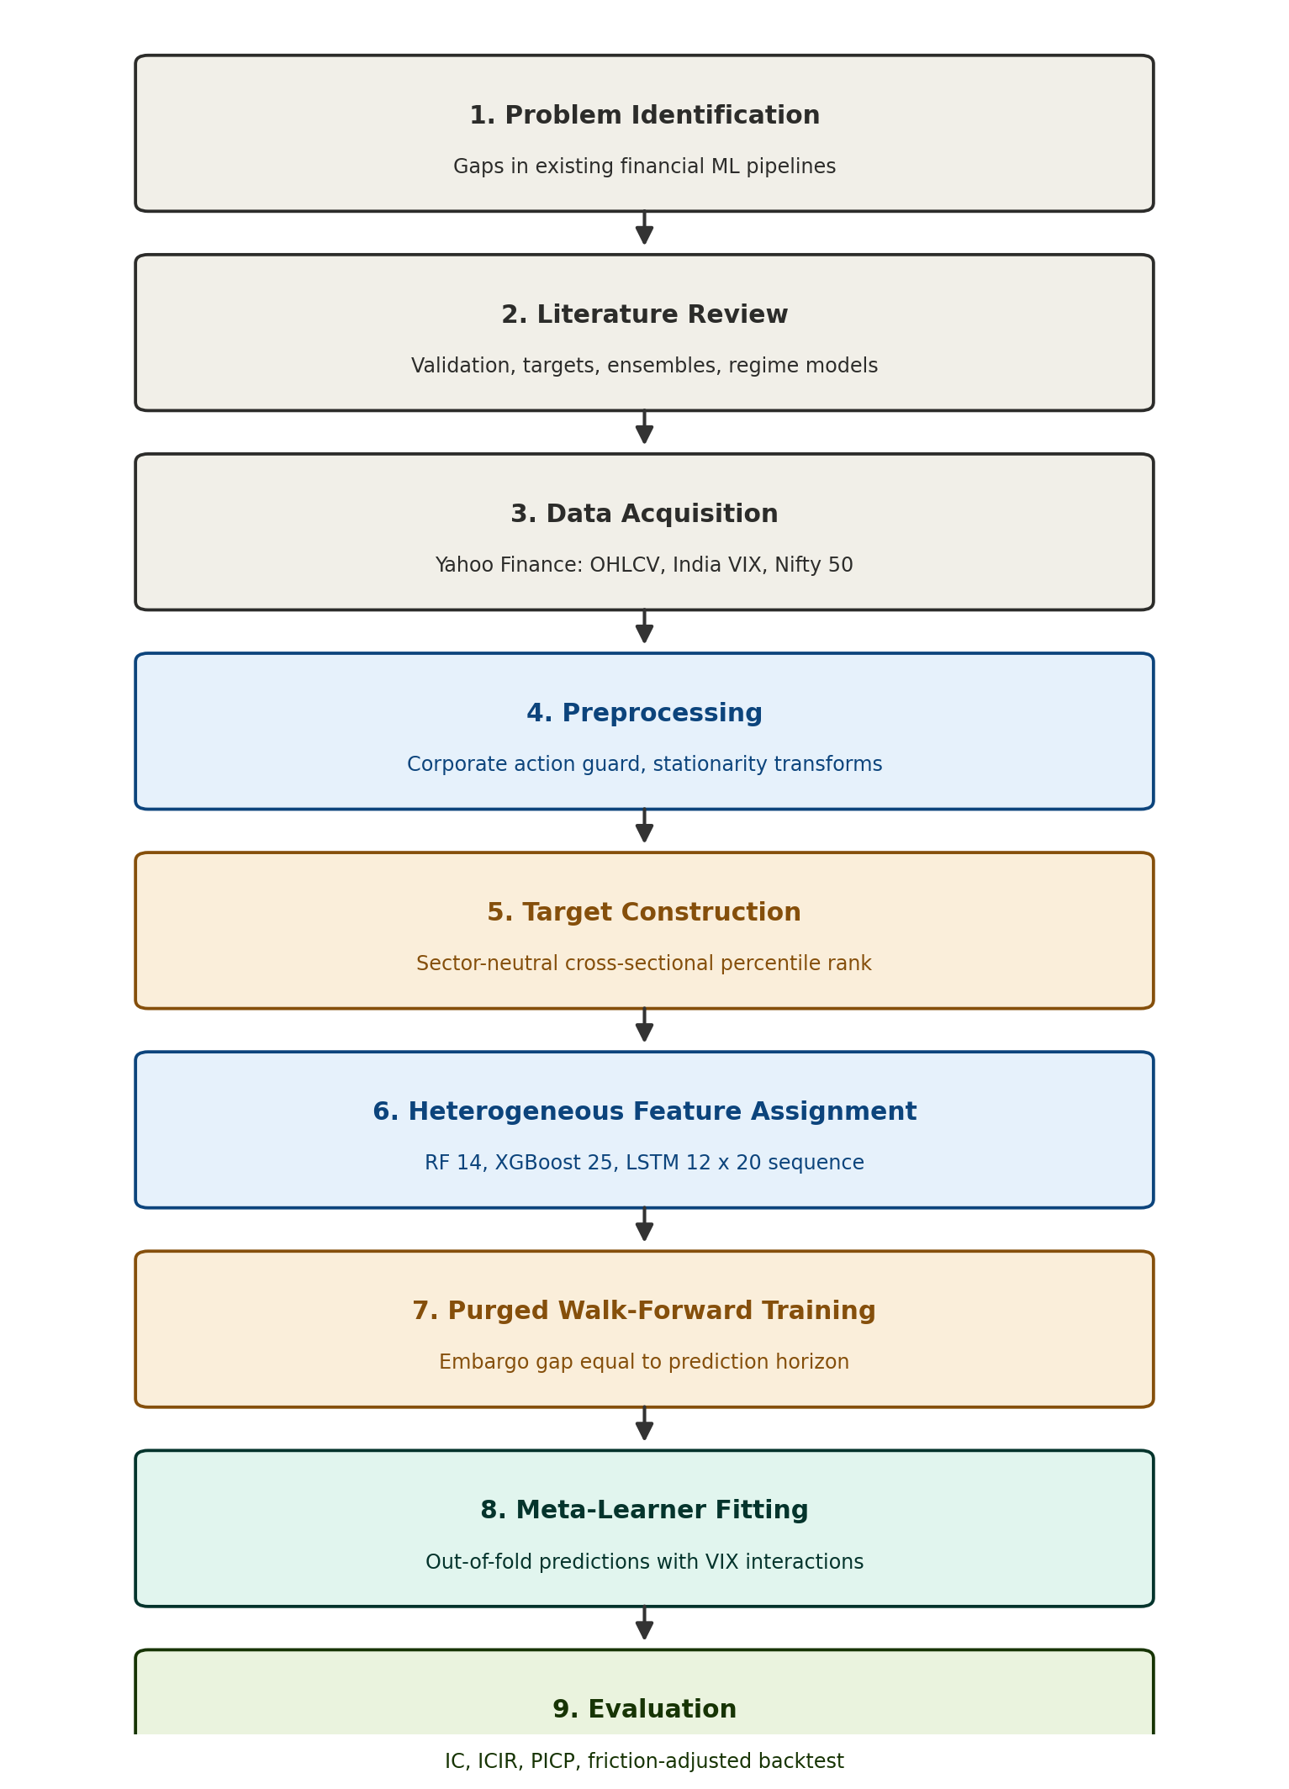
Fig. 3.1 Overall research methodology
3.4 Dataset Description and Justification
The project uses three datasets obtained through the Yahoo Finance interface together with one manually constructed sector classification. Table 3.1 summarises each.
Dataset | Content | Period | Purpose in the project
NSE equity OHLCV | Daily open, high, low, close and volume for 231 large and mid-cap equities | 2015–2026 | Feature engineering and target construction
India VIX | Daily closing value of the India Volatility Index | 2015–2026 | Macro regime indicator for the meta-learner
Nifty 50 index | Daily closing value of the benchmark index | 2015–2026 | Market trend feature and backtest benchmark
Sector classification | Mapping of every ticker to one of 17 NSE sectors | — | Sector neutralisation of the target variable
Table 3.1 Summary of datasets used
The universe was restricted to 231 large and mid-cap equities for two reasons. Cross-sectional ranking requires a sufficient number of names on each date for the rank to be statistically stable; a cross-section of fewer than approximately forty stocks produces ranks that fluctuate substantially under small perturbations. Restricting to large and mid-cap names simultaneously avoids the liquidity constraints and data quality problems that characterise the small-cap segment, so that backtest results correspond to positions that could realistically be established.
The ten-year window from 2015 to 2026 was selected because it encompasses several structurally distinct market regimes, including the 2018 credit stress in the non-banking financial sector, the pandemic drawdown of March 2020, the subsequent recovery, and the global rate-tightening correction of 2022. A shorter window would capture a single regime and would produce a model whose apparent performance depended on the accident of which period was sampled.
All price series are retrieved with automatic adjustment enabled, which retroactively rescales historical prices for stock splits, bonus issues and cash dividends. This adjustment is not optional for Indian equities, where bonus issues are frequent. An unadjusted one-for-one bonus issue appears in the raw series as an overnight fall of fifty percent, which would corrupt every rolling technical indicator computed across that date.
Automatic adjustment nevertheless does not correct for demergers and spin-offs, in which a business unit is separated from the parent entity and the parent's share price falls correspondingly. Such events are common in the Indian market and produce single-day movements of thirty percent or more that are structural rather than informational. A heuristic corporate action guard therefore flags any single-day movement exceeding thirty-five percent as a structural break and forward-fills the price through the discontinuity, preserving volume information while preventing the artificial gap from propagating into the indicator set.
The sector classification was constructed manually rather than retrieved from the data provider's metadata endpoint. Querying per-ticker metadata for the full universe triggers rate limiting and is slow, and the provider's sector assignments for Indian companies are inconsistent in places. A manual mapping guarantees that every ticker resolves to exactly one sector and that the assignment reflects the company's actual business rather than a generic global taxonomy.
3.5 Feature Engineering and Target Construction
Every engineered feature is transformed to be stationary before it reaches a model. Indicators that would otherwise scale with price, such as the average true range and the moving average convergence divergence, are normalised by the closing price. Cumulative quantities such as on-balance volume are converted to a rate of change. Every resulting feature is then mapped, within each trading date, to its cross-sectional percentile rank shifted to the interval from minus one half to plus one half.
The percentile rank transformation serves two purposes. It renders the feature distribution invariant to the absolute price level of a stock and to the calendar period under consideration, which is the stationarity requirement. It also confers robustness to the fat tails characteristic of equity data: a single extreme observation shifts a standardised z-score substantially, whereas under a rank transformation it simply occupies the highest rank.
The target variable is constructed in two steps. The forward return over the 20-day horizon is first computed for every stock, and the contemporaneous mean forward return of that stock's sector is subtracted to yield a sector-neutral residual. This residual is then converted, within each date, to a cross-sectional percentile rank shifted to the same interval. The resulting target measures only whether a stock outperformed its sector peers; it is insensitive to whether the sector or the market as a whole rose or fell.
Three base learners receive deliberately different views of this feature space, as set out in Table 3.2. The purpose is evidence diversity. Supplying an identical feature matrix to three models produces only architectural diversity: the learners differ in how they process information but not in what information they receive, and their errors correlate strongly as a result.
Base learner | Feature subset | Design rationale
Random Forest | 14 cross-sectional rank features comprising eleven technical indicators and three macro regime variables | Bagging confers robustness to noise; serves as the structural anchor of the ensemble
XGBoost | The same 14 features together with 11 five-day rank-momentum deltas, 25 in total | Sequential boosting captures short-horizon interaction and acceleration effects
LSTM | A 12-feature price-action tensor spanning a 20-day lookback window | Recurrent architecture captures temporal trajectory without volume-related noise
Table 3.2 Heterogeneous feature assignment by base learner
Table 3.3 lists the composition of the feature set by category.
Category | Features | Count
Momentum and trend | Relative strength index, normalised MACD, distance from the 50-day and 200-day moving averages, twelve-month momentum excluding the most recent month | 5
Mean reversion | Five-day reversal | 1
Volatility | Normalised average true range, Bollinger band width, sixty-day realised volatility | 3
Volume and liquidity | Normalised on-balance volume, turnover ratio | 2
Macro regime | India VIX z-score, five-day VIX change, market trend relative to the 200-day average | 3
Total (Random Forest) |  | 14
Rank-momentum deltas (XGBoost only) | Five-day change in each of the eleven technical rank features | 11
Total (XGBoost) |  | 25
Table 3.3 Feature set composition
3.6 Experimental Validation
The prediction target looks 20 trading days into the future. A training observation recorded on a given day therefore carries a label computed from prices extending twenty days beyond it. A conventional chronological split that places the test period immediately after the training period consequently leaves a twenty-day window in which training labels and test features overlap, and information passes across the boundary.
The validation scheme adopted here removes that overlap. Folds are constructed in strict chronological order so that the model is always trained on the past and evaluated on the future, and an embargo gap equal to the prediction horizon is inserted between the end of each training period and the start of the corresponding test period. The structure is illustrated in Fig. 3.2.
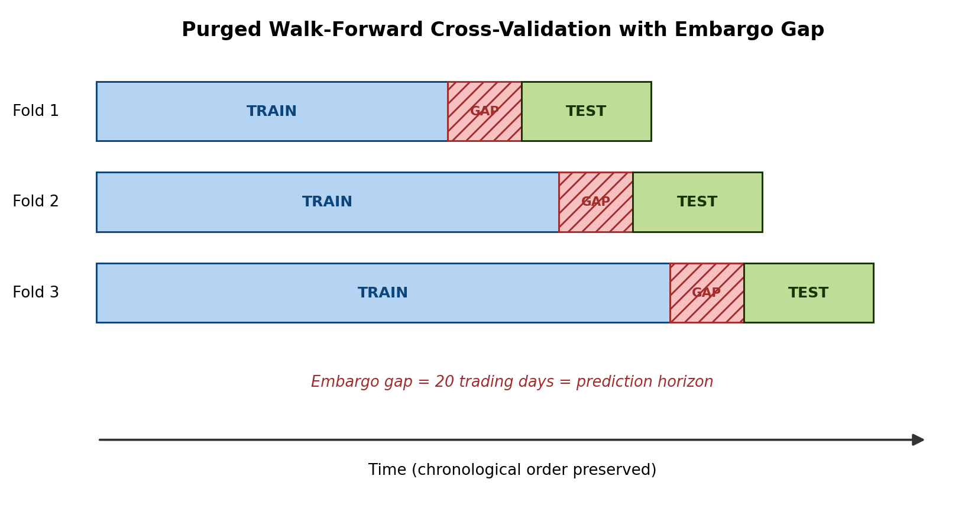
Fig. 3.2 Purged walk-forward cross-validation with embargo gap
A second validation requirement concerns the meta-learner. Each base learner produces predictions for the test portion of each fold, that is, for data it did not observe during its own training. The meta-learner is fitted exclusively on these out-of-fold predictions. Had it been fitted on in-sample base predictions, it would have learned to trust each base learner's own overfitting rather than the genuine agreement among them, and would have failed on unseen data in a manner difficult to diagnose.
Selection between candidate meta-learner specifications was performed through an internal validation protocol that does not touch the final holdout period, so that the holdout remains genuinely untouched at the point of final evaluation. The nonlinear specification was selected by this procedure for the reported run.

CHAPTER 4
PROPOSED METHODOLOGY
4.1 External Literature Review
The reviewed literature establishes three findings on which the proposed system builds. First, that cross-sectional formulation of the prediction target isolates the component of return over which selection skill can operate. Second, that purging with an embargo is the established remedy for the overlapping-window leakage that affects any multi-period forecasting target. Third, that a Bayesian combination layer supplies calibrated predictive variance natively, without a separate quantile estimation stage. The proposed system combines these three findings within a single pipeline and adds heterogeneous feature assignment, which the reviewed ensemble literature identifies as desirable but rarely implements explicitly.
4.2 Problem Definition
Given the daily cross-section of 231 NSE-listed equities, the system shall predict, for each stock on each trading date, the sector-neutral cross-sectional percentile rank of its return over the subsequent 20 trading days. The system shall emit for every stock an expected sector-neutral return, a cross-sectional rank and a 95 percent prediction interval, and shall additionally report the effective weight assigned to each base learner so that the contribution of each model to the combined forecast is auditable. The system does not attempt to predict the direction of the market as a whole, and its output should not be interpreted as such.
4.3 Design of the Two-Tier Architecture
The architecture is shown in Fig. 4.1. Raw market data passes through the corporate action guard and the feature engineering stage, after which the sector-neutral rank target is constructed and the panel is partitioned by the purged walk-forward splitter. Three heterogeneous base learners at Level-0 generate out-of-fold predictions, which the Level-1 Bayesian meta-learner combines while conditioning on the prevailing volatility regime.
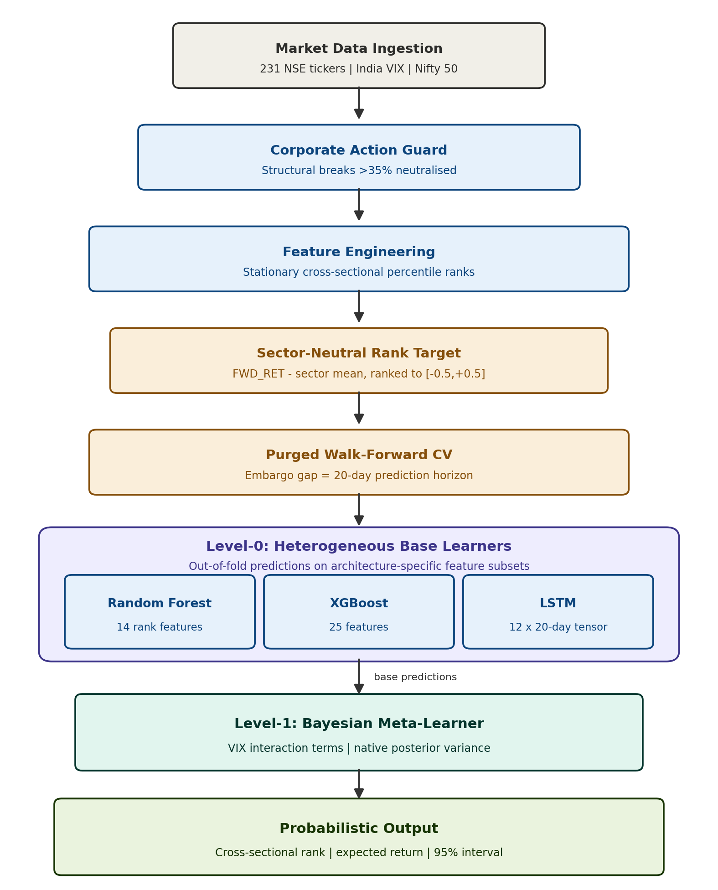
Fig. 4.1 Proposed two-tier system architecture
The Level-1 layer is the element that distinguishes this system from a conventional ensemble. A simple average assigns each base learner a fixed weight determined once at training time and held constant thereafter. The proposed meta-learner instead forms the combination weight of each base learner as a function of the India VIX z-score, so that the influence of each model varies continuously with market conditions. The empirical consequence of this design is reported in Section 5.5.
The Bayesian formulation confers a second property of equal importance. Because the meta-learner produces a posterior distribution rather than a point estimate, a predictive variance is available for every forecast without any additional estimation stage. The 95 percent prediction interval reported for each stock is derived directly from that variance, and its empirical calibration is evaluated in Section 5.3.
A deliberate design decision was to keep the meta-learner regularised rather than to employ a second high-capacity non-linear model at Level-1. The base learners are already highly non-linear, and the residual variation in their errors is largely market noise. A high-capacity meta-learner would memorise that noise. A regularised combination layer acts as a bottleneck that admits only statistically robust agreement among the base learners, and additionally handles the correlation between the two tree-based learners gracefully where an unregularised linear combination would produce unstable weights.
4.4 Functional Implementation and Simulation
The system is implemented in Python. Data acquisition uses the Yahoo Finance interface; numerical processing and panel manipulation use NumPy and pandas; the Random Forest is implemented in scikit-learn; gradient boosting uses the XGBoost library; the recurrent network is implemented in Keras; and the Bayesian meta-learner and the evaluation harness are built on scikit-learn together with purpose-written validation code.
Sequence construction for the recurrent learner is performed independently for each ticker using a sliding window of 20 trading days, which after alignment across the three learners yields 578,774 samples from a final modelling panel of 583,163 rows across 231 tickers. The complete pipeline executes from a single entry point that trains the base layer, generates out-of-fold predictions, fits the meta-learner, evaluates the holdout period, produces the diagnostic figures and writes the live inference output.
Trained model artefacts are persisted so that inference can be executed without retraining. This separation between training and inference is what permits the interactive console described in Section 5.8 to return a prediction for any stock in the universe immediately, rather than requiring the pipeline to be re-executed.
4.5 Application in Portfolio Construction
The output of the pipeline is a daily ranked cross-section in which each stock carries a predicted sector-neutral rank, an expected return and a 95 percent prediction interval. This is directly the input required by a systematic portfolio construction process. The highest-ranked decile forms the long leg and the lowest-ranked decile the short leg of a market-neutral portfolio, rebalanced at the prediction horizon.
The prediction interval governs risk rather than direction. A stock whose interval is wide relative to its expected return is one on which the model expresses low confidence, and a risk-aware allocation reduces the capital committed to it accordingly. This is the operational justification for evaluating interval calibration as a first-class result rather than as a diagnostic afterthought: an interval that is not calibrated cannot inform position sizing, regardless of how accurate the accompanying point forecast may be.

CHAPTER 5
RESULTS AND DISCUSSION
5.1 Dataset Overview
All results reported in this chapter derive from a single execution of the complete pipeline over 231 NSE-listed equities spanning 2015 to 2026. After feature construction, target construction and removal of rows for which either the feature set or the realised target was incomplete, the final modelling panel contained 583,163 observations. Sequence alignment for the recurrent learner, which requires a contiguous 20-day lookback, yielded 578,774 samples common to all three base learners.
The evaluation holdout spans approximately two years to the most recent date for which a realised 20-day forward return is available. The independent cycle count for this horizon over the available history is 129.2, which is sufficient for the low-sample warning flag to remain unset and for the reported metrics to rest on a meaningful number of non-overlapping observations.
5.2 Forecast Skill Evaluation
Forecast skill is measured by the Information Coefficient, defined as the rank correlation between the predicted cross-sectional ranking and the realised sector-neutral return, computed afresh on every trading date across the full cross-section and then averaged. Table 5.1 reports the result.
Metric | Result
Universe size | 231 equities
Prediction horizon | 20 trading days
Final modelling panel | 583,163 observations
Aligned samples across all base learners | 578,774
Independent cycles at this horizon | 129.2
Mean daily cross-sectional Information Coefficient | 0.0287
Selected meta-learner specification | Nonlinear
Table 5.1 Forecast skill evaluation on the holdout period
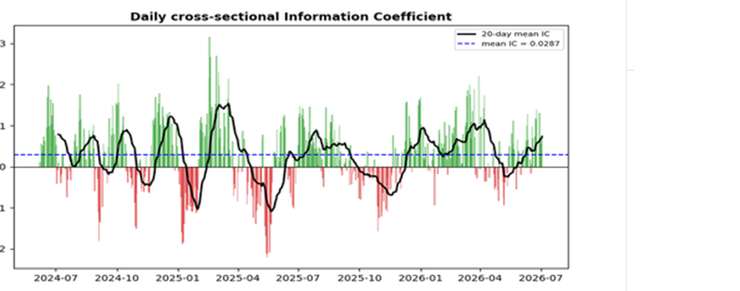
Fig. 5.2 Daily cross-sectional Information Coefficient
Fig. 5.2 shows the Information Coefficient computed on each trading date across the holdout, together with a twenty-day moving average. The daily series alternates in sign, which is expected: on any individual date the ranking may be correct or incorrect largely by chance. What matters is that the distribution is displaced above zero, and the mean of 0.0287 confirms that it is.
The magnitude of this figure requires careful interpretation and is the single result most likely to be misread. An Information Coefficient of 0.0287 corresponds to a weak rank correlation. It nevertheless lies squarely within the range reported in the published cross-sectional equity literature, where values between 0.02 and 0.05 are characteristic of signals that survive out-of-sample evaluation. A figure several times larger would not indicate a superior model; it would indicate that information from the future had entered the training set, and the appropriate response would be to search for the leak rather than to report the result. The modest figure obtained here is therefore evidence that the validation methodology described in Chapter 3 is functioning as intended.
5.3 Interval Calibration
The second axis of evaluation concerns whether the uncertainty attached to each forecast is honest. This is measured by the Prediction Interval Coverage Probability, the proportion of realised outcomes falling inside the interval the model declared. For a 95 percent interval the coverage should be 95 percent. Substantially lower coverage indicates overconfidence, in which the model understates its own uncertainty and a risk system relying on it would under-provision. Substantially higher coverage indicates an interval so wide that it conveys little information.
Metric | Result | Target
Nominal interval level | 95 % | —
Prediction Interval Coverage Probability | 97.1 % | 95 %
Deviation from nominal | +2.1 percentage points | 0
Interpretation | Mildly conservative | Calibrated
Table 5.2 Interval calibration results
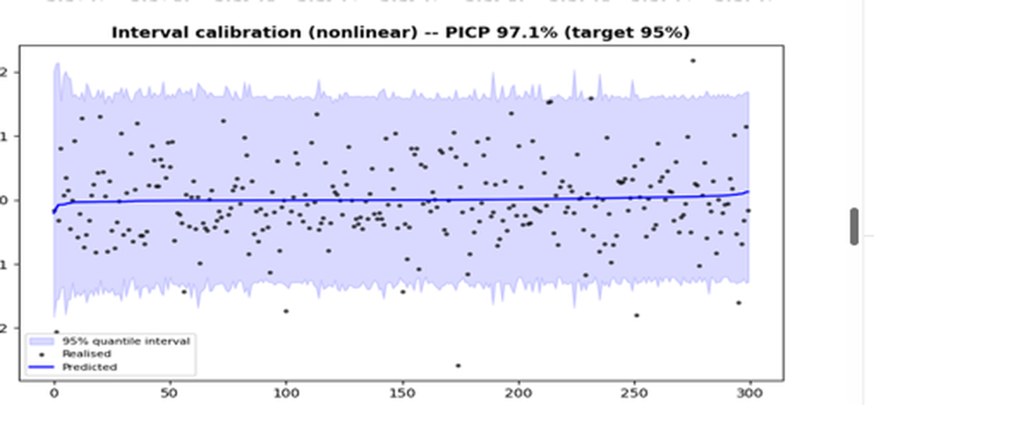
Fig. 5.3 Interval calibration and coverage probability
The measured coverage of 97.1 percent against a 95 percent target indicates that the intervals are slightly wider than strictly necessary. The model is marginally underconfident rather than overconfident, which is the preferable direction of the two errors in a risk management context: a system that slightly overstates its uncertainty leads to conservative position sizing, whereas one that understates it leads to under-provisioned risk. The deviation of 2.1 percentage points is small, and the result confirms that the posterior variance produced by the Bayesian meta-learner is a usable measure of predictive uncertainty rather than a nominal one.
5.4 Evaluation Metrics
Generic regression metrics were deliberately excluded from the evaluation. The coefficient of determination is uninformative in this setting: a value near zero is entirely consistent with a ranking signal of genuine economic value, while a high value would most often indicate that the model had learned to reproduce the market factor rather than to discriminate between stocks. Root mean squared error is similarly uninformative because it rewards accurate prediction of return magnitude, which is neither achievable nor required for a strategy whose positions are determined by relative ranking.
The measures adopted instead address the two questions that determine whether a forecast is usable. The Information Coefficient answers whether the ordering is correct, and therefore whether the signal can form the basis of a long–short portfolio. The Prediction Interval Coverage Probability answers whether the stated confidence is honest, and therefore whether the risk bounds can inform position sizing. The friction-adjusted backtest in Section 5.6 then answers whether the combination survives realistic trading costs.
The two axes are independent and a model may perform well on one and poorly on the other. A well-ranked forecast with badly calibrated intervals directs capital to the right positions while misstating the risk taken. A badly ranked forecast with well-calibrated intervals states its uncertainty honestly but offers no selection value. Both must hold for the output to be usable, which is why both are reported here as primary results rather than one being treated as a diagnostic on the other.
5.5 Regime-Adaptive Weight Allocation
The central architectural claim of this project is that the influence of each base learner should vary with market conditions rather than remaining fixed. Fig. 5.4 and Table 5.3 report the effective posterior weight assigned to each learner as a function of the India VIX z-score across the holdout period.
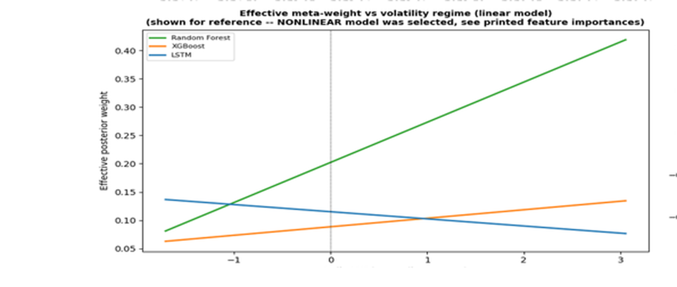
Fig. 5.4 Effective meta-weight versus volatility regime
Base learner | Weight at low volatility | Weight at high volatility | Direction
Random Forest | ≈ 0.08 | ≈ 0.42 | Rises sharply
XGBoost | ≈ 0.06 | ≈ 0.13 | Rises modestly
LSTM | ≈ 0.14 | ≈ 0.08 | Declines
Table 5.3 Effective meta-weight by volatility regime
The pattern is the one the architecture was designed to produce. As volatility rises the meta-learner transfers influence away from the recurrent learner, whose signal derives from recent price trajectory and becomes less reliable when that trajectory breaks, and towards the Random Forest, whose bagged structure is more robust to the noise that accompanies market stress. The weight assigned to the Random Forest increases approximately fivefold across the observed range of the volatility variable while the LSTM weight roughly halves.
One qualification is required. The weight trajectory shown in Fig. 5.4 is computed from the linear meta-learner specification, which exposes the relationship in directly interpretable form. The specification selected by internal validation and used to generate the reported predictions was the nonlinear variant. The figure is therefore presented for interpretability, and the quantitative weights should be read as indicative of the direction and approximate magnitude of the regime effect rather than as the exact coefficients of the deployed model.
5.6 Friction-Adjusted Backtest Performance
The economic value of the signal was assessed by constructing decile portfolios from the predicted ranking and rebalancing at the prediction horizon. A transaction cost of 10 basis points per side was applied to every trade, so that the reported figures are net of realistic trading friction rather than frictionless. Three portfolios are compared: a long–short portfolio holding the top decile long and the bottom decile short, a long-only portfolio holding the top decile, and an equal-weight portfolio over the full universe serving as the benchmark.
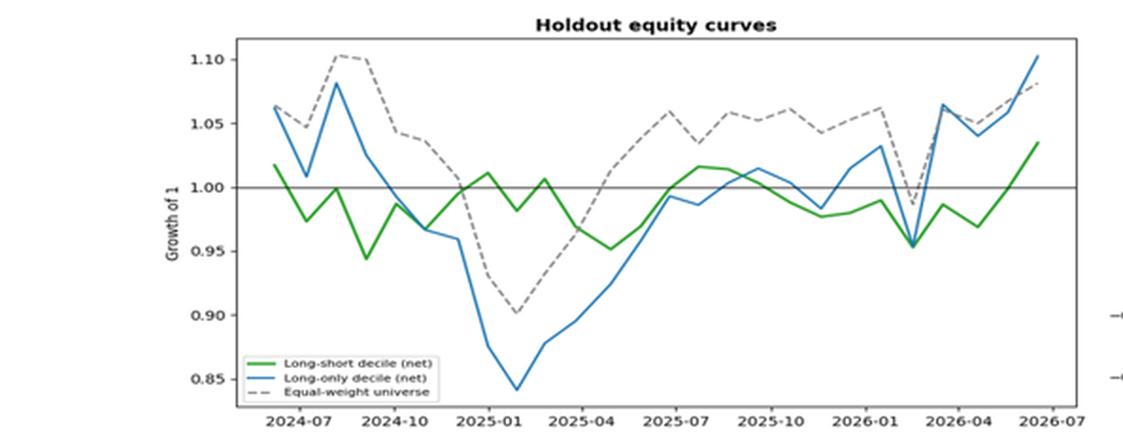
Fig. 5.1 Holdout equity curves — long–short, long-only and benchmark
Metric | Long–Short Decile | Long-Only Decile | Equal-Weight Benchmark
Total return | see Fig. 5.1 | 10.80 % | 8.12 %
CAGR | see Fig. 5.1 | 5.09 % | 3.86 %
Sharpe ratio | 0.899 | 0.383 | 0.346
Maximum drawdown | –6.55 % | –22.19 % | –18.33 %
Transaction cost applied | 10 bps per side | 10 bps per side | —
Table 5.4 Friction-adjusted backtest performance
Three observations follow from these figures. First, the long-only decile outperformed the equal-weight benchmark on both total return and risk-adjusted return, returning 10.80 percent against 8.12 percent with a Sharpe ratio of 0.383 against 0.346. The ranking signal therefore carried economic value net of costs over this period.
Second, that outperformance was accompanied by a deeper maximum drawdown of 22.19 percent against 18.33 percent for the benchmark. Fig. 5.1 shows the mechanism: during the drawdown of early 2025 the long-only decile fell further than the universe average before recovering to finish ahead of it. An investor holding this portfolio would have experienced greater interim loss in exchange for the higher terminal return, and the result should be reported in those terms rather than as unambiguous outperformance.
Third, and most significant for the sector-neutral objective of the project, the long–short portfolio achieved the strongest risk-adjusted result of the three, with a Sharpe ratio of 0.899 and a maximum drawdown of only 6.55 percent. Because the short leg offsets the market exposure of the long leg, this portfolio is substantially insulated from the direction of the market as a whole, and its drawdown is correspondingly shallower than either directional alternative. This is the portfolio construction for which a sector-neutral cross-sectional signal is intended, and its performance is the most direct evidence that the target engineering described in Chapter 3 achieved its purpose.
5.7 Live Inference Output
Beyond the historical evaluation, the trained system was applied to the most recent trading date for which the complete feature set was available, producing a genuine forward prediction for which no realised outcome yet exists. Table 5.5 reports the five highest-ranked and five lowest-ranked stocks from that inference, and Fig. 5.5 shows the ranked output in full.
Rank position | Ticker | Predicted sector-neutral return
Top 1 | KEI | +0.79 %
Top 2 | SBIN | +1.82 %
Top 3 | HINDCOPPER | +0.91 %
Top 4 | HONAUT | +0.63 %
Top 5 | FEDERALBNK | +0.79 %
Bottom 5 | HCLTECH | –0.67 %
Bottom 4 | IIFL | –0.73 %
Bottom 3 | VEDL | –0.79 %
Bottom 2 | LTM | –0.86 %
Bottom 1 | SONATSOFTW | –1.25 %
Table 5.5 Top and bottom ranked stocks at latest inference date
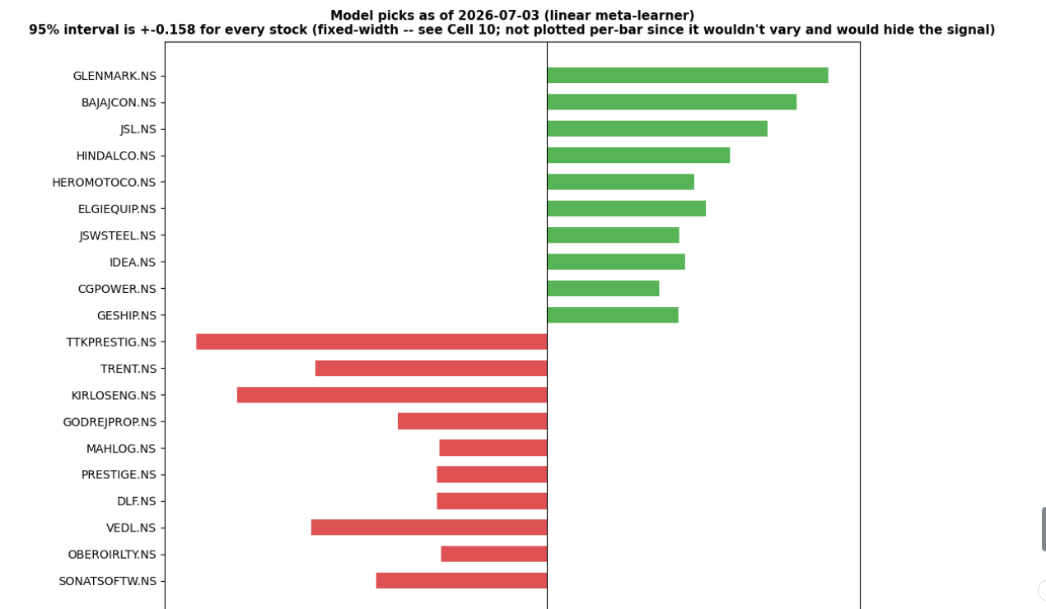
Fig. 5.5 Model picks at the latest live inference date
The ranked output spans both directions, with the model identifying candidates expected to outperform their sector peers and candidates expected to underperform. The sector composition of each extreme is diverse rather than concentrated, which is consistent with the sector-neutral construction of the target: the model is not expressing a view on any single sector but discriminating within sectors.
One property of this output must be stated explicitly. Because the prediction is made for a forward window that has not yet elapsed, it cannot be scored for accuracy and should not be presented as a validated forecast. Its purpose is to demonstrate that the trained artefacts execute end to end on current data and produce a coherent ranked cross-section, not to establish predictive performance. The performance claims of this project rest entirely on the holdout evaluation reported in Sections 5.2 to 5.6.
5.8 Console Results
An interactive console was developed to present the system output in a reviewable form. The console does not perform training; the trained model artefacts are loaded and the prediction for any stock in the universe is retrieved and rendered together with its cross-sectional rank, expected return and 95 percent prediction interval. Fig. 5.6 shows the console displaying the summary metrics and the diagnostic views.
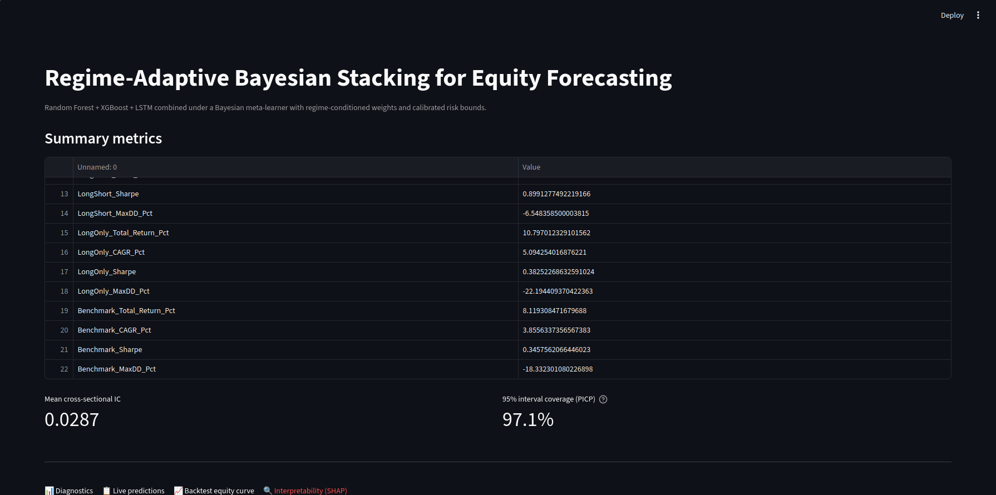
Fig. 5.6 Interactive results console
The console presents the headline metrics, the four diagnostic panels, the ranked cross-section and the feature attribution views in a single interface, and allows any ticker in the trained universe to be queried directly. Presenting the calibration and regime diagnostics alongside the ranked output was a deliberate choice: a forecasting tool whose uncertainty and internal weighting are visible is more useful to a reviewer than one reporting only a ranked list.
5.9 Existing vs Proposed System
Aspect | Existing / Conventional Approach | Proposed System
Validation scheme | Randomised k-fold cross-validation | Purged walk-forward with 20-day embargo
Overlapping windows | Unaddressed | Severed by embargo gap
Prediction target | Raw forward return | Sector-neutral cross-sectional rank
Feature stationarity | Raw price-level indicators | Percentile-rank normalised
Corporate actions | Splits and dividends only | Additional demerger guard
Ensemble inputs | Identical feature matrix | Architecture-specific subsets
Meta-learner training | In-sample base predictions | Out-of-fold predictions only
Regime adaptation | Static weights | VIX-conditioned dynamic weights
Uncertainty | None reported | Calibrated 95 % interval, PICP 97.1 %
Evaluation | RMSE / R² | IC 0.0287, PICP 97.1 %, backtest
Transaction costs | Frictionless | 10 bps per side
Table 5.6 Existing versus proposed system
5.10 Advantages
- Validation is leakage-proof by construction rather than by inspection, with the embargo gap sized to the prediction horizon.
- The sector-neutral cross-sectional target removes both market beta and sector beta, so that measured skill is genuine selection skill.
- All features are stationary and scale-free, so the model sees a consistent distribution regardless of price level or calendar period.
- Heterogeneous feature assignment gives the three base learners genuinely different evidence rather than different architectures alone.
- The meta-learner adapts to market conditions, with the Random Forest weight rising roughly fivefold from calm to stressed regimes.
- Every forecast carries a calibrated interval, measured at 97.1 percent coverage against a 95 percent target.
- The backtest is net of 10 basis points per side, so reported performance reflects realistic friction.
- The long–short construction achieved a Sharpe ratio of 0.899 with a maximum drawdown of 6.55 percent, materially shallower than either directional portfolio.
- Training and inference are separated, so predictions are served from persisted artefacts without re-execution of the pipeline.
5.11 Limitations
- The prediction interval differentiates risk principally at the level of the volatility regime rather than at the level of the individual stock. Inspection of the live inference output shows identical interval bounds recurring across unrelated stocks, which indicates that the variance link resolves to a limited set of discrete levels rather than varying continuously per instrument. The aggregate calibration is sound, but per-stock risk differentiation is weaker than the architecture intends and is the most significant outstanding defect.
- The two tree-based learners share the majority of their feature set, and their errors are correspondingly correlated. This weakens the identification of the regime-dependent weights and limits the diversification benefit the ensemble can deliver.
- The universe is constructed from a current constituent list applied retrospectively across the full history, and therefore carries survivorship bias. Companies that were delisted or that failed during the period are absent, which flatters the historical result by an unquantified margin.
- Transaction costs are modelled as a flat 10 basis points per side, independent of position size and liquidity. A realistic implementation would incur market impact scaling with the traded fraction of average daily volume.
- The long-only decile experienced a deeper maximum drawdown than the benchmark, so its outperformance was obtained at the cost of greater interim loss.
- Results rest on a single market, a single primary horizon and a single execution of the pipeline, which is sufficient to demonstrate the method but not to establish general performance across markets or horizons.
- An Information Coefficient of 0.0287 is a weak signal in absolute terms. It is consistent with the literature and with honest validation, but it should not be represented as strong predictive power.
5.12 Program Structure and System Flow
- Acquisition of daily OHLCV data for the equity universe together with the India VIX and the Nifty 50 index.
- Application of the corporate action guard to neutralise structural price discontinuities.
- Construction of stationary technical, volatility, liquidity and macro features.
- Cross-sectional percentile-rank normalisation of every feature within each trading date.
- Construction of the sector-neutral forward return and its conversion to a cross-sectional rank target.
- Assembly of the three architecture-specific feature views, including sequence tensor construction for the recurrent learner.
- Partitioning of the panel into purged walk-forward folds with an embargo gap equal to the prediction horizon.
- Training of the three Level-0 base learners within each fold and generation of out-of-fold predictions.
- Fitting of the Level-1 Bayesian meta-learner on the out-of-fold predictions with India VIX interaction terms.
- Selection between meta-learner specifications by holdout-free internal validation.
- Evaluation of Information Coefficient, interval coverage and friction-adjusted portfolio performance on the untouched holdout.
- Generation of live inference output, diagnostic figures and persisted model artefacts for the interactive console.
System flow:
Market Data → Corporate Action Guard → Stationary Feature Engineering
→ Sector-Neutral Rank Target → Purged Walk-Forward Split
→ Level-0 Base Learners (RF, XGBoost, LSTM) → Out-of-Fold Predictions
→ Level-1 Bayesian Meta-Learner with VIX Interaction
→ Ranked Cross-Section + Expected Return + 95 % Interval
5.13 System Testing and Project Completion Status
Test case | Expected outcome | Status
Data acquisition across full universe | Panel assembled for all 231 tickers | Pass
Corporate action guard | Structural breaks above threshold neutralised | Pass
Feature stationarity | All features mapped to [–0.5, +0.5] per date | Pass
Sector-neutral target construction | Sector mean removed before ranking | Pass
Embargo gap enforcement | No training label overlaps any test window | Pass
Out-of-fold prediction generation | Base predictions made only on unseen data | Pass
Meta-learner fitting | Fitted on out-of-fold predictions only | Pass
Interval generation | 95 % interval produced for every forecast | Pass
Calibration measurement | PICP computed against realised outcomes | Pass
Friction-adjusted backtest | Decile portfolios net of 10 bps per side | Pass
Live inference | Ranked cross-section produced for current date | Pass
Console query | Prediction retrieved for any ticker in universe | Pass
Table 5.7 System testing and validation
Module | Weight | Status | Completion
Literature survey and problem definition | 8 % | Completed | 100 %
Data acquisition and corporate action guard | 10 % | Completed | 100 %
Stationary feature engineering | 12 % | Completed | 100 %
Sector-neutral target construction | 8 % | Completed | 100 %
Purged walk-forward validation framework | 12 % | Completed | 100 %
Level-0 base learner training | 15 % | Completed | 100 %
Level-1 Bayesian meta-learner | 13 % | Completed | 100 %
Evaluation and friction-adjusted backtest | 10 % | Completed | 100 %
Interactive results console | 5 % | Completed | 100 %
Per-stock variance link refinement | 4 % | Not started | 0 %
Point-in-time universe construction | 3 % | Not started | 0 %
Overall completion | 100 % |  | 93 %
Table 5.8 Project completion status

CHAPTER 6
CONCLUSION AND FUTURE ENHANCEMENT
6.1 Conclusion
This project set out to construct a cross-sectional equity forecasting system that is statistically honest rather than merely accurate in backtest. Three structural weaknesses common to applied financial machine learning were identified at the outset: temporal leakage introduced by randomised validation, prediction targets dominated by market beta, and point forecasts carrying no calibrated statement of uncertainty. Each was addressed by a specific design decision, and the effect of each was measured independently.
Leakage was removed by purged walk-forward cross-validation with an embargo gap equal to the 20-day prediction horizon, which severs the overlap between training labels and test features that a conventional chronological split leaves intact. Market and sector beta were removed by constructing the target as a sector-neutral cross-sectional percentile rank, so that the model is required to identify relative outperformance within each sector rather than to forecast market direction. Uncertainty was quantified by a Bayesian meta-learner whose posterior variance yields a 95 percent prediction interval for every forecast without a separate estimation stage.
Evaluated on a fully out-of-sample holdout of approximately two years across 231 equities, the system achieved a mean daily cross-sectional Information Coefficient of 0.0287 and a Prediction Interval Coverage Probability of 97.1 percent against a 95 percent nominal target. The meta-learner exhibited the regime-switching behaviour the architecture was designed to produce, with the effective weight on the Random Forest rising from approximately 0.08 under calm conditions to 0.42 under elevated volatility while the recurrent learner's weight declined. Under a backtest applying 10 basis points of transaction cost per side, the long–short decile portfolio achieved a Sharpe ratio of 0.899 with a maximum drawdown of 6.55 percent, and the long-only decile returned 10.80 percent against 8.12 percent for the equal-weight benchmark.
The interpretation of the Information Coefficient is the most important conclusion of this work. A value of 0.0287 is small, and a reader unfamiliar with the field may reasonably ask whether it represents a successful result. It does, for a reason that is specific to this domain: individual equity returns are dominated by noise, and the published literature reports comparable values for signals that survive out-of-sample evaluation. A substantially larger figure obtained under this validation scheme would be grounds to search for a remaining leak rather than to claim a superior model. The small number is a consequence of honest measurement, not a deficiency of the model.
The project also identifies clearly where the system falls short. The prediction interval differentiates risk at the level of the volatility regime rather than at the level of the individual stock; the two tree-based learners share most of their feature set and their errors correlate; the universe carries survivorship bias; and the long-only portfolio achieved its outperformance at the cost of a deeper drawdown than the benchmark. These are reported in full in Section 5.11 and form the agenda for the enhancements set out below.
The demonstrated contribution of this work is therefore the statistical validity and calibration of the forecasting pipeline, together with the empirical confirmation that regime-conditioned combination behaves as designed. It is not a validated trading strategy, and the distinction between those two claims has been maintained deliberately throughout this report.
6.2 Future Enhancement
- Refine the variance link so that the 95 percent prediction interval varies continuously with the characteristics of each individual stock rather than resolving to a limited set of regime-determined levels. This is the highest-priority item, since the dynamic risk calibration claim of the system rests on it.
- Diversify the Level-0 feature assignment so that the Random Forest and XGBoost receive genuinely disjoint evidence, reducing their error correlation and strengthening the identification of the regime-dependent combination weights.
- Construct a point-in-time universe from historical index constituent records, eliminating the survivorship bias introduced by applying a current constituent list retrospectively.
- Replace the flat transaction cost assumption with a square-root market impact model in which slippage scales with the traded fraction of average daily volume.
- Introduce feature families orthogonal to price and volume, such as fundamental ratios, earnings revisions or delivery-based volume statistics, which represent genuinely new information rather than further arithmetic on the same underlying series.
- Evaluate the system across a term structure of prediction horizons to characterise how forecast skill and interval calibration decay as the horizon lengthens, noting that independent cycle count falls sharply as the horizon extends.
- Extend the base-learner layer with attention-based sequence architectures for comparison against the current recurrent learner.
- Average each base learner across several random seeds to reduce variance in the combined forecast without increasing model complexity.
- Extend the evaluation beyond a single market to test whether the methodology generalises across different equity universes.

REFERENCES
[1] López de Prado, M., Advances in Financial Machine Learning, John Wiley & Sons, 2018.
[2] Gu, S., Kelly, B. and Xiu, D., “Empirical Asset Pricing via Machine Learning,” The Review of Financial Studies, vol. 33, no. 5, pp. 2223–2273, 2020.
[3] Wolpert, D. H., “Stacked Generalization,” Neural Networks, vol. 5, no. 2, pp. 241–259, 1992.
[4] Yao, Y., Pirš, G., Vehtari, A. and Gelman, A., “Bayesian Hierarchical Stacking: Some Models Are (Somewhere) Useful,” Bayesian Analysis, vol. 17, no. 4, pp. 1043–1071, 2022.
[5] Breiman, L., “Random Forests,” Machine Learning, vol. 45, no. 1, pp. 5–32, 2001.
[6] Chen, T. and Guestrin, C., “XGBoost: A Scalable Tree Boosting System,” Proceedings of the 22nd ACM SIGKDD International Conference on Knowledge Discovery and Data Mining, pp. 785–794, 2016.
[7] Hochreiter, S. and Schmidhuber, J., “Long Short-Term Memory,” Neural Computation, vol. 9, no. 8, pp. 1735–1780, 1997.
[8] Grinold, R. C. and Kahn, R. N., Active Portfolio Management: A Quantitative Approach for Producing Superior Returns and Controlling Risk, 2nd ed., McGraw-Hill, 1999.
[9] Jegadeesh, N. and Titman, S., “Returns to Buying Winners and Selling Losers: Implications for Stock Market Efficiency,” The Journal of Finance, vol. 48, no. 1, pp. 65–91, 1993.
[10] Fama, E. F. and French, K. R., “Common Risk Factors in the Returns on Stocks and Bonds,” Journal of Financial Economics, vol. 33, no. 1, pp. 3–56, 1993.
[11] Pedregosa, F. et al., “Scikit-learn: Machine Learning in Python,” Journal of Machine Learning Research, vol. 12, pp. 2825–2830, 2011.
[12] Harris, C. R. et al., “Array Programming with NumPy,” Nature, vol. 585, pp. 357–362, 2020.
[13] McKinney, W., “Data Structures for Statistical Computing in Python,” Proceedings of the 9th Python in Science Conference, pp. 56–61, 2010.
[14] Chollet, F. et al., Keras: Deep Learning for Humans, Open-Source Documentation, 2015.
[15] National Stock Exchange of India, Index Methodology and Sector Classification, https://www.nseindia.com.
[16] Yahoo Finance, Historical Market Data Interface, https://finance.yahoo.com.

PO & PSO ATTAINMENT
PO No. | Graduate Attribute | Attained | Justification
PO 1 | Engineering knowledge | Yes | Applied statistics, machine learning, time-series analysis and quantitative finance theory to a complex forecasting problem.
PO 2 | Problem analysis | Yes | Identified leakage, market-beta contamination and absent uncertainty quantification as the structural failure modes, and analysed each independently.
PO 3 | Design/Development of solutions | Yes | Designed a modular two-tier architecture in which validation, base learning and probabilistic combination are separable and independently measurable.
PO 4 | Conduct investigations of complex problems | Yes | Designed a purged walk-forward experimental protocol over 583,163 observations and measured skill, calibration and economic value separately.
PO 5 | Modern tool usage | Yes | Used Python, scikit-learn, XGBoost, Keras, NumPy and pandas together with a purpose-built evaluation harness and an interactive results console.
PO 6 | The Engineer and society | Yes | Addressed the transparency of algorithmic financial decision-making by reporting calibrated uncertainty alongside every forecast.
PO 7 | Environment and Sustainability | Yes | Employed computationally efficient tabular models in preference to large-scale deep architectures, limiting the computational cost of training.
PO 8 | Ethics | Yes | Reported an Information Coefficient consistent with the literature rather than an inflated figure, and documented every identified limitation explicitly.
PO 9 | Individual and team work | Yes | Feature engineering and base-learner development, and meta-learner design, evaluation and console implementation, were divided between the two team members.
PO 10 | Communication | Yes | Communicated objectives, methodology and results through this report, a review presentation and an interactive results console.
PO 11 | Project management and finance | Yes | Delivered the work in defined phases and evaluated the output against realistic transaction costs and a passive benchmark.
PO 12 | Life-long learning | Yes | Adopted Bayesian inference, ensemble stacking and financial validation methodology that lay outside the existing coursework.

PSO No. | Graduate Attribute | Attained | Justification
PSO 1 | To analyze, design and develop quality solutions in Communication Engineering by adapting the emerging technologies. | Yes | Designed and implemented a probabilistic machine learning pipeline applying current ensemble and Bayesian inference techniques to a large-scale time-series problem, with validation methodology drawn from current research practice.
PSO 2 | To innovate ideas and solutions for real time problems in industrial and domestic Automation using Embedded & IOT tools. | Yes | Addressed a real automated decision-making problem by producing structured, uncertainty-quantified output directly consumable by an automated portfolio construction process, served through a deployed interactive console.

