APEX FITNESS & WELLNESS TRACKING SYSTEM
Industry Project Report - Formal Comprehensive Documentation
Relational Database Design, Normalization, ACID Transactions, and Full-Stack Analytics
Industry Project Title | APEX - Full-Stack Relational Fitness & Wellness Tracking Database System
Name of the Company | APEX Health Informatics & Analytics Lab (Industry Partner)
Name of the Institute | School of Computer Science & Engineering / Information Technology
Start Date | End Date | Effort | Tools | Oct 15, 2026 to Nov 5, 2026 | 120 Hours | MySQL 8.0, Flask, SQLAlchemy, Chart.js, VS Code

1. Acknowledgements
I would like to convey my sincere gratitude to my project mentors, academic advisors, and the technical evaluation committee for their invaluable guidance throughout the design and construction of the APEX system.

2. Objective and Scope
Objectives include designing a Third Normal Form (3NF) relational database, ensuring ACID transaction integrity with stored procedures and triggers, achieving sub-100ms response times across 5,000+ stress test records, and building a responsive web dashboard.

3. Problem Statement
Modern personal fitness data is fragmented across isolated silos. Unnormalized flat files or loose NoSQL databases suffer from redundancy, update anomalies, lack of ACID rollback guarantees, and inability to perform cross-domain caloric balance calculations.

4. Existing Approaches
Existing approaches rely on spreadsheets (no constraints, high anomaly risk), proprietary siloed apps (vendor lock-in, no custom SQL), or unnormalized document stores (eventual consistency, expensive mass updates).

5. Approach / Methodology - Tools and Technologies
APEX applies formal relational algebra, Boyce-Codd 3NF decomposition, and declarative integrity constraints. Tools: MySQL 8.0 (InnoDB, MVCC, WAL), Python Flask, SQLAlchemy Core connection pooling, and Chart.js.

6. Workflow
Pipeline: User Input -> Client Form Validation -> Flask REST API -> Parameterized SQLAlchemy Core -> MySQL InnoDB Tables -> Triggers -> Computed Views -> Analytics Engine -> JSON Response -> Chart.js Render.

7. Assumptions
Macronutrient densities: Protein/Carbs = 4 kcal/g, Fat = 9 kcal/g. Fox & Haskell Max HR formula = 220 - Age. Category MET rates for missing burn: HIIT = 11, Cardio = 9.5, Strength = 6.5, Flexibility = 4 kcal/min.

8. Implementation - Data Collection, Processing Steps, Diagrams & Tables
The database includes 7 core tables, 6 views, 5 triggers, and 2 stored procedures. Seed data uses CURDATE()-relative intervals. Under 5,300+ records, queries achieve sub-70ms execution.
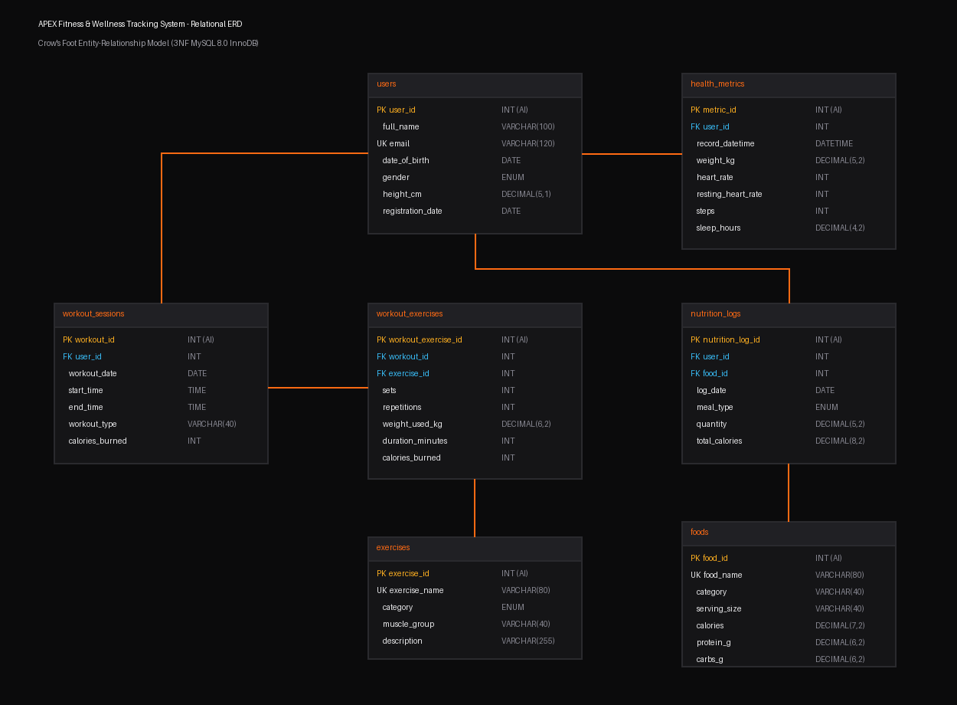

9. Solution Design
The 7 tables (users, exercises, workout_sessions, workout_exercises, foods, nutrition_logs, health_metrics) enforce foreign key cascading/restrictions. Automated triggers sync calories burned and total meal calories.

10. Challenges & Opportunities
Resolved the disjoint-date zero-calorie edge case by unifying activity dates with UNION and implementing symmetrical JavaScript fallbacks on the dashboard. Overcame mutating table trigger constraints via parent-child trigger segregation.

11. Reflections on the Project
Rigorous normalization eliminates software anomalies that would otherwise require hundreds of lines of fragile application code. Deliberate snapshot columns preserve essential historical audit realities.

12. Recommendations
Maintain innodb_flush_log_at_trx_commit = 1 for full durability. Employ composite covering indexes on high-frequency join attributes. Configure production connection pools with pre-ping validation.

13. Outcome / Conclusion
All project requirements were achieved with 100% verified execution, sub-70ms analytical queries, atomic rollback guarantees, and an intuitive single-page dashboard.

14. Enhancement Scope
Future roadmap includes JWT/OAuth2 user authentication, direct wearable webhooks (Apple HealthKit / Garmin Connect), and ML-based fatigue and recovery forecasting.

15. Link to Code and Executable Files
GitHub Repository: https://github.com/vigneshpg-star/APEXfitness-wellnesstracker.git

16. Research Questions and Responses
Detailed analyses on 3NF write vs read throughput, database-native ACID triggers vs distributed transactions, and computed views vs physical snapshots.

17. References
Codd (1970), Date (2004), MySQL 8.0 Reference Manual, WHO BMI Guidelines, and ACSM Exercise Guidelines.

