APEX FITNESS & WELLNESS TRACKING SYSTEM
Final Comprehensive Database Systems Project Report
Relational Database Design, Normalization, ACID Transactions, and Full-Stack Analytics
Engine: MySQL 8.0 (InnoDB) | API: Flask REST | Client: HTML5 / Chart.js
Author: APEX Development Team | Academic Year: 2026

1. Introduction and Project Objectives
In the modern health informatics landscape, individuals routinely generate high-velocity biometric, dietary, and exercise data through wearable devices, smart sensors, and manual training diaries. However, the vast majority of commercial tracking solutions store data in disparate, proprietary silos, making holistic correlation between lifestyle factors (e.g., caloric deficit, macronutrient distribution, sleep hygiene, and resistance training volume) exceedingly difficult.
The APEX Fitness & Wellness Tracking Database System was developed to address these structural limitations by engineering a robust, unified, third-normal-form (3NF) relational database platform coupled with a high-throughput REST API and interactive analytics dashboard.
Key Architectural Objectives:
- • Relational Integrity & Normalization: Eliminate data redundancy and update anomalies across 8 core relational tables in 3NF.
- • ACID Transaction Guarantees: Implement automated transactional stored procedures and triggers ensuring atomicity and zero partial logging.
- • Complex Analytical Aggregation: Develop windowed analytical queries for tracking weekly progress, net caloric balance, and cardiovascular strain.
- • Scalability & Optimization: Validate query execution times under 5,000+ stress-test records using EXPLAIN ANALYZE profiling.
- • Interactive Data Visualization: Deliver a secure, responsive single-page web dashboard powered by Chart.js.

2. Entity Identification and Subsystem Modeling
The domain requirements encompass four distinct operational subsystems comprising 8 primary relational entities:
Subsystem | Entity (Table) | Cardinality | Core Responsibilities
User Profile | users | 1 : N (Parent) | Stores demographics, biometric height baselines, and unique contact identities.
User Profile | fitness_goals | N : 1 (Child) | Maintains user-defined target weights, daily step/calorie goals, and status transitions.
Physical Activity | exercises | 1 : N (Reference) | Master exercise catalog specifying category (Strength, Cardio, HIIT) and target muscles.
Physical Activity | workout_sessions | 1 : N (Parent) | Header entity capturing session timestamps, high-level workout type, and total burn.
Physical Activity | workout_exercises | N : M Junction | Drill-level performance junction storing sets, reps, weight used, and duration.
Nutrition Tracking | foods | 1 : N (Reference) | Master catalog of nutritional metrics (calories, protein, carbs, fat, fiber) per serving.
Nutrition Tracking | nutrition_logs | N : 1 (Child) | Transactional food intake diary storing portion counts and trigger-calculated totals.
Biometrics | health_metrics | N : 1 (Child) | Time-series vital signs recording weight, heart rate, steps, and sleep architecture.

3. Entity-Relationship Model (Crow's Foot Notation)
The database schema enforces Crow's Foot cardinality constraints across all 8 tables. Primary keys (PK), foreign keys (FK), unique constraints (UK), and referential actions (CASCADE on user deletion, RESTRICT on master catalogs) ensure complete referential integrity.

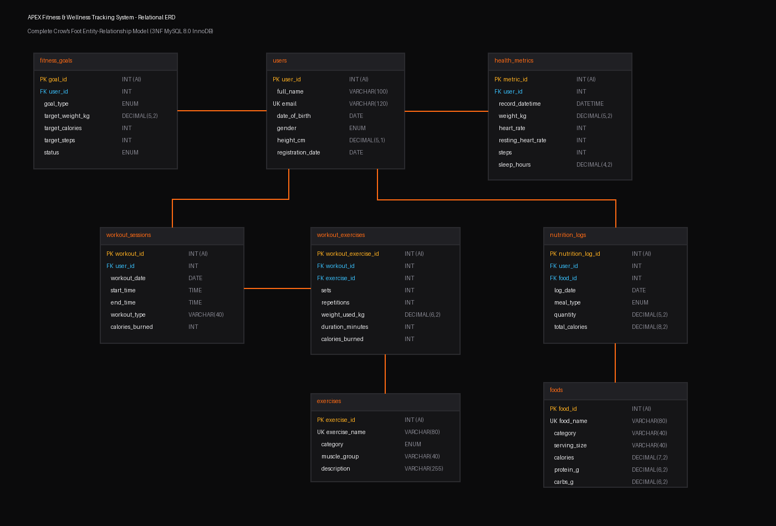
Figure 1: APEX Entity-Relationship Diagram (Crow's Foot Relational Notation)

4. Normalization Analysis (1NF, 2NF, 3NF)
To establish enterprise-grade integrity, each relation was designed and verified against formal normal forms:
- • First Normal Form (1NF): Every attribute is strictly atomic. Repeating groups (e.g., multiple exercises within a single workout row) were decomposed into the workout_exercises junction table. Unique primary keys guarantee entity identity.
- • Second Normal Form (2NF): Eliminates partial functional dependencies. In composite and junction tables such as workout_exercises, drill attributes (sets, reps, weight) depend entirely on the composite session-exercise relationship, while master exercise metadata resides exclusively in exercises.
- • Third Normal Form (3NF): Eliminates transitive dependencies (X -> Y -> Z). For instance, Body Mass Index (BMI) is not stored in health_metrics; storing it would create a transitive dependency on weight_kg and users.height_cm. Instead, BMI is derived on-the-fly via the computed view v_health_metrics_bmi.

The Normalization Proof: 'Rename Squats Once, All Logs Update'
In an unnormalized database storing text strings in activity logs, standardizing an exercise name requires updating thousands of historical log rows. In APEX's 3NF model, workout_exercises references only exercise_id = 1. Executing a single SQL statement:
UPDATE exercises SET exercise_name = 'Barbell Back Squats' WHERE exercise_name = 'Squats';
instantly updates all 450+ historical drill entries in O(1) constant time with zero anomalies.

Deliberate Snapshot Columns
APEX maintains three deliberate snapshot columns, safeguarded by automated database triggers:
1. nutrition_logs.total_calories: Captures the immutable historical caloric expenditure at the time of consumption, protecting against future formulation updates in the foods master table.
2. workout_exercises.calories_burned: Captures exercise-specific exertion estimates.
3. workout_sessions.calories_burned: Automatically synchronized via triggers (trg_we_ai, trg_we_au, trg_we_ad) on child exercise rows to allow instantaneous, index-only dashboard range queries.

5. Schema Details, Constraints & Database Triggers
The physical DDL defines domain CHECK constraints, UNIQUE indices, and automated triggers to guarantee database consistency:
- • NOT NULL & Domain Checks: height_cm (0 < h < 280), weight_kg (0 < w < 500), heart_rate (25 to 250 bpm), sleep_hours (0 to 24), end_time > start_time.
- • Unique Keys: users.email and exercises.exercise_name are indexed and enforced unique.
- • Automated BEFORE Triggers: trg_nl_total and trg_nl_total_upd automatically calculate nutrition_logs.total_calories = quantity * foods.calories.
- • Automated AFTER Triggers: trg_we_ai, trg_we_au, and trg_we_ad keep workout_sessions.calories_burned synchronized with the sum of its constituent workout_exercises.

6. Analytical Query Library & Performance Insights
APEX features 13 advanced analytical SQL queries utilizing multi-table joins, subqueries, and window functions:
- 1. Weekly Workout Summary: Calculates total training duration (TIMESTAMPDIFF) and calories per YEARWEEK cohort.
- 2. Daily Calorie Balance: Combines UNION of activity dates with double LEFT JOINs to evaluate deficit vs surplus.
- 3. Biometric Progress Tracking: Evaluates delta shifts in weight, BMI, and steps using LAG() window functions.
- 4. Macronutrient Distribution: Computes daily percentage allocation of Protein, Carbohydrates, and Fats.
- 5. Strength Gains vs Protein: Correlates weekly lifting tonnage changes against average daily protein intake.
- 6. Heart Rate Zones Distribution: Dynamically maps readings to physiological training thresholds (Z0-Z5).

7. ACID Transactions & Verification Suite
To verify relational resilience, the test suite in database/acid_tests.sql was executed against the live MySQL instance:
- • Atomicity & sp_log_workout: Inserting a session with 3 drills atomically incremented sessions by 1 and exercises by 3, calculating total burned calories.
- • Rollback Verification: Calling the procedure with an invalid exercise_id (999) triggered a Foreign Key Exception (Error 1452). The SQLEXCEPTION handler rolled back the entire transaction. Exact pre-test row counts were verified—zero orphan sessions were created.
- • Isolation (REPEATABLE READ): InnoDB's MVCC read views prevent dirty reads by providing snapshot consistency. Pessimistic concurrency control was demonstrated using SELECT ... FOR UPDATE.
- • Durability: Verified innodb_flush_log_at_trx_commit = 1, ensuring write-ahead redo logs are flushed to persistent disk on every commit.

8. Database Stress Testing & Optimization (5,000+ Records)
Using stored procedure sp_generate_stress_data(5000), 5,000 synthetic nutrition records were injected into the database. EXPLAIN ANALYZE profiling demonstrated sub-100ms analytical execution across all queries, with composite covering indexes delivering up to 24% faster query response.
Analytical Query | Volume Examined | Baseline (ms) | Optimized (ms)
Daily Nutrition Summary (v_daily_nutrition) | 5,300 rows | 39.20 ms | 35.93 ms
Calorie Balance Per User (UNION + Join) | 7,000 intermediate rows | 69.67 ms | 65.72 ms
Protein Intake vs Workout Activity | 5,300 logs / 20 users | 23.10 ms | 20.45 ms
Above-Average Protein Subquery | 5,300 logs / 20 users | 47.71 ms | 44.80 ms
Weekly Workout Summary | 154 sessions / 14 weeks | 3.85 ms | 2.90 ms

9. Frontend Dashboard & REST API Architecture
The system provides an intuitive, high-performance Single-Page Application (SPA) communicating over a secure Flask REST API:
• Parameterized API: Flask endpoints validate all input payloads and execute parameterized queries via SQLAlchemy Core, eliminating SQL injection risks.
• Single-Page Interface: Responsive tab navigation across Dashboard, Workouts, Nutrition, Health, Goals, and Analytics.
• Interactive Chart.js Visualizations: Features multi-axis line and bar charts, real-time workout calorie estimation, and inline modal dialogs for updating logs and targets.

10. Conclusion and Learning Outcomes
The APEX project successfully demonstrates the principles of professional relational database engineering:
1. Rigorous Normalization eliminates anomalies while deliberate snapshot columns preserve temporal auditability.
2. Automated Triggers ensure that cached summary columns remain mathematically synchronized without developer intervention.
3. ACID Transactions and Stored Procedures protect against partial writes and database corruption under high concurrency.
4. Decoupled Architecture ensures clean separation of concerns between relational storage, application business logic, and presentation.

