Spondylitis Detection Using Deep Learning Architecture
Spondylitis is a type of arthritis that primarily affects the spine, causing inflammation of the joints and ligaments, leading to pain, stiffness, and potentially, fusion of the vertebrae.
Existing techniques required medical experts to analyse X-Ray images to detect spondylitis but in propose user can upload X-Ray image and then deep learning CNN algorithm will analyse X-Ray image and then output as Normal or Spondylitis
To train and test Spondylitis we have used ‘Spondylitis imaging dataset’ which can be download from below URL
https://www.kaggle.com/datasets/yasserhessein/the-vertebrae-xray-images
Above dataset contains two labels such as ‘Normal and Spondylitis’.
To implement this project we have designed following modules
- New User Register: user can sign up with the application
- User Login: user can login to system
- Load & Process Spondy Dataset: using this model will load and normalize all dataset images and then split into train and test where application using 80% images for training and 20% for testing
- Train Detection Model: 80% training images will be input to deep learning CNN algorithm to trained a model and this model will be applied on 20% test images to calculate prediction accuracy
- Predict Spondylitis: using this module user can upload test image and then CNN model will predict weather image is normal or contains spondylitis symptoms.
- Recommendation: after detecting spondylitis user can run this module to get details on foods, treatments and exercises to treat disease.
SCREEN SHOTS
Install python 3.7.2 and then install all packages given in requirements.txt file and then install MYSQL and create database
To run project double click on ‘run.bat’ file to start python server and then will get below page
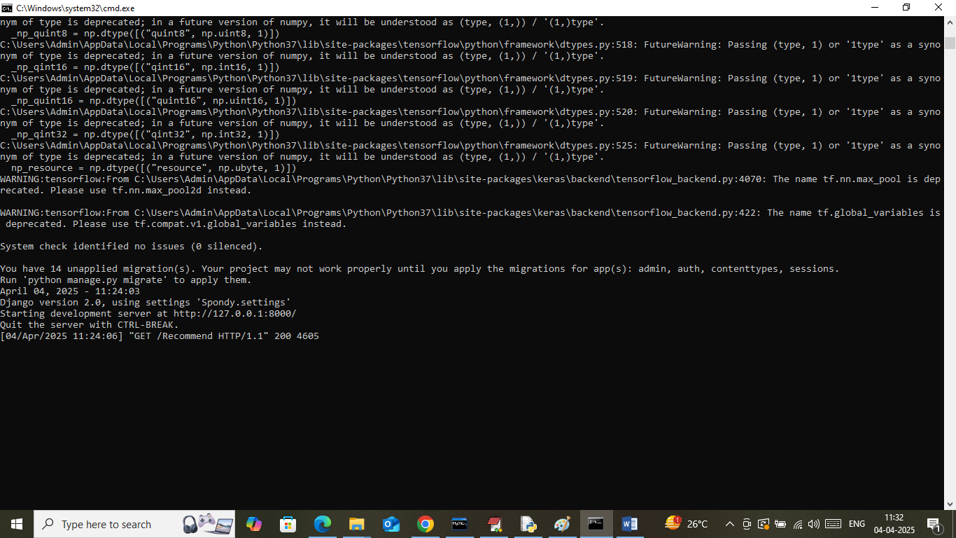
In above screen python server started and now open browser and enter URL as http://127.0.0.1:8000/index.html and then press enter key to get below page

In above screen click on ‘Registration Here’ link to get below page
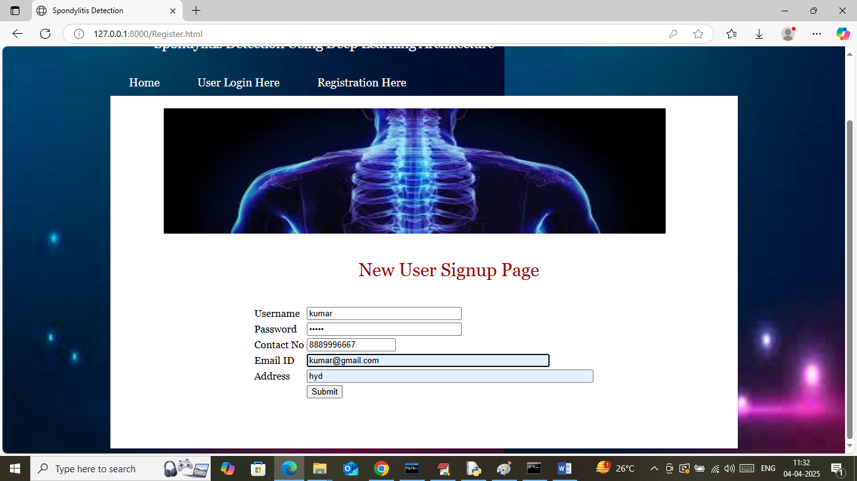
In above screen user is entering sign up details and then press button to get below page

In above screen user sign up process completed and now click on ‘User Login Here’ link to get below page

In above screen user is login and after login will get below page

In above screen user can click on ‘Load & Process Spondy Dataset’ link to load dataset and then will get below page
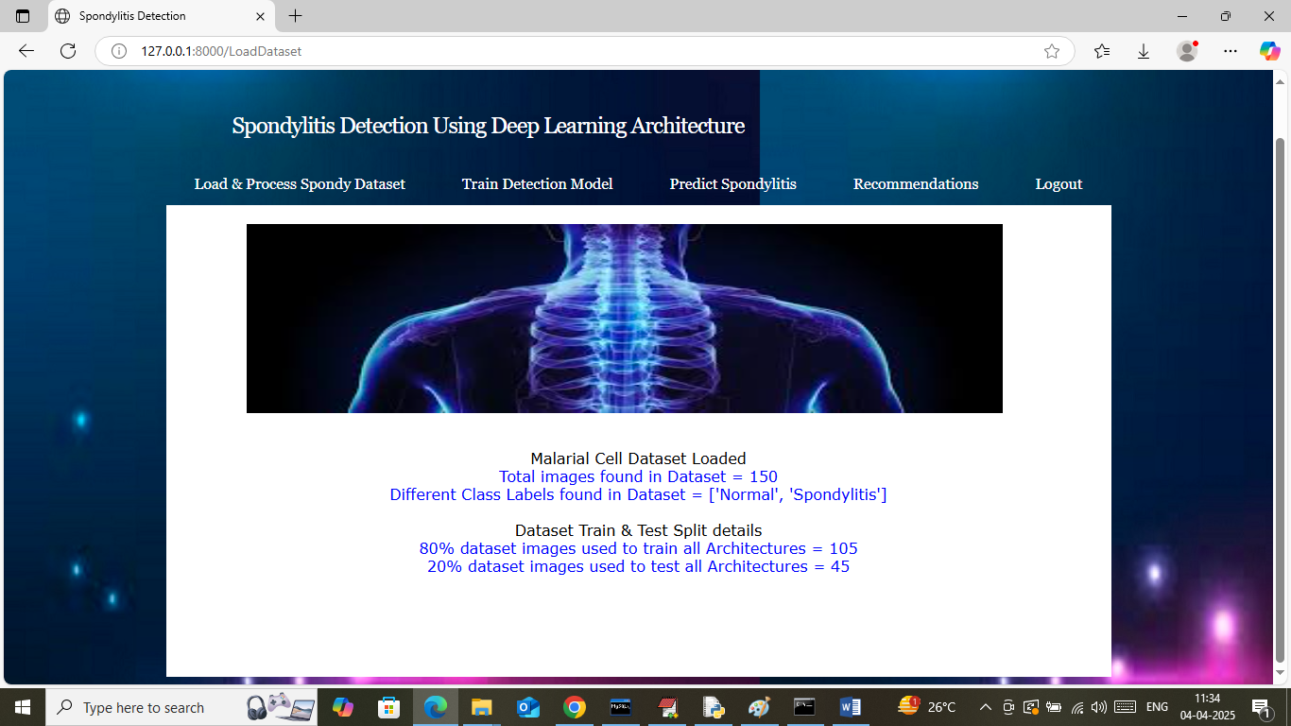
In above screen can see number of images loaded and processed from dataset and then can see train and test size. Now click on ‘Train Detection Model’ link to train al CNN algorithm and then will get below page
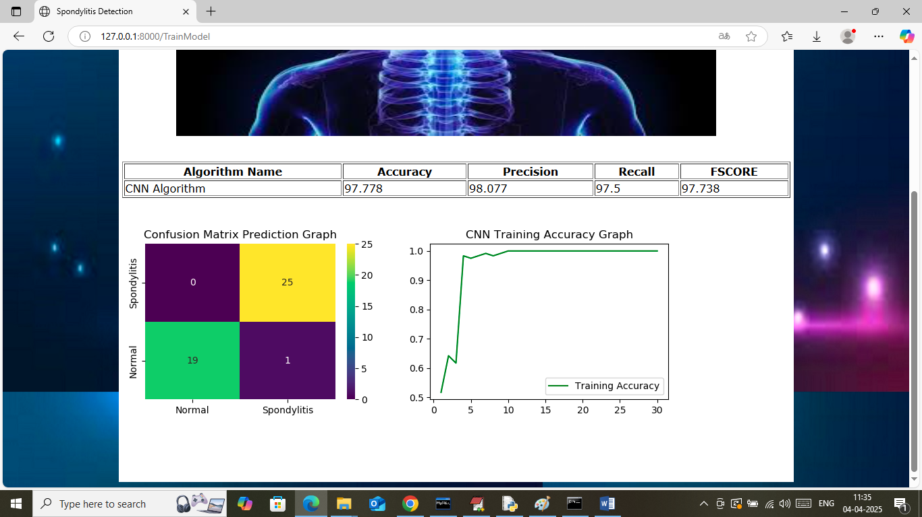
In above screen in table format can see accuracy, precision, recall, FSCORE of CNN algorithm. In above screen can see CNN can detect spondylitis with an accuracy of 97%. In confusion matrix graph x-axis represents Predicted Labels and y-axis represents true labels and then yellow and green boxes in diagonal represents correct prediction count and remaining blue boxes represents incorrect prediction count which are very few. In second graph can see training accuracy of CNN where x-axis represents ‘Number of training epochs’ and y-axis represents ‘accuracy’ and can see with each increasing epoch accuracy got increased and reached closer to 1. Now click on ‘Predict Spondylitis’ link to get below page

In above screen selecting and uploading image and then click on buttons to get below page
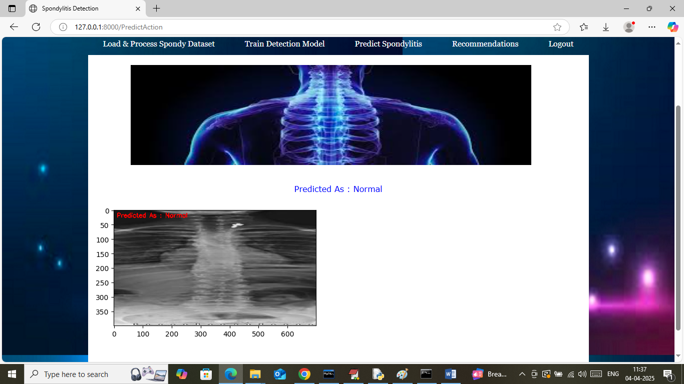
In above screen in red and blue text can see uploaded image detected as ‘Normal’ and similarly you can upload and test other images

In above screen uploading another image and below is the output
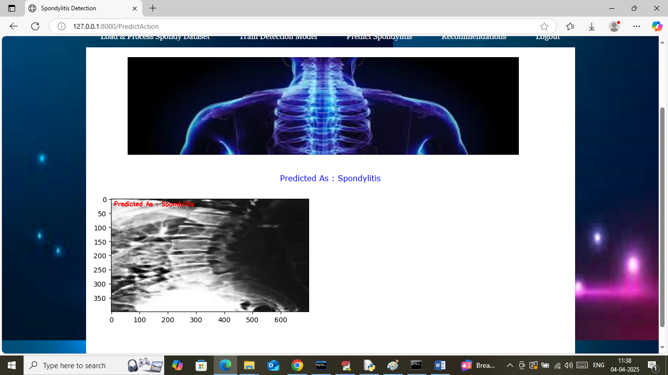
In above screen ‘Spondylitis’ detected. Now click on ‘Recommendation’ link to get below treatment details
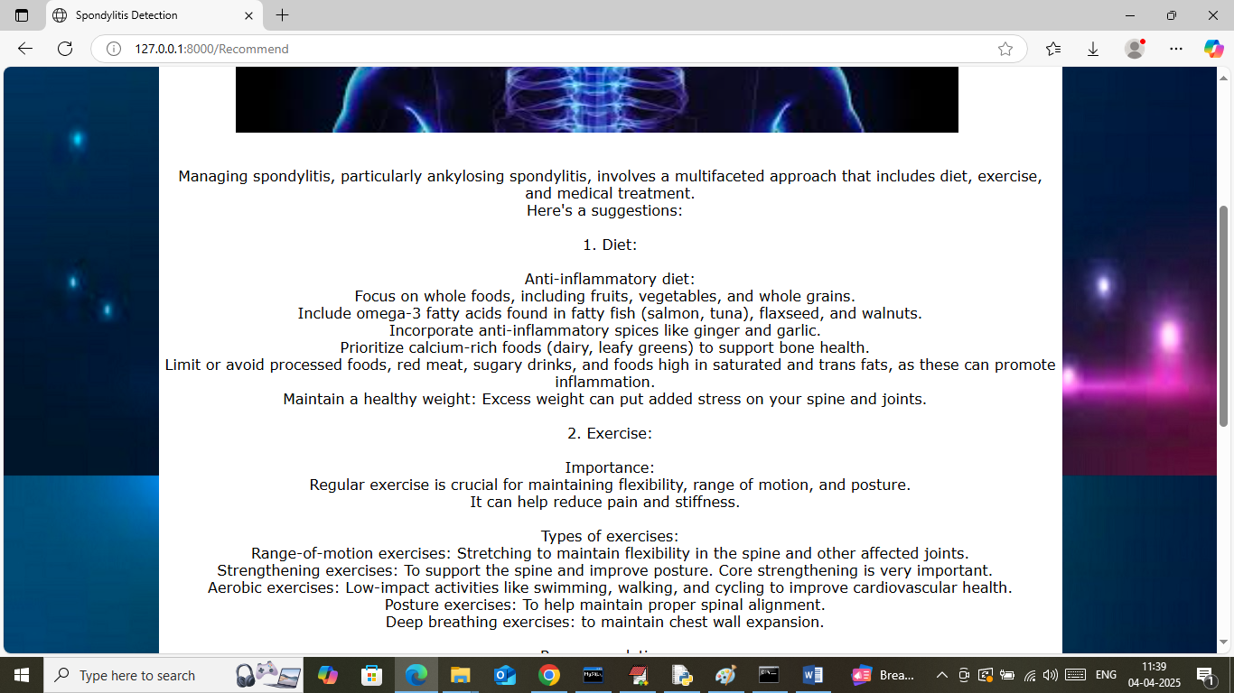
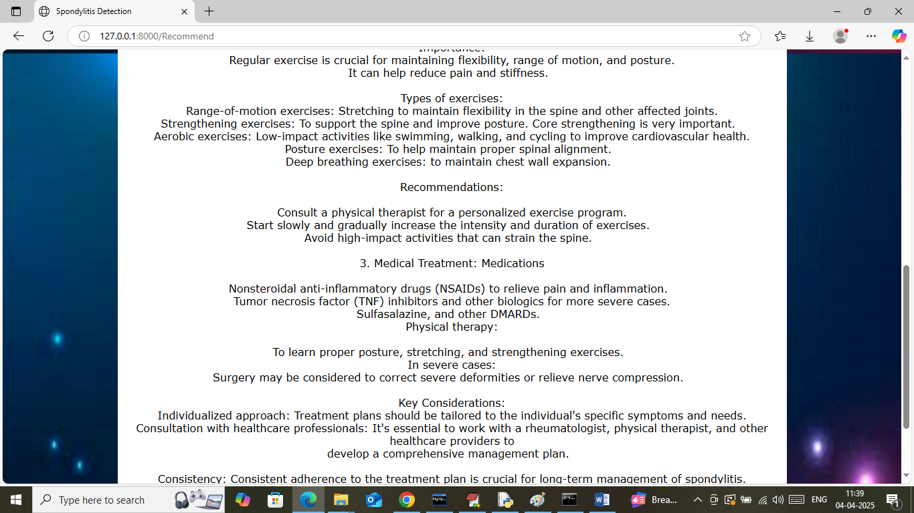
In above screen user can see Food, diet, treatment and other recommendation details

