Project Based Tasks

Name: P. Vignesh Reddy
Regd. No: 22PA1A05D9
Section: CSE-C

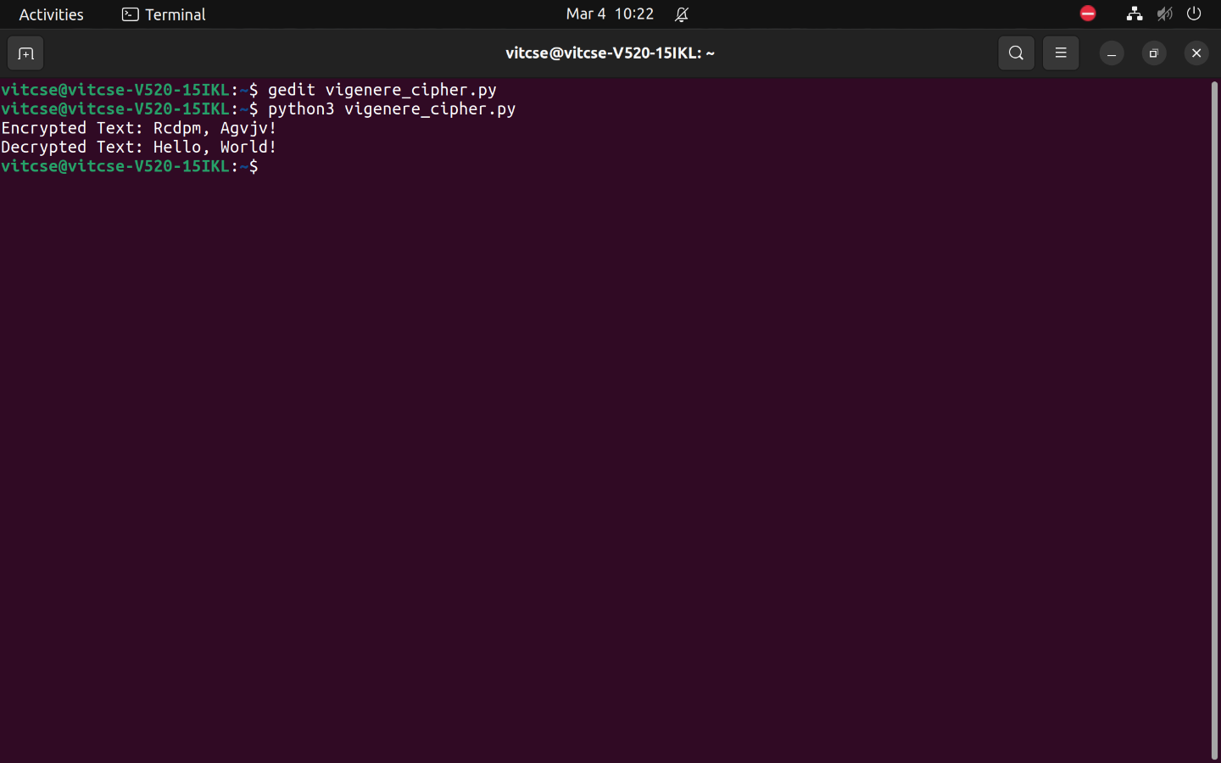

https://github.com/vigneshreddyputluri/Vigenere_Cipher

