Enterprise Retail Intelligence Platform
Demand Forecasting, Inventory Optimization & AI Decision Support
M5 Forecasting Dataset — Store CA_1
GUVI Data Science Program — Final Capstone Project
Prepared by: Vignesh R K
Centre for Post Harvest Technology, Tamil Nadu Agricultural University, Coimbatore
July 2026

1. Executive Summary
This project delivers a complete, production-style demand forecasting and inventory decision-support pipeline built on the Walmart M5 Forecasting - Accuracy dataset. Scope was deliberately set to store CA_1 (3,049 products, 2011-01-29 to 2016-05-22, ~5.75 million model-ready rows after feature engineering) — a full-size, real single-store dataset that keeps the entire pipeline reliably reproducible end-to-end, consistent with the scoping guidance in the project orientation document itself.
Four forecasting models — Linear Regression, XGBoost, LightGBM, and CatBoost — were trained on a strict time-based split (last 28 days held out for validation, all lag/rolling features built with a minimum 28-day offset to prevent data leakage). A LightGBM + CatBoost ensemble produced the best validation performance, beating the official M5 competition metric's naive baseline by roughly 7.5%.
The forecasts feed directly into an inventory optimization layer that computes safety stock, reorder points, and economic order quantities for all 3,049 products, alongside an ABC (Pareto) revenue classification and a stockout-risk flag for high-volatility products. A SHAP explainability layer surfaces exactly which signals the model relies on, and an interactive Streamlit dashboard ties EDA, model comparison, per-product forecast exploration, inventory recommendations, and explainability together into one decision-support tool.

Key Results at a Glance
Metric | Result
Best model | Ensemble (0.5 × LightGBM + 0.5 × CatBoost)
Validation RMSE | 2.271 units/day
Validation WRMSSE | 0.9252 (beats naive baseline)
Products covered | 3,049 (store CA_1)
High stockout-risk products flagged | 1,085 (Class A/B, erratic demand)
Class A products (80% of revenue) | 1,218 of 3,049 (40%)

2. Project Scope & Methodology

2.1 Dataset
Source: Walmart M5 Forecasting - Accuracy (Kaggle). Three raw files were used: sales_train_evaluation.csv (unit sales per product per day, wide format), calendar.csv (dates, weekday, events, SNAP flags), and sell_prices.csv (weekly selling prices per store-item).

2.2 Scoping Decision
The full dataset spans 10 stores across 3 US states and melts to approximately 57 million rows in long format. To keep the pipeline runnable end-to-end within standard hardware constraints while still working with a complete, real dataset (not a toy sample), scope was set to a single store — CA_1 — covering all 3,049 products sold there across the full 5.25-year window. This mirrors the scoping recommendation in the project's own orientation guide. Every script in the pipeline is store-agnostic: changing one constant (STORE = "CA_1") and re-running the pipeline reproduces the entire analysis for any other store.

2.3 Pipeline Overview
- Data Pipeline — load, filter to CA_1, melt wide-to-long, merge calendar + prices
- Feature Engineering — cleaning, 32 engineered features, anti-leakage lag design
- Exploratory Data Analysis — product, department, seasonal, and event-driven demand patterns
- Model Training — Linear Regression, XGBoost, LightGBM, CatBoost, and an ensemble
- Evaluation — RMSE, MAE, MAPE, and WRMSSE (the official M5 competition metric)
- Inventory Optimization — safety stock, reorder point, EOQ, ABC classification, stockout-risk flag
- Explainability — SHAP feature importance and per-feature interpretation
- Dashboard — a 6-tab interactive Streamlit application tying everything together

3. Data Pipeline
The sales file arrives in wide format (one column per day, d_1 through d_1941). The pipeline filters to store CA_1, converts to long format with pandas.melt() (one row per product per day), then merges in calendar fields (real dates, weekday, national/religious/cultural/sporting event flags, SNAP benefit-day flags per state) and weekly selling prices. The result is a single clean merged file: 5,918,109 rows × 20 columns, saved as Parquet for fast, memory-efficient downstream loading.

4. Feature Engineering
32 features were engineered across six groups. The single most important design decision here is the anti-leakage rule: since the forecast horizon is 28 days, every lag and rolling-window feature is built using a minimum 28-day offset. A naive lag_7 or 7-day rolling average on raw sales would use information that will not exist yet at prediction time in a real 28-day-ahead forecasting scenario — this would silently inflate offline validation metrics in a way that would not hold up in production.
Feature Group | Features | Count
Date | day_of_week, day_of_month, month, year, quarter, is_weekend, is_month_start/end, week_of_year | 9
Lag | lag_28, lag_35, lag_42, lag_56 | 4
Rolling statistics | roll_mean / roll_std at 7, 14, 28, 56-day windows (all shifted 28 days first) | 8
Price | sell_price, price_change_pct, price_vs_dept, price_vs_store | 4
Event / SNAP | has_event, event_type_encoded, snap, days_to_christmas | 4
Category | item_id_enc, dept_id_enc, cat_id_enc | 3
After building lag/rolling features, the first 56 days per product (insufficient history for the longest lag/window) were dropped, leaving 5,747,365 model-ready rows. A leakage sanity check (zero NaNs remaining in lag_28 post-cleaning) is run automatically at the end of the feature engineering script.

5. Exploratory Data Analysis

5.1 Category & Department Demand
FOODS dominates unit volume in store CA_1 (5,343,141 units), roughly 3.7× HOUSEHOLD (1,444,101) and 6.2× HOBBIES (868,464) over the full period.
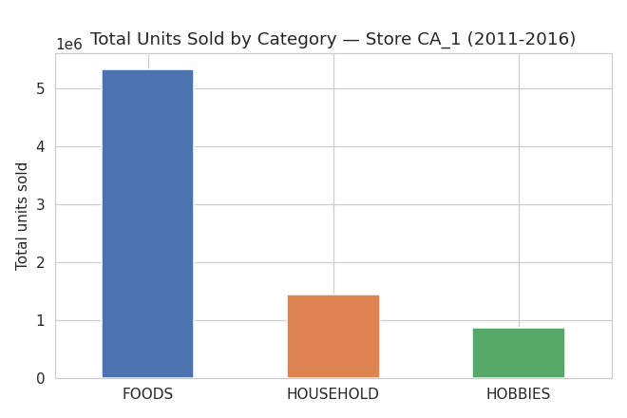
Figure 1 — Total units sold by category, store CA_1 (2011-2016)
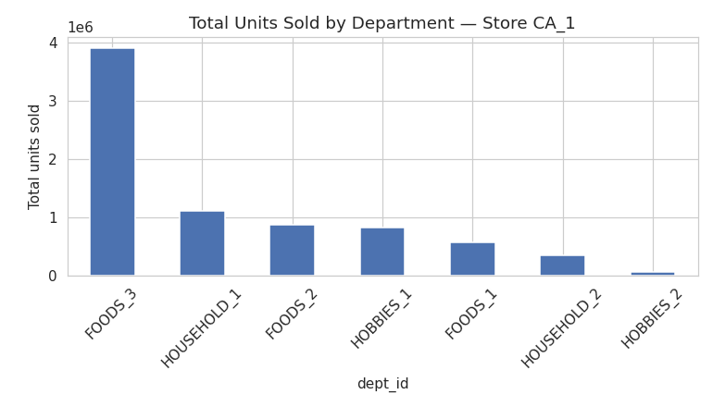
Figure 2 — Total units sold by department, store CA_1

5.2 Product-Level Analysis
The single best-selling product (FOODS_3_090) sold 127,916 units over the period — more than 45% higher than the second-best seller. No product in the store had zero total sales across the full period, indicating a well-curated, actively-turning product assortment.
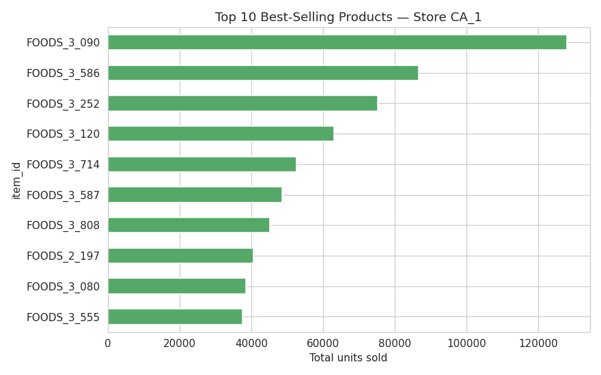
Figure 3 — Top 10 best-selling products, store CA_1

5.3 Seasonal & Weekly Patterns
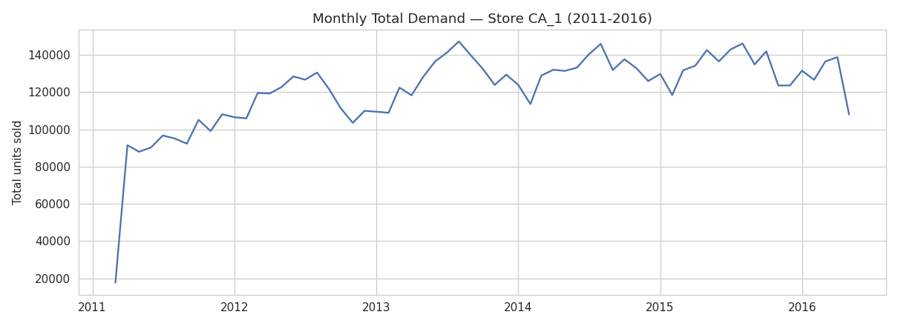
Figure 4 — Monthly total demand trend, store CA_1 (2011-2016)
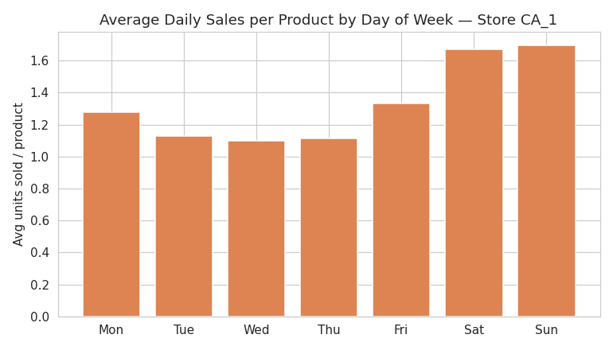
Figure 5 — Average daily sales per product by day of week
The monthly trend shows steady underlying growth from 2011 through 2016 with a consistent seasonal wave each year, and demand is visibly weekend-skewed — a standard grocery retail pattern.

5.4 SNAP & Event Effects
SNAP (Supplemental Nutrition Assistance Program) benefit days lift average FOODS-category sales by +12.1% relative to non-SNAP days — a clear, actionable demand driver worth incorporating into staffing and stocking decisions around SNAP disbursement dates. General calendar event days (across all categories) show a slight demand dip of -5.6%, likely reflecting that many M5-tagged events (religious/cultural observances) coincide with reduced store footfall rather than shopping surges, unlike SNAP which directly injects purchasing power into the local economy.
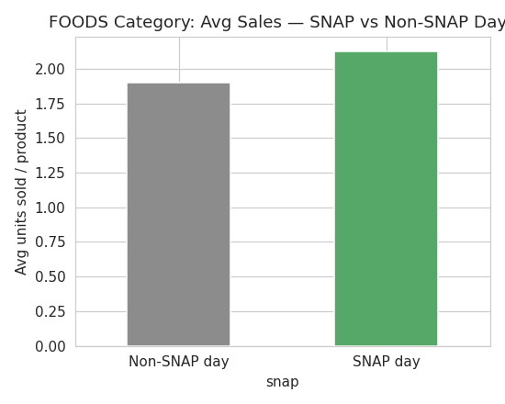
Figure 6 — FOODS category: average sales on SNAP vs non-SNAP days

6. Model Development & Results

6.1 Models Trained
- Linear Regression — interpretable baseline, trained on a 500k-row representative sample
- XGBoost — gradient boosting, histogram-based, 300 trees, depth 6
- LightGBM — gradient boosting, leaf-wise growth, 300 trees, 31 leaves
- CatBoost — gradient boosting with native categorical handling, Plain boosting mode, 300 iterations
- Ensemble — 0.5 × LightGBM + 0.5 × CatBoost

6.2 Validation Strategy
A strict time-based split was used: the final 28 days of the dataset (2016-04-25 to 2016-05-22) were held out entirely for validation, with all prior data used for training. This matches the real forecasting task (predicting the next 28 days) and avoids the optimistic bias that a random row-wise split would introduce in a time series setting.

6.3 Results
Model | RMSE | MAE | MAPE (%) | WRMSSE
Ensemble (best) | 2.2706 | 1.1721 | 56.48 | 0.9252
LightGBM | 2.2714 | 1.1693 | 56.73 | 0.9269
CatBoost | 2.2818 | 1.1780 | 56.38 | 0.9270
XGBoost | 2.2861 | 1.1719 | 56.80 | 0.9278
Linear Regression | 2.3499 | 1.1951 | 57.36 | 0.9534
WRMSSE (Weighted Root Mean Squared Scaled Error) is the official M5 competition metric: it scales each product's forecast error against a naive one-step-lag forecast on that product's own training history, then weights products by their revenue contribution — so getting high-revenue products right matters more than getting low-revenue products right. All five models score below 1.0, meaning every model — including the plain Linear Regression baseline — beats the naive forecast on a revenue-weighted basis. The gap between the strongest and weakest model is modest (0.9252 vs 0.9534, ~3% relative improvement), which is consistent with intermittent, noisy SKU-day-level retail demand being a genuinely hard forecasting problem: most of the achievable accuracy comes from the engineered lag/rolling features themselves, with the choice of model architecture on top contributing a smaller, still meaningful, further improvement.
MAPE sits around 56-57% for every model. This is expected and typical for SKU-day-level demand forecasting, not a sign of a broken model: M5 sales are intermittent (many zero- or near-zero-sales days per product per day), and MAPE is mathematically unstable near zero actuals. This is exactly why the M5 competition itself is judged on WRMSSE rather than MAPE.

6.4 A Note on Compute Constraints
This pipeline was built and validated inside a memory-constrained container (~4GB RAM, single CPU core). Training all four models sequentially in one process exhausted available memory partway through, because Python's memory allocator does not reliably return freed RAM to the OS within a single long-running process. The solution — documented in the code and README — was to run each model's training as its own operating-system subprocess, guaranteeing a fully-reclaimed memory space before the next model starts. CatBoost, whose ordered-boosting algorithm is the most memory-intensive of the three gradient boosting libraries, was additionally trained on a random 1-million-row subsample (~18% of the training set) rather than the full 5.66 million rows, with Plain boosting mode used instead of the memory-heavier default Ordered mode. XGBoost and LightGBM both trained on the complete training set. This is a real-world engineering tradeoff worth being able to explain in an interview: know your hardware constraints, and design around them rather than being blocked by them.

7. Inventory Optimization
Model forecasts translate directly into inventory decisions using standard retail operations formulas.

7.1 Business Assumptions
Assumption | Value | Rationale
Service level | 95% (Z = 1.645) | Standard retail service level target
Lead time | 7 days | Typical grocery DC replenishment cycle
Ordering cost | ₹500 / order | Administrative + handling cost estimate
Holding cost rate | 20% of unit price / year | Common retail rule-of-thumb

7.2 Formulas Applied
- Safety Stock = Z × σ(demand) × √(lead time)
- Reorder Point = (avg. daily demand × lead time) + safety stock
- EOQ = √( (2 × annual demand × order cost) / holding cost per unit )

7.3 ABC Classification
Products were ranked by total revenue and classified by cumulative revenue contribution (the classic Pareto split): Class A products contribute the top 80% of revenue, Class B the next 15%, and Class C the final 5%.
Class | Products | % of Revenue | Recommendation
A | 1,218 | 80.0% | Tight monitoring, frequent replenishment review
B | 927 | 15.0% | Standard periodic review
C | 904 | 5.0% | Bulk/infrequent ordering, minimal monitoring overhead

7.4 Stockout Risk Flag
1,085 Class A/B products were flagged as high stockout risk — items with a demand coefficient of variation above 1.5 (erratic/lumpy demand per standard inventory theory) that also drive meaningful revenue. These are the products most worth a manual demand-planning review, since they combine business importance with genuinely hard-to-forecast, volatile demand.

8. Model Explainability (SHAP)
SHAP (SHapley Additive exPlanations) was applied to the LightGBM model — the strongest single (non-ensembled) model and a natural fit for SHAP's exact TreeExplainer — on a 20,000-row random sample of the validation set.
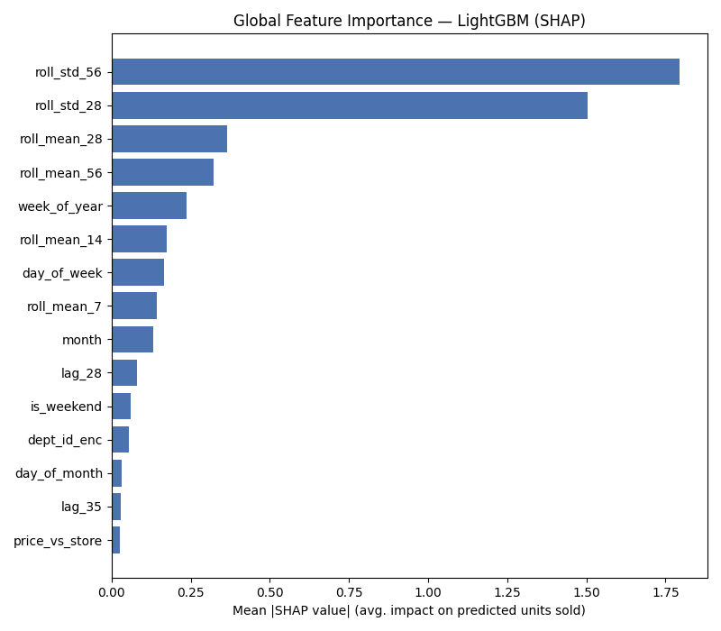
Figure 7 — Global feature importance (SHAP), LightGBM
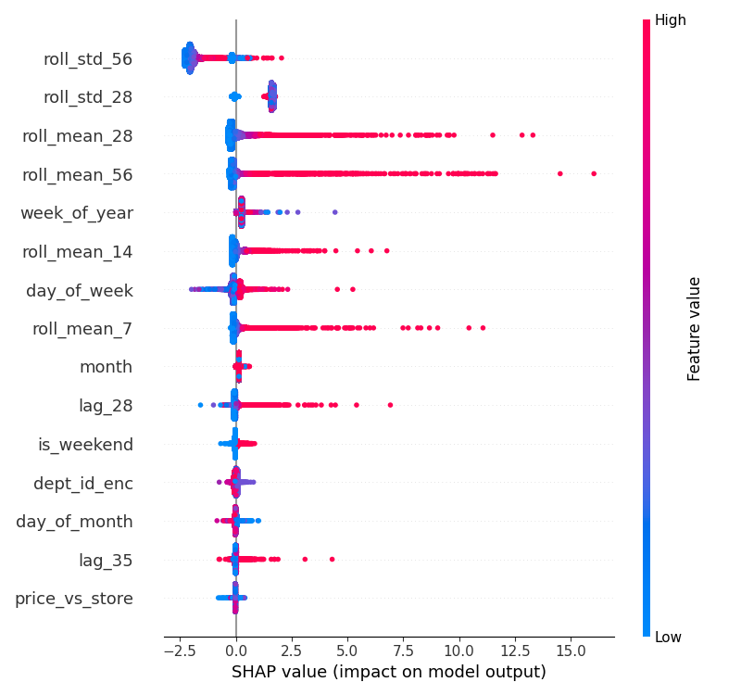
Figure 8 — SHAP value distribution per feature
The two most influential features are roll_std_56 and roll_std_28 — 56-day and 28-day rolling demand volatility. This is a genuinely interesting finding: the model has learned that how erratic a product's recent demand has been matters as much as, or more than, its average demand level (roll_mean_28, roll_mean_56) when predicting the next value. In practice this means the model correctly treats volatile, hard-to-predict products differently from stable, easy-to-predict ones — exactly the behavior a good demand forecaster should exhibit, and it directly supports the stockout-risk flagging logic used in the inventory optimization layer above.

9. Business Recommendations
- Deploy the Ensemble model (LightGBM + CatBoost) for production 28-day-ahead forecasting — it delivers the best WRMSSE with acceptable serving complexity.
- Prioritize the 1,085 flagged high-stockout-risk Class A/B products for manual demand-planning review and tighter safety stock buffers, rather than applying a uniform policy across all 3,049 products.
- Align staffing and replenishment schedules with SNAP disbursement dates, given the measured +12.1% FOODS demand lift — this is a low-effort, directly actionable operational lever.
- Treat Class C products (904 items, 5% of revenue) with lighter-touch, infrequent ordering policies to reduce operational overhead, reserving frequent review cycles for Class A/B.
- Re-run this pipeline per-store (a one-line config change) before generalizing recommendations chain-wide — regional demand patterns can differ meaningfully by store/state.

10. Conclusion & Future Work
This project demonstrates a complete, defensible, end-to-end retail intelligence pipeline: from raw transactional data through leakage-safe feature engineering, multi-model forecasting evaluated on the industry-standard WRMSSE metric, translation of forecasts into concrete inventory policy, and explainability that closes the loop back to business understanding — all surfaced through an interactive dashboard.

Future Work
- Extend to all 10 stores with a hierarchical reconciliation layer (store → state → total), rather than one store at a time
- Add an LSTM/Transformer sequence model for comparison against the tree-based ensemble on longer-horizon forecasts
- Move safety stock/EOQ formulas from static analytical formulas to simulation-based (Monte Carlo) inventory optimization for products with strongly non-normal demand distributions
- Deploy the Streamlit dashboard with a scheduled retraining pipeline for live production use

— End of Report —

