**Frontend Development with React.js**

**InsightStream: Navigate the News**

# Introduction

**Project Title: InsightStream:Navigation the News**

**Team Members:**

* Vignesh Sai Kumar B – Team Leader
* Hemalatha E – Team Member
* Brindha S – Team Member
* Charles Ruban C – Team Member

# Project Overview

**Purpose:**

InsightStream is a revolutionary web application designed to redefine how people discover and consume news. It provides an intuitive interface, dynamic search, and a vast range of news categories for all types of users.

**Features:**

* **News from API Sources**: Fetches news articles from external APIs using Rapid API integration.
* **Visual News Exploration**: Displays news through images and categories for easy navigation.
* **Advanced Search Feature**: Allows users to find news articles based on keywords and categories.
* **User-Friendly Design**: A seamless UI for smooth news consumption.
* **Subscription Feature**: Users can subscribe to receive daily news updates.

# Architecture

**Component Structure:**

* **Pages Folder**: Contains files for different routes such as Home, Categories, Search Results, and Article Page.
* **Components Folder**: Stores reusable components like Navbar, Hero Section, News Cards, Search Bar, and Footer.
* **Context Folder**: Manages state using Context API for global data handling.
* **Styles Folder**: Contains CSS files for styling the application.

**State Management:**

* **Context API** is used for global state management, ensuring efficient data flow across components.

**Routing:**

* Utilizes **React Router Dom** for seamless navigation between different pages.

# Setup Instructions

**Prerequisites:**

* **Node.js and npm** (<https://nodejs.org/en/download/>)
* **Git** (<https://git-scm.com/downloads>)
* **Code Editor** (Visual Studio Code recommended: <https://code.visualstudio.com/download>)

**Installation:**

1. Clone the repository from Google Drive:
2. git clone [repository link]
3. Navigate to the project directory:
4. cd news-app-react
5. Install dependencies:
6. npm install

# Folder Structure

● **src/** o **components/** (Reusable UI components) o **context/** (State management files) o **pages/** (Individual page components) o **styles/** (CSS and styling files) o **assets/** (Images and static resources)

# Running the Application

To start the development server, run:

npm start

The application will be accessible at <https://github.com/vigneshsai4851/newsapp.git>

# Component Documentation

**Key Components:**

* **Navbar**: Provides navigation across the app.
* **Hero Section**: Displays trending news and a search bar.
* **Category Cards**: Shows different news categories.
* **News List**: Fetches and displays news articles.
* **Article Page**: Redirects users to full news articles.

**Reusable Components:**

* **Button**: Standard button component.
* **SearchBar**: Search functionality for finding articles.
* **NewsCard**: Displays individual news articles.

# State Management

**Global State:**

* Managed using **Context API**, ensuring efficient data sharing across components.

**Local State:**

* Component-level state managed using React’s **useState** and **useEffect** hooks.

# User Interface

* **Home Page**: Displays trending news and popular categories.
* **Search Page**: Lists articles based on user search queries.
* **Article Page**: Displays full news articles fetched from API.
* **Subscription Section**: Allows users to subscribe to daily updates.

# Styling

**CSS Frameworks/Libraries:**

* **Tailwind CSS** for styling (<https://tailwindcss.com/>)
* **React Icons** for UI icons

**Testing:**

**Testing Strategy:**

* Unit tests using **Jest** and **React Testing Library**.
* Integration tests for API calls and UI interactions.

# Screenshots or Demo

* Project Demo: <https://drive.google.com/file/d/1EHMiVtVakx1KbQHjvwFC3TsBFdQ2qBuj/view?usp=drivesdk>
* Screenshot :

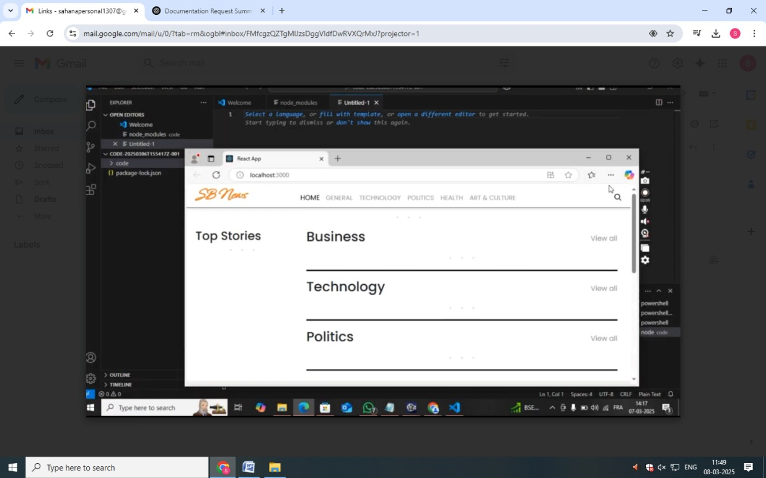

# ● Known Issues

* API rate limits may cause restricted access to news articles.
* Some articles might have missing images depending on the source.

# Future Enhancements

* **Dark Mode**: Implementing a dark theme for better user experience.
* **User Authentication**: Allowing users to personalize their news feed. ● **Commenting System**: Enabling discussions on news articles.