**REPORT**

# iCare Health Monitoring and User-Information

Team: Tech Innovation



Tech Innovation:

Vignesh.S

BarathJayan D

Ananthakrishnan VS

Sairam BR

**ABSTRACT**

During the recent decade we have seen an incredible improvement concerning miniaturized electronic devices, in order to facilitate their integration in handheld equipment’s. Wearable communication technologies can offer promising solutions in biomedical, consumer electronics, military, and smart home applications. This invention demonstrates the estimation of Blood Glucose level by designing a substrate-based flexible antenna in the 2.4 GHz industrial, scientific, and medical radio (ISM) bands. A flexible antenna is a significant part of the new generation of wireless communication systems in which the substrate offers moderate dielectric values by changing the concentration of the raw materials. Synthesized nickel particle-based flexible nickel aluminate (NiAl2O4) is utilized as a substrate material to make an effective antenna for microwave applications. The nickel aluminate substrate was made with 42% concentration of nickel, and has a dielectric constant of 4.979 and a thickness of 1 mm. Design and performance analyses of the antenna were performed and the antenna performances were investigated based on the reflection coefficient in normal and bent conditions. The dielectric properties of human blood over a broad frequency range were measured with and without adding the glucose content for different type of blood groups. The obtained results demonstrate a significant variation between the dielectric properties of blood with and without glucose agents and the difference is larger in conductivity than in relative permittivity. The variation with the conductivity of signals received by the antenna can predict the level of glucose content present in the blood.

**The application is to develop medical web-application based on microservices for patient’s health care. Application contains web service for user management and the set of services to simulate the sending of medical telemetry data to server. Services for data storage & processing are simple CRUD**

**Table of Contents**

|  |  |
| --- | --- |
| **Contents** | **Page No.** |
| Abstract | i |
| Table of Contents | ii |

|  |  |  |
| --- | --- | --- |
| **Chapter 1:** | **Introduction** | iii |
| **Chapter 2:** | **Objectives** | iv |
| **Chapter 3:** | **System Design** | iv |
| **Chapter 4:** | **System Implementation** | v |
| **Chapter 5:** | **Applications** | ix |
| **Chapter 6:** | **Conclusion and Future Scope** | ix |
|  | **References** |  |

**Introduction:**

Present innovation deals with the design of a flexible antenna with nickel particle-based flexible nickel aluminate (NiAl2O4) as a substrate material in order to estimate the glucose content of the blood by evaluating the conductivity and relative permittivity properties.

Emerging technologies like ASP.NET Web API and JavaScript frameworks like AngularJS makes it easy to design and build Single Page Applications (SPAs) web sites using ASP.NET Web API and the popular client-side JavaScript library called AngularJS. The idea behind this series is learning various components of the Angular JS library and making developers comfortable in AngularJS. We will do some hands-on with the Angular JS library by building an **iCare Health Monitoring and User Information** throughout this series. This Project Tracking website will be used by a fictitious Organization and will allow employees of an organization to create a new project and add user stories. Once the user stories are in place, the project manager will assign the tasks to his/her team members. Team members will perform the task and update the progress of the task(s) on the web site. Containerization is an approach to software development in which an application or service, its dependencies, and its configuration (abstracted as deployment manifest files) are packaged together as a container image. The containerized application can be tested as a unit and deployed as a container image instance to the host operating system (OS). Just as shipping containers allow goods to be transported by ship, train, or truck regardless of the cargo inside, software containers act as a standard unit of software deployment that can contain different code and dependencies. Containerizing software this way enables developers and IT professionals to deploy them across environments with little or no modification. Containers also isolate applications from each other on a shared OS. Containerized applications run on top of a container host that in turn runs on the OS (Linux or Windows). Containers therefore have a significantly smaller footprint than virtual machine (VM) images.

**Objectives:**

Web applications (or web apps) are programs on the internet that can be accessed in web browsers (Firefox, Chrome, Safari, IE, etc.). These programs can provide any kind of functionality that you need to help your business or organization run more smoothly. Some examples of web apps are product catalogs, search engines, project management tools, web mail, and the list goes on and on.

Web apps are very dynamic. They allow users to interact with your data to get the exact information they want. They are also very good at automating day-to-day tasks. Imagine a system that lists your inventory, shows related parts for a chosen item, and allows a user to order a part and have it shipped, all automatically. This site would automatically update for people as they used it – the number of parts in the system changes as the number of parts grows or shrinks. Keeping a static web site up-to-date with inventory, counts, orders, etc., would be so much work that it borders on impossible.

Due to the technological advancements in electromagnetic fields, it can be widely used in medical applications to detect various diseases. In this work, we present a novel idea to detect the glucose content of blood by designing a Planar Inverted F antenna (PIFA) which is more commonly available in mobile devices. Our basic idea is to design PIFA antenna using CST software and thereby fabricating the antenna with one port and identifying its reflection parameters and VSWR ratio. Different groups of blood samples (A, B, AB and O) were collected and the dielectric parameters such as dielectric constant, dielectric loss and conductivity were determined at the frequency of 2.4 GHz. The antenna is excited by a source and radiated towards the finger of the human body. The permittivity, Conductivity, permeability and absorption power by the skin tissues and bloods are identified and compared with the standard values determined by the blood samples. Results showed that the Energy received from the normal blood sample and affected blood with increased glucose content gets varied and from this simulation results we can be able to conclude the amount of glucose content present in the blood.

**System Design:**

The reference application is cross-platform and can run on Windows, Linux or Mac OS. A microservice-oriented architecture with multiple standalone microservices (simple CRUD) is used. The Http protocol is used for communication between web application and microservices. Communication across multiple microservices is based on the Event Bus with commands & events. The application uses the Mass Transit event bus with RabbitMQ message broker.

Microservices

The microservices in the application are completely independent and are not aware of the existence of other microservices.

* API Gateway
* Sensor Microservice
* Data Processor Microservice
* Identity Microservice
* Profile Microservice
* Report Microservice
* Event Bus
* Data Source
* Web App

**Built with**

* ASP.NET Core 3.1
* Microservices
* Clean architecture
* CRUD
* REST API
* Docker
* Entity Framework Core
* Automapper
* Health check
* xUnit
* Moq
* Serilog
* MassTransit
* RabbitMQ
* Open Tracing
* Jaeger

**System Implementation:**

**API Gateway**

API Gateway is a single-entry point for a microservice application. This service routes to the designated microservice.

In addition, each microservice has an external port and can be accessed from outside.

| **Microservice** | **Container name** | **Port** |
| --- | --- | --- |
| SQL Server | sqldata | 1433:80 |
| Gateway.API | gateway.api | 3000:80 |
| Sensor.API | sensor.api | 3001:80 |
| Report.API | report.api | 3002:80 |
| Profile.API | profile.api | 3003:80 |
| Identity.API | identity.api | 3004:80 |
| DataProcessor.API | dataprocessor_1.api | 3005:80 |
| DataProcessor.API | dataprocessor_2.api | 3006:80 |

**Sensor service**

Sensor microservice is designed to manage and store information about telemetry sensors and patient health data, collected by sensors.

**Data Processor Service**

Data Processor microservice is designed to process data received from substrate-based flexible antenna in the 2.4 GHz.

**Identity Service**

Identity microservice is designed to control access to application resources.

**Profile Service**

Profile microservice is designed to manage and store user profiles.

**Report Service**

Report microservice is designed to manage and store patient health reports, received from Data Processor microservice.

**Event Bus (MassTransit with RabbitMQ)**

The microservices in the application are completely independent and are not aware of the existence of other microservices.

Microservices use the event bus for communication. The event bus is implemented on the [Mass Transit](https://masstransit-project.com/) and uses the [RabbitMQ](https://www.rabbitmq.com/) as a message broker.

**Commands & Events**

Each microservice can be subscribed to certain events and commands, and can also send them.

A **command** can only be received by one microservice. At the same time, an unlimited number of microservices can be subscribed to **events**. The commands and events used by each microservice are presented below.

**Sensor.API**

| **Publish Events** | **Send Commands** | **Subcribed** |
| --- | --- | --- |
| IRecordRegistered | IProcessData | IDataProcessed |
| IRecordDeleted |  |  |
| IRecordUpdated |  |  |
| ISensorRegistered |  |  |
| ISensorDeleted |  |  |
| ISensorUpdated |  |  |

**DataProcessor.API**

| **Publish Events** | **Send Commands** | **Subcribed** |
| --- | --- | --- |
| IDataProcessed | IRegisterReport | IProcessData |

**Report.API**

| **Publish Events** | **Send Commands** | **Subcribed** |
| --- | --- | --- |
| IReportRegistered |  | IRegisterReport |
|  |  | IRecordDeleted |
|  |  | ISensorDeleted |
|  |  | IProfileDeleted |

**Profile.API**

| **Publish Events** | **Send Commands** | **Subcribed** |
| --- | --- | --- |
| IProfileRegistered |  |  |

**Data Source Microservive**

A data source is a microservice for simulating telemetry data collection with a specific time interval and sending data to a specified API (Sensor.API).

**Get Started**

To start data generation, send the following POST request:

http://localhost:3010/api/datasource/start

To stop DataSource microservice, send the following POST request:

http://localhost:3010/api/datasource/stop

To configure data generation parameters (sensor serial, data type, generation time interval), use the following POST request:

http://localhost:3010/api/datasource/configure

To check microservice state (working/stopped), use the following GET request:

http://localhost:3010/api/datasource/hc

**Additional Services**

Use Swagger UI service for more information on the DataSource API:

http://localhost:3010/swagger

Use Jaeger tracing service to verify that the generated data is sent to microservices through Gateway.API:

<http://localhost:16686>

**Wep Application Microservice**

Microservice is a single-page web application designed to control the process of collecting and processing data to monitor the health condition of the patient.

**Hardware**

**Brief description of Drawing**

The figures illustrate exemplary embodiments of the invention.

**Figure 1** CPW-PIFA geometry and the fabricated antenna

**Figure 2** Experimental reflection coefficient of CPW-PIFA

**Figure 3** Experimental Verification of Non-Invasive Glucometer

**Detailed description of the drawing**

The present invention relates to needle less measurement technique of blood glucose level by using RF signals.

**Figure 1**depicts the design of planar inverted F antenna by selecting a coplanar waveguide to feed the antenna resonator

**Figure 2** depicts the performance of CPW-PIFA under bending conditions and the reflection coefficient is experimentally determined.

**Figure 3** depicts the process flow of Non-Invasive Blood Glucometer in which the flexible antenna can be place in the hands of a person and the antenna emits a RF signal of 2.4GHz. Depending upon the received signal power the amount of glucose content in Blood can be measured.

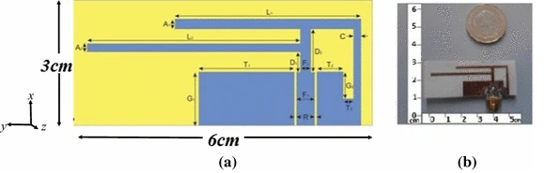

**Figure 1 CPW-PIFA geometry and the fabricated antenna**

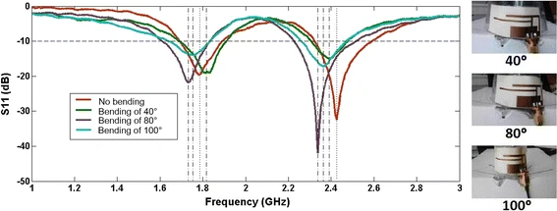

**Figure 2 Experimental reflection coefficient of CPW-PIFA**

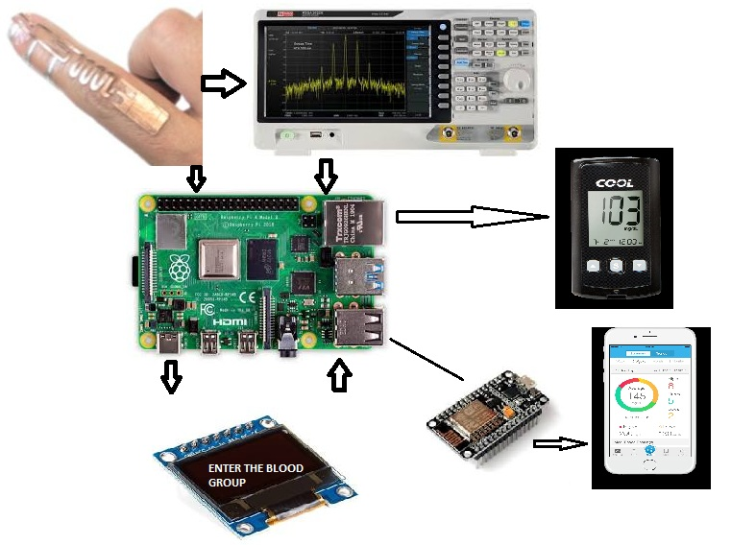

**Figure 3 Experimental Verification of Non-Invasive Glucometer**

**Applications:**

* [ASP.NET Core 3.1](https://docs.microsoft.com/en-us/aspnet/core/)
* [Microservices](https://docs.microsoft.com/en-us/dotnet/architecture/microservices/)
* [Clean architecture](https://docs.microsoft.com/en-us/dotnet/architecture/modern-web-apps-azure/common-web-application-architectures)
* [CRUD](https://docs.microsoft.com/en-us/iis-administration/api/crud)
* [REST API](https://restfulapi.net/)
* [Docker](https://www.docker.com/)
* [Entity Framework Core](https://docs.microsoft.com/en-us/ef/core/)
* [Automapper](https://automapper.org/)
* [Health check](https://docs.microsoft.com/en-us/aspnet/core/host-and-deploy/health-checks?view=aspnetcore-3.1)
* [xUnit](https://xunit.net/)
* [Moq](https://github.com/Moq/moq4/wiki/Quickstart)
* [Serilog](https://serilog.net/)
* [MassTransit](https://masstransit-project.com/)
* [RabbitMQ](https://www.rabbitmq.com/)
* [Open Tracing](https://opentracing.io/)
* [Jaeger](https://www.jaegertracing.io/)
* Angular 9

**Conclusion and Future Scope:**

we conclude that the presence of erythrocyte membrane causes significant variations in the dielectric parameters of human blood, apart from proteins and salt solutions. When a signal from a source is transmitted to the antenna at a frequency of 2.4GHz, the antenna radiates and an electromagnetic signal is passed into the fingers of human. As mentioned in the above table, the signals pass through a wet or dry skin, Fat, Muscle and Blood with different groups in which the dielectric properties are known. When there is change in Glucose content of the blood, the dielectric property of the blood gets varied which results in the variation in scattering parameters, Reflection parameters and Absorption Power. This change made can be calculated and the processor estimates the Content of blood glucose level in a binary value. The Node Mcu module connected with the processor Transmits the value obtained to the Cloud Platform and the values can be viewed continuously in the mobile application.

Health care is moving into the home increasingly often and involving a mixture of people, a variety of tasks, and a broad diversity of devices and technologies; it is also occurring in a range of residential environments. The factors driving this migration include the rising costs of providing health care; the growing numbers of older adults; the increasing prevalence of chronic disease; improved survival rates of various diseases, injuries, and other conditions (including those of fragile newborns); large numbers of veterans returning from war with serious injuries; and a wide range of technological innovations. The health care that results varies considerably in its safety, effectiveness, and efficiency, as well as its quality and cost.

The committee was charged with examining this major trend in health care delivery and resulting challenges from only one of many perspectives: the study of human factors. From the outset it was clear that the dramatic and evolving change in health care practice and policies presents a broad array of opportunities and problems. Consequently the committee endeavored to maintain focus specifically on how using the human factors approach can provide solutions that support maximizing the safety and quality of health care delivered in the home while empowering both care recipients and caregivers in the effort.

**My Patent File PDF:**

**https://drive.google.com/file/d/1hXPkhhxS5hnXwuVY83BQxwS1iMZV_HTO/view?usp=sharing**