Assignment 5

*Birthday* *Problem* and the *Coupon Collector's* Problem.

C1(M) = SQRT(Pi \* M /2)

B0(M) = M ln M

We are taking a range of numbers for more accurate results.

Birthday Problem.

Numbers generated before collision

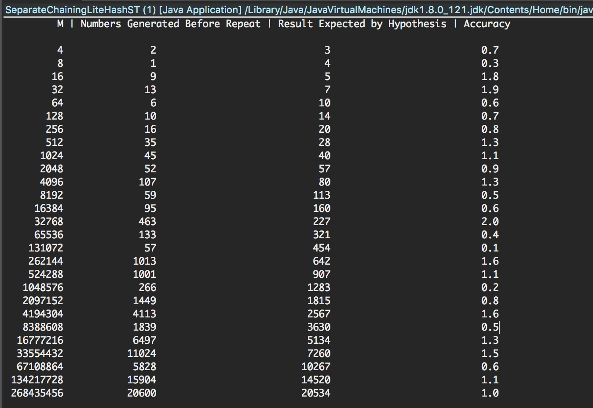

Average of the Accuracy in multiple tries.

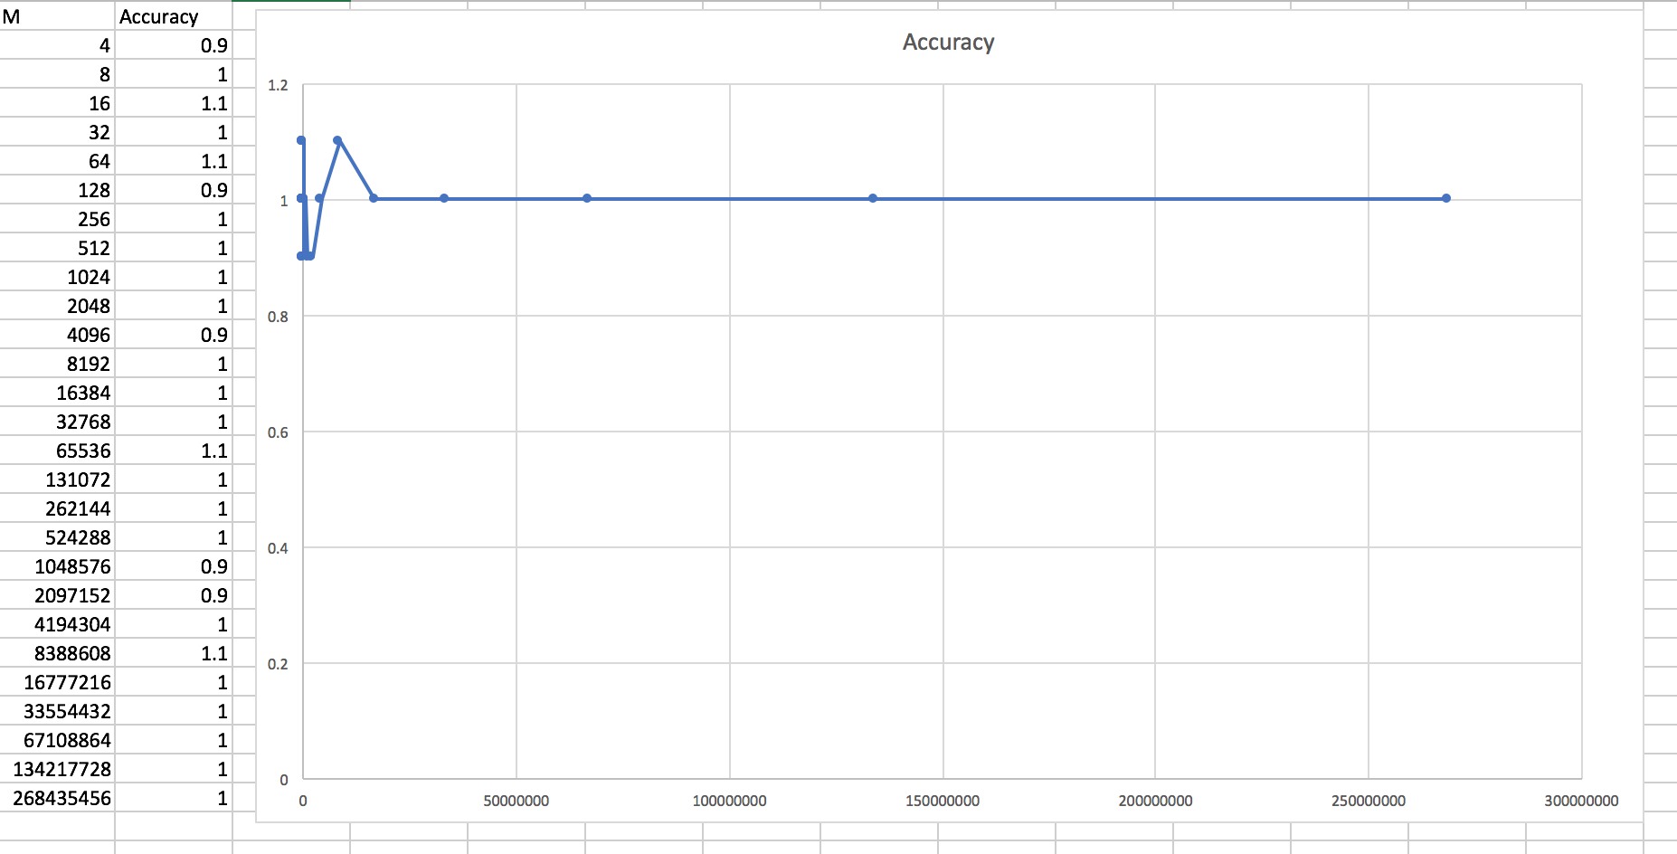

Overall the results were close to the expected results by the hypothesis (except for some outliers).We can consider that the number of integers generated before the first repeated value is found is ~SQRT(PI \* N/2).

Coupon Collector problem

Numbers generated before All Values

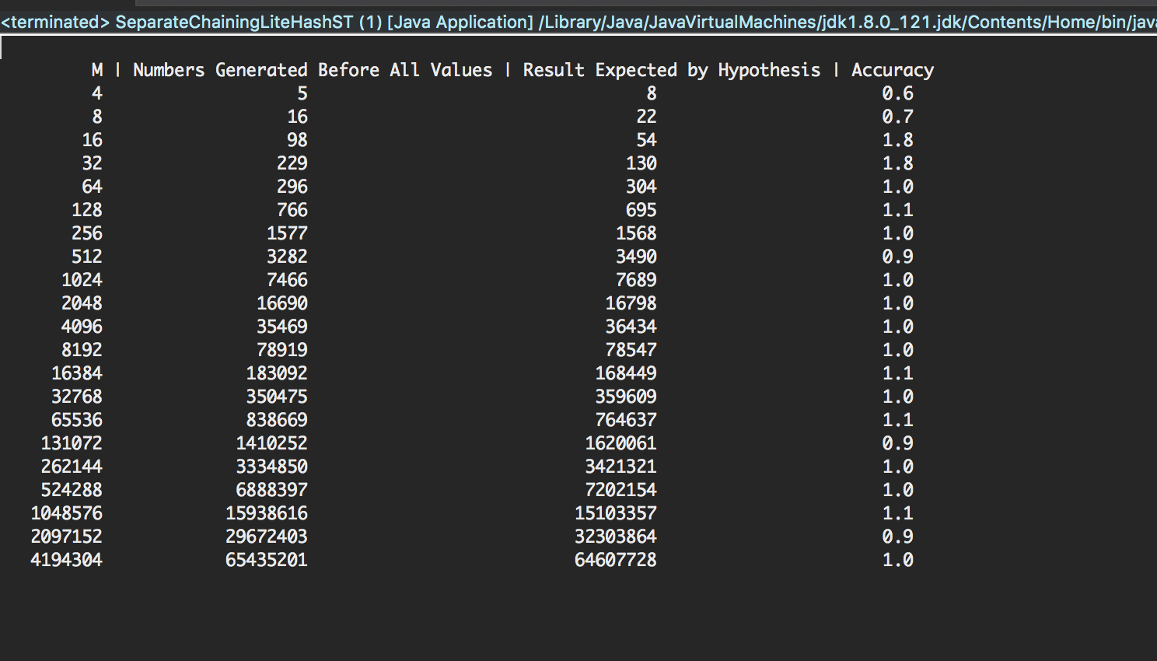

Average of the Accuracy in multiple tries.

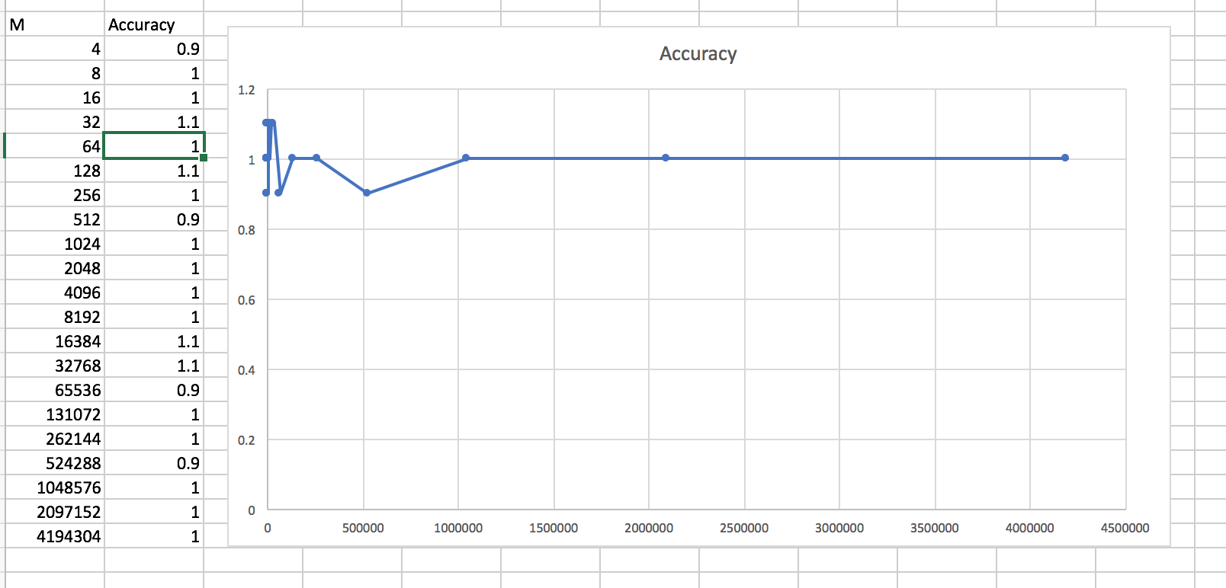

The experiments can prove the hypothesis that the number of integers generated before all possible values

are generated is ~ MlnM

Unit Testing

