

**GIS 5103: Foundations of Geographic Information Science**

**Instructor Name:** Sanaie-Movahed

**Presented By:**

Vignesh Thulasi Dass

**Assignment Title:** GIS Project

**Project:** Identifying the Potential Groundwater, Flood Risk and Drought Hit Areas in the Region of Punjab, India

**Submission Date:** 6/26/2020

Table of Contents

Introduction 2

Discussion of Data 2

Discussion of Methodology 3

Results/Conclusions 3

Map Products 3

References 19

Appendix 19

Introduction

* To identify Groundwater Potential Zones
* Drought prone Area analysis
* Flood Risk map

The study area is in the State of Punjab, India.

## Discussion of Data

By using GIS, it is also possible to generate groundwater maps without groundwater data also. But this data is not easily available. So, while performing groundwater potential zone analysis we not used observed data it is optional. The data, which used for Groundwater analysis, same data can be used for other analysis also, **like Flood risk, Drought prone area analysis**.

I have used both the vector and raster data, the watershedBND is the primary area of Vector data.

Raster data

1. Drainage
2. Rainfall
3. Slope
4. Dem
5. SoilRas
6. Landuse

The above raster data all have been classified with equal interval of 5

WGS_1984_UTM_Zone_43N is the spatial extent of my study area

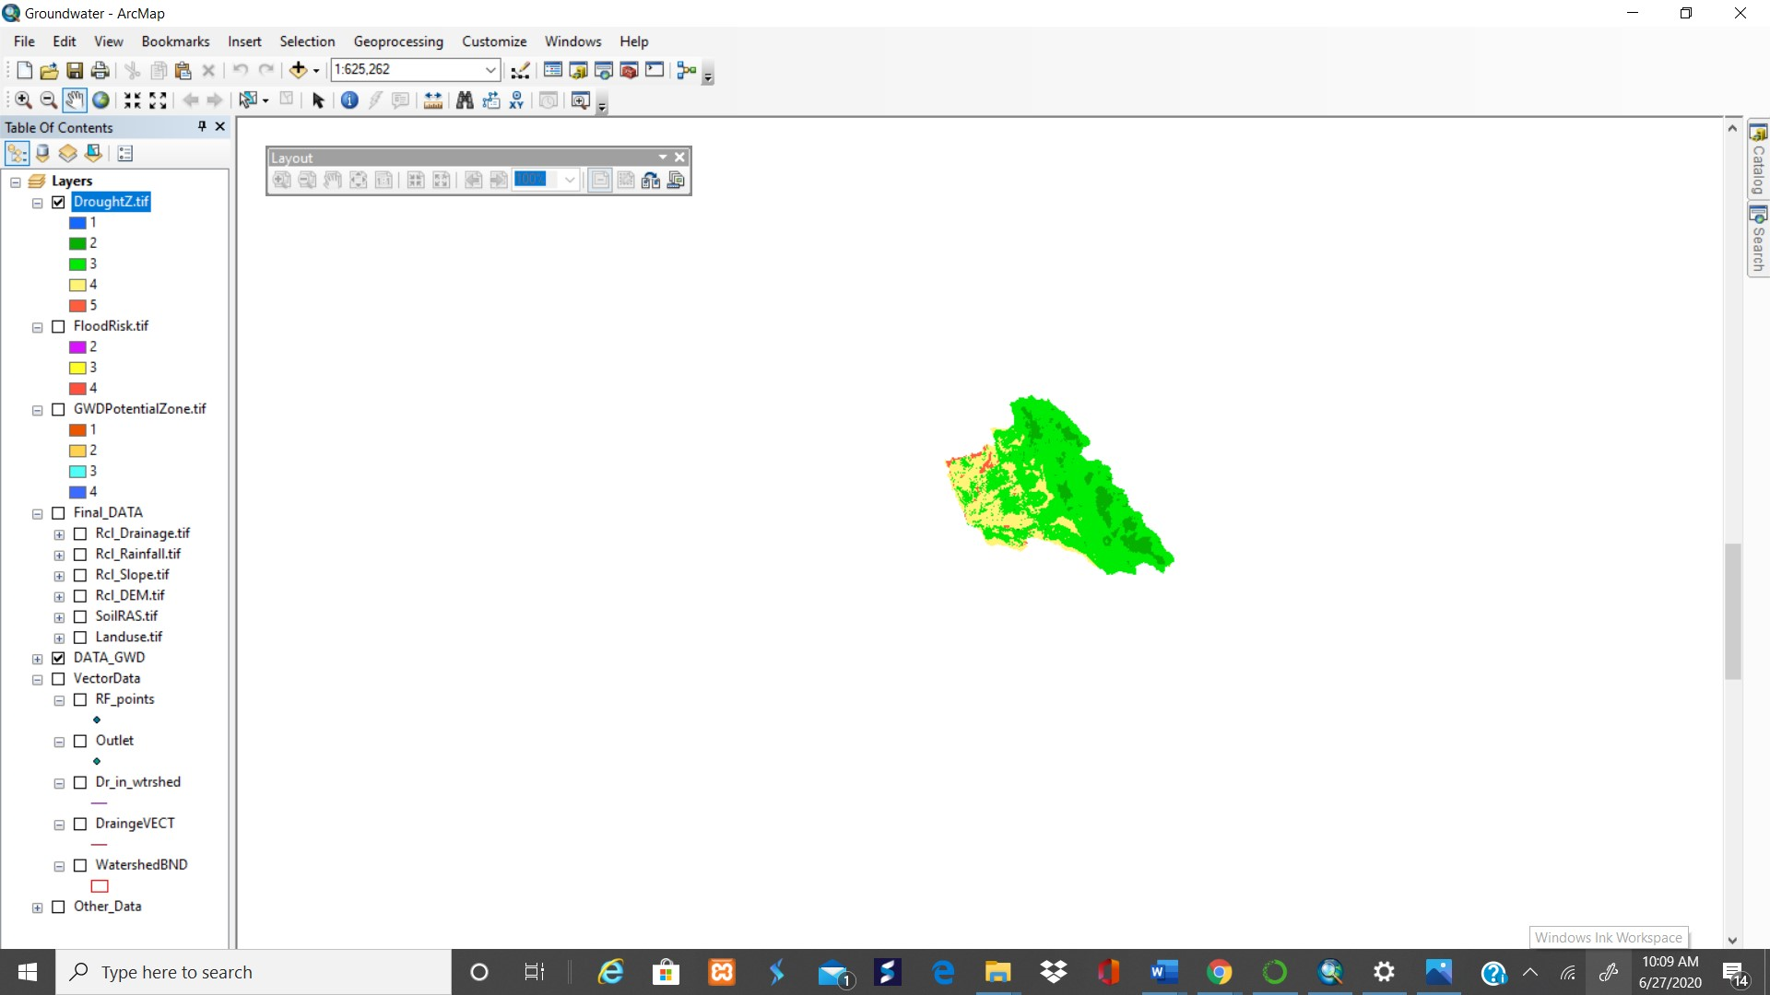

## Discussion of Methodology

I have used ArcMap for this, most of the tools were used in getting the desired results, weight overlay tool was used to obtain the final map with the above raster data.

Results/Conclusions

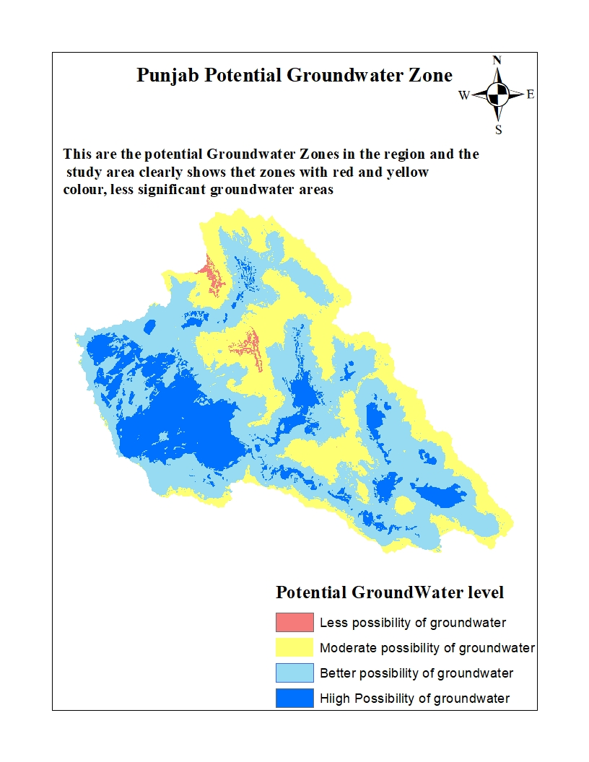

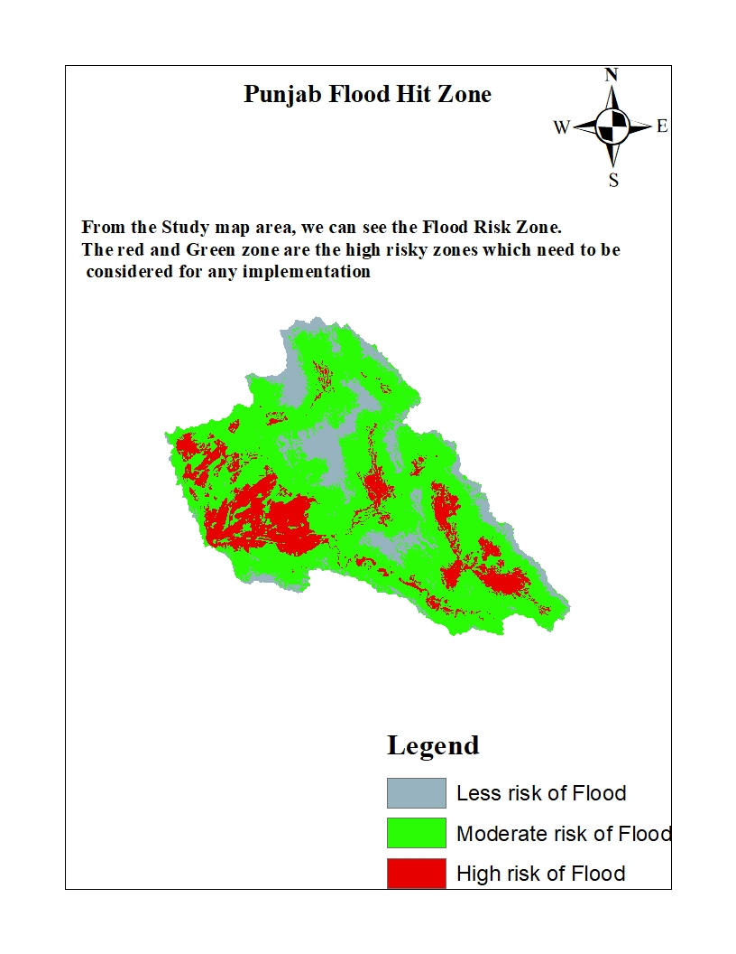

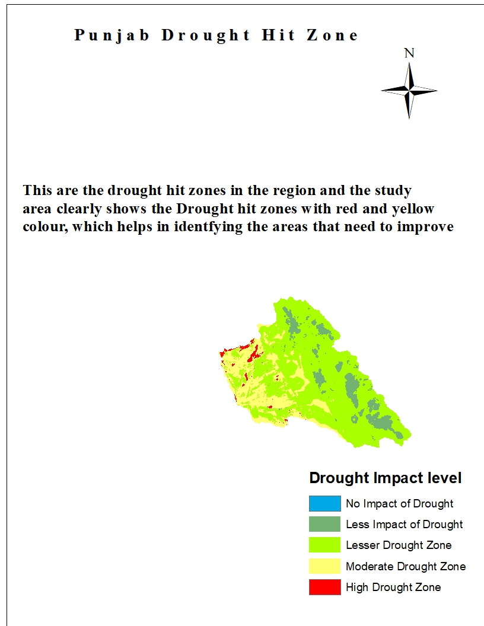

# References

Earthdata. (2020). Retrieved 27 June 2020, from <https://earthdata.nasa.gov/>

High-resolution gridded datasets. (2020). Retrieved 27 June 2020, from <https://crudata.uea.ac.uk/cru/data/hrg/>

GeoNetwork - The portal to spatial data and information. (2020). Retrieved 27 June 2020, from <http://www.fao.org/geonetwork/srv/en/metadata.show%3Fid=14116>