**Operation Manual**

**Build Details**

Isometric view of the device.

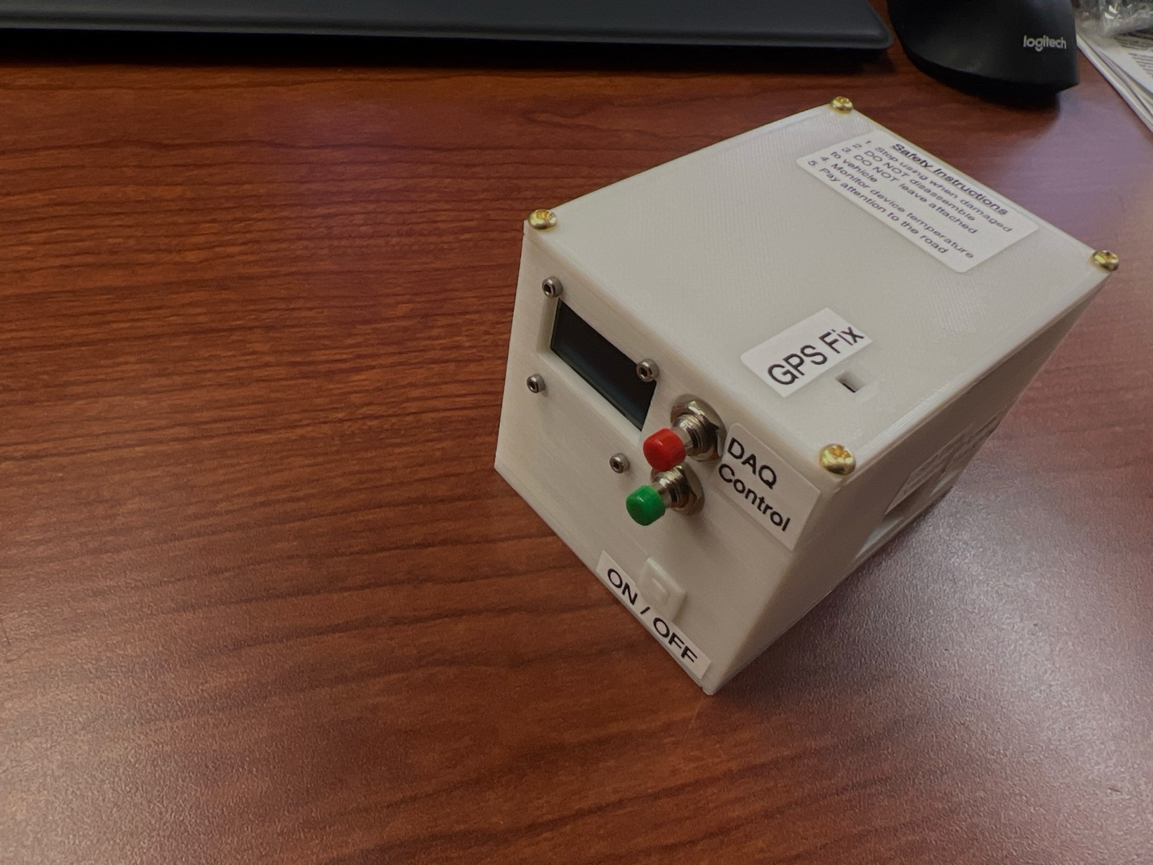

Device Control

Data Download

Battery Life Indicator

Charging Status Indicator

**Procedure**

**Data Acquisition**

1. Turn on the device by pressing the Power button once. When the power is on, you will see a red light around the power button area.
2. Wait for the display to come online and the device in ready status.

1. Even though the device is ready to collect data. Wait for GPS Fix. The GPS Fix is indicated by an orange LED on the top of the device. After a long power cycle, the GPS fix could take up to 10mins depending on the number of satellites that are reachable from your location. GPS Fix is only required for data collection, for data download you don’t have to wait for the fix.
2. You can start DAQ or download data from previous runs.
3. To start DAQ, press and hold red button for 3s. The display will indicate the start of data collection and it will also display the trial number since you last downloaded the data.
4. As the DAQ is running the display will show the elapsed time for the current trial.

1. When the data collection is running, you CANNOT do the following
   1. Download data
   2. Abruptly power off the device
   3. Disconnect the GPS Antenna
   4. Run out of battery charge
2. You can stop the DAQ by pressing and holding the red button for 3s. On the release of the button, after 3s, the screen will indicate the stop of DAQ and it will go back to the ready state which is shown above.

**Download data**

1. Prerequisites for the download process
   1. Device in “Ready!” state
   2. Data collection not in progress
2. Before inserting the USB, ensure that the USB is cleared of all the old data to better track the trials run.
3. Attach the provided cable and the USB drive as shown below and wait for the USB light to turn ON.

1. Press and hold the green button for 3s and release. The data copy process will start as shown below.

1. Once the copy is complete, the screen will go back to the “Ready!” state shown before.
2. Things NOT to do when the copy is in progress
   1. Start DAQ
   2. Unplug the USB drive
   3. Power OFF the device
   4. Run out of battery charge
3. After copy, the data will be cleared from the DAQ system and will only be available in the USB.
4. Once the data is copied the trial number will be reset back to 1. Now when you start DAQ the indicated trail number will start from 1 again.
5. Don’t leave the USB attached. Please remove once the download is complete. Otherwise, you will drain the device battery much quicker.