Credit Card Fraud Detection Using Fuzzy Logic and Neural Network

In this paper author is applying Fuzzy Logic member ship functions to correctly detect Fraud, suspicious or legal credit card transactions. In propose paper author is finding following values from dataset by using Fuzzy member ship functions

1. Time Difference: using this we will find difference between current transaction time and average transaction time (mean of all transaction time from single user). If transactions days difference < 4 then it will consider as LOW and if >= 4 and < 7 then its MEDIUM else HIGH
2. Amount Difference: using this we will find difference between current transaction amount and average transaction amount. You can find amount range for fuzzy member in Base Paper.
3. Location: finding transaction location is in Toronto or outside Toronto or outside Canada. Inside Toronto means LOW or 0 will be used and if outside Toronto then MEDIMU or 1 will be used else HIGH or 2 will be used
4. Interval: using this we find number of days difference from current transaction date to LAST transaction date
5. Frequency: using this we will find number of transactions per day.

After extracting all values then we will find class label as FRAUD if LOW values are more, label as Suspicious if MEDIUM values are more, label as FRAUD if HIGH values are more.

In below screen we are showing code to extract all member values. Here we are using 0 for LOW and 1 for MEDIUM and 2 for HIGH as LSTM and FUZZY will take only numeric values not character values.

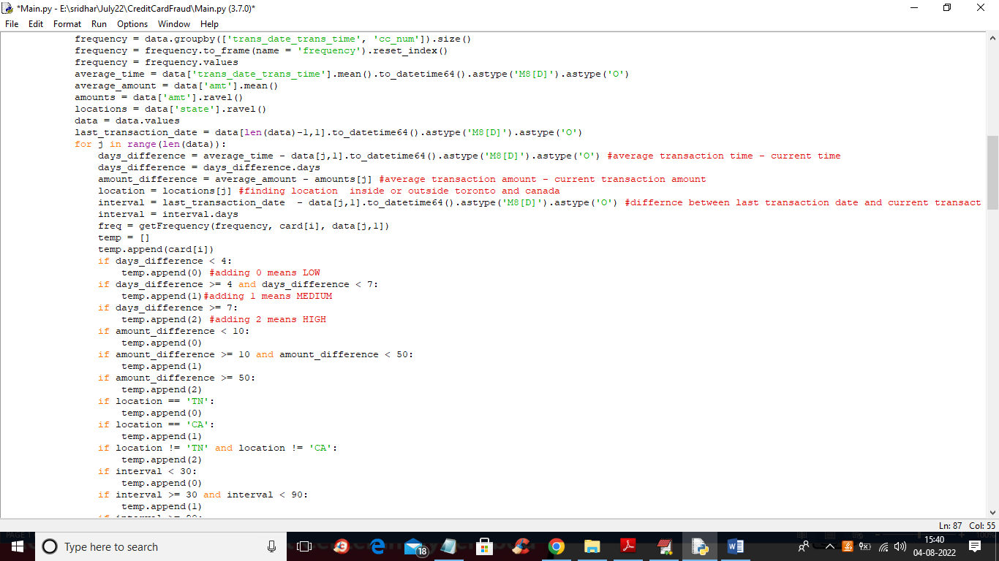

In above screen read red colour comments in code to know about fuzzy member function calculation. In below screen we are showing dataset details used in this project

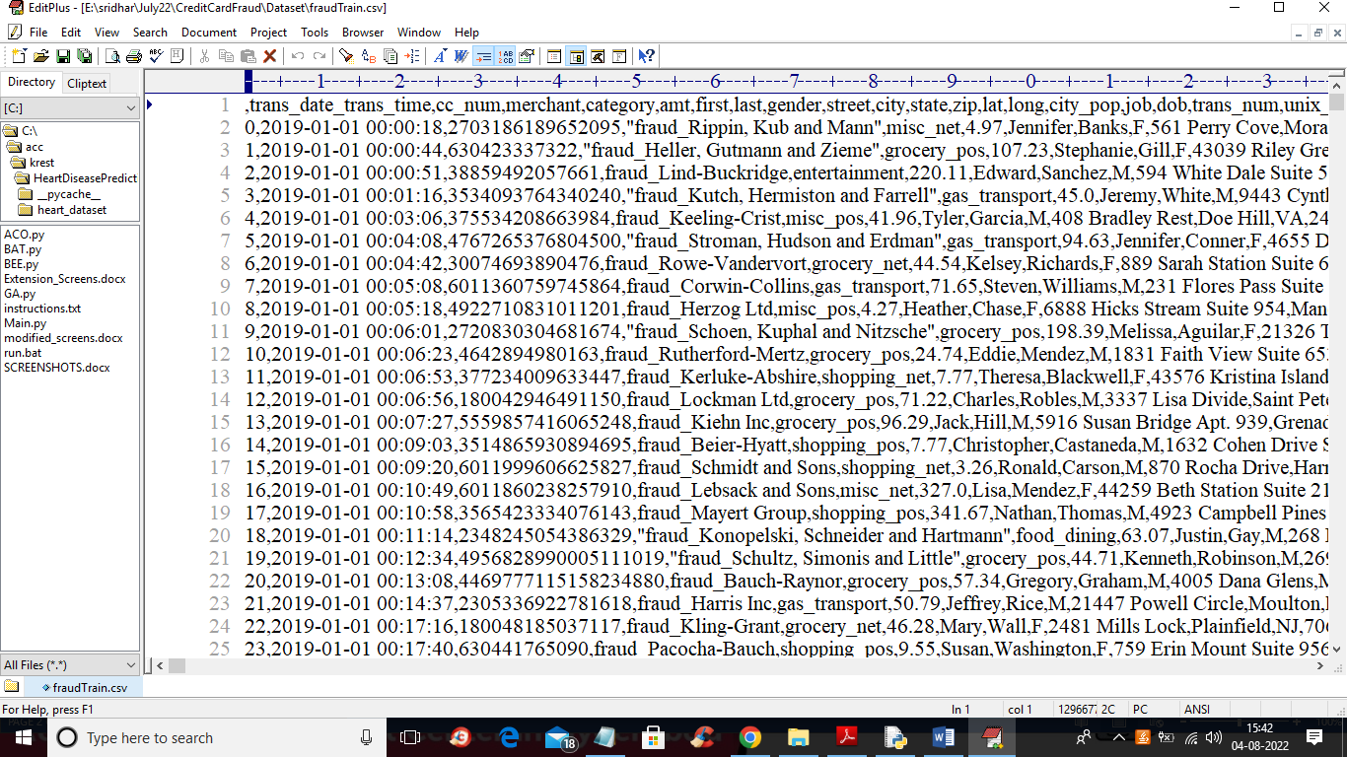

In above dataset screen first row contains dataset column names and remaining rows contains dataset values and we are using above dataset to extract fuzzy values and to train FUZZY and LSTM algorithm

To implement this project we have designed following modules

1. Upload Credit Card Fraud Dataset: using this module we will upload dataset to application
2. Calculate Fuzzy Membership Functions: using this module we will extract all membership function values from dataset
3. Run Fuzzy Logic Algorithm: using this module we will trained Fuzzy algorithm on membership values and then test the algorithm in terms of Mean Square Error (MSE refers to prediction error). The lower the MSE the better is the algorithm
4. Run LSTM Algorithm: using this module we will trained LSTM algorithm on same membership values and then calculate MSE
5. LSTM Training Graph: using this module we will plot LSTM training and testing MSE
6. MSE Comparison Graph: using this module we will plot MSE comparison graph between FUZZY algorithm and LSTM

In below screen we are showing code for LSTM

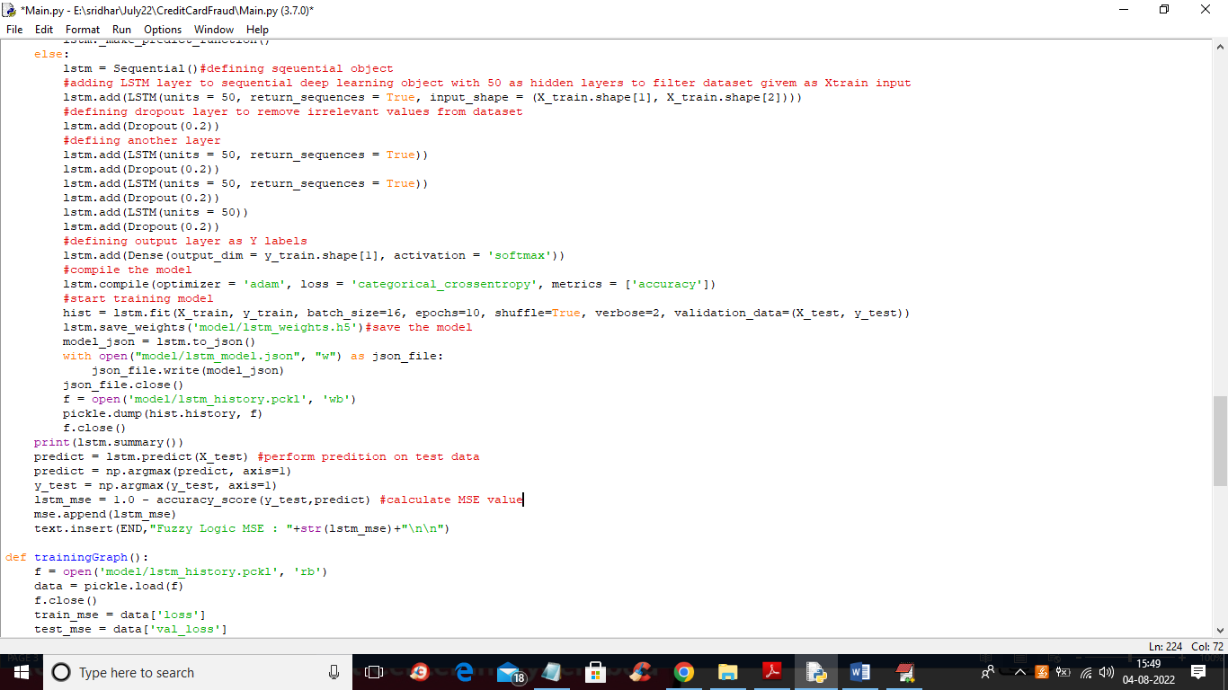

In above screen read red colour comments to know about LSTM model

SCREEN SHOTS

To run project double click on ‘run.bat’ file to get below screen

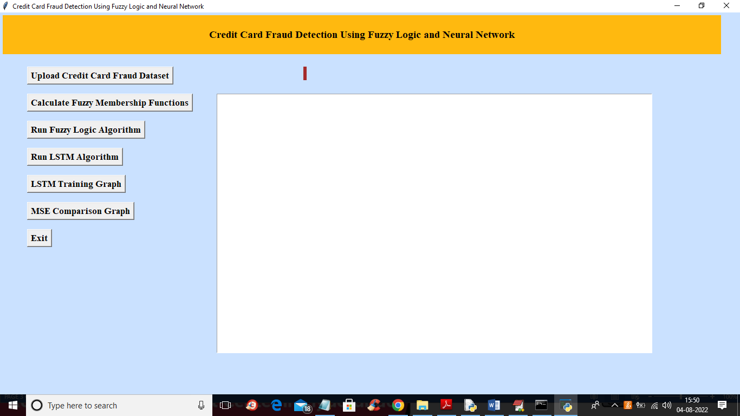

In above screen click on ‘Upload Credit Card Fraud Dataset’ button to upload dataset and to get below output

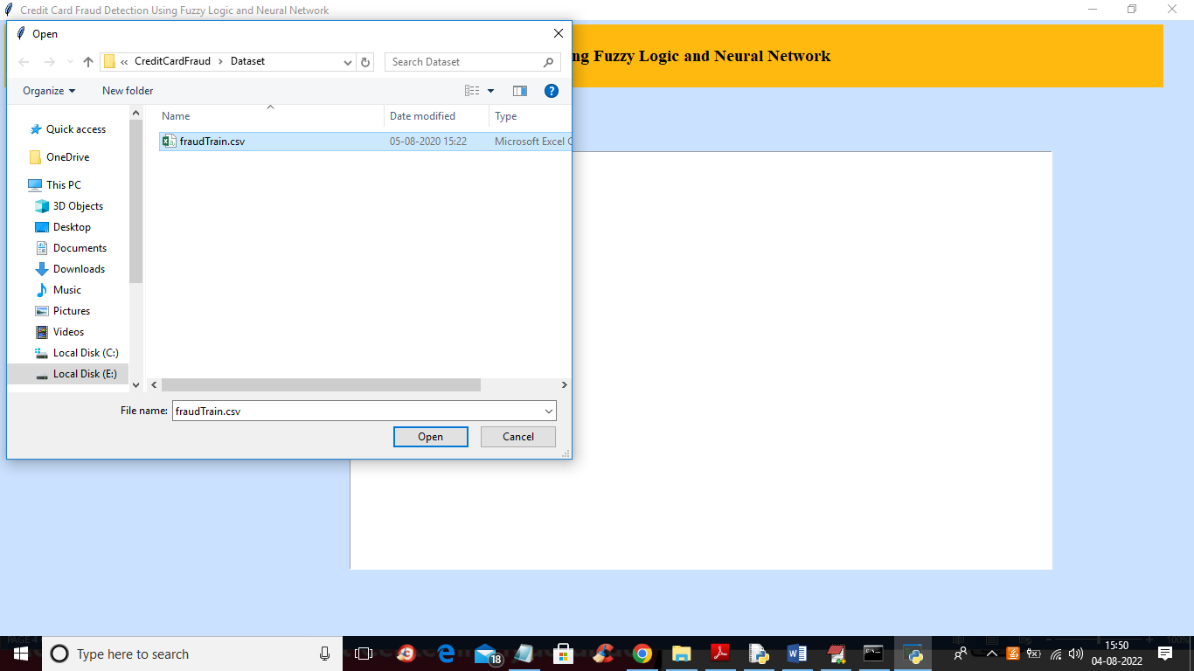

In above screen selecting and uploading fraud dataset and then click on ‘Open’ button to load dataset and get below output

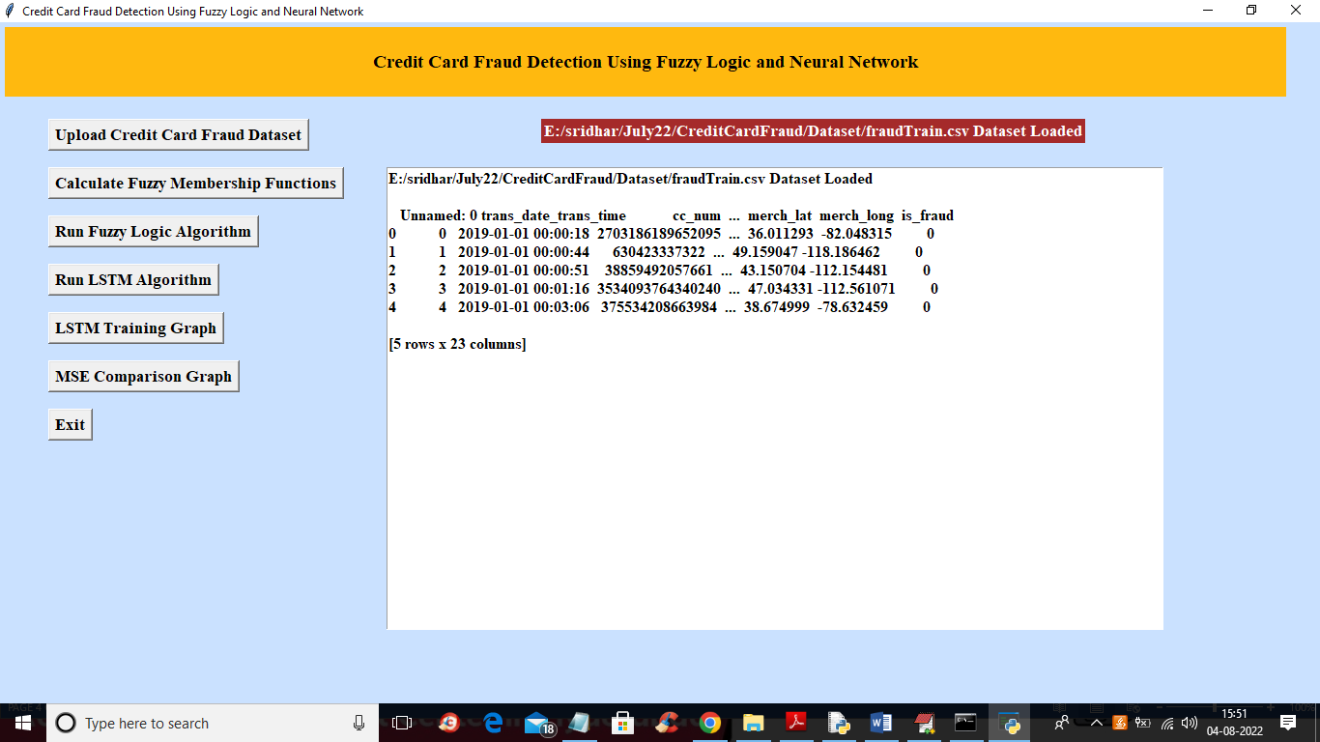

In above screen dataset loaded and from above dataset we need to calculate FUZZY member function so click on ‘Calculate Fuzzy Membership Functions’ button to calculate FUZY values and get below output

Note: in this project as LOW we have used 0 and 1 for MEDIUM and 2 for HIGH

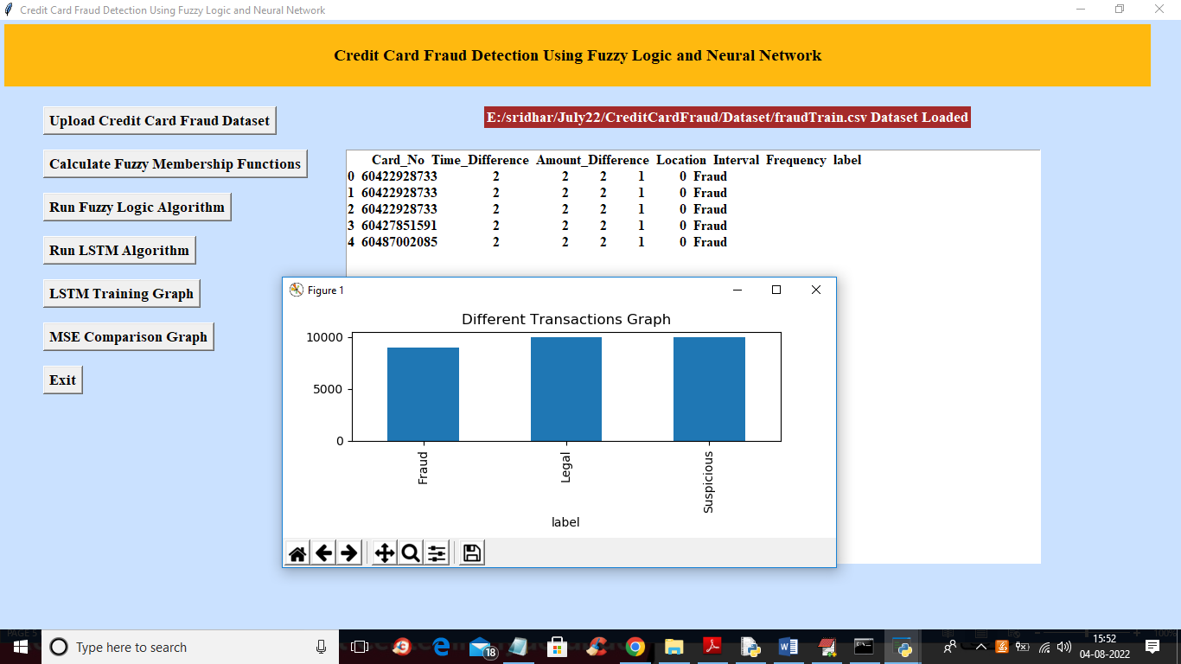

In above screen we have extracted fuzzy values from dataset and in graph x-axis represents type of transaction and y-axis represents number of records available in dataset for that transaction and now close above graph and then click on ‘Run Fuzzy Logic Algorithm’ button to train Fuzzy Logic on member ship values and get below output

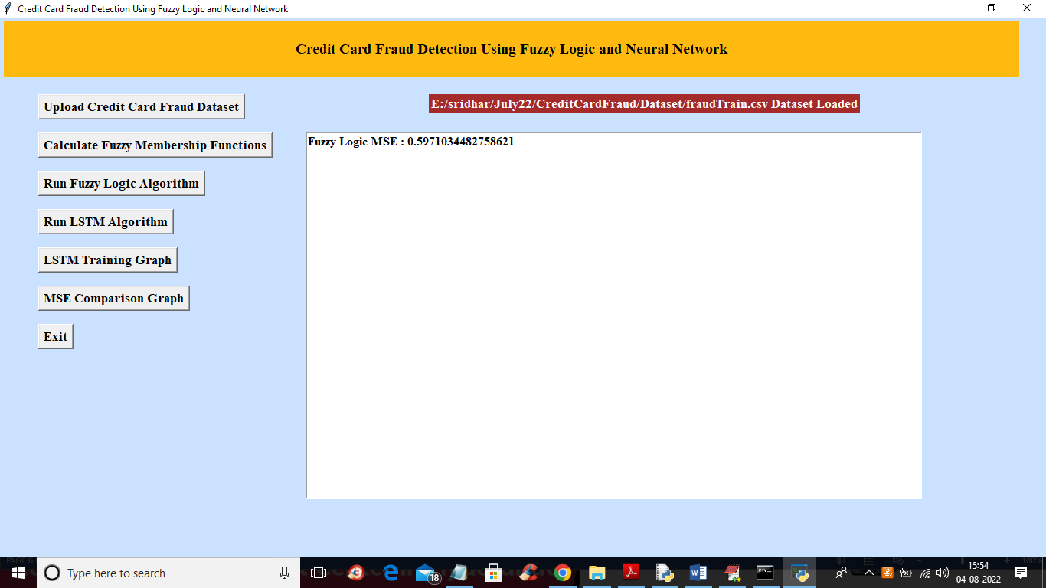

In above screen fuzzy training completed and we got MSE as 0.59 (algorithms get train on random splitted train and test data so MSE may vary for each run due to random data) and now click on ‘Run LSTM Algorithm’ button to train LSTM and get below output

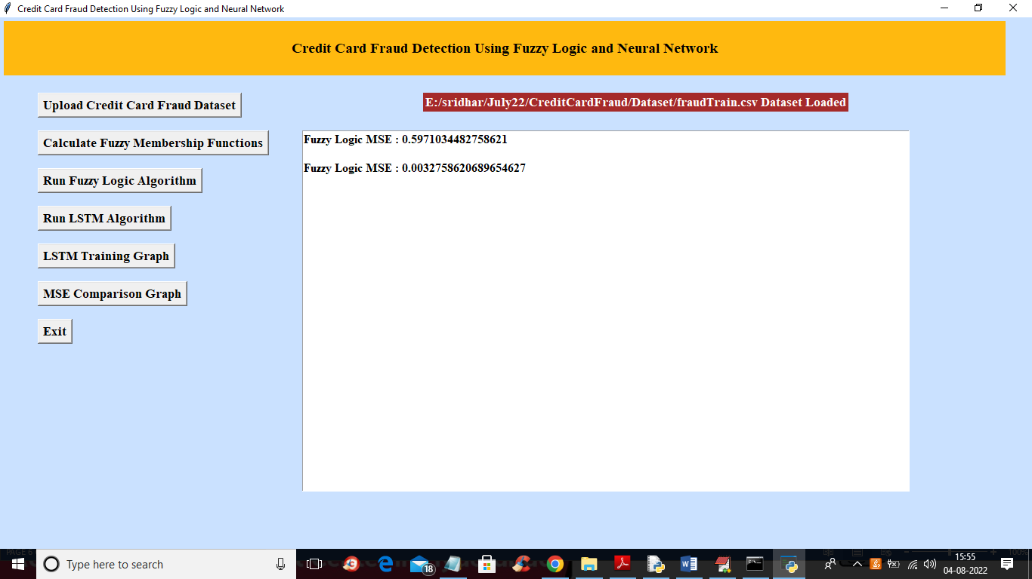

In above screen with LSTM we got 0.0032 MSE which is lesser than Fuzzy algorithm and now click on ‘LSTM Training Graph’ button to get below graph

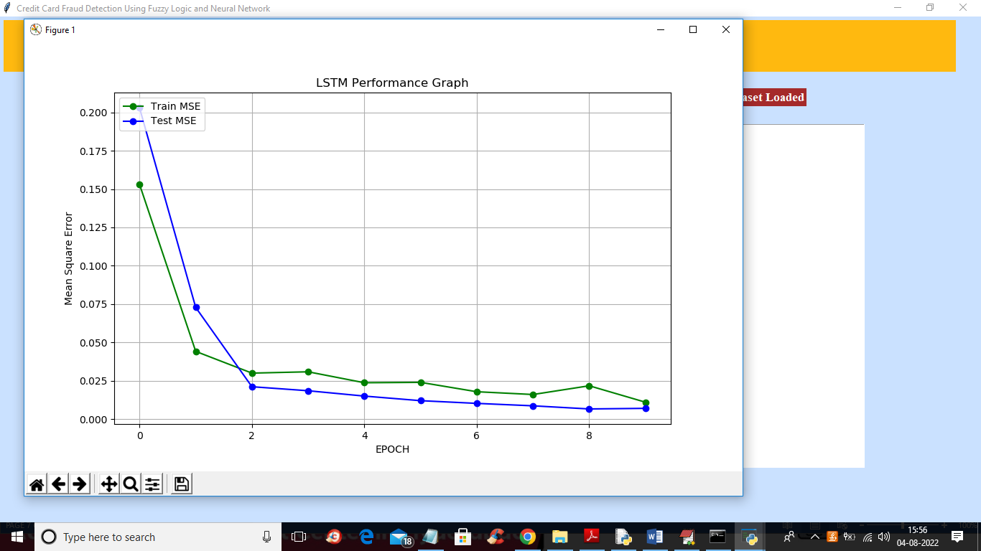

In above graph x-axis represents training POCH and y-axis represents MSE and we can see with each increasing epoch MSE got decrease and for any model decreasing MSE consider as best mode. Now close above graph and then click on ‘MSE Comparison Graph’ button to get below graph

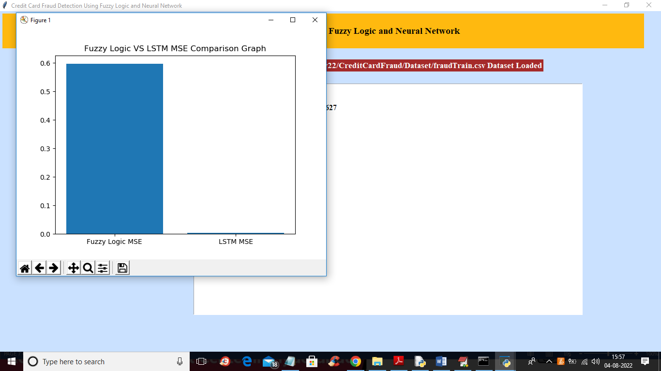

In above graph x-axis represents algorithm names and y-axis represents MSE values and in above graph we can see LSTM MSE is very low compare to Fuzzy so LSTM is better than Fuzzy algorithm