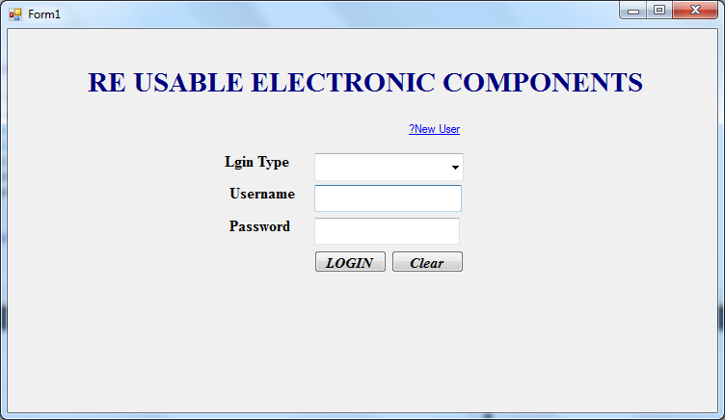

using System;

using System.Collections.Generic;

using System.ComponentModel;

using System.Data;

using System.Drawing;

using System.Linq;

using System.Text;

using System.Windows.Forms;

using System.Data.SqlClient;

namespace REuse

{

public partial class Form1 : Form

{

SqlConnection con = new SqlConnection(@"Data Source=.\SQLEXPRESS;AttachDbFilename=G:\New Project 2016\BishopUgProject\REuse\REuse\Reusedb.mdf;Integrated Security=True;User Instance=True");

SqlCommand cmd;

public Form1()

{

InitializeComponent();

}

private void Button1_Click(object sender, EventArgs e)

{

if (ComboBox1.Text == "ADMIN")

{

if (TextBox1.Text == "admin" & TextBox2.Text == "admin")

{

Admin a = new Admin();

a.Show();

}

else

{

MessageBox.Show("please Give correct Password");

}

}

else

{

con.Open();

cmd = new SqlCommand("select * from regtb where username='" + TextBox1.Text + "' and Password='" + TextBox2.Text + "'", con);

SqlDataReader dr = cmd.ExecuteReader();

if (dr.Read())

{

User u = new User();

u.uid = dr["userid"].ToString();

u.Show();

}

else

{

MessageBox.Show("please Give correct Password");

}

con.Close();

}

}

private void LinkLabel1_LinkClicked(object sender, LinkLabelLinkClickedEventArgs e)

{

UserRegistration u = new UserRegistration();

u.Show();

}

}

}

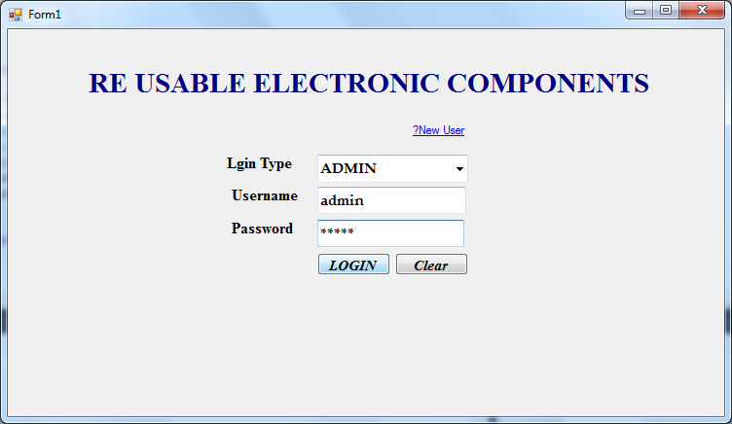

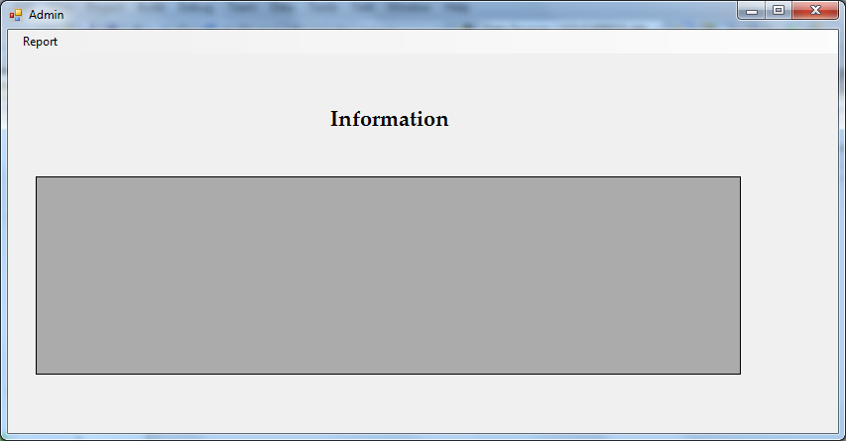

using System;

using System.Collections.Generic;

using System.ComponentModel;

using System.Data;

using System.Drawing;

using System.Linq;

using System.Text;

using System.Windows.Forms;

using System.Data.SqlClient;

namespace REuse

{

public partial class Admin : Form

{

SqlConnection con = new SqlConnection(@"Data Source=.\SQLEXPRESS;AttachDbFilename=G:\New Project 2016\BishopUgProject\REuse\REuse\Reusedb.mdf;Integrated Security=True;User Instance=True");

SqlCommand cmd;

public Admin()

{

InitializeComponent();

}

private void postCompantToolStripMenuItem_Click(object sender, EventArgs e)

{

}

private void userInfoToolStripMenuItem_Click(object sender, EventArgs e)

{

label1.Text = "User Info";

cmd = new SqlCommand("select * from regtb", con);

SqlDataAdapter da = new SqlDataAdapter(cmd);

DataTable dt = new DataTable();

da.Fill(dt);

dataGridView1.DataSource = dt;

dataGridView1.Refresh();

}

private void postCompantToolStripMenuItem_Click_1(object sender, EventArgs e)

{

label1.Text = "Post Compant Info";

cmd = new SqlCommand("select * from posttb", con);

SqlDataAdapter da = new SqlDataAdapter(cmd);

DataTable dt = new DataTable();

da.Fill(dt);

dataGridView1.DataSource = dt;

dataGridView1.Refresh();

}

private void userToolStripMenuItem_Click(object sender, EventArgs e)

{

}

private void buyCompantToolStripMenuItem_Click(object sender, EventArgs e)

{

label1.Text = "Buy Companet Info";

cmd = new SqlCommand("select * from buytb", con);

SqlDataAdapter da = new SqlDataAdapter(cmd);

DataTable dt = new DataTable();

da.Fill(dt);

dataGridView1.DataSource = dt;

dataGridView1.Refresh();

}

}

}

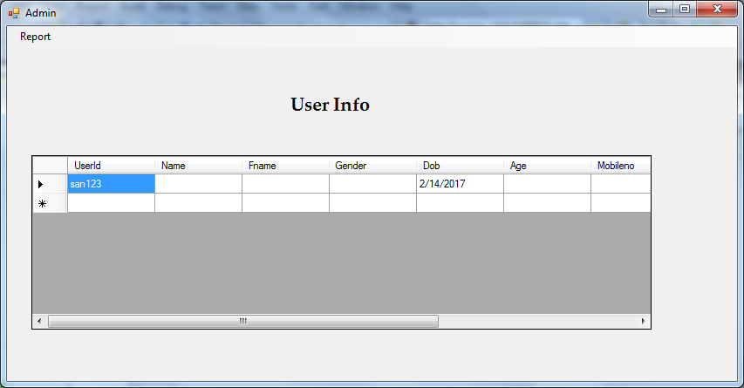

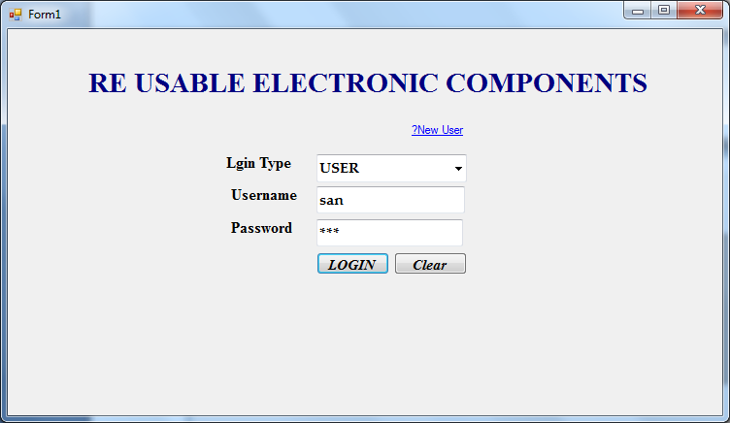

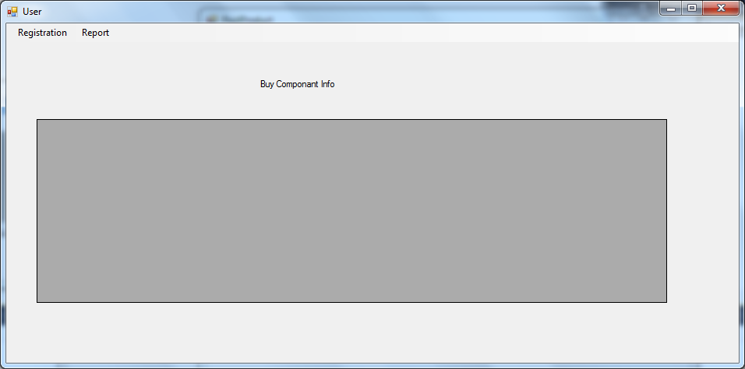

using System;

using System.Collections.Generic;

using System.ComponentModel;

using System.Data;

using System.Drawing;

using System.Linq;

using System.Text;

using System.Windows.Forms;

using System.Data.SqlClient;

namespace REuse

{

public partial class User : Form

{

SqlConnection con = new SqlConnection(@"Data Source=.\SQLEXPRESS;AttachDbFilename=G:\New Project 2016\BishopUgProject\REuse\REuse\Reusedb.mdf;Integrated Security=True;User Instance=True");

SqlCommand cmd;

public string uid;

public User()

{

InitializeComponent();

}

private void postProductToolStripMenuItem_Click(object sender, EventArgs e)

{

PostProduct p = new PostProduct();

p.uid = uid;

p.Show();

}

private void buyCompantToolStripMenuItem_Click(object sender, EventArgs e)

{

cmd = new SqlCommand("select * from buytb where userid='" + uid + "' ", con);

SqlDataAdapter da = new SqlDataAdapter(cmd);

DataTable dt = new DataTable();

da.Fill(dt);

dataGridView1.DataSource = dt;

dataGridView1.Refresh();

}

private void postCompantToolStripMenuItem_Click(object sender, EventArgs e)

{

cmd = new SqlCommand("select * from posttb where userid='" + uid + "' ", con);

SqlDataAdapter da = new SqlDataAdapter(cmd);

DataTable dt = new DataTable();

da.Fill(dt);

dataGridView1.DataSource = dt;

dataGridView1.Refresh();

}

private void buyProductToolStripMenuItem_Click(object sender, EventArgs e)

{

BuyProduct b = new BuyProduct();

b.uid = uid;

b.Show();

}

}

}

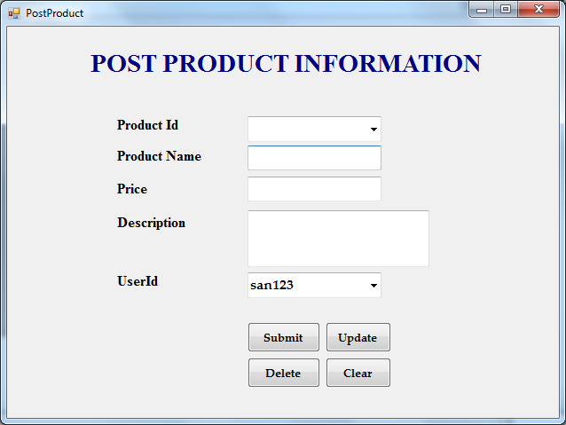

using System;

using System.Collections.Generic;

using System.ComponentModel;

using System.Data;

using System.Drawing;

using System.Linq;

using System.Text;

using System.Windows.Forms;

using System.Data.SqlClient;

namespace REuse

{

public partial class PostProduct : Form

{

SqlConnection con = new SqlConnection(@"Data Source=.\SQLEXPRESS;AttachDbFilename=G:\New Project 2016\BishopUgProject\REuse\REuse\Reusedb.mdf;Integrated Security=True;User Instance=True");

SqlCommand cmd;

public string uid;

public PostProduct()

{

InitializeComponent();

}

private void Button1_Click(object sender, EventArgs e)

{

cmd = new SqlCommand("insert into posttb values('" + comboBox2.Text + "','" + TextBox1.Text + "','" + TextBox2.Text + "','" + textBox3.Text + "','" + ComboBox1.Text + "')", con);

con.Open();

cmd.ExecuteNonQuery();

con.Close();

MessageBox.Show("Record Saved!");

}

private void PostProduct_Load(object sender, EventArgs e)

{

ComboBox1.Text = uid;

}

private void comboBox2_SelectedIndexChanged(object sender, EventArgs e)

{

// comboBox2.Items.Clear();

con.Open();

cmd = new SqlCommand("select * from posttb where Productid='" + comboBox2.Text + "'", con);

SqlDataReader dr = cmd.ExecuteReader();

if (dr.Read())

{

TextBox1.Text = dr["ProductName"].ToString();

TextBox2.Text = dr["Price"].ToString();

textBox3.Text = dr["Description"].ToString();

ComboBox1.Text = dr["UserId"].ToString();

}

con.Close();

}

private void comboBox2_FontChanged(object sender, EventArgs e)

{

}

private void comboBox2_Enter(object sender, EventArgs e)

{

comboBox2.Items.Clear();

con.Open();

cmd = new SqlCommand("select * from posttb", con);

SqlDataReader dr = cmd.ExecuteReader();

while (dr.Read())

{

comboBox2.Items.Add(dr["Productid"].ToString());

}

con.Close();

}

private void Button2_Click(object sender, EventArgs e)

{

cmd = new SqlCommand("update posttb set ProductName='" + TextBox1.Text + "',Price='" + TextBox2.Text + "',Description='" + textBox3.Text + "',Userid='" + ComboBox1.Text + "' where Productid='" + ComboBox1.Text + "'", con);

con.Open();

cmd.ExecuteNonQuery();

con.Close();

MessageBox.Show("Record updated");

}

private void button3_Click(object sender, EventArgs e)

{

cmd = new SqlCommand("delete from posttb where Productid='" + ComboBox1.Text + "'", con);

con.Open();

cmd.ExecuteNonQuery();

con.Close();

MessageBox.Show("Record Deleted");

}

private void button4_Click(object sender, EventArgs e)

{

ComboBox1.Text = "";

comboBox2.Text = "";

TextBox1.Text = "";

TextBox2.Text = "";

textBox3.Text = "";

}

}

}

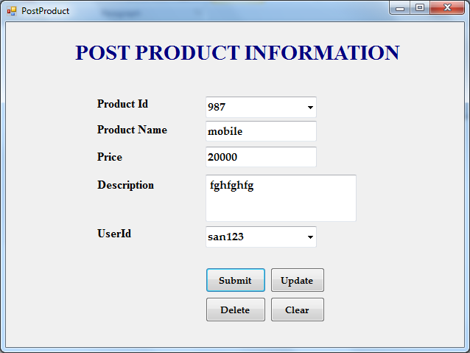



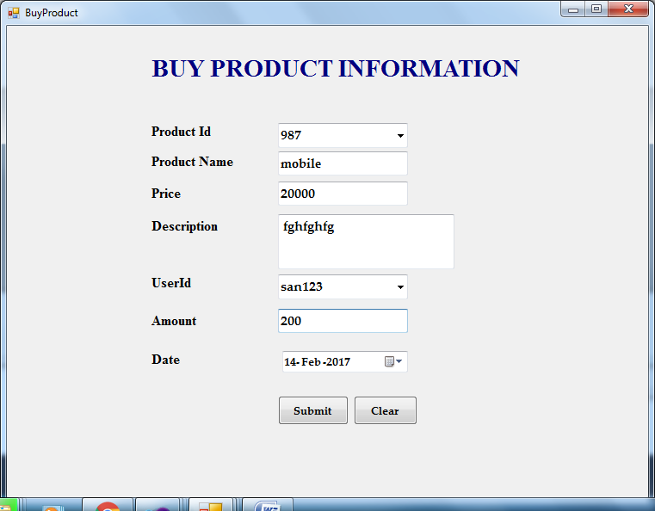



using System;

using System.Collections.Generic;

using System.ComponentModel;

using System.Data;

using System.Drawing;

using System.Linq;

using System.Text;

using System.Windows.Forms;

using System.Data.SqlClient;

namespace REuse

{

public partial class BuyProduct : Form

{

SqlConnection con = new SqlConnection(@"Data Source=.\SQLEXPRESS;AttachDbFilename=G:\New Project 2016\BishopUgProject\REuse\REuse\Reusedb.mdf;Integrated Security=True;User Instance=True");

SqlCommand cmd;

public string uid;

public BuyProduct()

{

InitializeComponent();

}

private void BuyProduct_Load(object sender, EventArgs e)

{

ComboBox1.Text = uid;

con.Open();

cmd = new SqlCommand("select * from posttb", con);

SqlDataReader dr = cmd.ExecuteReader();

while (dr.Read())

{

comboBox2.Items.Add(dr["Productid"].ToString());

}

con.Close();

}

private void comboBox2_SelectedIndexChanged(object sender, EventArgs e)

{

con.Open();

cmd = new SqlCommand("select * from posttb where Productid='" + comboBox2.Text + "'", con);

SqlDataReader dr = cmd.ExecuteReader();

if (dr.Read())

{

TextBox1.Text = dr["ProductName"].ToString();

TextBox2.Text = dr["Price"].ToString();

textBox3.Text = dr["Description"].ToString();

}

else

{

MessageBox.Show("No record Found!");

}

con.Close();

}

private void Button1_Click(object sender, EventArgs e)

{

cmd = new SqlCommand("insert into buytb values('" + comboBox2.Text + "','" + TextBox1.Text + "','" + TextBox2.Text + "','" + textBox3.Text + "','" + ComboBox1.Text + "','" + textBox4.Text + "','"+dateTimePicker1 .Text +"')", con);

con.Open();

cmd.ExecuteNonQuery();

con.Close();

MessageBox.Show("record Saved!");

}

}

}

