STACKBILL — Installation, Setup & Grafana Walkthrough
Version: 1.0.0
Prepared from: Uploaded STACKBILL operations guide and provided endpoints

Document Overview
This document contains two parts:
Part 2 — Frontend-to-Grafana workflow: Grafana initial login, add Prometheus data source and import dashboards for Linux and Windows.

Frontend to Grafana: GUI Walkthrough
- Scope: Steps from the frontend URL through Grafana initial login, configuring the Prometheus data source, and importing dashboards.

Endpoints and Credentials
• Frontend URL: http://123.176.58.142/
• Grafana URL: http://123.176.58.142/grafana
• Grafana login: Username: admin | Password: admin
• Recommended dashboard IDs from Grafana.com: Linux: 1860 | Windows: 19269

Step A — Access the frontend
1) Open a browser and navigate to the frontend URL. Confirm the home page renders and links to Grafana and Prometheus are visible.
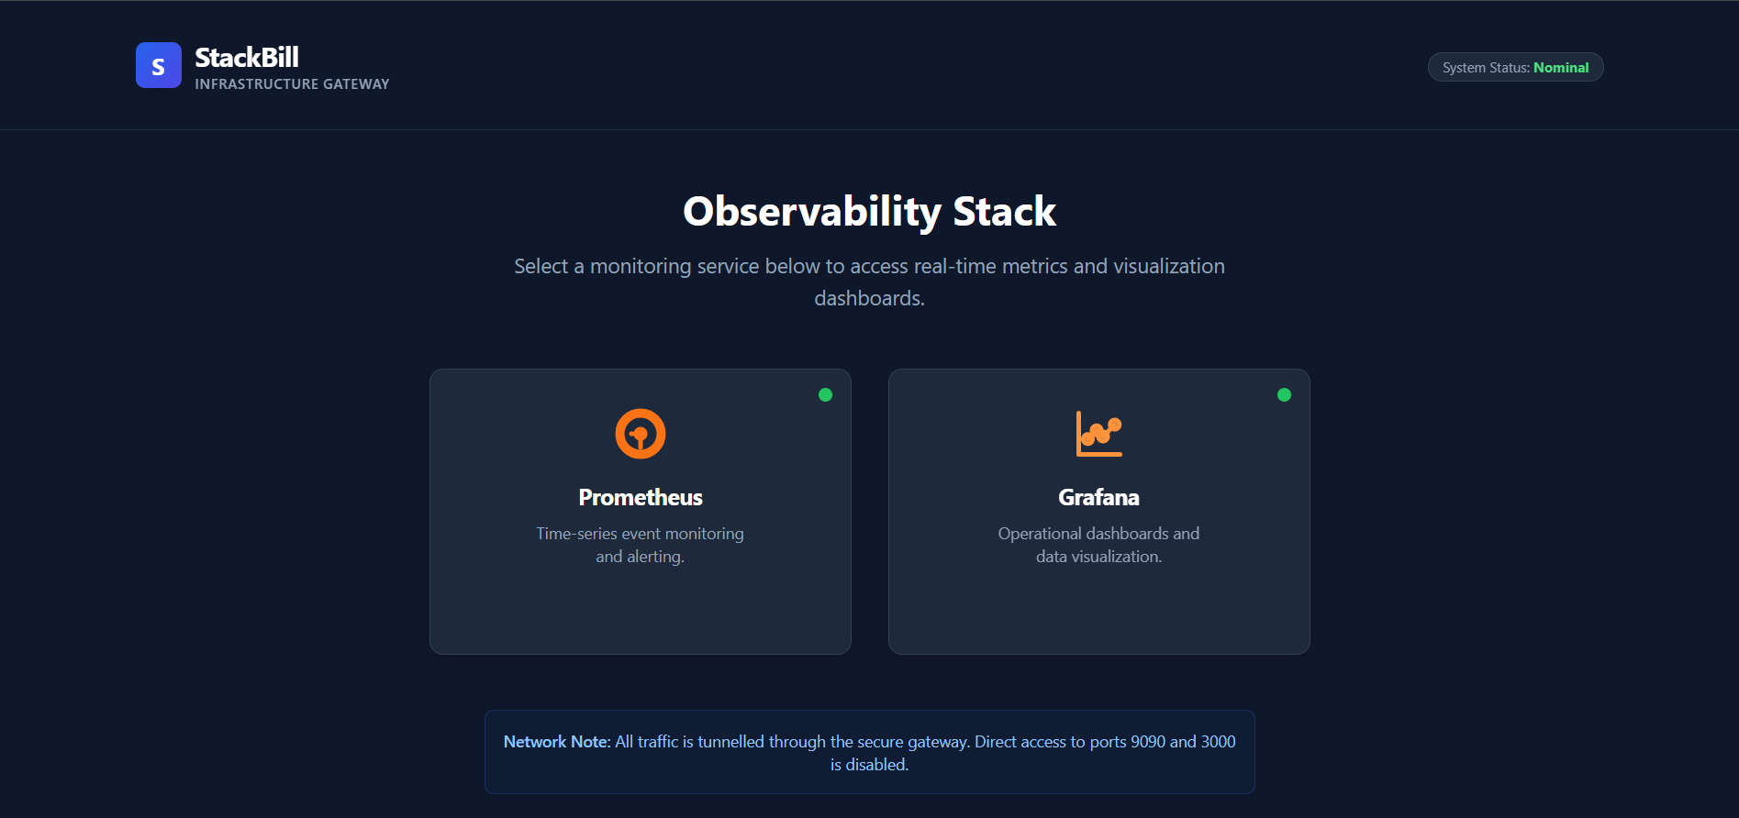
Figure 1: Frontend home page (placeholder).

Step B — Grafana: Initial login
- 1) Open Grafana at the Grafana URL and login using provided credentials. On first login, change the default password.
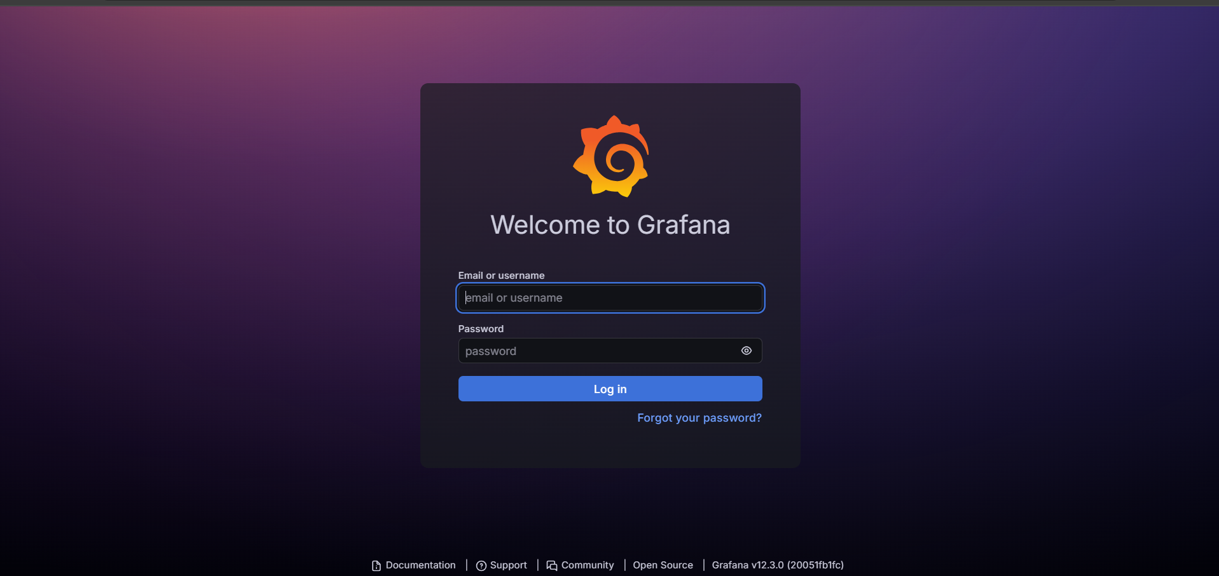.
Figure 2: Grafana login page (placeholder).

Step C — Add Prometheus data source
- Procedure:
1) In Grafana:
Configuration (gear) → Data Sources → Add data source → Prometheus.
2) Configure:
• Name: Prometheus
• URL: http://localhost:9090 (use host IP or container network alias if required)
• Access: Server (default)
3) Click Save & Test — expected: Data source is working (green confirmation).
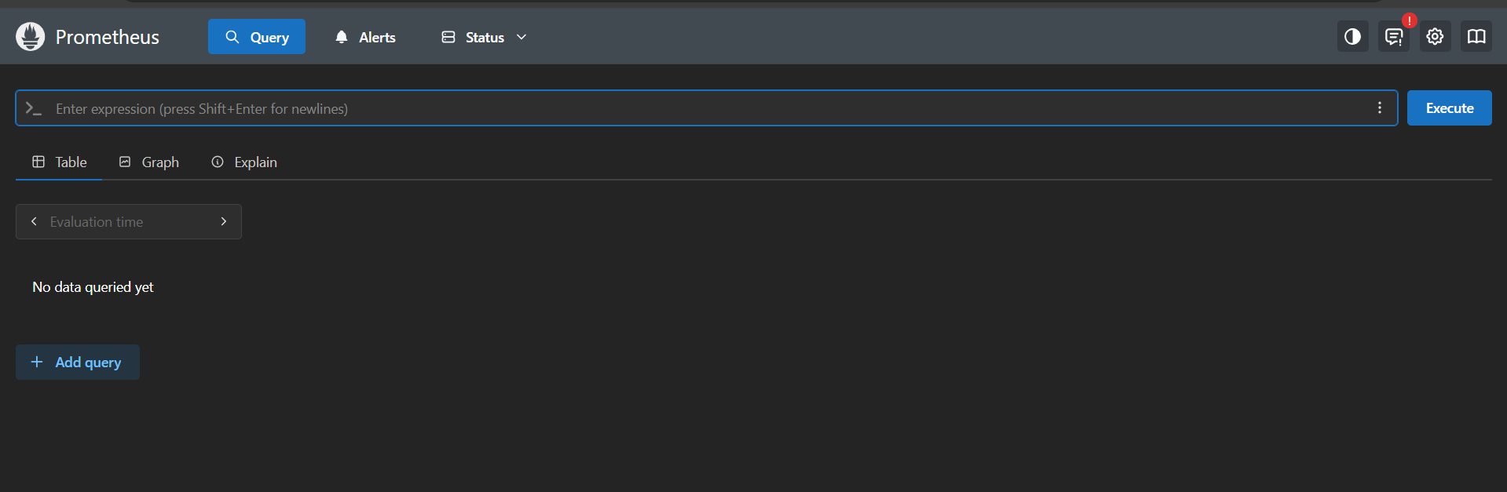
Figure 3: Data source configuration (placeholder).

Step D — Import dashboards
- Recommended community dashboards and IDs:
- Linux (Node Exporter Full) — Dashboard ID: 1860
- Windows (Windows Exporter) — Dashboard ID: 19269
- Import steps:
1) In Grafana: Click + → Import.
2) Enter dashboard ID (e.g., 1860) and click Load.
3) When prompted, select the Prometheus data source and click Import.
4) Repeat for Windows dashboard if Windows targets are in use.
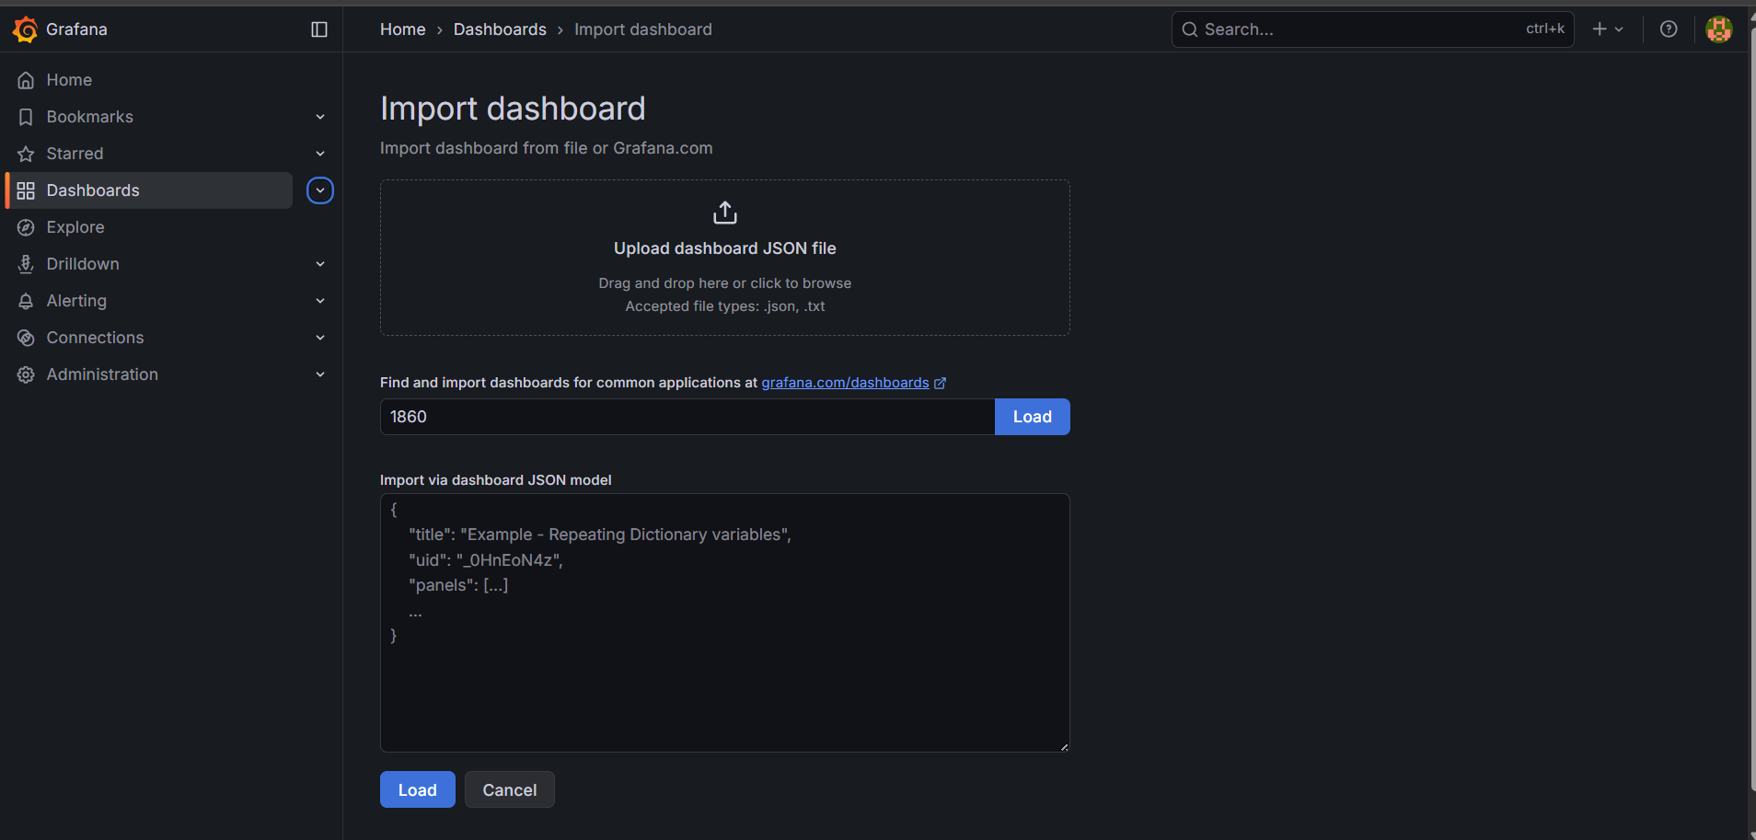
Figure 4: Import dashboard dialog (placeholder).

Verification — Dashboard data
- Open the imported dashboard and confirm panels show data.
- If panels show no data, confirm:
- - Prometheus targets show UP (Prometheus UI → Status → Targets).
- - Node exporter / Windows exporter metrics are reachable and being scraped.
- - Grafana data source is configured correctly and queries return results (Explore).

Appendix — Troubleshooting & Notes
- Quick checks and useful commands:
- Verify Grafana container/process: sudo podman ps | grep grafana
- Verify Prometheus targets: http://<server-ip>/prometheus → Status → Targets
- Test metrics endpoint: curl http://<target-ip>:9100/metrics
- Grafana: Configuration → Data Sources → Save & Test

