Study of Electronic Components
S. No | Components Name | Image | No. of Pins | Pin Details | Application | Symbol
I | Resistors
1. | Carbon Film Resistor | 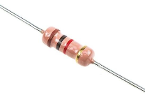 | 2 | Two non-polarized terminals; either lead can be connected to either side. | Current limiting, voltage division, biasing of circuits. | 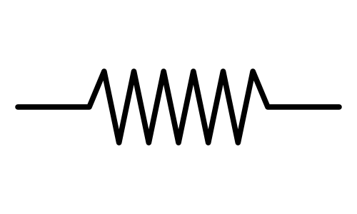
2. | Metal Film Resistor | 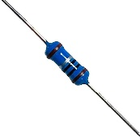 | 2 | Two non-polarized terminals; either lead can be connected to either side. | Precision and low-noise circuits, instrumentation, accurate voltage dividers.
3. | Potentiometer (Variable Resistor) | 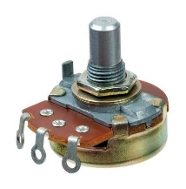 | 3 | Pin 1 and Pin 3: fixed ends of the resistive track; Pin 2: wiper (variable output). | Volume control, voltage adjustment, sensor calibration. | 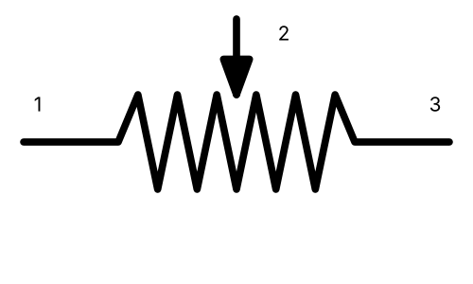
4. | Preset (Trimmer) Resistor | 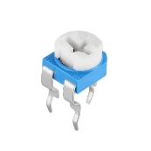 | 3 | Pin 1 and Pin 3: fixed ends of the resistive track; Pin 2: wiper (set with a screwdriver). | One-time calibration, bias/offset adjustment, fine tuning of circuits. | 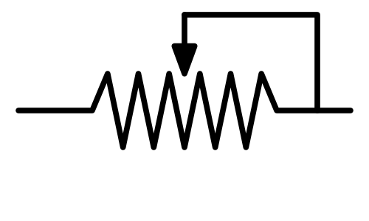
5. | LDR (Light Dependent Resistor) | 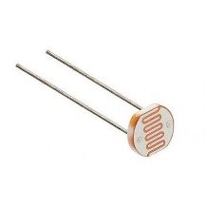 | 2 | Two non-polarized terminals; resistance decreases as light intensity increases. | Automatic street lights, light meters, dark/light-activated switches, alarms. | 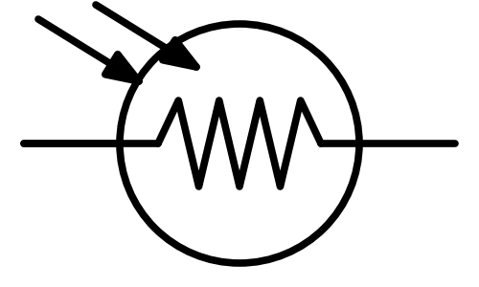
6. | Thermistor (NTC) | 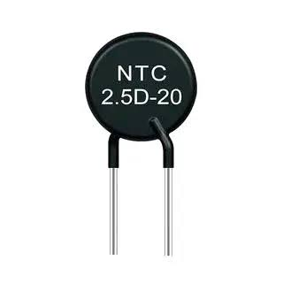 | 2 | Two non-polarized terminals; resistance decreases as temperature rises. | Temperature sensing, inrush-current limiting, temperature compensation. | 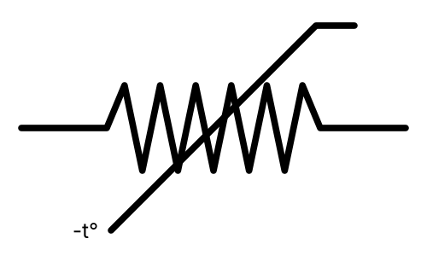
II | Capacitors
7. | Ceramic Capacitor | 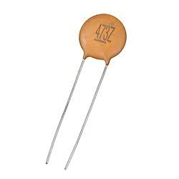 | 2 | Two non-polarized terminals; either lead can be connected to either side. | Noise filtering, decoupling, bypass circuits, oscillator circuits. | 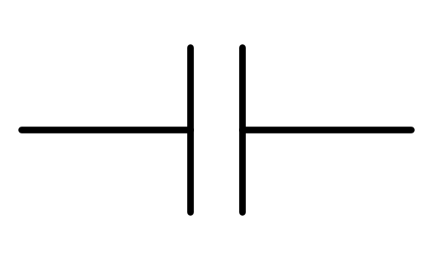
8. | Electrolytic Capacitor | 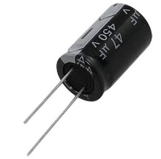 | 2 | Two polarized terminals: Positive (+) (long lead) and Negative (–) (short lead, marked with stripe). | Power supply filtering, smoothing rectifier output, energy storage. | 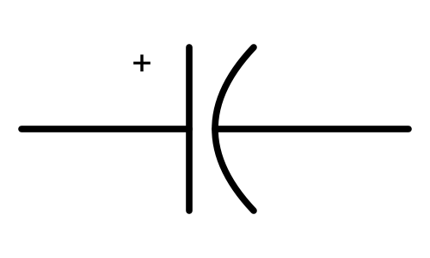
9. | Mica Capacitor | 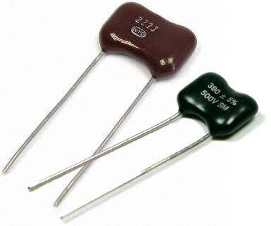 | 2 | Two non-polarized terminals; either lead can be connected to either side. | High-frequency RF circuits, oscillators, tuned circuits needing stable capacitance.
10. | Tantalum Capacitor | 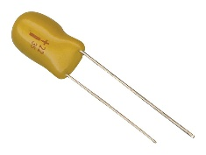 | 2 | Two polarized terminals: Positive (+) (marked with + sign / longer lead) and Negative (–). | Compact power-supply filtering, decoupling, timing circuits in portable devices.
11. | Polyester Film Capacitor | 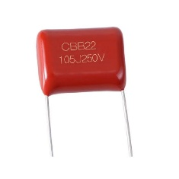 | 2 | Two non-polarized terminals; either lead can be connected to either side. | Coupling, decoupling, timing, filters, general-purpose audio and DC circuits.
12. | Variable (Trimmer) Capacitor | 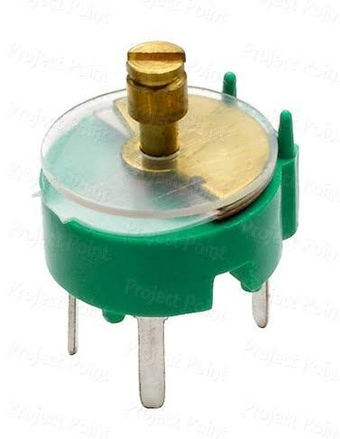 | 2 | Two terminals: fixed plate and rotor (variable) plate; capacitance adjusted with a screwdriver. | Tuning of RF and oscillator circuits, radio receivers, fine calibration. | 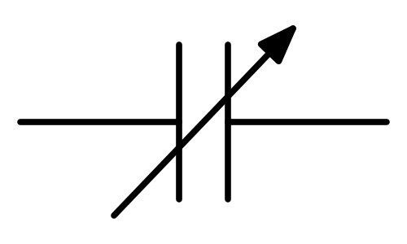
III | Inductors and Transformer
13. | Air Core Inductor | 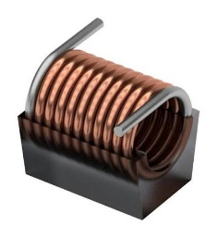 | 2 | Two non-polarized terminals (ends of the coil winding). | RF circuits, tuned circuits, high-frequency filters. | 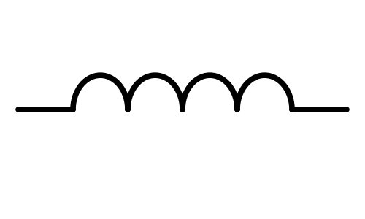
14. | Ferrite Core Inductor | 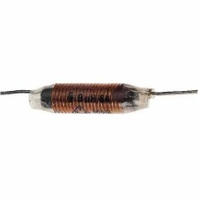 | 2 | Two non-polarized terminals (ends of the coil wound on a ferrite core). | EMI/noise suppression, chokes, SMPS, filter circuits. | 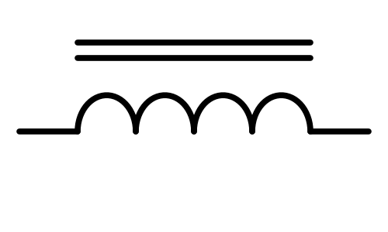
15. | Step-down Transformer | 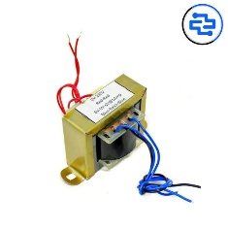 | 4 | Primary: two terminals (mains side, high voltage); Secondary: two terminals (low-voltage output). | Reducing 230 V AC to low AC voltage (e.g., 12 V, 9 V) in power supplies and adapters. | 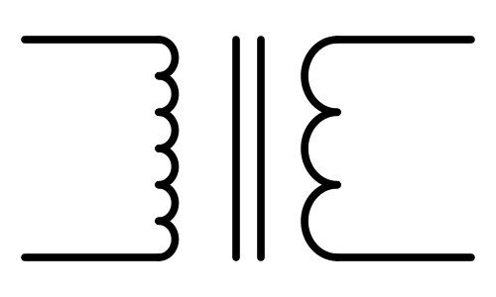
IV | Diodes
16. | PN Junction Diode (1N4007) | 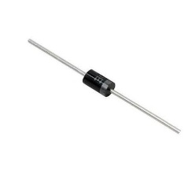 | 2 | Anode (A) and Cathode (K); cathode is marked with a silver band. | Rectification, reverse-polarity protection. | 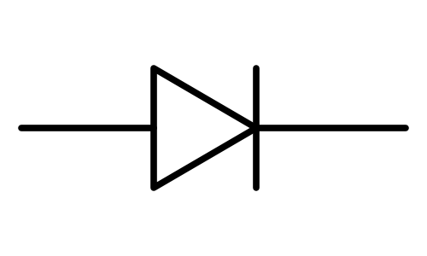
17. | Zener Diode | 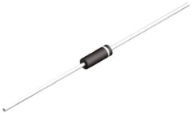 | 2 | Anode (A) and Cathode (K); cathode is marked with a band; operated in reverse bias. | Voltage regulation, voltage reference, overvoltage protection, clipping. | 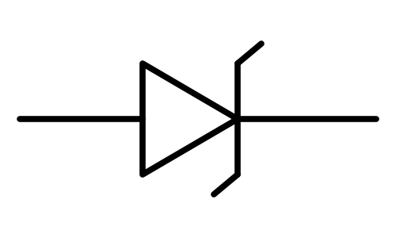
18. | LED | 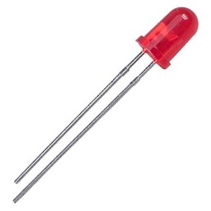 | 2 | Anode (+) (long lead) and Cathode (–) (short lead, flat side of the body). | Indicator lamps, displays, lighting. | 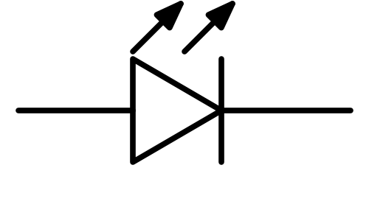
19. | Schottky Diode | 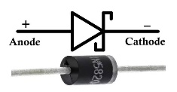 | 2 | Anode (A) and Cathode (K); cathode is marked with a band. | High-speed switching, SMPS rectification, low-voltage-drop rectifiers, reverse-polarity protection. | 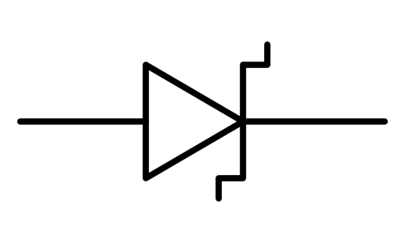
20. | Photodiode | 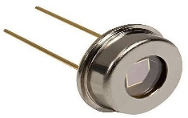 | 2 | Anode (A) and Cathode (K); operated in reverse bias; cathode is the short lead. | Light detection, optical sensors, IR remote receivers, optical communication. | 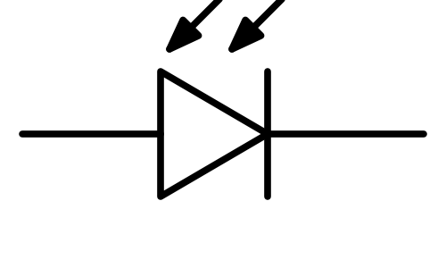
21. | Bridge Rectifier | 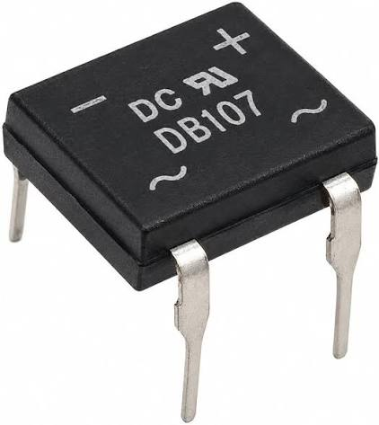 | 4 | Two AC input pins (~) and two DC output pins: Positive (+) and Negative (–). | Full-wave AC-to-DC conversion in power supplies and adapters. | 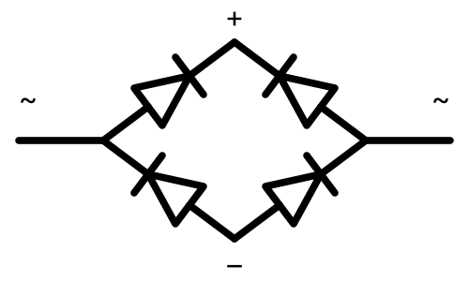
V | Transistors
22. | BC547 (NPN BJT) | 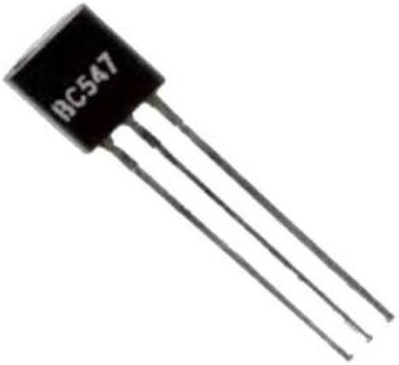 | 3 | Collector (C), Base (B) and Emitter (E); viewed from flat face with leads down: C-B-E. | Switching, amplification, driver circuits. | 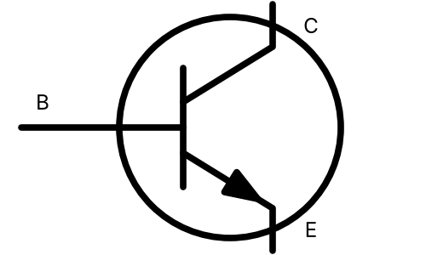
23. | BC557 (PNP BJT) | 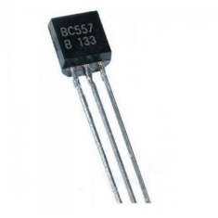 | 3 | Collector (C), Base (B) and Emitter (E); viewed from flat face with leads down: C-B-E. | Switching, amplification, high-side switching, complementary pair with BC547. | 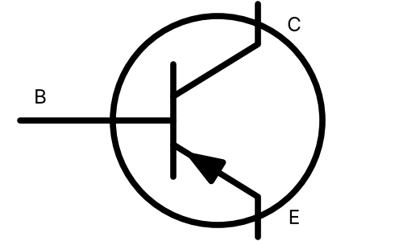
24. | 2N2222 (NPN BJT) | 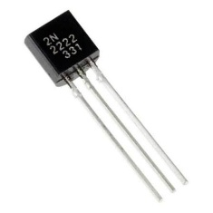 | 3 | Emitter (E), Base (B) and Collector (C); in the metal-can package, viewed from below, E is nearest the tab. | General-purpose switching (up to 800 mA), amplifiers, relay and LED drivers.
25. | IRF540 (N-MOSFET) | 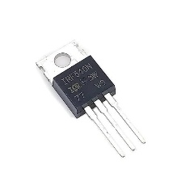 | 3 | Gate (G), Drain (D) and Source (S); viewed from the front (text side) with leads down: G-D-S; metal tab is Drain. | High-current switching, motor drivers, SMPS, inverters, PWM dimming. | 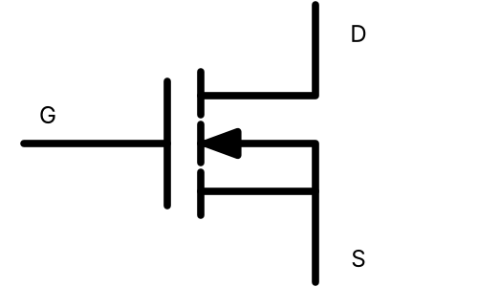
26. | JFET (BFW10) | 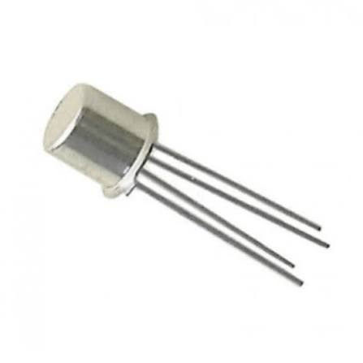 | 4 | Source (S), Drain (D), Gate (G) and Case; N-channel device in a metal can. | RF amplifiers, high-impedance buffers, analog switches, mixers. | 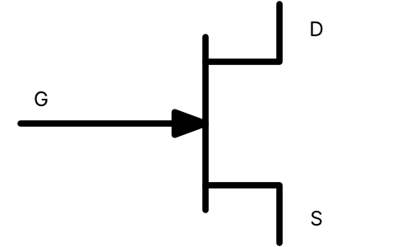
27. | UJT (2N2646) | 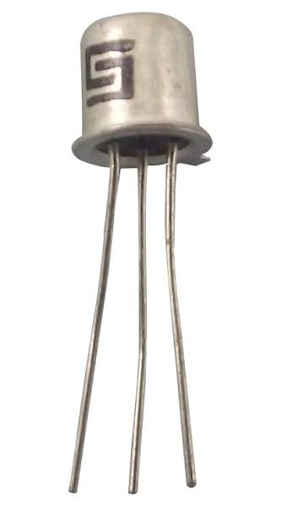 | 3 | Emitter (E), Base 1 (B1) and Base 2 (B2). | Relaxation oscillators, timing circuits, SCR/TRIAC triggering, sawtooth generation. | 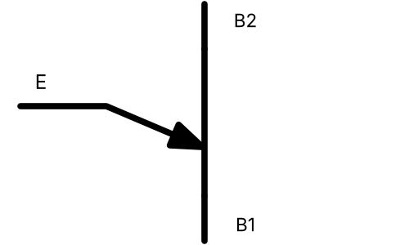
VI | Thyristors
28. | SCR (TYN612) | 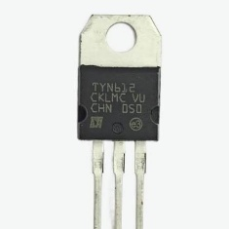 | 3 | Cathode (K), Anode (A) and Gate (G); viewed from the front with leads down: K-A-G; metal tab is Anode. | Controlled rectifiers, motor speed control, light dimmers, overvoltage protection. | 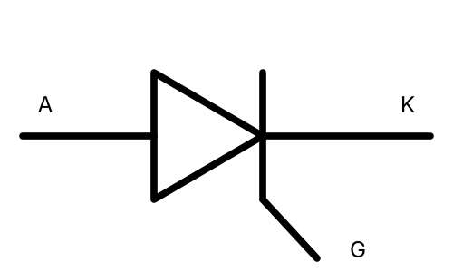
29. | TRIAC (BT136) | 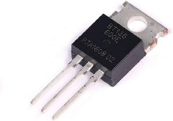 | 3 | Main Terminal 1 (MT1), Main Terminal 2 (MT2) and Gate (G); viewed from the front with leads down: MT1-MT2-G; metal tab is MT2. | AC power control, lamp dimmers, fan regulators, heater controllers. | 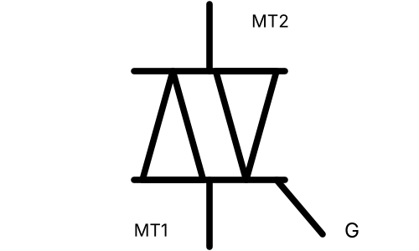
VII | Integrated Circuits
30. | IC 555 Timer | 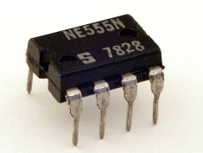 | 8 | Pin 1 GND, 2 Trigger, 3 Output, 4 Reset, 5 Control, 6 Threshold, 7 Discharge, 8 VCC. | Timer, astable/monostable multivibrator, pulse generation. | 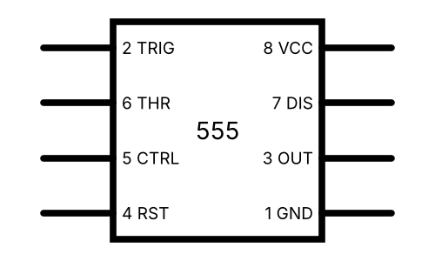
31. | IC 741 Op-Amp | 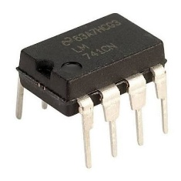 | 8 | Pin 1 Offset Null, 2 Inverting input (–), 3 Non-inverting input (+), 4 V–, 5 Offset Null, 6 Output, 7 V+, 8 NC. | Amplifiers, comparators, filters, integrators, oscillators. | 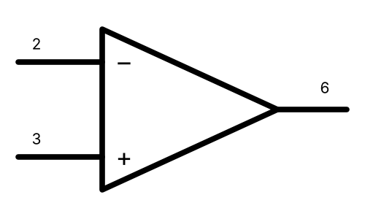
32. | IC 7805 Regulator | 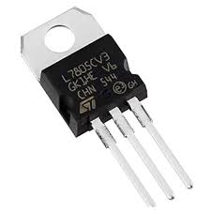 | 3 | Pin 1 Input, Pin 2 Ground, Pin 3 Output (viewed from the front, leads down). | Fixed +5 V regulated supply for digital circuits and microcontrollers. | 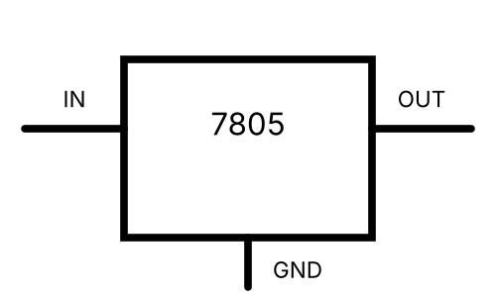
33. | IC LM317 Regulator | 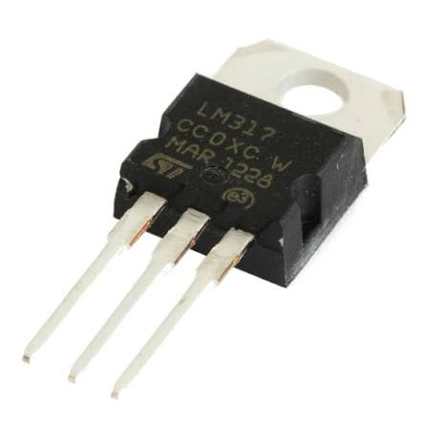 | 3 | Pin 1 Adjust (ADJ), Pin 2 Output, Pin 3 Input (viewed from the front, leads down). | Adjustable regulated supply (1.25 V to 37 V), battery chargers, current limiters. | 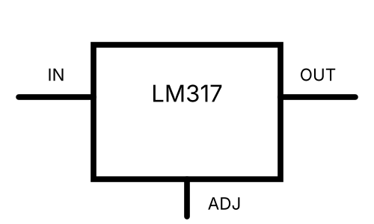
34. | IC 7400 (NAND) | 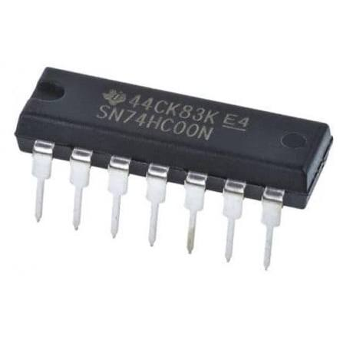 | 14 | Four 2-input NAND gates; Pin 7 GND, Pin 14 VCC; inputs 1,2 → output 3; 4,5 → 6; 9,10 → 8; 12,13 → 11. | Universal logic gate; building any logic function, latches, oscillators. | 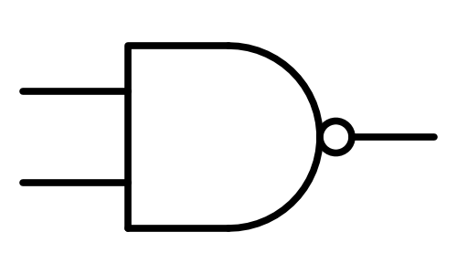
35. | IC 7404 (NOT) | 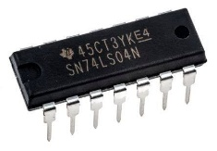 | 14 | Six inverters; Pin 7 GND, Pin 14 VCC; inputs 1, 3, 5, 9, 11, 13 → outputs 2, 4, 6, 8, 10, 12. | Signal inversion, buffering, oscillators, logic circuits. | 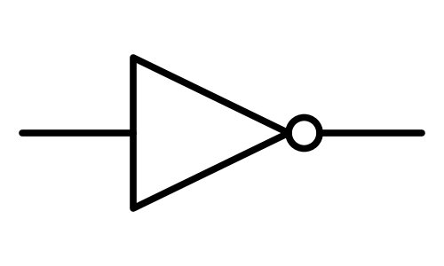
36. | IC 7408 (AND) | 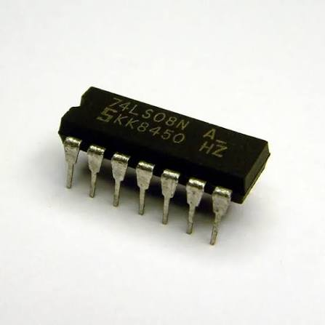 | 14 | Four 2-input AND gates; Pin 7 GND, Pin 14 VCC; inputs 1,2 → output 3; 4,5 → 6; 9,10 → 8; 12,13 → 11. | Logic AND operation, enable/gating circuits, digital systems. | 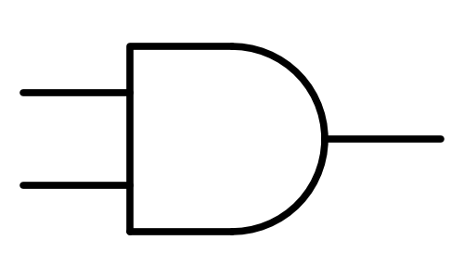
37. | IC 7432 (OR) | 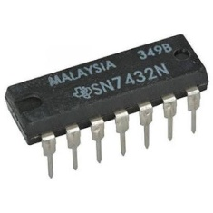 | 14 | Four 2-input OR gates; Pin 7 GND, Pin 14 VCC; inputs 1,2 → output 3; 4,5 → 6; 9,10 → 8; 12,13 → 11. | Logic OR operation, alarm/combining signals, digital systems. | 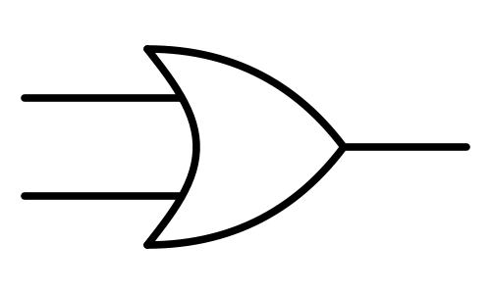
38. | IC 7486 (XOR) | 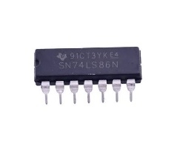 | 14 | Four 2-input XOR gates; Pin 7 GND, Pin 14 VCC; inputs 1,2 → output 3; 4,5 → 6; 9,10 → 8; 12,13 → 11. | Adders, parity checkers, comparators, controlled inverters. | 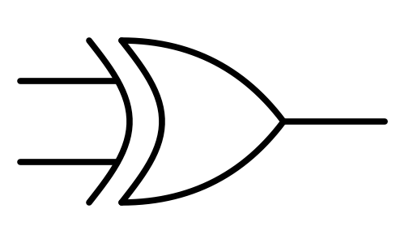
39. | IC 7447 (BCD to 7-Seg Decoder) | 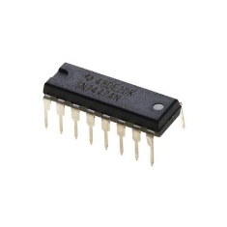 | 16 | Inputs A(7), B(1), C(2), D(6); outputs a(13), b(12), c(11), d(10), e(9), f(15), g(14); LT(3), BI/RBO(4), RBI(5); GND 8, VCC 16. | Driving common-anode 7-segment displays from BCD input in counters and clocks. | 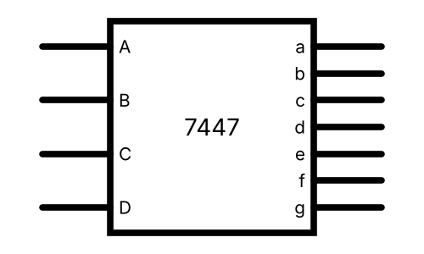
VIII | Switches
40. | Push Button Switch | 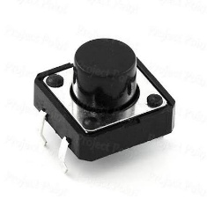 | 4 | Four legs in two internally connected pairs; pressing the button connects the two pairs. Non-polarized. | Manual triggering, reset, input to digital circuits. | 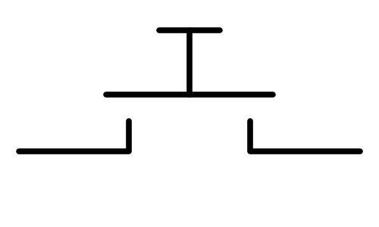
41. | Toggle Switch (SPDT) | 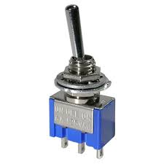 | 3 | Common (C) terminal in the middle and two throw terminals (position 1 and position 2). | Selecting between two circuits, ON/OFF and changeover control. | 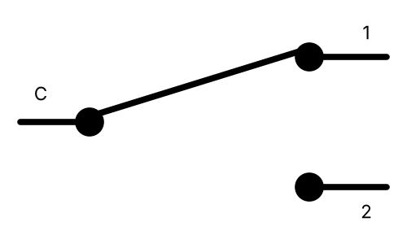
IX | Electromechanical Components
42. | Relay (5V/12V) | 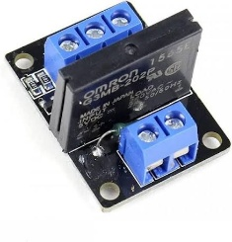 | 5 | Coil 1 and Coil 2 (coil terminals); Common (COM), Normally Open (NO) and Normally Closed (NC) contacts. | Switching high-power loads with a low-power signal, isolation, automation. | 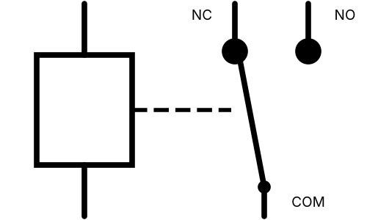
43. | Buzzer | 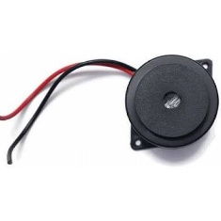 | 2 | Two polarized terminals: Positive (+) (long lead / marked) and Negative (–). | Alarms, indicators, timers, notification sounds. | 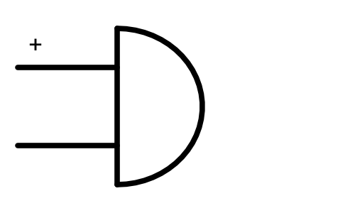
44. | Speaker (8 Ω) | 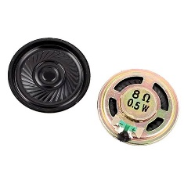 | 2 | Two terminals (voice coil): Positive (+) and Negative (–); 8 Ω impedance. | Audio output in amplifiers, radios, alarms and music players. | 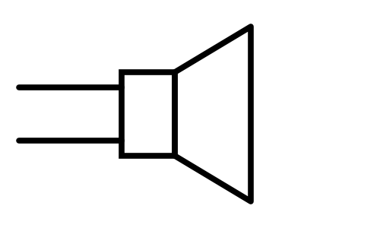
45. | DC Motor | 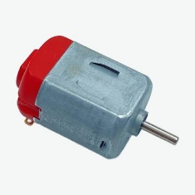 | 2 | Two terminals: Positive (+) and Negative (–); reversing polarity reverses the direction of rotation. | Fans, toys, robotics, pumps, small drives. | 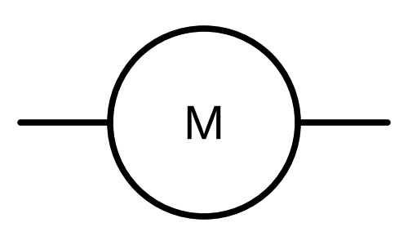
X | Protection
46. | Fuse | 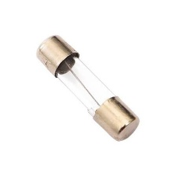 | 2 | Two non-polarized terminals; either lead can be connected to either side. | Overcurrent protection; the element melts and opens the circuit when current exceeds its rating. | 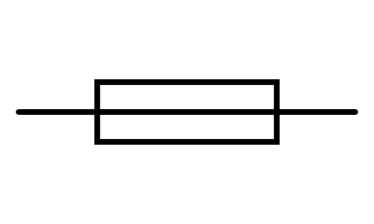
XI | Display
47. | 7-Segment Display | 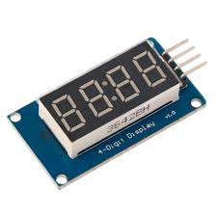 | 10 | Segment pins a, b, c, d, e, f, g and DP, plus common pin(s) (COM): common cathode or common anode. | Displaying numeric digits in clocks, counters, meters and calculators. | 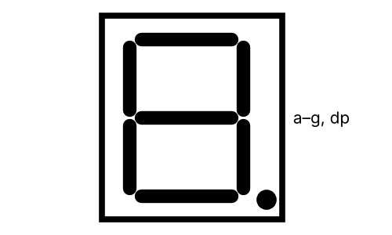
XII | Oscillator
48. | Crystal Oscillator | 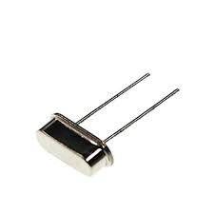 | 2 | Two non-polarized terminals (quartz crystal in a metal can); either lead can be connected to either side. | Clock source for microcontrollers, frequency generation, timers, communication circuits. | 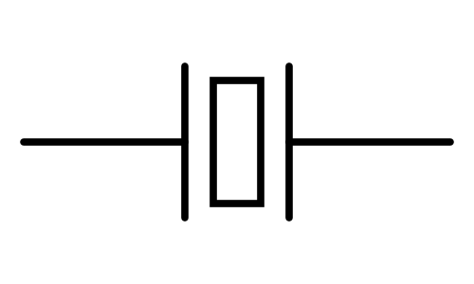
XIII | Source
49. | Battery / DC Cell | 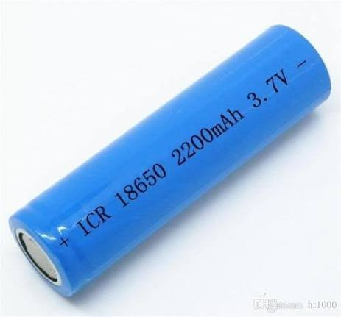 | 2 | Positive (+) terminal (longer line in the symbol) and Negative (–) terminal. | DC power source for portable and low-voltage circuits. | 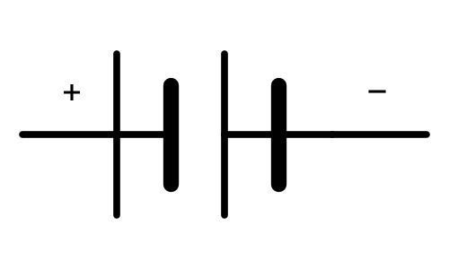
50. | Optocoupler (PC817) | 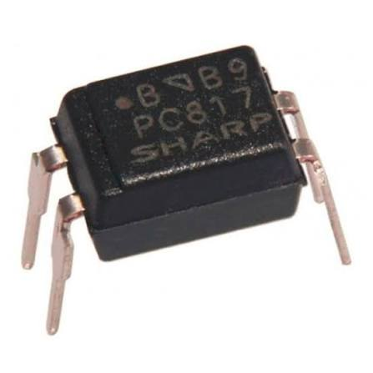 | 4 | Pin 1: Anode and Pin 2: Cathode (these form the input LED side); Pin 3: Emitter and Pin 4: Collector (these form the output phototransistor side) | Provides complete electrical isolation between two circuits while allowing signal transmission, protecting sensitive components from voltage spikes | 