County-Daily Flood and Hurricane Risk on the Gulf Coast
Training procedure and results
Gradient boosting against a Temporal Fusion Transformer, at 1-, 2- and 3-day lead
Run 20261104T015759Z-run · finished 2026-11-04T10:24:24+00:00 · 8.44 h on NVIDIA A100-SXM4-80GB
Panel sha256 33a1cabae86575a1218dde8d5c306664f11333e2c25d2f213cd180566ab861bb

1. What was predicted
The unit of analysis is a county-day. For each of the 356 Gulf Coast counties and each day from 2000 to 2026, the models answer a binary question: does a hazard event begin in this county within the next 3 days? The panel holds 3,252,826 such rows.
Two hazards are modelled separately, with separate labels and separate models:
- Flood — the onset day of a NOAA StormEvents flood episode. A positive exists because a local Weather Service office wrote the episode up, so this is a record of reported flooding, not of flooding.
- Hurricane / tropical storm — the day the HURDAT2 Atlantic best track passes through the county. This is purely geometric: a county grazed by a weak system and a county hit by a major landfall are the same positive.
Two target definitions are used throughout, and keeping them apart is the point of the whole lead-time section below:
- Pooled target — onset falls anywhere in t+1 .. t+3. This is what the dashboard's headline risk cards report.
- Exact-lead target — onset falls on exactly t+k, for k in 1, 2, 3. Obtained by a within-county shift of the onset column, so no day leaks across a county boundary.
The pooled question is strictly easier than the 3-day exact-lead question. Reporting a pooled score as a '3-day forecast' is the specific overstatement the exact-lead sweep exists to prevent.

2. Features
All 26 features are available on the morning the model runs, with one important exception noted in section 10. They fall into four groups:
Group | Features | What it carries
Rainfall, antecedent | prcp, prcp_max_stn, prcp_prev3/7/14/30/60/90 | how wet the county already is, over six windows
Rainfall, forward | prcp_fwd1, prcp_fwd3, prcp_fwd3_max, log_fwd3 | rain over the prediction window itself
Normalised rainfall | ratio_prev3, ratio_fwd3, ratio_prev30 | rain divided by that county's own climatology, so a wet county and a dry county are on one scale
Season and place | tmax, tmin, month_sin, month_cos, hurricane_season, lat, lon | where and when
Exposure | pop_density, RPL_THEME1, RPL_THEME4, RPL_THEMES | CDC Social Vulnerability Index themes and population density
Table 1. Feature groups. Column order is fixed in v2_models.FEATS because an XGBoost DMatrix takes its feature names from the DataFrame column order and rejects a layout that differs from training.
Monotone constraints are applied to every rainfall, ratio and log feature, forcing predicted risk to be non-decreasing in each of them. More rain can never lower predicted risk. This costs a little fit and buys a model whose behaviour can be defended without inspecting it.
Missing values are passed through to XGBoost rather than imputed. The booster learned its own default direction for missingness during training, so filling at scoring time would evaluate a different function from the one that was fitted.

3. Splits
Splits are by calendar year and are never shuffled. No row from a test year informs training or model selection, and because the split is temporal rather than random, no county contributes neighbouring days to both sides of the boundary.
Split | Years | Rows | Counties | Flood onsets | Flood rate | Hurricane onsets | Hurricane rate
train | 2000-2014 | 1,867,821 | 356 | 20,766 | 1.1118% | 4,306 | 0.2305%
val | 2015-2019 | 619,985 | 354 | 7,132 | 1.1504% | 1,600 | 0.2581%
test | 2020-2026 | 765,020 | 356 | 8,052 | 1.0525% | 2,244 | 0.3833%
Table 2. Split sizes and class balance. Both targets are rare-event problems; hurricane onset is roughly one county-day in four hundred.
Label availability is capped where the source is not yet final: Hurricane / tropical storm through 2024. The HURDAT2 best track is finalised a season behind, so hurricane metrics are scored on a shorter test window than flood metrics (185,757 test rows are excluded). The two hazards' test sets are therefore not the same size and their absolute average precisions are not directly comparable to each other.
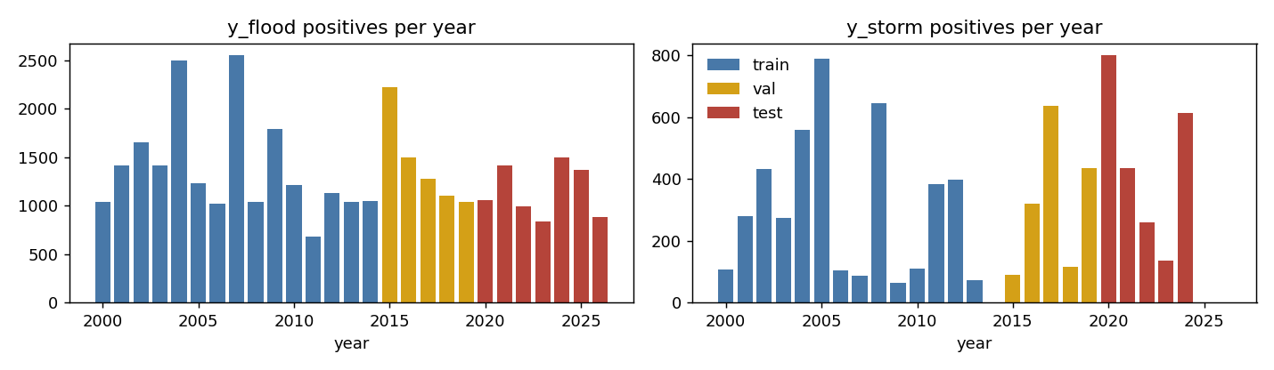
Figure 1. Rows and positive counts by split.

4. Baselines
No model is accepted until it beats every baseline. Each baseline ranks county-days by a single raw feature -- no fitting at all -- and is scored with the same metric on the same test rows. On a rare-event target this is a much harder bar than it sounds, because a single rainfall feature already carries most of the signal a flood model has.
Hazard | Baseline feature | Test AP | XGBoost / baseline | Rank
Flood | ratio_prev3 | 0.11408 | 2.28x | strongest
Flood | ratio_fwd3 | 0.07656 | 3.39x
Flood | prcp_fwd3 | 0.07403 | 3.51x
Flood | log_fwd3 | 0.07403 | 3.51x
Flood | prcp_fwd3_max | 0.06905 | 3.76x
Flood | prcp_prev30 | 0.03270 | 7.95x
Flood | pop_density | 0.02157 | 12.05x
Flood | month_climatology | 0.01739 | 14.95x
Flood | constant_prevalence | 0.01053 | 24.69x
Hurricane / tropical storm | prcp_fwd3_max | 0.03759 | 4.66x | strongest
Hurricane / tropical storm | prcp_fwd3 | 0.03452 | 5.08x
Hurricane / tropical storm | log_fwd3 | 0.03452 | 5.08x
Hurricane / tropical storm | ratio_prev3 | 0.03176 | 5.52x
Hurricane / tropical storm | ratio_fwd3 | 0.02544 | 6.89x
Hurricane / tropical storm | prcp_prev30 | 0.01212 | 14.47x
Hurricane / tropical storm | month_climatology | 0.01014 | 17.29x
Hurricane / tropical storm | pop_density | 0.00627 | 27.98x
Hurricane / tropical storm | constant_prevalence | 0.00383 | 45.73x
Table 3. Every single-feature baseline, pooled target. The strongest one per hazard is the bar the model has to clear.

5. Gradient boosting
XGBoost with a logistic objective, learning rate 0.05, max depth 6, min child weight 50, subsample 0.9, colsample_bytree 0.9 and L2 5.0. Up to 2,000 rounds with early stopping after 50 rounds without validation improvement.
A saved booster contains best_iteration + early trees, because save_model writes every tree early stopping trained, not only the ones up to the best round. Scoring the whole file silently evaluates an overfit model. Every prediction in this project therefore passes iteration_range=(0, best_iteration+1), with best_iteration read from the run's results JSON rather than from the model file.
Hazard | Best iteration | Trees in file | Val AP | Test AP | Test base rate | Lift | vs best baseline
Flood | 336 | 386 | 0.33628 | 0.25989 | 1.0525% | 24.7x | 2.28x
Hurricane / tropical storm | 135 | 185 | 0.12510 | 0.17530 | 0.3833% | 45.7x | 4.66x
Table 4. Pooled gradient-boosting results.
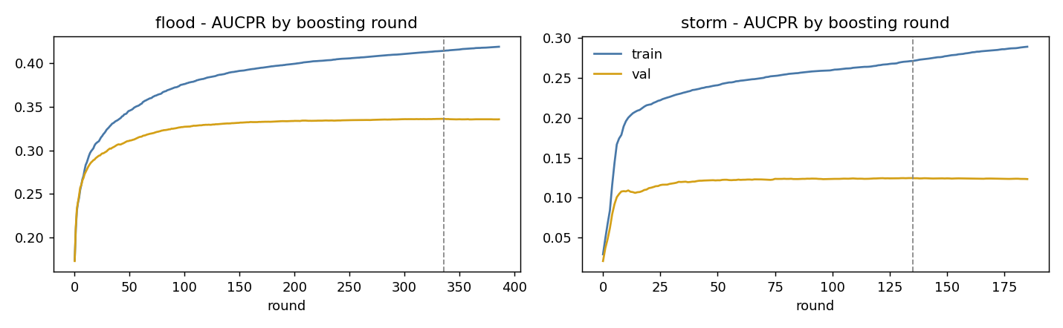
Figure 2. Training and validation curves, with the early-stopping point marked.
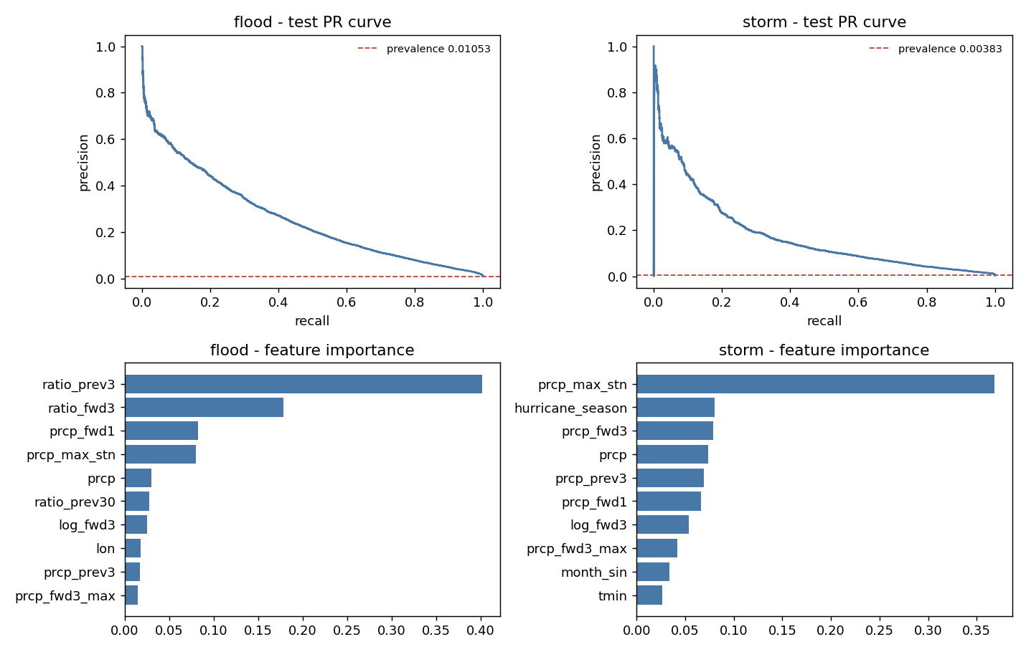
Figure 3. Precision-recall on the test years, against the base rate.
Feature importance confirms what the baselines imply -- the ratio features dominate the flood model, and the maximum station rainfall dominates the hurricane model:
Hazard | Top features by gain
Flood | ratio_prev3 (0.402), ratio_fwd3 (0.179), prcp_fwd1 (0.083), prcp_max_stn (0.080), prcp (0.030), ratio_prev30 (0.027)
Hurricane / tropical storm | prcp_max_stn (0.368), hurricane_season (0.080), prcp_fwd3 (0.079), prcp (0.073), prcp_prev3 (0.069), prcp_fwd1 (0.066)
Table 5. Six highest-gain features per hazard.

6. Temporal Fusion Transformer
The transformer sees a 30-day encoder window per county, with hidden size 32, 4 attention heads, dropout 0.2 and hidden continuous size 16. Trained with learning rate 0.01, batch size 512, up to 30 epochs with early stopping after 5 epochs without improvement.
Because onset is rare, training uses a positive-class weight of 50. That weight makes the loss learnable but inflates every output: the raw flood predictions average 0.11170 against an observed rate of 0.01056, a factor of 11. Isotonic regression fitted on the validation split corrects this. Isotonic is monotone, so it moves the probabilities onto a readable scale without reordering them, and average precision barely changes.
Hazard | Epochs run | Best val loss | Test windows | Raw pred mean | Calibrated pred mean | Observed rate | AP before | AP after
Flood | 13 | 0.43376 | 757,279 | 0.11170 | 0.00909 | 0.01056 | 0.24292 | 0.23503
Hurricane / tropical storm | 6 | 0.49643 | 579,263 | 0.05141 | 0.00253 | 0.00383 | 0.05895 | 0.05407
Table 6. Transformer training and the effect of calibration. The AP columns show that calibration costs almost nothing in ranking quality, which is the point of using a monotone method.
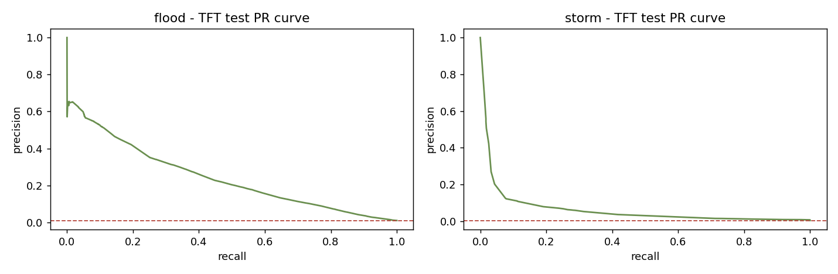
Figure 4. Transformer precision-recall on test.
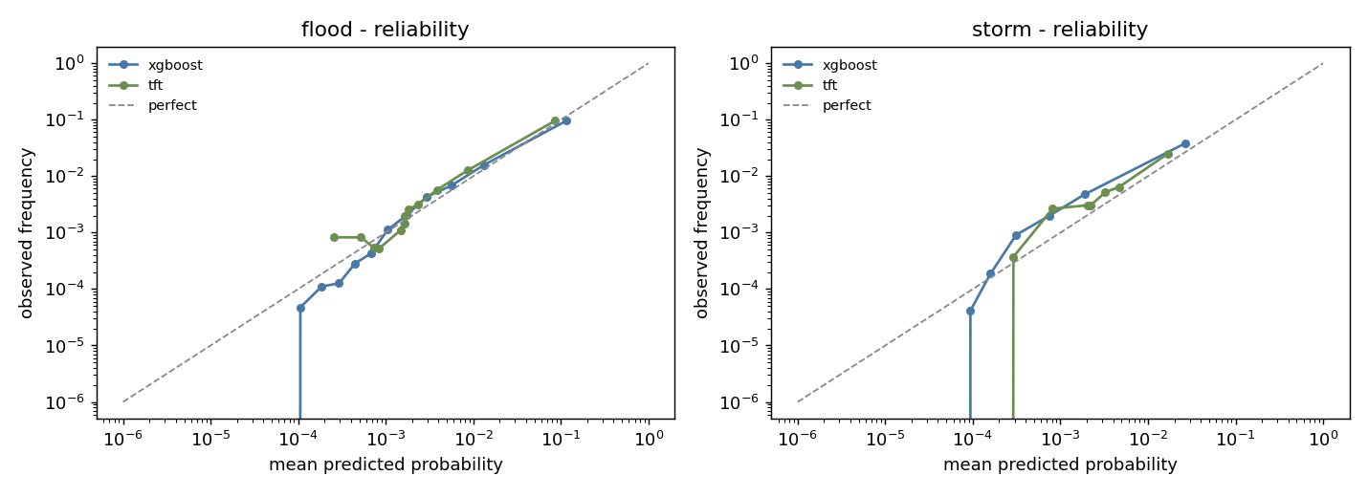
Figure 5. Reliability after isotonic calibration -- predicted probability against observed frequency.

7. Gradient boosting against the transformer
Both models were fitted on the same panel, the same splits and the same label, so the only thing differing within a hazard is the architecture.
Hazard | Model | Test AP | Lift over base rate | vs best baseline
Flood | XGBoost (monotone) | 0.25989 | 24.7x | 2.28x
Flood | Temporal Fusion Transformer | 0.23503 | 22.2x | 2.06x
Hurricane / tropical storm | XGBoost (monotone) | 0.17530 | 45.7x | 4.66x
Hurricane / tropical storm | Temporal Fusion Transformer | 0.05407 | 14.1x | 1.44x
Table 7. Pooled target, test years.
Gradient boosting wins both hazards. On floods the margin is narrow -- 0.25989 against 0.23503, a factor of 1.11 -- close enough that the transformer is a credible alternative. On hurricanes it is not close: 0.17530 against 0.05407, a factor of 3.24, and the transformer clears its baseline by only 1.44x.
The likely explanation is sample size rather than architecture. Hurricane onset occurs on 0.383% of county-days, and a 30-day encoder window spends almost all of its capacity on sequences containing no event at all. The transformer also cost hours of A100 time against seconds of boosting on the same data, so on this problem the heavier model is both worse and more expensive. That is a result worth reporting rather than hiding: a sequence model is not automatically the right answer for a rare-event tabular panel.
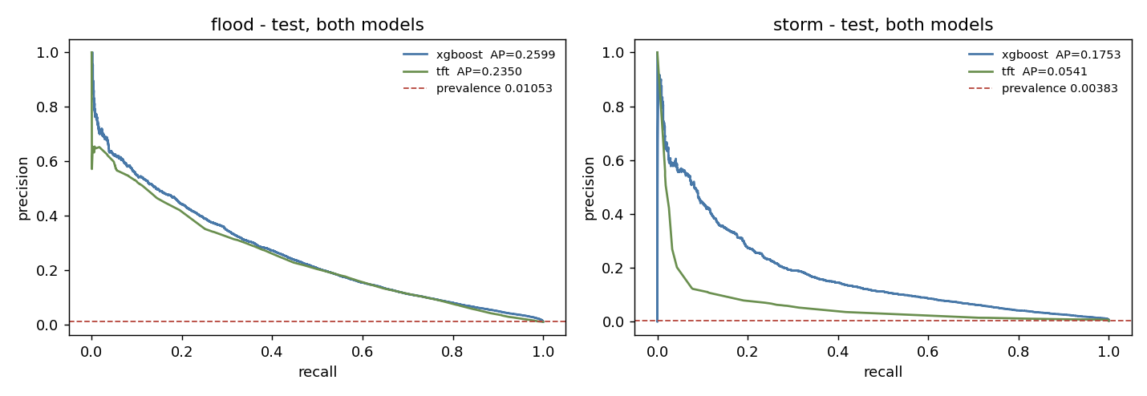
Figure 6. Both architectures against both baselines, pooled target.

8. How much warning it actually buys
A single pooled number hides the thing a user needs most. Each lead below therefore has its own model, trained on its own target, and each is scored against the strongest single-feature baseline for that same target -- which changes with lead, and gets harder to beat as the signal weakens.
Hazard | Lead | Test base rate | Baseline | Baseline AP | XGBoost AP | vs base | TFT AP | vs base
Flood | +1 day | 0.3725% | ratio_fwd3 | 0.09035 | 0.17179 | 1.90x | 0.10706 | 1.18x
Flood | +2 day | 0.3711% | ratio_fwd3 | 0.10823 | 0.12669 | 1.17x | 0.12586 | 1.16x
Flood | +3 day | 0.3707% | ratio_fwd3 | 0.05325 | 0.07490 | 1.41x | 0.06357 | 1.19x
Hurricane / tropical storm | +1 day | 0.1280% | prcp_fwd3 | 0.04103 | 0.09879 | 2.41x | 0.05414 | 1.32x
Hurricane / tropical storm | +2 day | 0.1280% | prcp_fwd3 | 0.04580 | 0.07207 | 1.57x | 0.05110 | 1.12x
Hurricane / tropical storm | +3 day | 0.1280% | prcp_fwd3 | 0.01682 | 0.03716 | 2.21x | 0.03429 | 2.04x
Table 8. The exact-lead sweep. Six models per architecture, each trained and scored on its own target.
Gradient-boosting skill decays monotonically with lead in both hazards. Flood average precision runs 0.17179 to 0.12669 to 0.07490 across +1, +2 and +3 days, a loss of 56% from the shortest lead to the longest; hurricane runs 0.09879 to 0.07207 to 0.03716, a loss of 62%.
The transformer is monotone on hurricanes but not on floods, where the +2 day model (0.12586) scores above the +1 day model (0.10706). Six independent fits of a high-variance model on a rare target will not order themselves perfectly, and the inversion is reported rather than smoothed away: it is a reason to treat the transformer's per-lead numbers as noisier than the boosted ones, not a finding about lead time.
The ratio over baseline does not decay neatly, and this is worth being explicit about rather than presenting as a win. The baseline is losing signal at the same rate the model is: the strongest flood baseline falls from 0.10823 at +2 days to 0.05325 at +3. The ratio therefore rises while the underlying forecast gets worse. Read the average-precision columns for forecast quality and the ratio columns only for whether the model is earning its complexity.
Across the six lead-hazard combinations, gradient boosting takes 6 of 6.
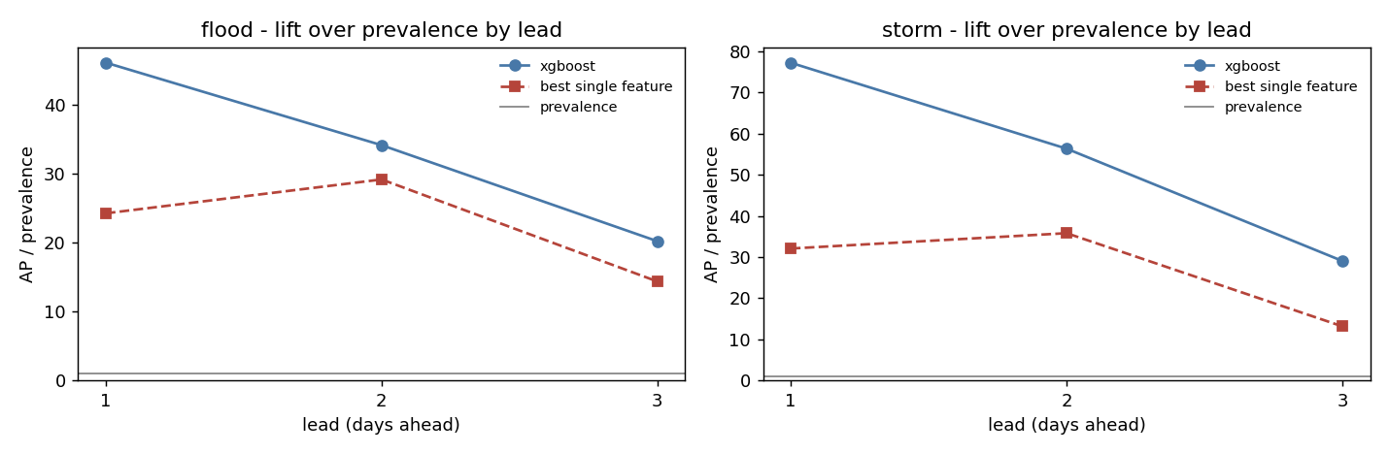
Figure 7. XGBoost average precision against lead.
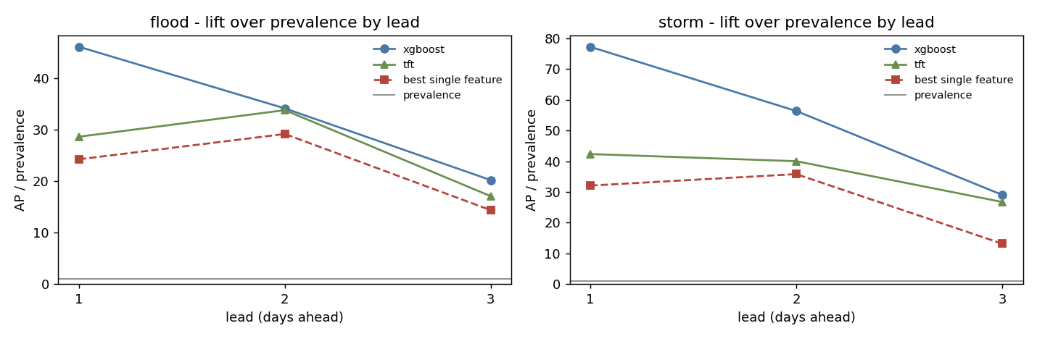
Figure 8. Both architectures against lead, with baselines.

9. Deviation from observation
Average precision measures ranking. It says nothing about whether the predicted probabilities are the right size, or about what happens at a usable decision threshold. The tables below score both models against two null predictors -- always-zero, and the constant base rate -- at a threshold set to the 99th percentile of each model's own predictions.

9.1 Flood
Metric | Always zero | Base rate | XGBoost | TFT
observed_events | 8,000 | 8,000 | 8,000 | 8,000
predicted_mean | 0.00000 | 0.01112 | 0.01182 | 0.00909
bias_pred_minus_obs | -0.01056 | 0.00055 | 0.00125 | -0.00148
brier | 0.01056 | 0.01045 | 0.00906 | 0.00897
brier_skill_vs_baserate | -0.01068 | -0.00003 | 0.13286 | 0.14156
calibration_error_ECE | 0.01056 | 0.00172 | 0.00207 | 0.00158
hits | 95 | 95 | 2,517 | 2,442
misses | 7,905 | 7,905 | 5,483 | 5,558
false_alarms | 7,478 | 7,478 | 5,056 | 5,131
POD_recall | 0.01188 | 0.01188 | 0.31462 | 0.30525
precision | 0.01254 | 0.01254 | 0.33236 | 0.32246
CSI_critical_success | 0.00614 | 0.00614 | 0.19278 | 0.18597
F1 | 0.01220 | 0.01220 | 0.32325 | 0.31362
Table 9. Flood deviation metrics on the test years.

9.2 Hurricane / tropical storm
Metric | Always zero | Base rate | XGBoost | TFT
observed_events | 2,220 | 2,220 | 2,220 | 2,220
predicted_mean | 0.00000 | 0.00231 | 0.00249 | 0.00253
bias_pred_minus_obs | -0.00383 | -0.00153 | -0.00134 | -0.00130
brier | 0.00383 | 0.00382 | 0.00346 | 0.00371
brier_skill_vs_baserate | -0.00385 | -0.00061 | 0.09403 | 0.02759
calibration_error_ECE | 0.00383 | 0.00269 | 0.00139 | 0.00132
hits | 33 | 33 | 867 | 444
misses | 2,187 | 2,187 | 1,353 | 1,776
false_alarms | 5,760 | 5,760 | 4,926 | 5,349
POD_recall | 0.01486 | 0.01486 | 0.39054 | 0.20000
precision | 0.00570 | 0.00570 | 0.14966 | 0.07664
CSI_critical_success | 0.00414 | 0.00414 | 0.12133 | 0.05866
F1 | 0.00824 | 0.00824 | 0.21640 | 0.11082
Table 10. Hurricane / tropical storm deviation metrics on the test years.
Two things are worth drawing out. First, both models carry positive Brier skill over the constant base rate, so the probabilities are informative and not merely well-ordered. Second, the false-alarm counts are large in absolute terms at every usable threshold. This is inherent to a rare-event target and is the reason the dashboard presents a relative band rather than a yes/no alert: at a base rate near one percent, the flood model's precision of 0.33 is a strong result and still means two flagged days in three are quiet.

10. Known limitations
Training rainfall is observed, not forecast. The forward rainfall features use station observations over the prediction window, which a real forecaster would not have on the morning the model runs. This is the single largest overstatement in the project. Every lead-time number in this document should be read as an upper bound on what an operational system would achieve. The fix is to retrain the forward features on archived forecasts (GEFSv12 reforecast).
- The label is an observational record, not hazard physics. A flood positive exists because someone reported it; an unreported flood is a negative. A hurricane positive is a track intersection and carries no intensity information.
- Coverage is 356 counties, all within the five Gulf states and all with a rainfall station in the source data. Nothing here supports a claim about counties outside that set.
- No held-out-state validation was run. Earlier work measured skill retention when a whole state is removed from training; this run did not repeat it.
- The rainfall record has gaps. The panel spans 9,645 calendar days; the median county has 9,595 of them and the worst has 3,702. 28 counties fall below 80% coverage, and 296 of the 3,023 events listed on the dashboard have no day of their three-day lead-up in the record.
- No soil moisture and no river gauges. Antecedent wetness is proxied by 30-, 60- and 90-day rainfall, a weak substitute for catchment state.
- No hurricane wind field, track forecast, intensity or storm surge.
- Only 8,052 flood and 2,244 hurricane onsets fall in the test period. Confidence intervals on every metric here are correspondingly wide and none are reported.

11. Provenance and reproducibility
Field | Value
Run id | 20261104T015759Z-run
Environment | colab on host 365f956f8873
Started (UTC) | 2026-11-04T01:57:59+00:00
Finished (UTC) | 2026-11-04T10:24:24+00:00
Wall time | 30,384.7 s (8.44 h)
GPU | NVIDIA A100-SXM4-80GB
Python / numpy / pandas | 3.13.16 / 2.4.6 / 2.2.3
xgboost / torch | 3.4.1 / 2.11.0+cu130
Panel path | /content/drive/MyDrive/crisk/artifacts/daily_panel.parquet
Panel sha256 | 33a1cabae86575a1218dde8d5c306664f11333e2c25d2f213cd180566ab861bb
Panel rows / counties / years | 3,252,826 / 356 / 2000-2026
Self-contained | True
Warm parents | {}
Random seed | 0
Table 11. Run manifest. The run is sealed: its own directory holds the models, the results and the hashes, and nothing outside it contributed to a reported number.
Reproducibility was verified locally before any of these numbers reached the dashboard. The local copy of the panel hashes identically to the one the run read. Each of the eight boosters -- two pooled and six exact-lead -- was reloaded from the run directory and re-scored on the test rows, and every one reproduced its recorded test average precision to five decimal places. The check is the __main__ block of v2_models.py and can be re-run at any time.
The dashboard serves XGBoost because it wins both hazards. The transformer numbers on the dashboard's comparison panel are read from this run's results files rather than re-scored in the browser, so the figures in this document and the figures on the dashboard come from the same source and cannot diverge.

