**1. Name of program:**

Operational Process Automation – Reporting.

**2. Objective:**

A code-based solution using Python and SQL that will automate the process of importing data, preparing reports, and delivering reports on/at scheduled days/times, to designated stakeholders.

**3. Scope – Summary:**

* + Project - Requirements
  + Folder Structure Creation for the program flow
  + Source file creation/updation with current date
  + Running Python File
  + Program-Execution:
    - Read the source files for data
    - Export the read data to DBMS as per the provided mappings.
    - Report generation from DBMS to a new excel file with necessary customizations.
  + **Project – Requirements**
  + Chrome Driver – To automate browser to get Visa bulletin Information
  + Pyodbc – To establish connection between Python code and DBMS
  + Pandas – To retrieve and manipulate source file data
  + Chardet – for encoding
  + Xlsxwriter – to write data from data frames to external excel files
  + Openpyxl – for excel formatting
  + Email – to enabling E-mailing functionality from script
  + Fernet – for data encryption
  + **Folder Structure for the program flow:**
  + The following folders will be manually created at the path where the code will be placed for the ease of flow of program
  + Processed Reports
  + Source Data

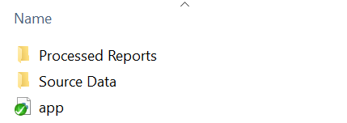

* Processed Reports folder - The path that will hold the processed output files
* Source data folder - The path that will hold the Source input files which are going to be processed.
* **app.py** - This is the executable Python file that we have to run it in the command prompt.
* **Running Python File:**
* Go to the respective folder and type **cmd** in the address bar and click enter it will open a command prompt or else you can open command prompt from the run command (Win Key + R) and move to the respective folder by using **cd command.**

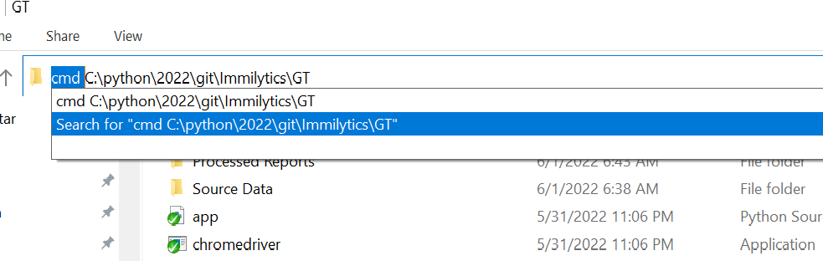

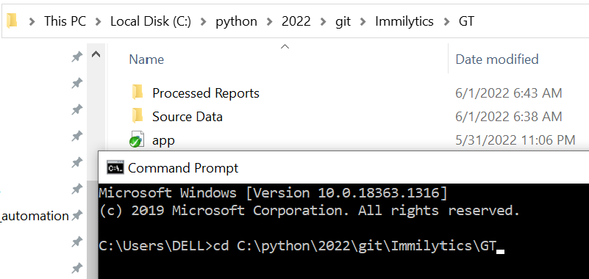

* Then run python **dataaudit** file by running following command:

python **dataaudit.py**

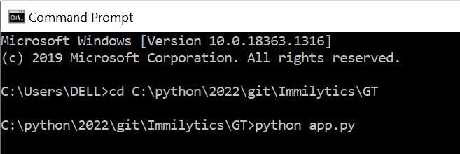

* And Then Press Enter to start Program Execution.
* **Program-Execution:**
* **Reads the source files for data (Beneficiary File):**
* Thus the acquired source files namely Reports Automation - Beneficiary Data (HQ Based) (for ImmiLytics), Reports Automation - Case Data (HQ Based) will be renamed as per the below conventions
* Reports Automation_Beneficiary Data_(client-name)_mmddyyyy
* Reports Automation_Case Data_(client-name)_mmddyyy. and will be placed in the source file folder.
* Now the code searches and picks for the Beneficiary data file in the source folder that contains the current date in its filename.
* This uses pandas framework to read the content of the file and stores within as data frames
* Now the code reads the number of rows the dataframe has and loops repetitive for ‘n’ number of rows the dataframe holds.
* During each looping it reads the data of all the columns of the each respective rows and assigns to the respective columns as defined by the mappings and pushes/adds the data of each rows to the Beneficiary table as denoted in the respective SQL code.
* The loop ends once feeding data of all the rows in dataframe that is extracted from the source beneficiary file.
* **Reads the source files for data (Case data File):**
* Once the insertion of data to the DBMS from the beneficiary data is completed the same identical process is restarted for case file as elaborated below
* The code now searches and picks for the Case data file in the source folder that contains the current date in its filename.
* This uses pandas framework to read the content of the file and stores within as data frames.
* Now the code reads the number of rows the dataframe has and loops repetitive for ‘n’ number of rows the the dataframe holds.
* During each looping it reads the data of all the columns of the each respective rows and assigns to the respective columns as defined by the mappings and pushes/adds the data of each rows to Case table as denoted in the respective SQL code with the respective beneficiaryXref as ForeignKey.
* The loop ends once feeding data of all the rows in dataframe that is extracted from the source case file.
* **Report generation:**
* Now once all the datas from the beneficiary files are available in the DBMS it’s time to query all the tables as per the requirements to create a output file as required.
* The code queries the Client data table in the database for record that has a definite delivery date in it.
* And creates the Output file with the following tabs:
* Open Cases -
* Filed & Pending Cases
* Approved & Closed Cases
* Cases on Hold
* Priority Date Report
* Active Beneficiary List
* Further it moves to create Document Expiration Report with the below tab name. It will generate by monthly basis when the client file running at the first time of the month.
* Doc Exp Report - 8 Months Out
* The sheet enlists all active beneficiaries whose any one of the below criteria did not yet expire
* I797ExpirationDate
* FinalNivDate
* VisaPedDate
* EadExpirationDate
* AdvanceParoleExpirationDate
* Ds2019ExpirationDate
* ReEntryPermitExpirationDate
* GreenCardExpirationDate
* MostRecentPassportExpirationDate
* VisaExpirationDate BETWEEN
* **Sending mail:**
* Once all the reports are ready it’s time to mail the clients
* The code checks for availability of the recipient mail id’s from ClientsDetails table and further checks if the SEND_MAIL option is enabled/disabled
* The code gets the mail ID’s of the primary recipient and secondary recipient.
* And only in an account of SEND_MAIL_TO_CLIENT is too enabled the secondary recipients are also considered.
* An **send_exp_report** option is set to provide an option to whether to include are not the “Document Expiration Report” in the mailing attachments.
* Once the report being sent the “**report_sent_on**” column of clients details table are updated accordingly.
* **Processed Reports:**
* Once Processed the command prompt will show ‘Finished’ status, upon which we shall check reports in the processed report folder.

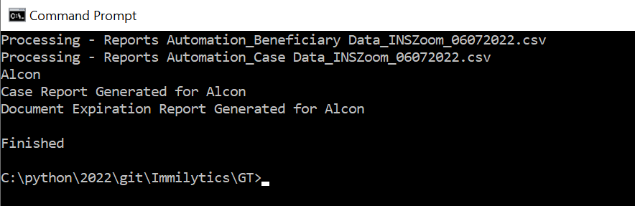

* The Processed Report will created at Processed Folder with the respective date of report generation.



