**PIZZA SALES SQL QUERIES**

1. **KPI’s**
2. **Total Revenue:**

SELECT SUM(total_price) AS Total_revenue FROM Pizza_sales;



1. **Average Order Value:**

SELECT SUM(total_price) / COUNT(DISTINCT order_id) AS avg_order_value FROM Pizza_sales;



1. **Total Pizzas Sold:**

SELECT SUM(quantity) AS Total_pizza_sold FROM Pizza_sales;

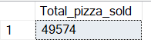

1. **Total Orders:**

SELECT COUNT(DISTINCT order_id) AS Total_orders FROM Pizza_sales;



1. **Average Pizza Per order:**

SELECT CAST(CAST(SUM(quantity) AS DECIMAL(10,2)) /

CAST(COUNT(DISTINCT order_id) AS DECIMAL(10,2)) AS DECIMAL(10,2)) AS Avg_pizzas_per_order FROM Pizza_sales;

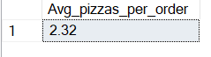

1. **-TRENDS:**
2. **DAILY TREND FOR TOTAL ORDERS:**

SELECT DATENAME(DW, order_id), COUNT(DISTINCT order_id) AS Total_orders FROM Pizza_sales

GROUP BY DATENAME(DW, order_id);

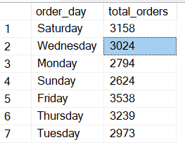

1. **HOURLY TREND FOR TOTAL ORDERS:**

SELECT DATEPART(HOUR,order_time) AS order_hourS, COUNT(DISTINCT order_id) AS total_order FROM Pizza_sales

GROUP BY DATEPART(HOUR,order_time)

ORDER BY DATEPART(HOUR,order_time);

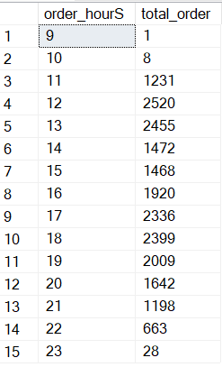

1. **PERCENTAGE OF SALES BY PIZZA CATEGORY:**

SELECT pizza_category,SUM(total_price) AS Total_sales, CAST(SUM(total_price) * 100/(SELECT SUM(total_price) FROM Pizza_sales)AS DECIMAL(10,2)) AS Total_sales FROM Pizza_sales

WHERE MONTH(order_date)=1

GROUP BY pizza_category;

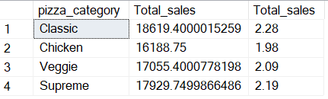

1. **PERCENTAGE OF SALES BY PIZZA SIZE:**

SELECT pizza_size,CAST(SUM(total_price)AS DECIMAL(10,2)) AS Total_sales, CAST(SUM(total_price) * 100/(SELECT SUM(total_price) FROM Pizza_sales)AS DECIMAL(10,2)) AS PCT FROM Pizza_sales

WHERE DATEPART(QUARTER, order_date)=1

GROUP BY pizza_size

ORDER BY pizza_size;

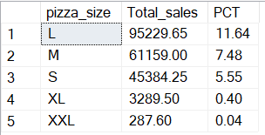

1. **TOTAL PIZZAS SOLD BY PIZZA CATEGORY:**

SELECT pizza_category, SUM(quantity) AS Total_pizza_sold

FROM Pizza_sales

GROUP BY pizza_category;

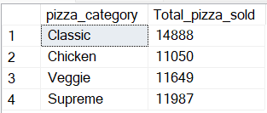

1. **TOP 5 BEST SELLERS BY TOTAL PIZZAS SOLD:**

SELECT TOP 5 pizza_name, SUM(quantity) AS Total_pizza_sold

FROM Pizza_sales

GROUP BY pizza_name

ORDER BY SUM(quantity) DESC;

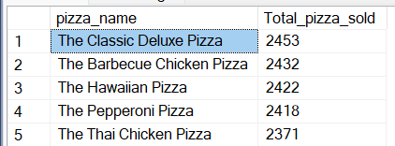

1. **BOTTOM 5 WORST SELLERS BY TOTAL PIZZAS SOLD:**

SELECT TOP 5 pizza_name, SUM(quantity) AS Total_pizza_sold

FROM Pizza_sales

GROUP BY pizza_name

ORDER BY SUM(quantity) ASC;

