**PROJECT 2: ENVIRONMENTAL MONITORING**

**PHASE 2: INNOVATION**

**Project Title: IoT Environmental Monitoring in Public Parks**

**1. Introduction:**

* Recap of the project's primary goal and key components.

**2**. **Design Transformation Steps:**

* **Step 1**: Sensor Selection
* Identify and evaluate temperature and humidity sensors.
* Consider reliability, accuracy, and cost-effectiveness.
* Consider options like the SHT series for high accuracy.
* **Step 2**: IoT Device Development
* Develop IoT sensors based on selected sensors.
* Implement power source strategy (battery, solar, or hybrid).
* Ensure robust connectivity (Wi-Fi, cellular, LPWAN).
* **Step 3**: Environmental Monitoring Platform
* Design a user-friendly web-based interface.
* Create real-time data display dashboards.
* Enable access to historical environmental data.
* Integrate weather forecast data.
* **Step 4**: Integration Approach
* Define data transmission protocol and frequency.
* Implement robust data security measures.
* Ensure scalability for future expansion.
* 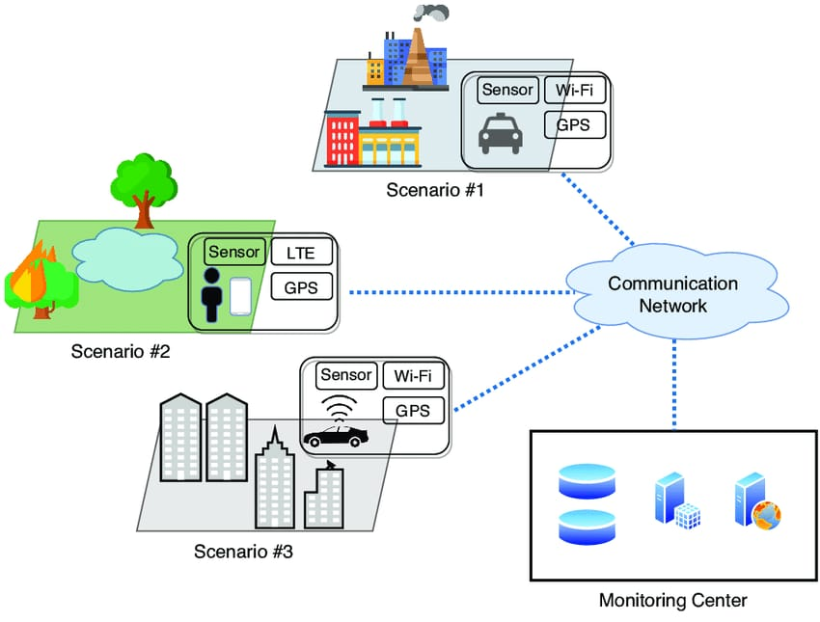Utilize Python for platform development.

**3**. **Step Details**:

* **Step 1**: Sensor Selection
* Research and evaluate available temperature and humidity sensors in the market.
* Consider factors such as accuracy, reliability, cost, and power consumption.
* Choose sensors that best fit project requirements.
* Procure an initial batch of sensors for testing.
* **Step 2**: IoT Device Development

Engage hardware engineers and developers to design IoT sensor prototypes.

* Develop a prototype enclosure for protection from weather elements.
* Test sensors for accuracy and reliability in a controlled environment.
* Decide on the power source strategy, weighing the pros and cons of battery, solar, or a hybrid system.
* Select appropriate connectivity options (Wi-Fi, cellular, or LPWAN).

* **Step 3**: Environmental Monitoring Platform
* 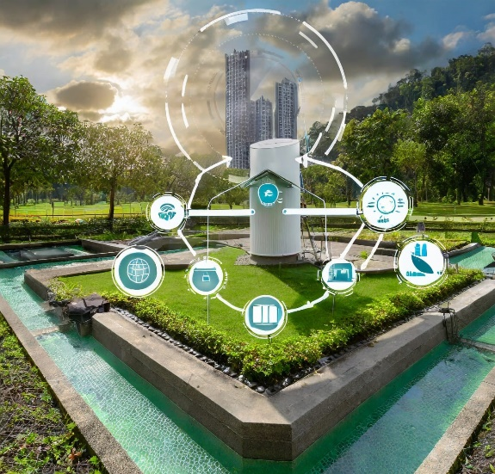Collaborate with user experience (UX) designers to create a user-friendly web-based interface.
* Develop real-time data display dashboards with interactive elements.
* Create a database for storing historical environmental data.
* Integrate weather forecast APIs for predictive capabilities.

* **Step 4**: Integration Approach
* Define a data transmission protocol (e.g., MQTT, HTTP) and determine the frequency of data transmission from IoT devices to the platform.
* Implement data encryption and user authentication for data security.
* Design the platform architecture with scalability in mind, allowing for easy addition of sensors or parks.
* Utilize Python and relevant frameworks for platform development, ensuring seamless sensor integration.

**4**. **Testing and Iteration:**

* Test IoT sensors in real-world park environments to ensure accurate data collection.
* Conduct usability tests with park visitors to gather feedback on the web-based platform.
* Continuously iterate on both the hardware and software based on user feedback and data analysis.

**5**. **Implementation and Deployment:**

* Develop the final IoT sensor system and environmental monitoring platform based on refined prototypes.
* Deploy IoT sensors in selected public parks as per the deployment plan.
* Launch the environmental monitoring platform for public access.
* Provide training for park administrators on platform usage and maintenance.

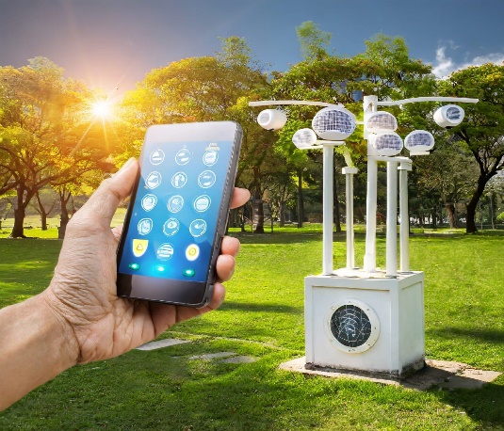**6**. **Monitoring and Evaluation**:

* Continuously monitor the performance of IoT devices and gather user feedback.
* Measure the impact of the project on visitor satisfaction and park utilization.

**7**. **Sustainability and Future Enhancements**:

* Develop a maintenance plan to ensure long-term functionality of IoT devices and the platform.
* Stay updated with advancements in IoT and web technologies for future enhancements.
* Consider expanding the project to additional parks or adding new features based on user needs and technological advancements.

**Conclusion**:

This document outlines the comprehensive steps for transforming the design concept into an innovative IoT Environmental Monitoring solution for public parks. Each step is carefully detailed, ensuring that the project aligns with its defined objectives and requirements while being user-centric and adaptable for future growth and sustainability.