**PROJECT 2: ENVIRONMENTAL MONITORING**

**PHASE 3: DEVELOPMENT**

To start building your IoT-enabled Environmental Monitoring in Parks system and deploy IoT devices (e.g., temperature and humidity sensors) in various locations within public parks, follow these steps:

**Step 1**: Choose the Right IoT Devices

* **Select Sensors**: Choose suitable temperature and humidity sensors based on the environmental conditions of the parks. Consider factors such as the range of temperature and humidity you need to measure, power requirements, and connectivity options.
* **Microcontroller/Single Board Computer**: Select microcontrollers (like Arduino, Raspberry Pi) or single-board computers (like Raspberry Pi) that are compatible with the chosen sensors and can connect to the internet.

**Step 2**: Set Up IoT Devices

* **Connect Sensors**: Connect the temperature and humidity sensors to the microcontroller or single-board computer according to the sensor's datasheet and the microcontroller's GPIO pins.
* **Power Supply**: Provide a stable power supply to the devices. Consider using batteries, solar power, or a combination depending on the deployment location and duration.
* **Internet Connectivity**: Establish internet connectivity for the devices. This could be through Wi-Fi, GSM, Lora WAN, or other IoT protocols based on the park's infrastructure.
* Set up the IoT devices following the manufacturer's guidelines. Ensure they are properly connected to the power source and the network.

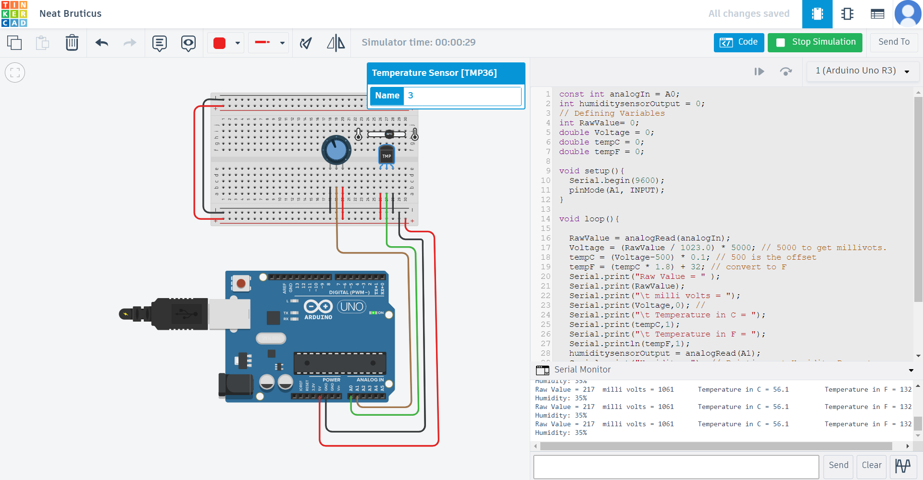

**Step 3**: Develop Firmware/Software

* **Write Firmware/Software**: Develop firmware or software for the microcontroller/single-board computer to read data from sensors and prepare it for transmission. You can use programming languages like C, Python, or JavaScript based on the platform you've chosen.

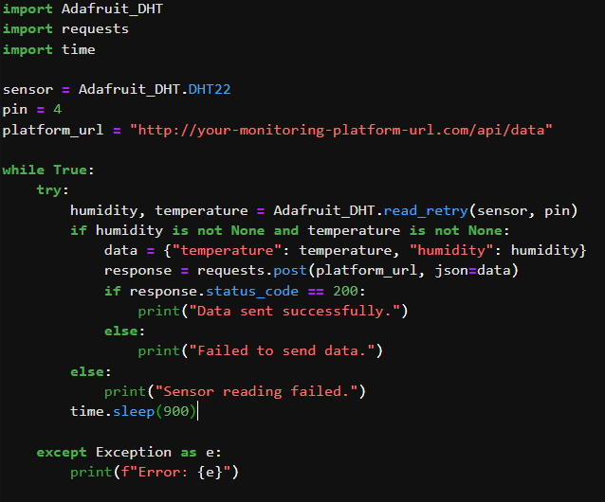**Python:**

**Output:**

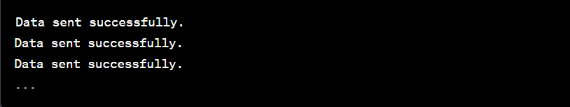

**Step 4**: Set Up a Data Collection and Storage System

* **API/Server**: Create an API or server to receive data from IoT devices. You can use frameworks like Flask (Python), Express (Node.js), or Django (Python) to create the API.
* **Database**: Set up a database (like MySQL, PostgreSQL, MongoDB) to store the received environmental data. Create a schema to organize the data efficiently.

**Step 5**: Data Visualization and Analysis

* **Visualization Tools**: Use visualization tools (such as Grafana, Kibana, or custom web applications) to create dashboards for real-time monitoring of environmental data.
* **Data Analysis**: Implement data analysis algorithms if necessary to gain insights from the collected data. Python libraries like Pandas and NumPy can be helpful for this purpose.

**Step 6**: Maintenance and Monitoring

* **Remote Monitoring**: Implement remote monitoring and management capabilities for the IoT devices. This can include remote firmware updates and status monitoring.
* Regular Maintenance: Schedule regular maintenance checks for the devices to ensure they are functioning correctly.

**Conclusion:**

By following these steps, you can deploy IoT devices equipped with temperature and humidity sensors in various locations within public parks, enabling real-time environmental monitoring and data analysis.