**PROJECT TITLE: IOT ENVIRONMENTAL MONITORING IN**

**PUBLIC PARKS**

**PHASE 5: DOCUMENTATION**

**PROJECT DEFINITION:**

The project’s primary goal is to establish an Internet of Things (IoT) infrastructure for monitoring environmental conditions, specifically temperature and humidity, in public parks. This endeavor seeks to deliver real-time environmental data to park visitors through a public platform, allowing them to make informed decisions regarding their outdoor activities.

**1**.**Project Objectives**:

* + **Real-time Environmental Monitoring:** Implement a system that continuously monitors temperature and humidity in public parks.
  + 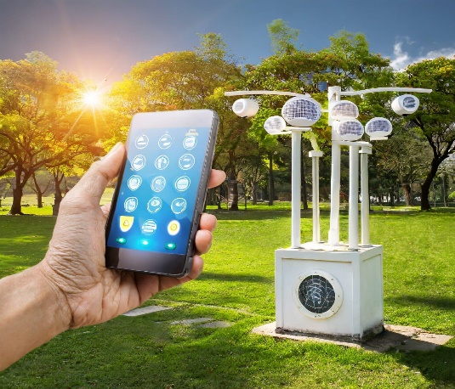**Aiding Park Visitors**: Furnish park visitors with access to real-time environmental data to facilitate planning and enhance their outdoor experience.
  + **Promoting Outdoor Experiences**: Encourage and enable park visitors to engage in outdoor activities by providing data-driven insights.
  + **Enhancing Visitor Satisfaction**: Improve visitor satisfaction by ensuring they are well-prepared for changing weather conditions.

**2**.**IoT device deployment:**

* **Connect Sensors**: Connect the temperature and humidity sensors to the microcontroller or single-board computer according to the sensor's datasheet and the microcontroller's GPIO pins.
* **Power Supply**: Provide a stable power supply to the devices. Consider using batteries, solar power, or a combination depending on the deployment location and duration.
* **Internet Connectivity**: Establish internet connectivity for the devices. This could be through Wi-Fi, GSM, Lora WAN, or other IoT protocols based on the park's infrastructure.
* Set up the IoT devices following the manufacturer's guidelines. Ensure they are properly connected to the power source and the network.

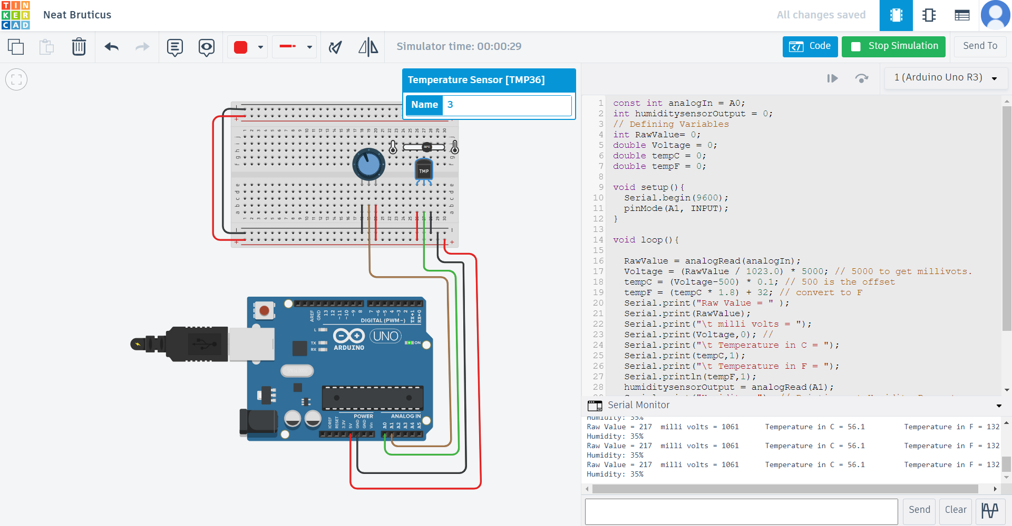

**3**.**Code Implementation**:

Developing software for the microcontroller/single-board computer to read data from sensors and prepare it for transmission. We can use programming languages like C, Python, or JavaScript based on the platform. Here, we have used Python programming languages.

**Python:**

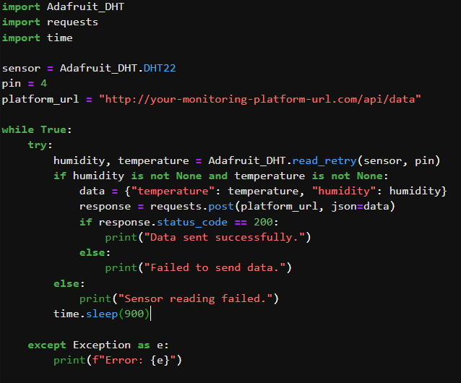

**Output:**



**4**.**Platform Development**:

Building an environmental monitoring platform to display real-time temperature and humidity data from IoT devices involves creating a web-based interface. We used HTML, CSS, and JavaScript to achieve this. Here's a step-by-step process to get complete. Before we start coding, we assured that we have a basic development environment setup. We used Visual Studio Code Editor and a web server to host our application.

1. **Create the HTML Structure:**

Start by creating the HTML structure for our environmental monitoring platform. Here's a simple example:

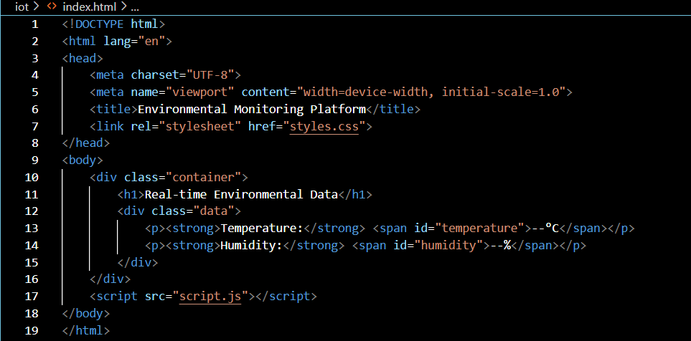

1. **Style Your Page (CSS)**:

We created a CSS file (styles.css) to style our page. This is where we added colours, fonts, and layout adjustments to make the platform visually appealing.

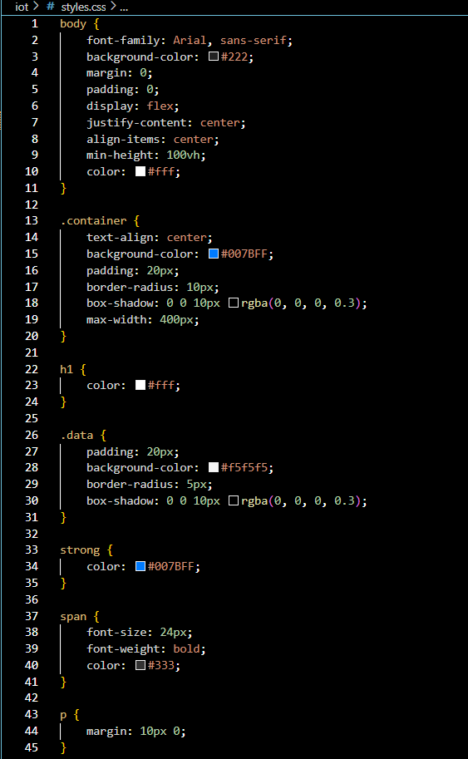

1. **JavaScript for Real-time Data (script.js)**:

Now, we needed JavaScript to fetch and display real-time data from IoT devices. We used AJAX or fetch API to get data from a server where IoT devices send updates. For this example, we used a simulated function:

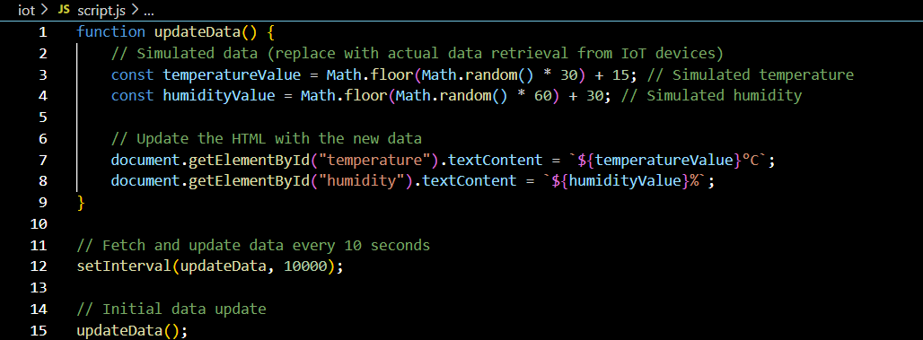

1. **UI Platform**:

Creating a user interface (UI) platform for environmental monitoring enhances the user experience and provides an accessible way for stakeholders to visualize and interact with real-time data.

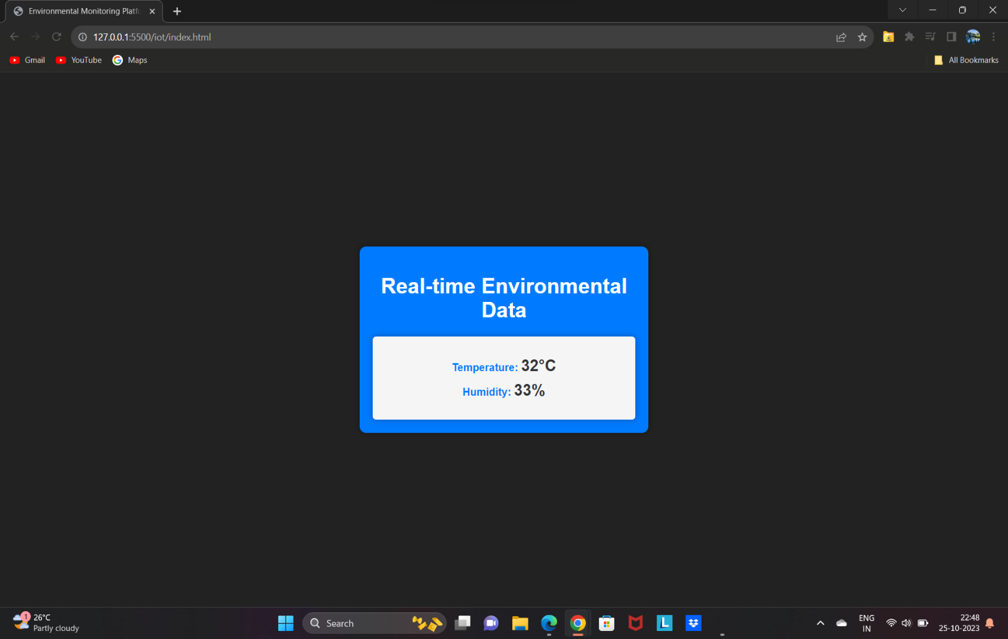

**5**.**Benefits for Park Visitors**:

A real-time environmental monitoring system in parks benefits visitors and promotes outdoor activities in the following key ways:

* **Safety and Comfort**: Visitors can stay safe and comfortable by accessing real-time data on temperature, humidity, and weather conditions, enabling them to make informed choices for outdoor activities and attire.
* **Recreation Planning**: Park visitors can make activity decisions based on current conditions, enhancing their experience and reducing the risk of weather-related issues.
* **Weather Alerts**: The system provides real-time weather alerts, helping visitors prepare for sudden weather changes and stay safe during their park visit.
* **Environmental Education**: Visitors can learn about the local environment and its ecosystems, fostering environmental awareness and education.
* **Customized Experiences**: Real-time data allows visitors to tailor their experiences, such as birdwatching, to optimal weather conditions.
* **Increased Park Usage**: The system encourages more visitors to the park, increasing park usage and revenue.
* **Year-Round Activities**: Visitors can better plan year-round activities based on season-specific data.
* **Community Engagement**: Real-time data fosters community engagement and encourages visitors to contribute to environmental conservation efforts.
* **Research Opportunities**: Collected data supports scientific research, benefiting local environmental understanding and preservation.
* **Emergency Response**: Real-time monitoring aids emergency response and decision-making in case of natural disasters or injuries.

**Conclusion**:

In summary, the "Environmental Monitoring in Parks" project has achieved its goals of improving park experiences and promoting outdoor activities. Through IoT device deployment and a user-friendly monitoring platform, it ensures visitor safety and informed decision-making. The project encourages year-round park usage, fosters environmental education, and offers real-time weather alerts. It served a valuable contribution to enhancing park experiences and environmental awareness.