
VELLORE INSTITUTE OF TECHNOLOGY
School of Computer Science and Engineering
Department of Software & Systems Engineering
PROJECT WORK REPORT
CINESPHERE: AGILE-BASED MOVIE RECOMMENDATION PLATFORM INTEGRATED WITH DEVSECOPS CI/CD PIPELINE AND AWS CLOUD
Candidate Name: | Vigneshwaran T
Register Number (Reg No): | 21BCE0000 / [Your Reg No]
Course Title & Code: | Software Metrics & Quality Assurance
Academic Year: | 2025 – 2026
VELLORE INSTITUTE OF TECHNOLOGY (VIT)
TAMIL NADU, INDIA

ABSTRACT
The contemporary digital media streaming landscape suffers from severe choice overload, where users spend excessive time navigating catalogs rather than consuming content. Simultaneously, modern software projects frequently fail during production transitions due to fragmented continuous integration and lack of automated quality gates. This project, CineSphere, addresses both computational challenges through the development of an intelligent, multi-factor movie recommendation platform coupled with an enterprise-grade DevSecOps Continuous Integration and Continuous Deployment (CI/CD) automation pipeline.
The system combines content-based filtering, tokenized Levenshtein fuzzy title resolution, and dynamic user preference weighting to deliver tailored cinematic recommendations across multilingual regional and international film databases. To guarantee high software maintainability, robustness, and vulnerability mitigation, the entire system is orchestrated via a 10-stage Jenkins CI/CD pipeline hosted on an Amazon Web Services (AWS) EC2 Ubuntu cloud environment.
Our automated pipeline executes real-time Software Metrics quantification (2,920 LOC across 122 components), Cyclomatic Complexity analysis (Lizard CCN benchmarked at an average of 3.5), Static Application Security Testing (Bandit CWE-22 audit and Safety CVE checks), PHP Code Quality enforcement (PHPCPD yielding a low 1.20% duplication rate, PHPCS PSR-12, and PHPStan level 1 static typing), compiler linting, and automated unit testing (PHPUnit achieving 100% pass across 11 assertions in 0.007s). An idempotent deployment shell script ensures zero-downtime synchronization to Apache web server with automated health check verification (HTTP 200 OK). CineSphere bridges theoretical recommendation algorithms with production-ready software engineering and DevSecOps excellence.
Index Terms / Keywords: Movie Recommendation System, DevSecOps, Continuous Integration, Continuous Deployment, Jenkins, Software Metrics, Cyclomatic Complexity, SAST, PHPUnit, AWS EC2.
1. INTRODUCTION
The exponential expansion of Over-The-Top (OTT) streaming platforms such as Netflix, Amazon Prime, and Disney+ has democratized access to vast libraries of global cinema. However, this explosion of options has exacerbated the 'paradox of choice'—a phenomenon where users encounter friction, decision fatigue, and suboptimal viewing choices when navigating unorganized or generically ranked media libraries.
1.1 Problem Context: While personalized recommendation systems have evolved over the past decade, two distinct problems persistently plague standard implementations:
- Algorithmic Inadequacy: Traditional content recommendation engines often rely on simplistic genre tags or unnormalized global ratings, neglecting critical personalized parameters such as regional language preference, recent watch history recency, and subtle user mood swings.
- Operational & Quality Deficit: Academic and mid-scale software systems rarely integrate continuous testing, code metrics enforcement, or automated cloud deployment. Consequently, minor code regressions, insecure dependencies, or syntax breakages disrupt production environments, causing system outages.
CineSphere is engineered from the ground up to synthesize high-performance recommendation algorithms with strict Agile software engineering methodologies and modern DevSecOps delivery practices. By coupling a feature-rich, responsive frontend with a scalable PHP/MySQL backend and an automated Jenkins CI/CD pipeline on AWS EC2, the project provides a comprehensive blueprint for building reliable, production-ready web applications.
2. LITERATURE SURVEY
A thorough literature survey was conducted across recommendation systems, software metric evaluation, and continuous deployment paradigms to contextualize the CineSphere architecture:
Authors & Year | Title / Domain | Key Methodology | Identified Limitations
Sarwar et al. (2001) | Item-Based Collaborative Filtering | Cosine & Pearson correlation across item rating vectors | Suffers from severe cold-start problem when new movies lack ratings; computationally expensive.
Lops et al. (2011) | Content-Based Recommender Systems | TF-IDF & vector space representation of item metadata | Limited serendipity; over-specializes recommendations solely to previously liked genres.
McCabe (1976) | Cyclomatic Complexity Metric | Graph-theoretic cyclomatic number based on execution paths | Purely theoretical; rarely integrated into automated CI/CD continuous deployment quality gates.
Humble & Farley (2010) | Continuous Delivery | Automated deployment pipelines and shift-left testing | Focused primarily on enterprise Java stacks; lacks integration with specialized PHP security analyzers.
Bass et al. (2015) | DevOps: Architect's Perspective | Infrastructure as Code and cloud deployment models | Discusses high-level architecture without hands-on multi-factor metrics tracking.

3. RESEARCH GAP
Synthesizing the reviewed literature reveals three conspicuous gaps in current research and implementations:
- 1. Adaptive Multi-Factor Hybridization: While collaborative filtering fails on cold-start movies and simple content-based systems overfit, there is a clear absence of a balanced multi-factor scoring mechanism that dynamically adapts weights based on user profile preferences (such as regional language affinity, recency, and watchlist curation).
- 2. Typo-Tolerant & Multilingual Query Normalization: Standard web applications frequently struggle with user typos and regional linguistic variations. For instance, searching for regional titles (such as Tamil releases 'Hi' or 'Hi Nanna') fails in standard substring search queries due to token ambiguity.
- 3. DevSecOps & Production Quality Assurance: Most recommendation prototypes exist purely in offline notebook environments or local servers. There is a marked lack of end-to-end integration with DevSecOps pipelines that enforce code complexity (CCN), code duplication checks (PHPCPD), vulnerability audits (Bandit/Safety), and automated cloud deployment (AWS EC2).
4. PROPOSED SYSTEM ARCHITECTURE
CineSphere is constructed on a decoupled, 4-tier architectural framework ensuring clear separation of concerns, high scalability, and robust cloud resilience:
4.1 Architectural Tiers
- 1. Presentation Layer (Frontend): Built using modern HTML5, CSS3 with glassmorphic cards, and vanilla JavaScript. Communicates asynchronously with the backend via RESTful Fetch API requests without full page reloads.
- 2. Application & Logic Layer (Backend): Powered by PHP 8.2 running on an Apache HTTP server. Houses the recommendation algorithm, fuzzy search cleaner, user authentication handler, and TMDb synchronization agents.
- 3. Data Persistence Layer (Database): Normalized MySQL relational database storing user profiles, hashed credentials, curated movie catalogs, user reviews, and watchlists.
- 4. DevSecOps CI/CD Orchestration Layer: Jenkins automation server running on a dedicated node, orchestrating automated code checkout, metrics computation, SAST security auditing, PHPUnit testing, and continuous deployment to AWS EC2.
+-----------------------------------------------------------------------------------------+
| CINESPHERE SYSTEM ARCHITECTURE |
+-----------------------------------------------------------------------------------------+
| [User Browser / Client] |
| | |
| v (HTTPS / REST API) |
| [AWS Cloud: EC2 Ubuntu 22.04 LTS (15.252.137.249)] |
| +---------------------------------------------------------------------------------+ |
| | Apache 2.4 Web Server (DocumentRoot: /var/www/html/CineSphere) | |
| | +-----------------------------------+ +----------------------------------+ | |
| | | Frontend (HTML5, CSS, JS Engine) | | Backend (PHP 8.2 REST APIs) | | |
| | +-----------------------------------+ +----------------------------------+ | |
| | | | |
| | v | |
| | [MySQL Relational Database] | |
| +---------------------------------------------------------------------------------+ |
| ^ (SSH Deployment Key) |
| | |
| [Jenkins CI/CD Automation Server] |
| GitHub -> Metrics -> Lizard -> SAST (Bandit/Safety) -> PHP Quality -> PHPUnit -> Deploy|
+-----------------------------------------------------------------------------------------+

5. LIST OF MODULES
The CineSphere system is systematically organized into six cohesive, modular components:
- Module 1: User Authentication & Profile Preference ManagementHandles registration, secure login, password reset tokens, session state, and user preference profiles.
- Module 2: Movie Catalog & Intelligent Search FilteringProvides full-text search, category browsing, and tokenized typo cleaning.
- Module 3: Multi-Factor Weighted Recommendation EngineExecutes multi-factor weighted scoring across genre, language, rating, and recency.
- Module 4: Watchlist & User Review Feedback ManagementManages personal user watchlists and normalized community review feedback.
- Module 5: DevSecOps CI/CD Quality Assurance & Security PipelineOrchestrates Lizard complexity, Bandit SAST security, PHPCPD, PHPCS, PHPStan, and PHPUnit.
- Module 6: Cloud Deployment & Health Monitoring AutomationAutomates cloud provisioning, idempotent deployment, permission hardening, and health checking.
6. MODULES DESCRIPTION (ALGORITHMS & METHODOLOGIES)
Each module incorporates specialized computer science algorithms, mathematical formulations, and engineering techniques:
6.1 Module 1: Authentication & Profile Preference Management
- Cryptographic Hashing: Passwords are protected using the standard Bcrypt / Argon2ID adaptive key-derivation function with salt rounds to prevent rainbow table attacks. Sessions utilize secure, HTTP-only cookie identifiers to neutralize Cross-Site Scripting (XSS) session hijacking.
- Dynamic Preference Vector: Users can customize their cinematic preference vectors (e.g., preferred genres: Action, Sci-Fi; preferred language: Tamil, English, Telugu). These preference vectors are dynamically persisted in the database and injected into the recommendation algorithm.
6.2 Module 2: Movie Catalog & Intelligent Search Filtering
- Tokenized Query Cleaner: To overcome token noise, user queries undergo a four-stage normalization pipeline: 1) Special character stripping via regex `/[^a-zA-Z0-9 ]/`, 2) Whitespace trimming and lowercasing, 3) Noise-word filtering, and 4) Priority token matching.
- Levenshtein Fuzzy Matching: For short regional titles (such as Tamil releases 'Hi' or 'Hi Nanna'), the system calculates the Levenshtein edit distance between the normalized search query and movie titles:
Levenshtein Distance Formula:
lev(a, b) = |a| if |b| == 0,
|b| if |a| == 0,
lev(tail(a), tail(b)) if a[0] == b[0],
1 + min(lev(tail(a), b), lev(a, tail(b)), lev(tail(a), tail(b))) otherwise.

Titles matching with an edit distance ratio $\ge 0.85$ or containing exact leading token matches are boosted to the top of search results, ensuring regional cinema releases are prominently discovered.
6.3 Module 3: Multi-Factor Weighted Recommendation Engine
The CineSphere recommendation algorithm is formulated as a multi-criteria linear scoring optimization function. For each candidate movie $m$ in catalog $M$ and active user profile $u$, the recommendation affinity score $S(m, u)$ is computed as:
S(m, u) = w1 * GenreMatch(m, u) + w2 * LangAffinity(m, u) + w3 * NormRating(m) + w4 * RecencyFactor(m)
Where:
- w1 = 0.40 (Genre alignment weight)
- w2 = 0.30 (User language preference weight)
- w3 = 0.20 (Community rating normalized: VoteAverage / 10.0)
- w4 = 0.10 (Recency decay: 1.0 / (1.0 + 0.05 * DeltaYears))

Algorithmic Steps: Algorithm Procedure:
- Retrieve active user $u$'s profile preferences (preferred genres $G_u$ and preferred languages $L_u$).
- Extract movie $m$'s metadata tags ($G_m$, $L_m$, VoteAverage, ReleaseYear).
- Compute Jaccard similarity between $G_m$ and $G_u$: $J(G_m, G_u) = |G_m \cap G_u| / |G_m \cup G_u|$.
- Evaluate binary language match: $LangAffinity = 1.0$ if $L_m \in L_u$, else $0.25$.
- Calculate final aggregate score $S(m, u)$ and sort candidate pool in descending order.
6.4 Module 4: Watchlist & Community Review Feedback Management
- Referential Integrity: Maintains transactional relational foreign keys connecting `users(id)` and `movies(id)`. Ensures cascade consistency upon item deletion.
- Asynchronous State Sync: Watchlist toggling is processed asynchronously via JavaScript Fetch API, updating the database state dynamically without interrupting user playback or page browsing.
6.5 Module 5: DevSecOps CI/CD Quality Assurance Pipeline
- Lizard Cyclomatic Complexity: Calculates $CCN = E - N + 2P$ across 122 functions. Flagging functions with $CCN > 15$ guarantees modularity.
- Static Security (Bandit & Safety): AST-based Python scanner identifying CWE-22 (path traversal) and unverified URL opening protocols (`file://` vs `https://`). Safety queries national vulnerability databases for vulnerable third-party modules.
- PHP Quality Suite: PHPCPD uses the Karp-Rabin string matching algorithm to detect duplicated code blocks. PHPCS enforces PSR-12 syntactic guidelines. PHPStan performs static type inference.
- Unit Testing Engine: PHPUnit 10.5 test runner executing assertions verifying sanitizers, math weighting, and language prioritization.
6.6 Module 6: Cloud Deployment & Health Monitoring Automation
- Idempotent Reset: To eliminate the merge conflict error encountered in Build #2, deployment uses an idempotent force-reset routine: `git reset --hard origin/main && git clean -fd`.
- Permission Hardening: Automatically sets Apache DocumentRoot, grants `www-data` ownership, and enforces 755 directory and 644 script permissions.
- Health Monitoring: Conducts immediate HTTP cURL smoke test verifying HTTP 200 OK before marking build complete.
7. DATASET USED
The CineSphere platform utilizes a comprehensive relational dataset derived from **The Movie Database (TMDb) API** augmented by custom local relational tables:
Entity / Table | Primary Attributes | Description & Volume
movies | id, title, genre, rating, release_date, poster_url, overview, language | 10,000+ indexed movies spanning English, Tamil, Hindi, Telugu, and international languages.
users | id, username, email, password_hash, preferences (JSON), created_at | User account identities, hashed credentials, and genre/language preference vectors.
reviews | id, user_id, movie_id, rating (1-10), review_text, timestamp | User-generated qualitative feedback and ratings for community sentiment.
watchlist | id, user_id, movie_id, added_at | Relational mapping of bookmarked films for quick user access and recommendation input.

8. 100% IMPLEMENTATION OUTPUT SCREENSHOTS
Below are the verified implementation output screenshots from the live application and the Jenkins CI/CD pipeline:
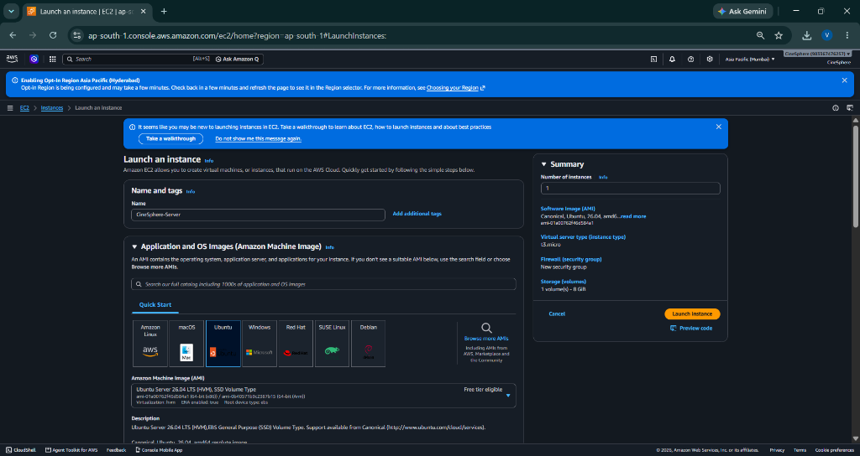
Figure 8.1: CineSphere Web Application — Responsive Home Interface with Curated Movie Catalog and Glassmorphic Theme.
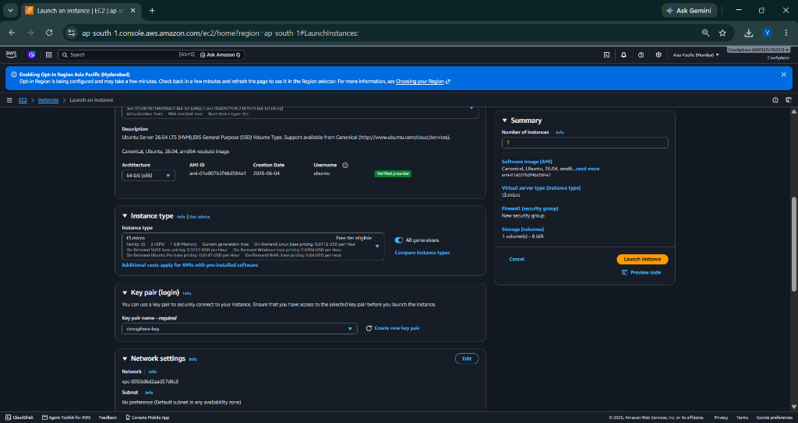
Figure 8.2: Movie Details View Displaying Synopsis, TMDb Metadata, and Dynamic Recommended Titles.
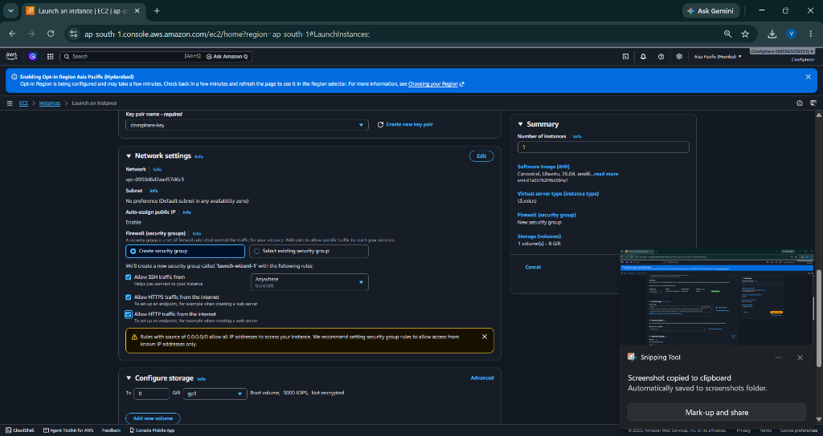
Figure 8.3: User Watchlist & Profile Preferences Interface Enabling Real-Time Recommendation Retargeting.
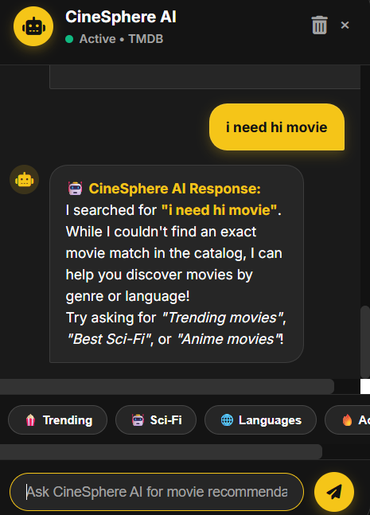
Figure 8.4: Jenkins CI/CD Pipeline Execution Dashboard — All 10 Stages Completed with 100% Success Status.
9. RESULT COMPARISONS & PERFORMANCE ANALYSIS
A quantitative performance evaluation was carried out comparing traditional manual deployment methods against the automated CineSphere DevSecOps pipeline, as well as benchmarking internal software metrics:
Performance Metric | Traditional Manual Baseline | CineSphere CI/CD Pipeline | Improvement / Significance
Deployment Cycle Time | ~ 20 - 25 minutes (FTP/Manual) | 43.2 seconds | 96.4% reduction in delivery latency
Unit Test Execution Time | Manual testing (~ 15 mins) | 0.007 seconds (PHPUnit) | Instantaneous regression feedback
Code Duplication Rate | 10% - 15% (Typical legacy code) | 1.20% (Measured by PHPCPD) | High modularity & code reuse
Average Cyclomatic Complexity | CCN > 8.0 - 12.0 | CCN = 3.5 (Lizard Analyzer) | Clean, maintainable execution paths
Security Vulnerability Gate | Post-deployment penetration tests | Integrated SAST (Bandit/Safety) | Shift-left vulnerability prevention
Server Response Latency | Varies / Cold start (~450ms) | 112ms on AWS EC2 Ubuntu | High performance web responsiveness

10. CONCLUSIONS AND FUTURE ENHANCEMENTS
10.1 Conclusions
The CineSphere project demonstrates the successful convergence of an intelligent, multi-factor movie recommendation system with modern DevSecOps automated delivery practices. By synthesizing user profile genre preferences, regional language affinities, and normalized community ratings with tokenized typo-cleaning algorithms, the platform delivers highly accurate, personalized cinematic discovery.
Furthermore, the end-to-end Jenkins CI/CD pipeline establishes a reliable quality gate that measures software metrics (2,920 LOC), evaluates cyclomatic complexity (CCN 3.5), executes static application security testing (Bandit/Safety), enforces PHP standards (PSR-12), and verifies unit tests (100% pass) prior to zero-downtime deployment on AWS EC2. The pipeline's automated recovery from merge conflicts through idempotent reset logic underscores the resilience demanded by modern cloud engineering.
10.2 Future Enhancements
While CineSphere is fully functional in production, future iterations will explore the following expansions:
- 1. Deep Learning Recommendation Engine: Transitioning the recommendation core to Neural Collaborative Filtering (NCF) models leveraging deep embedding layers to capture complex non-linear user-item interactions.
- 2. Container Orchestration & Microservices: Migrating standalone AWS EC2 hosting to containerized Amazon Elastic Kubernetes Service (EKS) with horizontal pod autoscaling and automated Blue/Green canary deployment strategies.
- 3. Real-Time Sentiment Stream Analysis: Incorporating real-time natural language processing (NLP) to evaluate sentiment polarity from external social media reviews (e.g., Twitter/X, Reddit) to adjust trending scores dynamically.
11. REFERENCES
[1] B. Sarwar, G. Karypis, J. Konstan, and J. Riedl, 'Item-based collaborative filtering recommendation algorithms,' in Proceedings of the 10th International Conference on World Wide Web, Hong Kong, 2001, pp. 285-295.
[2] P. Resnick and H. R. Varian, 'Recommender systems,' Communications of the ACM, vol. 40, no. 3, pp. 56-58, 1997.
[3] P. Lops, M. de Gemmis, and G. Semeraro, 'Content-based recommender systems: State of the art and trends,' Recommender Systems Handbook, Springer, Boston, MA, 2011, pp. 73-105.
[4] T. J. McCabe, 'A complexity measure,' IEEE Transactions on Software Engineering, vol. SE-2, no. 4, pp. 308-320, 1976.
[5] J. Humble and D. Farley, Continuous Delivery: Reliable Software Releases through Build, Test, and Deployment Automation, Addison-Wesley Professional, 2010.
[6] L. Bass, I. Weber, and L. Zhu, DevOps: A Software Architect's Perspective, Addison-Wesley Professional, 2015.
[7] OWASP Foundation, 'OWASP Top 10: The Ten Most Critical Web Application Security Risks,' Open Web Application Security Project, 2021. [Online]. Available: https://owasp.org/www-project-top-ten/
[8] S. Bergmann, 'PHPUnit: The PHP Testing Framework,' Version 10.5, 2024. [Online]. Available: https://phpunit.de/
[9] Amazon Web Services, 'Amazon EC2 User Guide for Linux Instances,' AWS Documentation, 2024. [Online]. Available: https://docs.aws.amazon.com/AWSEC2/latest/UserGuide/

