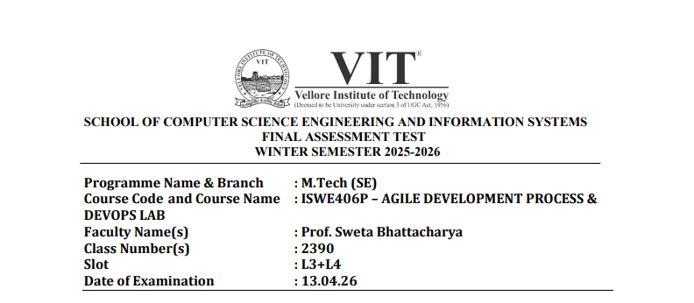
Name: VIGNESHWARAN T
Reg no: 23MIS0587

QUESTION:
Design and implement a Voting Eligibility System program that determines whether a person is eligible to vote based on specific criteria. The program should define an appropriate class to store voter details such as name, age, citizenship, voter ID, and ID validity status. It must accept input for one or more voters and evaluate eligibility using the conditions that the voter must be at least 18 years old, must be a citizen of the country (e.g., Indian citizen), and must possess a valid voter ID. The program should display whether each voter is eligible or not, and in cases of ineligibility, it should clearly indicate the reason, such as being underage, not a citizen, or having an invalid ID

1. Create a GitHub repository for a Maven-based application following the standard Maven directory structure [10]

GitHub repository link: https://github.com/vigneshwaran21-vicky/Agile_FAT_Mavin.git

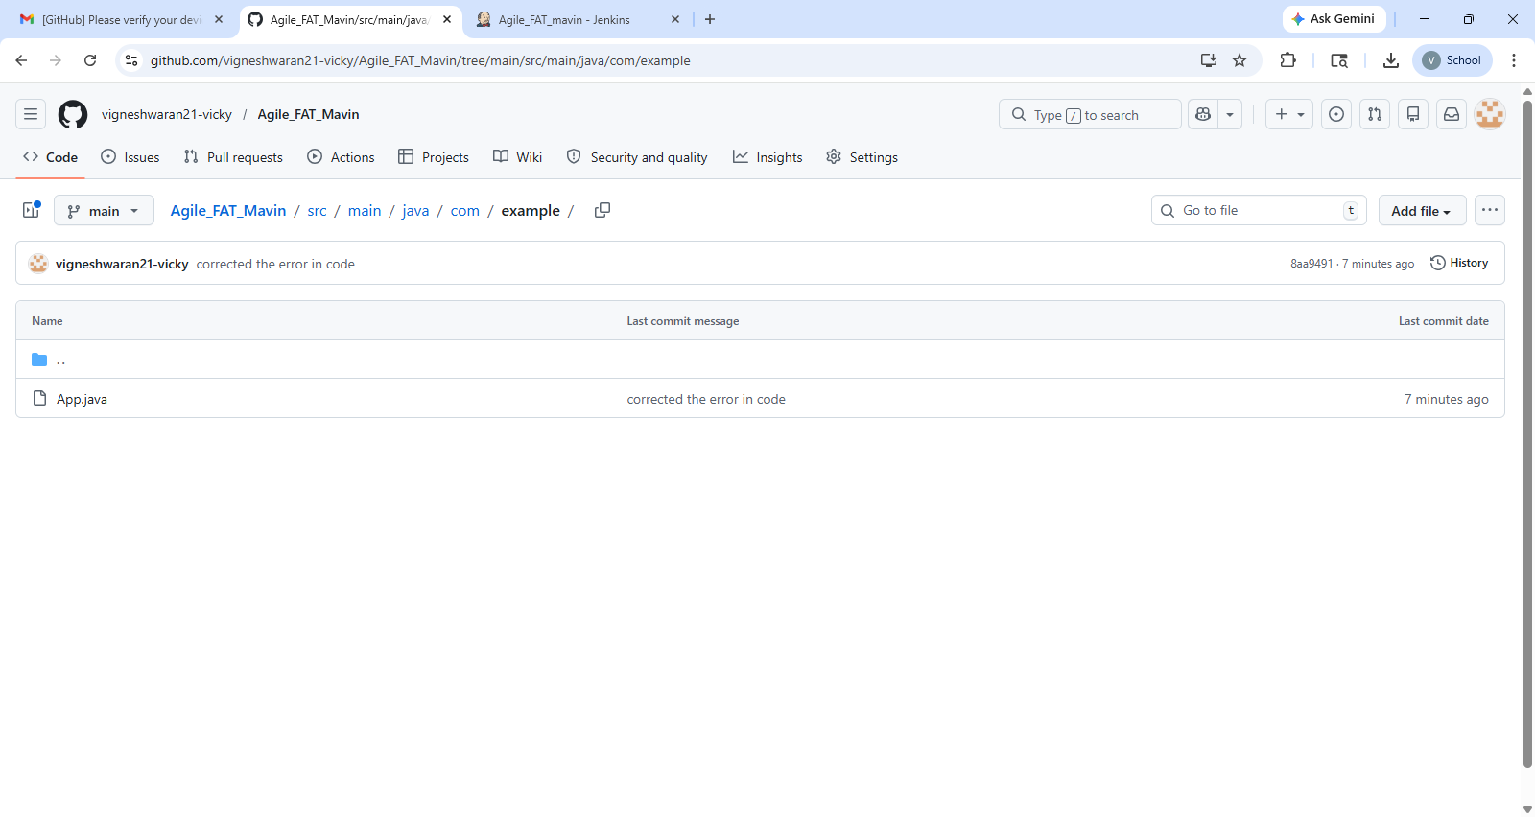

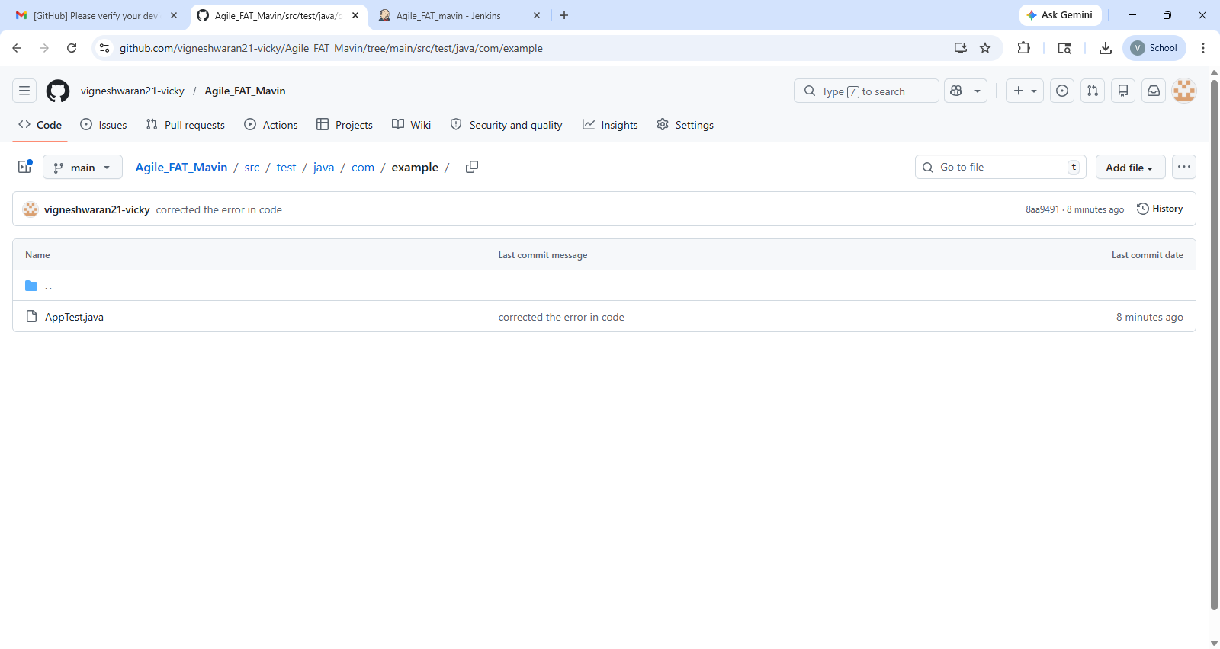

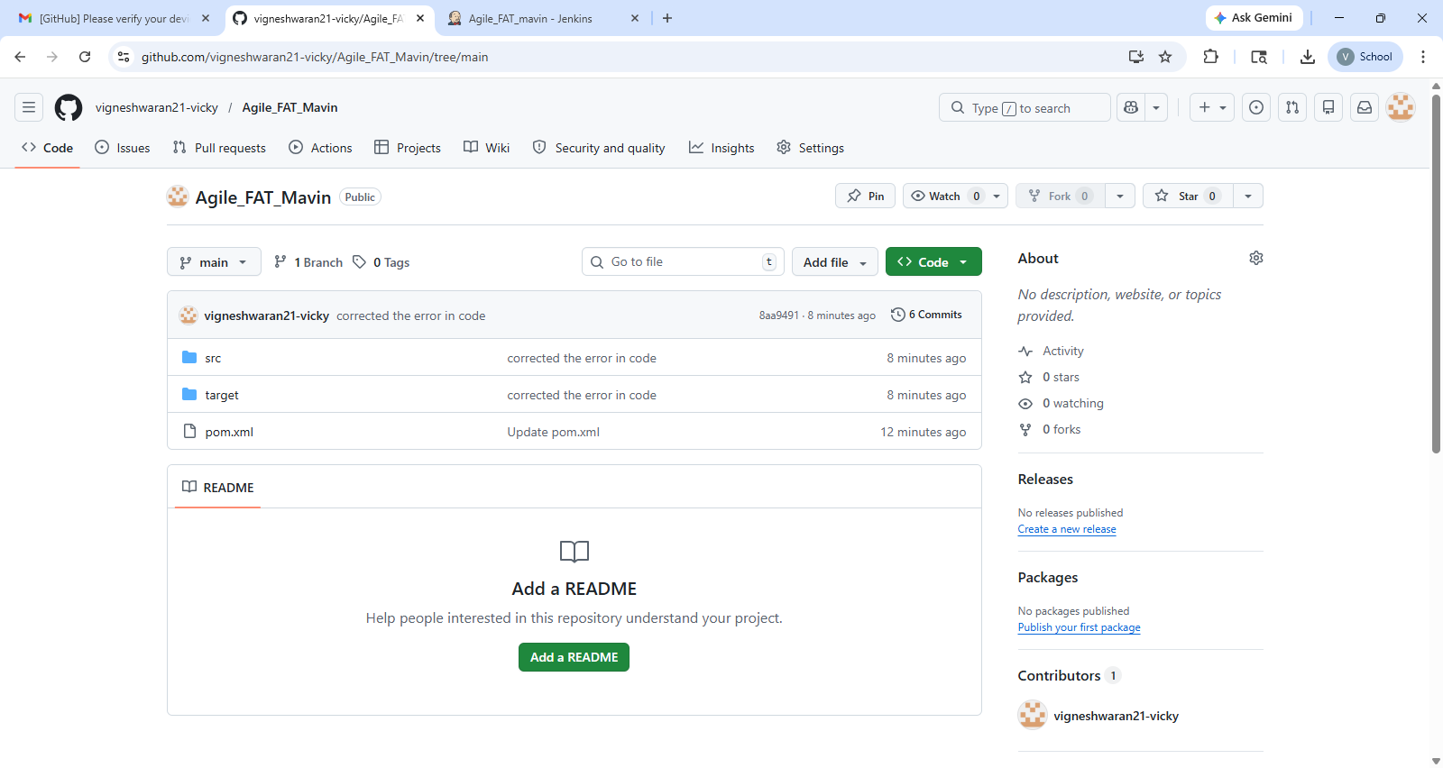

Codes:-

src/main/java/com/example/App.java

package com.example;
import java.util.Scanner;
public class App {
public static String getEligibilityStatus(int age, boolean isCitizen, boolean hasValidID) {
if (age < 18) return "Ineligible (Reason: Underage)";
if (!isCitizen) return "Ineligible (Reason: Not a citizen)";
if (!hasValidID) return "Ineligible (Reason: Invalid ID)";
return "Eligible";
}
public static void main(String[] args) {
Scanner sc = new Scanner(System.in);
System.out.println("--- Voting Eligibility System ---");
System.out.print("Enter Name: ");
String name = sc.nextLine();
System.out.print("Enter Age: ");
int age = sc.nextInt();
System.out.print("Is Citizen (true/false): ");
boolean citizen = sc.nextBoolean();
System.out.print("Is ID Valid (true/false): ");
boolean validID = sc.nextBoolean();
String status = getEligibilityStatus(age, citizen, validID);
System.out.println("\nVoter: " + name);
System.out.println("Status: " + status);
sc.close();
}
}

src/test/java/com/example/AppTest.java

package com.example;
import static org.junit.jupiter.api.Assertions.assertEquals;
import org.junit.jupiter.api.Test;
public class AppTest {
@Test
public void testEligibleVoter() {
assertEquals("Eligible", App.getEligibilityStatus(25, true, true));
}
@Test
public void testUnderageVoter() {
assertEquals("Ineligible (Reason: Underage)", App.getEligibilityStatus(17, true, true));
}
@Test
public void testNonCitizen() {
assertEquals("Ineligible (Reason: Not a citizen)", App.getEligibilityStatus(30, false, true));
}
@Test
public void testInvalidID() {
assertEquals("Ineligible (Reason: Invalid ID)", App.getEligibilityStatus(20, true, false));
}
}

pom.xml

<project xmlns="http://maven.apache.org/POM/4.0.0"
xmlns:xsi="http://www.w3.org/2001/XMLSchema-instance"
xsi:schemaLocation="http://maven.apache.org/POM/4.0.0
http://maven.apache.org/xsd/maven-4.0.0.xsd">

<modelVersion>4.0.0</modelVersion>

<groupId>com.vote</groupId>
<artifactId>voting-app</artifactId>
<version>1.0-SNAPSHOT</version>

<dependencies>
<dependency>
<groupId>org.junit.jupiter</groupId>
<artifactId>junit-jupiter</artifactId>
<version>5.10.0</version>
<scope>test</scope>
</dependency>
</dependencies>

<build>
<plugins>
<plugin>
<groupId>org.apache.maven.plugins</groupId>
<artifactId>maven-surefire-plugin</artifactId>
<version>3.0.0</version>
</plugin>
</plugins>
</build>

</project>

2. Clone this repository into VS Code, make the necessary code modifications, and commit the changes back to the Git repository [10]

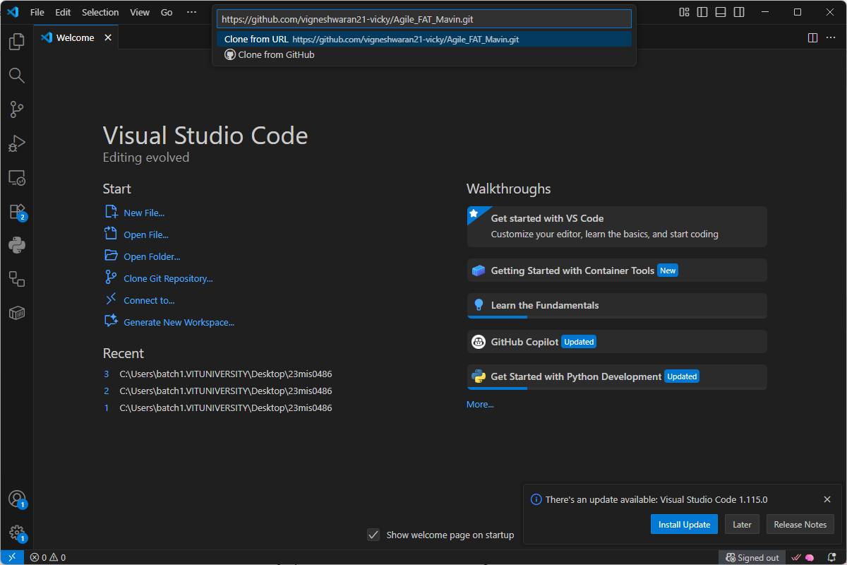

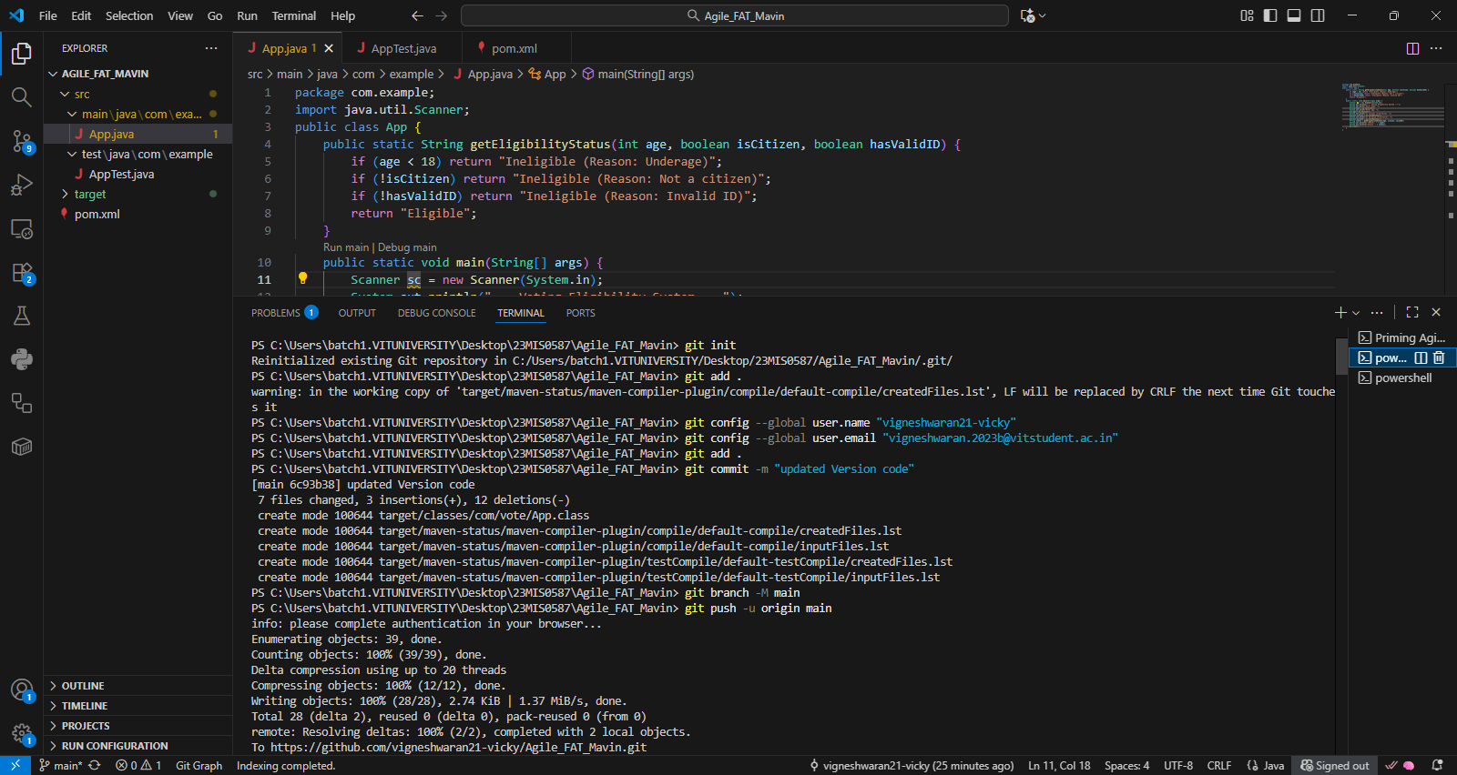

3. Build and verify the application within VS Code to ensure it is compatible with Jenkins integration [10]

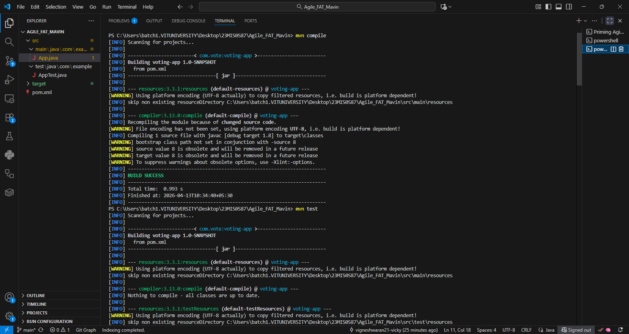

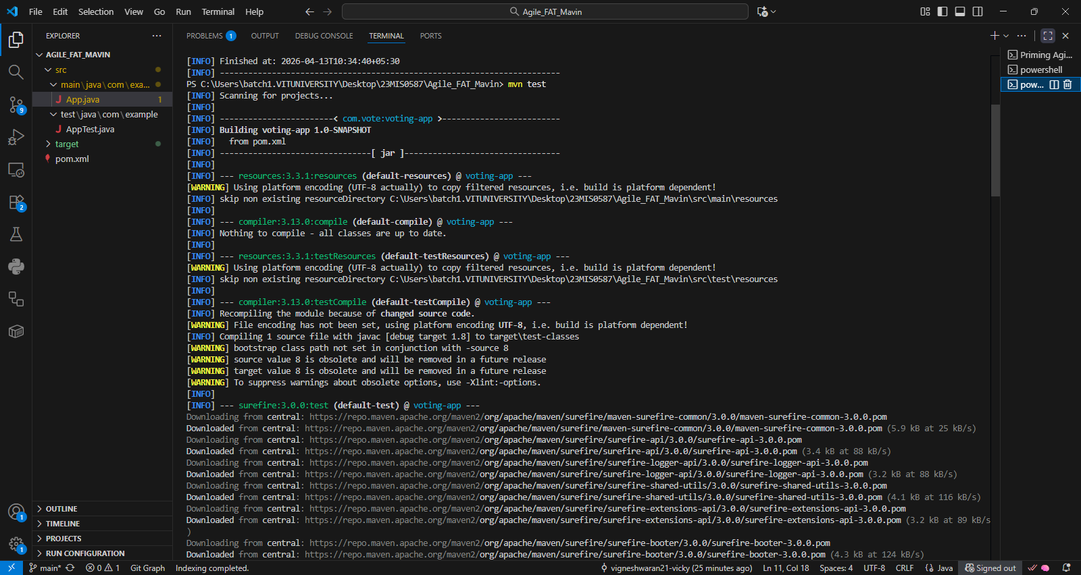

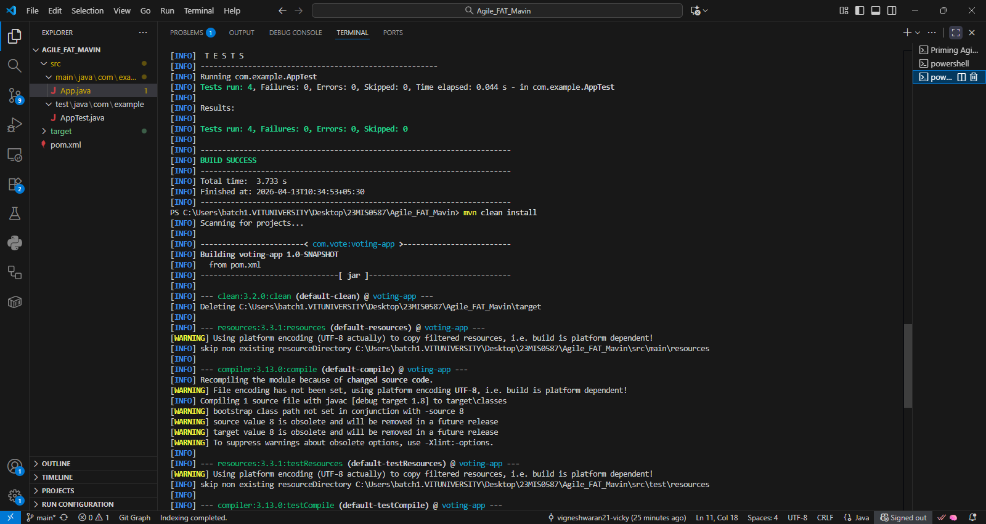

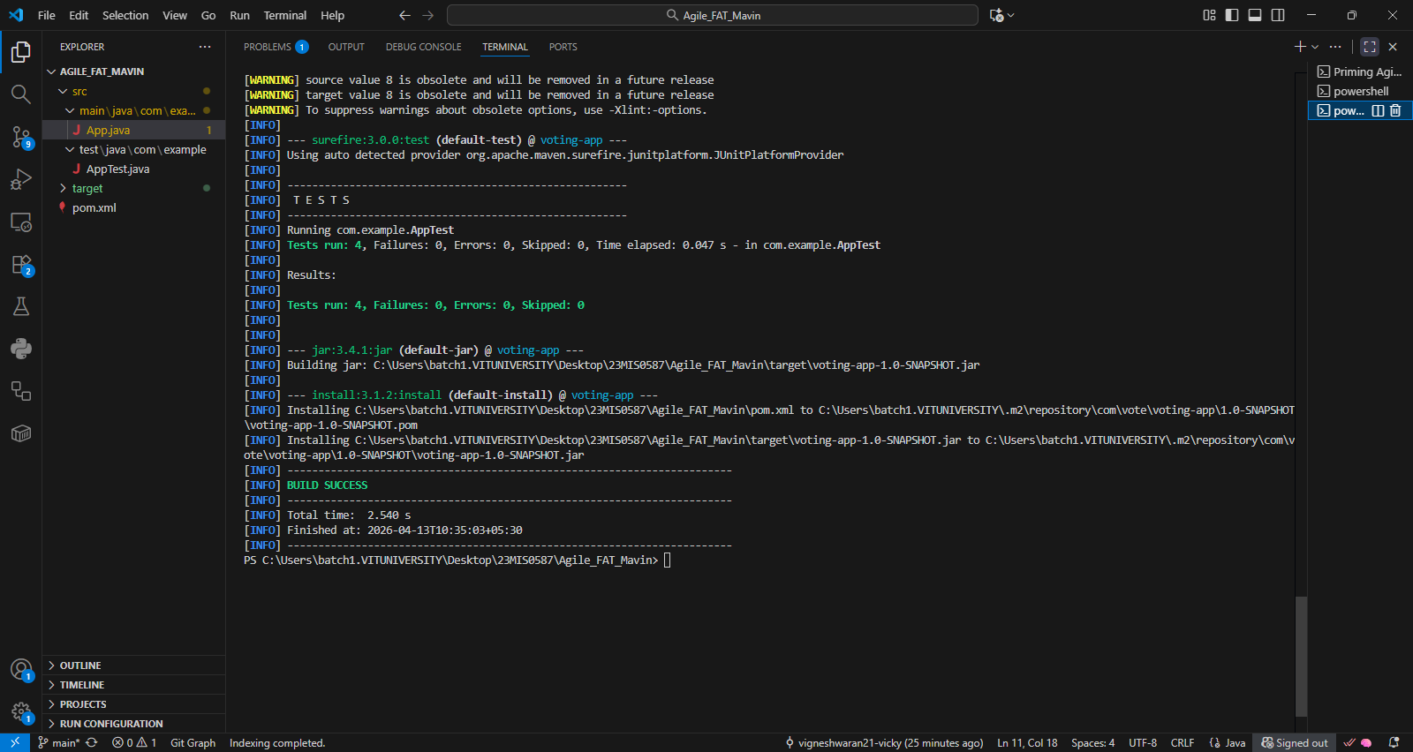

4. Finally, set up a Pipeline project in Jenkins and execute the CI/CD process by writing and running the required pipeline script [20]

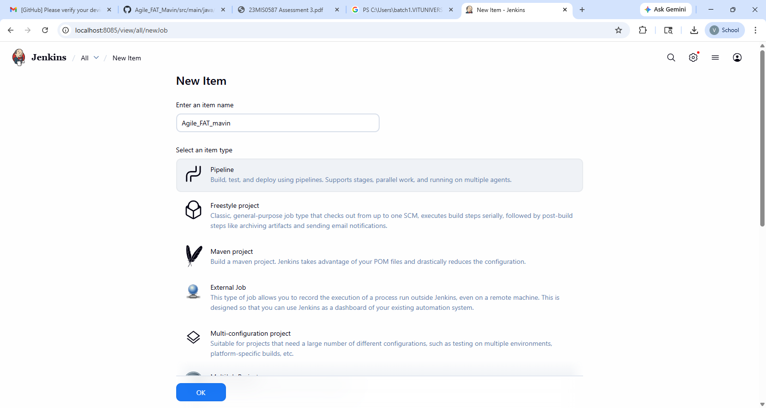

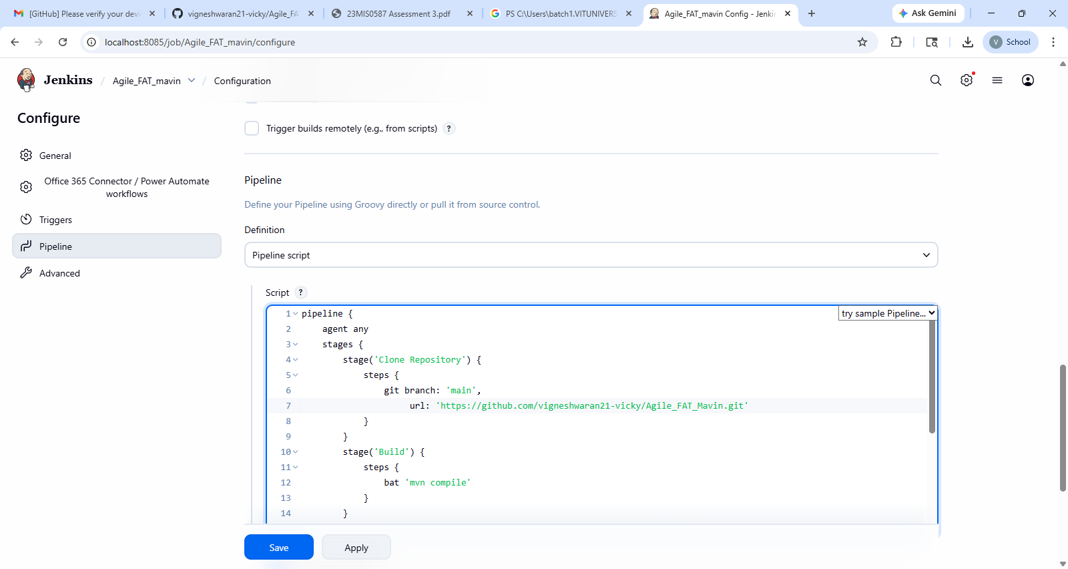

Pipeline Script:-

pipeline {
agent any
stages {
stage('Clone Repository') {
steps {
git branch: 'main',
url: 'https://github.com/vigneshwaran21-vicky/Agile_FAT_Mavin.git'
}
}
stage('Build') {
steps {
bat 'mvn compile'
}
}
stage('Test') {
steps {
bat 'mvn test'
}
}
stage('Package') {
steps {
bat 'mvn clean install'
}
}
}
}

