Software Requirements Specification (SRS)
LocalRide: Local Ride-Sharing Application
Field | Detail
Version | 1.0 (Draft)
Standard followed | IEEE 830 / ISO/IEC/IEEE 29148 structure
Note | “LocalRide” is a placeholder name. Rename it to match your project.

Contents
- Introduction
- Overall Description
- Specific Requirements
- System Models (UML)
- Other Requirements and Appendices

1. Introduction

1.1 Purpose
This document specifies the functional and non-functional requirements of LocalRide, a mobile and web application that connects riders with nearby drivers for affordable, on-demand or scheduled rides within a city or local region, including optional seat-sharing between riders travelling in the same direction.
It is intended for developers, testers, project managers, instructors/clients and any stakeholder who needs to understand what the system must do.

1.2 Scope
LocalRide will allow: - Riders to request, schedule, track, pay for and rate rides. - Drivers to register, get verified, accept rides, navigate and receive earnings. - Administrators to manage users, verify drivers, monitor rides, handle disputes and view reports.
In scope: registration/authentication, ride request and matching, live tracking, fare calculation, payments, ratings, notifications, ride history, admin panel, SOS/safety features.
Out of scope (v1.0): inter-city travel, food/parcel delivery, vehicle rental, in-app insurance purchase.

1.3 Definitions, Acronyms and Abbreviations
Term | Meaning
SRS | Software Requirements Specification
Rider | A user who requests a ride
Driver | A verified user who provides rides
Ride Pool | A shared ride where multiple riders split one vehicle
ETA | Estimated Time of Arrival
OTP | One-Time Password
GPS | Global Positioning System
API | Application Programming Interface
SOS | Emergency alert feature

1.4 References
- IEEE Std 830-1998, Recommended Practice for Software Requirements Specifications
- UML 2.5 Specification (OMG)
- Google Maps Platform / OpenStreetMap documentation (for mapping)
- Local transport and data-protection regulations (to be confirmed for the target region)

1.5 Document Overview
Section 2 describes the product in general terms. Section 3 lists specific requirements. Section 4 contains UML models. Section 5 covers other requirements and appendices.

2. Overall Description

2.1 Product Perspective
LocalRide is a new, self-contained system using a client-server architecture. It integrates with external services: a maps/geolocation provider, a payment gateway, an SMS/email/push notification service and an identity/document verification service.

2.2 Product Functions (Summary)
- User registration, login and profile management
- Driver onboarding and document verification
- Ride request (immediate or scheduled) and fare estimation
- Driver-rider matching based on proximity and availability
- Real-time tracking of the vehicle and trip
- Ride sharing (pooling) with fare splitting
- Cashless and cash payments, wallet, receipts
- Ratings and reviews
- Notifications (push, SMS, email)
- Safety features (SOS, trip sharing, emergency contacts)
- Admin dashboard, dispute handling and reports

2.3 User Classes and Characteristics
User class | Description | Technical skill
Rider | General public, smartphone users | Low to medium
Driver | Licensed drivers with a registered vehicle | Low to medium
Administrator | Company staff managing operations | Medium
Support Agent | Handles complaints and refunds | Medium

2.4 Operating Environment
- Mobile: Android 9+ and iOS 14+
- Web (admin/rider): latest two versions of Chrome, Firefox, Edge, Safari
- Server: cloud-hosted Linux, relational database (e.g., PostgreSQL), REST API
- Network: 3G/4G/5G or Wi-Fi with GPS-enabled devices

2.5 Design and Implementation Constraints
- Must comply with local transport-authority rules and data-protection law (e.g., GDPR-style consent).
- Payment handling must follow PCI-DSS by delegating card data to the payment gateway.
- Third-party map and payment APIs impose usage limits and costs.

2.6 Assumptions and Dependencies
- Users have smartphones with GPS and an internet connection.
- Drivers hold valid licences and vehicle registrations.
- Third-party services (maps, payments, SMS) are available and reliable.

3. Specific Requirements

3.1 Functional Requirements
FR-1 Account Management
ID | Requirement | Priority
FR-1.1 | The system shall allow users to register using phone number and/or email with OTP verification. | High
FR-1.2 | The system shall allow login, logout and password/OTP recovery. | High
FR-1.3 | The system shall allow users to edit profile details (name, photo, emergency contacts). | Medium
FR-1.4 | The system shall allow users to select role: Rider or Driver. | High

FR-2 Driver Onboarding
ID | Requirement | Priority
FR-2.1 | Drivers shall upload driving licence, vehicle registration, insurance and ID photo. | High
FR-2.2 | Admin shall approve or reject driver applications with a reason. | High
FR-2.3 | Drivers shall toggle availability (online/offline). | High
FR-2.4 | The system shall record vehicle details (type, model, plate number, seat capacity). | High

FR-3 Ride Request and Matching
ID | Requirement | Priority
FR-3.1 | Riders shall enter pickup and drop-off locations via map pin or address search. | High
FR-3.2 | The system shall display fare estimate, distance and ETA before confirmation. | High
FR-3.3 | Riders shall choose ride type: Solo, Shared (Pool) or Scheduled. | High
FR-3.4 | The system shall find available drivers within a configurable radius and send them the request. | High
FR-3.5 | Drivers shall accept or decline within a time limit (e.g., 30 s); on timeout the request goes to the next driver. | High
FR-3.6 | Riders shall be able to cancel a ride; a cancellation fee applies after driver acceptance beyond a grace period. | Medium
FR-3.7 | Riders shall be able to schedule a ride up to a set number of days ahead. | Medium

FR-4 Trip Execution and Tracking
ID | Requirement | Priority
FR-4.1 | The system shall show the driver’s live location and ETA to the rider. | High
FR-4.2 | The system shall verify the rider at pickup using a ride OTP or PIN. | High
FR-4.3 | The system shall provide turn-by-turn navigation for the driver. | High
FR-4.4 | The system shall record the actual route, distance and duration. | High
FR-4.5 | Riders shall share live trip status with trusted contacts. | Medium

FR-5 Ride Sharing (Pooling)
ID | Requirement | Priority
FR-5.1 | The system shall group riders with compatible routes and time windows, up to vehicle capacity. | Medium
FR-5.2 | The system shall split the fare fairly among pooled riders based on distance shared. | Medium
FR-5.3 | Riders shall see co-rider first names and ratings (no contact details). | Low

FR-6 Payments
ID | Requirement | Priority
FR-6.1 | The system shall support card, mobile wallet, in-app wallet and cash payments. | High
FR-6.2 | The system shall compute the final fare from base fare, distance, time, surge factor, tolls and taxes. | High
FR-6.3 | The system shall generate a receipt by email/in-app after every trip. | High
FR-6.4 | The system shall calculate driver earnings and platform commission and support payouts. | High
FR-6.5 | The system shall support promo codes and refunds. | Medium

FR-7 Ratings and Feedback
ID | Requirement | Priority
FR-7.1 | Riders and drivers shall rate each other (1-5 stars) with optional comments after a trip. | High
FR-7.2 | The system shall flag drivers or riders whose average rating falls below a threshold. | Medium

FR-8 Notifications
ID | Requirement | Priority
FR-8.1 | The system shall send push/SMS notifications for request status, driver arrival, trip start/end and payment. | High

FR-9 Safety
ID | Requirement | Priority
FR-9.1 | The system shall provide an SOS button that alerts emergency contacts and support with live location. | High
FR-9.2 | The system shall detect major route deviations and prompt the rider. | Medium
FR-9.3 | The system shall mask phone numbers using in-app calling/chat. | Medium

FR-10 Ride History
ID | Requirement | Priority
FR-10.1 | Users shall view past and upcoming rides with details, fare and receipts. | High

FR-11 Administration
ID | Requirement | Priority
FR-11.1 | Admin shall manage users, drivers, vehicles and ride records. | High
FR-11.2 | Admin shall configure fares, surge rules, commission and service areas. | High
FR-11.3 | Admin shall view dashboards and reports (rides, revenue, active users, cancellations). | Medium
FR-11.4 | Support agents shall handle complaints, disputes and refunds. | Medium

3.2 External Interface Requirements
User interfaces
- Rider app: home map, destination search, ride options, tracking screen, payment, history, profile.
- Driver app: online toggle, incoming request card, navigation, earnings, documents.
- Admin web portal: dashboard, tables, filters, configuration forms.
- Interfaces shall be responsive, follow platform design guidelines and support at least English plus one local language.
Hardware interfaces
- GPS receiver, network connectivity, camera (document upload/photo).
Software interfaces
Service | Purpose
Maps and Geocoding API | Routing, ETA, address search, distance
Payment Gateway API | Card/wallet processing, refunds, payouts
SMS/Email/Push Service | OTP and notifications
Identity Verification API (optional) | Document validation

Communication interfaces
- HTTPS (TLS 1.2+) for REST APIs, WebSocket or MQTT for real-time location updates.

3.3 Non-Functional Requirements
ID | Category | Requirement
NFR-1 | Performance | Ride request-to-driver-notification latency shall be under 3 seconds for 95% of requests.
NFR-2 | Performance | Live location updates shall refresh every 3-5 seconds.
NFR-3 | Scalability | The system shall support at least 10,000 concurrent users and scale horizontally.
NFR-4 | Availability | Uptime shall be at least 99.5% monthly (excluding planned maintenance).
NFR-5 | Reliability | No ride or payment record shall be lost; daily backups with point-in-time recovery.
NFR-6 | Security | Passwords hashed (bcrypt/argon2); all traffic encrypted; role-based access control; JWT/OAuth2 sessions.
NFR-7 | Privacy | Location and personal data collected only with consent; retention limits enforced; users can request data deletion.
NFR-8 | Usability | A new rider shall be able to book a ride within 3 minutes of first launch without training.
NFR-9 | Compatibility | Support Android 9+, iOS 14+, and modern browsers.
NFR-10 | Maintainability | Modular architecture, documented APIs, at least 70% unit-test coverage on core modules.
NFR-11 | Portability | Deployable on any major cloud provider using containers.
NFR-12 | Accessibility | Comply with WCAG 2.1 AA where applicable.
NFR-13 | Legal | Comply with local transport, tax and data-protection regulations.

3.4 Business Rules
- BR-1: A driver may hold only one active trip at a time (except pooled rides within seat capacity).
- BR-2: A driver with expired documents cannot go online.
- BR-3: The platform commission is a configurable percentage of each fare.
- BR-4: A rider with an unpaid balance cannot request a new ride.
- BR-5: Cancellation fees apply only after the grace period defined by the admin.

4. System Models (UML)

4.1 Use Case Diagram
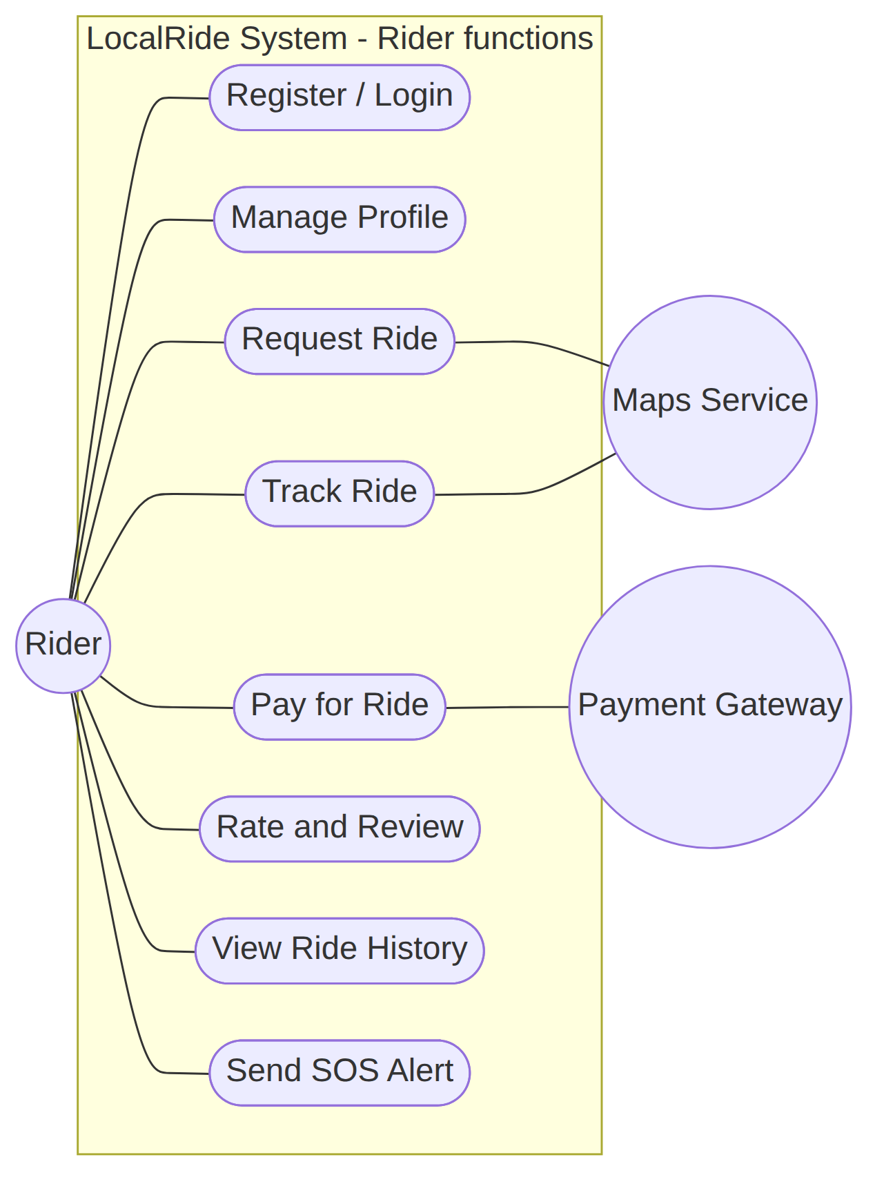
Figure 1a: Use case diagram - Rider
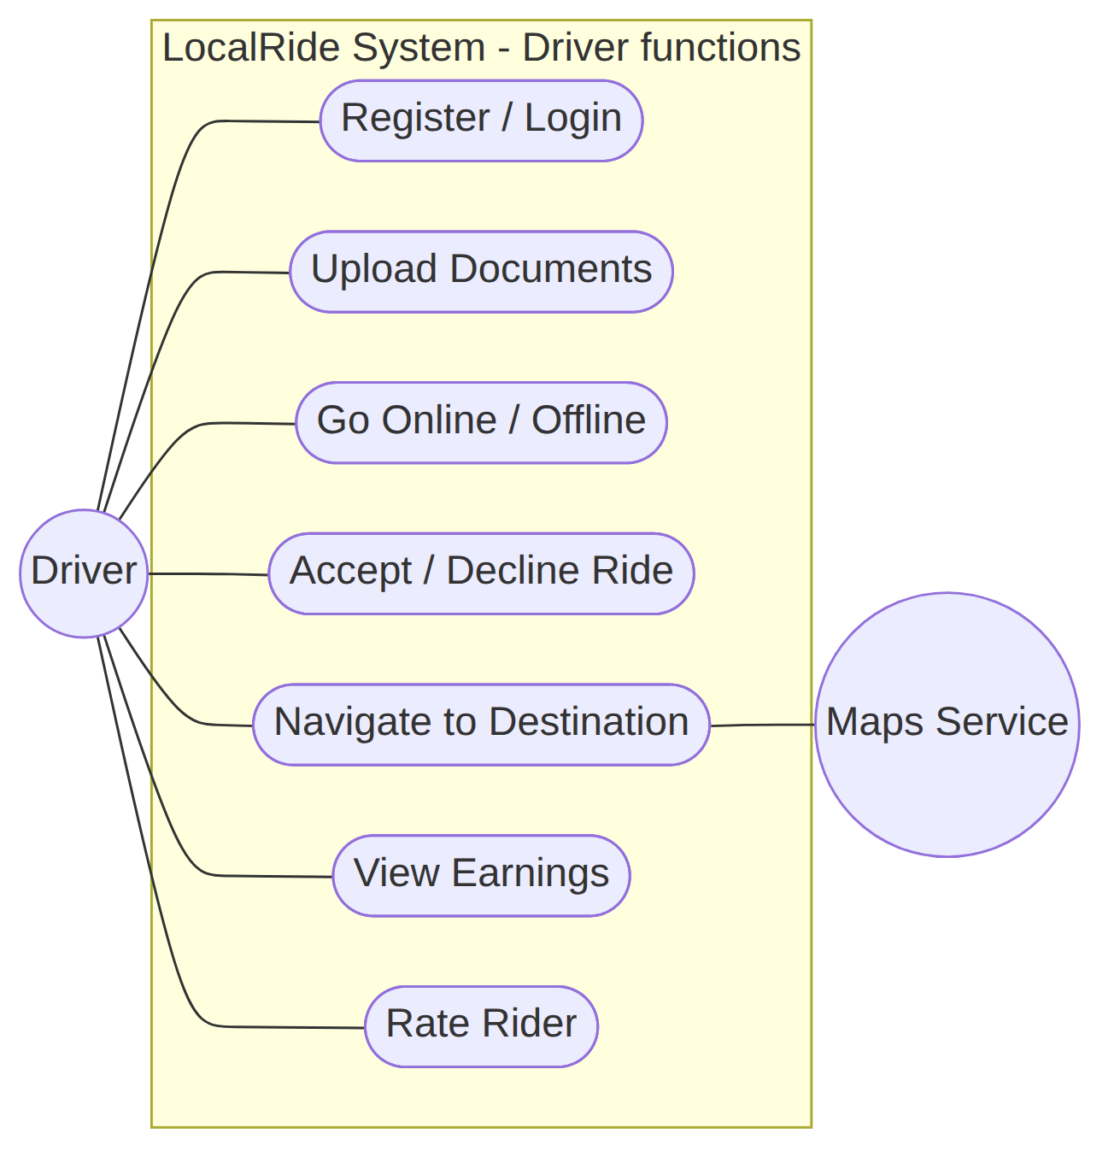
Figure 1b: Use case diagram - Driver
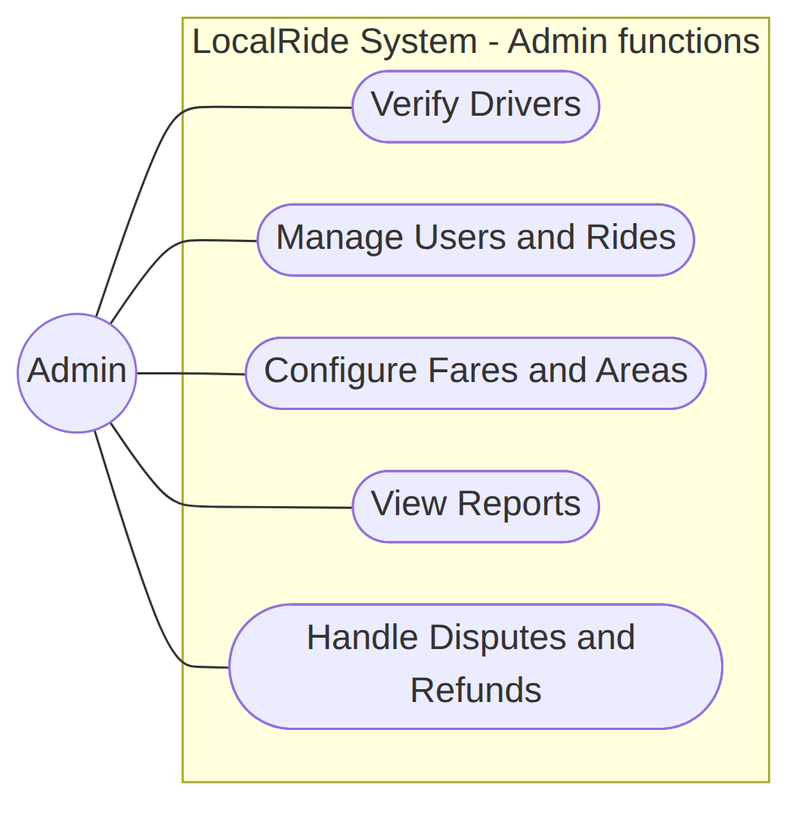
Figure 1c: Use case diagram - Admin

4.2 Class Diagram
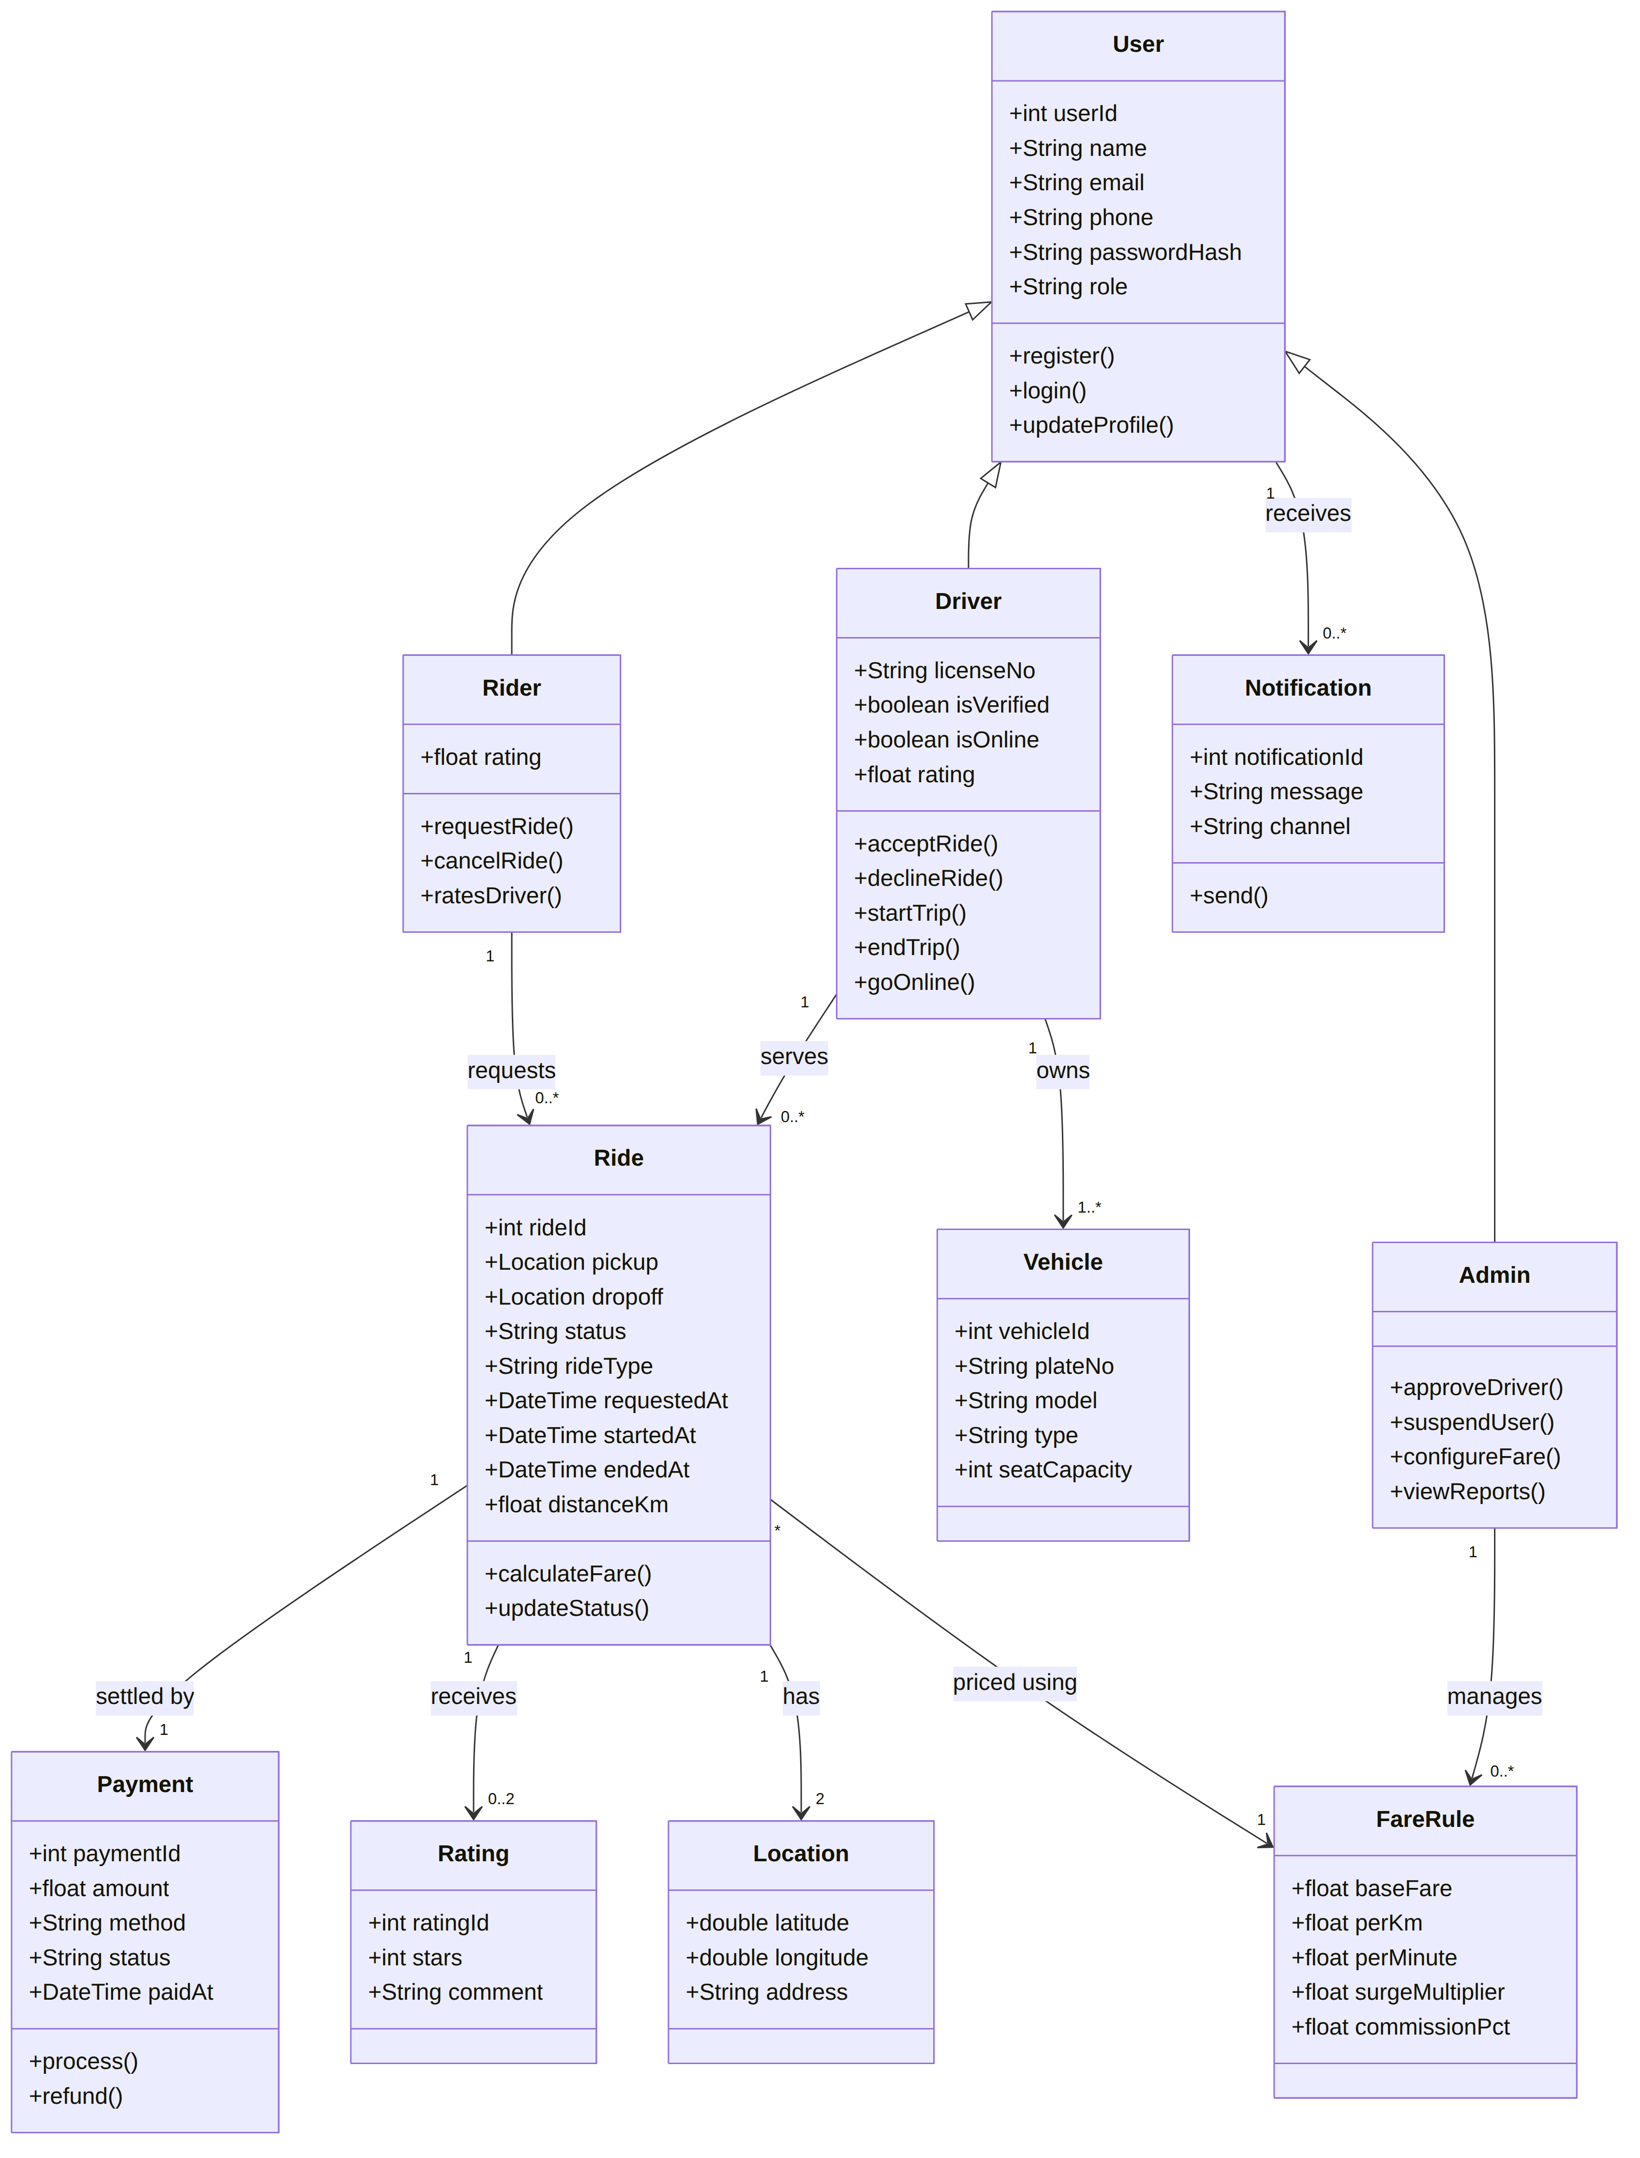
Figure 2: Class diagram

4.3 Sequence Diagram: Request and Complete a Ride
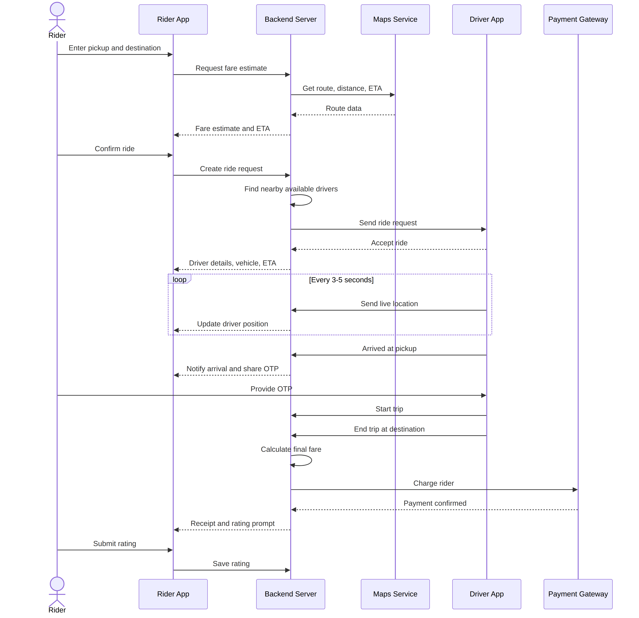
Figure 3: Sequence diagram - request and complete a ride

4.4 Activity Diagram: Ride Booking Flow
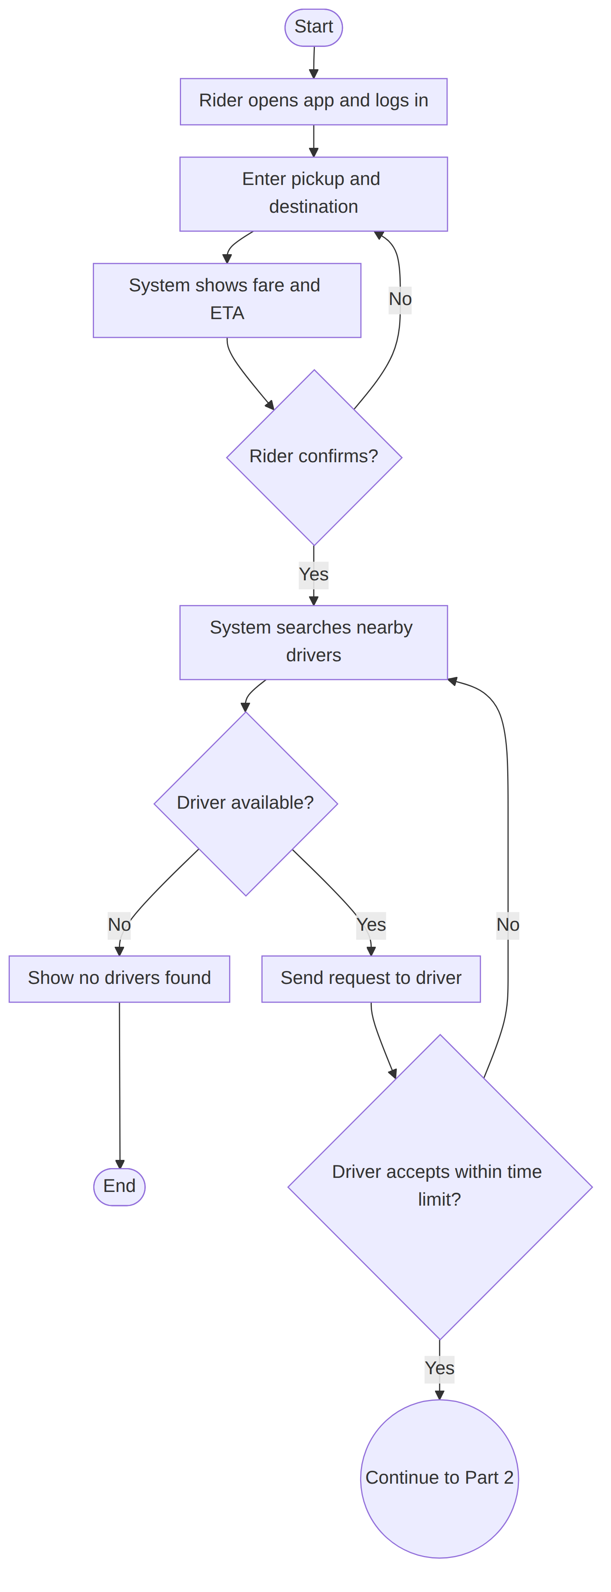
Figure 4a: Activity diagram - request and matching (Part 1)

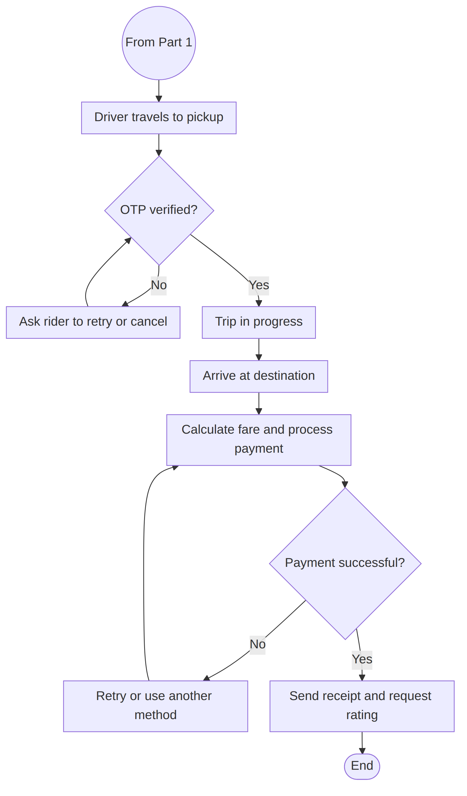
Figure 4b: Activity diagram - trip and payment (Part 2)

4.5 State Diagram: Ride Lifecycle
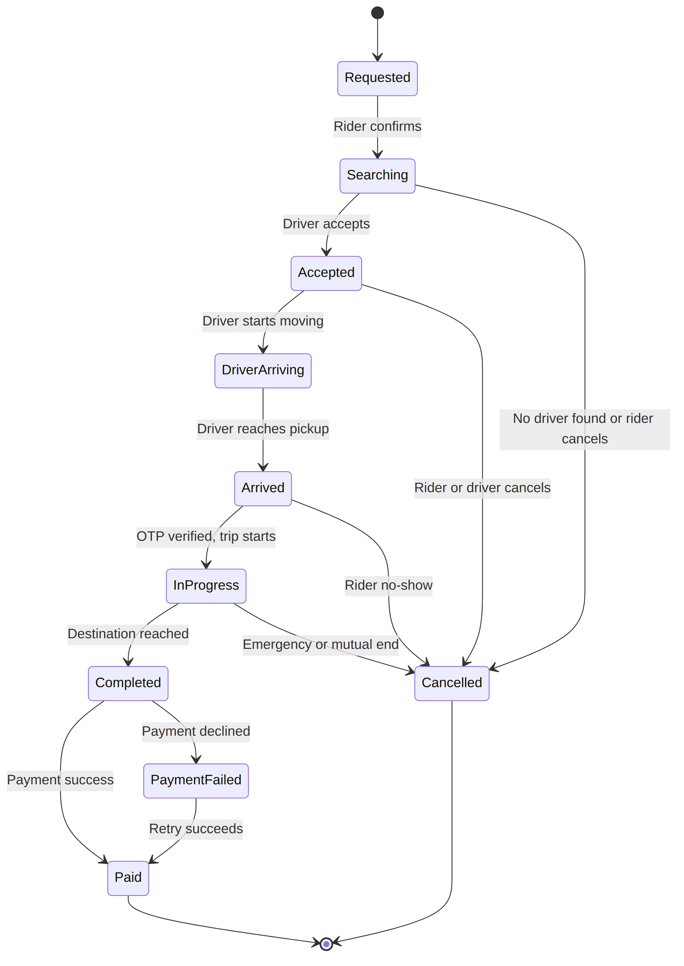
Figure 5: State diagram - ride lifecycle

4.6 Component / Deployment Diagram
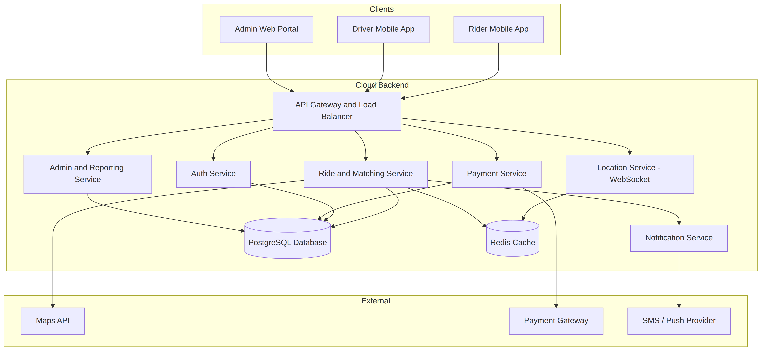
Figure 6: Component / deployment diagram

4.7 Entity-Relationship Diagram (Data Model)
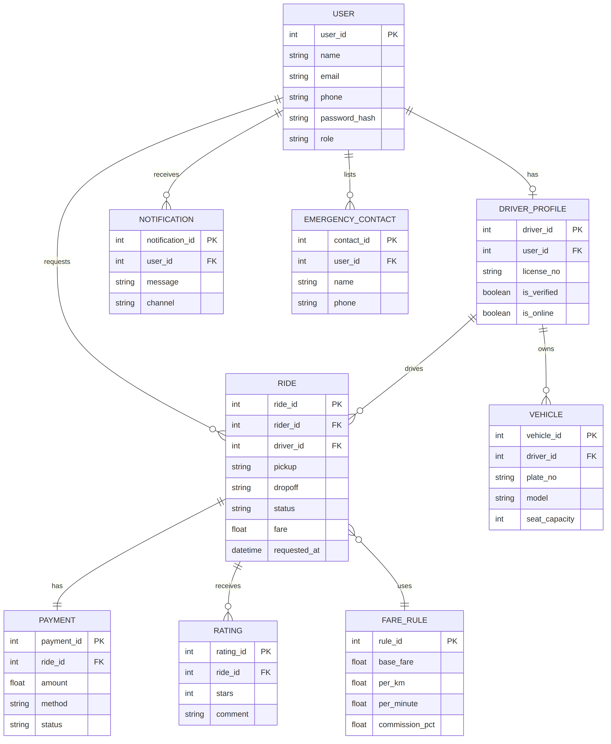
Figure 7: Entity-relationship diagram

5. Other Requirements and Appendices

5.1 Traceability (Sample)
Use Case | Functional Requirements
Register / Login | FR-1.1, FR-1.2
Request Ride | FR-3.1 to FR-3.7
Track Ride | FR-4.1 to FR-4.5
Pay for Ride | FR-6.1 to FR-6.5
Rate and Review | FR-7.1, FR-7.2
Send SOS Alert | FR-9.1 to FR-9.3
Verify Drivers | FR-2.1, FR-2.2
Configure Fares and Areas | FR-11.2

5.2 Acceptance Criteria (Examples)
- A rider can complete registration, request a ride and receive a driver assignment in under 3 minutes in a test environment.
- Cancelling a ride after the grace period charges the configured fee.
- Pressing SOS sends location to all emergency contacts within 5 seconds.

5.3 Future Enhancements
- Scheduled recurring commutes and corporate accounts
- Women-only or verified-community ride options
- In-app chat with translation
- EV and bike/scooter categories
- AI-based demand prediction and dynamic pricing

5.4 Open Issues
- Final choice of target city/region and applicable regulations
- Payment gateway selection and supported payment methods
- Whether v1.0 includes pooling or launches with solo rides only
- Commission model and driver payout schedule
End of document

