**Media Streaming with IBM Cloud Video Streaming**

|  |  |
| --- | --- |
| **Date** | **26-10-2023** |
| **Team ID** | **675** |
| **Project Name** | **Media Streaming with IBM Cloud Video Streaming** |

**Media Streaming with IBM Cloud Video Streaming**

**PHASE 4:**Development Part 2

**Introduction**

We need to create an advanced online movie streaming platform using IBM Cloud Video Streaming. The platform should allow users to easily upload and watch their favorite movies and videos whenever they want. Our main goal is to enable people to enjoy movie nights with friends and family, no matter where they are. To make the movie-watching experience even better, we're dedicated to providing a smoothly integrated streaming service that ensures outstanding video quality, making users feel like they're in a real cinema.

In this document, we will outline the problem statement, the steps involved in solving it, and the design thinking approach that will guide our project.

**Problem Statement**

Develop a virtual cinema platform leveraging IBM Cloud Video Streaming capabilities. Empower users to effortlessly upload and stream their preferred movie titles and videos on a "just-in-time" basis. Facilitate the communal enjoyment of cinematic evenings with loved ones, regardless of their geographical dispersion. Enhance the art of cinematic viewing by providing uninterrupted streaming services and delivering top-tier video playback quality, culminating in an authentically immersive cinematic experience.

**Backend Development**

**Step 1:** Establish Your Development Environment

Ensure you have PHP, HTML, and JavaScript installed on your system. You'll also need to set up a cloud-based video streaming service for optimal performance.

**Step 2:** Design Your Database Schema

Define the entities needed for your virtual cinema platform, including users, uploaded videos, movie details, and viewing history. Create corresponding tables in your MySQL database to represent these entities.

**Step 3:** Develop the PHP Application

Create a PHP application in your project directory. Set up configurations and initialize your app, ensuring it's ready to handle video uploads and streaming.

**Step 4:** Configure Database Connection

Establish a connection between your PHP application and the MySQL database. Utilize tools like SQL Alchemy or PHP's built-in MySQL functions to simplify database interactions. Securely store your database credentials.

**Step 5:** Define Models for Uploaded Videos and Movie Details

Create models that map to your database schema, such as Upload, Movie, and User. Specify the fields and relationships for each model.

**Step 6:** Create API Endpoints for Uploading and Streaming Videos

Define routes and endpoints for handling video uploads and streaming requests. These routes will facilitate users in uploading their preferred movie titles and seamlessly streaming them.

**Step 7:** Implement User Authentication

Incorporate user authentication using PHP to ensure secure access to the platform. Utilize techniques like sessions and token-based authentication for added security.

**Step 8:** Integrate Cloud Video Streaming Capabilities

Leverage cloud-based video streaming services (e.g., AWS Media Services) to deliver high-quality, uninterrupted video playback. Configure the integration in your PHP application for seamless streaming experiences.

**Step 9:** Enhance Video Playback Quality

Optimize video playback quality by utilizing appropriate encoding and compression techniques. Ensure a top-tier viewing experience for all users, regardless of their location.

**Step 10:** Test and Debug Your Virtual Cinema Platform

Thoroughly test the platform's functionalities, including video uploading, streaming, user authentication, and playback quality. Debug any issues to guarantee a smooth user experience.

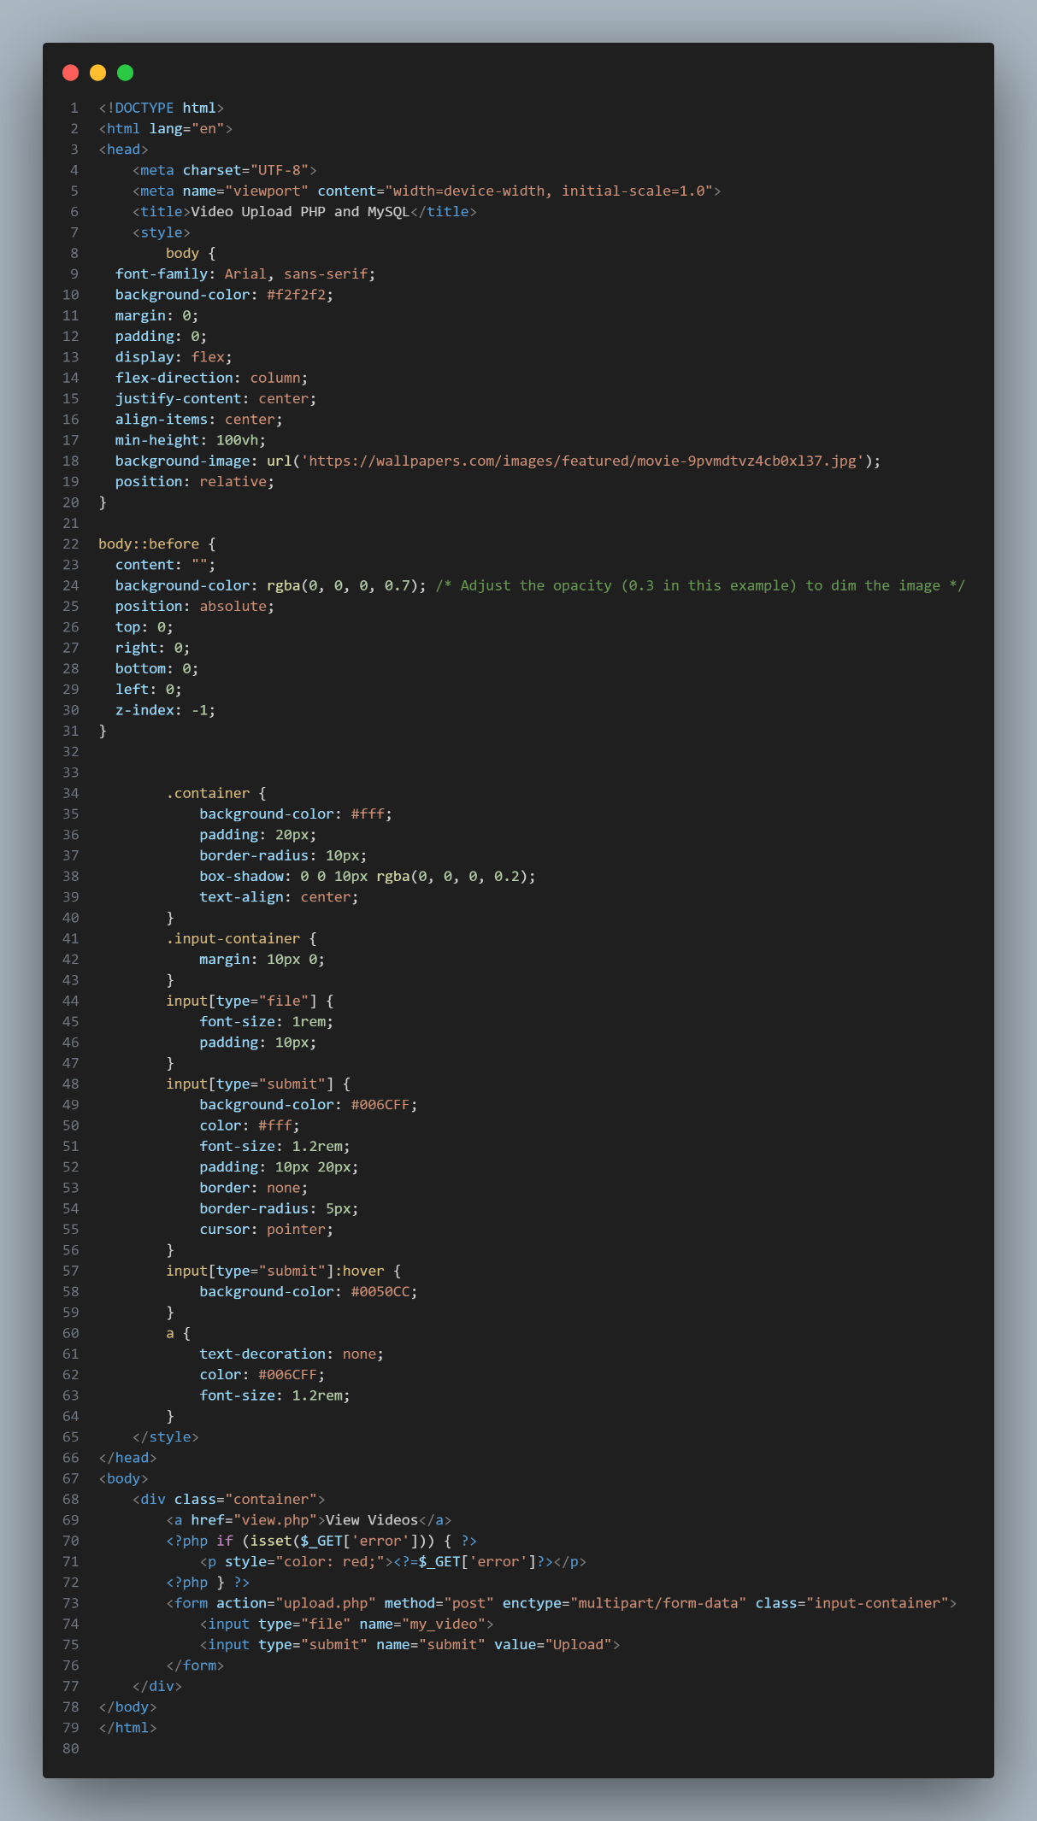

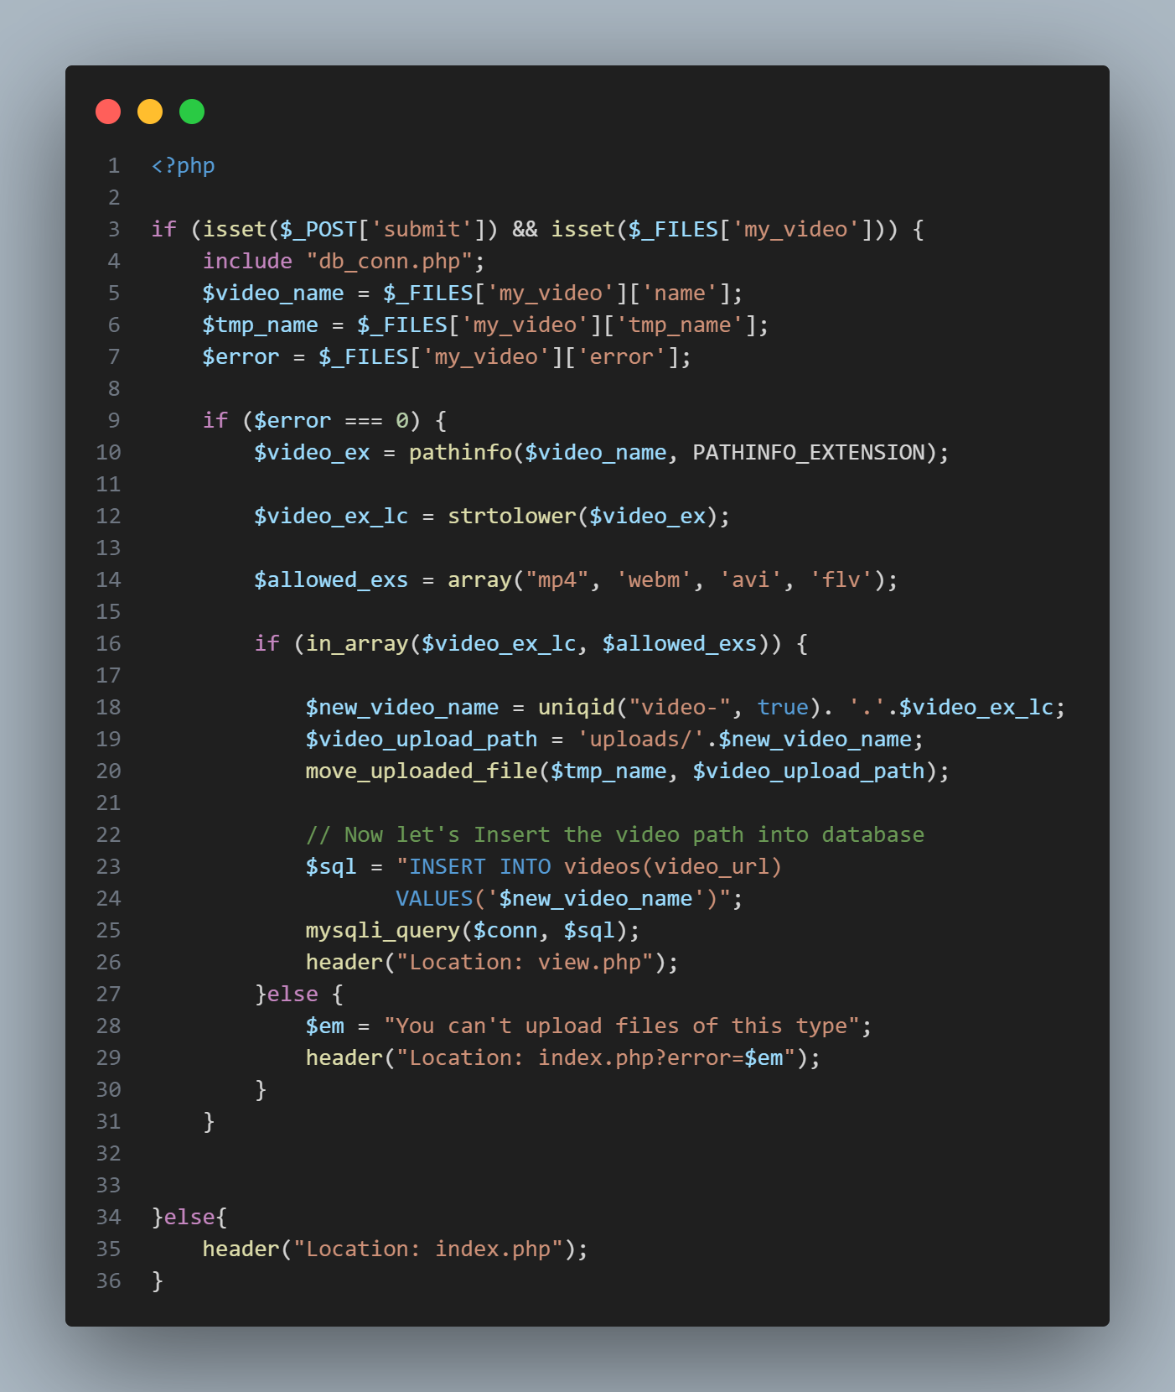

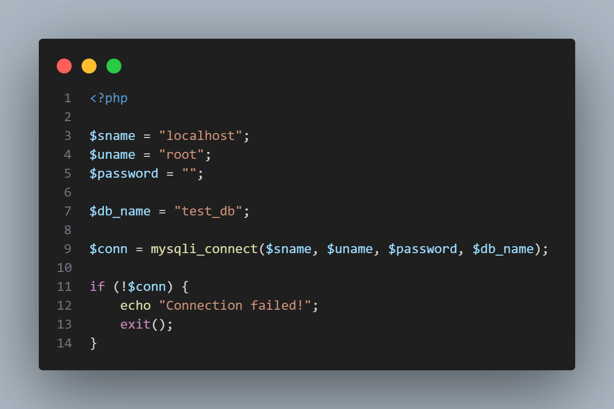

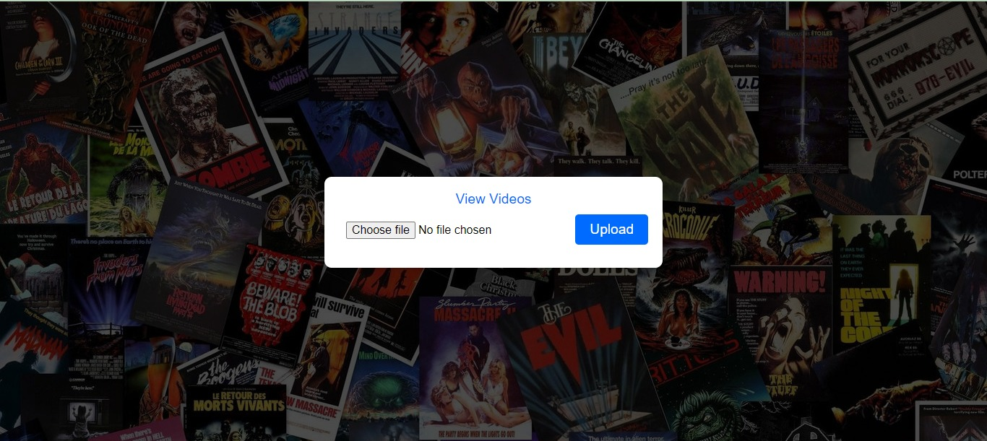

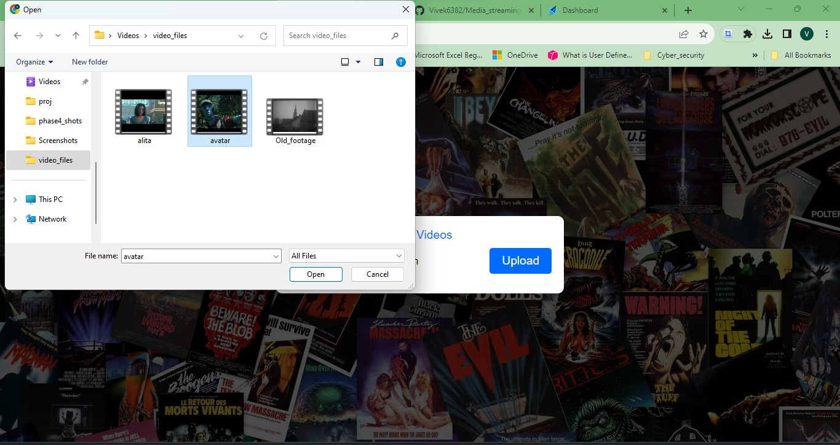

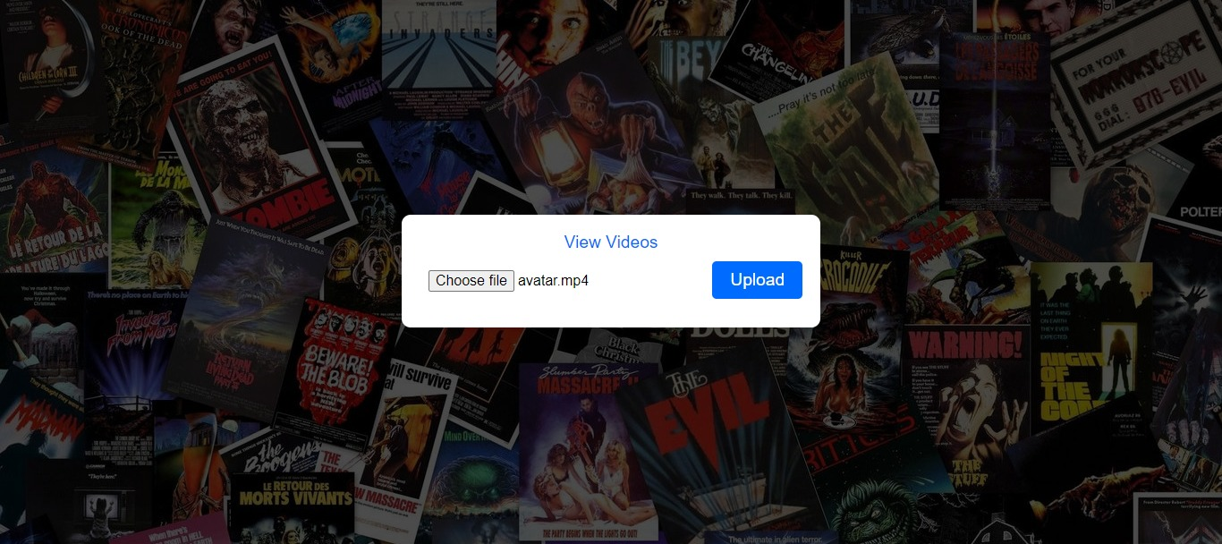

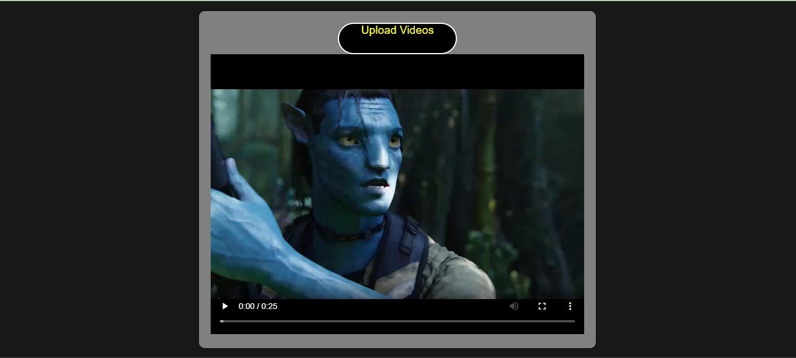

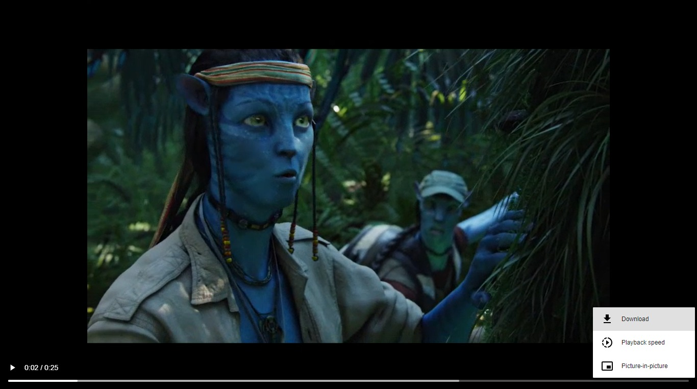

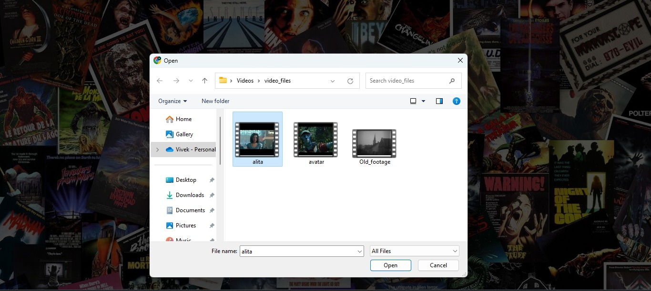

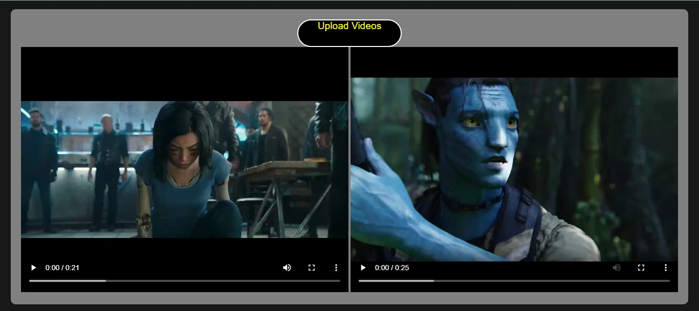

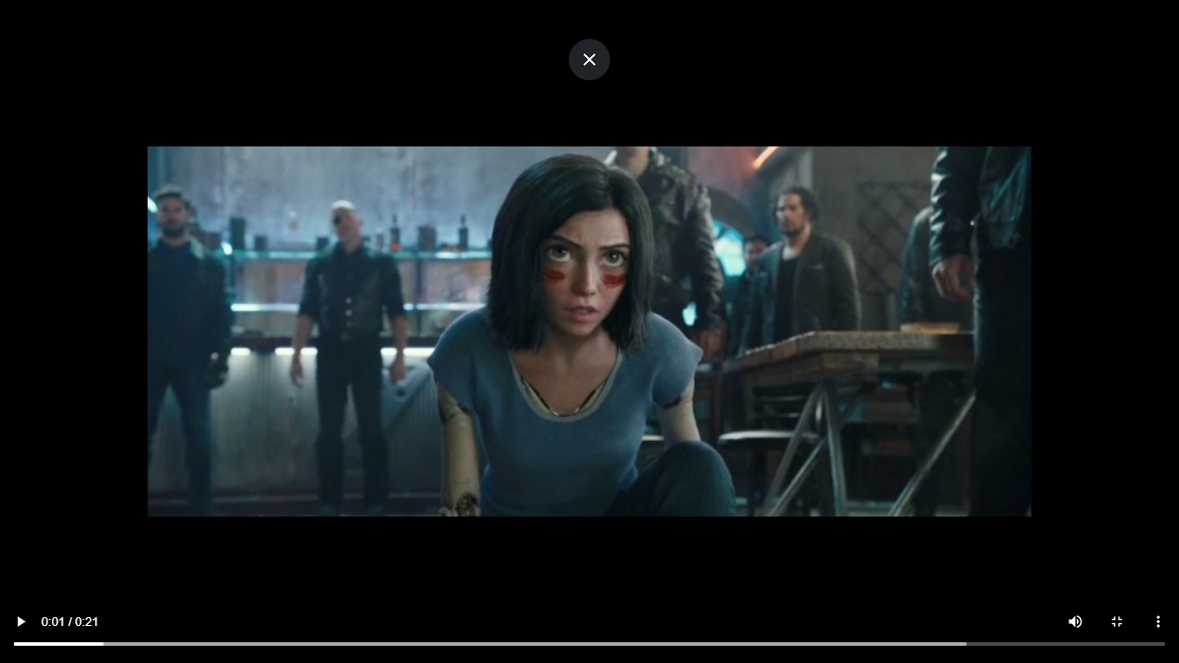

**Conclusion**

In conclusion, creating a virtual cinema platform with PHP, HTML, and JavaScript, coupled with cloud video streaming capabilities, is an exciting endeavor. This technological amalgamation offers a robust framework for delivering seamless, high-quality cinematic experiences. Throughout this guide, you've gained insights into setting up your development environment, designing a robust database schema, implementing user authentication, integrating advanced video streaming services, and deploying your application. Remember, staying attuned to evolving technologies and user preferences will be pivotal in ensuring a captivating and enduring cinematic viewing experience for your audience.