AGORA

Version: 1.0
Date of Release: May 11,2018



This document contains proprietary information of Aithent and is tendered subject to the condition that the information be retained in confidence.
Document Information
Author(s) | : | Karol M
Document Status | : | Draft
Compliance Status | : | Mandatory

Document Control Information
Total Pages | : | 14
Review Period | : | As and when required per scope of project.
Distribution | : | PL, TL and team members

Revision History
Version No. | Release Date | Description of Change | Approved By
1.0 | May 11, 2018 | Initial Release

Table of Contents
1 Introduction 2
2 Registration- Individual 2
3 Registration- Group 2
3.1 Adding member to group 2

List of Figures

Figure 2-1: Individual- Sign Up Page 2
Figure 2-2: Individual- Signing Up Details 2
Figure 2-3: Individual- Registration Successful 2
Figure 2-4: Individual- Validation Email 2
Figure 2-5: Individual- Password Credentials 2
Figure 2-6: Individual- Logging In 2
Figure 2-7: Individual- Homepage 2
Figure 3-1: Group- Signing Up 2
Figure 3-2: Group- Confirmation Message 2
Figure 3-3: Group- Validation Email 2
Figure 3-4: Group- Password Credentials 2
Figure 3-5: Member- Signing Up 2
Figure 3-6: Member- Confirmation Message 2
Figure 3-7: Member- Assigning Administrator 2
Figure 3-8: Member- Validation email 2
Figure 3-9 Member- Approval by Administrator 2

Introduction
This document will guide the users how to register with Agora as an Individual or Group/Company.

Individual Registration
An individual will have to follow the below steps to register with Agora:
- Using any browser go to the Agora registration page (https://agora.aithent.com)
- Click on Sign Up to enter the individual’s information required to complete the registration.
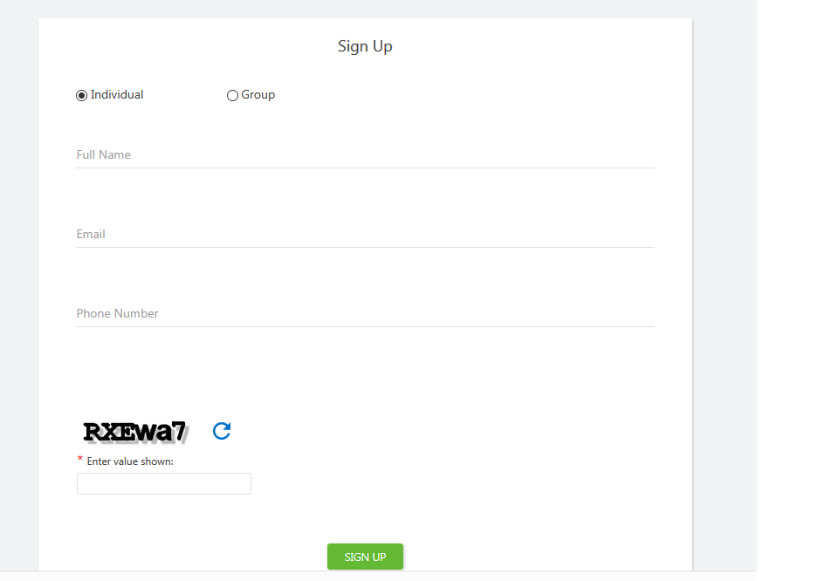
Figure 2-1: Individual- Sign Up Page

- Enter the information in all fields and click SIGN UP. Make sure to select Individual radio button.
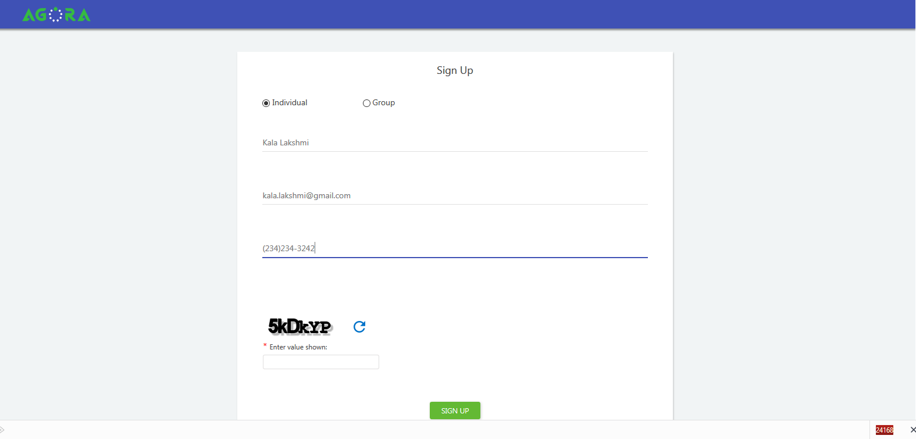
Figure 2-2: Individual- Signing Up Details

- Once the registration with Agora is successful, a confirmation message will be displayed as shown below. In case the given email is already registered, ‘User already exists.’ message will be displayed.
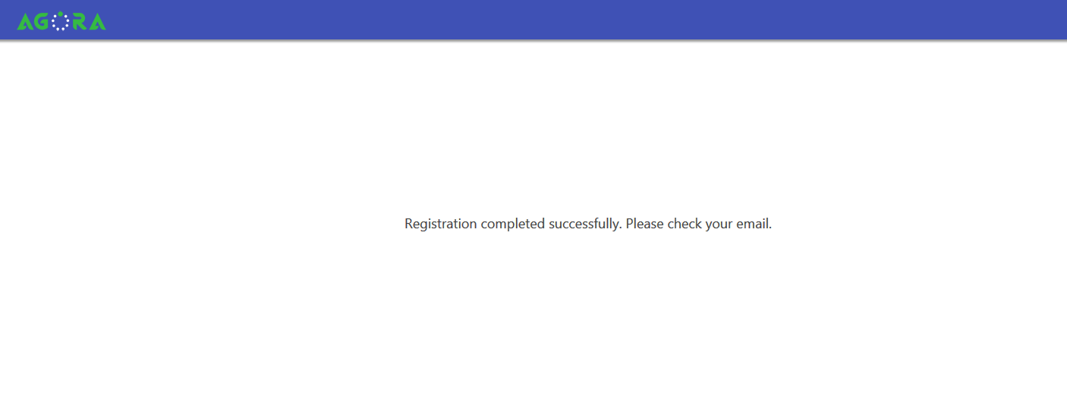
Figure 2-3: Individual- Registration Successful

- An email will be sent to the registered email address to activate the account as shown below
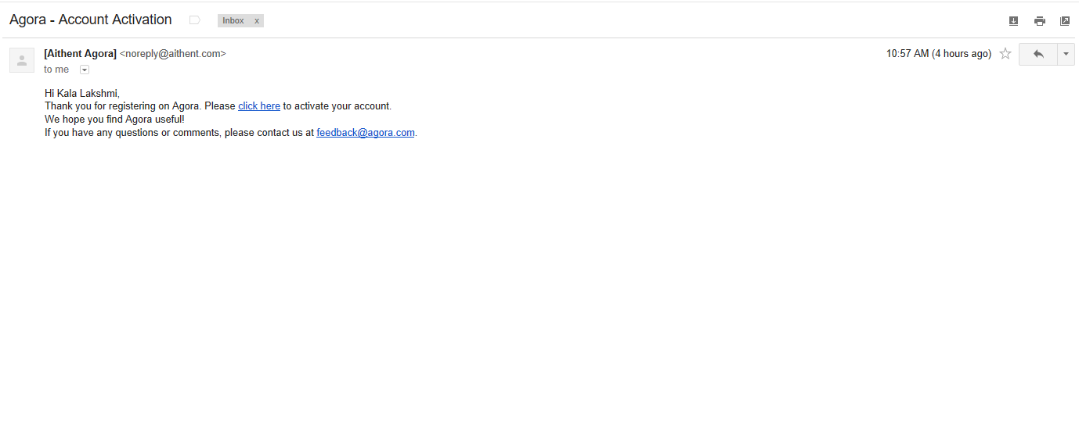
Figure 2-4: Individual- Activation Email

- Click the hyperlink provided in the email to activate the account and provide the password credential and security questions & answers. Security question and answers are required for the user to self-reset the password, if forgotten. Once all information are provided, click SAVE. On successfully saving the information, “Data Successfully Saved” message will be displayed and the user will be redirected to the login page.
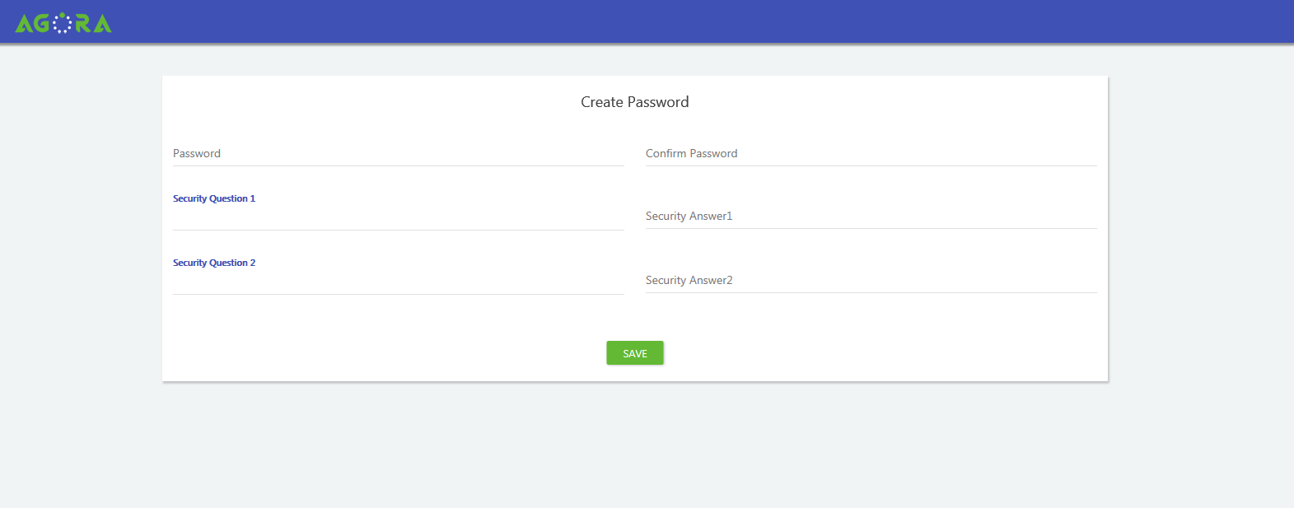
Figure 2-5: Individual- Password Credentials

- Login using the appropriate credentials.
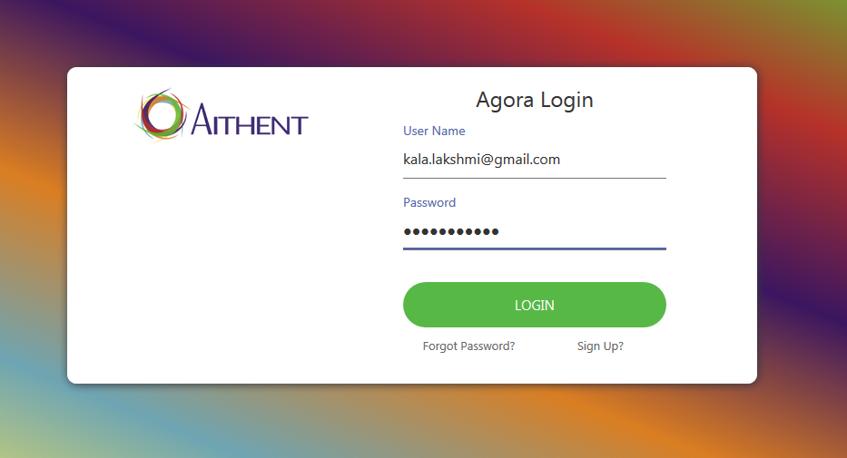
Figure 2-6: Individual- Logging In

- Upon successful login, the homepage will be displayed.
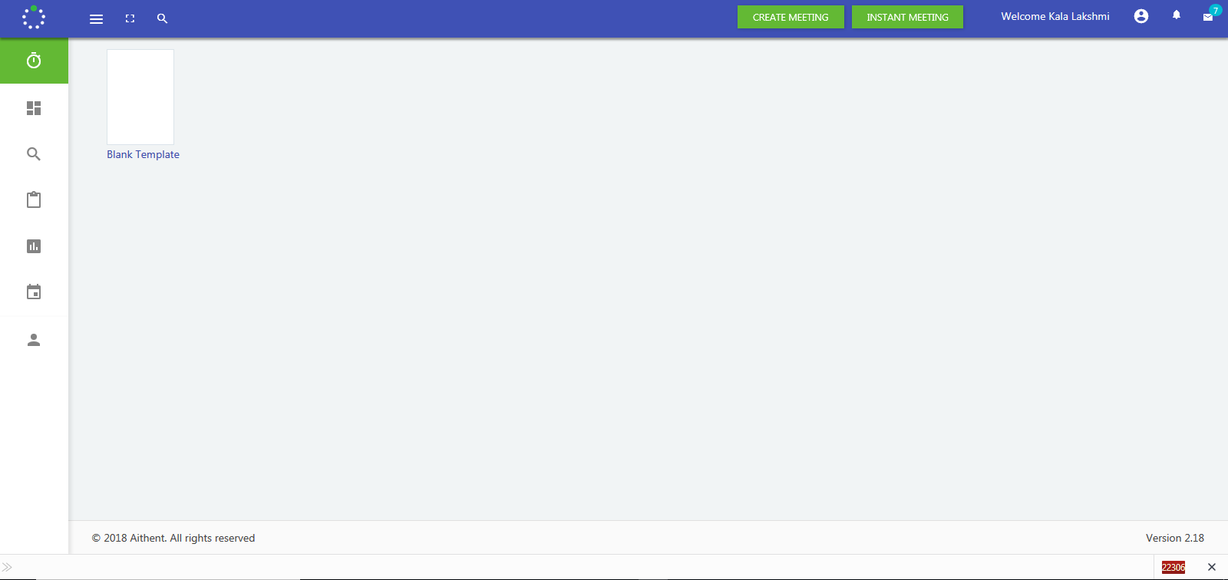
Figure 2-7: Individual- Homepage

Group/Company Registration
To register as a Group/Company, follow the steps below:
- Using any browser go to the Agora registration page (https://agora.aithent.com)
- Click on Sign Up to enter the individual’s information required to complete the registration
- Enter the information in all fields and click SIGN UP. Make sure to select Group radio button.

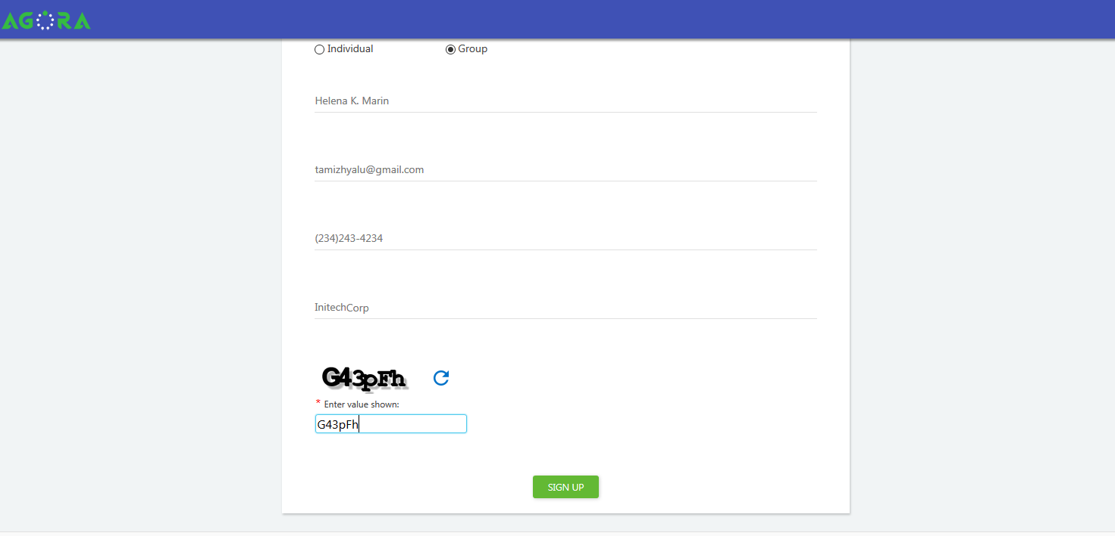
Figure 3-8: Group- Signing Up

- Once the registration with Agora is successful, a confirmation message will be displayed as shown below. In case the given email is already registered, ‘User already exists.’ message will be displayed. The individual who has signed up for Group account will be the default Administrator and a user for the group. .
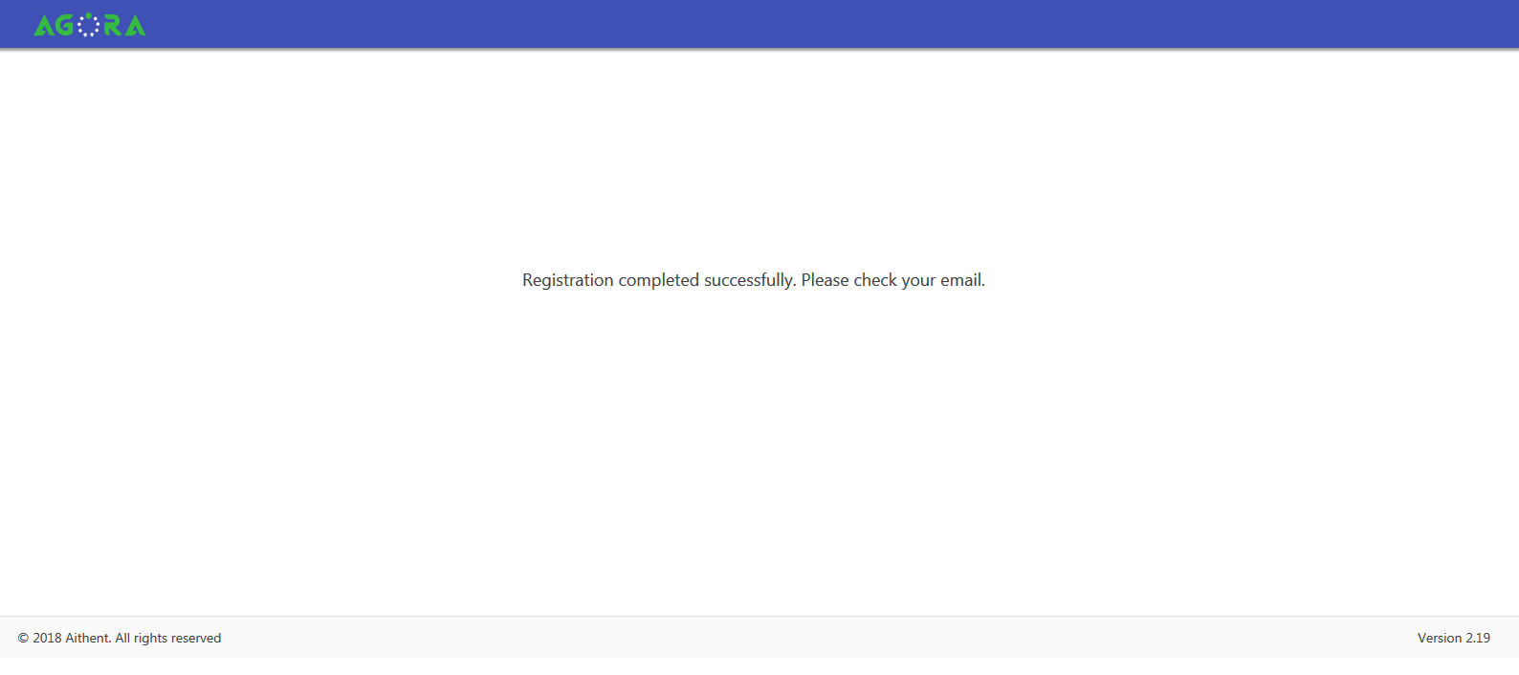
Figure 3-9: Group- Confirmation Message

- An email will be sent to the registered email address to activate the account as shown below.An email will be sent to the registered email address as shown below
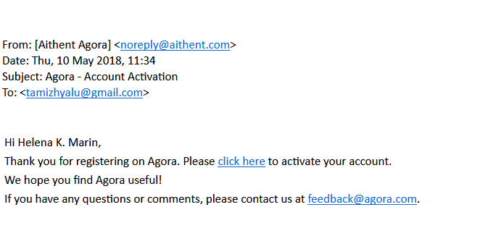
Figure 3-10: Group- Activation Email

- Click the hyperlink provided in the email to activate the account and provide the password credential and security questions & answers. Security question & answers are required for the Administrator to self-reset the password, if forgotten. Once all information are provided, click SAVE. On successfully saving the information, “Data Successfully Saved” message will be displayed and the user will be redirected to the login page.
Figure 3-11: Group- Password Credentials
- Login using the appropriate credentials.

Adding member to group
Today the members of the group have to self-register themselves. In the following version, import from CSV/XLS files will be provided. The following steps are required to be performed for self-registering with a group.
A user while registering with the group/company must select the already registered company.
- Using any browser go to the Agora registration page (https://agora.aithent.com)
- Click on Sign Up to enter the individual’s information required to complete the registration
- Enter the information in all fields, including selecting the company to which you want to be a member and click SIGN UP. Make sure to select Group radio button.
- In case, the Group name is not visible in the list, then you would be the Administrator and an User to the new group name entered.
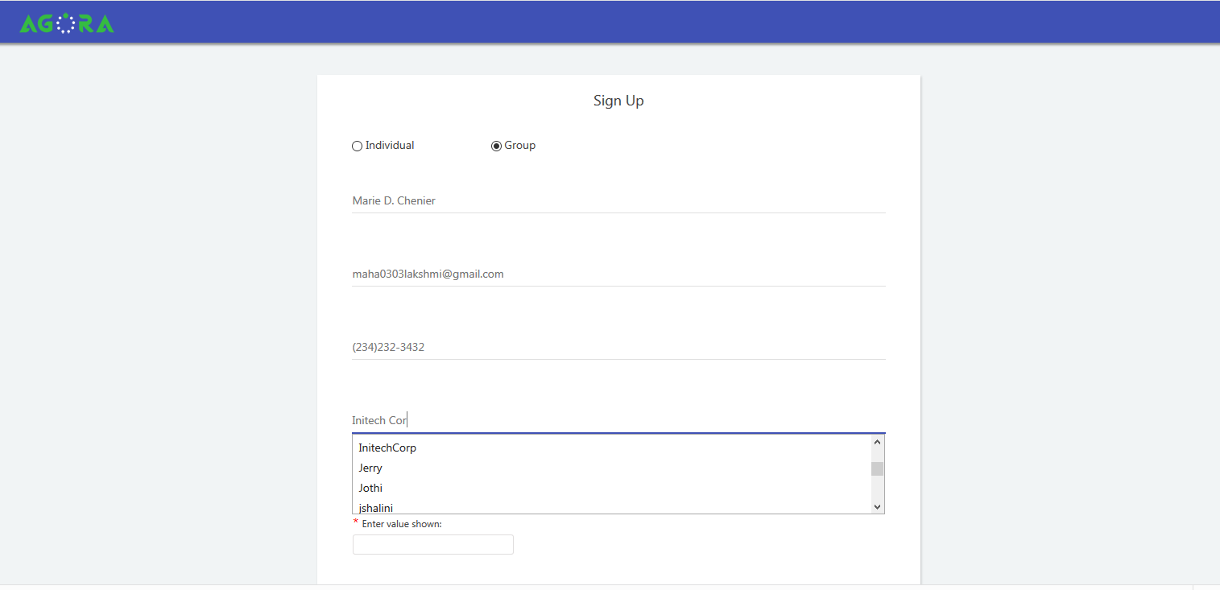
Figure 3-12: Member- Signing Up

- A new group will be created if a new name is entered in ‘Company name’ field. The corresponding individual will be made administrator.

- The following message will be displayed, when you select an existing Group/Company. Click OK to add a member. Click Cancel if a new group is to be created/registered.

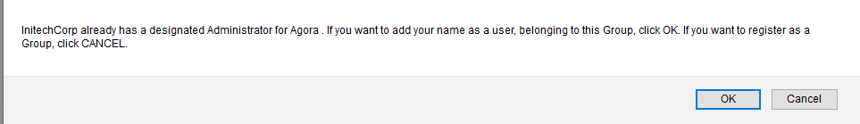
Figure 3-13: Member- Confirmation Message

- If Cancel is clicked, a new group will be created under the same name and the corresponding member will be made Administrator of the group.

- Upon clicking OK button, a pop up with list of Administrator(s) will be displayed. Select the appropriate radio button. Select other if you want to be made administrator. Click OK.

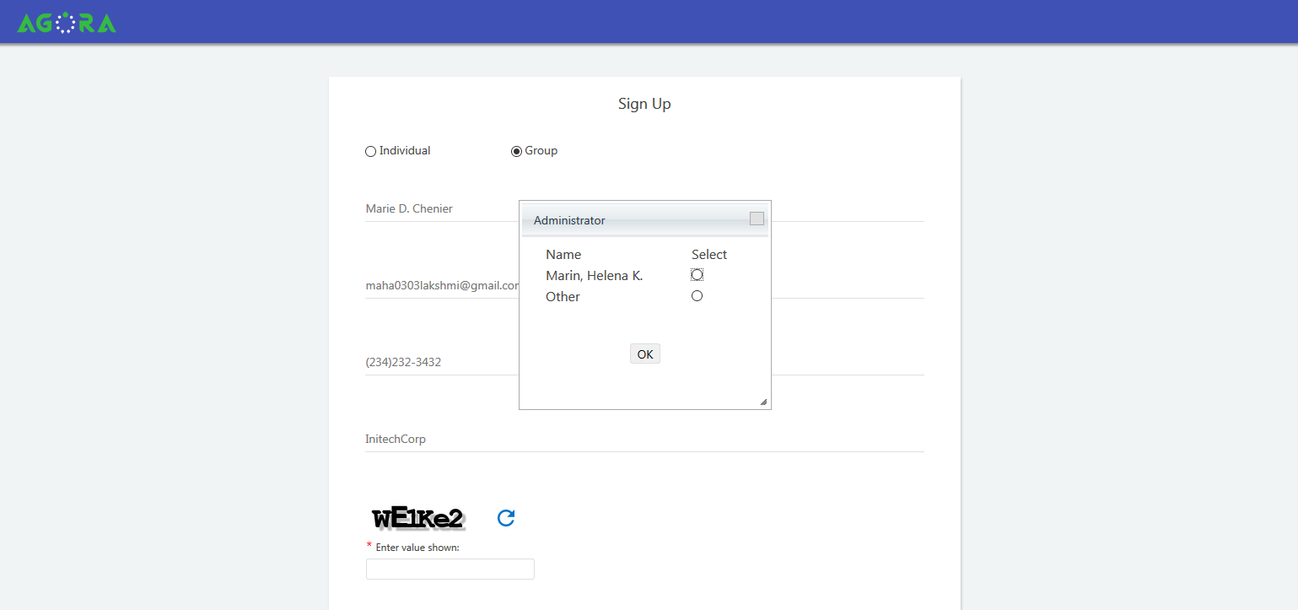
Figure 3-14: Member- Assigning Administrator

- An email will be sent to Administrator with member details to be activated.
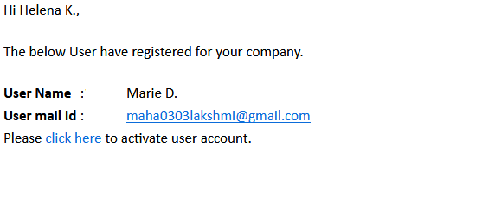
Figure 3-15: Member- Validation email
- An email will also be sent to the member’s registered email address to complete validation process (as discussed earlier). However, member will be able to access the application only if he/she is approved by the Administrator.

- The Administrator must click on the link provided to activate the member account. A page with list of members pending for approval will be displayed. Select the appropriate members and click Approval. The members will be added to the group.
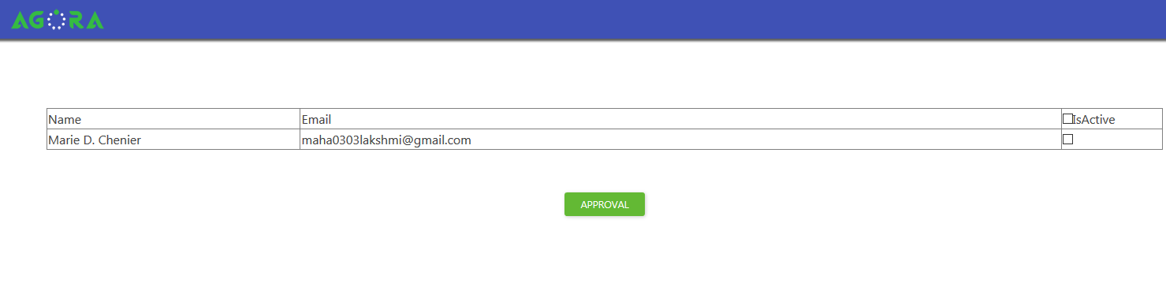
Figure 3-16 Member- Approval by Administrator
- Once the member is approved and the password credentials & security questions have been provided, he/she will be able to access Agora and will be able to schedule meetings with other members in the group. .

