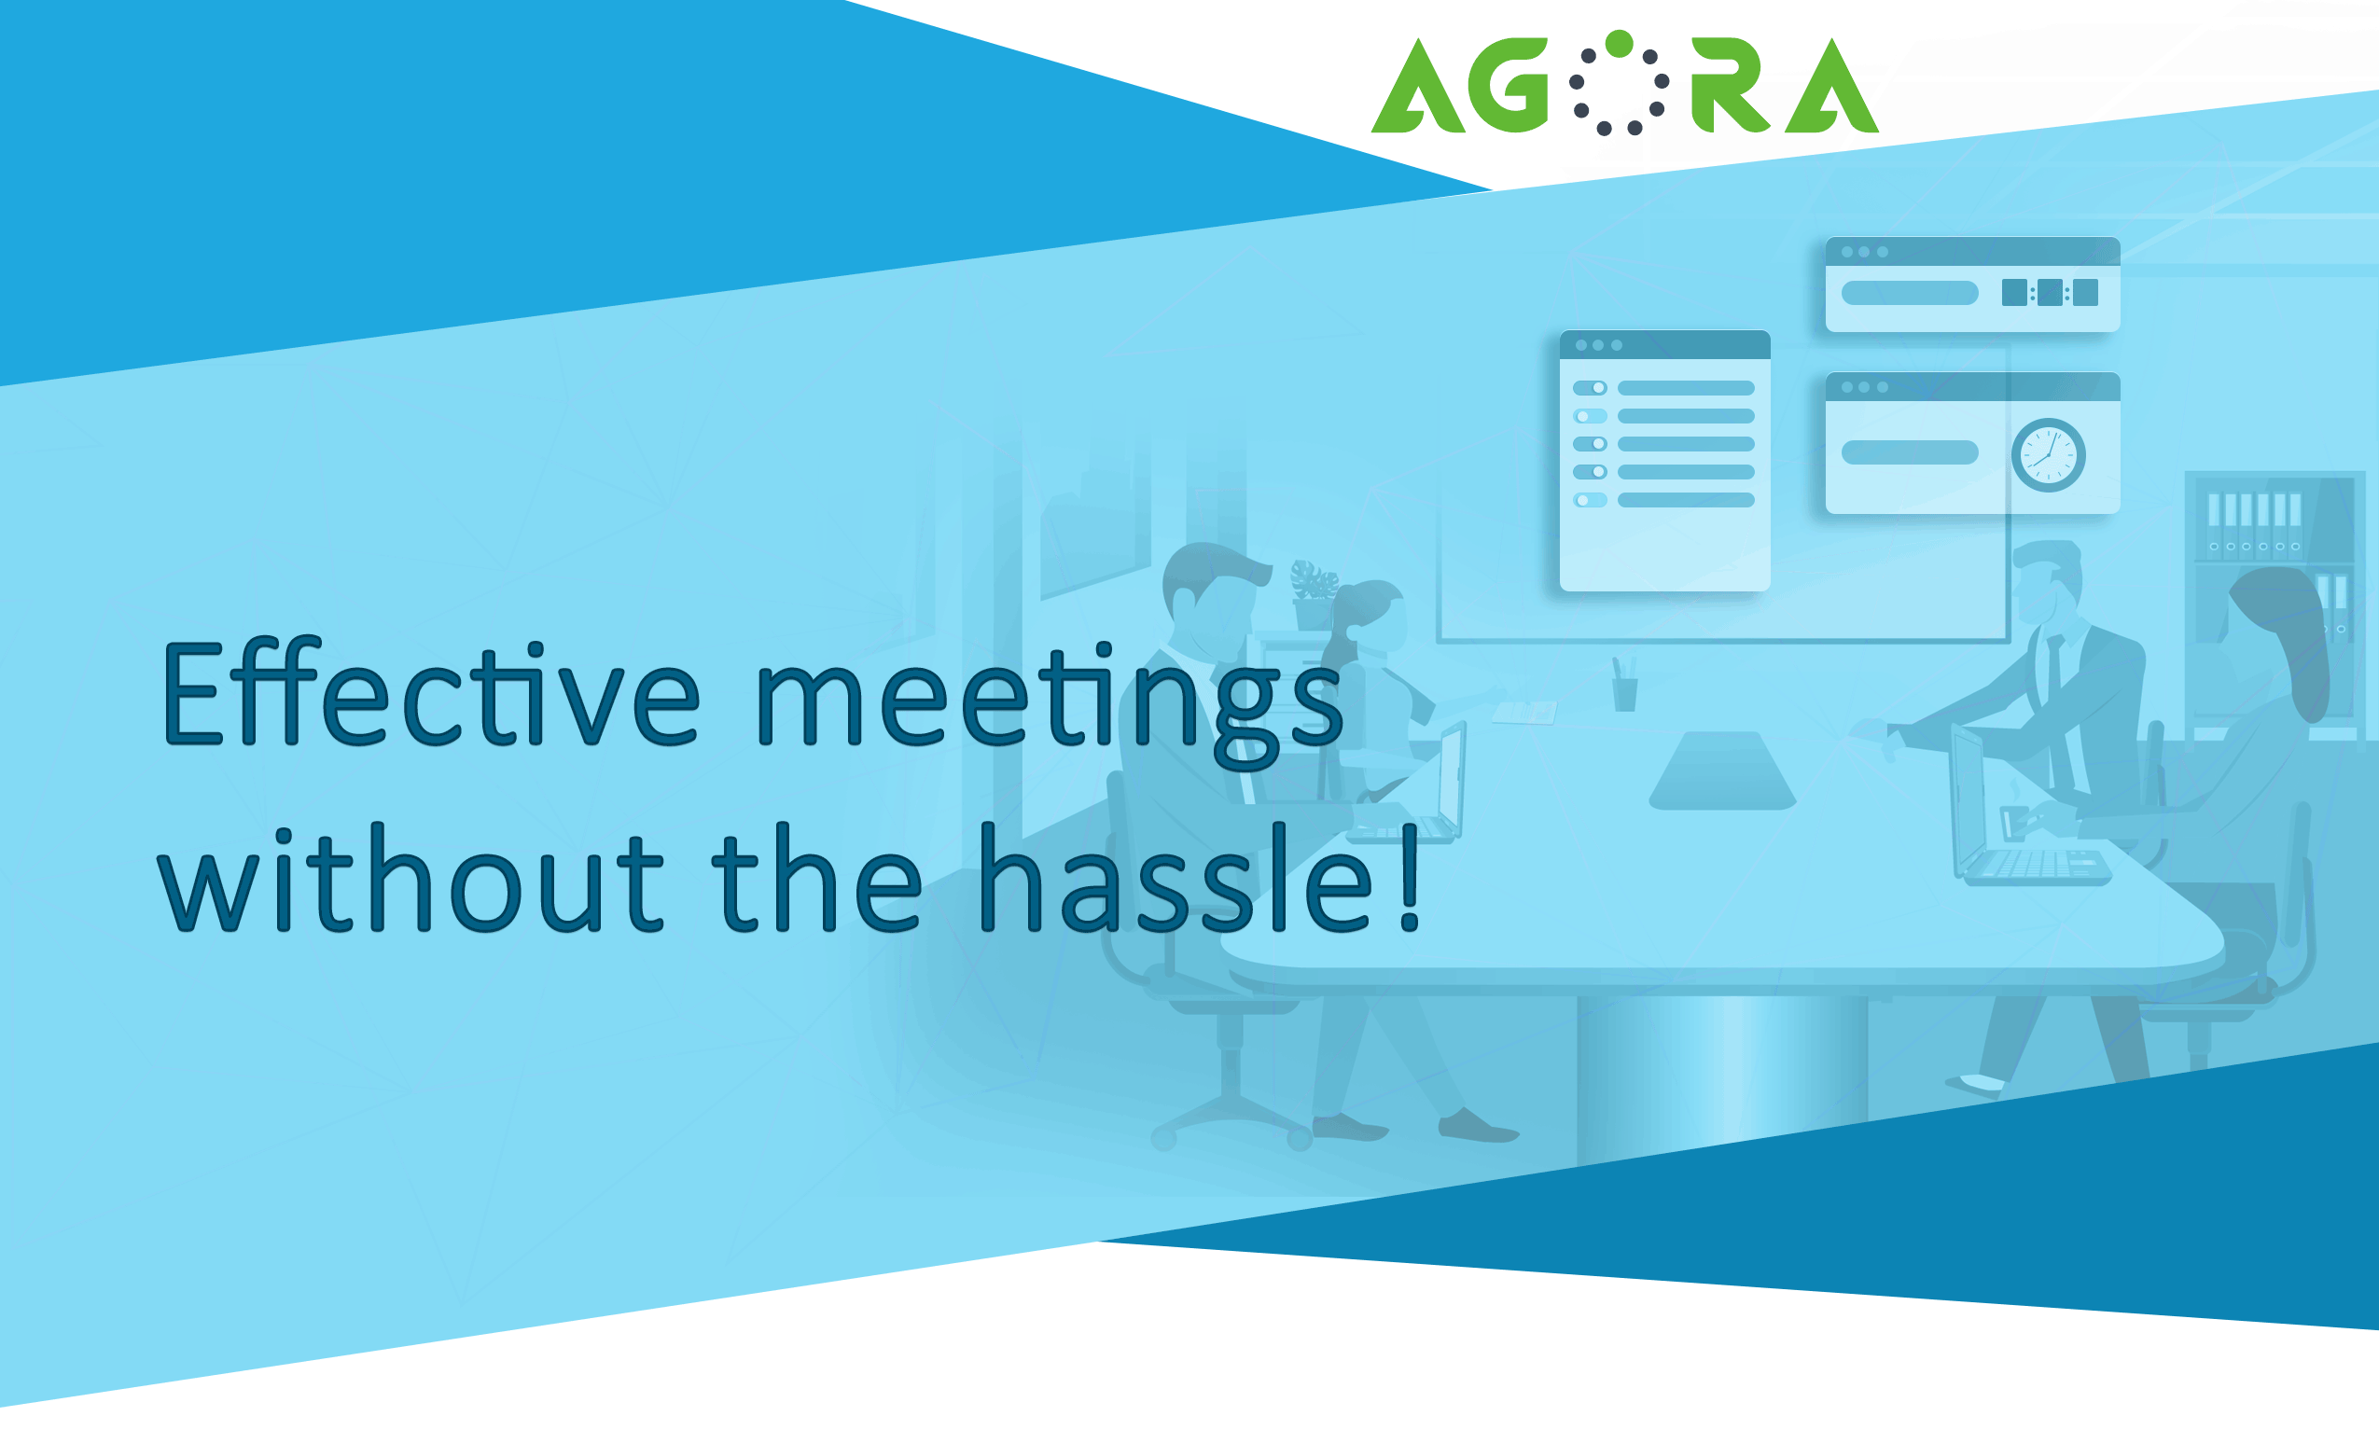

Agora helps every step of the way, from scheduling to minutes distribution, for smooth execution and greater ROI. Convene extraordinary meetings every time.

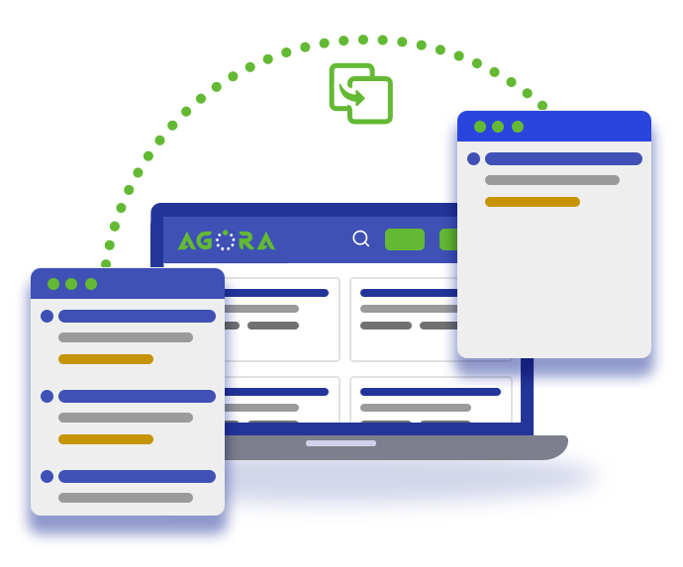 | Easily define the agenda or copy an agenda from a previously held meeting.

Include review material with the meeting invites to help attendees find all the information in one place. | 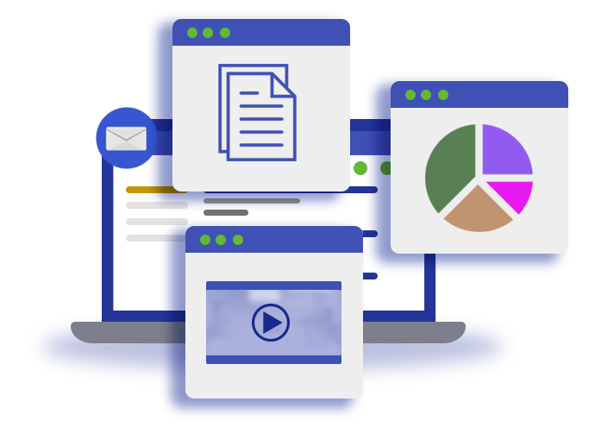

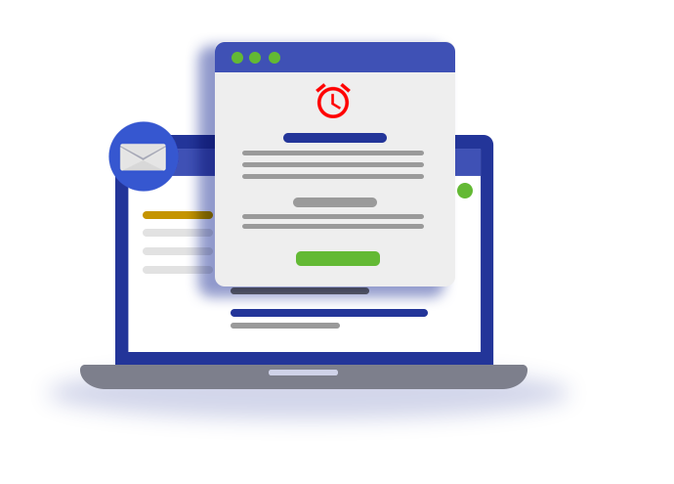 | Automatically send reminders to all invitees. Reminders include a link to meeting details; supporting documentation is only a click away.

Track attendance. Record time taken on agenda items. Easily analyze meeting data. | 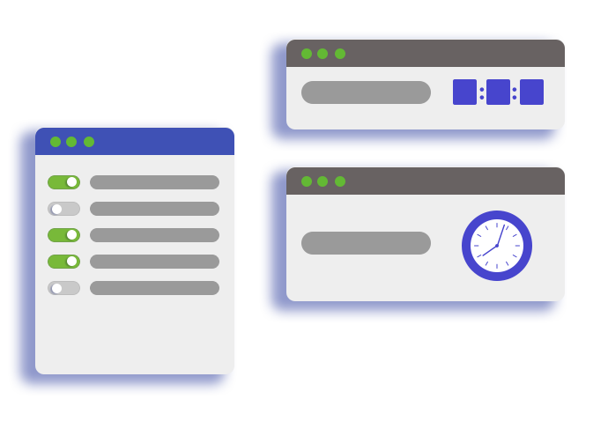

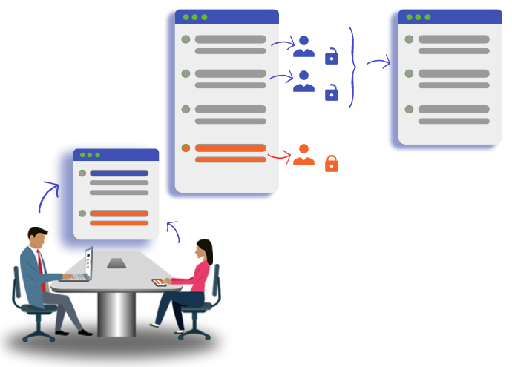 | Securely share notes enabling collaborative minute taking. And, yes, for doodlers there is even a way to keep notes private!

Assign tasks to attendees and non-attendees. While non-attendees will not automatically receive meeting details, they will receive notification of an assigned task. | 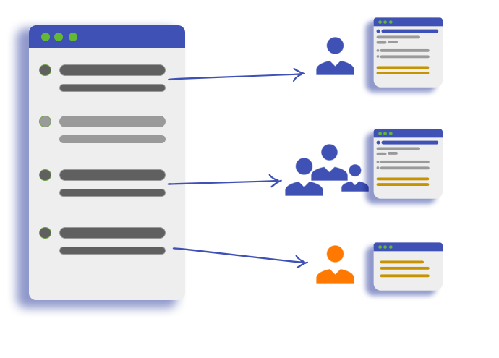

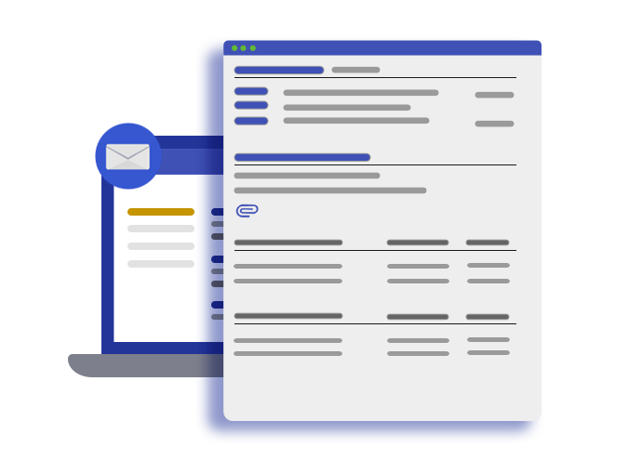 | Use meeting notes to generate draft minutes quickly. Send the draft to attendees for review. Meeting chair can easily approve the minutes.

Efficiently manage and store all relevant meeting information. Powerful search and reporting functions ensure meeting data is not forgotten. | 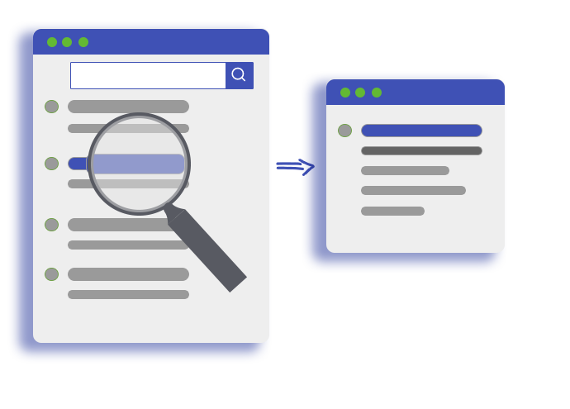

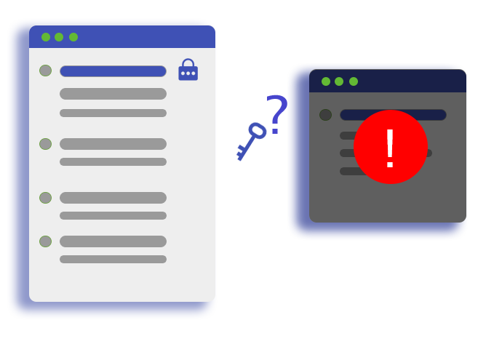 | Support for confidential meetings with the meeting chair defining the encryption key! Even the Agora team cannot help you if you forget your key.

Track open tasks easily to ensure that these do not fall off the radar. | 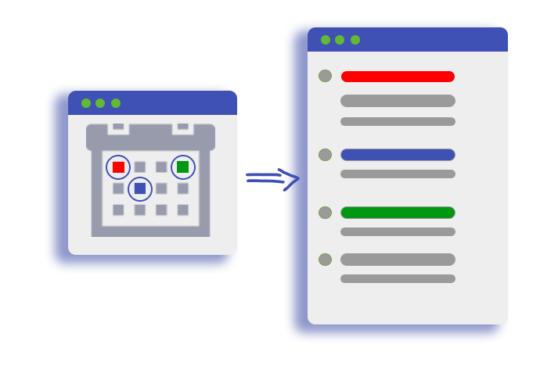

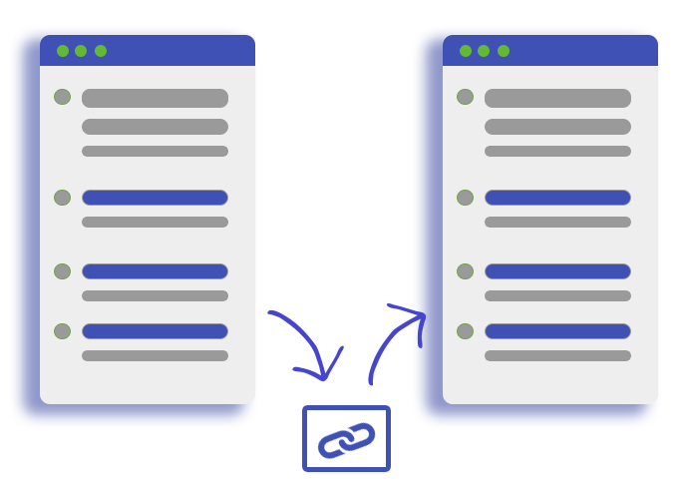 | Support for recurring meetings and linked meetings. Easily review discussions from previous meetings in the thread.


Aithent Inc.
19 Fulton Street, Suite #408, New York, New York 10038
Ph: (212) 725-7646 Fax: (212) 725-7647
www.aithent.com
© 2018 Aithent Inc. All rights reserved.
for more information, contact info@aithent.com

