PROJECT DOCUMENTATION

Subsystem Requirements Specification

For Project:
NYSID - Licensing Bureau
Entity Renewal License Web Process

Release No: 1.4
August 3, 2004

Client: Licensing Bureau

Approvals:
DOI Project Manager: _________________________ Date: __________

Licensing Project Manager: _________________________ Date: __________

Document Number: EntityRenReq.doc
u:\lic\admin\reqdoc\online
User Requirements Specification History

Document Location

Ensure that this document is current. Printed documents and locally copied files may become obsolete due to changes to the master document.

Revision History

Date of this revision: 08/03/2004 | Date of Next revision: TBD

Revision Number | Revision Date | Summary of Changes | Changes marked
1.0 | 03/24/2004 | First issue | N
1.1 | 06/23/2004 |  | N
1.2 | 07/08/2004 |  | N
1.3 | 07/12/2004 |  | N
1.4 | 08/03/2004 | Add Instructions Page | N

Approvals

This document requires the following approvals.

Name | Title

Distribution

This document has been distributed to
Name | Title
Ron Minafri | Systems
Marc Ehlinger | Systems
Lisa Morrell | Systems
Sal Castiglione | Licensing/CSB Bureau Chief
Jack Chaskey | Supervising Insurance Examiner - CSB
Phil Jurgelon | Licensing
Clark Williams | Licensing
Jackie Catalfamo | Licensing

Table of Contents
1 INTRODUCTION 5
1.1 IDENTIFICATION 5
1.2 SCOPE 5
1.3 PURPOSE AND OBJECTIVE 5
1.4 DOCUMENT ORGANIZATION 5
2 RELATED DOCUMENTATION 6
2.1 PARENT DOCUMENTS 6
2.2 APPLICABLE DOCUMENTS 6
2.3 REFERENCE DOCUMENTS 6
3 GENERAL WEB APPLICATION REQUIREMENTS 7
3.1 SYSTEM REQUIREMENTS 7
3.2 PAGE REQUIREMENTS 7
3.2.1 HEADER 7
3.2.2 FOOTER 7
4 WEB ORIGINAL LICENSE APPLICATION 8
1.1 DYNAMIC LICENSE WEB APPLICATION DESIGN REQUIREMENTS 8
4.1.1 BACKGROUND 8
4.1.2 GENERAL DYNAMIC LICENSE WEB APPLICATION REQUIREMENTS 10
PROCESS FLOW 10
4.3 CORPORATE RENEWAL APPLICATION PAGES 11
4.3.1 LOGIN PAGE 11
4.3.2 LICENSE PENDING RENEWAL PAGE 14
4.3.3 INSTRUCTIONS PAGE 14
4.3.4 SUBLICENSEE/INACTIVE OFFICER PAGE 16
4.3.5 ADD SUBLICENSEE/INACTIVE OFFICER PAGE 18
4.3.6 SUB-LICENSEE BIOGRAPHICAL INFORMATION PAGE 20
4.3.7 BACKGROUND QUESTIONS PAGE 22
4.3.8 CONTINUING EDUCATION (CE) QUESTION PAGE FOR SUBLICENSEES ONLY 24
4.3.9 CERTIFICATION AND ATTESTATION PAGE 26
4.3.10 LAST SUBLICENSEE PAGE 28
4.3.11 SUBLICENSEE CONFIRMATION PAGE 29
4.3.12 ENTITY BIOGRAPHICAL INFORMATION 29
4.3.13 FEE DETAILS PAGE 32
4.3.14 CHECK INVOICE 32
4.3.15 CREDIT CARD SUBMISSION 32
4.3.16 CREDIT CARD INVOICE 32
5 LION PROCESSING 33
6 DATA RETENTION 33
APPENDIX A - GLOSSARY OF TERMS AND ACRONYMS 34
APPENDIX B – FEE SCHEDULE CALCULATION 35
APPENDIX C - NOTES 37

INTRODUCTION
This is Release 1.0 of the Licensing Corporate Renewal License Web Application Requirements Specification document dated 06/23/04. This document defines the detailed subsystem requirements for a Corporate Renewal License Web Application and LION application interfacing requirements.

IDENTIFICATION
This document is identified as the Licensing Corporate License Renewal Web Application Requirements Specification document. The production of this document is the responsibility of the COOL project team. Document approval is the responsibility of the Systems Bureau Project Leader and the Licensing Bureau Project Leader. The Systems Bureau Project Leader will maintain the baseline version of this document.

SCOPE
This document defines the Licensing Corporate License Renewal Web Application Requirements for the Web License Application System. It defines the dynamic Web page construction which will be the foundation for this Web application as well as future Department Web licensing application systems, specific corporate renewal (Class BR) application requirements, and the requirements for capturing the application data and interfacing it into the LicLion database for functional processing by the Licensing LION System.

PURPOSE AND OBJECTIVE
The purpose of this document is to provide the Corporate Renewal License Web Application Requirements. The objective of this document is to meet the following goals.
- Define the Subsystem Requirements in a manner that facilitates the creation of a dynamic Web application system design.
- Define the Subsystem Requirements in a manner that facilitates the validation and capturing of the application data and the interfacing of the data into the LicLion database to allow for functional processing by the Licensing LION System.

DOCUMENT ORGANIZATION
This document is organized into the following sections and appendices:
- Section 1 defines the purpose and objective.
- Section 2 lists the parent, applicable, and reference documents.
- Section 3 defines the dynamic license Web application design requirements.
- Section 4 defines the functional requirements.
- Section 5 defines the LION processing requirements.
- Section 6 defines the data retention requirements.
- Appendix A contains a list of acronyms.
- Appendix B contains an issue list.

RELATED DOCUMENTATION
This section identifies the documents that are related to the contents of this document as indicated in the following paragraphs.

PARENT DOCUMENTS
The parent documents establish the criteria and technical basis for the existence of this document. The parent documents are:
- Hardcopy Corporate License Renewal Application
- Hardcopy Partnership License Renewal Application
- Hardcopy LLC License Renewal Application

APPLICABLE DOCUMENTS
Applicable documents are those documents whose content is considered to form a part of this document. The specified parts of the applicable documents carry the same weight as if they were stated within the body of this document. The applicable documents are:
- Online Renewal Requirements Document
- Original Resident License Web Process
- EA Renewal Document (Individual)
- DMV Credit Card Requirements

REFERENCE DOCUMENTS
Reference documents are those documents that, although not a part of this document, serve to amplify or clarify its contents, or dictate work policy or procedures. The specific reference documents are:
- National Association of Insurance Commissioners (NAIC) Uniform Application for Individual Non-resident License

GENERAL WEB APPLICATION REQUIREMENTS

SYSTEM REQUIREMENTS
The application will be written in Enterprise Java Beans. The application will run on EAServer 3.6.1 with E-Portal.

PAGE REQUIREMENTS

HEADER


FOOTER
The following needs to appear at the bottom of each Web page:

*PRIVACY POLICY* | ACCESSIBILITY | DISCLAIMER

Please note the order of the items and that *PRIVACY POLICY* is surrounded by asterisks.

See http://www.ins.state.ny.us/nyins.htm for an example.

The URL’s associated with each link are:
ACCESSIBILITY – hpoffnos.htm#accessibility
PRIVACY POLICY – hpgndis4.htm
DISCLAIMER – hpgndis1.htm

WEB ORIGINAL LICENSE APPLICATION

DYNAMIC LICENSE WEB APPLICATION DESIGN REQUIREMENTS

BACKGROUND
Although the dynamic license Web application will be written to allow for the submission of all types of license applications (jurisdiction, license type, business type, and license class), the licensing structure for New York State will be used as the basis for creating the application. Each license application is labeled by referencing one item from each of the four categories below; for example, an application would be described as original individual life agent license application.

Category 1 – Jurisdiction
- New York
- Etc.
Category 2 - License Types
- Original
- Re-licensing
- Renewal
Category 3 - Business Types
- Individual (I)
- TBA (T)
- Partnership (P)
- Corporation (C)
- Limited Liability Corporation (LLC)
Category 4 - License Class
- Life Agent (LA)
Appointment required
Section 2103(a), Life, Accident & Health, Variable Annuities Agent
2 years--7/1 to 6/30 of odd years
- Life Broker (LB)
Section 2104(b)(1)(a), Life, Accident & Health, Variable Annuities Broker
2 years-- issued between 3/01 and 6/30 to expire 2/28 of odd years; issued between 7/01 and 10/31 to expire 6/30 of odd years; issued between 11/01 and 2/28-9 to expire 10/31 of odd years
- Property/Casualty Agent (PC)
Appointment required
Section 2103(b), Property and Casualty Agent
- one qualified by examination who was licensed PC agent within last 2 years
- current resident BR
- non-resident
- baggage only
- Broker (BR)
Section 2104, all lines except Life, Bail Bonds, Annuities
License period – 2 years, 11/1 to 10/31 of even years
- Excess Line Broker
- Bail Bondsman
Appointment required
- Mortgage Guarantee
Appointment required
- Service Contract Registrant
- Public Adjuster
- Independent Adjuster
- Viatical Broker
- Reinsurance Intermediary
- Life Consultant
- General Consultant
- Limited Rental
Appointment required

For the purposes of this document, the concentration will be placed on Corporate Renewal applications for Life Agents, Life Brokers, Property Casualty Agents, and Broker applications.

To provide further background information, the following on-line renewal scenario is provided:
The renewal applicant accesses the Internet via direct network connection or dial-up. The applicant’s browser is used to access DOI’s Website that has a hyperlink to the renewal application that resides on the EA Server. The applicant enters their corporate application information on an SSL encrypted session. The information entered is validated and the applicant is prompted to correct any foreseeable data entry errors. Once the application has been validated and completed, a payment summary page is presented which contains a breakdown of the fees and the total owed so the applicant has a full understanding of the charges. It is on this page that the applicant chooses if they want to pay by check or credit card. If the applicant chooses to pay by check, a transaction ID is generated by the Web application and the information is saved to the database with a status of “pending” payment. If the applicant chooses to pay by credit card, a screen is displayed where they will enter their credit card information and select the “Process” button to submit the credit card information. The “Process” button will maintain state to prevent duplicate credit card submissions. Upon selection of the button, a transaction ID is generated by the application and the credit card subsystem packages the transaction and submits it to the Department’s credit card processing agency (Department of Motor Vehicle) over the New York State MAN. The credit card processing agency forwards the request in an encrypted data stream to their credit card processor who submits it to the applicant’s card issuing bank for authorization of the card and verification of the applicant’s credit limit. Once the card-issuing bank authorizes the transaction, a success status is rippled back to the credit card subsystem. The renewal application receives the successful status, logs the application information and credit card information, and informs the user that the charge was accepted. The designated funds are drafted from the card-issuing bank to DOI’s designated bank on a predetermined schedule.

GENERAL DYNAMIC LICENSE WEB APPLICATION REQUIREMENTS

Application Page
There are three types of segments displayed on the dynamic application pages:
- A label followed by a data field that has been populated with data from the LION database. The data cannot be edited.
- A label followed by a data field, which has been populated with data from the LION database. The data may be modified and saved to the database.
- A label followed by a data field. The data entered by the applicant is saved to the database.

It is the desire of the Department to maintain a segment maintenance table. The objective of the segment maintenance is to centralize the maintenance of segments that are common on many applications, thus reducing the amount of staffing resources required to maintain the applications. The validation for these data fields in the segment will be incorporated within the segments. The validation processes will me maintained in a common directory, thus making it accessible by all segments. Any authorized technical or non-technical Department staff will have the ability to add or change segments on the segment table. It is required that a history of all modifications to the segment table be retained to enable the Department to recreate the application exactly as it looked at the time of application submission.

A page maintenance table will determine the placement of these segments on a page. Any authorized technical or non-technical Department staff will have the ability to add, remove or change the sequence of the segments on any application page. It is required that a history of all modifications to the page maintenance table retained to enable the Department to recreate the application exactly as it looked at the time of the application submission.

PROCESS FLOW
Login Page

License Pending Renewal Page

Instructions
Page

Sublicensee/Inactive
Officer Page
Add Sublicensee/Inactive Officer Page
Add

Process

Has this sublic. completed Certification and Attestation Page?

1
Yes
No

Sub-licensee Biographical Page

2

2

Background
Questions Page

Is CE Required?

Continuing
Education Page
Yes

No

Certification and Attestation Page

Is this the last sublicensee?

1
No
Sublicensee Confirmation Page

Yes
Last Sublicensee Page

Entity Biographical Page

Pay by check
Pay by credit card
Fee Details
Page

Credit Card Submission Page
Check Invoice

Credit Card Invoice

CORPORATE RENEWAL APPLICATION PAGES

LOGIN PAGE

Description
An sublicensee of the corporation will enter the entity license number and his/her user ID on the login page

Layout
The Login Page will have the same format as that of the EA version of the individual renewal login page.
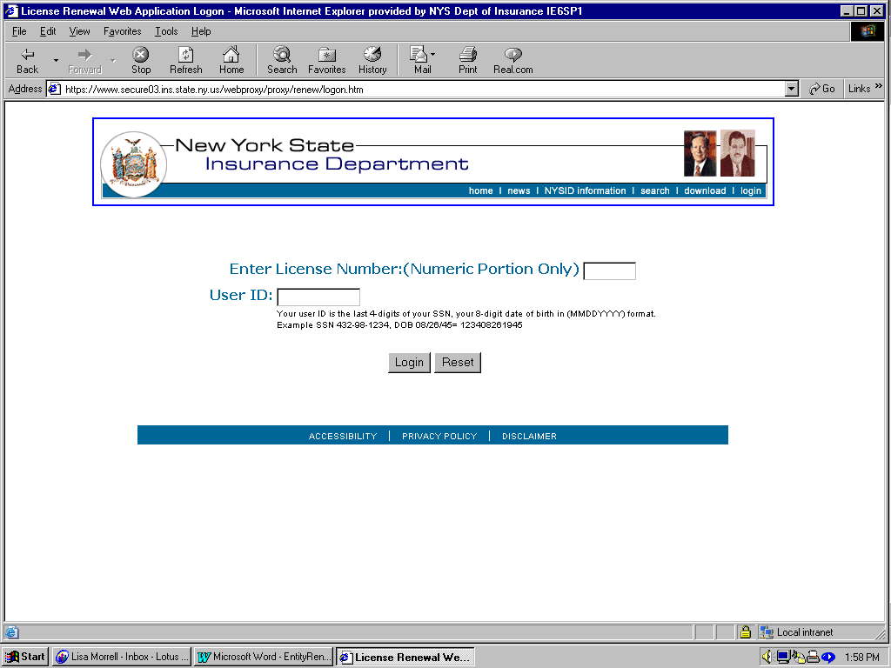

Page Validation
After the sublicensee enters their login information and selects the LOGIN button, the LicLION database and LicWebDatabase (for newly added sublicense) will be read to validate the login information (license number of the entity, DOB, and last four digits of the sublicensees SSN) and determine what licenses are pending renewal. A license is flagged for renewal if the following conditions exist: 1) the Web flag is “Y” for the class on the class table, 2) the renewal document sent field in LicLION license class table for that licensee and class is set to “Y”, 3) the renewal application has not already been processed in LicLION, and 4) the renewal application has not already been processed in LicWeb.

Error Messages

- If there are no renewals pending for the entity -
There are no licenses to renew for license number <entity license number>.

- If the user ID is not valid for the license number -
The user ID is NOT Valid – Please try again… If you continue to receive this message, please contact the Insurance Department by email at license@ins.state.ny.us OR phone at 518-474-6630 – when you here “Welcome” press ##.

Navigation
Login - Go to the Licenses Pending Renewal Page.
Reset - All information entered will be cleared from the page.

LICENSE PENDING RENEWAL PAGE

Description
This page lists all of the licenses pending renewal for the entity. On this page, the applicant selects the license to be renewed.

Layout
The Select Renewal Class page will have the same format as the EA Individual page except the entity name should appear on the License Pending Renewal Page and each page thereafter.

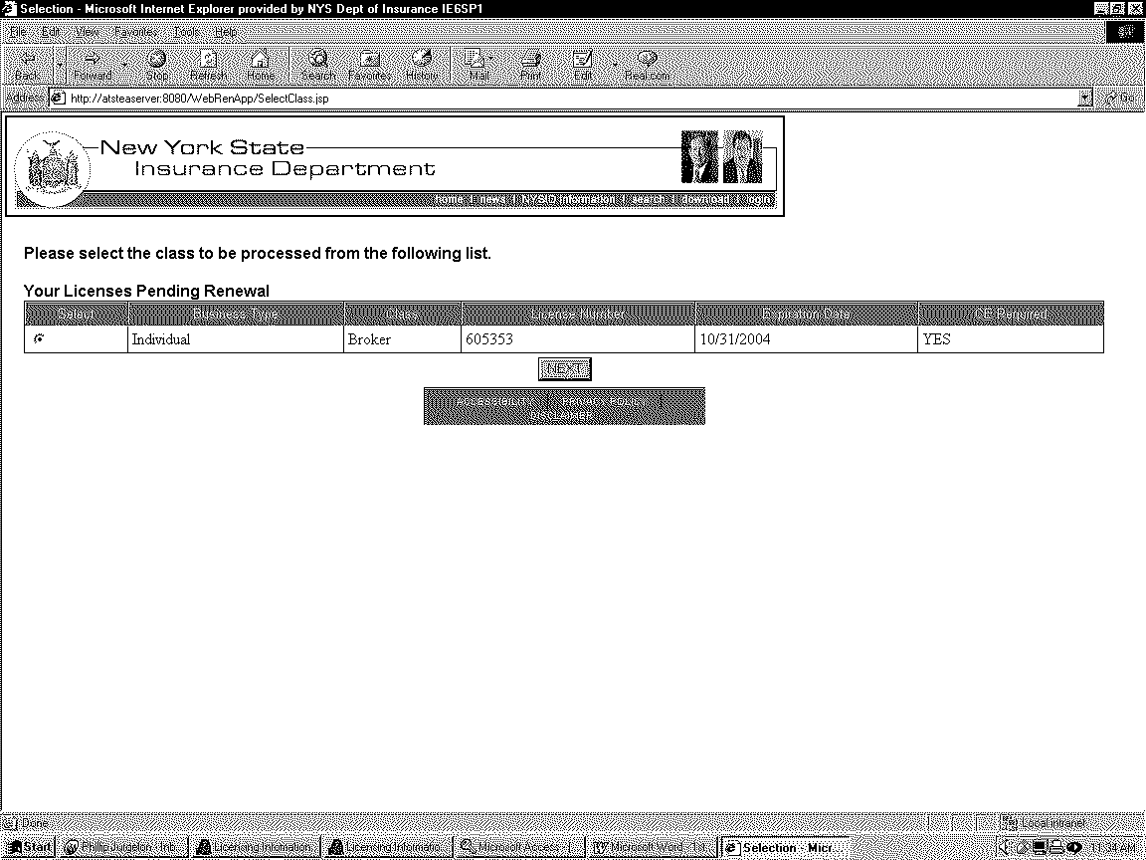

Navigation
Next – Go to the Instructions Page.

INSTRUCTIONS PAGE

Description
The Instruction Page provides information about completing the on-line application.

Layout
NEW YORK STATE INSURANCE DEPARTMENT
WEB RENEWAL INSTRUCTIONS FOR PROPERTY/CASUALTY BROKER ENTITIES
What must be done to renew this license on the Web?

All sublicensees must login in order to complete the application.

Pay the required fee by Credit Card or Check. If paying by CREDIT CARD, the renewal license may be issued within 2 business days. See the Fee Schedule. Separate payment is required for each application. $20.00 will be charged for each check dishonored by the bank.

If application indicates: “Continuing Education is Required” see the Continuing Education Note below.

Application must be fully processed and submitted by <license expiration date, MM/DD/YYYY> or your license will expire.

*Non-Resident - licensee who has declared a state OTHER than New York as their Home State and who is licensed or authorized in the state in which the principal place of business is located.

*Resident - licensee who has declared New York as their Home State.

COMPUTATION OF TOTAL FEE

LICENSE FEE - If your entity declares New York as their home state, pay the license fee listed in the Fee Schedule for New York. If your entity declares a state OTHER than New York as their home state, pay the license fee listed in the Fee Schedule for that state.

CONTINUING EDUCATION FILING FEE - Add a $10.00 filing fee if CE is REQUIRED for at least one sub-licensee who will be renewed on the license.

Submit by <license expiration date, Month Day, Year> or your license will expire.

STATUTORY LATE FILING FEE - Add $5.00 after <late filing date, Month Day, Year>.

TOTAL FEE - Add Continuing Education Filing Fee (if applicable) and/or statutory late filing fee (if applicable) to the License Fee listed in the Fee Schedule.
CONTINUING EDUCATION NOTE
If a sub-licensee is a licensee on more than one property/casualty BROKER license, he or she must check each application to determine if Continuing Education is required with that application.

<Year from the expiration date, YYYY> Renewal: 15 credit hours of Continuing Education are required for each sub-licensee whose name is followed by the statement “YES” under the “CE REQUIRED” column. Do NOT submit Continuing Education documentation. Credits must be accumulated during the biennial licensing period and before submitting this application. If you attested to Continuing Education credits to renew a General Consultant or a Property/Casualty Agent in <Year from the expiration date, YYYY>, the same credits may be used to renew a property/casualty BROKER license in <Year from the expiration date, YYYY>.

Non-residents who have met the Contiuing Educatin requirements of their Home State need not take New York Continuing Education Courses.

Next

Navigation
Next – Go to the Sublicensee/Inactive Officer Page.

SUBLICENSEE/INACTIVE OFFICER PAGE

Description
The Sublicensee/Inactive Officer Page allows the applicant to add/delete sublicensees/designated responsible persons and inactive officers.

Layout
License number <license number> - <name of sublicensee logged in>

Listed below are the entity’s known officers/director, members/managers with a Sublicensee/Designated Responsible Person indicator. ALL officers, directors, members/managers must be listed. You are required to add any officer/director, member/manager not listed below by selecting “Add Sublicensee/Designated Responsible Person or Inactive Officer” and entering the information requested. If sub-licensee/designated responsible person, indicate by selecting Yes in the Sublicensee column. Only qualified officers, directors, members/managers of your entity can be selected as sublicensee/designated responsible person; employees are not eligible. The entity will be licensed in those lines for which its sub-licensees/designated responsible persons are qualified.
To TERMINATE a listed officer/director, member/manager, click in the “Terminate Sublicensee” column for the person being terminate.

A.  Name  Last First M. I. |  |  | B.  Title of Officer/Director | C.  Date of Birth  (MMDDYYYY) | D.  CE Req. | E.  Sublicensee/ Designated Responsible Person | F.  Terminate  Sublicensee or Inactive Officer
 |  |  |  |  | Yes or No | Yes  No  | 
 |  |  |  |  | Yes or No | Yes  No  | 
 |  |  |  |  | Yes or No | Yes  No  | 
Next
Add Sublicensee/Designated Responsible Person or Inactive Officer
IN ORDER TO FULLY PROCESS THE ENTITY RENEWAL APPLICATION ALL SUB-LICENSEE MUST LOGIN AND COMPLETE THE RENEWAL APPLICATION

Page Validation
For each sublicensee/designated responsible person and inactive officer of the licensed entity:
- Name of sublicensee – Cannot edit. Pull from the LION database if first sublicensee to login for the license renewal, pull from the Web database if not the first sublicensee to login.
- Title of Sublicensee/Officer/Director – Cannot edit. Pull from the LION database if first sublicensee to login for the license renewal, pull from the Web database if not the first sublicensee to login.
- DOB - Cannot edit. Pull from the LION database if first sublicensee to login for the license renewal, pull from the Web database if not the first sublicensee to login.
- CE Required – Cannot edit. The field will display ‘Yes’ or ‘No’ depending upon whether CE is required. Pull from the LION database.
- Sublicensee/Designated Responsible Person – Can edit only if the sublicensee being edited has not completed the Certification and Attestation Page. Pull from the LION database if first sublicensee to login for the license renewal, pull from the Web database if not the first sublicensee to login.
- Terminating a Sublicensee or inactive officer/director etc - Can edit only if the sublicensee being terminated has not completed the Certification and Attestation Page. Pull from the LION database if first sublicensee to login for the license renewal, pull from the Web database if not the first sublicensee to login. A sublicensee cannot terminate him/her-self. If the sublicensee selects the terminate flag a popup box appears stating <name of sublicensee or inactive officer/director etc > – will be terminated effective <current expiration date of corporate license held>. The box will have two buttons ‘OK’ and ‘CANCEL’; if OK is selected, the sublicensee or inactive officer is terminated (can no longer login to renew the entity application); if CANCEL is selected, return to the Sublicensee/Inactive Officer Page with the TERMINATE check box unchecked. Once an sublicensee or inactive officer/director is terminated, all subsequent licensees to complete the application will see this information display on the page but will be unable to reinstate that terminated person; that is they will not be able to modify the termination indicator.
If more than 1 sublicensee is logged into the application at the same time, none of the sublicensees can go to the Add a Sublicensee/Inactive Officer Page.

Navigation
Next – If the sublicensee logged into the renewal application has already completed the Certification and Attestation Page
- AND if all sublicensees have completed the renewal application, go to the Last Sublicensee Page.
- AND if all sublicensees have not completed the renewal application, go to the Sublicensee Confirmation Page.
-
If the sublicensee logged into the renewal application has not completed the Certification and Attestation Page, go to the Sublicensee Biographical Information Page.

Add Sublicensee/Designated Responsible Person or Inactive Officer – Go to the Add Sublicensee/Inactive Officer Page.

ADD SUBLICENSEE/INACTIVE OFFICER PAGE

Layout
License number (license number> - <name of sublicensee logged in>

List all officers/directors, members/managers NOT already listed on previous page. Enter all information requested. If sub-licensee/designated responsible person, indicate by selecting Yes in the Sublicensee column. Only qualified officers, directors, members/managers of your entity can be selected as sublicensee/designated responsible person; employees are not eligible. The entity will be licensed in those lines for which its sub-licensees/designated responsible persons are qualified.

* Name Last, First M. I. | #  Title of Officer/Director | * Date of Birth  (MMDDYYYY) | * Social Security Number | Check here if  sub-licensee/designated responsible person
1. |  |  |  | 
2. |  |  |  | 
3. |  |  |  | 
4. |  |  |  | 
5. |  |  |  | 
* - Required information for all entities.
# - Required information for a corporate entity.
Add
Cancel

Page Validation
For each sublicensee/inactive officer added:
- Name – Required.
- Title of Sublicensee/Officer/Director – Required if Business Type = C (Corporation).
- DOB – Required.
- SSN – Required.
- Sublicensee/designated responsible person – At least one is required for the entity – Optional.

Note: The added sublicensee(s) will need to complete this renewal application before the application is considered complete.

Navigation
Force tabs on the Date of Birth and SSN fields.

Add – Display a OK popup box indicating:
- If data was entered on the page - “Sublicensee(s) has been added. Each new sublicensee(s) must complete a renewal application.” When the applicant clicks OK, go to Sublicensee/Inactive Officer Page.
Note: NO INACTIVE OFFICER/DIRECTOR CAN BE ADDED IF ANY SUBLICENSEE HAS ALREADY COMPLETED THE ATTESTATION PAGE. HOWEVER, A SUBLICENSEE MAY BE ADDED AT ANY TIME DURING THE ENTITY RENEWAL APPLICATION PROCESS. Meaning only the first sublicensee to log in can add an inactive officer/director. If an attempt is made to add an inactive officer/director after a sublicensee has completed the Certification and Attestation Page, a message box must appear stating “The renewal process was already started. No inactive officer/director can be added at this time. If you have any questions, please contact the Department by email at licensing@ins.state.ny.us or call 518-474-6630. When you here WELCOME press ## .”
- If no information was entered - “Enter required information on this page.” When the applicant clicks OK, return to Add Sublicensee/Inactive Officer Page.
- If officer being added is already listed on application – “<Name of Officer> already exists. Will not be added.”

Cancel – Display an OK popup box indicating “No Sublicensee/inactive officer has been added.” When the applicant clicks OK, go to the Sublicensee/Inactive Officer Page.

Special Processing
If a sublicensee (sublicensee/designated person checked) is added on an entity application:

Phase I - the license will be pended for Manual review for Phase 1. During the evening batch process, a report should print listing the new sublicensees once the entity application has been fully completed. A screen in LION needs to display the new sublicensee information, indicate PENDING, and allow for Licensing approval and processing.
If any officer is added on an entity application, LION must be checked for BC record. If the officer has an open BC, this information must be listed on the OPEN BC Report.
LicWeb and LION need to track any officer(s) who have been added, including open BC.

Phase II – the sublicensee must be checked for an open BC. The license will be issued with the original sublicensees (who have not been terminated) and with any new sublicensee who does not have an open BC. Newly added sublicensee(s) with an open BC get a pending status on the member tab in LION.
If any newly added officer has an open BC and there is no BC on the entity, the entity will get a secondary BC in LION

SUB-LICENSEE BIOGRAPHICAL INFORMATION PAGE

Layout
License number (license number> - <name of sublicensee logged in>
1. Name Last, First M. I. |  | 2. Title of Officer/Director |  | 3. Date of Birth | 4. Gender  M F |  | 5. CE REQ.  Yes or No
6. Do you wish to modify this address? Yes No
7. Residence Number and Street (Required) | 8. P.O. Box (if any)
9. City | 10. State |  | 11. Zip Code |  |  | 12. Check here if sub-licensee/designated responsible person
Next
∇
**NON-RESIDENTS
HOME STATE

IT IS CERTIFIED THAT I AM CURRENTLY LICENSED AND IN GOOD STANDING IN MY HOME STATE FOR THE LINES OF AUTHORITY BEING APPLIED FOR IN THIS APPLICATION. Yes NO

(NON-RESIDENT MUST COMPLETE THIS QUESTION IN LIEU OF SUBMITTING A HARD COPY HOME STATE CERTIFICATION.)

Page Validation
- Name of sublicensee – CanNOT edit. Pull from the LION database if first sublicensee to login for the license renewal, pull from the Web database if not the first sublicensee to login.
- Title of Sublicensee/Officer/Director – Required if Business Type = C (corporation). Pull from the LION database if first sublicensee to login for the license renewal, pull from the Web database if not the first sublicensee to login.
- DOB - Cannot edit. Pull from the LION database if first sublicensee to login for the license renewal, pull from the Web database if not the first sublicensee to login.
- Gender – Male or Female – Required; Can edit. Pull from the LION database if first sublicensee to login for the license renewal, pull from the Web database if not the first sublicensee to login.
- CE Required – Cannot edit. The field will display ‘Yes’ or ‘No’ depending upon whether CE is required. Pull from the LION database.
- Do you wish to Modify this Address – Yes or No - Required. If ‘Yes’ then address can be edited; if ‘No’ address cannot be edited. Pull from the LION database if first sublicensee to login for the license renewal, pull from the Web database if not the first sublicensee to login.
- Residence Address Line 1 - Required. Pull from LION Database if available (Phase 2)
- Residence P.O. Box - Optional. . Pull from LION Database if available (Phase 2)
- Residence City - Required. . Pull from LION Database if available (Phase 2)
- Residence State or Foreign Country – Required . Pull from LION Database if available (Phase 2)
- Residence Zip Code – Required . Pull from LION Database if available (Phase 2)
- Sublicensee/DRP Check box - Pull from the LION database if first sublicensee to login for the license renewal, pull from the Web database if not the first sublicensee to login.
- Home State Drop Down Box should contain 49 states, the District of Columbia and any foreign counties where reciprocal (fee maintenance table); do not include NY as a selection.
- Non-resident Home State Certification Question – this question must be answered by all non-resident sublicensees. Residency is determined by the data entered on the Sub-licensee Biographical Page. If homestate is not equal to NY the sublicensee is a non-resident.

Navigation
Next – Go to the Background Questions Page.

BACKGROUND QUESTIONS PAGE

Description
The Background Questions Page will work much like the Original License Application Background Questions Page on EA Server. The questions and pages will be defined on tables in LicLION and dynamically generated on the Web page. In addition to controlling the display of questions through table entries, Licensing needs to further control the display with business rules associated with the table definitions (Phase 2). This type of functionality was defined for the Original License Application but has not been developed to-date.

Layout
License number (license number> - <name of sublicensee logged in>

Background Information
1. The Applicant/sublicensee must read the following very carefully and answer every question Since the execution and filing of its last application, has the corporation or any of its officers or directors, individually or through connection with a corporation:
(a) Ever been convicted of, or currently charged with, committing a crime, whether or not adjudication was withheld?  “Crime” includes a misdemeanor, felony, or a military offense. You may exclude misdemeanor traffic citations and juvenile offenses.  “Convicted” includes, but is not limited to, having been found guilty by verdict of a judge or jury, having entered a plea of guilty or nolo contendre, or having been given probation, a suspended sentence or a fine.  If answered YES provide in the space below the full name and date of birth of person(s) involved: | Yes | No
- Ever been involved in an administrative proceeding regarding any professional or occupational license?  “Involved” means having a license censured, suspended, revoked, canceled, and terminated; or, being assessed a fine, placed on probation or surrendering a license to resolve an administrative action. “Involved” also means being named as a party to an administrative or arbitration proceeding which is related to a professional or occupational license. “Involved” also means having a license application denied or the act of withdrawing an application to avoid a denial. You may exclude terminations due solely to noncompliance with continuing education requirements or failure to pay a renewal fee.  If answered YES provide in the space below the full name and date of birth of person(s) involved:  _______________________________________________________________________________________________ | Yes | No

- Has any demand been made or judgment rendered against the corporation or any of its officers or directors, individually or through connection with a corporation for overdue monies by an insurer, insured or producer, or ever been subject to a bankruptcy proceeding? | Yes | No
- Been notified by any jurisdiction to which you are applying of any delinquent tax obligation that is not the subject of a repayment agreement?  If answered YES provide in the space below the full name and date of birth of person(s) involved and identify the jurisdiction(s):  _______________________________________________________________________________________________ | Yes | No
- Currently a party to, or ever been found liable in, any lawsuit or arbitration proceeding involving allegations of fraud, misappropriation or conversion of funds, misrepresentation or breach of fiduciary duty?  If answered YES provide in the space below the full name and date of birth of person(s) involved:  _______________________________________________________________________________________________ | Yes | No
- Ever had an insurance agency contract or any other business relationship with an insurance company terminated for any alleged misconduct?  If answered YES provide in the space below the full name and date of birth of person(s) involved:  _______________________________________________________________________________________________ | Yes | No
- Do you have a child support obligation in arrearage?  If you answer yes to Question 7, by how many months are you in arrearage? Months | Yes | No
- Are you the subject of a child support related subpoena or warrant? | Yes | No
Next

Cancel

Page Validation
- All main segments must be completed.
- Subsegments must be completed if the main section is answered affirmative (same as validation in the EA version of the Individual Renewal Application).

Navigation
Cancel – Go to the Sublicensee/Inactive OfficerPage.
Next – If continuing education is required (see 4.3.6.4.1), go to the Continuing Education Page. If continuing education is not required, then go to the Certification and Attestation Page.

Determining If CE Is Required
1) Read tblLClass on the LicLION database for application class = cLCLClss, cLCLCEReqd = ‘Y’. If cLCLCEReqd = ‘N’, then CE not required for class.
2) Read tblLLicenseClass on the LicLION database for applicant entity ID (obtained from tblLMaster during login validation) = nLLCEntId, application class = cLLCClss, cLLCCEReq = ‘Y’. If cLLCCEReq = ‘N’, then CE is not required for the applicant.
3) If the sublicensee/designated responsible person has been added during the renewal process, then CE is not required.

Special Processing
Print an irregularity report during the nightly Web to LION batch process for all sublicensees who answered any of the irregularity questions affirmatively once the application is fully completed by all sublicensees. This report will be similar to the irregularity report printed for the individual renewal applications.

CONTINUING EDUCATION (CE) QUESTION PAGE FOR SUBLICENSEES ONLY

Description
The Continuing Education Page allows those sublicensees who require continuing education (CE) to enter their course information. The page will contain instructional text and 15 CE credit and completion date input boxes. The applicant must enter sufficient amount of hours for that class. The number of hours required is obtained from LicLION database. The page will display all applicable courses entered by the CE providers and stored in the LION database. These courses will be displayed only and may not be edited. To complete the required number of credits the applicant may enter the remaining courses in the spaces provided. Data saved in LION should distinguish between Provider entered data and Applicant entered data.

NOTE – no newly added sublicensees will require CE.

Layout
License number (license number> - <name of sublicensee logged in>

CONTINUING EDUCATION QUESTION
15 Credit Hours of Continuing Education are required. Do not submit Continuing Education Documents. Credits must have been accumulated {tblLClass.cLCLCEHrsReqd} during the biennial licensing period.

If you are a non-resident, you must have met the Continuing Education requirements of your State of Domicile. Section A or B must be completed. You will be charged anIn addition you will be charged an additional $10.00 to renew this license.

- New York Approved Continuing Education:
I attest that I have completed statutory Continuing Education as Yes No
indicated below and maintain certificates evidencing this.

IT WILL BE NECESSARY FOR YOU TO ENTER THE DETAILS BELOW FOR THE NEW YORK APPROVED CONTINUING EDUCATION COURSES THAT YOU HAVE TAKEN BUT NOT YET SUBMITTED TO THE DEPARTMENT BY THE PROVIDER

COURSE CREDITS COMPLETION DATE COURSE CREDITS COMPLETION DATE
NY NY

NY NY

NY NY

NY NY

NY NY

NY NY

NY NY

NY

OR

If you answered (A) above and provided New York Course information, DO NOT answer (B). You can now proceed by selecting “Next.”

B) Non-Resident Home State Certification Attestation:
I hereby attest that I have met the Continuing Education criteria
of my home state.. Yes No
∇

My state is:

Continuing Education Note: You may use the same applicable credits for other licenses you may hold as long as the course was taken within the same biennial licensing period as the license being renewed.
Next

Page Validation
- The course number must be validated against the LION database.
- The sum of all CE credits entered and stored in LION must equal the amount of credits in tblLClass field cLCLCEHrsReqd.
- If the applicant takes the same course as a prior renewal the course will not be applicable.
- The CE data retrieved from tblLCEDetails is not editable.
- The licensee must complete the course within the correct licensing period. If the licensee enters a completion NOT in the correct time frame the message should be:
Not a valid course completion date for this renewal. Credits must have been accumulated after the effective date of the license you are renewing and before the application you are processing.
- The course completion day cannot be beyond the current date.

Navigation
Next - Go to the Certification and Attestation page.

CERTIFICATION AND ATTESTATION PAGE

Description
The applicant certification and attestation page must be completed by the applicant. This page is static.

Layout
The Certification and Attestation Page will have the same format and function as that of the Certification and Attestation Page on the EA version of the individual renewal, however the wording will be different:

License number (license number> - <name of sublicensee logged in>

**Attestation and Signatures required on page 4

Applicant Certification and Attestation
The undersigned Sub-licensees/Designated Responsible Officer(s)/Director(s) hereby certifies, under penalty of perjury that:

- All of the information submitted in this application and attachments is true and complete and (I am) or (We are) aware that submitting false information or omitting pertinent or material information in connection with this application is grounds for license or registration revocation and may subject (me)(us) and the business entity to civil or criminal penalties.
- Where required by law, the business entity hereby designates the Commissioner, Director, or Superintendent of Insurance, or an appropriate representative in each jurisdiction for this application is made to be its agent for service of process regarding all insurance matters in the respective jurisdiction and agree that service upon the Commissioner, Director, or Superintendent of that jurisdiction is of the same legal force and validity as personal service upon the business entity.
- The business entity grants permission to the Commissioner, Director, or Superintendent of Insurance in each jurisdiction for which this application is made to verify any information supplied with any federal, state or local government agency, current or former employer or insurance company.
- The jurisdictions are hereby authorized to give any information they may have concerning (me) or (us) to any federal, state or municipal agency, or any other organization as referenced in Section 110 of the New York State Insurance Law and the jurisdictions and any person acting on their behalf are hereby released from any and all liability of whatever nature by reason of furnishing such information.
- It is acknowledged that (I) or (We) understand and comply with the insurance laws and regulations of the jurisdictions to which is being applied for licensure/registration.
- For Non-Resident License Applicants, it is certified that (I) or (we) have been licensed within the last ninety (90) days and in good standing in the home state/resident state for the lines of authority requested from the non-resident state.

CHILD SUPPORT NOTIFICATION:
PERSONS FOUR MONTHS IN ARREARS IN CHILD SUPPORT OR WHO HAVE FAILED TO COMPLY WITH A SUMMONS, SUBPOENA OR WARRANT RELATING TO PATERNITY OR CHILD SUPPORT PROCEEDING MAY BE SUBJECT TO SUSPENSION OF THEIR BUSINESS, PROFESSIONAL DRIVER AND/OR RECREATIONAL LICENSE AND PERMITS INCLUDING BUT NOT LIMITED TO LICENSES ISSUED PURSUANT TO §11-0713 OF THE ENVIRONMENTAL CONSERVATION LAW.
INTENTIONAL SUBMISSION OF FALSE STATEMENTS FOR PURPOSES OF FRUSTRATING/DEFEATING LAWFUL ENFORCEMENT OF SUPPORT OBLIGATIONS IS PUNISHABLE UNDER §175.35 OF THE PENAL LAW. PRIVACY NOTIFICATION:
PURSUANT TO ART. 1 SEC. 5 OF THE NYS TAX LAW, IT IS MANDATORY THAT YOU REPORT YOUR SOCIAL SECURITY NO. AND/OR EMPLOYER IDENTIFICATION NO. YOUR FAILURE TO RESPOND MAY BE REPORTED TO THE DEPT. OF TAXATION AND FINANCE. THESE TAX IDENTIFICATION NUMBERS ARE BEING COLLECTED TO ENABLE THE DEPT. OF TAXATION AND FINANCE TO IDENTIFY ENTITIES WHICH ARE DELINQUENT IN OR HAVE UNDERSTATED THEIR TAX LIABILITIES, AND MAY BE USED FOR ANY PURPOSE AUTHORIZED BY THE TAX LAW. THEY WILL BE MAINTAINED BY THE DIRECTOR, LICENSING SERVICES BUREAU, NYS INSURANCE DEPT., ONE COMMERCE PLAZA, ALBANY, NY 12257, (518) 474-6630.
THE NYS INSURANCE DEPT. WILL, ABSENT YOUR WRITTEN OBJECTION, , PROVIDE THESE TAX IDENTIFICATION NUMBERS TO THE NATIONAL ASSOCIATION OF INSURANCE COMMISSIONERS FOR INCLUSION IN ITS PRODUCER DATABASE. A WRITTEN OBJECTION MUST BE MAILED TO: LICENSING SERVICES BUREAU, NYS INSURANCE DEPT., ONE COMMERCE PLAZA, ALBANY, NY 12257.

I agree and wish to continue.

Navigation

“I agree and wish to continue” – If this is the last sublicensee (see 4.3.8.3.1) then go to the Last Sublicensee Page. If this is not the last sublicensee go to the Sublicensee Confirmation Page.

Last Sublicensee Determination

To determine if this is the last sublicensee all indicated sublicensees (including newly added sublicensees) must have either completed the Certification and Attestation Page or be indicated as terminated.

LAST SUBLICENSEE PAGE

Description
The last sublicensee page will display when ALL sublicensees have completed the Certification and Attestation Page.

Layout
License number (license number> - <name of sublicensee logged in>

All sublicensees have completed their personal information.
A.  Name  Last First M. I. |  |  | B.  Title of Officer/Director | C.  Date of Birth  (format) | D.  CE REQ. | E. Sublicensee/ Designated Responsible Person | F.  Terminate  Sublicensee/ Inactive officer?
 |  |  |  |  | Yes or No | Yes  No  | 
 |  |  |  |  | Yes or No | Yes  No  | 
 |  |  |  |  | Yes or No | Yes  No  | 
Yes
No
Do you wish to complete the renewal process at this time?

Page Validation
Information displayed on this screen cannot be edited
ONCE A SUBLICENSEE’S STATUS IS COMPLETE NO CHANGES CAN BE MADE TO HIS/HER RECORD.

Navigation
Yes – Go to the Entity’s Biographical Page
No – Go Sublicensee Confirmation Page

SUBLICENSEE CONFIRMATION PAGE

Description
The sublicensee confirmation page will have the same format as the check invoice page. It will confirm the sublicensee submission and list the pending sublicensees.

Layout
License number (license number> - <name of sublicensee logged in>

SUBLICENSEE CONFIRMATION PAGE

Sublicensee – {Name of Sublicensee} has completed their personal information.

The following Sublicensees are still pending:

{Sublicensee 1}
{Sublicensee 2}

In order to fully process the entity renewal application all sublicensees must log in and complete the renewal application.

Login
Home

Page Validation
None.

Navigation
Login – Go to the Entity Renewal Login Page
Home – Go to www.ins.state.ny.us

ENTITY BIOGRAPHICAL INFORMATION

Description
The Entity Biographical Information Page captures the biographical information of the entity. The page may be a static page that may be used for other corporate applications.

Layout
License number (license number> - <name of sublicensee logged in>

ENTITY(CORPORATION, PARTNERSHIP,LIMITED LIABILITY RENEWAL APPLICATION FOR PROPERTY/CASUALTY LICENSE UNDER SECTION 2103(b) OF THE INSURANCE LAW

1. Name of applicant:  Corporate Name in Full |  |  |  | Telephone Number
Do you wish to modify the principal business address? Yes  No  |  |  |  | If assigned, National Producer No. (NPN)
Principal Business Address:
Street and number (Required) |  |  |  | P.O. Box (if any)
City, Town or Village |  | County |  | State |  |  |  | Zip
Do you wish to modify the mailing address? Yes  No  Same as Business Yes  No 
Mailing Address: (Required) (Indicate if same as Business)
Street and number |  |  |  | P.O. Box (if any)
City, Town or Village |  | County |  | State |  |  |  | Zip
1a.  HOME STATE  IT IS CERTIFIED THAT THE APPLICANT ENTITY IS CURRENTLY LICENSED AND IN GOOD STANDING IN ITS HOME STATE FOR THE LICENSE APPLIED FOR IN THIS APPLICATION  (NON-RESIDENT MUST COMPLETE THIS QUESTION IN LIEU OF SUBMITTING A HARD COPY HOME STATE CERTIFICATION.) |  |  |  |  |  |  | Yes  No 
2. Identify all owners with 10% interest or voting interest:
Name |  |  | SSN/FEIN |  |  | Title
Primary E-mail:
Confirm Primary E-mail:
Secondary E-mail:
Web Site Address (Optional):
Submitted By: Name |  |  |  |  | Submitted By: Phone
(If the principal business address is changed, the Insurance Department must be notified in writing immediately.)
Next
Cancel

Page Validation

Input Box/Field Validations:
- Name of Applicant – From LION can not edit.
- Fed. Employer ID No. – asterisked out similar to ssn
- Telephone No – Optional/editable
- National Producer Number – display only, cannot be modified.
- Business Address Line 1 – Required (Editable if Modification question answered yes.)
- Business P.O. Box – Optional (Editable if Modification question answered yes.)
- Business City – Required (Editable if Modification question answered yes).
- Business County – Required - if NYS (Editable if Modification question answered yes).
- Business Zip or Foreign Country – Required (Editable if Modification question answered yes).
- Mailing Address – Required - if “Same as Business” is selected then an identical mailing address record should be made using the business address. Mailing address fields on the Original application are not required and should be null.
- Home State – Required – same homestate rules apply as on the EA INDIVIDUAL RENEWAL
- Primary Email Address - If no e-mail address is provided Popup Message must appear:
“No email address has been provided. Providing an email address will enable you to receive Ins.Dept updates, including early notice of online renewals & material quickly and electronically.” (Same as EA Individual Renewal: When ok is clicked return to Primary Email Address field; if nothing is again entered they can continue; no message box appears a 2nd time.
- Submitted By – Optional

Navigation
Cancel – Go to the previous page.
Next – Go to the Fee Details Page.

FEE DETAILS PAGE

Description
The Fee Details Page does not appear until the last sublicensee has completed the application. The Fee Details Page will have the same format as that of the EA version of the Fee Details Page from the individual renewal. The fees are calculated by using the home state selected and to read the fee table that resides in LicLION plus the number of sublicensees. The fees for non-resident are based on their home state and the number of sublicensees (see Appendix . B for fee calculation.) Additionally, the statutory late fee should be controlled by licensing at the class level similar to the “available on the web check”.

This page must include the NG checks and dishonored fine check functionality that is written in the P/C Renewal Apache Application.

Navigation
Cancel – Go to the Certification and Attestation Page.
Pay by Check – Go to the Check Invoice Page.
Pay by Credit Card – Go to the Credit Card Submission Page.

CHECK INVOICE

Description
The Check Invoice Page will have the same format and function as that of the Check Invoice Page on the Original EA Application.

Navigation
Home – Go to www.ins.state.ny.us

CREDIT CARD SUBMISSION

Description
The Credit Card Submission Page will have the same format and function as that of the Credit Card Submission Page on the Original EA Application.

Navigation
Cancel – Go to the Fee Details Page.
Process – Go to the Credit Card Invoice Page.

CREDIT CARD INVOICE

Description
The Credit Card Invoice Page will have the same format and function as that of the Credit Card Invoice Page on the Original EA Application.

Navigation
Home – Go to www.ins.state.ny.us

LION PROCESSING
- Need to code the batch program to move the completed entity renewal application data from LicWeb to LicLION each evening. Nightly batch processing will process only those records where all sublicensees are complete and a payment method has been indicated.

- If a sublicensee is added on an entity application, the license will be pended for Manual review for Phase 1. During the evening batch process, a report should print listing the new sublicensees (Report Format?). A screen in LION needs to display the new sublicensee information, indicate PENDING, and allow for Licensing approval and processing (Screen Format?).

- Print an irregularity report during the nightly Web to LION batch process for all sublicensees who answered any of the irregularity questions affirmatively. This report will be similar to the irregularity report printed for the individual renewal applications.

- Process pending resident applications through the non-resident licensing application on the processing unit tree.

- We need to know in LION where the corp renewal is in process – whether its pending check or pending sublicensee completion.

- A separate tab to be built for inactive officers in LION.

DATA RETENTION
Three years retention on the entity renewal applications on the LicWeb and LicLION databases. Before the data is purged we would like the data exported to tab delimited files named the same as the table name it was sitting in. The data exported should be for a complete calendar year and burnt to a CD for each year.

For example: 1/1/05 we should burn to a CD containing entity renewal data submitted during the Year 2001.

APPENDIX A - GLOSSARY OF TERMS AND ACRONYMS
COMPANY An insurance company licensed to write business in NYS.
DEPARTMENT The New York State Insurance Department
JURISDICTIONS States
N/A Not Applicable
NYS New York State
NYSID New York State Insurance Department
PAGE Web Page
RESIDENT APPLICANT Applicant must maintain and file with the Department a business or resident address in NYS
SSN Social Security Number
TBD To Be Determined
US United States

APPENDIX B – FEE SCHEDULE CALCULATION
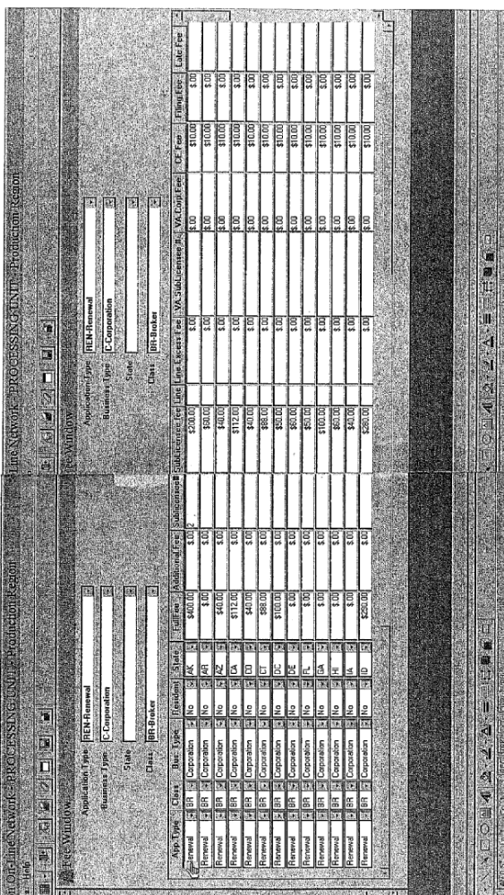

The ? table in the LicLION database is used to calculate the entities license renewal fee. The query to this table would be:
1) application type = renewal, 2) class = class of license being renewed, 3) business type = business type of entity, 3) resident = ???, and 4) state = entities state of domicile.

The minimum fee is stored in the full fee field. If the number of sublicensees associated with the entity is less than or equal to the number in the sublicensee field, the renewal fee would be the minimum fee would be charged. If the number of sublicensees associated with the entity is greater than the number in the sublicensee field, then the renewal fee would be the minimum fee plus (the number of sublicensees exceeding the number in the sublicensee field times the sublicensee fee).

Example: Corporate renewal for class BR. The corporation is domiciled in Arkansas and has 10 sublicensees.

Renewal Fee = minimum fee + (the number of sublicensees exceeding the number in the sublicensee field times the sublicensee fee)
= $400 + ((10-2) * $200)
= $400 + $1,600
= $2,000

APPENDIX C - NOTES
- If BC is on corporation, renewal license is issued but no new sublicensee can be added; the added sublicensee will need to get a pending status; information will appear on Open BC report
- If BC is on added sublicensee - sublicensee status is “pending”; information will appear on Open BC report
- A logged in sublicensee cannot terminate him/herself; may be a problem if the only sublicensee is or has been terminated.
- IF all existing sublicensees are terminated and the added sublicensee(s) have an open BC, the license is issued with NO sub-licensees.
- Cross check owner name with sublicensee/inactive officer name
- Not a problem for BR class but other classes – entity is licensed for the lines of authority that the sublicensee(s) is qualified for; what if added sublicense as an additional line of authority? What if terminated sublicensee has the only life line of authority?
- Once a sublicense has completed their part of the application, NONE of the information for that person can be edited.

